Week 1 - Day 2

Table of Contents

[CH101-008 UA Fall 2016](/CH101-008/)

[About](/CH101-008/about/)

# Week 1 - Day 2

Aug 19, 2016

[Quizlet for terms in this lecture](https://quizlet.com/_2fb8jn)

Download Word (docx):

## Navigate using audio

# Some online homework discussion

* Audio 0:00:29.813843
* You log on to the [MyLabsPlus](http://ua.mylabsplus.com) website
  + Go to assignments
    - They are arranged in order
    - Audio 0:01:13.422000
    - They are due at midnight, but you get 1% per hour late off your score. So you aren’t SOL if you don’t get it right on time
    - You get a drop on the homework
  + Audio 0:03:18.888195
    - Speech about tax returns is actually about:
      * You have 5 freebies on the clicker questions
        + absences
      * Same is true for the lab
        + You get 2 absences

More starts penalties

* + Audio 0:06:21.001575
    - Re-iterating
      * You get one drop grade in the class
        + Shoot to make it the last test because it is the hardest
  + Pre-labs are due mid-day the day before your lab
    - If you have a Monday lab, your pre-lab is due noon Sunday
* Audio 0:09:10.406530
  + You have two attempts at getting multiple choice right in homework
  + 6 on numeric

# Chapter 1 Notes Part 2

## Classification of Pure Substances

* Pure substances can be categorized into two types:
  + Elements
  + Compounds
* This categorization depends on whether or not they can be broken down (or decomposed) into simpler substances.
* An *element* is a substance that cannot be chemically broken down into simpler substances.
  + Basic building blocks of matter
  + Composed of single type of atom, like helium
* A *compound* is a substance composed of two or more elements in fixed definite proportions.
* Most elements are chemically reactive and combine with other elements to form compounds.

## Heterogeneous Mixture

* A *heterogeneous mixture* is one in which the composition varies from one region of the mixture to another.
  + Made of multiple substances, whose presence can be seen (example: a salt and sand mixture)
    - Portions of a sample of a heterogeneous mixture have different composition and properties.

## Homogeneous Mixture

* A *homogeneous mixture* is one made of multiple substances, but it appears to be one substance.
* All portions of a sample have the same composition and properties (like sweetened tea).
* Homogeneous mixtures have uniform compositions because the atoms or molecules that compose them mix uniformly.

## The Scientific Approach to Knowledge

* Audio 0:12:42.707245
* The approach to scientific knowledge is empirical
* It is based on observation and experimentation.
* The scientific method is a process for understanding nature by observing nature and its behavior through experimentation.
* Key characteristics of the scientific method
  + Observations
  + Formulation of hypotheses
  + Experimentation
  + Formulation of laws and theories

## Observations

* Observations:
  + They are also known as data.
  + They are the descriptions about the characteristics or behavior of nature.
* Observations, verification of observations, and experimentation can lead scientists to formulate a hypothesis.

## The Scientific Approach to Knowledge

* Scientists try to understand the universe through empirical knowledge gained through observation and experiment

## Gathering Empirical Knowledge ─ Observation

* Some observations are descriptions of the characteristics or behavior of nature ─ qualitative
* Some observations compare a characteristic to a standard numerical scale ─ quantitative

## From Observation to Understanding

* Audio 0:15:58.585935
* Hypothesis – a tentative interpretation or explanation for an observation
* A good hypothesis is one that can be tested to be proved wrong!

## Testing Ideas

* Audio 0:17:57.155168
* Ideas in science are tested with experiments
* An experiment is a set of highly controlled procedures designed to test whether an idea about nature is valid
* The experiment generates observations that will either validate or invalidate the idea

## Is this a good hypothesis?

* Audio 0:19:00.330922
* Yesterday, the phase of the moon was a crescent. I observed that it rained a lot yesterday.
* It also rained during the previous crescent moon.
* I hypothesize that crescent moons cause rain showers
  + The hypothesis is the ‘why?’
* My answer: This is a good hypothesis because it can be tested and proved wrong
* Audio 0:21:04.453540
* Best answer: C
  + It’s a good hypothesis because it’s falsifiable
  + Audio 0:23:23.754722
  + Audio 0:25:56.261455
  + Good reasons to understand the importance of hypothesis

## From Specific to General Understanding

* Audio 0:26:25.458523
* A *hypothesis* is a potential explanation for a single or small number of observations
* A *scientific theory* is a general explanation for why things in nature are the way they are and behave the way they do
  + Integrates a lot of different observations
  + Lets us predict what’s happening in the universe

## Think about it

* Given what you just learned about the term “Theory”, what’s wrong with this statement:
  + “The theory of gravity is just a theory and therefore probably wrong”
    - Audio 0:27:55.076377
    - By the time you get to calling things theories, they have been tested *a lot*
      * The scientific method says you can’t prove anything, you can only disprove things
      * You’ll have to explain exceptions to the theory at some point so a new theory will emerge

## From Specific to General Observations

* A *scientific law* is a statement that summarizes all past observations and predicts future observations
  + *Law of Conservation of Mass* – “In a chemical reaction matter is neither created nor destroyed.”
* A scientific law allows you to predict future observations
* 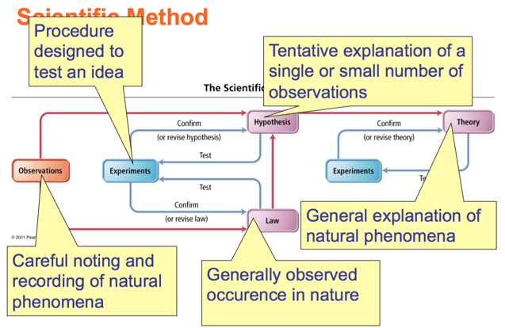
  + Audio 0:31:28.593326

## Relationships Between Pieces of the Scientific Method

* 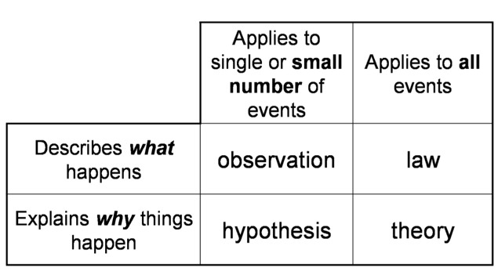

## The Scientific Approach to Knowledge

* It is necessary to be careful with the information presented by an experimentalist who lacks theoretical principles… [he] gathers at random several facts and presents them as proofs… scientific knowledge without reasoning [theory] does not exist.”
  + J. le R. d’Alembert (1717-1783), from Nouvelles Experiences sur la Resistance des Fluids. Jombert, Paris (1997)
* D’Alembert was always surrounded by controversy. ….Unfortunately he carried [his]… pugnacity into his scientific research and once he had entered a controversy, he argued his cause with vigour and stubbornness. He closed his mind to the possibility that he might be wrong…
  + Thomas L. Hankins (1990). Jean D’Alembert: Science and the Enlightenment. Taylor & Francis. p. 236. ISBN 2881243991

## Why Is Scientific Measurement Important?

* Scientific data can be either qualifiable or quantifiable
  + Qualifiable data are observational
    - Subjective in nature
    - Examples: color, shape
* Quantifiable data are measurable (empirical).
  + Objective in nature
  + Uses equipment (e.g., glassware, balance, instrumentation) capable of generating empirical data with standardized *UNITS*.
    - English system (e.g., inch, feet, etc.) – International System of Units (SI)
    - Metric system

## What Is a Measurement?

* Audio 0:36:17.268476
* quantitative observation
* comparison to an agreed- upon standard
* every measurement has a number and a unit
* 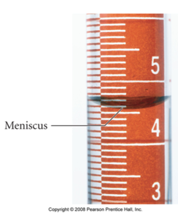

## Significant Figures

* Audio 0:37:46.810624
* No measurement can be more accurate than half the smallest division
  + Note: Tro says 1/10 of smallest division
* Often write +- to indicate this: 11+-1 mm, 1.1 +-0.3 cm
* No error range given? Then assume + half the least Significant Figure
  + 
* Audio 0:39:46.713576
* Any digit that is not zero is significant
  + 1.234 kg 4 significant figures
* Zeros between nonzero digits are significant
  + 606 m 3 significant figures
* Zeros to the left of the first nonzero digit are not significant
  + 0.08 L 1 significant figure
* If a number is greater than 1, then all zeros to the right of the decimal point are significant
  + 2.0 mg 2 significant figures
* If a number is less than 1, then only the zeros that are at the end and in the middle of the number are significant
  + 0.004020 g 4 significant figures
* [test your ability](https://www.khanacademy.org/math/arithmetic-home/arith-review-decimals/arithmetic-significant-figures-tutorial/e/significant_figures_1)

## How many significant figures are in each of the following measurements?

* Audio 0:42:44.871665
* 24 mL
  + 2
* 3001 g
  + 4
* 0.0320 m^3
  + 3
* 6.4 x 104 molecules
  + 2
* 560 kg
  + 2

## Rounding Rules for Significant Figures

* Audio 0:44:53.580413
* Digit being rounded > 5
  + Add 1 to least significant digit
  + Result: 4.16 with 2 sig figs becomes 4.2
* Digit being rounded < 5
  + Result: 4.14 with 2 sig figs becomes 4.1
* ROUND AT THE END OF THE PROBLEM

## Addition or Subtraction - Significant Figures

* The answer cannot have more digits to the right of the decimal point than any of the original numbers
  + 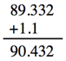
    - 1.1 has one sig fig after decimal
    - round 90.432 to 90.4
  + 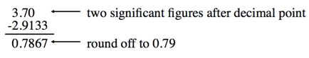
* Look at sig figs in the given variables in the problem and have that many in your answer

## Vocab

|  |  |
| --- | --- |
| Term | Definition |
| element | a substance that cannot be chemically broken down into simpler substances |
| compound | a substance composed of two or more elements in fixed definite proportions |
| heterogeneous mixture | mixture in which the composition varies from one region of the mixture to another |
| homogeneous mixture | mixture made of multiple substances, but it appears to be one substance |
| observations | also known as data |
| hypothesis | a tentative interpretation or explanation for an observation |
| qualitative | type of observation which describe characteristics of something |
| quantitative | type of observation which are compare a characteristic to a standard numerical scale |
| experiment | a set of highly controlled procedures designed to test whether an idea about nature is valid |
| scientific theory | a general explanation for why things in nature are the way they are and behave the way they do |
| scientific law | a statement that summarizes all past observations and predicts future observations |
| Law of Conservation of Mass | In a chemical reaction matter is neither created nor destroyed |

Please enable JavaScript to view the [comments powered by Disqus.](https://disqus.com/?ref_noscript)

## CH101-008 UA Fall 2016

* CH101-008 UA Fall 2016
* [jmbeach1@crimson.ua.edu](mailto:jmbeach1@crimson.ua.edu)
* jmbeach
* hey_beach

Notes and study materials for The University of Alabama's Chemistry 101 course offered Fall 2016.