Week 10 - Day 1

Table of Contents

[CH101-008 UA Fall 2016](/CH101-008/)

[About](/CH101-008/about/)

# Week 10 - Day 1

Oct 17, 2016

* [Vocab](https://quizlet.com/_2nmciq)

Download Word (docx):

## Navigate using audio

# Chapter 8

* Audio 0:01:43.748905
* Chemical Reactions and Chemical Quantities
* 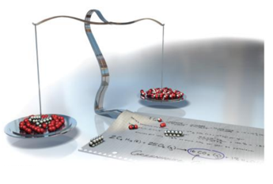

## Climate Change and Combustion of Fossil Fuels: The Greenhouse Effect

* Audio 0:02:03.985553
* Greenhouse gases in the atmosphere:
  + Allow sunlight to enter the atmosphere
  + Warm Earth’s surface
  + Prevent some of the heat generated by the sunlight from escaping
    - 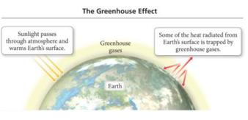
    - The balance between incoming and outgoing energy from the sun determines Earth’s average temperature.

## Global Warming

* Scientists have measured an average >0.8 °C rise in atmospheric temperature since 1860.
* During the same period, atmospheric CO2 levels have risen >25%.
* Are the two trends causal?
* 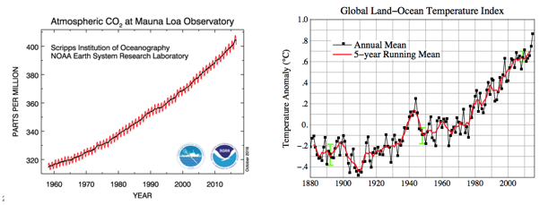

# How Much Matters

* Audio 0:04:16.146433
* It’s important to know how much CO2 is in the air. We’re going to learn how to calculate that

## Physical Changes in Matter

### What is a physical change?

* Audio 0:04:38.768317
* Changes that alter *only the state or appearance*, but not composition, are *physical changes*.
* The atoms or molecules that compose a substance do not change their identity during a physical change.
* 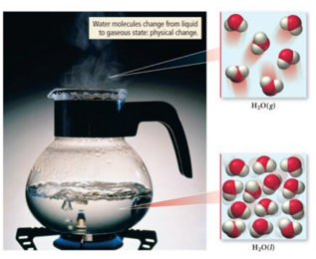
* When water boils, it changes its state from a liquid to a gas.
* The gas remains composed of water molecules, so this is a physical change.

## Chemical Changes in Matter

### What is a chemical change?

* Audio 0:05:34.019413
* Changes that alter the composition of matter are chemical changes.
* During a chemical change, atoms rearrange, transforming the original substances into different substances.
* 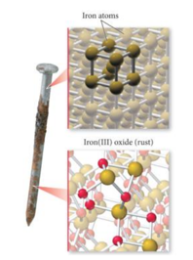
  + A rusting nail is a chemical change.
  + Rust occurs when the iron atoms exchange electrons with oxygen atoms— combining to form a NEW or different chemical substance.
  + Iron rust is the compound iron(III) oxide (Fe2O3).

# Clicker 1

* A chemical change

## Chemical Reactions

## Writing and Balancing Chemical Reactions

* Audio 0:10:25.923688
* Reactions involve chemical changes in matter resulting in new substances.
* Reactions involve rearrangement and exchange of atoms to produce new molecules.
* A chemical reaction is a written statement.
  + It states the quantities, the chemical identity of the substances in the reaction, and their physical state.
  + Example:
  + CH4(g) + O2(g) → CO2(g) + H2O(l)
  + Reactants → Products

## Chemical Equations - Short hand for Describing a Chemical Reaction

* Chemical equations:
* Provide information about the reaction
  + Molecular or ionic formulas of reactants and products
  + States of reactants and products
* Gas (g), liquid (l), solid (s), and aqueous (aq)
  + Relative numbers of reactant and product molecules that are required
  + Can be used to determine weights of reactants used and products that can be made

## The Quantities in Chemical Reactions

* Audio 0:13:21.733959
* The amount of every substance used and made in a chemical reaction is related to the amounts of all the other substances in the reaction.
  + Law of conservation of mass
  + Balancing equations by balancing atoms
* The study of the numerical relationship between chemical quantities in a chemical reaction is called *stoichiometry*.
  + 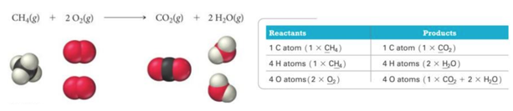

## Practice Problem: Balancing and Writing Chemical Equations

* Audio 0:15:29.644462
* Write a balanced equation for the reaction between solid cobalt (III) oxide and solid carbon to produce solid cobalt and carbon dioxide gas

## Practice Problem: Balancing and Writing Chemical Equations

* Audio 0:21:12.182118
* Write a balanced equation for the combustion of gaseous butane (C4H10) with gaseous oxygen to give carbon dioxide and gaseous water.

# Clicker 2

* What is the stoichiometric coefficient for oxygen?
  + B2H6(g) + O2(g) -> B2O3(s) + H2O(g)
* What is the stoichiometric coefficient for oxygen?
  + A) 1
  + B) 2
  + C) 3
  + D) 4
  + E) 6

C

# Clicker 3

* Audio 0:33:38.836503
* Balance the following equation with the smallest whole number coefficients. Choose the answer that is the sum of the coefficients in the balanced equation. Do not forget coefficients of “one.”
  + Cr2(SO4)3 + RbOH -> Cr(OH)3 + Rb2SO4
  + A) 10
  + B) 12
  + C) 13
  + D) 14
  + E) 15

## Reaction Stoichiometry: What Is it about?

* Audio 0:36:31.466481
* The coefficients in a chemical reaction specify the relative amounts in molecules and in moles of each of the substances involved in the reaction.
  + 2 C8H18(l) + 25 O2(g) → 16 CO2(g) + 18 H2O(g)
    - This could mean molecules or moles
* What the above BALANCED chemical equation says:
  + 2 molecules of C8H18 react with 25 molecules of O2 to form 16 molecules of CO2 and 18 molecules of H2O.
  + 2 moles of C8H18 react with 25 moles of O2 to form 16 moles of CO2 and 18 moles of H2O.
    - 2 mol C8H18 : 25 mol O2 : 16 mol CO2 : 18 mol H2O

## Cooking Stoichiometry: Making Pizza

* Audio 0:38:36.393984
* The number of pizzas you can make depends on the amount of ingredients you use.
* 1 crust + 5 oz. tomato sauce + 2 cups cheese → 1 pizza
* This relationship can be expressed mathematically.
  + 1 crust : 5 oz. sauce : 2 cups cheese : 1 pizza
* We can compare the amount of pizza that can be made from 10 cups of cheese:
  + Since 2 cups cheese : 1 pizza, then:
  + 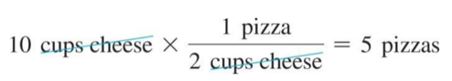
    - 10 cups of cheese = 5 pizzas

## Mole-to-Mole Conversions

* Audio 0:41:17.963464
* In the same way that the ratio was used from the pizza recipe example, the *stoichiometric ratio* acts as a conversion factor between the amount in moles of a reactant to moles of a product.
  + 2 C8H18(l) + 25 O2(g) → 16 CO2(g) + 18 H2O(g)
  + Reactant to product:
    - Stoichiometric ratio: 2 moles C8H18 : 16 moles CO2
* Stoichiometric ratio can be between:
  + Reactant to reactant
    - Stoichiometric ratio: 2 moles C8H18 : 25 moles O2
  + Product to product:
    - Stoichiometric ratio: 16 moles CO2 : 18 moles H2O

## How Many Moles of CO2 Form If 22.0 Moles of C8H18 Are combusted (Burned)?

* Audio 0:42:05.496505

## Mole-to-Mass and Mass-to-Mass Conversions

* Stoichiometric ratios can be used as a conversion factor between the amount in grams (mass) of a reactant used to determine mass (grams) of a product made.
* Strategy: A is reactant and B is the product.
* Mass of A → Moles of A → Stoichiometric ratio B : A → Moles B → Mass B
* mass A × (1 mole A/mol.mass A) × (mole B/mole A) × (mol.mass B/1 mol B)

|  |  |
| --- | --- |
| Term | Definition |
| physical change | changes that alter only the state or appearance, but not composition |
| chemical changes | changes that alter the composition of matter |
| stoichiometry | the study of the numerical relationship between chemical quantities in a chemical reaction |
| stoichiometric ratio | acts as a conversion factor between the amount in moles of a reactant to moles of a product |

Please enable JavaScript to view the [comments powered by Disqus.](https://disqus.com/?ref_noscript)

## CH101-008 UA Fall 2016

* CH101-008 UA Fall 2016
* [jmbeach1@crimson.ua.edu](mailto:jmbeach1@crimson.ua.edu)
* jmbeach
* hey_beach

Notes and study materials for The University of Alabama's Chemistry 101 course offered Fall 2016.