Week 10 - Day 2

Table of Contents

[CH101-008 UA Fall 2016](/CH101-008/)

[About](/CH101-008/about/)

# Week 10 - Day 2

Oct 19, 2016

* [Quizlet](https://quizlet.com/_2o1wff)

Download Word (docx):

## Navigate using audio

# Announcements

* Audio 0:00:49.845897
* NOYCE Presentation
  + Summer Internship for year 1
  + Pays money
    - $1350 for 3 weeks (Deadline April 6, 2017)
  + [Noyce Program](http://uanoyce.ua.edu/ua-noyce-internship.html)
  + Asks you to teach while you go to school

## How Many Moles of CO2 Form If 22.0 Moles of C8H18 Are combusted (Burned)?

* Audio 0:06:51.877125

## Mole-to-Mass and Mass-to-Mass Conversions

* Audio 0:17:07.273524
* 2 C8H18(l) + 25 O2(g) → 16 CO2(g) + 18 H2O(g)
* Problem:
* Determine the mass (grams) of CO2 produced when 3.6 × 1015 grams of C8H18 is burned in excess oxygen gas.
* Strategy:
  + Need a balanced reaction
  + From the balance reaction, use the stoichiometric relationship between C8H18 and CO2.
* Mass of C8H18 → Moles of C8H18 → Stoichiometric ratio 2 C8H18 : 16 CO2 → Moles of CO2 → Mass of CO2

## Problem: Determine the mass (grams) of CO2 produced when 3.6 × 1015 grams of C8H18 is burned in excess oxygen gas.

* Audio 0:19:15.117851
* 2 C8H18(l) + 25 O2(g) → 16 CO2(g) + 18 H2O(g)

## Practice Problem: Stoichiometry plants produce glucose (C6H12O6) from CO2 and water. How much glucose can a plant produce from 37.8 g CO2

* Audio 0:21:44.744416

## Limiting Reactant, Theoretical Yield

* Audio 0:28:22.489586
* Back to the pizza recipe:
  + 1 crust + 5 oz. tomato sauce + 2 cups cheese → 1 pizza
* Suppose you have 4 crusts, 10 cups of cheese, and 15 oz. tomato sauce. How many pizzas can you make?
* Strategy:
* We have enough crusts to make 
* We have enough cheese to make 
* We have enough tomato sauce to make 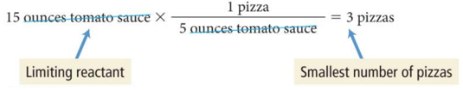
  + If you are given two or more quantities or reactants, then it is a limiting reagent problem

## Limiting Reactant: Pizza Problem Continued

* We have enough crusts for 4 pizzas, enough cheese for 5 pizzas, but ONLY enough tomato sauce for 3 pizzas.
  + Therefore, only 3 pizzas can be made.
  + The tomato sauce *limits* how many pizzas can be made.
  + 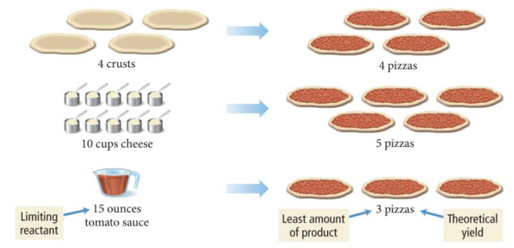

## Limiting Reactant and Theoretical Yield Connection

* Audio 0:32:11.720988
* In the pizza analogy, the tomato sauce is the *limiting reactant*, the reactant that makes the least amount of product.
  + The limiting reactant is also known as the limiting reagent.
* The maximum number of pizzas that can be made depends on this ingredient, the tomato sauce.
  + In chemical reactions, this is called the *theoretical yield*.
* Theoretical yield is the amount of product that can be made in a chemical reaction based on the amount of limiting reactant.
  + Example:
    - The ingredient that makes the least amount of pizza determines how many pizzas you can make (theoretical yield).

## More Making Pizzas

* Audio 0:33:57.386964
* Assume that while making pizzas, a pizza is burnt or dropped on the floor and only two pizzas are available to eat.
* The actual amount of product made in a chemical reaction is called the *actual yield*.
* Actual yield is about efficiency.
  + To determine your efficiency in making pizzas, a percentage value can be calculated.
  + In chemical reactions, this is called a *percent yield*.
  + 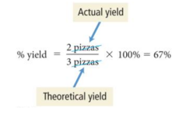

## Summarizing Limiting Reactant and Theoretical Yield

* Audio 0:35:14.485560
* The limiting reactant (or limiting reagent) is the reactant that is completely consumed in a chemical reaction and limits the amount of product.
* The reactant in excess is any reactant that occurs in a quantity greater than is required to completely react with the limiting reactant.
* The theoretical yield is the amount of product that can be made in a chemical reaction based on the amount of limiting reactant.
* The actual yield is the amount of product actually produced by a chemical reaction.
* The percent yield is calculated as:
  + (actual yield /theoretical yield) × 100 = percent yield%

## Chemical Reaction

* In reactions with multiple reactants, it is likely that one of the reactants will be completely used before the others.
  + When this reactant is used up, the reaction stops and no more product is made.
* The reactant that limits the amount of product is called the *limiting reactant*.
  + It is sometimes called the limiting reagent.
  + The limiting reactant gets completely consumed.
* Reactants not completely consumed are called *excess reactants*.
  + The reactant in excess is any reactant that occurs in a quantity greater than is required to completely react with the limiting reactant.
* The amount of product that can be made from the limiting reactant is called the *theoretical yield*.

## Practice Problem: Stoichiometry—Limiting Reactant and Theoretical Yield

* Audio 0:36:18.679366
* Ammonia, NH3, can be synthesized by
  + 2NO(g) + 3H2(g) è 2NH3(g) + 2H2O(g)
* Starting with 86.3 g NO and 25.6 g H2, find the theoretical yield of NH3

## What is the percent yield of C2H2 if 62.80 g of water yields 15.38 g of C2H2 using the following equation.

* Audio 0:46:17.094052
  + CaC2(s) + 2 H2O(l) → Ca(OH)2(aq) + C2H2(g)
  + A) 13.84%
  + B) 33.90%
  + C) 91.47%
  + D) 48.10%
  + E) 68.52%

B

|  |  |
| --- | --- |
| Term | Definition |
| limiting reactant | the reactant that makes the least amount of product |
| theoretical yield | the amount of product that can be made in a chemical reaction based on the amount of limiting reactant |
| actual yield | the actual amount of product made in a chemical reaction |
| percent yield | the efficiency percentage of how much product is made in a chemical reaction (Calculated as 100 * actual yield / theoretical yield ) |
| excess reactants | reactants not completely consumed are called |

Please enable JavaScript to view the [comments powered by Disqus.](https://disqus.com/?ref_noscript)

## CH101-008 UA Fall 2016

* CH101-008 UA Fall 2016
* [jmbeach1@crimson.ua.edu](mailto:jmbeach1@crimson.ua.edu)
* jmbeach
* hey_beach

Notes and study materials for The University of Alabama's Chemistry 101 course offered Fall 2016.