Recitation Week 10 (test 3 - Recitation 2)

Table of Contents

[CH101-008 UA Fall 2016](/CH101-008/)

[About](/CH101-008/about/)

# Recitation Week 10 (test 3 - Recitation 2)

Oct 24, 2016

* 1) Draw the molecular orbital diagrams to determine which of the following is most stable.
  + A) F2
  + B) F2^2+
  + C) Ne2^2+
  + D) O2^2+
  + E) F2^2-
* 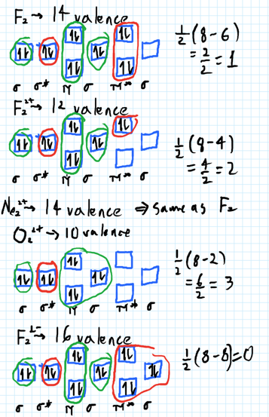
* 2) Use molecular orbital diagrams to determine which of the following are paramagnetic.
  + A) O2^2-
  + B) Ne2^2+
  + C) O2^2+
  + D) F2^2+
  + E) None of the above are paramagnetic
* At six or twelve valence electrons, it is paramagnetic
* 3) Draw the molecular orbital diagram needed, and determine which of the following is paramagnetic.
  + A) B2^2+
  + B) B2^2-
  + C) N2^2+
  + D) C2^2-
  + E) B2
* 4) Draw the molecular orbital diagram shown to determine which of the following is most stable.
  + A) C2^2+
  + B) N2^2+
  + C) B2
  + D) C2^2-
  + E) B2^2+
* 5) Which statement regarding stable heteronuclear diatomic molecules is false?
  + A) All have bond orders greater than zero.
  + B) The antibonding molecular orbitals have more of the character of the more electropositive element than of the more electronegative element.
  + C) Their molecular orbital diagrams are more symmetrical than those of homonuclear diatomic molecules.
  + D) The bonding molecular orbitals have more of the character of the more electronegative element than of the less electronegative element.
  + E) The greater is the difference in energy between two overlapping atomic orbitals, the more polar the resulting bond is, due to electrons occupying the resulting bonding molecular orbital.
* 6) When the equation below is correctly balanced, the coefficients a, b, c, d have which values?
  + a Fe3O4(s) + b C(s) -> c Fe(l) + d CO2(g)
  + A) 1232
  + B) 1321
  + C) 2121
  + D) 2132

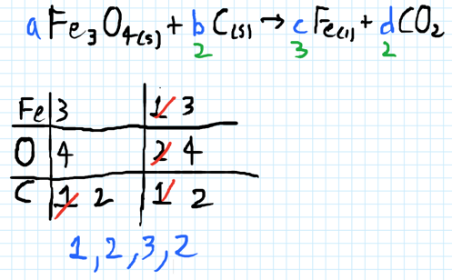

* 7) How many grams of Li3N can be formed from 1.75 moles of Li? Assume an excess of nitrogen.
  + 6 Li(s) + N2(g) -> 2 Li3N(s)
  + A) 18.3 g Li3N
  + B) 20.3 g Li3N
  + C) 58.3 g Li3N
  + D) 61.0 g Li3N
  + E) 15.1 g Li3N
* 8) A 14.01 g sample of N2 reacts with 3.02 g of H2 to form ammonia (NH3). If ammonia is the only product, what mass of ammonia is formed?
  + A) 17.03 g
  + B) 1.10 g
  + C) 14.01 g
  + D) 3.02 g
  + E) 23.07 g
* 9) Consider the following balanced reaction. How many grams of water are required to form 75.9 g of HNO3? Assume that there is excess NO2 present. The molar masses are as follows: H2O = 18.02 g/mol, HNO3 = 63.02 g/mol.
  + 3 NO2(g) + H2O(l) -> 2 HNO3(aq) + NO(g)
  + A) 38.0 g H20
  + B) 21.7 g H20
  + C) 43.4 g H20
  + D) 10.9 g H20
  + E) 26.5 g H2O
* 10) Give the theoretical yield, in moles, of CO2 from the reaction of 4.00 moles of C8H18 with 4.00 moles of 02.
  + 2C8H18 + 25O2 -> 16CO2 + 18H2O
  + A) 0.640 moles
  + B) 64.0 moles
  + C) 2.56 moles
  + D) 16.0 moles
* 11) Determine the limiting reactant (LR) and the mass (in g) of nitrogen that can be formed from 50.0 g N204 and 45.0 g N2H4. Some possibly useful molar masses are as follows: N204 = 92.02 g/mol, N2H4 = 32.05 g/mol.
  + N204(1) + 2 N2H4(1) 3 N2(g) + 4 H20(g)
  + A) LR = N2H4, 59.0 g N2 formed
  + B) LR = N2O4, 105 g N2 formed
  + C) LR = N2O4, 45.7 g N2 formed
  + D) LR = N2H4, 13.3 g N2 formed
  + E) No LR, 45.0 g N2 formed
* 12) Give the percent yield when 28.16 g of CO2 are formed from the reaction of 4.000 moles of QH18 with 4.000 moles of O2.
  + 2 C8H18 + 25 O2 -> 16 CO2 + 18 H2O
  + A) 20.00%
  + B) 25.00%
  + C) 50.00%
  + D) 12.50%

Please enable JavaScript to view the [comments powered by Disqus.](https://disqus.com/?ref_noscript)

## CH101-008 UA Fall 2016

* CH101-008 UA Fall 2016
* [jmbeach1@crimson.ua.edu](mailto:jmbeach1@crimson.ua.edu)
* jmbeach
* hey_beach

Notes and study materials for The University of Alabama's Chemistry 101 course offered Fall 2016.