Week 11 - Day 1 (End of Ch 8)

Table of Contents

[CH101-008 UA Fall 2016](/CH101-008/)

[About](/CH101-008/about/)

# Week 11 - Day 1 (End of Ch 8)

Oct 24, 2016

* [Quizlet](https://quizlet.com/_2oqbry)

Download Word (docx):

## Navigate using audio

## Practice Problem: Combustion Reaction How many grams of products are formed during the combustion of 100. g of ethanol? (and how much oxygen is consumed)?

* Audio 0:02:46.104807

## Alkali Metal Reaction: A Type of Chemical Reaction

* Audio 0:07:08.868545
* Overview of Alkali Metals:
* The alkali metals (group 1A) have ns1 outer electron configurations.
  + Form +1 cation to “achieve” noble gas configuration.
* The reactions of the alkali metals with nonmetals are vigorous.
* Common reaction for alkali metals (M) is with halogens (X)
  + 2 M + X2 → 2 MX
  + Example: 2 Na(s) + Cl2(g) → 2 NaCl(s)
* The alkali metals react vigorously with water to form the dissolved alkali metal ion, the hydroxide ion, and hydrogen gas:
  + 2 M(s) + 2 H2O(l) → 2 M+(aq) + 2 OH–(aq) + H2(g)
  + The reaction is highly exothermic and can be explosive because the heat from the reaction can ignite the hydrogen gas.
    - 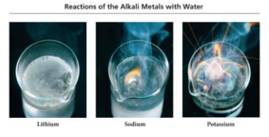

## Halogen Reaction: A Type of Chemical Reaction

* Audio 0:09:58.472842
* Halogen Overview:
* Group 7 elements that have ns2np5 outer electron configurations:
  + Mostly form –1 anions (F only forms –1 anion) to achieve the “noble gas configuration”
  + Most reactive of the nonmetal elements
* The halogens (X) tend to react with metals especially with Group 1 and 2A metals to form ionic compounds such as metal halides (MXn).
  + 2 M + n X2 → 2 MXn
  + Example: 2 Fe(s) + 3 Cl2(g) → 2 FeCl3(s)
* The halogens react with hydrogen to form hydrogen halides.
  + H2( g) + X2 → 2 HX(g)
  + 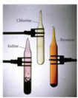

## Clicker 1

* Audio 0:14:33.764259
* Two samples of calcium and fluoride are decomposed into their constituent elements. The first sample showed that the yield of products was 100% (really!). If the second sample produced 294 mg of fluorine, how many g of calcium were formed? (Ca: 40.08, F: 19.00)
  + A) 0.280 g
  + B) 3.10 * 10^2 g
  + C) 3.13 g
  + D) 0.310 g
  + E) 2.80 * 10^2 g

D

* Audio 0:17:21.888102
* End of chapter 8

# Chapter 9

* Introduction to Solutions & Aqueous Reactions

## Why a whole “introductory” chapter on chemistry in water?

* Audio 0:18:22.136923
* Water is ubiquitous: human body is 50-65% water
* Water is (relatively) cheap
* Water is a good solvent
* Many reactions go faster in water

## Solution Concentration and Solution Stoichiometry

* Audio 0:20:23.634573
* When table salt is mixed with water, it seems to disappear or become a liquid, and the mixture is homogeneous.
  + The salt is still there, as you can tell from the taste or simply boiling away the water.
* Homogeneous mixtures are called *solutions*.
* The component of the solution that changes state is called the *solute*.
* The component that keeps its state is called the solvent.

## Solution Concentration: Categories

* Audio 0:22:26.471631
* *Dilute solutions* have a small amount of solute compared to solvent.
* Concentrated solutions have a large amount of solute compared to solvent
* Can also describe Quantitatively

## OLD Solution Concentration: Molality

* A (not so) common way to express a solution concentration is molality (M).
  + *Molality* is the amount of solute (in moles) divided by the mass of solvent (in kg). CH102

## Solution Concentration: Molarity

* Audio 0:23:35.675700
* 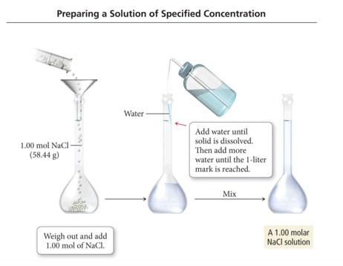

## Solution Concentration: Molarity

* Audio 0:25:57.189268
* A common way to express a solution concentration is molarity (M).
  + Molarity is the amount of solute (in moles) divided by the volume of solution (in liters).
  + 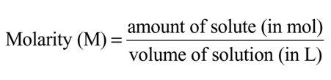

## Using Molarity in Calculations

* Audio 0:26:25.553273
* The molarity of a solution can be used as a conversion factor between moles of the solute and liters of the solution.
  + For example: A 0.500 M NaCl solution contains 0.500 mol NaCl for every liter of solution.
  + 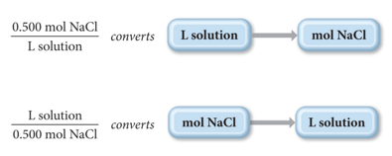

## Practice Problem: Calculating Concentrations

* Audio 0:28:53.770758
* What is the molarity of a solution made by dissolving 25.5 g of KBr in enough water to give 1.75 L of solution?

## Clicker 2

* Audio 0:32:28.311372
* Determine the molarity of a solution formed by dissolving 97.7 g LiBr in enough water to yield 750.0 mL of solution. (Li: 6.941, Br: 79.90)
  + A) 1.50 M
  + B) 1.18 M
  + C) 0.130 M
  + D) 0.768 M
  + E) 2.30 M

A

## Practice Problem: Calculating Concentrations

* Audio 0:34:48.656203 How many liters of a 0.125 M NaOH solution contain 0.255 mol of NaOH?

## Solution Dilution: Making a Solution from a Solution: C1·V1 = C2·V2

* Audio 0:37:43.525017
* A dilution is when a new solution is prepared from a stock solution (more concentrated solution).
* To make solutions of lower concentrations from these stock solutions, more solvent is added.
  + The amount of solute doesn’t change; just the volume of solution changes:
    - moles solute in solution 1 = moles solute in solution 2
    - The concentrations and volumes of the stock and new solutions are inversely proportional.
* The mathematical relationship is C1·V1 = C2·V2, or if the concentration unit is Molarity, then it can be written as M1·V1 = M2·V2.

## Preparing 3.00 L of 0.500 M CaCl2 from a 10.0 M Stock Solution

* Audio 0:40:33.998639
* 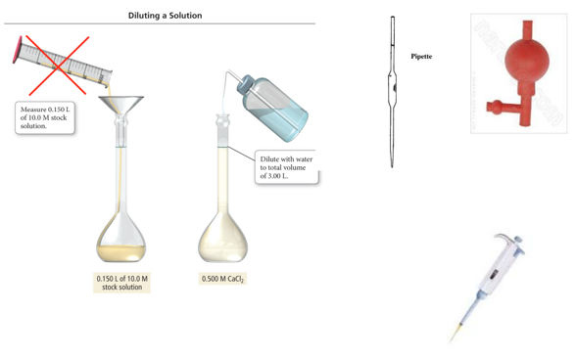

## Practice Problem: Calculating Concentrations To what volume should 0.200 L of 15 M NaOH solution be diluted to give a 3 M NaOH solution?

* Audio 0:42:51.333854

## Clicker 3

* Audio 0:47:55.628953
* What is the concentration of HCl in the final solution when 65 mL of a 9.0 M HCl solution is diluted with pure water to a total volume of .15 L?
  + A) 2.1 × 10-2 M
  + B) 3.9 M
  + C) 21 M
  + D) 3.9 × 10^3 M

B

# Vocab

|  |  |
| --- | --- |
| Term | Definition |
| solution | homogeneous mixtures |
| solute | component of solution which changes state |
| dilute solutions | solutions which have a small amount of solute compared to solvent |
| molarity | amount of solute (in moles) divided by the volume of solution (in liters) |

Please enable JavaScript to view the [comments powered by Disqus.](https://disqus.com/?ref_noscript)

## CH101-008 UA Fall 2016

* CH101-008 UA Fall 2016
* [jmbeach1@crimson.ua.edu](mailto:jmbeach1@crimson.ua.edu)
* jmbeach
* hey_beach

Notes and study materials for The University of Alabama's Chemistry 101 course offered Fall 2016.