Week 11 - Day 2

Table of Contents

[CH101-008 UA Fall 2016](/CH101-008/)

[About](/CH101-008/about/)

# Week 11 - Day 2

Oct 26, 2016

[Quizlet](https://quizlet.com/_2pqdkt)

Download Word (docx):

## Navigate using audio

* Audio 0:04:20.568986

# Clicker 1

* How many molecules of sucrose (C12H22O11, molar mass = 342.30 g/mol) are contained in 14.3 mL of 0.140 M sucrose solution
  + A) 8.29 * 10^22 molecules C12H22O11
  + B) 1.21 * 10^21 molecules C12H22O11
  + C) 6.15 * 10^22 molecules C12H22O11
  + D) 1.63 * 10^23 molecules C12H22O11
  + E) 5.90 * 10^24 molecules C12H22O11

B

## Solution Stoichiometry

* Audio 0:07:44.395193
* Molarity (moles solute/liter of solution) relates the moles of solute to the liters of solution.
  + Molarity can be used to convert between amount of reactants and/ or products in a chemical reaction when either the reactant or product is given in volume.
* Example: 20.0 mL of 0.50 M NaCl
* Molarity of A × Volume of A = moles A
* 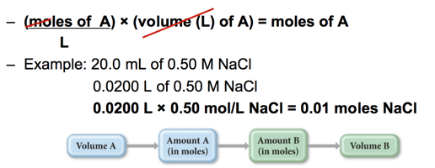

## Practice Problem: Solution Stoichiometry

* Audio 0:08:39.470935
* What volume (in L) of 0.150 M KCl solution will completely react with 0.150 L of a 0.175 M Pb(NO3)2 solution?

## Clicker 2

* Audio 0:16:26.983035
* What volume of 0.244 M KCl solution is required to react exactly with 50.0 mL of 0.210 M PB(NO3)2 solution?
  + A) 97.4 mL
  + B) 116 mL
  + C) 43.0 mL
  + D) 86.1 mL
  + E) 58.1 mL

D

## Types of Aqueous Solutions and Solubility

* Audio 0:20:31.538420
* You can’t add infinite amounts of solute to your solution
* Consider two familiar aqueous solutions: salt water and sugar water.
  + Salt water is a homogeneous mixture of NaCl and H2O.
  + Sugar water is a homogeneous mixture of C12H22O11 and H2O.
* How do solids such as salt and sugar dissolve in water?
  + Likes dissolve likes.
  + If your solute has roughly similar properties to your solvent, it will dissolve

## What Happens When a Solute Dissolves?

* Audio 0:23:19.196102
* There are attractive forces between the solute particles holding them together.
* There are also attractive forces between the solvent molecules.
* When we mix the solute with the solvent, there are attractive forces between the solute particles and the solvent molecules.
* If the attractions between solute and solvent are strong enough, the solute will dissolve.
* 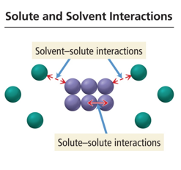

## Charge Distribution in a Water Molecule

* Audio 0:25:45.466724
* There is an uneven distribution of electrons within the water molecule.
  + This causes the oxygen side of the molecule to have a partial negative charge (δ–) and the hydrogen side to have a partial positive charge (δ+).
  + 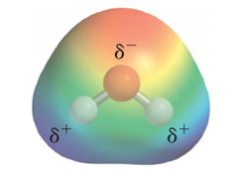

## Solute and Solvent Interactions in an Ionic Solution: A Salt Solution

* Audio 0:26:59.261993
* When sodium chloride is put into water, the attraction of Na+ and Cl– ions to water molecules competes with the attraction among the oppositely charged ions themselves.
  + Sodium chloride is an ionic compound (metal + nonmetal).
  + Ionic compounds when dissolved in water are called salt solutions.
  + 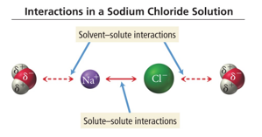

## Sodium Chloride (NaCl) Dissolving in Water

* Each ion is attracted to the surrounding water molecules and pulled off and away from the crystal.
* When it enters the solution, the ion is surrounded by water molecules, insulating it from other ions.
* The result is a solution with free moving charged particles able to conduct electricity.
* 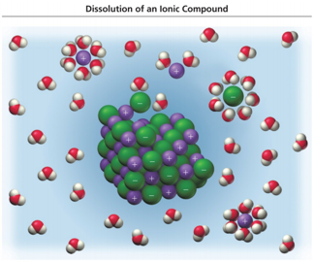

## Electrolyte and Nonelectrolyte Solutions

* Audio 0:29:17.039172
* Materials that dissolve in water to form a solution that will conduct electricity are called *electrolytes*.
* Materials that dissolve in water to form a solution that will not conduct electricity are called *nonelectrolytes*.
* A solution of salt (an electrolyte) conducts electrical current. A solution of sugar (a nonelectrolyte) does not.
* 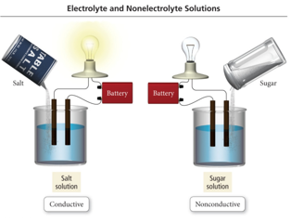

## Salt versus Sugar Dissolved in Water NaCl solution Sugar–water solution

* 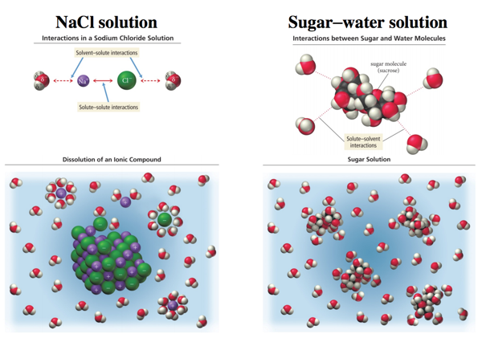

## Electrolyte Solutions: What Are They?

* Audio 0:31:02.947720
* *Electrolytes* are classified by how they dissolve in water.
  + If their dissociation is into ions:
    - Strong electrolytes
      * Completely dissociate into ions
      * Example: CaCl2(s) → Ca2+ + 2 Cl−
    - Weak electrolytes
      * Partial dissociation into their ions
      * Example: HCOOH(aq) H+ + HCOO−
  + Molecular compounds that dissolve in water but do not form ions when they go into solution are called nonelectrolytes.

## Electrolyte Solutions: Strong and Weak

* Audio 0:32:53.074436
* *Ionic substances* such as sodium chloride (NaCl) that completely dissociate into ions when they dissolve in water are *strong electrolytes*.
  + 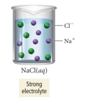
* *Acids* are compounds that when dissolved in water dissociate to give H+
* *Bases* are compounds that when dissolved in water dissociate to give OH-
  + 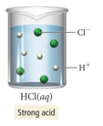
* Depending on the acid or base, their dissociation in water can be complete or partial.
  + Example:
    - HCl(aq) hydrochloric acid is a strong acid.
      * It dissociates completely in water.
        + HCl would be a *strong electrolyte*.
    - Acetic acid (e.g., vinegar) (HC2H3O2) is a weak acid—it dissociates partially in water.
      * HC2H3O2 is a *weak electrolyte*.
* 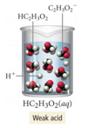

## Clicker 3

* Audio 0:36:58.662109
* Which of the following will have the highest electrical conductivity?
  + A) 0.045 M Al2(SO4)3
  + B) 0.050 M (NH4)2CO3
  + C) 0.10 M NaBr
  + D) 0.10 M Kl
  + E) 0.10 M KF

A

## Electrolyte and Nonelectrolyte Solutions

* Sugar (C12H22O11) is a molecular compound.
  + Most *molecular compounds* (except for acids and bases) dissolve in water as intact molecules.
    - 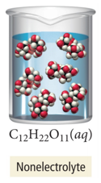
  + *Nonelectrolyte* solution

## Electrolytic Properties of Solution

* 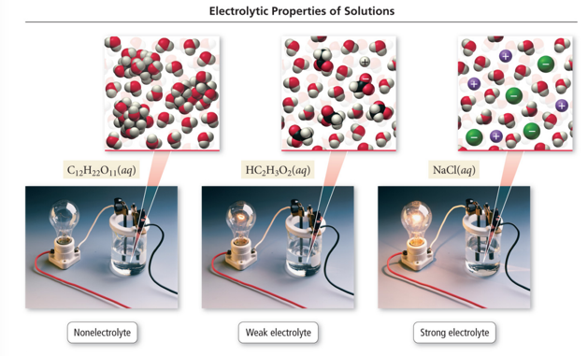

## The Solubility of Ionic Compounds

* Audio 0:39:50.836785
* When an ionic compound dissolves in water, the resulting solution contains:
  + Not the intact ionic compound itself, but its component ions dissolved in water
* NOT all ionic compounds dissolve in water.
  + Example:
    - If we add AgCl to water, for example, it remains solid and appears as a white powder at the bottom of the water.
* In general, a compound is termed *soluble* if it dissolves in water and *insoluble* if it does not.

## Solubility of Salts

* Audio 0:41:22.482755
* If solid silver nitrate (AgNO3) is added to water, it dissolves and forms a strong electrolyte solution.
* Silver chloride (AgCl), on the other hand, is almost completely insoluble.
  + If solid AgCl is mixed with water, virtually all of it remains as a solid within the liquid water.
* 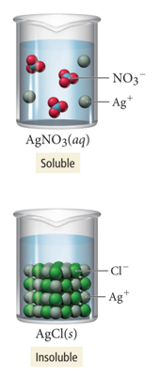

## When Will a Salt Dissolve?

* Audio 0:41:46.575491
* Whether a particular compound is soluble or insoluble depends on several factors.
* Predicting whether a compound will dissolve in water is not easy.
* The best way to do it is to do some experiments to test whether a compound will dissolve in water, and then develop some rules based on those experimental results.

## Solubility Rules

* Audio 0:41:59.485417
* 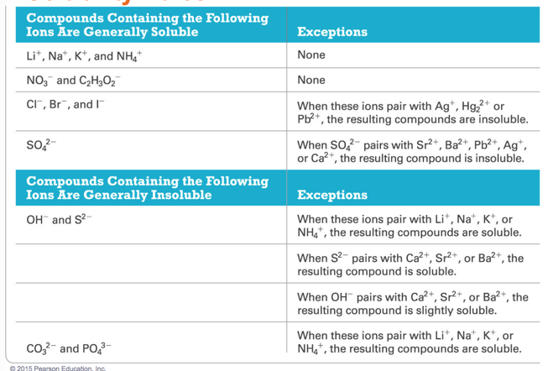

## Practice Problem: Ionic Compound Solubility

* Predict whether each compound is soluble or insoluble
* (a) PbCl2
* (b) CuCl2
* (c) Ca(NO3)2
* (d) BaSO4

# Vocab

|  |  |
| --- | --- |
| Term | Definition |
| electrolytes | materials that dissolve in water to form a solution that will conduct electricity |
| nonelectrolytes | materials that dissolve in water to form a solution that will not conduct electricity are called |
| acids | compounds that when dissolved in water dissociate to give H+ |
| bases | compounds that when dissolved in water dissociate to give OH- |
| soluble | compound which dissolves in water |

Please enable JavaScript to view the [comments powered by Disqus.](https://disqus.com/?ref_noscript)

## CH101-008 UA Fall 2016

* CH101-008 UA Fall 2016
* [jmbeach1@crimson.ua.edu](mailto:jmbeach1@crimson.ua.edu)
* jmbeach
* hey_beach

Notes and study materials for The University of Alabama's Chemistry 101 course offered Fall 2016.