Week 12 - Day 2 (Ch 9 - Pt 3)

Table of Contents

[CH101-008 UA Fall 2016](/CH101-008/)

[About](/CH101-008/about/)

# Week 12 - Day 2 (Ch 9 - Pt 3)

Nov 2, 2016

Download Word (docx):

## Navigate using audio

## Clicker 1

* Audio 0:00:38.000666
* Give the net ionic equation for the reaction (if any) that occurs when aqueous solutions of Na2CO3 and HCl are mixed
  + A) 2H+(aq)+CO3 2-(aq) → H2CO3(s)
  + B) 2Na+(aq)+CO3 2-(aq)+2H+(aq) + 2Cl- (aq) → H2CO3(s)+2NaCl(aq)
  + C) 2H+(aq)+CO3 2-(aq) → H2O(l)+CO2(g)
  + D) 2Na+(aq)+CO3 2-(aq)+2H+(aq)+2Cl- (aq)→H2CO3(s)+2Na+(aq)+2Cl- (aq)
  + E) No reaction occurs.

C

## How to Name an Oxyacid

* Audio 0:03:09.986990
* If a polyatomic ion name ends in
  + –ate, then change the ending to a
  + –ic suffix.
  + Example:
    - NO3 − is the nitrate ion, so it would become nitric.
    - 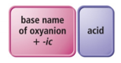
* If a polyatomic ion name ends in
  + –ite, then change the ending to a
  + –ous suffix.
  + Example:
    - SO3 2− is the sulfite ion, so it would become sulfurous.
  + 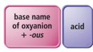
* Finally, write the word acid at the end of all names.

## Practice Naming Acids

* Audio 0:04:58.589530
  1. H2S
     + Hydrosulfuric acid
  2. HClO3
     + chloric acid
  3. HC2H3O2
     + acetic acid

## Clicker 2

* What is the name for an aqueous solution of HIO
  + A) hydroiodic acid
  + B) hypoiodous acid
  + C) iodous acid
  + D) iodic acid
  + E) periodic acid

B

## Acid–Base Chemical Reactions

* Audio 0:08:22.756094
* Audio 0:12:28.774412
* Acid–Base Reaction:
  + An acid reacts with a base producing water (or in some cases a weak electrolyte) and a salt.
  + An acid–base reaction is also called a neutralization reaction.
* In acid–base reactions, as in precipitation reactions, the reactions occur when the anion from one reactant combines with the cation of the other.

## Acid–Base Reactions

* Audio 0:13:19.839427
* When an acid and base react, the reaction is called a *neutralization reaction*.
  + Example:
    - 2 HNO3(aq) + Ca(OH)2(aq) → Ca(NO3)2(aq) + 2 H2O(l)
* As long as the salt that forms is soluble in water, the net ionic equation for an acid–base reaction is:
  + H+(aq) + OH–(aq) → H2O(l)
* A neutralization reaction is completed when the moles of acid equal the moles of base in the solution.
  + Moles of acid = Moles of base
* A neutralization reaction does not always mean that the pH of the solution is 7.

## Acids and Bases in Solution

* Audio 0:16:36.637260
* Acids ionize in water to form H+ ions; more precisely, the H from the acid molecule is donated to a water molecule to form hydronium ion, H3O+.
* Most chemists use H+ and H3O+ interchangeably.
* Bases dissociate in water to form OH– ions.
  + Bases, such as NH3, that do not contain OH– ions produce OH– by pulling H off water molecules.
* In the reaction of an acid with a base, the H+ from the acid combines with the OH– from the base to make water. – The cation from the base combines with the anion from the acid to make the salt.
* 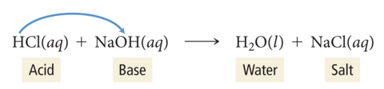

## Acid–Base Reaction

* HCl(aq) + NaOH(aq) → NaCl(aq) + H2O(l)
* The reaction of hydrochloric acid (acid) and sodium hydroxide (base) forms sodium chloride (soluble salt) and water.
* 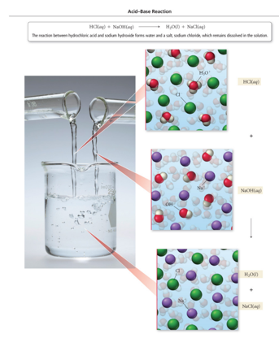

## Predict the Product of Acid–Base Reactions

* HCl(aq) + Ba(OH)2(aq) → ?
* (H+ + Cl−) + (Ba2+ + OH−) → (H+ + OH−) + (Ba2+ + Cl−)
  + HCl(aq) + Ba(OH)2(aq) → H2O(l) + BaCl2
  + 2 HCl(aq) + Ba(OH)2(aq) → 2 H2O(l) + BaCl2(aq)

## Predict the Product of Acid–Base Reactions

* Audio 0:18:17.410585
* H2SO4(aq) + LiOH(aq) → ?
* (H+ + SO4 2−) + (Li+ + OH−) → (H+ + OH−) + (Li+ + SO4 2−)
  + H2SO4(aq) + LiOH(aq) → H2O(l) + Li2SO4
  + H2SO4(aq) + 2 LiOH(aq) → 2 H2O(l) + Li2SO4(aq)

## Clicker 3

* Audio 0:21:18.340305
* Which of the following is an acid-base reaction?
  + A) C(s) + O2(g) → CO2(g)
  + B) 2 HClO4(aq) + Ca(OH)2(aq) → 2 H2O(l) + Ca(ClO4)2(aq)
  + C) Fe(s) + 2 AgNO3(aq) → 2 Ag(s) + Fe(NO3)2(aq)
  + D) MgSO4(aq) + Ba(NO3)2(aq) → Mg(NO3)2(aq) + BaSO4(s)
  + E) None of the above are acid base reactions.

B

## Acid–Base Titrations

* Audio 0:21:37.385327
* This is a problem because some things can not be legally put down the sink and it depends on the acidity
* In a *titration*, a substance in a solution of known concentration is reacted with another substance in a solution of unknown concentration.
* When exactly enough solution has been added the reactants are in their stoichiometric ratio. Called the *equivalence point*
  + The solution of known concentration is added slowly from an instrument called a burette.
    - A long glass tube with precise volume markings that allows small additions of solution
* The titrant is the solution in the burette.
* 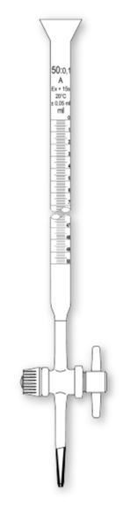

## Acid–Base Titrations

* Audio 0:25:27.198386
* In acid–base titrations, because both the reactant and product solutions are colorless, a chemical is added that changes color when the solution undergoes large changes in acidity/alkalinity.
  + The chemical is called an *indicator*.
* The *endpoint* of a reaction is when the indicator color changes.
* The endpoint of an acid–base titration is where the number of moles of H+ equals the number of moles of OH–.
  + This is known as the *equivalence point*.

## Acid–Base Titration

* Audio 0:26:39.290296
* 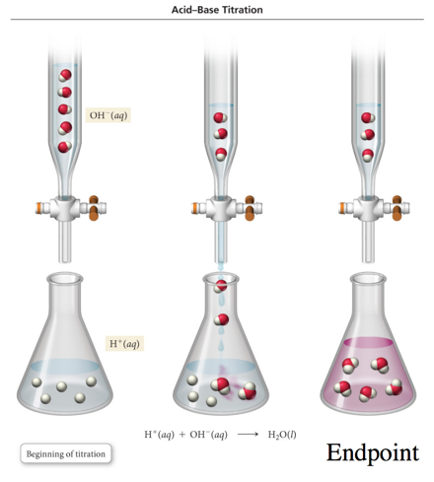

## Titration

* 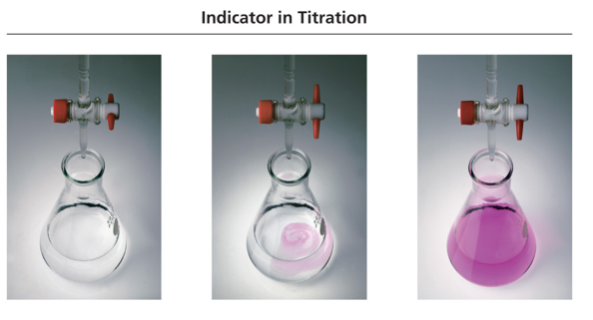
* In this titration, NaOH is added to a dilute HCl solution. When the NaOH and HCl reach stoichiometric proportions (the equivalence point), the indicator changes color to pink.

## Practice Problem: Acid–Base Titration

* Audio 0:32:01.268341
* The titration of a 10.00 mL sample of HCL solution of unknown concentration requires 12.54 ml of a 0.100 M NaOH solution to reach the equivalence point. What is the concentration of the unknown HCl solution in M?

## Clicker 4

* Audio 0:33:40.733664
* The titration of 25.0 mL of an unknown concentration of H2SO4 solution requires 83.6 mL of 0.12 M LiOH solution. What is the concentration of the H2

## Gas-Evolution Chemical Reactions

* Audio 0:41:08.439627
* In a gas-evolution reaction, a gas forms, resulting in bubbling.
* In both acid–base and gas-evolution reactions, as in precipitation reactions, the reactions occur when the anion from one reactant combines with the cation of the other.
  + Many gas-evolution reactions are also acid– base reactions.

## Example of Gas-Evolution Reactions

* Audio 0:42:31.119388
* Some reactions form a gas directly from the ion exchange.
  + K2S(aq) + H2SO4(aq) → K2SO4(aq) + H2S(g)
* Other reactions form a gas by the decomposition of one of the ion exchange products into a gas and water.
  + NaHCO3(aq) + HCl(aq) → NaCl(aq) + H2CO3(aq)
  + H2CO3(aq) → H2O(l) + CO2(g)

## Gas-Evolution Reaction

* Audio 0:44:17.526266
* NaHCO3(aq) + HCl(aq) H2O(l) + NaCl(aq) + CO2(g)
* When aqueous sodium bicarbonate is mixed with aqueous hydrochloric acid, gaseous CO2 bubbles are the result of the reaction.
* 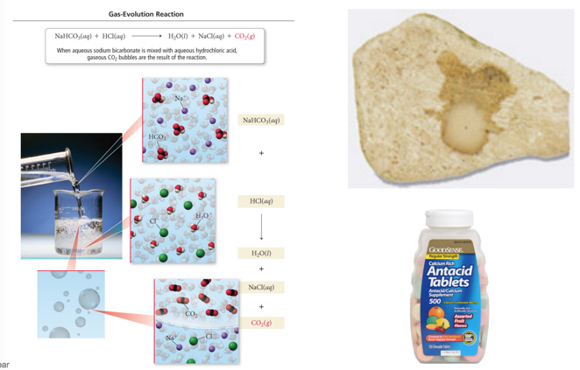

## Types of Compounds That Undergo GasEvolution Reactions

* Audio 0:44:59.297799
* 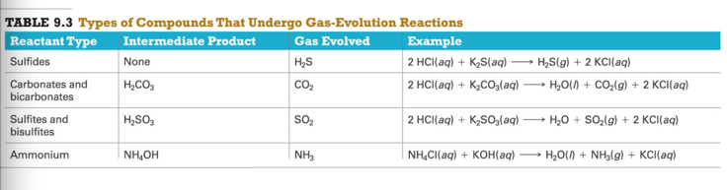

Please enable JavaScript to view the [comments powered by Disqus.](https://disqus.com/?ref_noscript)

## CH101-008 UA Fall 2016

* CH101-008 UA Fall 2016
* [jmbeach1@crimson.ua.edu](mailto:jmbeach1@crimson.ua.edu)
* jmbeach
* hey_beach

Notes and study materials for The University of Alabama's Chemistry 101 course offered Fall 2016.