Week 12 - Day 3

Table of Contents

[CH101-008 UA Fall 2016](/CH101-008/)

[About](/CH101-008/about/)

# Week 12 - Day 3

Nov 4, 2016

[Quizlet](https://quizlet.com/_2r2yd9)

Download Word (docx):

## Navigate using audio

* Next Wednesday is Test 3!!

## Clicker 1

* Audio 0:03:32.431301
* The titration of 80.0 mL of an unknown concentration of H3PO4 solution requires 126 mL of .218 M KOH solution. What is the concentration of H3PO4 solution (in M)
  + A) 1.03 M
  + B) 0.343 M
  + C) 0.114 M
  + D) 0.138 M
  + E) 0.0461 M

## Oxidation–Reduction Reactions

* Audio 0:09:22.846460
* The reactions in which electrons are transferred from one reactant to the other are called *oxidation–reduction reactions*.
  + These are also called redox reactions.
  + Many redox reactions involve the reaction of a substance with oxygen.
  + Examples:
  + 2 C8H18(l) + 25 O2(g) → 16 CO2(g) + 18 H2O(g) (combustion)
  + 2 H2(g) + O2(g) → 2 H2O(g)
  + 4 Fe(s) + 3 O2(g) → 2 Fe2O3(s) (rusting)

## Oxidation and Reduction (Redox)

* Audio 0:11:42.911701
* To convert a free element into an ion, the atoms must gain or lose electrons.
  + NOTE: If one atom loses electrons, another must accept them.
* Atoms that *lose electrons* are being *oxidized*.
  + The reaction is referred to as *oxidation*.
* Atoms that *gain electrons* are being *reduced*.
  + The reaction is referred to as *reduction*.
* Audio 0:14:01.108735
* Example: 2 Na(s) + Cl2(g) → 2 NaCl(s)
  + Audio 0:14:42.939831
  + Na → Na+ + 1 e– (oxidation; sodium lost electrons)
  + Cl2 + 2 e– → 2 Cl– (reduction; chlorine atom gained electrons)

## Redox Reactions

* Audio 0:15:20.876721
* Oxidation and reduction must occur simultaneously.
  + If an atom loses electrons, another atom must take them.
* The reactant that reduces an element in another reactant is called the reducing agent.
  + The *reducing agent* contains the element that is oxidized.
* The reactant that oxidizes an element in another reactant is called the *oxidizing agent*.
  + The oxidizing agent contains the element that is reduced.
* Example: 2 Na(s) + Cl2(g) → 2 NaCl(s)
  + Na is oxidized, while Cl is reduced.
  + Na is the reducing agent, and Cl2 is the oxidizing agent.

## Oxidation States: “Electron Book Keeping”

* Audio 0:19:09.006032
* For reactions that are not metal + nonmetal, or do not involve O2, a method for determining how the electrons are transferred is required to determine which element is being oxidized and which element is being reduced.
* Chemists assign a number to each element in a reaction called an *oxidation state* that allows them to determine the electron flow in the reaction.
  + Audio 0:20:40.459510
  + Even though they look like them, oxidation states are not ion charges!
    - Oxidation states are imaginary charges assigned based on a set of rules.
    - Ion charges are real, measurable charges.

## Rules for Assigning Oxidation States

* Audio 0:23:41.166326
* The following rules are in order of priority:
  1. Free elements have an oxidation state = 0.
     + Na = 0 and Cl2 = 0 in 2 Na(s) + Cl2(g)
  2. Monatomic ions have an oxidation state equal to their charge.
     + Na = +1 and Cl = −1 in NaCl
  3. (a) The sum of the oxidation states of all the atoms in a compound is 0.
     + Na = +1 and Cl = −1 in NaCl, (+1) + (−1) = 0

## Rules for Assigning Oxidation States Continued

* Audio 0:25:29.324643
  1. (b) The sum of the oxidation states of all the atoms in a polyatomic ion equals the charge on the ion.
     + N = +5 and O = −2 in NO3 –, (+5) + 3(−2) = −1
  2. (a) Group I metals have an oxidation state of +1 in all their compounds.
     + Na = +1 in NaCl
  3. (b) Group II metals have an oxidation state of +2 in all their compounds.
     + Mg = +2 in MgCl2
  4. In their compounds, nonmetals have oxidation states according to the following table.
     + Nonmetals higher on the table take priority.

## Rules for Assigning Oxidation States

* 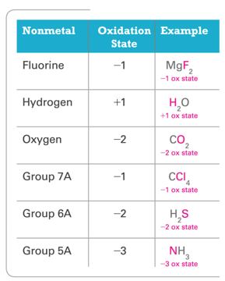

## Practice Problem: Assigning Oxidation States

* Audio 0:28:14.744310
* Assign an oxidation state to each atom in each element, ion or compound (a) Cl2 (b) Na+ (c) KF (d) CO2 (e) SO4^2- (f) K2O2

## Clicker 2

* Audio 0:35:08.680784
* Determine the oxidation state of nitrogen in NO2
  + A) +5
  + B) +3
  + C) 0
  + D) +2
  + E) +4

E

## Identifying Redox Reactions

* Audio 0:36:40.373032
* Oxidation: An increase in oxidation state
* Reduction: A decrease in oxidation state
* 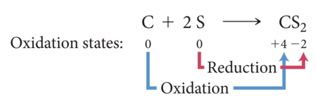
  + Carbon changes from an oxidation state of 0 to an oxidation state of +4.
    - Carbon loses electrons and is oxidized.
  + Sulfur changes from an oxidation state of 0 to an oxidation state of –2.
    - Sulfur gains electrons and is reduced.

## Redox Reaction

* Audio 0:37:34.617890
* NOTE:
* The transfer of electrons does not need to be a complete transfer (as occurs in the formation of an ionic compound) for the reaction to qualify as oxidation–reduction.
  + For example, consider the reaction between hydrogen gas and chlorine gas:
    - H2(g) + Cl2(g) → 2 HCl(g)
* When hydrogen bonds to chlorine, the electrons are unevenly shared, resulting in:
  + An increase of electron density (reduction) for chlorine
  + A decrease in electron density (oxidation) for hydrogen

## Combustion as Redox

* 2 H2(g) + O2(g) → 2 H2O(g)
* Hydrogen and Oxygen reacts to form water in the gaseous state (steam).
* 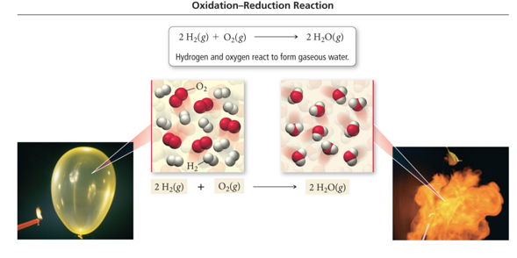

## Practice Problem: Oxidation States and Identifying

* Audio 0:39:01.686365
* What Is Being Oxidized and What Is Being Reduced Use oxidation state to identify the element that is oxidized and the element that is reduced:
* Mg(s) +2 H2O(l) à Mg(OH)2(aq) + H2(g)

## Clicker 3

* Audio 0:39:32.867693
* What element is undergoing reduction (if any) in the following reaction?
  + Zn(s) + 2AgNO3(aq) -> Zn(NO3)2(aq) + 2 Ag(s)
  + A) Zn
  + B) N
  + C) O
  + D) Ag
  + E) This is not an oxidation-reduction reaction

D

## Redox without Combustion

* 2 Na(s) + Cl2(g) → 2 NaCl(s)
* Sodium metal transfers electrons to chlorine gas to form solid sodium chloride. The sodium metal is reduced and chlorine is oxidized.
* 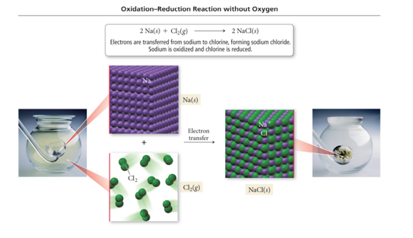

## Practice Problem: Oxidation States and Identifying

* What Is Being Oxidized and What Is Being Reduced
* Determine whether or not each reaction is an oxidation-reduction reaction. For each oxidation-reduction reaction, identify the oxidizing agent and the reducing agent.
  + a) 2 Mg(s) + O2(g) à 2 MgO(s)
  + b) 2HBr(aq) + Ca(OH)2(aq) à 2 H2O(l) + CaBr2(aq)
  + c) Zn(s) + Fe2+(aq) à Zn2+(aq) + Fe(s)

# Vocab

|  |  |
| --- | --- |
| Term | Definition |
| titration | when a substance in a solution of known concentration is reacted with another substance in a solution of unknown concentration |
| equivalence point | when exactly enough solution has been added the reactants are in their stoichiometric ratio |
| indicator | chemical that changes color when the solution undergoes large changes in acidity/alkalinity |
| endpoint | when the indicator changes color during titration |
| equivalence point | when the number of moles of H+ equals the number of moles of OH– in an acid-base titration |
| oxidation | when atoms lose electrons |
| reduction | when atoms gain electrons |
| reducing agent | contains the element that is oxidized in a redox reaction |
| oxidizing agent | the reactant that oxidizes an element in another reactant in a redox reaction |
| oxidation–reduction reactions | reactions in which electrons are transferred from one reactant to the other |

Please enable JavaScript to view the [comments powered by Disqus.](https://disqus.com/?ref_noscript)

## CH101-008 UA Fall 2016

* CH101-008 UA Fall 2016
* [jmbeach1@crimson.ua.edu](mailto:jmbeach1@crimson.ua.edu)
* jmbeach
* hey_beach

Notes and study materials for The University of Alabama's Chemistry 101 course offered Fall 2016.