Week 13 - Day 1 (Ch 10 - pt 1)

Table of Contents

[CH101-008 UA Fall 2016](/CH101-008/)

[About](/CH101-008/about/)

# Week 13 - Day 1 (Ch 10 - pt 1)

Nov 7, 2016

[Quizlet](https://quizlet.com/_2r2v9c)

Download Word (docx):

## Navigate using audio

* Test Wednesday

# Clicker 1

* Audio 0:00:51.121105
* Which choice gives the correct oxidation numbers for all three elements in Rb2SO3 in the order that the elements are shown in the formula?
  + A) -2, +6, -2
  + B) -1, +4, -3
  + C) +2, +4, -2
  + D) +1, +4, -2
  + E) +1, +6, -6

D

# Chapter 10

## Thermochemistry

* Audio 0:03:04.167112
* 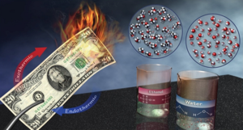

## Nature of Energy, Work, and Heat

* Audio 0:03:40.491883
* *Energy* is anything that has the capacity to do work.
  + Think of *energy* as a quantity an object or collection of objects can possess
  + Energy can be exchanged between objects through contact.
  + For example:
    - through collisions
* *Work* is a force acting over a distance.
  + Energy = work = force × distance
* *Heat* is the flow of energy caused by a difference in temperature.
* Think of heat and work as the two different ways that an object can exchange energy with other objects.
  + Either out of it, or into it

## Classification of Energy

* Audio 0:06:25.636622
* *Kinetic energy* is energy of motion or energy that is being transferred.
* *Thermal energy* is the energy associated with temperature.
  + Thermal energy is a form of kinetic energy.
  + 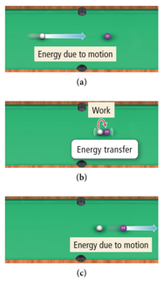

## Classification of Energy

* Audio 0:08:21.249403
* *Potential energy* is energy that is stored in an object or energy associated with the composition and position of the object.
  + Audio 0:09:49.310141
  + Energy stored in the structure of a compound is potential energy.
  + 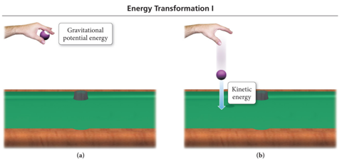

## Manifestations of Energy

* Audio 0:12:15.834511
* 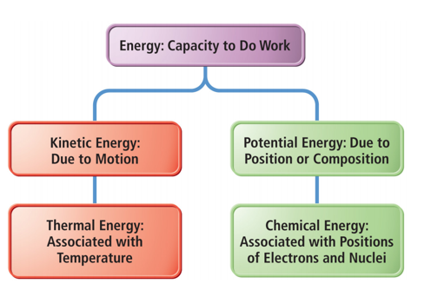

## Some Forms of Energy

* Audio 0:13:00.066117
* Heat or thermal energy
  + Kinetic energy associated with molecular motion
* Electrical
  + Kinetic energy associated with the flow of electrical charge
* Light or radiant energy
  + Kinetic energy associated with energy transitions in an atom
* Nuclear
  + Potential energy in the nucleus of atoms
* Chemical
  + Potential energy due to the structure of the atoms, the attachment between atoms, the atoms’ positions relative to each other in a molecule, or the molecules’ relative positions in the structure

## Units of Energy

* Audio 0:14:08.320504
* The amount of kinetic energy an object has is directly proportional to its mass and velocity.
  + KE = ½mv2
* When the mass is in kg and velocity is in m/s, the unit for kinetic energy is a *joule* (J).
  + 1 J = kg m2/s2 = 1 N m
  + 1 joule of energy is the amount of energy needed to move a 1 kg mass at a speed of 1 m/s.
* A *calorie* (cal) is the amount of energy needed to raise the temperature of one gram of water 1 °C.
  + 1 kcal = energy needed to raise 1000 g of water 1 °C
* A food Calorie (Cal) is 1000 calories.
  + 1 kcal is equivalent to ONE food Calorie = kcals.

## Conversion between Energy Units

* 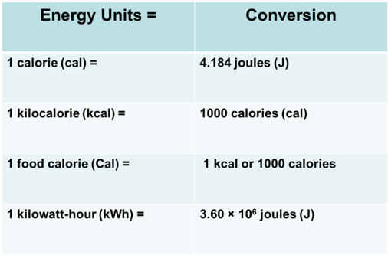

## Conservation of Energy

* Audio 0:18:02.274506
* The *law of conservation of energy* states that energy can be neither created nor destroyed.
* When energy is transferred between objects, or converted from one form to another, the total amount of energy present at the beginning must be present at the end.
* 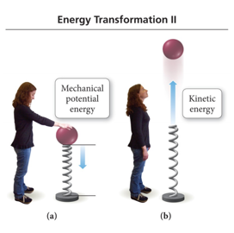

## System and Surroundings

* *System* is defined as the material within which the process we are studying happens.
* *Surroundings* are defined as everything else with which the system can exchange energy.
* *Thermodynamics* is the study of energy that is exchanged between the system and the surroundings.
  + Energy can flow from the system to the surroundings.
    - Energy of the system drops; energy of surroundings increases.
    - *Exothermic* (flow out of system)
  + Energy can flow into the system from the surroundings.
    - Energy of the system increases; energy of the surroundings decreases.
    - *Endothermic* (flow into system)

## Comparing the Amount of Energy in the System and Surroundings during Transfer

* Audio 0:24:03.313606
* Conservation of energy means that the amount of energy gained or lost by the system has to be equal to the amount of energy lost or gained by the surroundings.
* 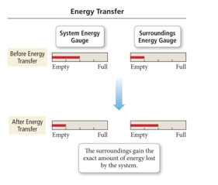

## The First Law of Thermodynamics: Law of Conservation of Energy

* *Thermodynamics* is the study of energy and its interconversions.
* Audio 0:24:58.285011
* The first law of thermodynamics is the law of conservation of energy.
  + This means that the total amount of energy in the universe is constant.
  + Therefore, you can never build a system that will continue to produce energy without some source of energy.

## Energy Flow and Conservation of Energy

* Audio 0:26:06.301332
* Conservation of energy requires that the sum of the energy changes in the system and the surroundings must be zero.
* Change(energyuniverse) = 0
  + =Change(Energysystem) + Change(Energysurroundings)
  + ΔEnergyuniverse = 0 = ΔEnergysystem + ΔEnergysurroundings
  + Δ is the symbol that is used to mean change.
    - – Final amount – initial amount

## Internal Energy

* Audio 0:27:47.890733
* The *internal energy* is the sum of the kinetic and potential energies of all of the particles that compose the system.
* The change in the internal energy of a system only depends on the amount of energy in the system at the beginning and end.
  + ΔE = Efinal – Einitial
  + ΔEreaction = Eproducts − Ereactants
* A *state function* is a mathematical function whose result only depends on the initial and final conditions, not on the process used.
* It is an *Extensive Property* –depends upon the amount of material

## State Function

* To reach the top of the mountain, there are two trails:
  + 1. Long and winding
    2. Short but steep
* Regardless of the trail, when you reach the top, you will be 10,000 ft above the base.
* The distance from the base to the peak of the mountain is a state function. It depends only on the difference in elevation between the base and the peak, not on how you arrive there!
* 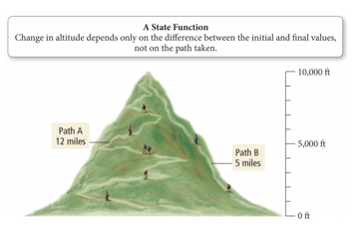

## In Summary:

* Audio 0:33:20.823776
* If the reactants have a higher internal energy than the products:
  + ΔEsys is said to be negative because energy flows OUT of the system into the surroundings.
* If the reactants have a lower internal energy than the products:
  + ΔEsys is said to be positive because energy flows INTO the system from the surroundings.
* The internal energy of the system can be thought in a similar manner.
  + Energy flowing out of the system is like a withdrawal and therefore carries a negative sign.
  + Energy flowing into the system is like a deposit and carries a positive sign.

## Energy Exchange

* Audio 0:34:35.272796
* Energy is exchanged between the system and surroundings through heat and work.
  + *q* = heat (thermal) energy
  + *w* = work energy
  + q and w are NOT state functions; their value depends on the process.
    - ΔE = q + w
    - 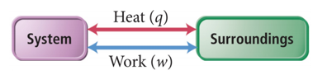

## Energy Exchange

* Audio 0:35:29.581181
* Chemists are “System Oriented” so energy gained by system is positive, energy lost is negative
* doesn’t matter if it is heat flow or work
* (Older) engineering convention where heat flow in is positive and work out is positive
* 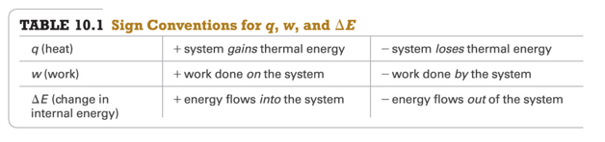

## Heat Exchange

* Audio 0:36:39.238039
* *Heat* is the exchange of thermal energy between a system and surroundings.
* Heat exchange occurs when system and surroundings have a difference in temperature.
* *Temperature* is the measure of the thermal energy within a sample of matter.
* Heat flows from matter with high temperature to matter with low temperature until both objects reach the same temperature.
  + Thermal equilibrium

## Quantity of Heat Energy Absorbed: Heat Capacity

* Audio 0:38:11.929773
* When a system absorbs heat, its temperature increases.
* The increase in temperature is directly proportional to the amount of heat absorbed.
* The proportionality constant is called the *heat capacity, C*.
  + q = C × ΔT
  + Units of C are J/°C or J/K.
* The larger the heat capacity of the object being studied, the smaller the temperature rise will be for a given amount of heat.

## Factors Affecting Heat Capacity

* The heat capacity of an object depends on its amount of matter.
  + Directly proportional to mass.
  + 200 g of water requires twice as much heat to raise its temperature by 1 °C as does 100 g of water.
* The heat capacity of an object depends on the type of material.
  + 1000 J of heat energy will raise the temperature of 100 g of sand 12 °C, but only raise the temperature of 100 g of water by 2.4 °C.

## Clicker 2

* Which of the following signs on q and w represent a system that is doing work on the surroundings, as well as gaining heat from the surroundings?
  + A) q=+, w=-
  + B) q = -, w = +
  + C) q = +, w = +
  + D) q = -, w = -
  + E) None of these represent the system referenced

A

# Vocab

|  |  |
| --- | --- |
| Term | Definition |
| energy | anything that has the capacity to do work |
| work | force acting over a distance |
| kinetic energy | energy of motion |
| thermal energy | energy associated with temperature |
| potential energy | energy stored in an object or associated with the composition of an object |
| heat | the flow of energy caused by a difference in temperature |
| joule | the unit for kinetic energy (N m) |
| calorie | the amount of energy needed to raise the temperature of one gram of water 1 °C |
| law of conservation of energy | states that energy can be neither created nor destroyed |
| system | the material within which the process we are studying happens |
| surroundings | defined as everything other than the system with which the system can exchange energy |
| thermodynamics | the study of energy and its interconversions |
| internal energy | the sum of the kinetic and potential energies of all of the particles that compose the system |
| state function | mathematical function whose result only depends on the initial and final conditions, not on the process used |
| temperature | the measure of the thermal energy within a sample of matter |

Please enable JavaScript to view the [comments powered by Disqus.](https://disqus.com/?ref_noscript)

## CH101-008 UA Fall 2016

* CH101-008 UA Fall 2016
* [jmbeach1@crimson.ua.edu](mailto:jmbeach1@crimson.ua.edu)
* jmbeach
* hey_beach

Notes and study materials for The University of Alabama's Chemistry 101 course offered Fall 2016.