Week 13 - Day 2

Table of Contents

[CH101-008 UA Fall 2016](/CH101-008/)

[About](/CH101-008/about/)

# Week 13 - Day 2

Nov 9, 2016

Download Word (docx):

## Navigate using audio

# 3rd Tests

* Chapters 6.10 - 10.3
* Nonprogrammable calculator
* Pencil
* Eraser
* If you arrive after 7pm, you have taken your drop grade.

# Review Day

* Clicker 1
* Audio 0:04:25.997870
* Which of the following signs on q and w represent a system that is doing work on the surroundings, as well as gaining heat from the surroundings?
  + A) q=+, w=-
  + B) q = -, w = +
  + C) q = +, w = +
  + D) q = -, w = -
  + E) None of these represent the system referenced

A

* Audio 0:06:45.527461

## clicker 2

* Which of the following signs on q and w represent a system that the surroundings are doing work on, as well as gaining heat from the surroundings?
  + A) q = +, w = -
  + B) q = -, w = +
  + C) q = +, w = +
  + D) q = -, w = -
  + E) None of these represent the system referenced

C

## Clicker 3

* How many of the following molecules are polar?
* PCl5 COS XeO3 SeBr2
  + A) 2
  + B) 0
  + C) 1
  + D) 3
  + E) 4

D

## Clicker 4

* Audio 0:14:22.599679
* When an… Answer: A. Sulfides accept for sodium. Sulfide is 2- so it just goes into the Mn.

## Clicker 5

* Audio 0:17:34.714245
* Give the net ionic equation for the reaction

Answer: D

## Clicker 6

* Audio 0:20:52.685314
* Determine the reducing agent in the following

Answer: E. Lithium is the substance that is losing its electrons and causing the reaction to be reduced

## Clicker 7

* Audio 0:26:39.117323
* Draw the appropriate molecular orbital diagram and determine which of the following are paramagnetic.
  + A) B2^2+
  + B) B2^2-
  + C) N2^2+
  + D) C2^2-
  + E) B2
* Answer: E. Looking for six or twelve valence electrons

## Clicker 8

* Audio 0:30:33.281519
* How many moles of nitrogen are formed when 58.6 g of KNO3 decomposes according to the following reaction? The molar mass of KNO3 is 101.11 g/mol
  + 4KNO3(s) -> 2K2O(s) + 2N2(g) + 5O2(g)
  + A) 0.290 mol N2
  + B) 0.580 mol N2
  + C) 18.5 mol N2
  + D) 0.724 mol N2

Answer: A

## Clicker 9

* Audio 0:34:13.545160
* According to the following reaction, how many grams of sulfur are formed when 37.4 g of water are formed? (S: 32.07, H: 1.0079, O: 15.999)
  + 2H2S(g) + SO2(g) -> 3 S(s) + 2H2O 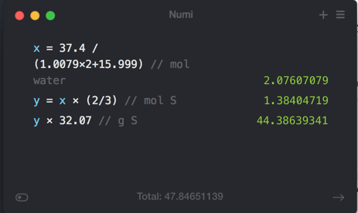

## Clicker 10

* Audio 0:37:15.066241 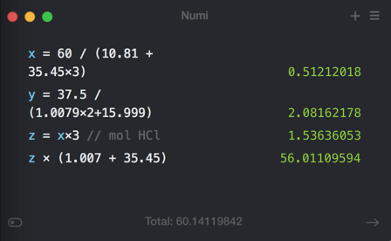

## Clicker 11

* Audio 0:45:58.730799
* Calcium oxide … + 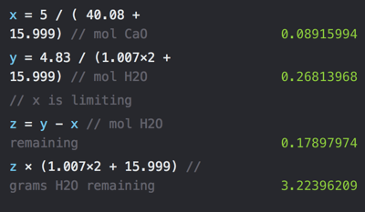

Please enable JavaScript to view the [comments powered by Disqus.](https://disqus.com/?ref_noscript)

## CH101-008 UA Fall 2016

* CH101-008 UA Fall 2016
* [jmbeach1@crimson.ua.edu](mailto:jmbeach1@crimson.ua.edu)
* jmbeach
* hey_beach

Notes and study materials for The University of Alabama's Chemistry 101 course offered Fall 2016.