Week 13 - Day 3

Table of Contents

[CH101-008 UA Fall 2016](/CH101-008/)

[About](/CH101-008/about/)

# Week 13 - Day 3

Nov 11, 2016

[Quizlet](https://quizlet.com/_2r2zzj)

Download Word (docx):

## Navigate using audio

## Quantifying Heat Energy

* Audio 0:03:56.456416
* The *heat capacity* of an object is proportional to the following:
  + Directly proportional to mass
  + The specific heat of the material
* The quantity of heat absorbed by an object can be determined if the following are known:
  + Mass
  + Specific heat capacity
  + Temperature change

## Specific Heat Capacity

* Audio 0:05:10.723769
* Measure of a substance’s intrinsic ability to absorb heat.
* The *specific heat capacity* is the amount of heat energy required to raise the temperature of one gram of a substance 1 °C.
  + Cs
  + Units J/(g · °C)
* The *molar heat capacity* is the amount of heat energy required to raise the temperature of one mole of a substance 1 °C.
* 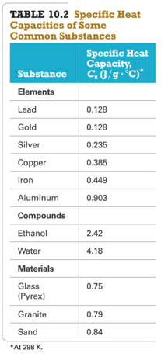

## Practice Problem:

### Temperature Changes and Heat Capacity

* Audio 0:09:58.630420
* You find a pre-1982 penny in the snow. How much heat is absorbed as it warms from -8.0 °C to body temperature, 37.0 °C? Assume the penny is pure copper and has a mass of 3.10 g

## Clicker 1

* Audio 0:12:20.872114
* A sample of copper absorbs 43.6 kJ of heat, resulting in a temperature rise of 75.0°C, determine the mass (in kg) of the copper sample if the specific heat capacity of copper is 0.385 J/g°C
  + A) 1.51
  + B) 6.62
  + C) 1.26
  + D) 7.94
  + E) 3.64

A

## Heat Transfer and Final Temperature

* Audio 0:17:13.460079
* When two objects at different temperatures are placed in contact, heat flows from the material at the higher temperature to the material at the lower temperature.
* Heat flows until both materials reach the same final temperature.
* The amount of heat energy lost by the hot material equals the amount of heat gained by the cold material.
* If one is defined as our system, the other as surroundings then:
  + qsystem=-qsurroundings
  + qsys = -qsurr
* 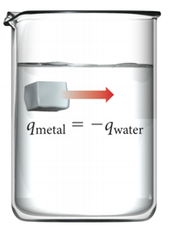

## Thermal Energy Transfer

* Audio 0:19:06.599992
* A block of metal at 55 °C is added to water at 25 °C.
* Thermal energy transfers heat from the metal to the water.
* The exact final temperature depends on the following:
  + The mass of the metal
  + The mass of water
  + Specific heat capacities of the metal and of water
  + 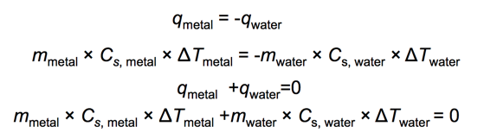
  + 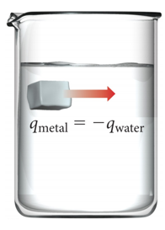

## Practice Problem: Thermal Energy Transfer

* Audio 0:19:36.161583
* A 32.5 g cube of aluminum initially at 45.8 oC is submerged into 105.3 g of water at 15.4 oC. What is the final temperature? (Assume there is no heat lost)

## Clicker 2

* Audio 0:26:13.227245
* A 43.9-g piece of copper (CCu= 0.385 J/g°C) at 135.0°C is plunged into 254 g of water at 39.0°C. Assuming that no heat is lost to the surroundings, what will the final temperature of the system be?
  + A) 100.0°C
  + B) 40.5°C
  + C) 62.5°C
  + D) 87.0°C
  + E) 53.1°C

B

## Pressure–Volume Work

* Audio 0:33:15.662283
* *PV work* is work caused by a volume change against an external pressure.
* When gases expand, ΔV is positive, but the system is doing work on the surroundings, so wgas is negative.
* As long as the external pressure is kept constant, w = –PΔV.
  + Workgas = External Pressure × Change in Volumegas
* To convert the units to joules, use 101.3 J = 1 atm · L.
  + 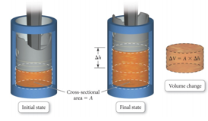

## Practice Problem: Pressure–Volume Work

* Audio 0:36:20.018920
* To inflate a balloon you must do pressure-volume work on the surroundings. If you inflate a balloon from a volume of 0.100 L to 1.85L, against atmospheric pressure (1.00 atm), how much work is done (in Joules)

## Clicker 3

* Audio 0:38:59.416030
* Calculate the change in internal energy (delta E) for a system that is giving off 25.0kJ of heat and is changing from 12.00 L to 6.00 L in volume at 1.50 atm pressure (remember that 101.3 J = 1 L*atm) 25.9 kJ

D

# Vocab

|  |  |
| --- | --- |
| Term | Definition |
| heat capacity | directly proportional to mass |
| specific heat capacity | the amount of heat energy required to raise the temperature of one gram of a substance 1 °C |
| molar heat capacity | the amount of heat energy required to raise the temperature of one mole of a substance 1 °C |
| Pressure volume work | work caused by a volume change against an external pressure (w = –PΔV) |

Please enable JavaScript to view the [comments powered by Disqus.](https://disqus.com/?ref_noscript)

## CH101-008 UA Fall 2016

* CH101-008 UA Fall 2016
* [jmbeach1@crimson.ua.edu](mailto:jmbeach1@crimson.ua.edu)
* jmbeach
* hey_beach

Notes and study materials for The University of Alabama's Chemistry 101 course offered Fall 2016.