Week 14 - Day 1

Table of Contents

[CH101-008 UA Fall 2016](/CH101-008/)

[About](/CH101-008/about/)

# Week 14 - Day 1

Nov 14, 2016

# Clicker 1

* A sample of NI3 is contained in a piston and cylinder. The samples rapidly decomposes to form nitrogen gas and iodine gas, and releases 3.30 kJ of heat and does 950 J of work. What is ∆E?
  + A) -953.3 J
  + B) +953.3 J
  + C) -4250 J
  + D) -946.7 J
  + E) +4250 J

C

## Exchanging Energy between System and Surroundings

* Exchange of heat energy
  + q = mass × specific heat × ΔTemperature
* Exchange of work
  + w = −Pressure × ΔVolume
  + 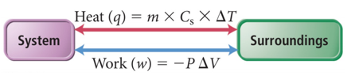

## Measuring ΔE: Calorimetry at Constant Volume

* Because ΔE = q + w, ΔE can be determined by measuring q and w.
* In practice, it is easiest to do a process in such a way that there is no change in volume, so w = 0.
  + At constant volume, ΔEsystem = qsystem.
* In practice, temperature changes of individual chemicals involved in the reaction cannot be observed directly, so instead the temperature change in the surroundings is measured.
  + Using an insulated container (e.g., controlled surroundings)
  + qsystem = −qsurroundings
* The surrounding area is called a *bomb calorimeter* and is usually made of a sealed, insulated container filled with water.
  + qsurroundings = qcalorimeter = –qsystem

## Bomb Calorimeter

* 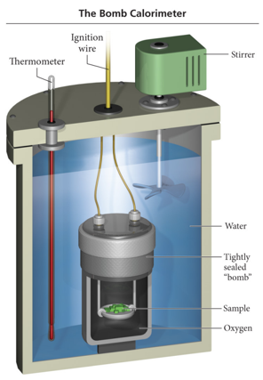
* It is used to measure ΔE because it is a constant volume system.
* The heat capacity of the calorimeter is the amount of heat absorbed by the calorimeter for each degree rise in temperature and is called the *calorimeter constant*.
  + Ccal, kJ/°C

## Practice Problem: Measuring ΔErxn in a Bomb Calorimeter

* When 1.010 g of sucrose (C12H22O11) undergoes combustion in a bomb calorimeter, the temperature rises from 24.92 oC to 28.33 oC. Find ΔErxn for the combustion of sucrose (in kJ/mol). The heat capacity of the calorimeter is 4.90 kJ/oC.

## Clicker 2

* A 35.6 g sample of ethanol (C2H5OH) is burned in a bomb calorimeter, according to the following reaction. If the temperature rose from 35.0 to 76.0°C and the heat capacity of the calorimeter is 23.3 kJ/°C, what is the value of ΔErxn? The molar mass of ethanol is 46.07 g/mol.
  + C2H5OH(l) + 3 O2(g) → 2 CO2(g) + 3 H2O(g) ΔErxn = ?
  + A) -1.24 × 103 kJ/mol
  + B) +1.24 × 103 kJ/mol
  + C) -8.09 × 103 kJ/mol
  + D) -9.55 × 103 kJ/mol
  + E) +9.55 × 103 kJ/mol

A 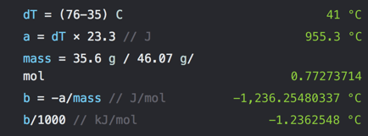

## Enthalpy: Heat Evolved at Constant Pressure

* “Bomb” Calorimetry is nice but…. we would like to work at atmospheric pressure
* For a system at e.g. atmospheric pressure the total energy is E plus the energy required to push the gas aside to make space for the system: PV
* The *enthalpy, H*, of a system is the sum of the internal energy of the system and the product of pressure and volume.
  + H is a state function.
    - H = E + PV
* The *enthalpy change, ΔH*, of a reaction is the heat evolved in a reaction at constant pressure.
  + ΔHreaction = qreaction at constant pressure
* Usually ΔH and ΔE are similar in value; the difference is largest for reactions that produce or use large quantities of gas.

## Endothermic and Exothermic Reactions

* When ΔH is negative, heat is being released by the system into the surroundings.
  + The surroundings will “feel” hot.
  + Temperature of the surroundings increased from the energy released by the system.
  + This is called an *exothermic reaction*.
* When ΔH is positive, heat is being absorbed by the system from the surroundings.
  + The surroundings will “feel” cold.
* Temperature of the surroundings decreased because energy left the surroundings to flow into the system.
* This is called an *endothermic reaction*.

## Particulate View of Exothermic Reactions

* For an exothermic reaction, the surrounding’s temperature rises due to a release of thermal energy by the reaction.
* This extra thermal energy comes from the conversion of some of the chemical potential energy in the reactants into kinetic energy in the form of heat.
* During the course of a reaction, existing bonds are broken and new bonds are made.
* The products of the reaction have less chemical potential energy than the reactants.
* The difference in energy is released as heat.

## Particulate View of Endothermic Reactions

* In an endothermic reaction, the surrounding’s temperature drops due to absorption of some of its thermal energy by the reaction.
* During the course of a reaction, existing bonds are broken and new bonds are made.
* The products of the reaction have more chemical potential energy than the reactants.
* To acquire this extra energy, some of the thermal energy of the surroundings is converted into chemical potential energy stored in the products.

## Enthalpy of Chemical Reaction

* The enthalpy change in a chemical reaction is an extensive property.
  + The more reactants you use, the larger the enthalpy change.
* By convention, we calculate the enthalpy change for the number of moles of reactants in the reaction as written. C3H8(g) + 5 O2(g) → 3 CO2(g) + 4 H2O(g) ΔH = −2044 kJ 1 mol C3H8(g) = –2044 kJ or 5 mol O2(g) = –2044 kJ

## Practice Problem: Enthalpy Stoichiometry

* Calculate the heat (in kJ) associated with the complete combustion of all of the propane in a 13.2 kg propane tank: C3H8(g) + 5O2(g) è 3CO2(g) + 4H2O(g) ΔHrxn= -2044 kJ

## Measuring ΔH: Calorimetry at Constant Pressure

* Reactions done in aqueous solution are at constant pressure.
* The calorimeter is often nested foam cups containing the solution.
  + qreaction = –qsolution = –(masssolution × Cs, solution × ΔT)
* ΔHreaction = qconstant pressure = qreaction
  + To get ΔHreaction per mol, divide by the number of moles.
* 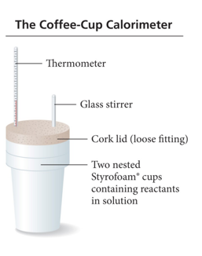

## Practice Problem: Calorimetry Magnesium metal reacts with hydrochloric acid:

* Mg(s) + 2HCl(aq) –> MgCl2 + H2(g) you combine 0.158 g of Mg with enough HCl to make 100.0 mL of solution in a coffee-cup calorimeter. T of the solution rises from 25.6 oC to 32.8 oC. Find ΔHrxn, assume density of solution is 1.00g/ml

# Vocab

|  |  |
| --- | --- |
| Term | Definition |
| bomb calorimeter | used to measure ΔE because it is a constant volume system |
| calorimeter constant | the amount of heat absorbed by the calorimeter for each degree rise in temperature (capacity) |
| enthalpy (H) | the sum of the internal energy of the system and the product of pressure and volume |

Please enable JavaScript to view the [comments powered by Disqus.](https://disqus.com/?ref_noscript)

## CH101-008 UA Fall 2016

* CH101-008 UA Fall 2016
* [jmbeach1@crimson.ua.edu](mailto:jmbeach1@crimson.ua.edu)
* jmbeach
* hey_beach

Notes and study materials for The University of Alabama's Chemistry 101 course offered Fall 2016.