Week 14 - Day 2

Table of Contents

[CH101-008 UA Fall 2016](/CH101-008/)

[About](/CH101-008/about/)

# Week 14 - Day 2

Nov 16, 2016

## clicker 1

* Given w=0, an endothermic reaction has the following
  + A) +ΔH and -ΔE
  + B) - ΔH and +ΔE
  + C) + ΔH and +ΔE
  + D) - ΔH and –ΔE

If w = 0, no work done, endothermic so heat must flow into the system both positive (C)

## Clicker 2

* A piece of iron (mass = 25.0 g) at 398 K is placed in a styrofoam cup containing 25.0 mL of water at 298 K. Assuming that no heat is lost to the cup or the surroundings, what will the final temperature of the water be? The specific heat capacity of iron = 0.449 J/g C
  + A) 348 K
  + B) 308 K
  + C) 287 K
  + D) 325 K
  + E) 388 K

Answer: B <iframe width="560" height="315" src="https://www.youtube.com/embed/cG6zPlmIk9g" frameborder="0" allowfullscreen></iframe>

## Hess’s Law: Relationships Involving ΔHrxn

* Enthalpy of a reaction is always associated with a particular reaction.
  + If the reaction is changed (e.g., reversed, doubled), the ΔH reflects those changes.
    - Enthalpy is an extensive physical thermal property.
* Example:
  + When a reaction is multiplied by a factor, ΔHrxn is multiplied by that factor because ΔHrxn is extensive.
    - C(s) + O2(g) → CO2(g) ΔH = −393.5 kJ
      * 2 C(s) + 2 O2(g) → 2 CO2(g) ΔH = 2(−393.5 kJ) = −787.0 kJ.
  + If a reaction is reversed, then the sign of ΔH is changed.
    - CO2(g) → C(s) + O2(g) ΔH = +393.5 kJ

## Relationships Involving ΔHrxn Hess’s Law

* If a reaction can be expressed as a series of steps, then the ΔHrxn for the overall reaction is the sum of the heats of reaction for each step.
  + 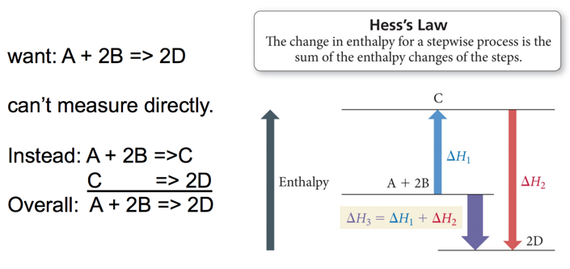
  + 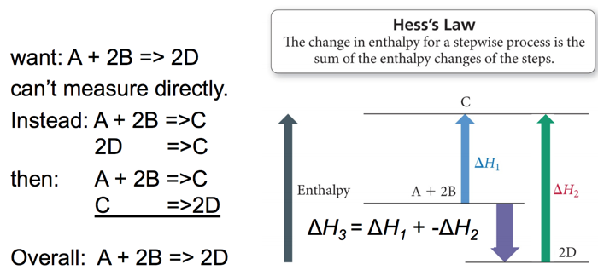

## Practice Problem: Hess’s Law

* Find ΔHrxn for: 3C(s) + 4H2(g) -> C3H8(g)
* use:
  + C3H8(g) + 5O2(g) -> 3CO2(g) + 4H2O(g) ΔH= -2043 kJ
  + C(s) + O2(g) -> CO2(g) ΔH= -393.5 kJ
  + 2H2(g) + O2(g) -> 2H2O(g) ΔH= -483.6 kJ

## Clicker 3

* Use the standard reaction enthalpies given below to determine ΔH°rxn for the following reaction
  + P4(g) + 10 Cl2(g) → 4PCl5(s) ΔH°rxn = ?
* Given:
  + PCl5(s) → PCl3(g) + Cl2(g) ΔH°rxn = +157 kJ
  + P4(g) + 6 Cl2(g) → 4 PCl3(g) ΔH°rxn
    - A) -1835 kJ
    - B) -1364 kJ
    - C) -1050. kJ
    - D) -1786 kJ
    - E) -2100. kJ

Answer: A <iframe width="560" height="315" src="https://www.youtube.com/embed/TzY2Y0j8J-A" frameborder="0" allowfullscreen></iframe>

## Bond Energies

* Chemical reactions involve breaking bonds in reactant molecules and making new bonds to create the products.
* The ΔHreaction can be estimated by comparing the cost of breaking old bonds to the income from making new bonds.
* The amount of energy it takes to break one mole of a bond in a compound is called the *bond energy*.
  + In the gas state
  + Homolytically—each atom gets ½ bonding electrons

## Determining Enthalpies from Bond Energies

* The actual bond energy depends on the surrounding atoms and other factors.
* Average bond energies can be used to estimate the ΔHrxn.
  + Works best when all reactants and products in gas state
* Bond breaking is endothermic, ΔH(breaking) = (+) value.
* Bond making is exothermic, ΔH(making) = (−) value.
  + ΔHrxn = ∑ (ΔH(bonds broken)) + ∑ (ΔH(bonds formed))

## Trends in Bond Energies

* In general, the more electrons two atoms share, the stronger the covalent bond. – Must be comparing bonds between like atoms
  + C≡C (837 kJ) > C═C (611 kJ) > C—C (347 kJ)
  + C≡N (891 kJ) > C═N (615 kJ) > C—N (305 kJ)
* In general, the shorter the covalent bond, the stronger the bond.
  + Must be comparing similar types of bonds
  + Br—F (237 kJ) > Br—Cl (218 kJ) > Br—Br (193 kJ)
  + Bonds get weaker down the column.
  + Bonds get stronger across the period.

## Table of Average Bond Energies

* 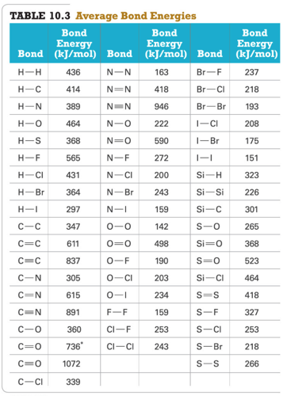
* 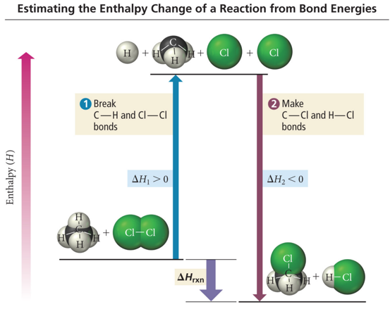

## Practice Problem: ΔHrxn from Bond Energies

* Hydrogen gas can be made by the reaction of methane gas and steam:
  + CH4(g) + 2 H2O(g) è 4 H2(g) + CO2(g)
* Use bond energies to calculate ΔHrxn for this reaction

## Clicker 4

* Use the bond energies provided to estimate ΔH°rxn for the reaction below.
  + C2H4(g) + H2(g) → C2H6(g) ΔH°rxn = ?
  + Bond Bond Energy (kJ/mol)
    - C-C 347
    - C-H 414
    - C=C 611
    - C≡C 837
    - H-H 436
* A) -128 kJ
* B) +98 kJ
* C) +700 kJ
* D) -102 kJ
* E) -166 kJ

Answer: A

Please enable JavaScript to view the [comments powered by Disqus.](https://disqus.com/?ref_noscript)

## CH101-008 UA Fall 2016

* CH101-008 UA Fall 2016
* [jmbeach1@crimson.ua.edu](mailto:jmbeach1@crimson.ua.edu)
* jmbeach
* hey_beach

Notes and study materials for The University of Alabama's Chemistry 101 course offered Fall 2016.