Week 14 - Day 3

Table of Contents

[CH101-008 UA Fall 2016](/CH101-008/)

[About](/CH101-008/about/)

# Week 14 - Day 3

Nov 18, 2016

## Clicker 1

* Use the standard reaction enthalpies given below to determine ΔH°rxn for the following reaction 2 NO(g) + O2(g) → 2 NO2(g) ΔH°rxn = ?
  + Given:
    - N2(g) + O2(g) → 2 NO(g) ΔH°rxn = +183 kJ
    - 1/2 N2(g) + O2(g) → NO2(g) ΔH°rxn = +33 kJ
  + A) -150. kJ
  + B) -117 kJ
  + C) -333 kJ
  + D) +115 kJ
  + E) +238 kJ

Answer: B

## Standard Conditions and Standard Enthalpy of Formation (ΔHf)

* Audio 0:00:21.144316
* The *standard state* is the state of a material at a defined set of conditions.
  + Pure gas at exactly 1 atm pressure
  + Pure solid or liquid in its most stable form at exactly 1 atm pressure and temperature of interest
    - Usually 25 °C
  + Substance in a solution with concentration 1 M
* The *standard enthalpy change*, ΔH°, is the enthalpy change when all reactants and products are in their standard states.
  + Audio 0:02:59.978786
* The *standard enthalpy of formation, ΔH°f*, is the enthalpy change for the reaction forming 1 mole of a pure compound from its constituent elements.
  + The elements must be in their standard states.
  + The ΔHf° for a pure element in its standard state = 0 kJ/mol.

## Table of Standard Enthalpies (ΔHf)

* Audio 0:05:22.505566
* 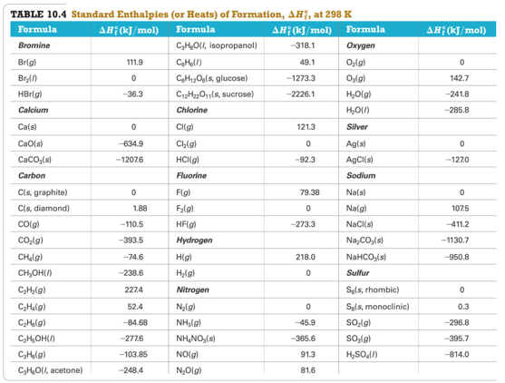

## Practice Problem: Standard Enthalpies of Formation (ΔHf)

* Audio 0:08:11.763970
* Write the appropriate equations for the heats of formation of MgCO3(s) and C6H12O6(s)

## Clicker 2

* The standard enthalpy of formation (ΔHo f) for potassium chloride is the enthalpy change for the reaction:
  + A) K(g) + ½Cl2(g) è KCl(g)
  + B) K+(g) + Cl- (g) è KCl(s)
  + C) 2K(s) + Cl2(g) è 2KCl(s)
  + D) K(s) + ½Cl2(g) è KCl(s)
  + E) K+(g) + Cl- (g) è KCl(g)

Answer: D

## Calculating Standard Enthalpy Change for a Reaction

* Audio 0:12:36.053007
* Any reaction can be written as the sum of formation reactions (or the reverse of formation reactions) for the reactants and products.
* The ΔH° for the reaction is then the sum of the ΔHf° for the component reactions. ΔH° reaction = ∑nΔHf °(products) − ∑nΔHf °(reactants) ∑ means sum. n is the stoichiometric coefficient of the reaction.

## CH4(g) + 2 O2(g) → CO2(g) + 2H2O(g)

* C(s, graphite) + 2 H2(g) → CH4(g) ΔHf°= − 74.6 kJ/mol CH4
* C(s, graphite) + O2(g) → CO2(g) ΔHf°= −393.5 kJ/mol CO2
* H2(g) + ½ O2(g) → H2O(g) ΔHf° = −241.8 kJ/mol H2O

## CH4(g) + 2 O2(g) → CO2(g) + 2H2O(g)

* Audio 0:17:54.502946
* 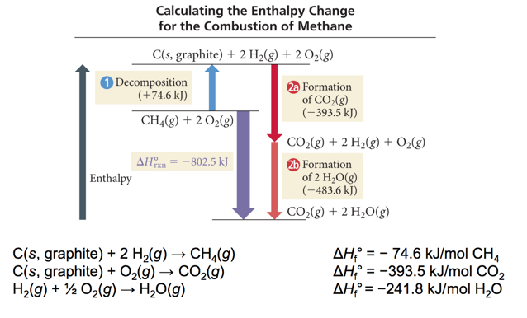
* 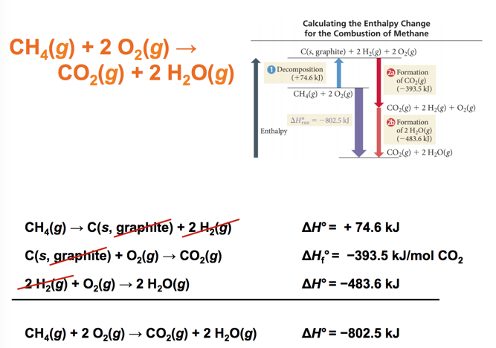

## Practice Problem: Standard Enthalpies of Formation (ΔHf )

* Audio 0:18:40.315050
* What is the change in enthalpy for the reaction 4NH3(g) + 5O2(g) è 4NO(g) + 6H2O(g)

## Clicker 3

* Audio 0:21:26.032462
* Use the ΔH°f information provided to calculate ΔH°rxn for the following SO2Cl2(g) + 2 H2O(l) → 2 HCl(g) + H2SO4(l) ΔH°rxn = ?
  + ΔH° f (kJ/mol)
  + SO2Cl2(g) -364
  + H2O(l) -286
  + HCl(g) -92
  + H2SO4(l) -814
* A) -256 kJ
* B) +161 kJ
* C) -62 kJ
* D) +800. kJ
* E) -422 kJ

Answer: C

## Ionic Bonding and the Crystal Lattice

* Audio 0:26:20.219643
* The extra energy that is released comes from the formation of a structure in which every cation is surrounded by anions, and vice versa.
* This structure is called a crystal lattice.
* The crystal lattice is held together by the electrostatic attraction of the cations for all the surrounding anions.
* The crystal lattice maximizes the attractions between cations and anions, leading to the most stable arrangement.

## Lattice Energy

* The extra stability that accompanies the formation of the crystal lattice is measured as the lattice energy.
* The lattice energy is the energy released when the solid crystal forms from separate ions in the gas state.
  + Always exothermic
  + Hard to measure directly, but can be calculated from knowledge of other processes
* Lattice energy depends directly on the size of charges and inversely on distance between ions.

## Determining Lattice Energy: The Born–Haber Cycle

* The *Born–Haber cycle* is a hypothetical series of reactions that represents the formation of an ionic compound from its constituent elements.
* The reactions are chosen so that the change in enthalpy of each reaction is known except for the last one, which is the lattice energy.

## Born–Haber Cycle and Hess’s Law

* 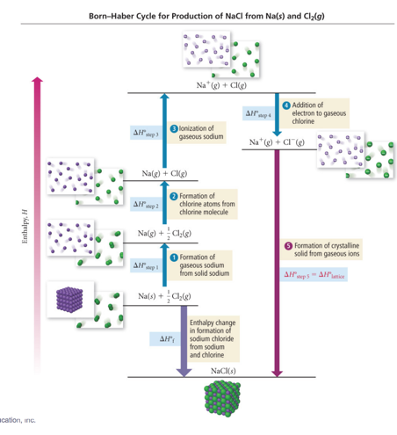
* Use Hess’s law to add up enthalpy changes of other reactions to determine the lattice energy.
* 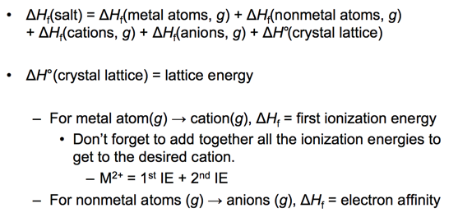

## Trends in Lattice Energy: Ion Size

* Audio 0:31:13.639819
* The force of attraction between charged particles is inversely proportional to the distance between them.
* Larger ions mean the center of positive charge (nucleus of the cation) is farther away from the negative charge (electrons of the anion).
  + Larger ion = weaker attraction
  + Weaker attraction = smaller lattice energy

## Lattice Energy versus Ion Size

* Audio 0:31:57.501608
* The force of attraction between oppositely charged particles is directly proportional to the product of the charges.
* Larger charge means the ions are more strongly attracted.
  + Larger charge = stronger attraction
  + Stronger attraction = larger lattice energy
  + 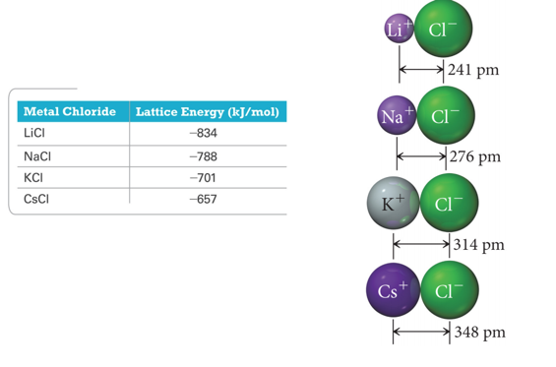

## Trends in Lattice Energy: Ion Charge

* The force of attraction between oppositely charged particles is directly proportional to the product of the charges.
* Larger charge means the ions are more strongly attracted.
  + Larger charge = stronger attraction
  + Stronger attraction = larger lattice energy
* Of the two factors, ion charge is generally more important.
* 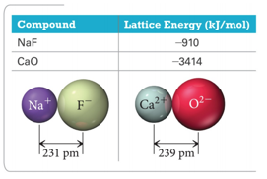

## Which compound should have the largest lattice energy?

# Ch 11

* What is a Gas?

# Vocab

|  |  |
| --- | --- |
| Term | Definition |
| bond energy | amount of energy it takes to break one mole of a bond in a compound |
| standard state | state of a material at a defined set of conditions |
| standard enthalpy change (ΔH°) | the enthalpy change when all reactants and products are in their standard states |
| standard enthalpy of formation (ΔH°f) | the enthalpy change for the reaction forming 1 mole of a pure compound from its constituent elements |
| Born–Haber cycle | a hypothetical series of reactions that represents the formation of an ionic compound from its constituent elements |

Please enable JavaScript to view the [comments powered by Disqus.](https://disqus.com/?ref_noscript)

## CH101-008 UA Fall 2016

* CH101-008 UA Fall 2016
* [jmbeach1@crimson.ua.edu](mailto:jmbeach1@crimson.ua.edu)
* jmbeach
* hey_beach

Notes and study materials for The University of Alabama's Chemistry 101 course offered Fall 2016.