Week 15 - Day 1 (Start Ch 11)

Table of Contents

[CH101-008 UA Fall 2016](/CH101-008/)

[About](/CH101-008/about/)

# Week 15 - Day 1 (Start Ch 11)

Nov 21, 2016

* Audio 0:00:59.904181
* 2 - 4:30 saturday and sunday after next
  + review sessions in shelby hall

## Clicker 1

* Audio 0:02:40.435200
* How much energy is evolved during the formation of 197 g of Fe according to the reaction below? (Fe: 55.85) Fe2O3(s)+2Al(s)->Al2O3(s)+2Fe(s) delta H rxn = -852kJ
* A) 1.52*10^3 kJ
* B) 3.02*10^3 kJ
* C) 8.40*10^3 kJ
* D) 964 kJ
* E) 482 kJ

Answer: A 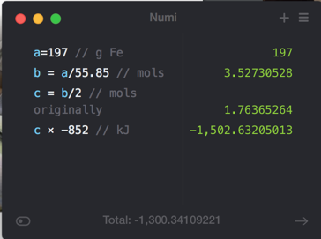

## Gas Pressure

* Audio 0:07:39.758980
* Gas pressure is a result of the constant movement of the gas molecules and their collisions with the surfaces around them.
* The pressure of a gas depends on several factors:
  + Number of gas particles in a given volume
  + Volume of the container
  + Average speed of the gas particles
  + Mass of the gas particles

## Gas Pressure

* The total pressure exerted by a gas depends on frequency of collisions & momentum change during a collision:
* Number of gas particles in a given volume
  + The fewer the gas particles, the lower the force per unit area and the lower the pressure.
    - A low density of gas particles results in low pressure. A high density of gas particles results in high pressure.
    - As volume increases, concentration of gas molecules decreases (number of molecules does not change, but since the volume increases, the concentration goes down).
      * This, in turn, results in fewer molecular collisions, which results in lower pressure.
* Momentum of individual molecules
  + speed and mass of molecules
    - Temperature
* 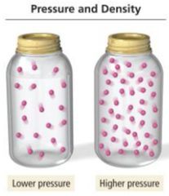

## Atmospheric Pressure Effects

* Audio 0:10:36.762960
* Variation in pressure in Earthʼ s atmosphere creates wind, and changes in pressure help us to predict weather.
  + The H in this map indicates regions of high pressure, usually associated with clear weather.
  + The L indicates regions of low pressure, usually associated with unstable weather.
* The number of gas particles in a given volume decreases with increasing altitude.
  + Hence, pressure decreases with increasing altitude.
* 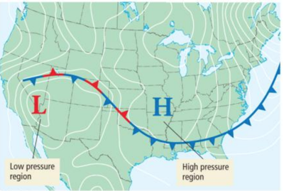

## Pressure Imbalance in the Ear

* Audio 0:11:41.834490
* If there is a difference in pressure across the eardrum membrane, the membrane will be pushed out.
  + The result is what we commonly call a “popped eardrum.”
* 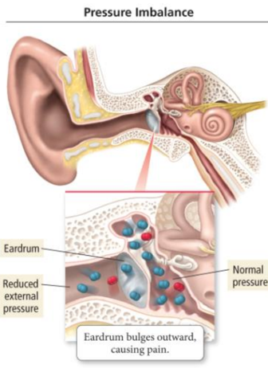

## Pressure Units

* Audio 0:13:12.088425
* Common units of pressure:
  + Millimeter of mercury (Hg)
* mmHg
  + Torr
* Same as millimeter of mercury
  + Atmosphere (atm)
* Conversion between pressure units:
  + 1 mmHg = 1 torr
  + 760 mmHg = 1 atm
  + 760 torr = 1 atm
* 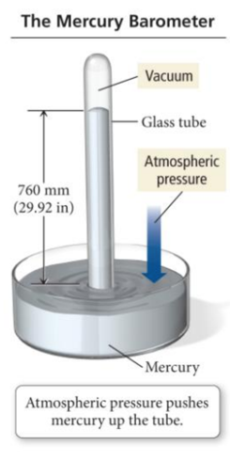

## A Table of Pressure Units

* Audio 0:17:58.486884
* 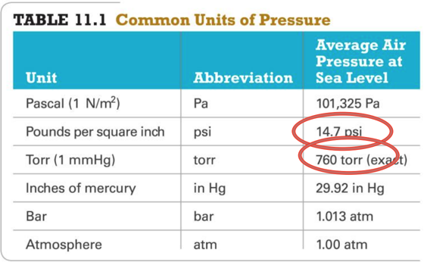

## The Manometer

* Audio 0:18:10.818952
* The pressure of a gas trapped in a container can be measured with an instrument called a manometer.
* Manometers are U-shaped tubes partially filled with a liquid that are connected to the gas sample on one side and open to the air on the other.
* A competition is established between the pressures of the atmosphere and the gas.
  + The difference in the liquid levels is a measure of the difference in pressure between the gas and the atmosphere.
* For this sample, the gas pressure is greater than atmospheric pressure; the mercury level on the left side of the tube is higher than the level on the right.
* 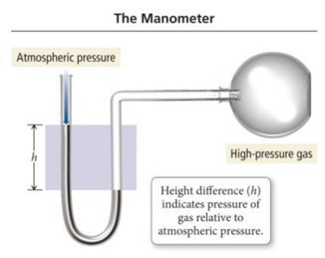

## Basic Properties of Gases

* Audio 0:20:54.286850
* There are four basic properties of a gas:
  + Pressure (P)
    - Units in atmosphere (atm)
  + Volume (V)
    - Units in liters (L)
  + Temperature (T)
    - Units in Kelvin (K)
      * Where Kelvin (K) = Celsius T + 273
  + Amount in moles (n)
* These properties are interrelated.
  + When one changes, it affects the others.
    - The simple gas laws describe the relationships between pairs of these properties.

## The Simple Gas Laws

* Audio 0:23:11.105305
* The simple gas laws are as follows:
  + Boyleʼs Law
* Investigates pressure and volume relationship
  + Charlesʼs Law
* Investigates volume and temperature relationship
  + Avogadroʼs Law
* Investigates volume and amount (mole) relationship

## Boyleʼs Law: Volume and Pressure

* Audio 0:25:25.284216
* Robert Boyle (1627–1691) and Robert Hooke used a J-tube to measure the volume of a sample of gas at different pressures.
* They trapped a sample of air in the J-tube and added mercury to increase the pressure on the gas.
  + They observed an inverse relationship between volume and pressure.
* Hence, an increase in one causes a decrease in the other.
* Inverse Relationship As the volume of a gas sample is decreased, gas molecules collide with surrounding surfaces more frequently, resulting in greater pressure. A plot of the volume of a gas versus pressure. The plot shows that volume and pressure are inversely related.
* Pressure of a gas is inversely proportional to its volume when temperature and the amount of gas are held constant.
  + As P increases, V decreases by the same factor.
  + P × V = constant
* Graphing Boyle’s Law
  + A graph of P versus V results in a curve.
  + A graph of P versus 1/V results in a straight line plot.
* Relationship:
  + P1 × V1 = P2 × V2

## Boyleʼs Law and Diving

* Audio 0:26:17.106941
* For every 10 m of depth, a diver experiences approximately one additional atmosphere of pressure due to the weight of the surrounding water.
  + At 20 m, for example, the diver experiences approximately 3 atm of pressure.
* If a diver holds his or her breath and rises to the surface quickly, the outside pressure drops to 1 atm.
  + According to Boyleʼs law, what should happen to the volume of air in the lungs?
* Because the pressure is decreasing by a factor of 3, the volume will expand by a factor of 3, causing damage to internal organs.
* Always exhale when rising!

## Clicker 2

* What volume (in mL) will a sample of F2 gas occupy in a syringe at 5.5 atm, if the F2 has a volume of 25.0 mL at 1.2 atm?
  + A) 11 mL
  + B) 17 mL
  + C) 3.8 mL
  + D) 5.5 mL
  + E) 7.6 mL

Answer: D

## Charlesʼs Law: Volume and Temperature Have a Direct Relationship

* Audio 0:32:43.927172
* The volume of a fixed amount of gas at a constant pressure increases linearly with increasing temperature in kelvins.
  + Volume and temperature have a direct relationship
* if the volume of a gas increases with increasing temperature.
* V = constant × T (T measured in kelvins)
* V/T = constant
* (V1/T1) = (V2/T2)

## Charlesʼs Law: Graphically

* Audio 0:34:58.249430
* The extrapolated lines cannot be measured experimentally because all gases condense into liquids before –273.15 °C is reached.
* If the lines are extrapolated back to a volume of 0, they all show the same temperature, −273.15 °C = 0 K, called *absolute zero*.
* 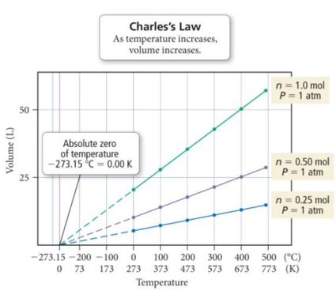

## Charlesʼs Law: A Molecular View

* When the temperature of a gas sample increases, the gas particles move faster.
  + Collisions with the walls are more frequent.
  + The force exerted with each collision is greater.
* The only way for the pressure (the force per unit area) to remain constant is for the gas to occupy a larger volume so that collisions become less frequent and occur over a larger area.
* If a filled balloon is moved from an ice water bath to a boiling water bath, its volume expands as the gas particles within the balloon move faster (due to the increased temperature) and collectively occupy more space.

## Clicker 3

* Audio 0:37:40.527989
* To what temperature must a balloon, initially at 25 C and 2.00 L, be heated in order to have a volume of 6.00L?
  + A) 993 K
  + B) 403 K
  + C) 75 K
  + D) 655 K
  + E) 894 K

Answer: A 

# Vocab

|  |  |
| --- | --- |
| Term | Definition |
| gas pressure dependencies | number of gas particles in a given volume and momentum of particles |
| manometer | measures pressure of gas trapped in a container |
| boyle’s law | p1 * v1 = p2 * v2 |
| charle’s law | v = constant * T (direct relationship) |

Please enable JavaScript to view the [comments powered by Disqus.](https://disqus.com/?ref_noscript)

## CH101-008 UA Fall 2016

* CH101-008 UA Fall 2016
* [jmbeach1@crimson.ua.edu](mailto:jmbeach1@crimson.ua.edu)
* jmbeach
* hey_beach

Notes and study materials for The University of Alabama's Chemistry 101 course offered Fall 2016.