Week 16 - Day 1

Table of Contents

[CH101-008 UA Fall 2016](/CH101-008/)

[About](/CH101-008/about/)

# Week 16 - Day 1

Nov 28, 2016

* [Quizlet](https://quizlet.com/_2tt8jg)

Download Word (docx):

## Navigate using audio

# Final

* Week from today
* Slightly more weighted toward things on ch 10 and 11
* Review session
  + 2 - 4:30 Saturday and Sunday after next
    - review sessions in Shelby hall
* Final is 11:30 - 2
* Liquid nitrogen experiment

## Clicker 1

* Audio 0:06:15.196390
* To what volume will a sample of gas expand if it is heated from 50.0 C and 2.33 L to 500.0 C?
  + A) 5.57 L
  + B) 23.3 L
  + C) 0.233 L
  + D) 0.97 L
  + E) 0.184 L

Answer: A 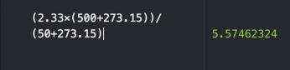

## Avogadroʼs Law: Volume and Moles Have a Direct Relationship

* Audio 0:11:31.193983
* Volume is directly proportional to the number of gas molecules when pressure and temperature are held constant. – More gas molecules = larger volume
* Equal volumes of gases contain equal numbers of molecules. – The gas doesn’t matter.
* V = constant × n (moles)
* V/n = constant
* (V1/n1) = (V2/n2)
* The volume of a gas sample increases linearly with the number of moles of gas in the sample.
* 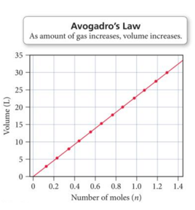

## Clicker 2

* Audio 0:14:23.279569
* If a sample of 0.29 moles of Ar occupies 3.8 L under certain conditions, what volume will 0.66 moles occupy under the same conditions?
  + A) 12
  + B) 8.6
  + C) 17
  + D) 5.0
  + E) 15

Answer: B 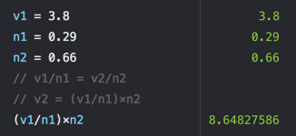

## Ideal Gas Law: PV = nRT

* Audio 0:17:10.738500
* The simple gas law relationships discussed so far can be combined into a single law that encompasses all of them.
  + V α (1/P) Boyle’s Law
  + V α T Charles’s Law
  + V α n Avogadro’s Law
* Ideal gas law: PV = nRT – Where
  + P is pressure in atm
  + V is volume in liters
  + n is moles
  + R is the ideal gas law constant, 0.0821 (L · atm)/(K · mol) – T is temperature in kelvins

## Ideal Gas Law: PV = nRT

* Audio 0:18:31.572724
* 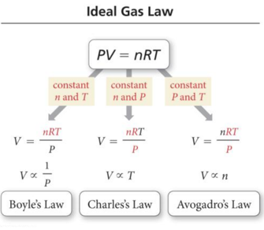 · The other gas laws are found in the ideal gas law if two variables are kept constant. · The ideal gas law allows us to find one of the variables if we know the other three.

## Practice Problem: Ideal Gas Law

* Audio 0:19:52.714114
* Calculate the volume occupied by 0.845 mol of nitrogen gas at a pressure of 1.37 atm and temperature of 42 °C

## Practice Problem: Ideal Gas Law

* Audio 0:22:41.752192
* Calculate the number of moles of gas in a 3.24 L basketball inflated to a total pressure of 24.3 psi

## Standard Conditions

* Audio 0:26:03.240956
* Because the volume of a gas varies with pressure and temperature, chemists have agreed on a set of conditions to report our measurements so that comparison is easy. – These are called standard conditions (STP).
* Standard pressure = 1 atm
* Standard temperature = 273 K = 0 °C
* Standard amount = 1 mol
* Standard volume = 22.4 L – The volume occupied by one mole of a substance is its molar volume at STP (T = 273 K or 0 °C and P = 1atm).
* 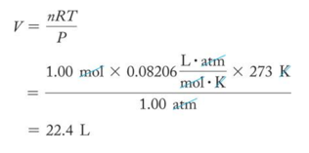

## Molar Volume at STP

* Audio 0:28:15.214651
* The volume of one mole of gas at STP is called the molar volume.
  + 6.022 × 1023 molecules of gas – Note that the type of gas is immaterial.
* It is important to recognize that one-mole measures of different gases have different masses, even though they have the same volume.

## Density of a Gas

* Audio 0:29:06.988437
* Density is the ratio of mass to volume. – Density = (mass/volume)
* Density of a gas is generally given in grams/liter (g/L).
* The mass of 1 mol = molar mass.
* The volume of 1 mol at STP = 22.4 L.
  + Density (d) = [mass of gas (g/mol)]/[volume (L)]
    - Density (g/L) = (molar mass)/(molar volume)

## Density of a Gas at STP

* Audio 0:29:33.594188
* For example, the densities of helium and nitrogen gas at STP are as follows:
  + 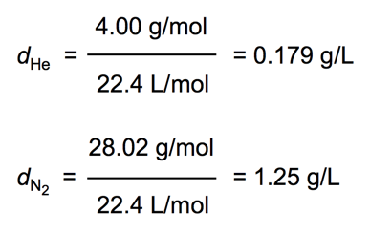

## Molar Mass of a Gas

* Audio 0:30:27.999878
* One of the methods chemists use to determine the molar mass of an unknown substance is to heat a weighed sample until it becomes a gas; measure the temperature, pressure, and volume; and use the ideal gas law.
  + 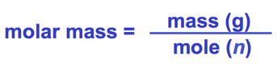

## Gas Density

* Audio 0:31:34.143033
* PV = nRT

## Gas Density

* Audio 0:34:08.137349
* 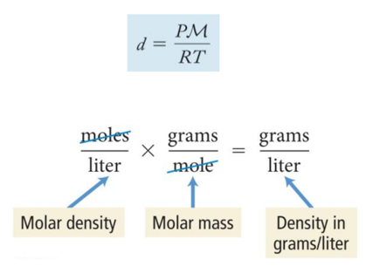

## Practice Problem: Density of a Gas

* Audio 0:34:25.383706
* A sample of gas has a mass of 0.311 g. Its volume is 0.225 L at 55 oC and pressure of 886 mmHg. What is the molar mass?

## Mixtures of Gases and Partial Pressures

* Many gas samples are not pure but are mixtures of gases.
* Dry air, for example, is a mixture containing nitrogen, oxygen, argon, carbon dioxide, and a few other gases in trace amounts.
* Therefore, in certain applications, the mixture can be thought of as one gas. – By knowing air’s pressure, volume, and temperature, the total moles of molecules in an air sample can be determined—even though they are different compounds.
  + 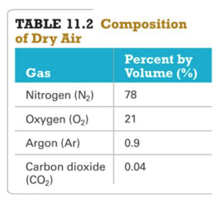

## Partial Pressure: Pgas

* Audio 0:38:48.952989
* The pressure of a single gas in a mixture of gases is called its partial pressure.
* The partial pressure of a gas can be calculated if – a fraction of the mixture it composes and the total pressure are known; or – the number of moles of the gas in a container of a given volume and temperature are known.
* The sum of the partial pressures of all the gases in the mixture equals the total pressure. This is known as Daltonʼs law of partial pressures.
  + Ptotal = Pa + Pb + Pc + …
* Gases behave independently.

## Partial Pressure: Pgas

* Audio 0:40:46.362349
* The pressure due to any individual component in a gas mixture is its partial pressure (Pn).
* The partial pressure from the ideal gas law can be determined by assuming that each gas component acts independently.
  + RT Pn = nn V

# Vocab

|  |  |
| --- | --- |
| Term | Definition |
| relationship between volume and moles | V = constant * n(moles) |
| standard conditions | Using these conditions 22.4 L is the volume of one mol of any gas (1 atm, 273 K (0 C), 1 mol) |
| partial pressure | the pressure of a single gas in a mixture of gases |
| Daltonʼs law of partial pressures | Ptotal = Pa + Pb + Pc + … |

Please enable JavaScript to view the [comments powered by Disqus.](https://disqus.com/?ref_noscript)

## CH101-008 UA Fall 2016

* CH101-008 UA Fall 2016
* [jmbeach1@crimson.ua.edu](mailto:jmbeach1@crimson.ua.edu)
* jmbeach
* hey_beach

Notes and study materials for The University of Alabama's Chemistry 101 course offered Fall 2016.