Week 16 - Day 2

Table of Contents

[CH101-008 UA Fall 2016](/CH101-008/)

[About](/CH101-008/about/)

# Week 16 - Day 2

Nov 30, 2016

# Final exam

* Next Monday
* Normal location
* 9:30 - 11:00
* Pencil
* Photo ID
* Calculator
* More weighted on new chapters
* 50 questions
* Review sessions saturday and sunday 2:00
  + Room 1004 Shelby Hall

## Clicker 1

* Audio 0:02:08.744030
* What is the partial pressure of oxygen in a mixture that contains 0.30 mol of O2, 0.70 mol of N2, and 0.25 mol of Ar with

## Clicker 2

* Audio 0:05:23.466658
* A 0.334 g sample of an unknown halogen occupies 109 mL at 398 K and 1.41 atm. What is the identity of the halogen? Br:79.90

Answer: C 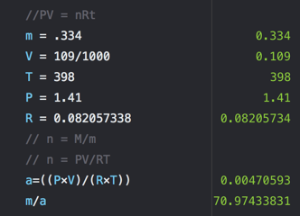

## Daltonʼs Law of Partial Pressures

* Audio 0:12:15.535453
* For a multicomponent gas mixture, we calculate the partial pressure of each component from the ideal gas law and the number of moles of that component (nn) as follows:
  + 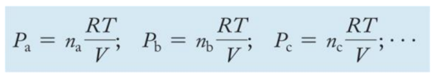
* The sum of the partial pressures of the components in a gas mixture equals the total pressure:
  + 

## Daltonʼs Law of Partial Pressures

* This relationship is known as Daltonʼs law of partial pressures.
* 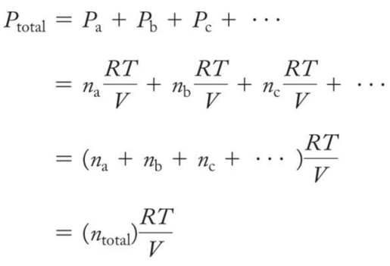

## Mole Fraction: χa

* Audio 0:13:15.434990
* The number of moles of a component in a mixture divided by the total number of moles in the mixture is the *mole fraction*.
  + 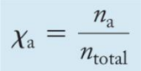
* The ratio of the partial pressure a single gas contributes and total pressure is equal to the mole fraction.
  + 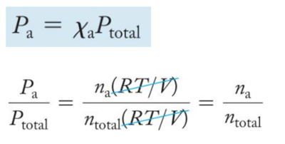

## Mole Fraction

* Audio 0:14:01.065205
* For gases, the mole fraction of a component is equivalent to its percent by volume divided by 100%. – Nitrogen has a 78% composition of air. Find its partial pressure.
  + 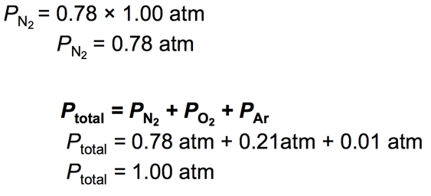

## Practice Problem: Total Pressure and Partial Pressures

* Audio 0:14:37.896502
* A 1.00 L mixture of helium, neon, and argon has a total pressure of 662 mmHg at 298 K. If the partial pressure of He is 341 mmHg and that of Ne is 112 mmHg, what mass of Ar is present?

## Deep-Sea Diving, the Bends, and Partial Pressures

* Audio 0:18:06.803368
* 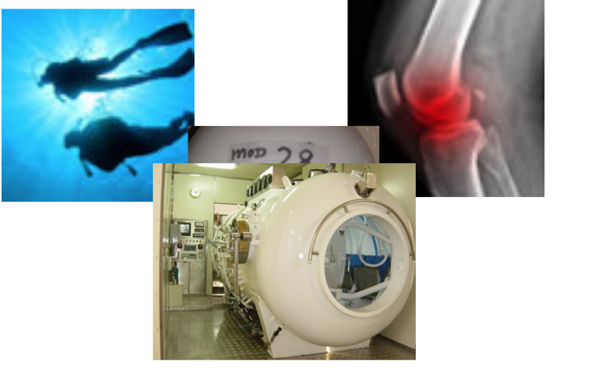

## Deep-Sea Diving and Partial Pressures

* Audio 0:22:33.181580
* 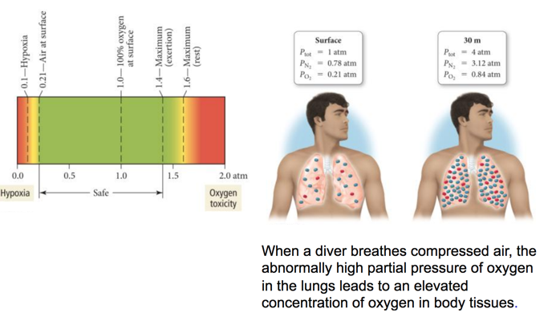
* When a diver breathes compressed air, the abnormally high partial pressure of oxygen in the lungs leads to an elevated concentration of oxygen in body tissues.

## Collecting Gases

* Audio 0:22:51.487861
* Gases are often collected by having them displace water from a container. – The problem is that because water evaporates, there is also water vapor in the collected gas.
* The partial pressure of the water vapor, called the vapor pressure, depends only on the temperature. – A table can be used to find the partial pressure of the water vapor when collecting a gas over water. – Example:
  + A gas sample is collected over water. The gas sample has a total pressure of 758.2 mmHg at 25 °C.
  + From a *vapor pressure* of water table, the partial pressure of the water vapor is 23.78 mmHg at 25 oC.
  + The partial pressure of the dry gas will be 734.4 mmHg.
* 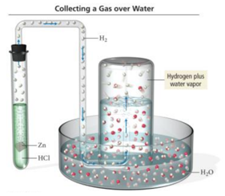

## Vapor Pressure of Water

* 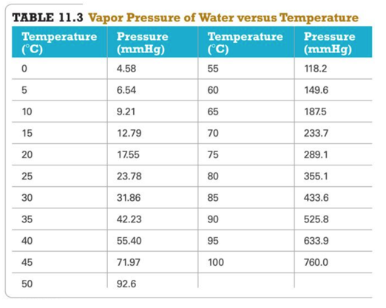

## Kinetic Molecular Theory

* Audio 0:25:29.060382
* The simplest model for the behavior of gases is the *kinetic molecular theory*.
* In this theory, a gas is modeled as a collection of particles (either molecules or atoms, depending on the gas) in constant motion.
* 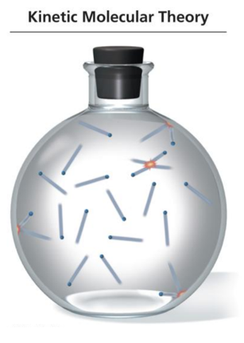

## Kinetic Molecular Theory Postulates

* The particles of the gas (either atoms or molecules) are constantly moving.
* The attraction between particles are neglected.
* When the moving gas particles hit another gas particle or the container, they do not stick; they bounce off and continue moving in another direction.
* There is a lot of empty space between the gas particles compared to the size of the particles.

## Kinetic Molecular Theory

* 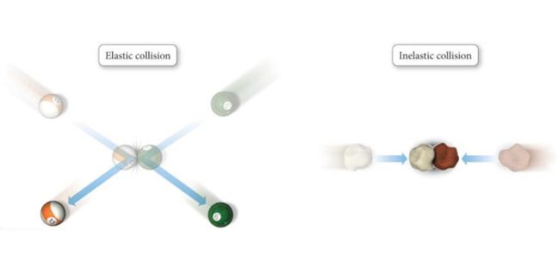

## Kinetic Molecular Theory

* The collision of one particle with another (or with the walls of its container) is completely elastic. – This means that when two particles collide, they may exchange energy, but there is no overall loss of energy.
  + Any kinetic energy lost by one particle is completely gained by the other.
* The average kinetic energy of the gas particles is directly proportional to the Kelvin temperature. – As you raise the temperature of the gas, the average speed of the particles increases.
  + But not all the gas particles are moving at the same speed!

## The Nature of Pressure

* Because the gas particles are constantly moving, they strike the sides of the container with a force.
* The result of many particles in a gas sample exerting forces on the surfaces around them is a constant pressure.
  + Pressure (P) = Force (F)/Area (A)

## Gas Laws Explain Boyleʼs Law

* Boyleʼs law says that the volume of a gas is inversely proportional to the pressure. – Decreasing the volume forces the molecules into a smaller space.
* More molecules will collide with the container at any one instant, increasing the pressure.

## Gas Laws Explain Charlesʼs Law

* Charlesʼs law says that the volume of a gas is directly proportional to the absolute temperature. – According to kinetic molecular theory, when we increase the temperature of a gas, the average speed—and thus the average kinetic energy—of the particles increases.
* The greater volume spreads the collisions out over a greater surface area, so that the pressure is unchanged.

## Gas Laws Explain Avogadroʼs Law

* Audio 0:27:49.912122
* Avogadroʼs law says that the volume of a gas is directly proportional to the number of gas molecules.
* Increasing the number of gas molecules causes more of them to hit the wall at the same time.
* To keep the pressure constant, the volume must then increase.

## Gas Laws Explain Daltonʼs Law

* Audio 0:28:02.848774
* Daltonʼs law says that the total pressure of a gas mixture is the sum of the partial pressures.
* According to kinetic molecular theory, the particles have negligible size and they do not interact. – Particles of different masses have the same average kinetic energy at a given temperature.
* Because the average kinetic energy is the same, the total pressure of the collisions is the same.

## Temperature and Molecular Velocities

* 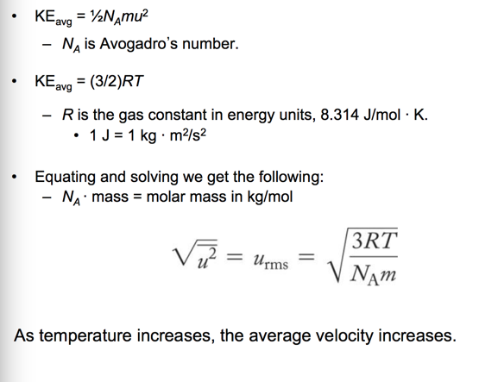

## Molecular Speed versus Molar Mass

* Audio 0:33:13.886790 • To have the same average kinetic energy, heavier molecules must have a slower average speed.
* 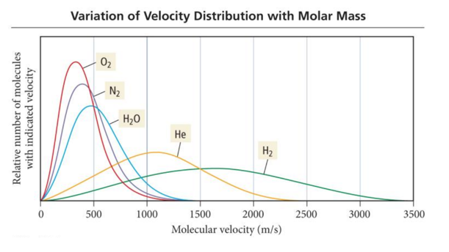

## Temperature versus Molecular Speed

* Audio 0:33:55.441736 • As the temperature of a gas sample increases, the velocity distribution of the molecules shifts toward higher velocity. – The distribution function “spreads out,” resulting in more molecules with faster speeds.
* 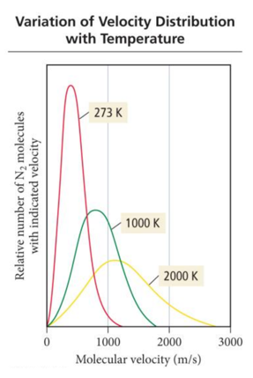

## Mean Free Path

* Audio 0:34:47.342762
* Molecules in a gas travel in straight lines until they collide with another molecule or the container.
* The average distance a molecule travels between collisions is called the *mean free path*.
* Mean free path decreases as the pressure increases.
* 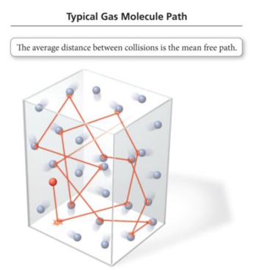

## Diffusion

* Audio 0:35:31.009397
* The process of a collection of molecules spreading out from high concentration to low concentration is called *diffusion*.
  + 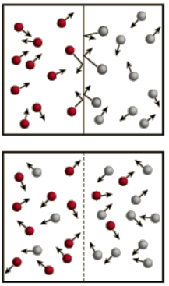

## Diffusion and Effusion

* Audio 0:36:50.045677
* The process by which a collection of molecules escapes through a small hole into a vacuum is called *effusion*.
* The rates of diffusion and effusion of a gas are both related to the root mean square (rms) velocity of the gas particles.
* For gases at the same temperature, this means that the rate of gas movement is inversely proportional to the square root of its molar mass.
* 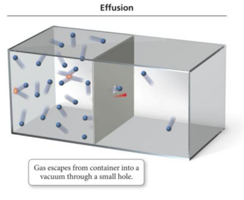

## Grahamʼs Law of Effusion

* The ratio of the rates of effusion of two different gases at the same temperature is given by the following equation:
* 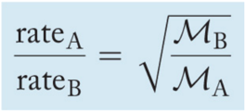

## Clicker 3

* Audio 0:39:33.577535
* The rate of effusion of oxygen

# Vocab

|  |  |
| --- | --- |
| Term | Definition |
| mole fraction | number of moles of a component in a mixture divided by the total number of moles in the mixture |
| vapor pressure | partial pressure of water vapor |
| kinetic molecular theory | model of gas behavior in which gas is modeled as a collection of particles (simplest model) |
| mean free path | average distance a molecule travels between collisions |
| diffusion | process of a collection of molecules spreading out from high concentration to low concentration |
| effusion | process by which a collection of molecules escapes through a small hole into a vacuum |

Please enable JavaScript to view the [comments powered by Disqus.](https://disqus.com/?ref_noscript)

## CH101-008 UA Fall 2016

* CH101-008 UA Fall 2016
* [jmbeach1@crimson.ua.edu](mailto:jmbeach1@crimson.ua.edu)
* jmbeach
* hey_beach

Notes and study materials for The University of Alabama's Chemistry 101 course offered Fall 2016.