Week 2 - Day 2

Table of Contents

[CH101-008 UA Fall 2016](/CH101-008/)

[About](/CH101-008/about/)

# Week 2 - Day 2

Aug 24, 2016

Download Word (docx):

## Navigate using audio

[Quizlet for terms in this lecture](https://quizlet.com/_2fmjqw)

* Audio 0:02:12.490025
* Recitation tonight
  + Going over practice problems
* Next Wednesday
  + Placement exam

## Millikan’s Oil Drop Experiment: The Charge-to-Mass Ratio for an Electron

* Audio 0:03:42.054463
* Using data from
  + Millikan’s experiment (–1.60 × 10–19 C/electron);
  + Thomson’s mass-to-charge ratio for electrons, it can be deducted that the mass of an electron is as follows:
  + 

## Radioactivity

* Audio 0:04:08.902546
* Some elements: Uranium, Radium, Thorium emit high energy radiation: alpha, beta, gamma rays
  + Gave the basis for what is in atoms
  + Audio 0:05:35.336223
  + 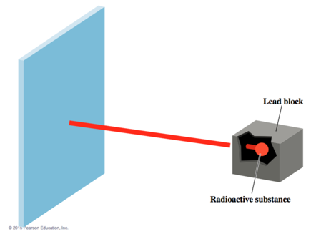
  + Audio 0:06:11.521979
  + Alpha is positively charged
  + 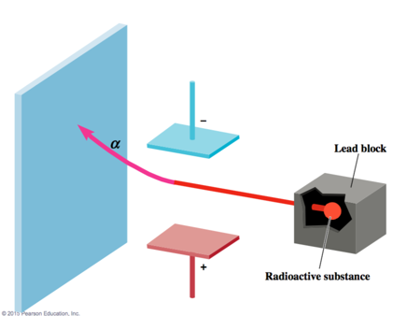
  + Audio 0:06:28.313205
  + Beta is negatively
  + 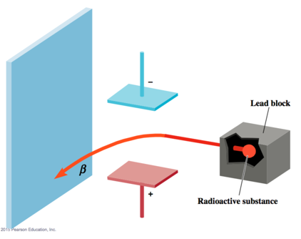
  + Gamma is neutrally charged
  + 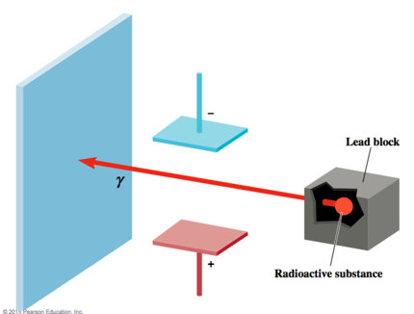
  + 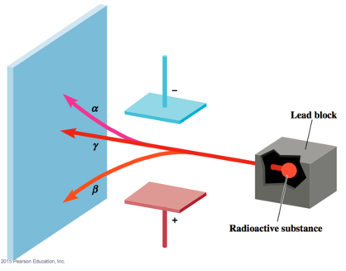

## Putting the pieces together:

* Audio 0:07:20.979240
* Beta particles: negatively charged = electrons
* Alpha particles: positively charged Ernest Rutherford showed that these are chemically part of helium atoms
* Audio 0:07:58.216800
* Gamma Rays: like light and X-rays, only more energy
* So where are the Electrons and the Positive Charge in an atom?
* Audio 0:08:27.289910
* 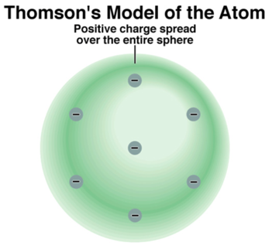

## The Ultimate Undergraduate Research Project

* Audio 0:09:44.109094
* (as carried out by Ernest Marsden under the direction of Johannes Gieger and Ernest Rutherford) Rutherford’s Experimental Design
* Audio 0:10:06.370006
* 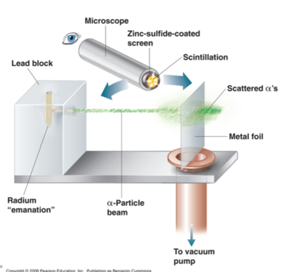
* Audio 0:11:02.745604
* 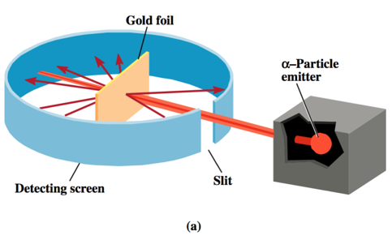

## Thomson’s Model Predicts:

* Multiple collisions, small deflections
* Rutherford on the large deflections:
* ’.. About as credible as if you had fired a 15- inch [artillery] shell at a piece of paper and it came back and hit you.’
* Audio 0:12:11.955108
* 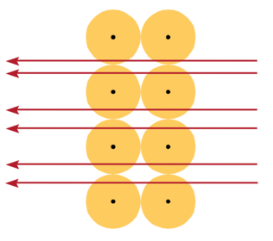
* Audio 0:12:34.844121
* 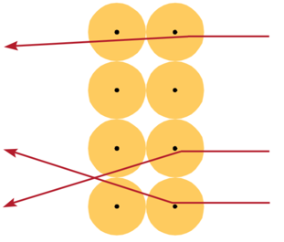
* Audio 0:12:53.542528
* 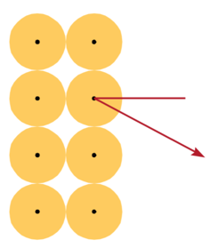
* 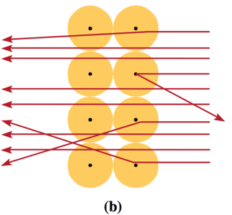
* Audio 0:13:40.032752
* 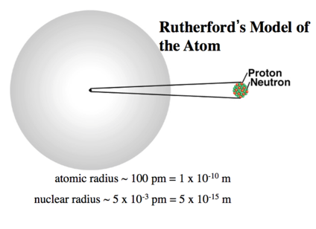
* Audio 0:14:53.573853
* 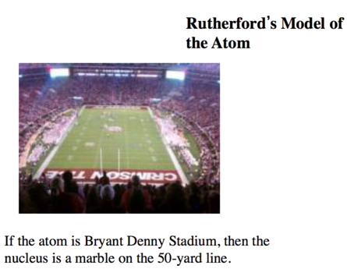

## Ernest Rutherford, Baron Nelson, BSc, DSc, Canterbury College, University of New Zealand

* Audio 0:15:04.348832
* 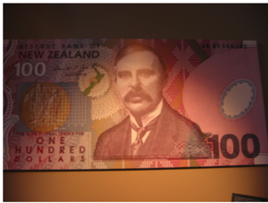
* 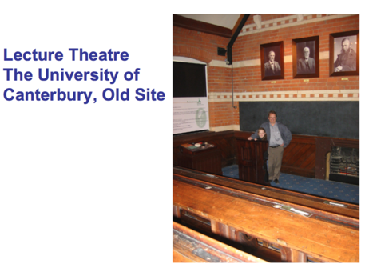

## Building on the Rutherford Atomic Model: The Nuclear Atom Model

* Audio 0:16:11.946000
* The nuclear theory of the atom has three basic parts
  1. Most of the atom’s mass and all of its positive charge are contained in a small core called a nucleus.
  2. Most of the volume of the atom is empty space, throughout which tiny, negatively charged electrons are dispersed.
  3. There are many negatively charged electrons outside the nucleus as there are positively charged particles (named protons) within the nucleus, so that the atom is electrically neutral.

## Protons (and Neutrons)

* Audio 0:17:40.279234
* Had bare proton (nucleus of hydrogen) Charge of alpha particle x 2 proton
* Mass of alpha particle x 4 proton
* So must be something else in the nucleus
  + Neutron

## Chadwick’s Experiment (1932)

* Audio 0:18:21.136318
* 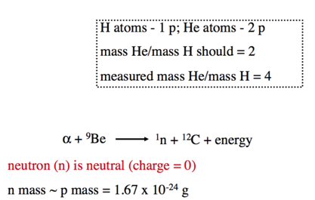

## The Atom’s Subatomic Particles

* Audio 0:20:04.055851
* All atoms are composed of the same subatomic particles:
  + Protons
  + Neutrons
  + Electrons
* Protons and neutrons have nearly identical masses
  + The mass of the proton is 1.67262 * 10^-27 kg
  + The mass of the neutron is 1.67493 × 10^–27 kg.
  + The mass of the electron is 9.1 × 10^31 kg.
* The charge of the proton and the charge of the electron are equal in magnitude but opposite in sign. The neutron has no charge.

## Subatomic Particles

* Audio 0:21:17.788117
* 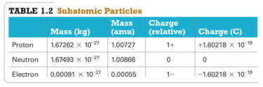

## Elements: Defined by Their Numbers of Protons

* The most important number to the identity of an atom is the number of protons in its nucleus.
* The number of protons defines the element.
* The number of protons in an atom’s nucleus is its atomic number and is given the symbol Z.

## Isotopes: Elements with Varied Number of Neutrons

* Audio 0:24:33.380011
* All atoms of a given element have the same number of protons; however, they do not necessarily have the same number of neutrons.
  + Example:
    - All neon atoms contain 10 protons, but they may contain 10, 11, or 12 neutrons.
    - All three types of neon atoms exist, and each has a slightly different mass.
    - 
* Atoms with the same number of protons but a different number of neutrons are called isotopes.

## Isotopes: Representation

* Audio 0:26:45.772174
* The sum of the number of neutrons and protons in an atom is its mass number and is represented by the symbol A.
* 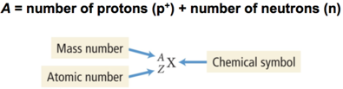
* X is the chemical symbol, A is the mass number, and Z is the atomic number.

## Isotopes: Representation

* Audio 0:28:13.708943
* A second common notation for isotopes is the chemical symbol (or chemical name) followed by a dash and the mass number of the isotope.
* 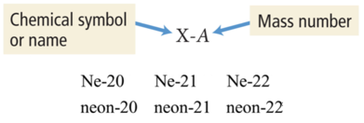

## Isotopes: Varied Number of Neutrons

* Audio 0:28:56.545513
* The relative amount of each different isotope in a naturally occurring sample of a given element is roughly constant.
* The percentages are called the natural abundance of the isotopes.
* 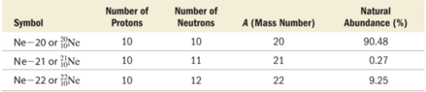

## Clicker Question

* Audio 0:32:59.698445
* What is the atomic number (Z), mass number (A), of chlorine with 18 neutrons?
* Z = 17, A = 35 (or 17 + 18)

## Ions: Charged Atoms Losing and Gaining Electrons

* Audio 0:34:19.624557
* The number of electrons in a neutral atom is equal to the number of protons in its nucleus (designated by its atomic number Z).
* In chemical changes, however, atoms can lose or gain electrons and become charged particles called ions.
  + Positively charged ions are called cations.
    - Metal elements, such as Na+, form cations.
  + Negatively charged ions are called anions.
    - Nonmetal elements, such as F–, form anions.

## Atomic Mass: The Average Mass of an Element’s Atoms

* Audio 0:36:03.449187
* Atomic mass is sometimes called the atomic weight or standard atomic weight.
* The atomic mass of each element is directly beneath the element’s symbol in the periodic table.
* The atomic mass of an element represents the average mass of the isotopes that compose that element
  + It is a weighted value based on the element’s natural abundance of each isotope.
* 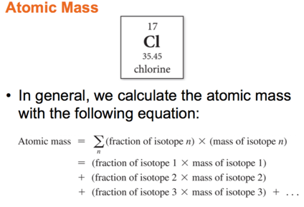
* Audio 0:36:29.805279
* 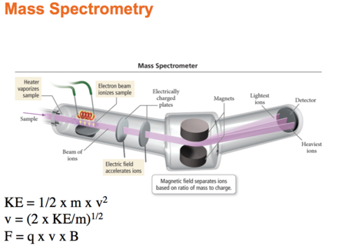

## Mass Spectrometry: Measuring the Mass of Atoms and Molecules

* The masses of atoms and the percent abundances of isotopes of elements are measured using mass spectrometry—a technique that separates particles according to their mass.
* 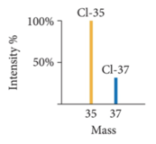

## Atomic Mass: Problem

* Naturally occurring chlorine consists of 75.77% chlorine-35 atoms (mass 34.97 amu) and 24.23% chlorine-37 atoms (mass 36.97 amu).
* Calculate chlorine’s atomic mass.
* Audio 0:39:29.943281
* 75.77 % / 100 % * 34.97 amu + 24.23%/100% * 36.97 amu

## Vocab

|  |  |
| --- | --- |
| term | definition |
| atomic number | number of protons in an atom’s nucleus (Z) |
| isotopes | atoms with the same number of protons but a different number of neutrons |
| mass number | the sum of the number of neutrons and protons in an atom |
| natural abundance | the relative amount of each different isotope in a naturally occurring sample of a given element (it is roughly constant) |
| atomic structure | highly condensed mass in nucleus with mostly empty space in electron cloud |
| nucleus | the small core of an atom (contains most of it’s mass and the positive charge) |
| protons | positively charged particles (in the nucleus of an atom) |
| cations | positively charged ions |
| anions | negatively charged ions |
| mass spectrometry | technique that separates particles according to their mass |

## CH101-008 UA Fall 2016

* CH101-008 UA Fall 2016
* [jmbeach1@crimson.ua.edu](mailto:jmbeach1@crimson.ua.edu)
* jmbeach
* hey_beach

Notes and study materials for The University of Alabama's Chemistry 101 course offered Fall 2016.