Week 2 - Recitation

Table of Contents

[CH101-008 UA Fall 2016](/CH101-008/)

[About](/CH101-008/about/)

# Week 2 - Recitation

Aug 24, 2016

## Questions

1. How are gases different from solids and liquids?
   * Gases can only be made up of atoms.
   * The particles in a gas attract each other much more strongly than in solids and liquids
   * Gases are compressible
   * Gases are colorless
2. Correctly report the result of the following computation
   * 4
   * 3.7
   * 3.72
   * 3.716
   * 3.7162 It looks like 1.6 would be the smallest but you wait until you are actually performing the devision to determine which is the smallest
3. An atom which has lost an electron is
   * a cation
   * unlikely to be found in homogeneous mixtures
   * electrically neutral
   * likely to behave exactly like the parent atom
   * an anion
4. Determine the number of protons, neutrons and electrons in the following: 
   * p = 18, n = 18, e = 22
   * p = 18, n = 22, e = 18
   * p = 22, n = 18, e = 18
   * p = 18, n = 22, e = 40
   * p = 40, n = 22, e = 18
5. Calculate the atomic mass of element “X” if it has 2 naturally occurring isotopes with the following masses and natural abundances
   * X-107 106.90509 amu 51.84%
   * X-109 108.90476 amu 48.46%
     + 107.90 amu
     + 108.00 amu
     + 107.79 amu
     + 108.32 amu
     + 108.19 amu
6. A new compound was recently discovered and found to have an atomic weight of 342.38 amu. This element has two isotopes, the lighter of which has a mass of 340.91 amu and an abundance of 68.322%. What is the mass of the heavier isotope?
   * 350.21
   * 345.55
   * 348
   * 108.32 amu
   * 108.19 amu

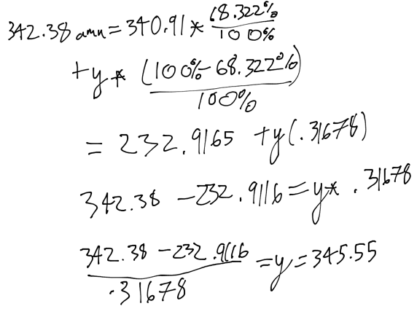

1. Two or more substances in variable proportions, where the composition is variable throughout are
   * a solution
   * a homogeneous mixture
   * a compound
   * an amorphous solution
   * a heterogeneous mixture
2. Calculate the mass of the air contained in a room that measures 2.50 m x 5.50 m x 3.00 m, given that the density of air is 1.29 g/dm^3 at 25 °C.
   * 3.13 x 10^-5 g
   * 32.0 kg
   * 53.2 kg
   * 53.2 g
   * 32.0 g
3. Three students measure the density of copper (density of copper 8.92 g/cm^3) and obtain the following results:

|  |  |  |
| --- | --- | --- |
| * Student A | * Student B | * Student C |
| * 7.99 g/cm^3 | * 8.91 g/cm^3 | * 6.50 g/cm^3 |
| * 7.98 g/cm^3 | * 8.90 g/cm^3 | * 6.90 g/cm^3 |
| * 8.01 g/cm^3 | * 8.92 g/cm^3 | * 7.20 g/cm^3 |

* Which student is precise but not accurate?
  + Students A and B
  + Student A
  + Student C
  + Student B
  + Students B and C

Please enable JavaScript to view the [comments powered by Disqus.](https://disqus.com/?ref_noscript)

## CH101-008 UA Fall 2016

* CH101-008 UA Fall 2016
* [jmbeach1@crimson.ua.edu](mailto:jmbeach1@crimson.ua.edu)
* jmbeach
* hey_beach

Notes and study materials for The University of Alabama's Chemistry 101 course offered Fall 2016.