Week 3 - Day 1

Table of Contents

[CH101-008 UA Fall 2016](/CH101-008/)

[About](/CH101-008/about/)

# Week 3 - Day 1

Aug 29, 2016

Download Word (docx):

## Navigate using audio

* [Quizlet for terms in this lecture](https://quizlet.com/_2g0nv3)

## Announcements

* If you’ve had an error while trying to do the pre-lab before the assignment was due, you will not be penalized and you will be able to participate in the lab
* If you go to recitation, you’ll see a grade, but you won’t actually get a grade for it, it’s just to let you know how you did
* Blackboard isn’t trustable in terms of what your actual grade is

## Energy of Matter

* Audio 0:01:00.206391
* all matter possesses energy
* energy is classified as either kinetic or potential
* energy can be converted from one form to another
* when matter undergoes a chemical or physical change, the amount of energy in the matter changes as well

## Energy of Matter - Kinetic

* Audio 0:02:50.452505
* Kinetic energy is energy of motion
  + motion of the atoms, molecules, and subatomic particles
  + thermal (heat) energy is a form of kinetic energy because it is caused by molecular motion

## Energy of Matter - Potential

* Audio 0:04:28.166741
* potential energy is energy that is stored in the matter
  + due to the composition of the matter and its position in the universe
  + chemical potential energy arises from electrostatic forces between atoms, molecules, and subatomic particles

## Conversion of Energy

* Audio 0:04:55.558320
* Can interconvert kinetic energy and potential energy
* whatever process that converts energy from one type or form to another, the total amount of energy remains the same
  + Law of Conservation of Energy

## Spontaneous Processes

* Audio 0:05:47.137848
* materials that possess high potential energy are less stable
* processes in nature tend to occur on their own when the result is material(s) with lower total potential energy
  + processes that result in materials with higher total potential energy can occur, but generally will not happen without input of energy from an outside source
* when a process results in materials with less potential energy at the end than there was at the beginning, the difference in energy is released into the environment
  + Released as heat
  + Can be used to drive your car, heat your house, cool your house, etc
* 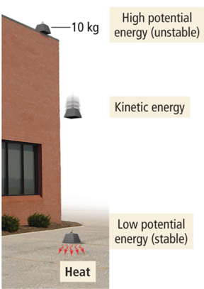
  + Audio 0:08:24.475547
  + Potential becomes kinetic energy which becomes heat

## Potential to Kinetic Energy

* Audio 0:09:14.128456
* 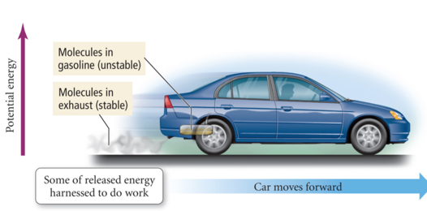
  + Gasoline burns, heat comes out tailpipe, but also propels car forward

## Properties of Matter

* Audio 0:09:54.800676
* physical properties are the characteristics of matter that can be changed without changing its composition
  + characteristics that are directly observable
* chemical properties are the characteristics that determine how the composition of matter changes as a result of contact with other matter or the influence of energy
  + characteristics that describe the behavior of matter

## Convert 172.9 F to degrees Celsius

* Audio 0:14:51.677292
* 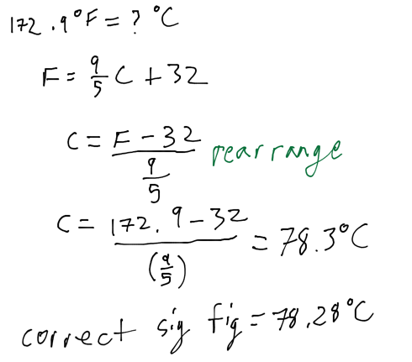

## Dimensional Analysis Method of Solving Problems

* Audio 0:17:11.366509
  1. Determine which unit conversion factor(s) are needed
  2. Carry units through calculation
  3. If all units cancel except for the desired unit(s), then the problem was solved correctly.

### Ex: How many mL are in 1.63 L?

* 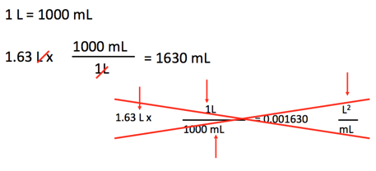

### Ex: The speed of sound in air is about 343 m/s. What is this speed in miles per hour? (1 mile = 1.609 km)

* Audio 0:20:52.486829
* 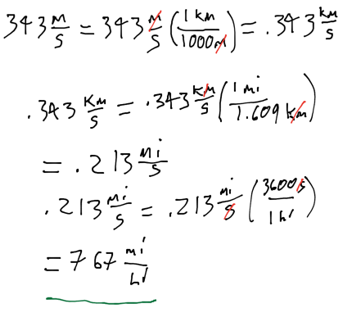

## What is a Mole?

* Audio 0:23:59.232240
* A mole is a scientist’s “baker’s dozen.”
  + When we count large numbers of objects, we often use units such as
    - 1 dozen objects = 12 objects
    - 1 gross objects = 144 objects.
* A mole (mol) of anything contains 6.02214 × 1023 pieces.
  + Examples:
    - 1 mol of marbles corresponds to 6.02214 × 1023 marbles.
    - 1 mol of sand grains corresponds to 6.02214 × 1023 sand grains.
* This number is Avogadro’s number.

## The Mole

* Audio 0:26:54.511808
* The second, and more fundamental, thing to understand about the mole is how it gets its specific value.
* The value of the mole is equal to the number of atoms in exactly 12 grams of pure C-12.
* 12 g C = 1 mol C atoms = 6.022×10^23 C atoms

## Mole Conversions: Atoms to Moles or Moles to Atoms

* Audio 0:28:02.694268
* Converting between number of moles and number of atoms is similar to converting between dozens of eggs and number of eggs.
* For atoms, you use the conversion factor 1 mol atoms = 6.022 × 1023 atoms.
* The conversion factors take the following forms:
  + 

## Converting between Mass and Moles

* Audio 0:28:55.905682
* The molar mass of any element is the conversion factor between the mass (in grams) of that element and the amount (in moles) of that element.
* Example:
  + 12.01 g C atoms = 1 mol C atoms
  + or 12.01 g C atoms/1 mol C atoms
  + or 1 mol C atoms/12.01 g C atoms

## Mass to Moles to Number of Particles: The Conceptual Plan

* Audio 0:30:08.760686
* 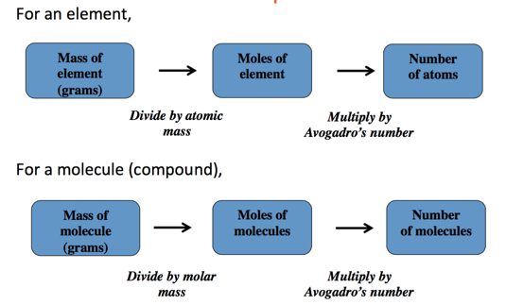

## Converting between Mass and Moles

* Audio 0:31:09.351315
* How many copper atoms are in a copper penny with a mass of 3.10 g? (Assume that the penny is composed of pure copper: Molar Mass of Copper: 63.55 g/mol)

## Ex: Converting mass and moles

* How many copper atoms are in a copper penny with a mass of 3.10 g? Mollar mass of Copper is 63.55g/mol
* Audio 0:33:32.001193
* 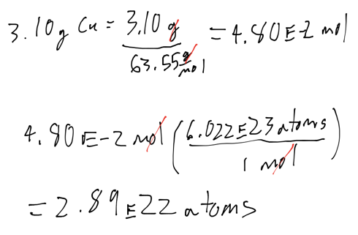

## Li atoms

* How many lithium atoms are in 97.9 grams of Lithium. The molar mass of Lithium is 6.94 g / mol
* Audio 0:35:39.657032
* 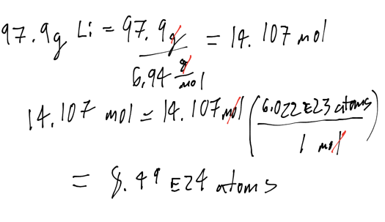

## Converting between Particles and Mass

* Audio 0:39:03.568008
* An aluminum sphere contains 8.55 * 10^22 aluminum atoms. What is the sphere’s radius in cm? Density of aluminum is 2.7 g/cm^3
  + 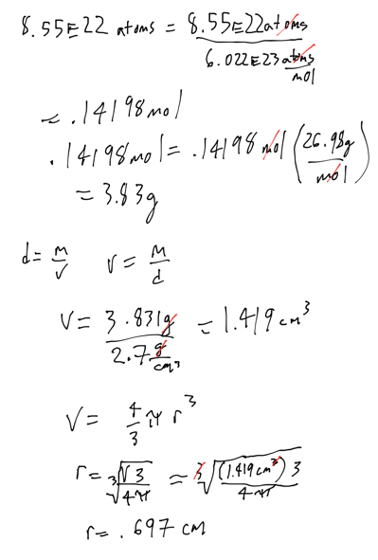

## Vocab

|  |  |
| --- | --- |
| Term | Definition |
| kinetic energy | energy of motion |
| potential energy | energy that is stored in matter |
| law of conservation of energy | says you cannot create or destroy energy |
| physical properties | properties that can be changed without changing matter’s composition |
| chemical properties | properties of matter which determine how the composition of matter changes when it contacts other matter |
| mole (Avogadro’s number) | 6.022 * 10^23 of anything |

## CH101-008 UA Fall 2016

* CH101-008 UA Fall 2016
* [jmbeach1@crimson.ua.edu](mailto:jmbeach1@crimson.ua.edu)
* jmbeach
* hey_beach

Notes and study materials for The University of Alabama's Chemistry 101 course offered Fall 2016.