Week 3 - Day 2

Table of Contents

[CH101-008 UA Fall 2016](/CH101-008/)

[About](/CH101-008/about/)

# Week 3 - Day 2

Aug 31, 2016

[Quizlet on terms from this lecture](https://quizlet.com/_2gas0u)

Download Word (docx):

## Navigate using audio

# Test 1

* In this room next Wednesday at recitation time (6:30 pm - 7:50 pm)
* Covers chapter 1, 2, and however we’ve got in 3
* This evening’s recitation is a survey to get a sense of each student’s background and how it affects their performance
  + Bring a pencil
  + 5 bonus points
  + Audio 0:02:42.008620

## Clicker question

* Audio 0:05:36.915010
* 4.21ft^3 to Liters
* 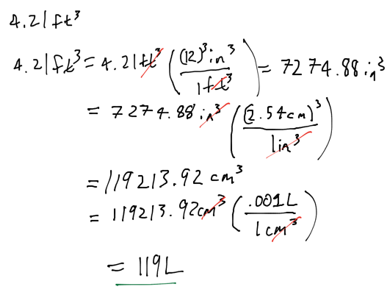

## 2nd Question

* Audio 0:11:49.252666
* How many atoms are in a sample of copper with volume of 0.475 cm^3 and a density of 8.96 g / cm^3?
  + 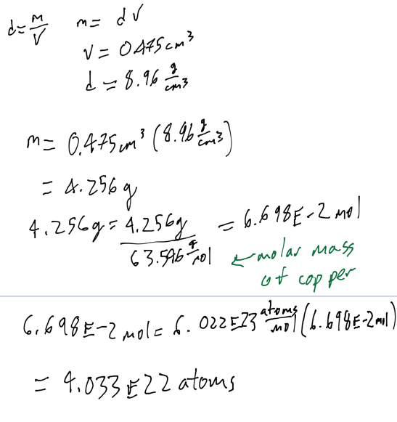

## Chapter 3

* Audio 0:18:47.526137

## Properties of Waves

* Audio 0:19:09.721677
* 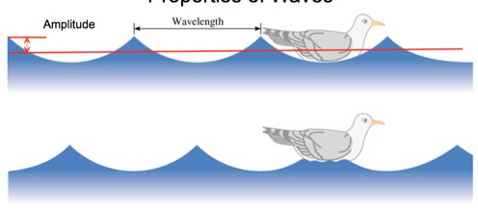
* Wavelength (λ) is the distance between identical points on successive waves.
* Amplitude is the vertical distance from the midline of a wave to the peak or trough.
* Audio 0:20:20.914304
* 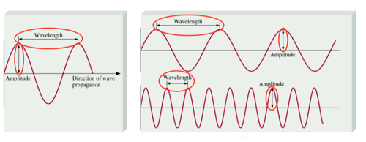
* Frequency (ν) is the number of waves that pass through a particular point in 1 second (Hz = 1 cycle/s).
* Audio 0:21:32.710413
* The speed (v) of the wave = λ x ν

## Light

* Audio 0:23:42.023732
* 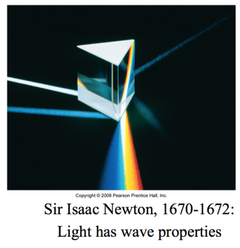

## Amplitude and Wavelength

* Audio 0:24:52.722734
* Wavelength and amplitude are independent properties.
  + The wavelength of light determines its color (intensive physical property).
* The amplitude, or intensity, determines its brightness (extensive physical property)
  + Brightness dependent on amplitude
* 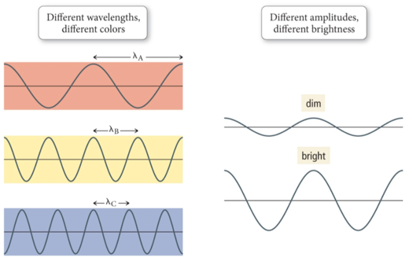

## Color

* Audio 0:26:15.944132
* The color of light is determined by its wavelength or frequency.
* White light is a mixture of all the colors of visible light.
  + A spectrum
  + Red Orange Yellow Green Blue Indigo Violet
* When an object absorbs some of the wavelengths of white light and reflects others, it appears colored; the observed color is predominantly the colors reflected.

## Maxwell

* Audio 0:26:23.185612
* Maxwell (1873), proposed that visible light consists of electromagnetic waves.
* 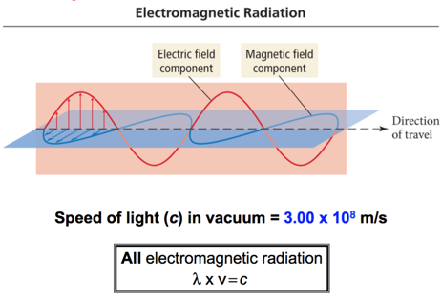

## Electromagnetic Spectrum

* Audio 0:29:13.853883
* 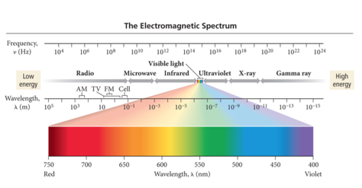

## Example problem

* Audio 0:30:56.499318
* An electromagnetic wave has a frequency of 6.0 x 10^4 Hz. Does this frequency fall in the visible region? Convert this frequency into wavelength (nm).
  + 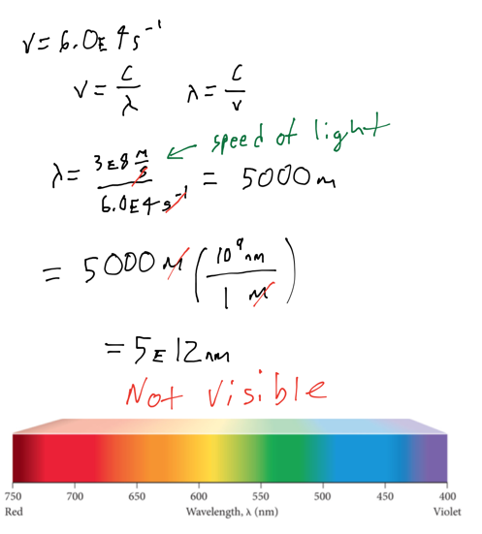

## Clicker Question

* Audio 0:34:13.178546
* What is the wave length of a wave with frequency 8.6 * 10^13 Hz?
* 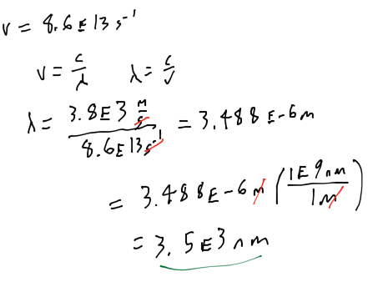

## Einstein and the Photoelectronic Effect

* Audio 0:39:00.844561
* Hertz observed that when (some) light shines on a metal surface, electrons are produced from the surface.
  + The electrons emitted from the metal surface are photoelectrons.
  + This phenomenon is called the photoelectric effect.
  + 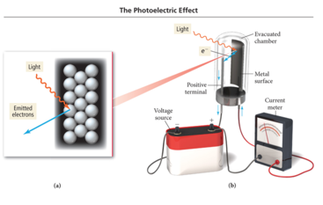
* Audio 0:40:20.734175
  1. Number of electrons depends upon light intensity
  2. More Kinetic energy at higher frequency of light
  3. Emission has a frequency threshold, below which there are no electrons
* 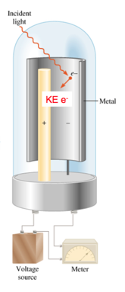

## Explaining the Photoelectric Effect

* Audio 0:42:05.218727
* Classic theory explanation:
  + The photoelectric effect according to classic wave theory attributed the electrons’ being emitted from the metal surface to the light energy being transferred to the electrons.
  + Classic theory states the following:
    - If the wavelength of light is made shorter or the light wave’s intensity is made brighter, more electrons should be ejected.
    - Energy of a wave is directly proportional to its amplitude and its frequency.
      * Example: If a dim light is used there should be a lag time before electrons are emitted in order to give the electrons time to absorb enough energy.

## Explaining the Photoelectric Effect

* Audio 0:42:13.093629
* Einstein’s explanation: Quantum theory
  + Experimental observations indicate the following:
    - A minimum frequency was needed before electrons would be emitted regardless of the intensity called the threshold frequency.
    - High-frequency light from a dim source caused electron emission without any lag time.

## Einstein’s idea: “Light Is Quantized.”

* Audio 0:43:33.274758
* Ejection of electrons from a metal surface by light:
  + One photon at the threshold frequency gives the electron just enough energy for it to escape the atom.
  + Binding energy, φ
  + When irradiated with a shorter wavelength photon, the electron absorbs more energy than is necessary to escape.
  + This excess energy becomes kinetic energy of the ejected electron.
    - 
  + Where (hυ) is a quantized packet of energy

## Explaining the Photoelectric Effect

* Einstein’s explanation: Quantum theory
  + Einstein proposed that the light energy was delivered to the atoms in packets called quanta or photons.
    - Energy = (hυ)
      * hυ = quanta
  + The energy of a photon of light is directly proportional to its frequency.
    - E = hc/λ
    - Or it is inversely proportional to its wavelength.
  + Symbols:
    - Planck’s Constant, (h) is a proportionality constant with a value of h = 6.626 × 10−34 J · s.
    - Speed of light (c) value is 3.00 × 108 m/s

## Black Body Radiation

* Audio 0:46:37.258672
* 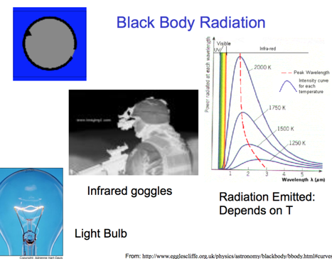
* If you heat something up in the dark, you can see it with infrared radiation
* “Black Body Problem” Solved by Planck in 1900 “… an act of despair … I was ready to sacrifice any of my previous convictions about physics …” Energy (light) is emitted or absorbed in discrete units (quantum).
* 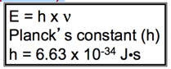

## Vocab

|  |  |
| --- | --- |
| Term | Definition |
| Wavelength | the distance between identical points on successive waves |
| amplitude | the vertical distance from the midline of a wave to the peak or trough |
| frequency | the number of waves that pass through a particular point in 1 second (Hz = 1 cycle/s) |
| photoelectric effect | describes the phenomenon in which light shines on a metal surface and electrons are produced from the surface |
| threshold frequency | minimum frequency needed before electrons are emitted |
| quanta (photons) | the packets of energy that light travels with |
| planck’s constant (h) | 6.626 * 10^-34 J s |
| speed of light (c) | 3 * 10^8 m/s |

Please enable JavaScript to view the [comments powered by Disqus.](https://disqus.com/?ref_noscript)

## CH101-008 UA Fall 2016

* CH101-008 UA Fall 2016
* [jmbeach1@crimson.ua.edu](mailto:jmbeach1@crimson.ua.edu)
* jmbeach
* hey_beach

Notes and study materials for The University of Alabama's Chemistry 101 course offered Fall 2016.