Week 3 - Day 3

Table of Contents

[CH101-008 UA Fall 2016](/CH101-008/)

[About](/CH101-008/about/)

# Week 3 - Day 3

Sep 2, 2016

* [Quizlet](https://quizlet.com/_2gl5z0)

Download Word (docx):

## Navigate using audio

# Announcements

* Audio 0:00:12.758487
* MyLabs Plus
  + Troubles
  + If you are still experiencing error messages, the problem is probably with your browser
    - Try clearing your cache and cookies
  + If your lab TA e-mails you that you can’t come to lab because you can’t use the homework site you will not be able to come
    - But if you follow “procedure” (not sure what procedure) you will be allowed to come (assuming the problem is actually with the Pearson site)

## Test 1

* Next Wednesday in our usual classroom at 6:30 PM
  + All you should bring is a pencil, calculator, and photo-ID
  + Try to get here close to time
    - If you forget your photo ID, it’s fixable, but a nuisance
  + Can’t leave the test before 7:05 PM even if you get through at 6:31 PM
  + Should know all the constants we’ve used and the three formulas we’ve used
  + Audio 0:09:21.043687
    - Anything in chapters 1, 2, or 3
  + Not all of chapter 3 will be on the test

# Chapter 3 - Part 2

## “Black Body Problem” Solved by Planck in 1900

* Audio 0:12:13.134181
* “… an act of despair … I was ready to sacrifice any of my previous convictions about physics …”
* Energy (light) is emitted or absorbed in discrete units (quantum).
  + Audio 0:12:39.255151
  + “One of the 7 or 8 numbers that define our universe”
* “a purely formal assumption … actually I did not think much about it…”

## Mystery 2, “Photoelectric Effect” Solved by Einstein in 1905

* Audio 0:13:59.822330
* “for his services to Theoretical Physics, and especially for his discovery of the law of the photoelectric effect” 1921
  + Light has both:
    1. wave nature
    2. particle nature
* Photon is a “particle” of light
  + Audio 0:15:56.294916
  + Photo electrons are emitted as soon as you turn the light on is explained by the photon description
* Predicted that KE would be linearly dependent upon frequency
* hv = KE + BE
* KE = hv - BE

## Example

* Audio 0:16:45.896720
* When copper is bombarded with high-energy electrons, X rays are emitted. Calculate the energy (in joules) associated with the photons if the wavelength of the X rays is 0.154 nm
  + 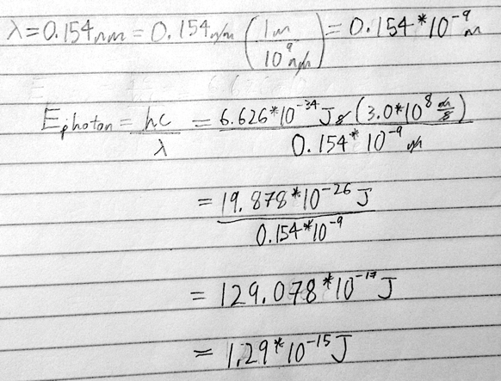

## Clicker Question

* Audio 0:22:58.445126
* A photon has a wavelength of 624 nm. Calculate the energy of the photon in joules
* Are there any extra reviews before the test?
  + Audio 0:27:22.163854
  + Some of Wednesday’s lecture will be review
  + Also, there’s practice on the MyLabsPlus website

## Emission Spectra

* Audio 0:28:51.812590
* 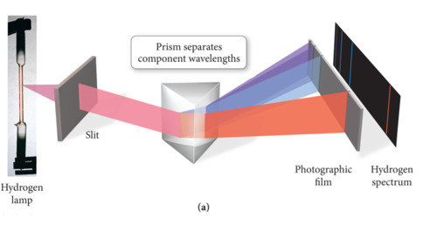
* Light had been thought of as a wave for a long time and now it’s being thought of as particles
  + People were asking why is light emitted and absorbed in fixed quantities?

## Examples of Spectra

* Audio 0:30:24.253251
* 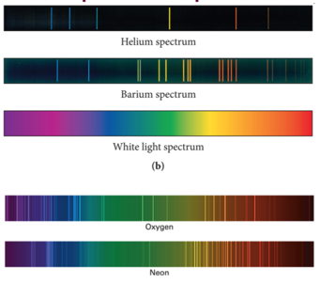
* Each element has its own emission spectrum
* All of this points to atoms emitting and absorbing light / energy in discrete packets

## The Bohr Model of the Atom

* Audio 0:31:23.054768
* The nuclear model of the atom (Rutherford model) does not explain what structural changes occur when the atom gains or loses energy.
  + He hypothesized that only certain orbits are allowed and came up with a model which predicted what was observed
* Bohr developed a model of the atom to explain how the structure of the atom changes when it undergoes energy transitions.
* Bohr’s major idea was that the energy of the atom was quantized, and that the amount of energy in the atom was related to the electron’s position in the atom.
  + Quantized means that the atom could have only very specific amounts of energy.

## Bohr’s Model

* Audio 0:32:22.750198
* The electrons travel in orbits that are at a fixed distance from the nucleus.
  + Found different shapes of orbits
  + Stationary states
  + Therefore, the energy of the electron was proportional to the distance the orbit was from the nucleus.
* Electrons emit radiation when they “jump” from an orbit with higher energy down to an orbit with lower energy.
  + Audio 0:32:58.969212
  + The emitted radiation was a photon of light.
  + The distance between the orbits determined the energy of the photon of light produced.

## Bohr Model of H Atoms

* Audio 0:33:26.216675
* Shows how particles jump orbits
* 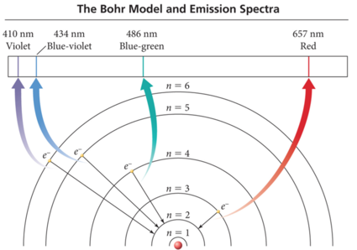

## Bohr’s Model of the Atom (1913)

* Audio 0:33:46.737388
  1. e- can only have specific (quantized) energy values
  2. light is emitted as e- and moves from one energy level to a lower energy level
     + 
* n (principal quantum number) = 1,2,3,…
* RH (Rydberg constant) = 2.18 x 10-18J
  + 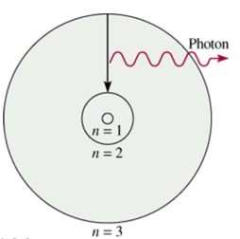

## Weakness’ of Bohr’s Model

* Audio 0:35:34.154227
* Only worked for Hydrogen, Li 2+, and Be 3+
* Only for a nucleus and one electron
* When charges are forced through curved path they emit radiation (Bermsstrahlung) so “orbits around nuclei are unstable”

## Wave Behavior Properties: Interference

* Audio 0:36:55.247976
* Einstein says light has wave and particle properties
* Now we think maybe particles have wave properties
* The interaction between waves (e.g., electromagnetic, ocean) is called interference.
* Interference Types:
  + Constructive interference: waves that interact so that they make a larger wave are said to be in phase
    - 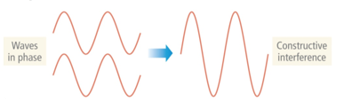
  + Destructive interference: Waves that interact so that they cancel each other out are said to be out of phase
    - 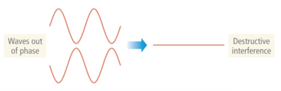

## Two-Slit Interference

* Audio 0:38:15.810042
* 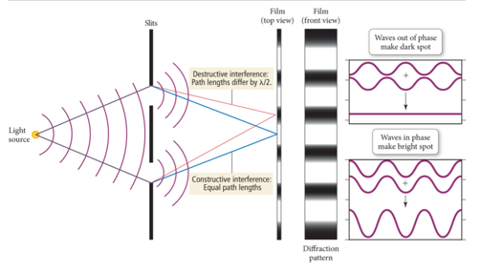
* Diffraction pattern
  + Either it goes through a slit or it doesn’t

## Wave Behavior Properties: Diffraction

* Audio 0:38:41.975443
* When traveling waves encounter an obstacle or opening in a barrier that is about the same size as the wavelength, they bend around it; this is called diffraction.
  + Traveling particles do not diffract
* The diffraction of light through two slits separated by a distance comparable to the wavelength results in an interference pattern of the diffracted waves.
* An interference pattern is a characteristic of all light waves.
* 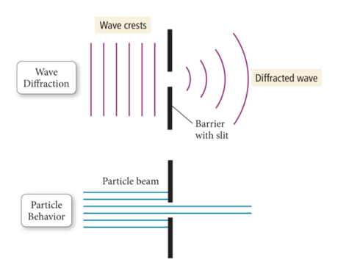

## Wave Behavior of Electrons

* Audio 0:39:38.320960
* De Broglie proposed that particles could have wavelike character.
* De Broglie predicted that the wavelength of a particle was inversely proportional to its momentum.
* Because it is so small, the wave character of electrons is significant.
* De Broglie relation
  + 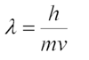

## Example problem

* Audio 0:40:32.639227
* What are the de Broglie wavelengths (in nm) associated with an electron traveling at 6.0 * 10^5 ms-1 and a 52.5 g Ping-Pong ball traveling at 15.6 m/s?
  + 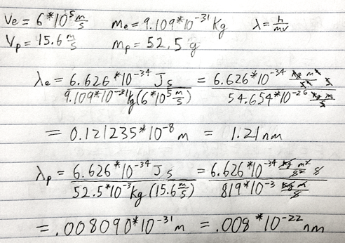

# Vocab

|  |  |
| --- | --- |
| Term | Definition |
| wave particle duality of light | describes that light acts like a wave and a particle in different scenarios |
| photon | particle of light |
| quantized | Property of atoms meaning that the atom could have only very specific amounts of energy |
| constructive interference (in phase) | occurs when waves that interact so that they make a larger wave |
| destructive interference (out of phase) | occurs when waves interact so that they cancel each other out |
| diffraction | occurs when waves bend around an obstacle or opening in a barrier which is about the same size as the wavelength |

Please enable JavaScript to view the [comments powered by Disqus.](https://disqus.com/?ref_noscript)

## CH101-008 UA Fall 2016

* CH101-008 UA Fall 2016
* [jmbeach1@crimson.ua.edu](mailto:jmbeach1@crimson.ua.edu)
* jmbeach
* hey_beach

Notes and study materials for The University of Alabama's Chemistry 101 course offered Fall 2016.