Week 3 - Recitaion

Table of Contents

[CH101-008 UA Fall 2016](/CH101-008/)

[About](/CH101-008/about/)

# Week 3 - Recitaion

Sep 2, 2016

## Density table

* 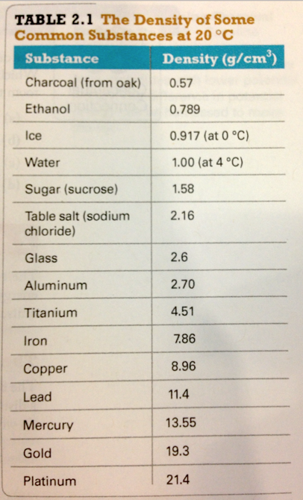

## Questions

* Which of the following has the largest density?
  + A material that has a mass of 10.0 g and a volume of 2.00 L
  + A material that has a mass of 6.13 g and a volume of 5 mL
  + A material that has a mass of 5 g and a volume of 10.0 cm^3
  + A material that sinks in ethanol but floats in water

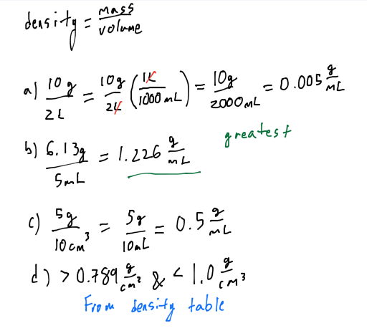

* A room measures 22 feet in width. What is the distance in meters? 1 in = 2.54 cm
  + 72m
  + 4.7m
  + 1.0m
  + 6.7m

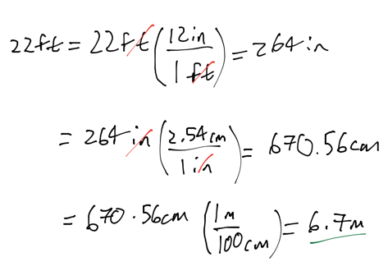

* How many ounces of mercury are in 1.0 m^3 of mercury? Hint: 1 oz = 28.35 g.
  + 6.5 * 10^6 oz
  + 4.8 * 10^5 oz
  + 5.2 * 10^4 oz
  + 6.5 * 10^4 oz
  + 48 oz
* Determine the mass of 2.5 cups of water if the density of water is 1.00 g/cm^3 and 1 cup = 240 mL
  + 2.5 g
  + 6.0 * 10^2
  + 1.0 * 10^-2
  + 2.4 * 10^2
  + 1.0 * 10^2
* A cube of aluminum (density = 2.7 g/mL) has a mass of 17.2 g. What is the edge length of the cube?
  + 6.34 cm
  + 1.85 cm
  + 2.58 cm
  + 3.59 cm
* Which of the following is FALSE?
  + The mole can be used to specify Avogadro’s number of anything
  + Avogadro’s number, 6.022 * 10^23, is an exact number.
  + The mole is equal to the number of atoms in exactly 12 g of carbon-12.
  + The value of an element’s molar mass in grams per mole is numerically equal to the element’s atomic mass in amu.
* Place the following types of electromagnetic radiation in order of decreasing energy
  + radio waves > infrared light > gamma rays
  + gamma rays > infrared light > radio waves
  + radio waves > gamma rays > infrared light
  + gamma rays > radio waves > infrared light
* Calculate the wavelength (in nm) of the blue light emitted by a mercury lamp with a frequency of 6.88 * 10^14 Hz.
  + 229 nm
  + 436 nm
  + 206 nm
  + 485 nm
  + 675 nm
* How many moles of Kr are contained in 398 mg of Kr?
  + 4.75 * 10^-3 moles Kr
  + 33.4 moles Kr
  + 2.11 * 10^-4 moles Kr
  + 2.99 * 10^-3 moles Kr
  + 1.19 * 10^-4 moles Kr
* Calculate the mass (in kg) of 4.87 * 10^25 atoms of Zn
  + 5.29 kg
  + 1.89 kg
  + 8.09 kg
  + 1.24 kg
  + 1.09 kg

Please enable JavaScript to view the [comments powered by Disqus.](https://disqus.com/?ref_noscript)

## CH101-008 UA Fall 2016

* CH101-008 UA Fall 2016
* [jmbeach1@crimson.ua.edu](mailto:jmbeach1@crimson.ua.edu)
* jmbeach
* hey_beach

Notes and study materials for The University of Alabama's Chemistry 101 course offered Fall 2016.