Week 4 - Day 1

Table of Contents

[CH101-008 UA Fall 2016](/CH101-008/)

[About](/CH101-008/about/)

# Week 4 - Day 1

Sep 7, 2016

Download Word (docx):

## Navigate using audio

Last lecture before test 1!

# Announcements

* Test tonight
  + Only like 20 Questions
  + Pencil, eraser, photo-ID
  + Audio 0:00:31.902459
  + No, no, no phones
  + You should know all the prefixes
    - how many ml in a liter
    - Any imperial to metric will be given
    - 12 in to a foot and 3 ft to a yard

## Clicker Question

* Find wavelength of electron with velocity of 1.87*10^7 m/s and mass of 9.11*10^-31 kg
* Audio 0:10:28.871589
* .0388 nm
* 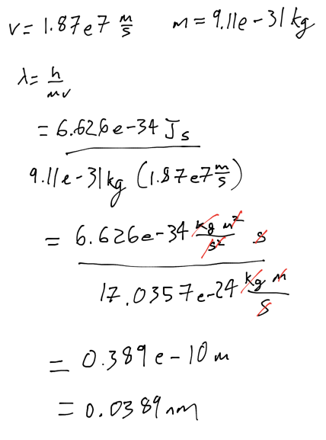

## Wave Nature of Particles

* Audio 0:15:57.282705
* 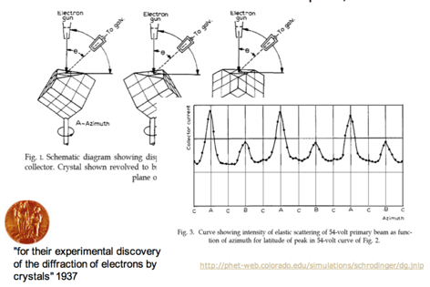

## Electron Diffraction

* Audio 0:19:15.239273
* 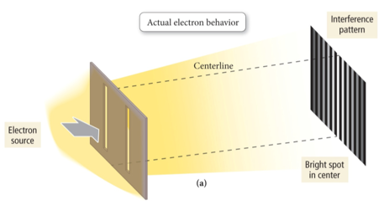
* Transmission Electron Microscope
  + 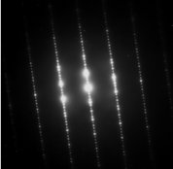
* If electrons behave only like particles, there should be only two bright spots on the target.
  + 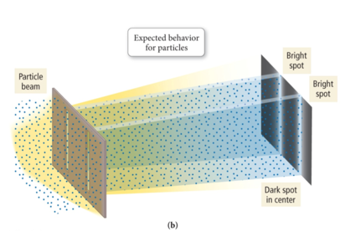

## Trajectory Vs Probability

* Audio 0:21:20.562074
* 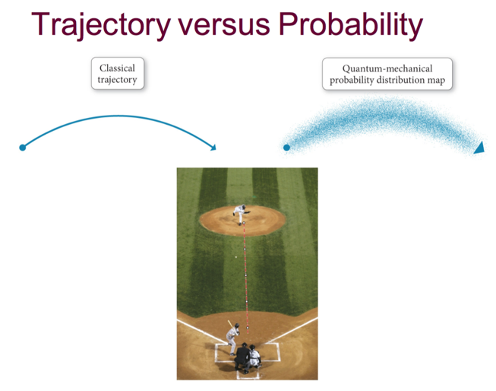
  + If you know the forces acting on an object with classical trajectory, you can tell exactly where it will land
  + With electrons, you can only know with a degree of certainty where it will be

## Uncertainty Principle Demonstration

* 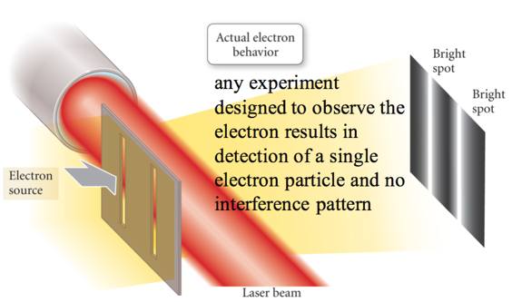

## Heisenberg’s Uncertainty Principle

* Heisenberg stated that the product of the uncertainties in both the position and speed of a particle was inversely proportional to its mass.
  + x = position, Δx = uncertainty in position
  + v= velocity, Δv = uncertainty in velocity
  + m=mass
    - 
* This means that the more accurately you know the position of a small particle, such as an electron, the less you know about its speed, and vice versa.
* Stopped short for practice questions

## Q1

* An element has three stable isotopes with masses of 27.977 amu, 28.976 amu, and 29.973 amu. The heavier two isotopes have an abundance of 4.68 % and 3.09 %. What is the atomic mass of the element?
  + 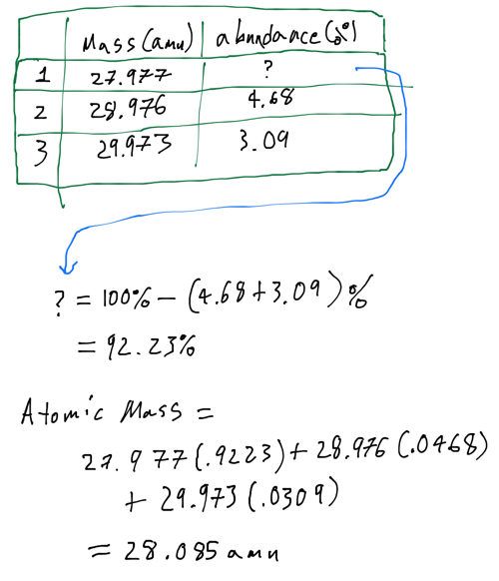

## Q2

* Rank in order of increasing mass
  + proton < neutron < electron
  + proton < electron < neutron
  + electron < neutron < proton
  + electron < proton < neutron

(answer is C)

## Q3

* How many protons, neutrons, and electrons are in isotope ^65_28X
  + 36 neutrons, 29 protons, and 29 electrons

## Q4

When waves of equal amplitude from two sources are in phase when they interact, it is called => constructive interference

## Q5

What is the frequency of an electron with wavelength 486.1 nm? + 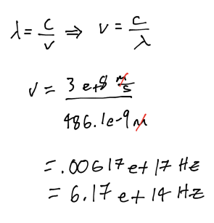

Please enable JavaScript to view the [comments powered by Disqus.](https://disqus.com/?ref_noscript)

## CH101-008 UA Fall 2016

* CH101-008 UA Fall 2016
* [jmbeach1@crimson.ua.edu](mailto:jmbeach1@crimson.ua.edu)
* jmbeach
* hey_beach

Notes and study materials for The University of Alabama's Chemistry 101 course offered Fall 2016.