Week 4 - Day 2

Table of Contents

[CH101-008 UA Fall 2016](/CH101-008/)

[About](/CH101-008/about/)

# Week 4 - Day 2

Sep 9, 2016

Download Word (docx):

## Navigate using audio

* [Quizlet](https://quizlet.com/_2hp5fp)

# Announcements

* average was about a 68% for test 1

# Ch 3 - part 3

## Phet simulation

* [standing waves](https://phet.colorado.edu/sims/html/wave-on-a-string/latest/wave-on-a-string_en.html)
* Audio 0:00:41.936541

## Applying Wave Theory

## Why is e- energy quantized?

* Audio 0:01:44.988052
* De Broglie (1924) reasoned that e- is both particle and wave.
  + Electron is a particle but has wave properties
  + Particles therefore must have both wave and particle properties
    - Audio 0:03:05.742985
    - 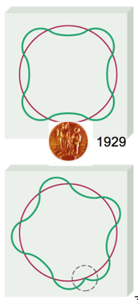
  + 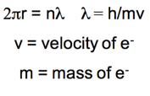

## Schrodinger Wave Equation

* Audio 0:04:54.889022
  + 
    - Don’t have to know this
    - H is an operator
    - Audio 0:06:08.804355
* In 1926 Schrodinger wrote an equation that described both the particle and wave nature of the e
* H is called an “operator”: in this case taking the second derivative with respect to x, y, and z. E is the energy
* Solution is a wave function: Ψ
* Audio 0:06:34.389254
  1. energy of e- is given by Ψ
  2. Ψ2 is the probability of finding e- in a volume of space
* A simple example of a wavefunction is:
  + Ψ=Asin(x)
* energy of e- is given by Ψ
* Audio 0:08:02.302205
* *Ψ^2 is the probability* of finding e- in a volume of space
* Audio 0:09:23.819222
* Schrodinger’s equation can only be solved exactly for simple systems (H atom). Must approximate its solution for multi- electron systems.
  + Our approximations though are good enough to work in practical application
  + Horizon made it to Pluto for example

## Quantum Numbers: The Solutions from the Wave Function, ψ

* Audio 0:12:06.144429
* Calculations show that the size, shape, and orientation in space of an orbital are determined by three integer terms in the wave function.
  + Quantize the energy of the electron
* These integers (solutions) are called *quantum numbers*.
  + There are four quantum numbers:
    - Principal quantum number,n
      * Energy level
  + Angular momentum quantum number, l
    - Orbital type
* Magnetic quantum number, ml
  + Audio 0:14:21.378733
  + Position of orbital in an X-Y-Z plot
* Spin quantum number, ms
  + Orientation of the spin of the electron
* These quantum numbers control how electrons are distributed in an atom

## Principal Quantum Number, n: The Energy Level

* Audio 0:15:13.929935
* It characterizes the energy of the electron in a particular orbital.
  + It is Bohr’s energy level.
* Values of n can be any whole number integer >= 1.
* It *determines the size (overall) and energy of an orbital*.
* The larger the value of n, the more energy the orbital has.
* The larger the value of n, the larger the orbital.
* Audio 0:17:10.934989
* Energies are defined as being “negative.”
  + An electron’s energy is lowered (made more negative) as a result of its interaction with the nucleus of the atom.
    - An electron would have E = 0 when it escapes the atom.
  + As n gets larger, the following occurs:
    - The amount of energy between orbitals gets smaller.
    - The energy of the orbital becomes greater (less negative).
* 
  + Won’t have to memorize this, but will need to know the energy is about 1/n^2
* Rydberg constant for hydrogen (R_h) is 2.10 * 10^-8 J

## Principal Energy Level in

* Audio 0:18:47.513089
* 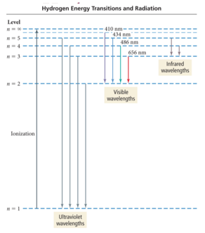

## Angular Momentum Quantum Number, l: The Orbital Quantum Number

* Audio 0:19:37.169700
* The angular momentum quantum number *determines the shape of the orbital*.
  + l can have integer values from 0 to (n – 1).
    - Ex n = 1
      * Only l=0 is allowed
    - n = 2
      * l = 0 or l = 1 are allowed
* Each value of l is designated by a particular letter that designates the shape of the orbital.
  + s orbitals are spherical.
  + p orbitals are like two balloons tied at the knots (dumbbell shape).
  + d orbitals are mainly like four balloons tied at the knots.
  + f orbitals are mainly like eight balloons tied at the knots.

## Magnetic Quantum Number, ml: The Position or Orientation Quantum Number

* Audio 0:22:55.744076
* The magnetic quantum number is an integer that specifies the orientation of the orbital.
  + The direction in space the orbital is aligned relative to the other orbitals
* Values are integers from −l to +l.
  + Including zero
  + Gives the number of orbitals of a particular shape
    - When l=2,the values of ml are−2,−1,0,+1,+2, which means there are five orbitals with l = 2.

## Describing an Orbital

* Audio 0:24:11.173521
* Each set of n, l, and ml describes one orbital.
* Orbitals with the same value of n are in the same principal energy level.
  + Also called the principal shell
* Orbitals with the same values of n and l are said to be in the same sublevel.
  + Also called a subshell

## Illustration of Energy Levels and Sublevels

* Audio 0:25:57.120934
* 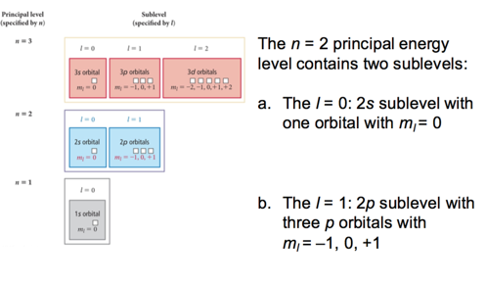

## Energy Levels and Sublevels

* Audio 0:26:50.216152
* In general:
  + The number of sublevels within a level = n
  + the number of orbitals within a level = 2l + 1
  + The number of orbitals in a level = n^2

## Quantum Leaps

* Audio 0:27:59.907574
* 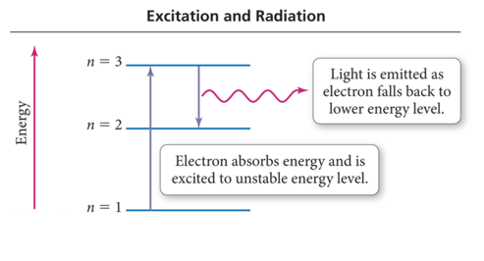
  + When an electron falls from a higher to lower energy level, light is emitted
    - An unstable state is when an electron is sitting in a state greater than 1

## How Does the Quantum Mechanical Model of an Atom Explain Atomic Spectra?

* Audio 0:29:26.973235
* Each wavelength in the spectrum of an atom corresponds to an electron transition between orbitals.
* When an electron is excited, it transitions from an orbital in a lower energy level to an orbital in a higher energy level.
* When an electron relaxes, it transitions from an orbital in a higher energy level to an orbital in a lower energy level.
* When an electron relaxes, a photon of light is released whose energy equals the energy difference between the orbitals.

## It Explains Electron Transitions

* Audio 0:30:54.218927
* To transition to a higher energy state, the electron must gain the correct amount of energy corresponding to the difference in energy between the final and initial states.
* Electrons in high energy states are unstable and tend to lose energy and transition to lower energy states.
* Each line in the emission spectrum corresponds to the difference in energy between two energy states.

## It Predicts the Spectrum of Hydrogen

* Audio 0:31:35.930644 • For an electron in an energy state n, there are (n–1) energy states it can transition to. Therefore, it can generate (n – 1) lines.

## Energy Transitions in Hydrogen

* Audio 0:32:20.175336
* The energy of a photon released is equal to the difference in energy between the two levels the electron is jumping between.
* It can be calculated by subtracting the energy of the initial state from the energy of the final state.
  + 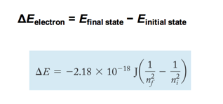
  + Don’t have to memorize this, just remember the 1/n^2 part

## Transitions

* 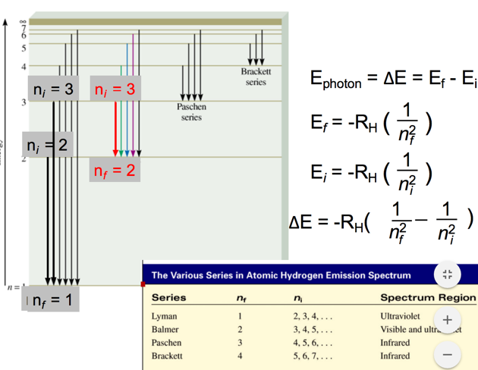
* Audio 0:36:02.535972

## Example problem

* Audio 0:37:09.180400
* Calculate the wavelength (in nm) of a photon emitted by a hydrogen atom when its electron drops from the n = 5 state to the n = 3 state.
  + 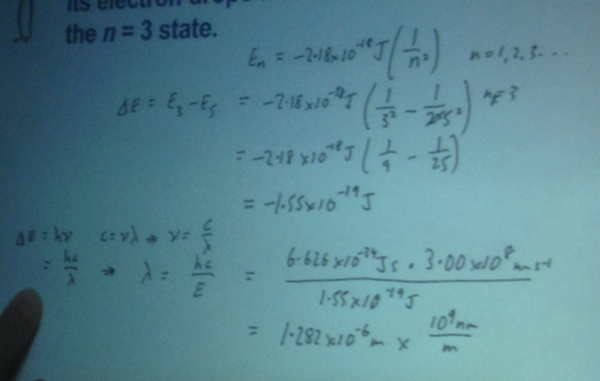
* Calculate the wavelength of the light emitted by a hydrogen atom during a transition of its electron from the n = 4 to the n = 1 principal energy level. Recall that for hydrogen En = -2.18 * 10-18 J*(1/n2)
* Audio 0:44:32.880831 A) 97.3 nm B) 82.6 nm C) 365 nm D) 0.612 nm E) 6.8 * 10-18 nm
* A
* Audio 0:45:56.374508
* It is possible to determine the ionization energy for hydrogen using the Bohr equation. Calculate the ionization energy for an atom of hydrogen, making the assumption that ionization is the transition from n=1 to n=infinity (RH=2.18 x 10-18 J) A) -2.18 × 10-18 J B) +2.18 × 10-18 J C) +4.59 × 10-18 J D) -4.59 × 10-18 J E) +4.36 × 10-18 J
* B

# Vocab

|  |  |
| --- | --- |
| Term | Definition |
| quantum numbers | integer solutions to the wave functions (energy level n, orbital level l, magnetic quantum number m_l, and spin quantum number m_s) |
| (quantum number) n | quantum number which controls the size and energy of an orbital |
| (quantum number) l | quantum number which controls the shape of the orbital |
| s orbital shape | spherical |
| p orbital shape | like two balloons tied at the knots |
| d orbital shape | like four balloons tied together |
| f orbital shape | like eight balloons tied together at the knots |
| m_l (quantum number) | quantum number which controls the position or orientation of orbitals |
| sublevel (subshell) | orbitals with the same values of n and l are said to be in the same _ |
| excited | An electron is said to be this when it transitions from an orbital of lower energy to an orbital of higher energy |
| relaxes | An electron is said to do this when it transitions from an orbital of higher to lower energy |

Please enable JavaScript to view the [comments powered by Disqus.](https://disqus.com/?ref_noscript)

## CH101-008 UA Fall 2016

* CH101-008 UA Fall 2016
* [jmbeach1@crimson.ua.edu](mailto:jmbeach1@crimson.ua.edu)
* jmbeach
* hey_beach

Notes and study materials for The University of Alabama's Chemistry 101 course offered Fall 2016.