Week 5 - Day 1

Table of Contents

[CH101-008 UA Fall 2016](/CH101-008/)

[About](/CH101-008/about/)

# Week 5 - Day 1

Sep 12, 2016

Download Word (docx):

## Navigate using audio

# End of chapter 3 / Beginning of chapter 4

* [Quizlet](https://quizlet.com/_2hp83r)

# Anouncements

* Going over the clicker question from last class

## Schrodinger Wave Equation

* Audio 0:01:46.280749

## What are the allowed values of quantum numbers?

* Audio 0:02:40.811261

## Schrodinger Wave Equation Ψ = fn(n, l, ml, ms)

* Ψ = fn(n, l, ml, ms)
* principal quantum number n
* n = 1, 2, 3, 4, ….
* 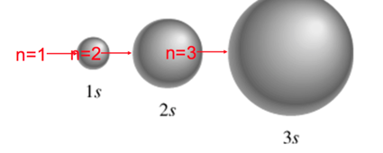
* Audio 0:05:02.318180
* 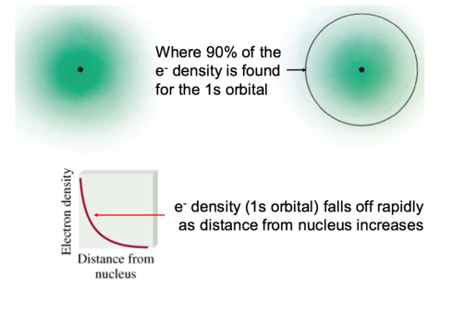
* You are trying to find where the electron *probably*
* The sphere is 90% chance of where you can find the electron

## The l quantum number

* Audio 0:07:39.803509
* controls shape of the space the electron can occupy
* 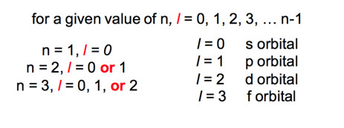

## l = 0 (s orbitals)

* 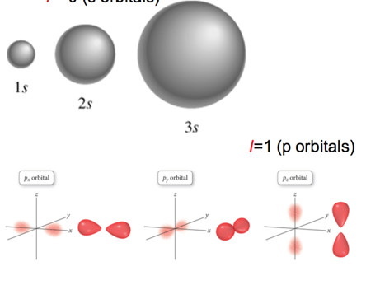

## l = 2 (d orbitals)

* Audio 0:09:58.512569
* 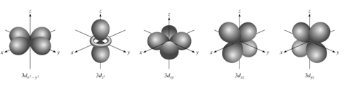
* Audio 0:12:02.335350
* 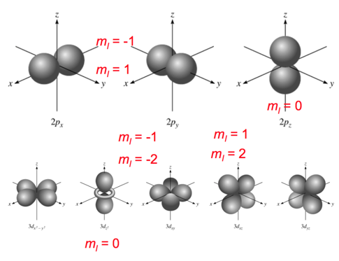
* There are many orientations for different orbital shapes.
  + For l = 1 (dumbell), you have three m_l orientations
  + For l = 2 (four balloons), 5 different orientations

## Schrodinger Wave Equation

* Audio 0:14:45.362121
* 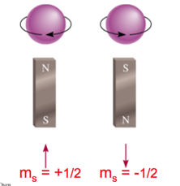
* Ψ= fn(n, l, ml, ms)
* spin quantum number ms
* ms = +1/2 or -1/2
* Stern-Gerlach
* Audio 0:15:13.028156
* 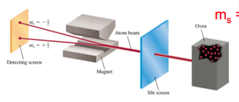
* Audio 0:16:48.075265
* 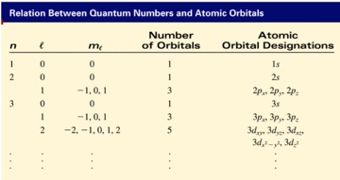

## Clicker question

* Audio 0:18:00.445172
* Electrons in an orbital with l = 2 are in a/an?
  + A) d orbital

## Question 2

* Audio 0:18:38.887100
* How many orbitals are allowed in a sublevel if the angular momentum quantum number for electrons in that sublevel is 3
  + If l = 3 what are possible m_l’s
  + 7

## Question 3

* What is the maximum number of electrons in a atom that can have the following set of quantum numbers?
  + 1
  + Audio 0:22:52.890279

## Probability & Radial Distribution Functions

* Audio 0:23:12.640771
* Ψ2 is the probability density
  + the probability of finding an electron at a particular point in space
  + for s orbital: maximum at the nucleus?
  + decreases as you move away from the nucleus
* the Radial Distribution function represents the total probability at a certain distance from the nucleus
  + maximum at most probable radius
* *nodes* in the functions are where the probability drops to 0
  + 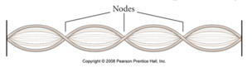

## Two Dimensional Standing wave with radial nodes

* Audio 0:28:08.691820
* 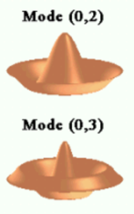

## 2s and 3s

* Audio 0:29:43.309772
* 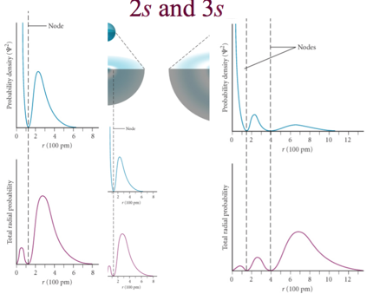
* Difference between probability density and the radial density

# Chapter 4 - Periodic Properties of the Elements

* Audio 0:31:36.612589
* How do we add electrons to orbitals?

## Schrodinger Wave Equation

* Audio 0:32:21.264224
* Ψ= fn(n, l, ml, ms)
* Existence (and energy) of electron in atom is described by its unique wave function Ψ.
* Pauli exclusion principle - no two electrons in an atom can have the same four quantum numbers.
* 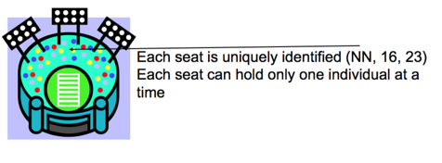
* Audio 0:34:53.838546

## Schrodinger Wave Equation

* Shell – electrons with the same value of n
* Subshell – electrons with the same values of n and l
* Orbital – electrons with the same values of n, l, and ml
* How many electrons can an orbital hold?
  + If n,l,and ml are fixed,then ms =1/2or-1/2 Ψ= (n, l, ml, 1/2)orΨ= (n, l, ml, -1/2)
  + An orbital can hold 2 electrons
* Audio 0:36:43.265603
* How many 2p orbitals are there in an atom?
  + 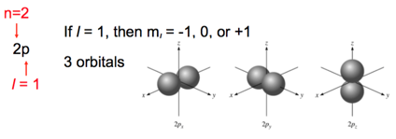

## Clicker 3

* + B

## Energy of orbitals in a single electron atom

* Audio 0:39:54.807493
* Energy only depends on principle quantum number n
* 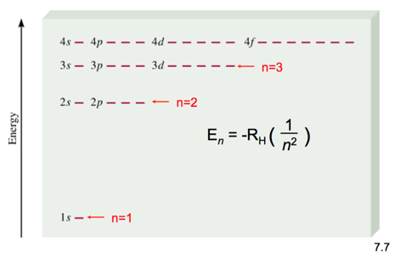
* 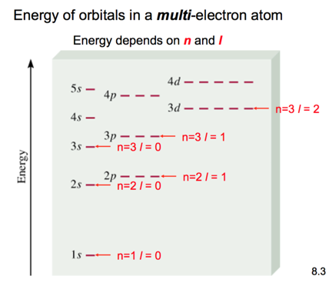

## Coulomb’s Law

* Audio 0:41:07.948707
* 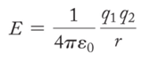
* Coulomb’s law describes the attractions and repulsions between charged particles.
  + For like charges, the potential energy (E) is positive and decreases as the particles get farther apart as r increases.
  + For opposite charges, the potential energy is negative and becomes more negative as the particles get closer together.
  + The strength of the interaction increases as the size of the charges increases.
    - Electrons are more strongly attracted to a nucleus with a 2+ charge than to a nucleus with a 1+ charge.

## Penetration & Shielding

* Audio 0:42:15.187414 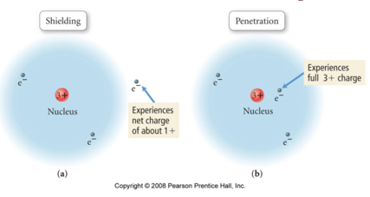
* Audio 0:43:45.128001
* From radial distribution function: 2s orbital penetrates more deeply
  + 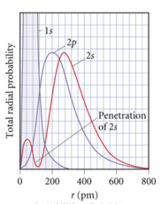 into 1s orbital than does 2p
* the weaker penetration => electrons in the 2p sublevel experience more repulsive force & are more shielded from nucleus (less attractive force)
* =>electrons in 2s sublevel lower E than in 2p
* Penetration causes the energies of sublevels in the same principal level to not be degenerate.
* In the fourth and fifth principal levels, the effects of penetration become so important that the s orbital lies lower in energy than the d orbitals of the previous principal level.
* The energy separations between one set of orbitals and the next become smaller beyond the 4s orbital.
  + The ordering can therefore vary among elements, causing variations in the electron configurations of the transition metals and their ions.
  + 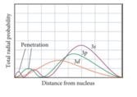

## General Energy Ordering of Orbitals for Multi-electron Atoms

* Audio 0:45:59.121493
* 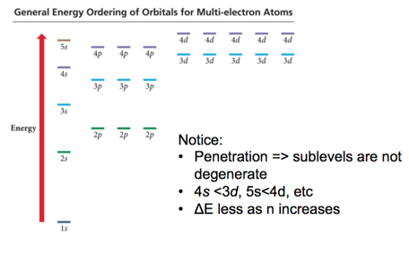

## Electron configurations

* Electron configuration is how the electrons are distributed among the various atomic orbitals in an atom.
* 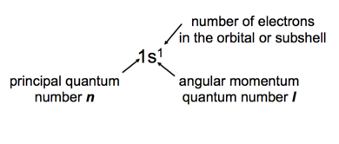

# Vocab

|  |  |
| --- | --- |
| Term | Definition |
| nodes | parts of a probability density function where probability drops to zero |
| unique | electrons’ existence in an atom is _ |
| Pauli exclusion principle | Says no two electrons in an atom can have the same four quantum numbers |
| shell | electrons with the same value of n are in the same _ |
| subshell | electrons with the same values of n and l are in the same _ |
| orbital | electrons with the same values of n, l, and ml are in the same _ |
| Coulomb’s law | says opposite charges attract and same charges repel |
| electron configuration | how electrons are distributed among the various atomic orbitals in an atom |

Please enable JavaScript to view the [comments powered by Disqus.](https://disqus.com/?ref_noscript)

## CH101-008 UA Fall 2016

* CH101-008 UA Fall 2016
* [jmbeach1@crimson.ua.edu](mailto:jmbeach1@crimson.ua.edu)
* jmbeach
* hey_beach

Notes and study materials for The University of Alabama's Chemistry 101 course offered Fall 2016.