Week 5 - Day 2

Table of Contents

[CH101-008 UA Fall 2016](/CH101-008/)

[About](/CH101-008/about/)

# Week 5 - Day 2

Sep 14, 2016

Download Word (docx):

## Navigate using audio

* [Quizlet](https://quizlet.com/_2jbja3)
* What is the maximum number of electrons in a atom that can have the following set of quantum numbers?
  + n = 4, l=3, m_l = 4, m_s = +1/2
  + A
  + It’s an illegal configuration

## Orbital Diagrams

* Audio 0:02:47.403928
* we often represent an orbital as a square and the electrons in that orbital as arrows
  + the direction of the arrow represents the spin of the electron
  + 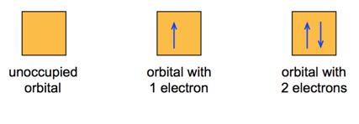

## Electron Configuration for Multi-electron Atoms

* Audio 0:03:39.319084
* Aufbau Principle
  + Energy levels and sublevels fill from lowest energy to highest
  + 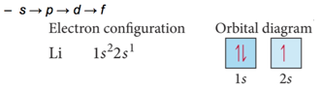
* Orbitals that are in the same sublevel have the same energy
* There can be no more than two electrons per orbital
  + Pauli exclusion principle
  + 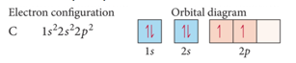

## How you fill up orbitals

* Audio 0:05:03.542404
* 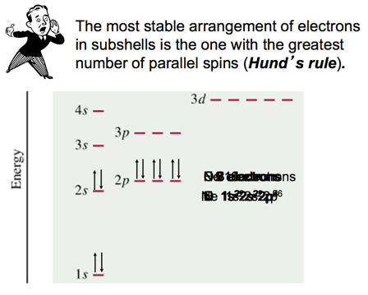

## Summarizing the Filling of Electrons in

* Audio 0:10:29.597607
* Atomic Orbitals
* Electrons occupy orbitals so as to minimize the energy of the atom; therefore, lower energy orbitals fill before higher energy orbitals.
  + Orbitals fill in the following order:
    - 1s2s2p3s3p4s3d4p5s4d5p6s.
* Orbitals can hold no more than two electrons each. When two electrons occupy the same orbital, their spins are opposite.
  + This is another way of expressing the Pauli exclusion principle (no two electrons in one atom can have the same four quantum numbers).

## Order of Subshell Filling in Ground State Electron Configurations

* Audio 0:12:05.347386
* start by drawing a diagram putting each energy shell on a row and listing the subshells, (s, p, d, f), for that shell in order of energy, (left-to-right)
* next, draw arrows through the diagonals, looping back to the next diagonal each time
* 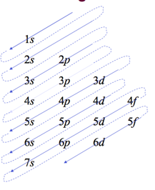

## Order of orbitals (filling) in multi-electron atom

* Audio 0:13:08.640348
* 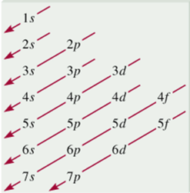
* 1s < 2s < 2p < 3s < 3p < 4s < 3d < 4p < 5s < 4d < 5p < 6s
  + Smallest n+l. For equal n+l, largest l

## Electron configuration Short Cut

* Audio 0:14:32.615145
* Ge: 1s2 2s2 2p6 3s2 3p6 4s2 3d10 4p2
* easier: [Ar] 4s2 3d10 4p2
* i.e. write [last noble gas] remainder of orbitals,

## Example – Write the Ground State Electron Configuration and Orbital Diagram and of Magnesium.

* Audio 0:16:50.900804
* How many electrons in Magnesium?
  + 12
* so need boxes for n=1, n=2 and n=3
* 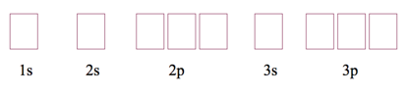

## Clicker 2

* Audio 0:22:03.927929
* Give the ground state electron configuration for Sr (Z=38)
  + Audio 0:22:55.093958
  + Look at periodic table. Rightmost element before Sr.
    - Find Kr
    - It is the second element past Kr, so it is Kr 5s2

## Finding Patterns: The Periodic Law and the Periodic Table

* Audio 0:26:15.808183
* In 1869, Mendeleev noticed that certain groups of elements had similar properties.
* He found that when elements were listed in order of increasing mass, these similar properties recurred in a periodic pattern.
* To be periodic means to exhibit a repeating pattern.

## The Periodic Law

* Audio 0:26:52.707876
* Mendeleev summarized these observations in the *periodic law*:
  + When the elements are arranged in order of increasing mass, certain sets of properties recur periodically.
* Note: Mendeleev ignored some of data, e.g. atomic mass of Te > atomic mass of l

## Mendeleev’s Periodic Table

* Audio 0:28:14.871013
* Mendeleev’s periodic table
  + organized known elements of the time in a table format.
    - He arranged the rows so that elements with similar properties would fall in the same vertical columns.
  + contained some gaps, which allowed him to predict the existence (and even the properties) of yet undiscovered elements.
    - Mendeleev predicted the existence of an element he called eka-silicon.
  + 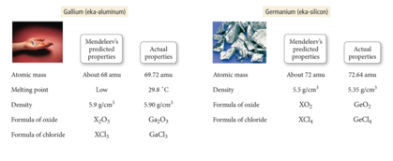

## The Modern Periodic Table: Its Format

* Audio 0:29:46.955888
* The elements are listed in order of increasing atomic number rather than increasing relative mass as they were in Mendeleev’s periodic table.
  + 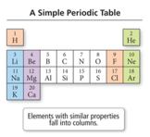
* Rows of the table are referred to as periods (or just plain rows).
* Columns in the table are referred to as groups or a family.
  + Elements in a group or family have similar properties.
  + NOTE: Mendeleev’s periodic law predicts pattern but does NOT explain why the patterns or similarity in properties occurs.
    - Quantum theory explains the why

## Modern Periodic Table

* Audio 0:31:45.843466
* 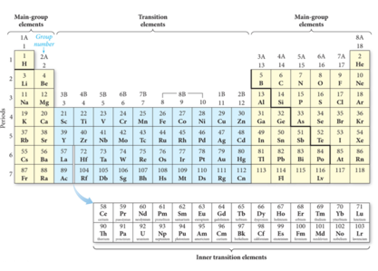

## Core Electrons, Valence Electrons, and the Periodic Table

* Audio 0:32:14.303407
* The group number corresponds to the number of electrons in last (unfilled valence shell)
  + valence electrons
* The length of each “block” is the maximum number of electrons the sublevel can hold.
* The period number corresponds to the principal energy level of the valence electrons.
  + 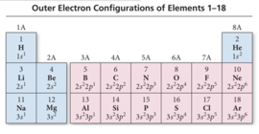

## Orbital blocks and their position in the periodic table

* 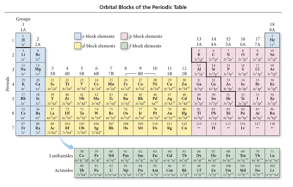

## Transition and Inner Transition Metals

* Audio 0:34:11.820224
* Transition metals (d block) and inner transition metals (f block) exhibit trends differing from those of main-group elements (s block and p block).
  + Because of sublevel splitting, the 4s sublevel is lower in energy than the 3d sublevel; therefore, the 4s orbital fills before the 3d orbital.
  + The difference in energy is not large.
* Some of the transition metals have irregular electron configurations in which the ns only partially fills before the (n − 1)d or doesn’t fill at all.
  + Therefore, their electron configuration must be found experimentally.

## Examples of Transition and Inner Transition Metals’ Electron Configurations

* Audio 0:36:43.269485
* 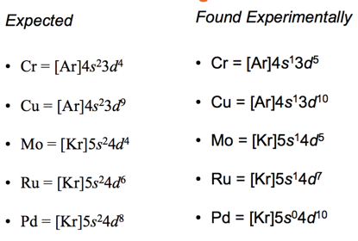
* Remember chromium and copper

## Clicker 3

* Give the ground state electron configuration for Br-
  + [Ar]4s2 3d10 4p6
  + has one more electron than normal because the sign is negative so 4p6

## Electron Configuration and Elemental Properties

* Audio 0:42:21.308974
* The properties of the elements follow a periodic pattern.
  + Elements in the same column have similar properties.
  + The elements in a period show a pattern that repeats.
* The quantum-mechanical model explains this because the number of valence electrons and the types of orbitals they occupy are also periodic.
  + 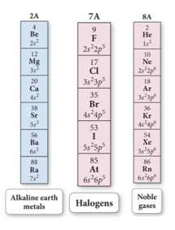

## Electron Configuration and Elemental Properties: The Metals

* Audio 0:44:26.334942

# Vocab

|  |  |
| --- | --- |
| Term | Definition |
| Aufbau principle | says energy levels and sublevels fill from lowest energy to highest |
| Hund’s rule | says every orbital in a subshell is singly occupied with one electron before any one orbital is doubly occupied, and all electrons in singly occupied orbitals have the same spin |
| periodic law | says that when the elements are arranged in order of increasing mass, certain sets of properties recur periodically |
| periods | rows of the periodic table |
| groups (family) | Columns in the periodic table |
| transition metals | d block of the periodic table |
| inner transition metals | f block of the periodic table |

Please enable JavaScript to view the [comments powered by Disqus.](https://disqus.com/?ref_noscript)

## CH101-008 UA Fall 2016

* CH101-008 UA Fall 2016
* [jmbeach1@crimson.ua.edu](mailto:jmbeach1@crimson.ua.edu)
* jmbeach
* hey_beach

Notes and study materials for The University of Alabama's Chemistry 101 course offered Fall 2016.