Week 5 - Day 3

Table of Contents

[CH101-008 UA Fall 2016](/CH101-008/)

[About](/CH101-008/about/)

# Week 5 - Day 3

Sep 16, 2016

Download Word (docx):

## Navigate using audio

* [Quizlet](https://quizlet.com/_2jbmf7)

# Announcements

* Audio 0:00:39.475037
* Scores got changed up, but now they’re changed back to what they were originally
* Ch 4 homework due next week

## Electron Configuration and Elemental Properties: The Metals

* Audio 0:03:02.434400
* Metallic elements make up the majority of the elements in the periodic table.
  + Alkali Metals:
    - They have one more electron than the previous noble gas and occupy the first column.
    - In their reactions, the alkali metals lose one electron, and the resulting electron configuration is the same as that of a noble gas.
      * Forming a cation with a 1+ charge
  + Alkaline Earth Metals:
    - They have two more electrons than the previous noble gas and occupy the second column.
* In their reactions, the alkaline earth metals lose two electrons, and the resulting electron configuration is the same as that of a noble gas.
  + Forming a cation with a 2+ charge

## Clicker 1

* Audio 0:06:10.831608
* Give the number of core electrons for Cd
  + Cd atomic # is 48, but based on it’s position on the periodic table, the d, valence electrons are not core, so the answer is 46

## Metallic Behavior and Electron Configuration

* Audio 0:08:00.666264
* 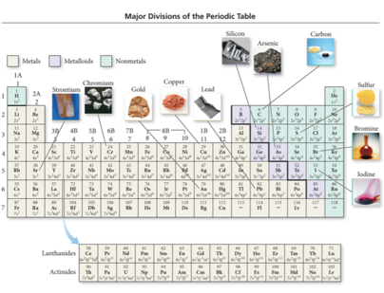

## Gaining or Losing Electrons

* Audio 0:09:07.638465
* Electrons want to be in the lowest lying orbital that has a vacancy
* If that is on another atom: electron transfers and get an ion
* Orbitals shrink across periodic table as nuclear charge increases across periodic table
* For metals: energy of orbitals is (generally) higher than surrounding matter: lose electrons and make cations
* For non-metals: energy of orbital is (generally) lower than surrounding matter: gain electrons and make anions

## Orbital Blocks and Their Position in the Periodic Table

* Audio 0:13:44.899521
* 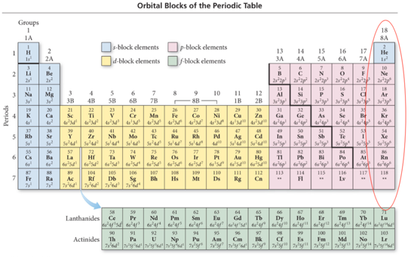

## Electron Configuration and Elemental Properties: Noble Gases

* Audio 0:14:56.898668
* 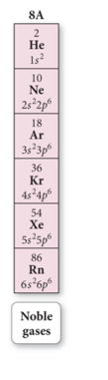
* The noble gases have eight valence electrons.
  + Except for He, which has only two electrons
* They are especially nonreactive.
  + He and Ne are practically inert.
* The reason the noble gases are so nonreactive is that the electron configuration of the noble gases is especially stable.

## Electron Configuration and Ion Formation

* Audio 0:15:50.407566
* Ion formation can be predicted by an element’s location in the periodic table.
* These atoms form ions that will result in an electron configuration that is the same as that of the nearest noble gas.
* Metals form cations (positively charged atoms).
  + Alkali metals (group 1A) form only +1 cations.
  + Alkaline earth metals (group 2A) form only +2 cations.
  + Transition, inner transition, and p-block metals form a variety of charged cations.
* Nonmetals form anions (negatively charged atoms).
* Halogens (group 7A) usually gain one electron to form –1 anions.
  + Other nonmetals can form a variety of charged anions.

## Electron Configuration and Ion Formation: Elements that Form Ions with Predictable Charges

* 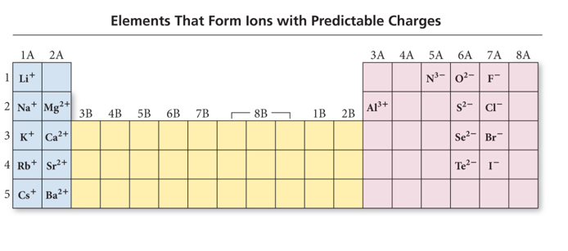

## Effective Nuclear Charge and the Screening Effect

* Audio 0:17:40.420403
* 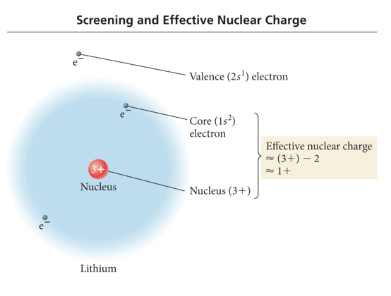
  + Nuclear charge minus core electrons

## Effective Nuclear Charge

* Audio 0:18:34.927551
* The effective nuclear charge is a net positive charge that is attracting a particular electron.
* Core electrons efficiently shield electrons in the outermost principal energy level from nuclear charge.
* Outermost electrons in the valence shell do not efficiently shield one another from nuclear charge.
* Z is the nuclear charge, and S is the number of electrons in lower energy levels.
  + Electrons in the same energy level contribute to screening, but since their contribution is so small, they are not part of the calculation.
* 

## Periodic Trends: Atomic Radii and Effective Nuclear Charge

* Audio 0:20:20.485159
* There are several methods for measuring the radius of an atom,and they give slightly different numbers.
* Van der Waals radius = nonbonding
* Covalent radius = bonding radius
* Atomic radius is an average radius of an atom based on measuring large numbers of compounds.
* 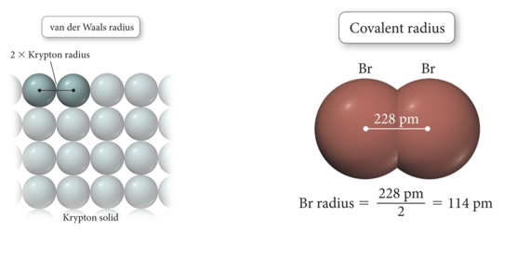

## Periodic Trends: Atomic Radii and Effective Nuclear Charge

* Audio 0:21:45.986365
* Atomic radius decreases across a period (left to right). – Adding electrons to the same valence shell
  + Effective nuclear charge increases.
  + Valence shell held closer
* Atomic radius increases down a group.
  + Valence shell farther from nucleus
  + Effective nuclear charge fairly constant (expansion mostly due to increasing n)
  + 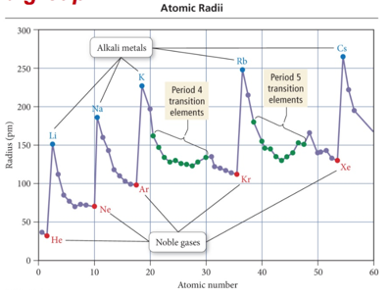

## Summarizing Atomic Radii Trend for Main- Group Elements

* Audio 0:25:24.843667
* The size of an atom is related to the distance the valence electrons are from the nucleus.
  + The larger the orbital an electron is in, the farther its most probable distance will be from the nucleus, and the less attraction it will have for the nucleus.
  + Traversing down a group adds a principal energy level, and the larger the principal energy level an orbital is in, the larger its volume.
  + Quantum-mechanics predicts that the atoms should get larger down a column.

## Summarizing Atomic Radii Trend for Main- Group Elements

* Audio 0:26:14.499563
* The larger the effective nuclear charge an electron experiences, the stronger the attraction it will have for the nucleus.
  + The closer their average distance will be to the nucleus, the stronger the attraction the valence electrons have for the nucleus.
  + Traversing across a period increases the effective nuclear charge on the valence electrons.
  + Quantum-mechanics predicts that the atoms should get smaller across a period.

## Summarizing Atomic Radii Trend for Transition Elements

* Audio 0:26:56.496332
* Atoms in the same group increase in size down the column.
* Atomic radii of transition metals are roughly the same size across the d block.
  + Much less difference than across main group elements
  + Valence shell ns2, not the (n − 1)d electrons
  + Effective nuclear charge on the ns2 electrons approximately the same

## Ions: Magnetic Properties

* Audio 0:27:41.873967
* Electron configurations that result in unpaired electrons mean that the atom or ion will have a net magnetic field; this is called paramagnetism.
  + Will be attracted to a magnetic field
* 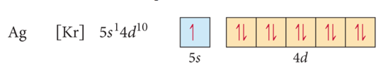
* Electron configurations that result in all paired electrons mean that the atom or ion will have no magnetic field; this is called diamagnetism.
  + Slightly repelled by a magnetic field
* 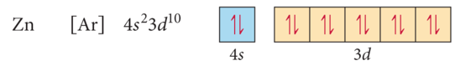

## Radii of Atoms and Their Ions: Cations

* Audio 0:30:05.119746
* Cation radius is smaller than its corresponding atom radius.
  + Loose electrons experiencing small effective nuclear charge; remaining electrons those experiencing a larger effective nuclear charge
* Traversing down a group increases the (n − 1) level, causing the cations to get larger.
* Traversing to the right across a period increases the effective nuclear charge for *isoelectronic* cations, causing the cations to get smaller.
* 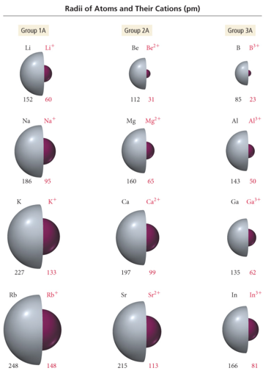
* Audio 0:32:15.588321
* isoelectronic = same number of electrons

## Radii of Atoms and Their Ions: Anions

* Audio 0:32:32.478937
* When atoms form anions, electrons are added to the valence shell.
* Addition of electrons increases repulsion in valence shell without compensating increase in effective nuclear charge
* The result is that the anion is larger than the atom. Traversing down a group increases the n level, causing the anions to get larger.
* Traversing to the left across a period decreases the effective nuclear charge for isoelectronic anions, causing the anions to get *larger*.
* 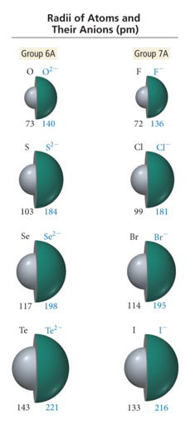
* oposite of what happens with cations

## Clicker 2

* Place the following in order of increasing radius
  + Br-, Na+, Rb+
  + Na+, Rb+, Br-

## Periodic Trend: Ionization Energy (Potential)

* Audio 0:37:37.889283
* Ionization Energy (IE):
* It is the minimum energy needed to remove an electron from an atom or ion in the gas phase.
* It is an endothermic process (requires the input of energy to remove the electron)
  + Valence electron easiest to remove, lowest IE
* First ionization energy = energy to remove electron from neutral atom – All atoms have first ionization energy. M(g) + IE1 èM1+(g) + 1 e–
* Second IE = energy to remove from 1+ ion, etc. M+1(g)
* IE2 è M2+(g) + 1 e–
* Audio 0:39:07.357544
* 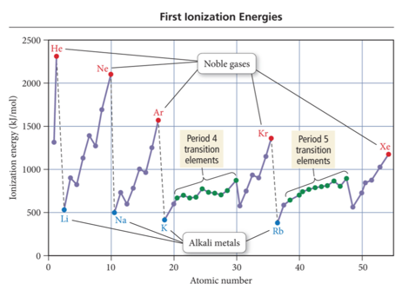
  + increases as you go across the periodic table
  + Charge shrinks the nucleus, takes more energy to remove the charge

## Periodic Trend: Ionization Energy (Potential)

* Audio 0:40:38.726742 Ionization Energy (IE):
* The larger the effective nuclear charge on the electron to be removed, the more energy it takes to remove it.
* The farther the most probable distance the electron is from the nucleus, the less energy it takes to remove it.
* Trend:
  + First IE decreases down the group.
* Valence electron is farther from nucleus.
  + First IE generally increases across the period. + Effective nuclear charge increases.

## Periodic Trend: Ionization Energy (Potential)

* Audio 0:40:54.665440
* 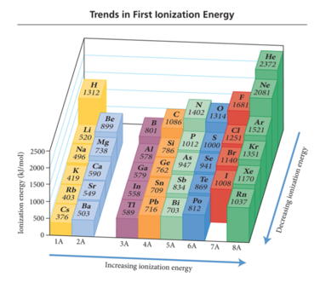
* Audio 0:42:14.239301
* 
  + Nitrogen has three unpaired electrons, the next electron has to go down an orbital which will make it a little easier to remove the last electron in oxygen to get to nitrogen.

## First Ionization Energy: Exceptions to the Trend

* Audio 0:43:42.531942
* GENERAL trend for first ionization energy of main-group elements is that as you go across a period, ionization energy increases.
  + Exceptions: 2A to 3A and 5A to 6A
* Exceptions are usually a result of
  + the type of orbital (s, p, d, or f) and its shielding ability;
  + repulsion factors associated with electrons occupying degenerate orbitals (i.e., p orbitals).
* B has smaller first ionization energy than Be due to electron position: 2p for B and 2s for Be. The electron in 2p orbitals has more shielding (i.e., lower effective nuclear charge) and therefore requires less energy for its removal than an electron in a 2s orbital.
* 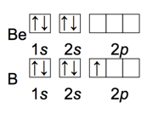

## Trends of Second and Successive Ionization Energies

* Audio 0:44:46.840846
* They depend on the number of valence electrons an element has. – ionization energies increase dramatically in going from valence to core electrons
* Removal of each successive electron costs more energy. – Shrinkage in size due to having more protons than electrons – Outer electrons closer to the nucleus; therefore harder to remove
* There’s a regular increase in energy for each successive valence electron.
* 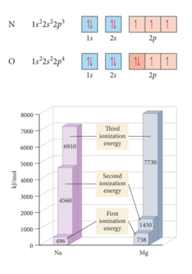
* 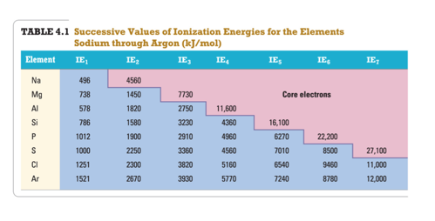

## Clicker 3

What period 3 element has the following ionization energies (all in kJ/mol)? IE1 = 1012 IE2 = 1900 IE3= 2910 IE4= 4960 IE5= 6270 A) Si B) S C) P D) Cl E) Mg IE6 = 22,200

# Vocab

|  |  |
| --- | --- |
| Term | Definition |
| alkali metals | elements which have one more electron than the previous noble gas and occupy the first |
| alkaline Earth Metals | elements which have two more electrons than the previous noble gas and occupy the second column |
| metalloids | an element whose properties are between those of metals and solid nonmetals |
| effective nuclear charge | a net positive charge that is attracting a particular electron |
| decreases | Atomic radius _ across a period (left to right) |
| paramagnetism | something which is _ will be attracted to a magnetic field |
| diamagnetism | something which is _ will be slightly repelled by a magnetic field |
| isoelectronic | same number of electrons |
| larger | traversing down the periodic table, atoms get larger or smaller? |
| ionization energy | the minimum energy needed to remove an electron from an atom or ion in the gas phase |
| smaller | IE _ down the group |
| larger | IE _ across the period to the right |

Please enable JavaScript to view the [comments powered by Disqus.](https://disqus.com/?ref_noscript)

## CH101-008 UA Fall 2016

* CH101-008 UA Fall 2016
* [jmbeach1@crimson.ua.edu](mailto:jmbeach1@crimson.ua.edu)
* jmbeach
* hey_beach

Notes and study materials for The University of Alabama's Chemistry 101 course offered Fall 2016.