Week 5 - Recitation (1st for test 2)

Table of Contents

[CH101-008 UA Fall 2016](/CH101-008/)

[About](/CH101-008/about/)

# Week 5 - Recitation (1st for test 2)

Sep 21, 2016

* Determine the energy change associated with the transition from n = 2 to n = 5 in the hydrogen atom.
  + -2.18 * 10^-19 J
  + +6.54*10^-19 J
  + +4.58 * 10^-19 J
  + -1.53 * 10^-19 J
  + +3.76 * 10^-19 J

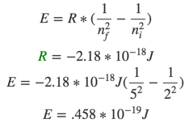

* It is possible to determine the ionization energy for hydrogen using the Bohr equation. Calculate the ionization energy (in kJ) for a mole of hydrogen atoms, making the assumption that ionization is the transition from n - 1 to n = infinity.
  + 7.62 * 10^3 kJ
  + 2.76 * 10^3 kJ
  + 1.31 * 10^3 kJ
  + 3.62 * 10^3 kJ
  + 5.33 * 10^3 kJ

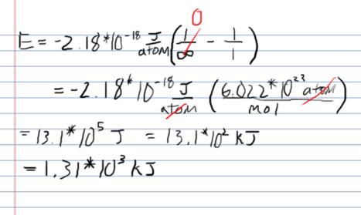

* Determine the end (final) value of n in a hydrogen atom transition, if the electron starts in n = 1 and the atom absorbs a photon of light with an energy of 2.044 * 10^-18 J
  + 3
  + 4
  + 2
  + 5
  + 6
* How many different values of l are possible in the third principal level?
  + 1
  + 2
  + 3
  + 0
  + 4
* Give the ground state electron configuration for Pb
  + [Xe]6s2 6p2
  + [Xe]6s2 5d10 6p2
  + [Xe]6s2 5f14 6d10 6p2
  + [Xe]6s2 4f14 5d10 6p2
  + [Xe]6s2 4f14 5d10 6s2 6p2
* Choose the valence orbital diagram that represents the ground state of Zn
  + 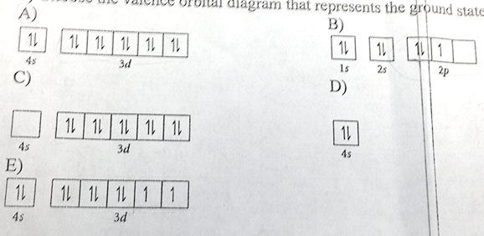
  + A
  + B
  + C
  + D
  + E
* Give the possible values for ml for a p orbital
  + 0, 1
  + -1, 0, 1
  + 1, 2
  + -2, -1, 0, 1, 2
* Describe the shape of a p orbital
  + spherical
  + dumbbell shaped
  + three lobes
  + four lobes
  + eight lobes
* No two electrons can have the same four quantum numbers is known as the
  + Pauli exclusion principle
  + Hund’s rule
  + Aufbau principle
  + Heisenberg uncertainty principle
* Choose the orbital diagram that represents the ground state of N
  + 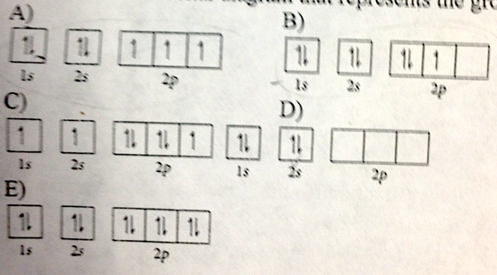
  + A
  + B
  + C
  + D
  + E
* Predict the charge that a calcium ion would have
  + 6-
  + 2-
  + 3+
  + 2+
  + 1+
* Which of the following statements is true?
  + An orbital that penetrates into the region occupied by core electrons is less shielded from nuclear charge than an orbital that does not penetrate and therefore has a lower energy
  + An orbital that penetrates into the region occupied by core electrons is more shielded from nuclear charge than an orbital that does not penetrate and therefore has a lower energy
  + It is possible for two electrons in the same atom to have identical values for all four quantum numbers
  + Two electrons in the same orbital can have the same spin
  + None of the above are true

Please enable JavaScript to view the [comments powered by Disqus.](https://disqus.com/?ref_noscript)

## CH101-008 UA Fall 2016

* CH101-008 UA Fall 2016
* [jmbeach1@crimson.ua.edu](mailto:jmbeach1@crimson.ua.edu)
* jmbeach
* hey_beach

Notes and study materials for The University of Alabama's Chemistry 101 course offered Fall 2016.