Week 6 - Day 2

Table of Contents

[CH101-008 UA Fall 2016](/CH101-008/)

[About](/CH101-008/about/)

# Week 6 - Day 2

Sep 21, 2016

Download Word (docx):

## Navigate using audio

* [Quizlet](https://quizlet.com/_2jbzxn)

# Announcements

* Audio 0:00:20.125734
* Homework issue
  + Electron configurations
    - There are differences sometimes in the order of writing them.
    - You get five or six freebies
      * If you’ve checked the electron configuration and it says you’re wrong, it may be the way the website works.
* Audio 0:02:01.735946
* Real world is complicated
  + He isn’t going to tell us anything that is *wrong* but everything we’re learning is a really watered-down, simplified version of the truth

## Energetics of Ionic Bond Formation: Using NaCl as an Example

* Audio 0:05:03.029702
  + Where we left off The ionization energy of the metal is endothermic.
  + 
* The electron affinity of the nonmetal is exothermic.
  + 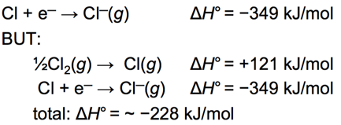
* Generally, the ionization energy of the metal is larger than the electron affinity of the nonmetal; therefore, the formation of the ionic compound should be endothermic.
* But the heat of formation of most ionic compounds is exothermic and generally large.
  + 

## Crystal Lattice and Lattice Energy of NaCl

* Audio 0:05:58.951668
  + Part of the energy formula in the previous slide does not add up because it does not account for the lattice shape of the compound
* Lattice energy
  + The extra stability that accompanies the formation of the crystal lattice is measured as the *lattice energy*.
    - Audio 0:07:54.475155
    - 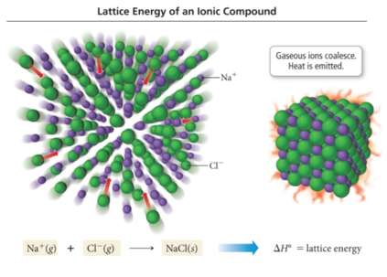
  + It is the energy released when the solid crystal forms from separate ions in the gas state.
    - Always exothermic
  + Lattice energy is measured directly but is calculated from knowledge of other processes.
  + It depends directly on the size of charges and inversely on distance between ions.
  + (Coulomb’s law)
  + Audio 0:09:53.359903
  + The most stable lattice is a very difficult calculation

## Ionic Bonding Model versus Reality

* Audio 0:10:12.809739
* implies that the positions of the ions in the crystal lattice are critical to the stability of the structure.
* predicts that moving ions out of position should therefore be difficult, and ionic solids should be hard.
  + Ionic solids are relatively hard compared to most molecular solids.
    - If you’ve ever touched a crystal, this is obvious
* implies that if the ions are displaced from their position in the crystal lattice, repulsive forces should occur.
  + this predicts that the crystal will become unstable and break apart. Theory predicts that ionic solids will be brittle.
    - If you strike a crystal with a hammer, it will shatter because it becomes unstable
      * The same is not true for metals
    - Ionic solids are brittle. When struck, they shatter.
* Audio 0:13:21.487007
* implies that, in the ionic solid, the ions are locked in position and cannot move around.
* predicts that ionic solids should not conduct electricity.
  + Audio 0:12:23.638218
  + To conduct electricity, a material must have charged particles that are able to flow through the material.
  + *Ionic solids do not conduct electricity*.
* implies that, in the liquid state or when dissolved in water, the ions will have the ability to move around. predicts that both a liquid ionic compound and an ionic compound dissolved in water should conduct electricity.
  + Ionic compounds conduct electricity in the liquid state or when dissolved in water.

## Conductivity of NaCl

* Audio 0:14:19.003024
* In NaCl(s), the ions are stuck in position and not able to move to the charged rods.
  + 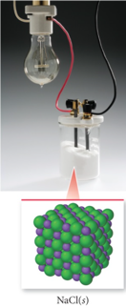
* In NaCl(aq), the ions are separated and are able to move to the charged rods.
  + 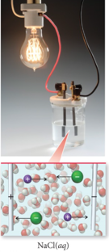

## Ionic Bonding and the Crystal Lattice

* Audio 0:14:34.266075
* The extra energy that is released comes from the formation of a structure in which every cation is surrounded by anions and vice versa.
  + This structure is called a *crystal lattice*.
* The crystal lattice is held together by the electrostatic attraction of the cations for all the surrounding anions.
  + Electrostatic attraction is a nondirectional force.
    - Therefore, there is *no ionic molecule*.
      * The chemical formula is an empirical formula, simply giving the ratio of ions based on charge balance.
* The crystal lattice maximizes the attractions between cations and anions leading to the most stable arrangement

## Ionic Compounds

* Audio 0:16:15.553827
* Ionic compounds are composed of cations (metals) and anions (nonmetals) bound together by ionic bonds.
  + Examples of ionic compounds:
    - NaBr, Al2(CO3)3, CaHPO4, and MgSO4
* The basic unit of an ionic compound is the formula unit, the smallest, electrically neutral collection of ions.
  + Example:
    - The ionic compound table salt, with the *formula unit* NaCl, is composed of Na+ and Cl+ions in a one-to-one ratio.
* Summarizing Ionic Compound Formulas
  + Ionic compounds always contain positive and negative ions.
  + In a chemical formula, the sum of the charges of the positive ions (cations) must equal the sum of the charges of the negative ions (anions).
  + The formula of an ionic compound reflects the smallest whole-number ratio of ions.

## Nomenclature: Naming Compounds

* Audio 0:18:01.496531
* Organic compounds: predominantly carbon Usually plus H, O, N, S
* Inorganic compounds: everything else
* Ionic Compounds: Cation followed by anion +-ide ## Naming Ionic Compounds
* Audio 0:19:25.857435
* Ionic compounds can be categorized into two types, depending on the metal in the compound.
* The first type contains a metal whose charge is invariant from one compound to another.
* Whenever the metal in this first type of compound forms an ion, the ion always has the same charge.
* 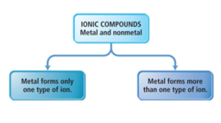
* Audio 0:21:00.382017
* Metals with invariant charges
  + 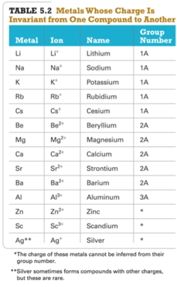
* common nonmetal anions
  + 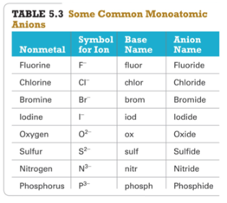

## Naming Binary Ionic Compounds of Type I Cations

* Audio 0:22:33.873986
* Binary compounds contain only two different elements. The names of binary ionic compounds take the following form:
* For example, the name for KCl consists of the name of the cation, potassium, followed by the base name of the anion, chlor, with the ending -ide.
  + KCl is potassium chloride.
    - We know potasium is +1, we know Cl is -1, so we don’t have to write it
* The name for CaO consists of the name of the cation, calcium, followed by the base name of the anion, ox, with the ending -ide.
  + CaO is calcium oxide.

## Chemical Nomenclature

* Audio 0:23:49.504979
* Ionic Compounds
  + often a metal + nonmetal
  + anion (nonmetal), add “ide” to element name
* 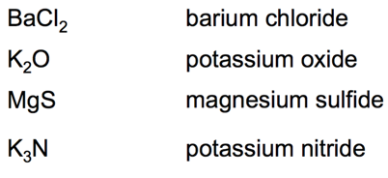

## Clicker 1

* Write the formula for calcium nitride
  + Ca_3N_2

## Lewis Structure Model: Representing a Substance’s Valence Electrons

* Audio 0:26:31.209408
* The Lewis Model:
  + Valence electrons are represented as dots.
    - 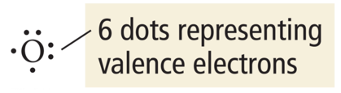
* Lewis electron-dot structures (Lewis structures) depict the structural formula with its valence electrons.
* Audio 0:27:52.445649
* Lewis structures focus on valence electrons because chemical bonding involves the transfer or sharing of valence electrons between two or more atoms.

## Octet Rule: A Guideline for Molecule Formation

* Audio 0:28:08.406107
* When atoms bond, they tend to gain, lose, or share electrons to give a noble gas–like configuration.
  + ns2np6
* Nonmetals: period 2 elements must obey the octet rule (i.e., eight valence electrons around each atom in the molecule).
* Exceptions to the octet rule: Expanded octets
  + (Sometimes octet rule doesn’t work)
  + Audio 0:29:09.248458
  + They involve the nonmetal elements located in period 3 and below.
  + Nonmetals (period 3 on down in the periodic table) follow the octet rule when they are not the center atom.
    - The center atom is the atom in the molecule that the other elements individually bond (attach) to.
  + When they are the center atom, they can accommodate more than eight electrons.
* Using empty valence d orbitals that are predicted by quantum theory

## Multivalent Metals: Naming Type II Ionic Compounds

* Audio 0:30:05.304852
* The metals in this category tend to have multiple charges (i.e., multivalent cations):
* Their charge cannot be predicted as in the case of most representative elements and must be noted in their name.
* Transition and inner transition metals
  + Iron (Fe) forms a 2+ cation in some of its compounds and a 3+ cation in others.
    - FeSO4: Here iron is a +2 cation (Fe2+).
    - Fe2(SO4)3: Here iron is a +3 cation (Fe3+).
* Many of the p-block metals
  + Not all p-block metals are multivalent.
  + Some main-group metals, such as Pb, Tl, and Sn, form more than one type of cation.

## Type II Cation

* Audio 0:31:26.941062
* 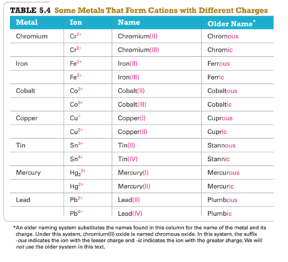

## Naming Type II Binary Ionic Compounds— Example: CrBr3

* Audio 0:32:36.900613
* To name CrBr_3, cation + total anion charge = 0
  + Cr charge + 3(Br+charge) = 0
  + Since each Br has a –1 charge, then
    - Cr charge + 3(–1) = 0
    - Cr charge + (–3) = 0
    - Cr = +3
  + Hence, the cation Cr3+ is called chromium(III), and Br^- is called bromide.
* The name for CrBr3 is chromium(III) bromide.

# Polyatomic Ions

* Audio 0:33:44.947274

## Oxyanions

* Audio 0:34:09.654184
* Most polyatomic ions are *oxyanions*, anions containing oxygen and another element.
* Noticethatwhenaseriesofoxyanionscontainsdifferent numbers of oxygen atoms, the oxyanions are named according to the number of oxygen atoms in the ion.
* Iftherearetwoionsintheseries,
  + the one with more oxygen atoms has the ending -ate; and +the one with fewer has the ending -ite.
* Forexample,
  + NO3+is nitrate SO_4^2+ is sulfate
  + NO2+is nitrite SO_3^2+ is sulfite
* If there are more than two ions in the series, then the prefixes hypo-, meaning less than, and per-, meaning more than, are used.
  + 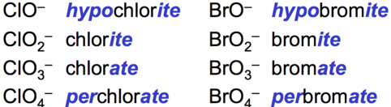

## Naming Ionic Compounds Containing Polyatomic Ions

* Audio 0:36:49.401712
* Ionic compounds that contain a polyatomic ion rather than a simple anion (e.g., Cl–) are named in the same manner as binary ionic compounds, except that the name of the polyatomic ion used.
  + For example, NaNO2 is named according to
    - its cation, Na+, sodium; and
    - its polyatomic anion, NO2–, nitrite.
  + Hence, NaNO2 is sodium nitrite.

## Common Polyatomic Ions

* 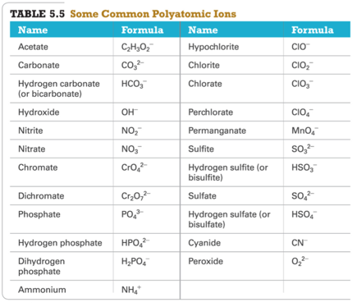
  + You should memorize this

## Chemical Nomenclature

* Audio 0:41:08.609726
* Ionic Compounds/Polyatomic Anion
* BaSO4 barium sulfate
* KMnO4 potassium permanganate Mg(OH)2 magnesium hydroxide
* KNO3 potassium nitrate
* (NH4)3PO4 ammonium phosphate

# Clicker 2

* Copper(II) phosphate’s formula
  + Cu_3(PO_4)2

## Hydrated Ionic Compounds

* Audio 0:44:52.355986
* *Hydrates* are ionic compounds containing a specific number of water molecules associated with each formula unit.
* Some ionic compounds have multiple hydrates

## Hydrates

* Common hydrate prefixes
  + hemi = 1⁄2
  + mono = 1
  + di = 2
  + tri=3
  + tetra = 4
  + penta = 5
  + hexa = 6
  + hepta = 7
  + octa = 8
* Other common hydrated ionic compounds and their names are as follows:
  + CaSO4 +1⁄2H2O is called calcium sulfate hemihydrate.
  + BaCl2 +6H2O is called barium chloride hexahydrate.
  + CuSO4 +6H2O is called copper sulfate hexahydrate.

# Vocab

|  |  |
| --- | --- |
| Term | Definition |
| lattice energy | the extra stability that accompanies the formation of the crystal lattice |
| ionic solid properties | relatively hard and brittle and don’t conduct electricity |
| crystal lattice | structre in which every cation is surrounded by anions and vice versa |
| binary compounds | compounds containing only two different elements |
| formula unit | empirical formulla of any ionic compound which is the lowest whole number ratio of ions |
| oxyanions | anions containing oxygen and another element |
| acetate formula | C_2H_3O_2^- |
| carbonate | CO_3^2- |
| hydrogen carbonate | HCO_3^- |
| hydroxide | OH^- |
| nitrite | NO_2^- |
| chromate | CrO_4^2- |
| dichromate | Cr_2O_7^2- |
| phosphate | PO_4^3- |
| hydrogen phosphate | HPO_4^2- |
| dihydrogen phosphate | H_2PO_4^- |
| ammonium | NH_4^+ |
| hypochlorite | ClO^- |
| chlorite | ClO_2^- |
| chlorate | ClO_3^- |
| perchlorate | ClO_4^- |
| permanganate | MnO_4^- |
| sulfite | SO_3^2- |
| hydrogen sulfite | HSO_3^- |
| sulfate | SO_4^2- |
| hydrogen sulfate | HSO_4^- |
| cyanide | CN^- |
| peroxide | O_2^2- |
| hydrates | ionic compounds containing a specific number of water molecules associated with each formula unit |

Please enable JavaScript to view the [comments powered by Disqus.](https://disqus.com/?ref_noscript)

## CH101-008 UA Fall 2016

* CH101-008 UA Fall 2016
* [jmbeach1@crimson.ua.edu](mailto:jmbeach1@crimson.ua.edu)
* jmbeach
* hey_beach

Notes and study materials for The University of Alabama's Chemistry 101 course offered Fall 2016.