Week 6 - Day 3

Table of Contents

[CH101-008 UA Fall 2016](/CH101-008/)

[About](/CH101-008/about/)

# Week 6 - Day 3

Sep 23, 2016

Download Word (docx):

## Navigate using audio

[Quizlet](https://quizlet.com/_2l3zie)

* Clicker lightning round
* What is TiCO_3?
  + Titanium (II) carbonate
* Audio 0:01:48.045761
* Give the formula for sodium perchlorate
  + NaClO_4
* Give the name for NaSO_3
  + sodium bisulfite
    - (SO_3 = sulfite)
* Give the name for KMnO_4
  + Potassium permanganate

# Covalent Bonding

* Audio 0:04:33.001883

## Covalent Bonding: Bonding and Lone Pair Electrons

* Audio 0:05:07.718537
* Electrons that are shared by atoms are called bonding pairs.
* Electrons that are not shared by atoms but belong to a particular atom are called lone pairs.
* Also known as nonbonding pairs
* Audio 0:06:48.740545
* 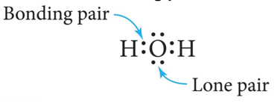
  + The top and bottom electrons on the O atom are lone pairs

## Single Covalent Bonds

* Audio 0:07:48.556923
* When two atoms share one pair of electrons, the result is called a single covalent bond.
* Two electrons
* One atom may use more than one single bond to fulfill its octet.
* To different atoms + H only duet
* 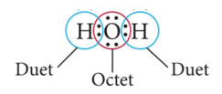
* 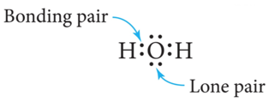

## Double Covalent Bond

* Audio 0:09:16.705706
* When two atoms share two pairs of electrons, the result is called a double covalent bond.
* Four electrons between the two atoms
  + Example: O2
  + 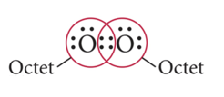
* Audio 0:10:33.321892
* Elements that can double-bond with each other and themselves are C, N, O, S, and P

## Triple Covalent Bond

* Audio 0:11:13.222743
* When two atoms share three pairs of electrons, the result is called a *triple covalent bond*.
* Six electrons between the two atoms
  + Example: N2
  + 
* Elements that can triple-bond with each other and themselves are C, N, O, and S.

## Covalent Bonding: Model versus Reality

* Audio 0:13:08.879773
* Lewis theory
* implies that some combinations should be stable, whereas others should not. + Stable combinations result in “octets.”
* allows us to predict the formulas of molecules of covalently bonded substances. + Hydrogen and the halogens are all diatomic molecular elements, as predicted by Lewis theory. + Oxygen generally forms either two single bonds or a double bond in its molecular compounds.
  + There are some stable compounds in which oxygen has one single bond and another in which it has a triple bond, but it still has an octet.

## Covalent Bonding: Model versus Reality

* Audio 0:14:51.981353
* Lewis theory of covalent bonding
* implies that the attractions between atoms are *directional*. + The shared electrons are most stable between the bonding atoms.
* predicts that covalently bonded compounds will be found as individual molecules. + Rather than an array like ionic compounds
  + *Compounds of nonmetals are made of individual molecule units*.

## Molecular Compounds: Formulas and Names

* Audio 0:16:15.133336
* Molecular compounds are composed of two or more nonmetals.
* The formula for a molecular compound cannot readily be determined from its constituent elements because the same combination of elements may form many different molecular compounds, each with a different formula.
* Nitrogen and oxygen form all of the following unique molecular compounds:
  + NO, NO2, N2O, N2O3, N2O4, and N2O5.

## Molecular Compounds

* Audio 0:17:43.500253
* Names of Molecular Compounds:
* Write the name of the element with the smallest group number first.
* If the two elements lie in the same group, then write the element with the greatest row number first.
* The prefixes given to each element indicate the number of atoms present.

## Binary Molecular Compounds

* Audio 0:18:59.257994
* 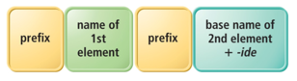
* These prefixes are the same as those used in hydrates:

|  |  |
| --- | --- |
| Prefix | Number |
| mono | 1 |
| di | 2 |
| tri | 3 |
| tetra | 4 |
| penta | 5 |
| hexa | 6 |
| hepta | 7 |
| octa | 8 |
| nona | 9 |
| deca | 10 |

* If there is only one atom of the first element in the formula, the prefix mono- is normally omitted

## Molecular Compounds

* Audio 0:20:34.443243

|  |  |
| --- | --- |
| molecule | name |
| HI | hydrogen iodide |
| NF_3 | nitrogen trifluoride |
| SO_2 | suffer dioxide |
| N_2Cl_4 | dinitrogen tetrachloride |
| NO_2 | nitrogen dioxide |
| N_2O | dinitrogen monoxide |

## Mass

* Audio 0:23:26.555568
* *Molecular mass* (or molecular weight) is the sum of the atomic masses (in amu) in a molecule
* 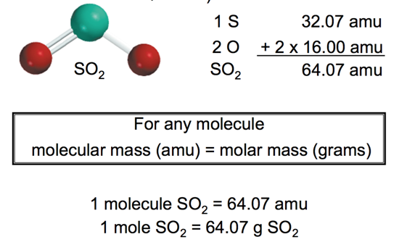

## Another Molecular Mass Example

* Audio 0:25:48.242857
* What is the Molecular Mass of C3H8O ?
* 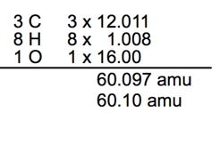

## Clicker question

* Find the molecular weight of urea (CH4N2O)
  + (All but 1% got it right)

## Using Molar Mass to Count Molecules by Weighing

* Audio 0:28:43.992973
* Molar mass in combination with Avogadro’s number can be used to determine the number of atoms in a given mass of the element.
* Use molar mass to convert to the amount in moles. Then use Avogadro’s number to convert to number of molecules. + 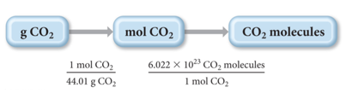

## Using Molecular Mass

* Audio 0:39:35.097586
* How many H atoms are in 72.5 g of C3H8O ?
* *Mass percent composition* of an element in a compound =
  + 
  + n is the number of moles of the element in 1 mole of the compound
  + 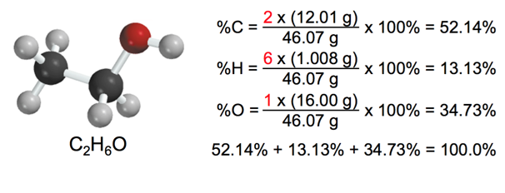
* Audio 0:42:11.330892
* What is the mass percent of Ca in CaCl2
* CaCl2 (Ca = 40.08, Cl = 35.45)

## Clicker 3

* Audio 0:44:25.808433

# Vocab

|  |  |
| --- | --- |
| term | Definition |
| bonding pairs | Electrons that are shared by atoms |
| lone pairs (nonbonding pairs) | Electrons that are not shared by atoms but belong to a particular atom |
| single covalent bond | when two atoms share one pair of electrons |
| double covalent bond | when two atoms share two pairs of electrons |
| triple covalent bond | when two atoms share three pairs of electrons |

Please enable JavaScript to view the [comments powered by Disqus.](https://disqus.com/?ref_noscript)

## CH101-008 UA Fall 2016

* CH101-008 UA Fall 2016
* [jmbeach1@crimson.ua.edu](mailto:jmbeach1@crimson.ua.edu)
* jmbeach
* hey_beach

Notes and study materials for The University of Alabama's Chemistry 101 course offered Fall 2016.