Week 7 - Day 1

Table of Contents

[CH101-008 UA Fall 2016](/CH101-008/)

[About](/CH101-008/about/)

# Week 7 - Day 1

Sep 26, 2016

Download Word (docx):

## Navigate using audio

## Mass Percent as a Conversion Factor

* Audio 0:01:05.568971
* the mass percent tells you the mass of a constituent element in 100 g of the compound
* the fact that CCl2F2 is 58.64% Cl by mass means that 100 g of CCl2F2 contains 58.64 g Cl
* this can be used as a conversion factor
* 100 g CCl2F2 : 58.64 g Cl

## Molecular Formulas

* Audio 0:01:54.462456
* The molecular formula is a multiple of the empirical formula
* Molecular Mass is the same multiple of the mass of the empirical formula
* Benzene:
* Empirical Formula: CH
  + 13.02 amu, 13.02 g/mol
* Molecular Formula: C6H6 which is 6xCH
  + 78.11 amu, 78.11 g/mol

## Determining a Chemical Formula from Experimental Data

* Audio 0:03:56.552943 Empirical Formula:
* Simplest whole-number ratio of the atoms of elements in a compound
* Can be determined from elemental analysis
* Masses of elements formed when a compound is decomposed, or that react together to form a compound
* Combustion analysis
* (Mass) Percent composition Note: An empirical formula represents a ratio of atoms or a ratio of moles of atoms, not a ratio of masses.

## Finding an Empirical Formula

* Audio 0:05:56.439211
  1. Convert the percentages to grams.
     + a) If not given, assume you start with 100 g of the compound.
     + b) Example: 24.5% C means 24.5 g C.
  2. Convert mass (grams) to moles. a) Use molar mass of each element. b) Example: 24.5 g C × (1 mol C/12.01 grams) = 2.00 mol C
  3. Divide all by the smallest number of moles to obtain the atom- to-atom ratio for each of the elements in the compound. a) If the result is within 0.1 of a whole number, round to the whole number.
  4. Multiply all mole ratios by a number to make all whole numbers. a) If ratio is .5, multiply all by 2; if the ratio is .33 or .67, multiply all by 3; and so on. b) Skip if already whole numbers.

## Example

* What is the empirical formula of a substance that contains 5.28 g of C, 1.11 g of H, and 3.52 g of O?

A) C2H5O B) C2H4O2 C) C2H4O3 D) C3H4O4

* Answer is A
* Audio 0:11:13.430592

## Combustion Analysis

* A common technique for analyzing compounds is to burn a known mass of compound and weigh the amounts of product made.
* This is generally used for organic compounds containing C, H, or O.
* 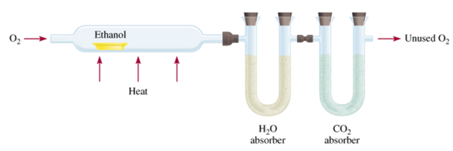
* Audio 0:22:35.779419
* Ex: you combust 11.5 g ethanol and collect 22.0 g CO2 and 13.5 g H2O.
* By knowing the mass of the product and composition of constituent element in the product, the original amount of constituent element can be determined.
* All the original C forms CO2, the original H forms H2O, and the original mass of O is found by subtraction.
* Once the masses of all the constituent elements in the original compound have been determined, the empirical formula can be found.

## Clicker

what is the empirical formula of the compound with the following composition? 2.1 % H, 65.3 % O, 32.6% S (H: 1.008, O: 16, S: 32.06) + C2H5O

## Example 5.16 + Find the molecular formula of butanedione

* Given: emp. form. = C2H3O; MM = 86.09 g/mol
* Find: molecular formula
  + C4H6O2

## Combustion analysis clicker

* Audio 0:34:34.156694
* 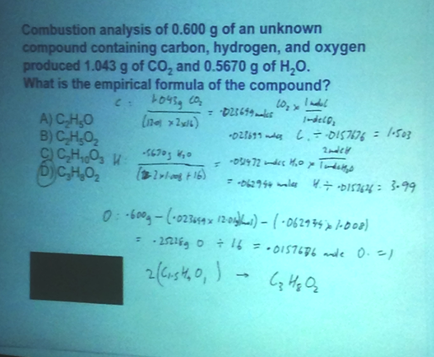

## Carbon Bonding

* Audio 0:39:10.776833
* carbon atoms bond almost exclusively covalently
  + compounds with ionic bonding C are generally inorganic
* when C bonds, it forms 4 covalent bonds
* 4 single bonds, 2 double bonds, 1 triple + 1 single, etc.
* carbon can form limitless chains of C atoms, both straight and branched, and rings of C atoms
* 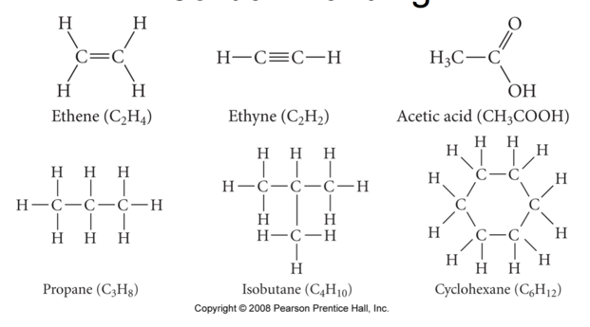

## Classifying Organic Compounds

* there are two main categories of organic compounds, hydrocarbons and functionalized hydrocarbons
* hydrocarbons contain only C and H
* most fuels are mixtures of hydrocarbons
* 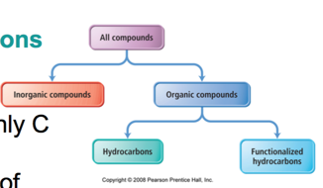

## Classifying Hydrocarbons

* Audio 0:41:37.320899
* hydrocarbons containing only single bonds are called alkanes
* hydrocarbons containing one or more C=C are called alkenes
* hydrocarbons containing one or more C=C are called alkynes
* hydrocarbons containing C6 “benzene” ring are called aromatic
* 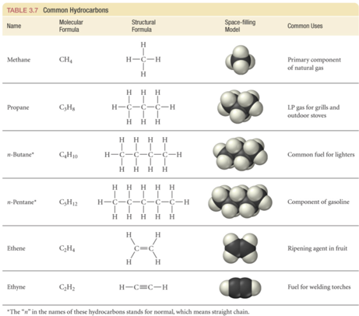

## Naming Straight Chain Hydrocarbons

* Base name to indicate the number of carbons in the chain
* suffix to indicate class and position of multiple bonds suffix –ane for alkane, –ene for alkene, –yne for alkyne
* 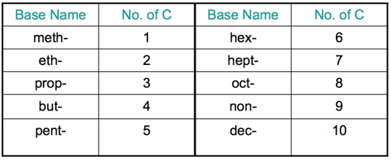
* 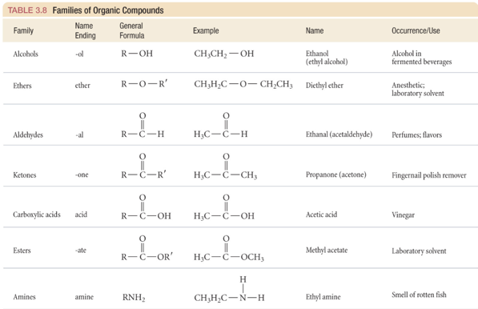

Please enable JavaScript to view the [comments powered by Disqus.](https://disqus.com/?ref_noscript)

## CH101-008 UA Fall 2016

* CH101-008 UA Fall 2016
* [jmbeach1@crimson.ua.edu](mailto:jmbeach1@crimson.ua.edu)
* jmbeach
* hey_beach

Notes and study materials for The University of Alabama's Chemistry 101 course offered Fall 2016.