Week 7 - Day 3

Table of Contents

[CH101-008 UA Fall 2016](/CH101-008/)

[About](/CH101-008/about/)

# Week 7 - Day 3

Sep 30, 2016

[Quizlet](https://quizlet.com/_2l40gx)

# Announcements

* Left off on formal charge
* Test 2 next Wednesday
  + Chapters 4 - 6
    - Just where we left off
  + Same rules as last time
    - Bring photo id
    - bring pencil
    - non-programmable calculator

## Clicker 1

* 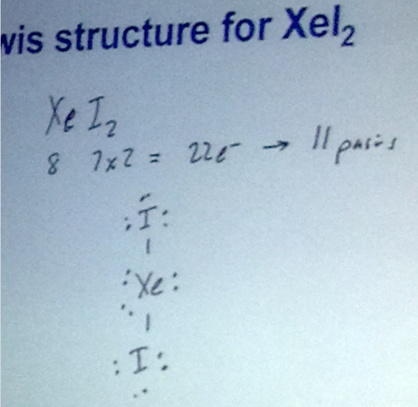

# Ch 6 continued (pt 2)

## Example: Formal Charge, SO2

* Audio 0:06:38.049121
* 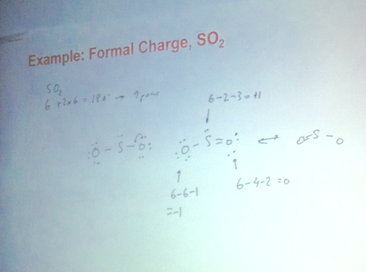
  + Formal charges: located on “appropriate atoms”
  + Audio 0:10:37.025317
  + Per atom, to calculate formal charge, you take the valence electrons minus the electrons on it minus the number of pairs on it.

## Practice Problem Assigning Formal Charges

* Audio 0:12:40.335303
* OCN-
* 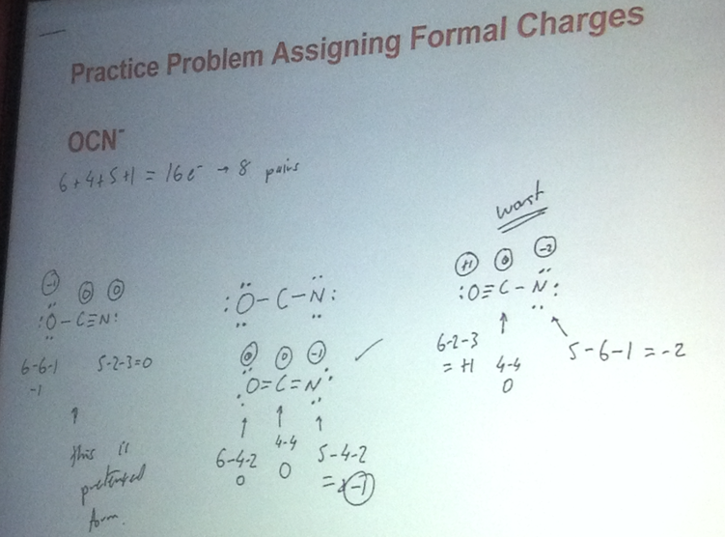

## Rules of Resonance Structures

* Audio 0:19:11.165662
* Resonance structures must have the same connectivity.
  + Only electron positions can change.
* Resonance structures must have the same number of electrons.
* Second row elements have a maximum of eight electrons.
  + Bonding and nonbonding
  + Third row can have expanded octet
* Formal charges must total the same.
  + Better structures have fewer formal charges.
  + Better structures have smaller formal charges.
  + Better structures have the negative formal charge on the more electronegative atom.

## Expanded Octets, Odd-Electron, and Other Species: The Exceptions to the Octet “Rule”

* Audio 0:21:06.805441
* The exceptions:
* Expanded octets:
  + Molecules or ions with more than eight electrons around an atom
  + Involve the nonmetal elements located in the 3rd period and below
* Nonmetals (3rd period down in the periodic table) follow the octet rule when they are not the “center” atom.
  + The center atom is the atom in the molecule where the other elements individually bond to (attach).
  + When they are the center atom, they can accommodate more than eight electrons.
* Using empty valence d orbitals that are predicted by quantum theory
* Odd-electron species (free radicals or radicals):
* Molecules or ions with an odd number of electrons
  + Legitimate Lewis structures cannot be written for they do not meet the “octet rule” as required by the Lewis model.
  + Example: NO
    - Has 11 valence electrons
    - Distribution of 11 electrons cannot meet the criteria under the Lewis model.
    - NO does exist as a molecule.
      * The Lewis model is not sophisticated enough to work for an odd number of electron compounds.
* Audio 0:22:20.060270
* Incomplete octets:
  + Elements (specifically metalloids and H atom) whose tendency is not to have a complete octet
    - H can only accompany two electrons (duet).
    - Boron (metalloid)
      * Prefer 6 electrons than 8 electrons
* 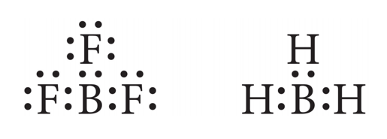

## Clicker 2

* What is the formal charge on the sulfur for best structure for the sulfate anion, SO4^2-?
  + Audio 0:27:21.796062
  + 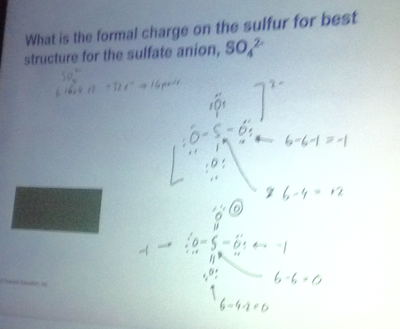
  + Most people said plus 2, but the answer is actually 0

## Bond Energies

* Audio 0:32:36.686918
* Chemical reactions involve breaking bonds in reactant molecules and making new bonds to create the products.
* The change in energy for a reaction can be estimated by comparing the cost of breaking old bonds to the energy released from making new bonds.
* The amount of energy, in the gaseous state, that it takes to break one mole of a bond in a compound is called the bond energy.
* Audio 0:34:03.982413
* The energy change required to break a particular bond in one mole of gaseous molecules is the bond energy
* 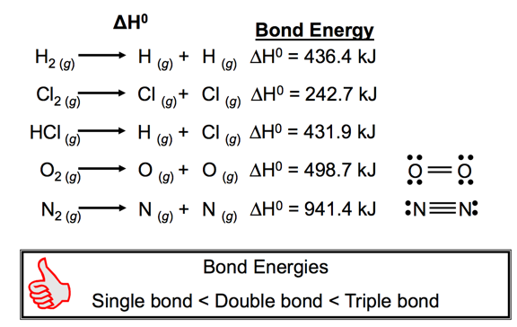

## Trends in Bond Energies

* Audio 0:36:20.771621
* In general, the more electrons two atoms share, the stronger the covalent bond.
  + For comparison of bonds between like atoms
  + C≡C (837 kJ) > C═C (611 kJ) > C—C (347 kJ)
  + C≡N (891 kJ) > C ═ N (615 kJ) > C—N (305 kJ)
* In general, the shorter the covalent bond, the stronger the bond.
  + For comparison of bonds between like atoms
  + Br—F (237 kJ) > Br—Cl (218 kJ) > Br—Br (193 kJ)
  + Bonds get weaker down the column.
  + Bonds get stronger across the period.

## Average Bond Energies

* 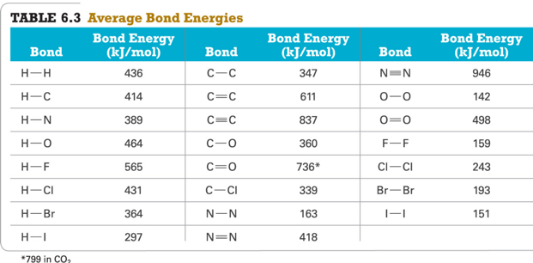

## Covalent Bonding: Model versus Reality for Bond Strength

* Audio 0:39:20.498710
* Lewis theory predicts that the more electrons two atoms share, the stronger the bond.
  + Single bond < Double bond < Triple bond
  + Lewis theory would predict that double bonds are twice as strong as single bonds, but the reality is they are less than twice as strong.
* *Bond strength* is measured by how much energy must be added into the bond to break it in half.

## Covalent Bonding: Model versus Reality for Bond Length

* Audio 0:40:57.263317
* Lewis theory predicts that the more electrons two atoms share, the shorter the bond should be.
  + When comparing bonds to like atoms
* Bond length is determined by measuring the distance between the nuclei of bonded atoms.
* In general, triple bonds are shorter than double bonds, and double bonds are shorter than single bonds.
* 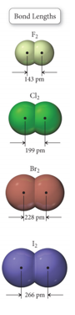

## Bond Lengths

* Audio 0:42:20.387950
* The distance between the nuclei of bonded atoms is called the bond length.
* Because the actual bond length depends on the other atoms around the bond, we often use the average bond length.
  + Averaged for similar bonds from many compounds
  + 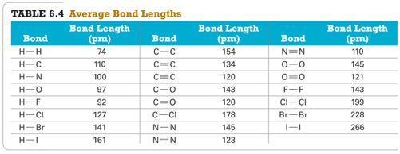

# Vocab

|  |  |
| --- | --- |
| Term | Definition |
| bond energy | the amount of energy, in the gaseous state, that it takes to break one mole of a bond in a compound |
| bond strength | measured by how much energy must be added into the bond to break it in half |
| bond length | determined by measuring the distance between the nuclei of bonded atoms |
| as bonds get longer they get _ | weaker |
| bonds get _ down a column and _ across a period | weaker / stronger |

Please enable JavaScript to view the [comments powered by Disqus.](https://disqus.com/?ref_noscript)

## CH101-008 UA Fall 2016

* CH101-008 UA Fall 2016
* [jmbeach1@crimson.ua.edu](mailto:jmbeach1@crimson.ua.edu)
* jmbeach
* hey_beach

Notes and study materials for The University of Alabama's Chemistry 101 course offered Fall 2016.