Week 8 - Day 2 (Last before test 2)

Table of Contents

[CH101-008 UA Fall 2016](/CH101-008/)

[About](/CH101-008/about/)

# Week 8 - Day 2 (Last before test 2)

Oct 5, 2016

Download Word (docx):

## Navigate using audio

# Announcements

* Audio 0:00:32.424965
* Test tonight
  + Bring pencil, photo id, calculator
  + You can start as late as 7 and you can’t leave until 7
  + Material from end of chapter 3 to end of chapter 6
  + Coulomb’s Law is physics
    - Only expects you to understand the directions / relative magnitudes of charges (no calculations)

# Clicker 1

* Audio 0:05:31.262428
* According to VSEPR theory, which one of the following molecules should have a molecular geometry that is trigonal bipyramidal?
  + SF4
  + XeF4
  + NF3
  + SF6
  + PF5
* The answer is PF5 because it is the only answer with five atoms attached to the central atom

## Representing Three-Dimensional Shapes on Paper

* Audio 0:07:41.096639
* Drawing molecules to show their dimensionality on paper (2-D) is difficult.
* How to draw a 3-D representation of molecule on paper:
  + By convention, the central atom is put in the plane of the paper.
  + Put as many other atoms as possible in the same plane and indicate with a *straight line*.
  + For atoms in front of the plane, use a *solid wedge*.
  + For atoms behind the plane, use a *hashed wedge*
* 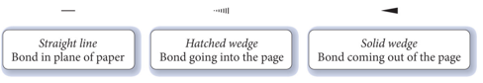

## Illustrations of Molecular Geometries of Molecules Using 3-D Notations

* Audio 0:10:13.039414
* 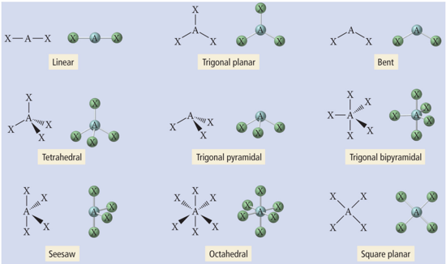

## Multiple Central Atoms and Their Geometries

* Audio 0:11:15.077734
* Many molecules have larger structures with many interior atoms.
  + Looking at “multiple center atoms”
  + Think of them as having multiple central atoms.
* For multiple center molecules:
  + Each center atom has a designated a shape.
* Example: Glycine
* The shape around the:
  + N atom is trigonal pyramidal
  + Left C is tetrahedral
  + Right C is trigonal planar
  + O is bent
* 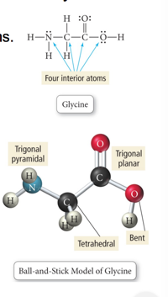

# Clicker 2

* Audio 0:15:17.202864
* Which species has the highest ionization energy?
  + A) Mg
  + B) Mg+
  + C) Mg2+
  + D) Al+
  + E) Al2+

C

# Clicker 3

* Audio 0:16:45.881866
* Give the ground state electron configuration for the ion of Ba
  + [Kr] 5s24d105p6

# Clicker 4

* Audio 0:19:07.805288
* Which reaction below represents the electron affinity of Li?
  + Answer in Recitation questions

# Clicker 5

* Audio 0:20:44.692817
* a) Na+
* b) Ga3+
* c) K+
* d) Mg2+
* e) Ca2+
  + C

# Clicker 6

* Audio 0:23:43.818176
* a) titanium (II) carbonate
* b) titanium carbide
* c) titanium carbonite
* c) titanium (II) carbonite
* a

# Clicker 7

* Audio 0:26:11.549016
* Calculate the molar mass of Al(C2H3O2)3
  + a) 86.03 g/mol
  + b) 204.13 g/mol
  + c) 56.00 g/mol
  + d) 258.09 g/mol
  + e) 139.9 g/mol
* B

# Clicker 8

* Audio 0:29:32.460732
* How many atoms of oxygen are contained in 47.6 g of Al2(CO3)3? The molar mass of Al2(CO3)3 is 233.99 g/mol
* We have 1/5th of a mol of Al2(CO3)3. There are nine mols of oxygen in one molecule. = 9 * avogandros number

# Clicker 9

* Audio 0:33:28.381248
* Determine the empirical formula for a compound that is 36.86% N and 63.14% O by mass. (O:15.999, N:14.0007)
* N2O3

# Clicker 10

* Audio 0:34:36.281792
* Determine the molecular formula of a compound that is 49.48% carbon, 5.19% hydrogen,28.85% nitrogen, and 16.48% oxygen. The molecular weight is 194.19 g/mol

# Clicker 11

* Audio 0:38:58.435866
* Which of the following reactions is associated with the lattice energy of CaS?
  + Ca(s) + S(s) -> CaS(s)
  + CaS(s) + S(s) -> CaS(s)
  + Ca2-(aq) + S2-(aq) -> CaS(s)
  + Ca2-(g) + S2-(g) -> CaS(s)
* D

# Clicker 11

* Choose the bond below that is the least polar
* P-F
* C-Br
* C-F
* C-I
* C-Cl
* Want to find the least electronegative difference
* D

# Clicker 12

* Which of the following resonance structures for OCN- will contribute most to the correct structure of OCN-?
* A) O(3 lone pairs) - C N(with 1 lone pair)

# Vocab

|  |  |
| --- | --- |
| Term | Definition |
| solid wedge | 3D representation for drawing molecular structures which represents a bond coming out of the page |
| solid hatched | 3D representation for drawing molecular structures which represents a bond going into the page |
| straight line | representation for drawing molecular structures which represents a bond in plane of the drawing surface |

Please enable JavaScript to view the [comments powered by Disqus.](https://disqus.com/?ref_noscript)

## CH101-008 UA Fall 2016

* CH101-008 UA Fall 2016
* [jmbeach1@crimson.ua.edu](mailto:jmbeach1@crimson.ua.edu)
* jmbeach
* hey_beach

Notes and study materials for The University of Alabama's Chemistry 101 course offered Fall 2016.