Week 8 - Day 3 (End of Chapter 6)

Table of Contents

[CH101-008 UA Fall 2016](/CH101-008/)

[About](/CH101-008/about/)

# Week 8 - Day 3 (End of Chapter 6)

Oct 7, 2016

Download Word (docx):

## Navigate using audio

# Announcements

* Average test grade was 70
* Ch 6 homework due Sunday night

# Polarity of Molecules

* Audio 0:01:22.952892
* For a molecule to be polar, it must have:
  + Polar bonds
    - Electronegativity difference
    - Bond dipole moments - measured
  + An unsymmetrical shape
    - Vector addition
* Audio 0:03:43.776817
* Polarity affects the intermolecular forces of attraction.
  + Example:
* Boiling points and solubilities
  + Like dissolves like
* Nonbonding pairs affect molecular polarity, a strong pull

# Molecule Polarity

* Audio 0:04:17.407335
* 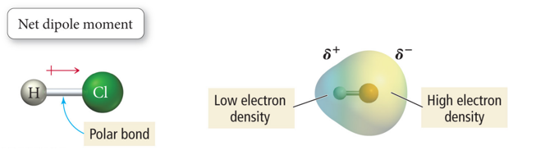
* The bond between the H atom and Cl atom in HCl molecule is polar.
* The bonding electrons are pulled toward the Cl end of the molecule because Cl is more electronegative (EN) than the H atom.
  + The net result is a polar molecule.
* 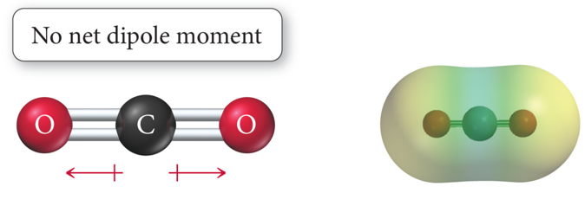
  + Second most electronegative element
  + Has polar bonds that are equally polar in opposite directions so the net result is that CO2 is not polar
* The bond between the C atom and O atoms in CO2 molecule is polar.
* The bonding electrons are pulled toward the O ends of the molecule equally because O is more electronegative (EN) than the C atom.
  + The net result is a nonpolar molecule.

Audio 0:06:24.175803

## Molecule Polarity

* The bond between the O atom and H atoms in H2O molecule is polar.
* Both sets bonding electrons are pulled toward the O end of the molecule equally because O is more electronegative (EN) than the H atom.
* Because of its geometry, the lone pairs do not negate the dipole moment that result from the each of the O–H bonds.
* The net result is a polar molecule.
* 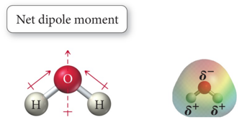

## Vector Addition

* Audio 0:07:47.798794
* 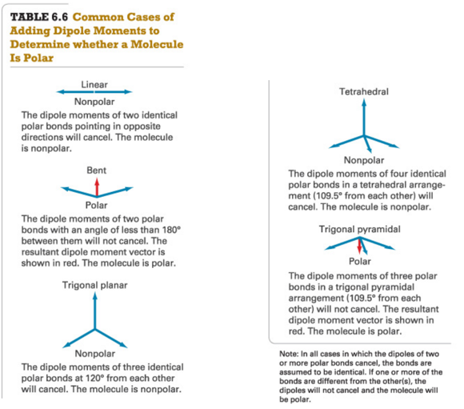
  + Water is more like the bent scenario
    - The sum of the bonds goes up so it’s polar (the vectors don’t cancel)
  + For CO2 and a trigonal planar molecule the vectors are equally strong in directions that cancel eachother out so they are not polar.

## Vector Addition: One Dimension

* One Dimension:
* To add two vectors that lie on the same line, assign one direction as positive.
* Vectors pointing in that direction have positive magnitudes.
* Consider vectors pointing in the opposite direction to have negative magnitudes.
* 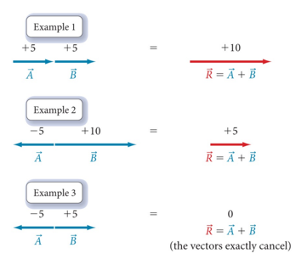
* Audio 0:09:58.418088
* Just draw the first. Draw the second where the first ends and then calculate the net result.

## Vector Addition: Two or More Dimensions

* Audio 0:10:34.308430 Two or More Dimensions:
* To add two vectors, draw a parallelogram in which the two vectors form two adjacent sides.
* Draw the other two sides of the parallelogram parallel to and the same length as the two original vectors.
* Draw the resultant vector beginning at the origin and extending to the far corner of the parallelogram as shown in Examples 4 and 5.
* To add three or more vectors, add two of them together first, and then add the third vector to the result (Examples 6 and 7).
* 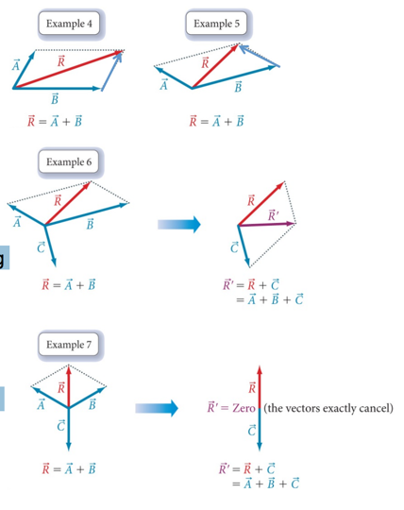

## Molecular Polarity Affects Solubility in Water

* Audio 0:13:22.721754
* Polar molecules are attracted to other polar molecules.
* Water is a polar molecule; therefore:
  + Other polar molecules will dissolve in water.
  + As well as ionic compounds
* Some molecules have both polar and nonpolar parts.
  + Example: Soap molecule
* 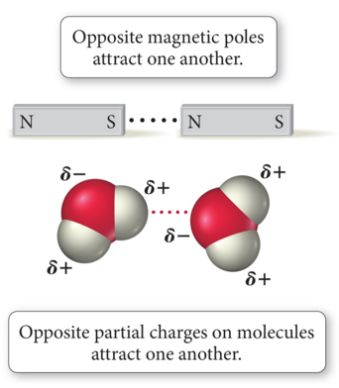

## Summarizing Determining Molecular Shape and Polarity

* Audio 0:14:38.522158
* Draw the Lewis structure for the molecule and determine its molecular geometry.
* Determine if the molecule contains polar bonds.
  + A bond is polar if the two bonding atoms have sufficiently different electro negativities.
  + If the molecule contains polar bonds, superimpose a vector, pointing toward the more electronegative atom, on each bond.
  + Make the length of the vector proportional to the electronegativity difference between the bonding atoms.
* Determine if the polar bonds add together to form a net dipole moment.
  + Sum the vectors corresponding to the polar bonds together. If the vectors sum to zero, the molecule is nonpolar.
  + If the vectors sum to a net vector, the molecule is polar

## Practice Problem: Is a Molecule Polar?

* Audio 0:15:19.845473
* Is NH3 polar?
  + 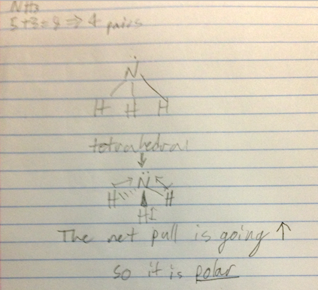
* Audio 0:17:55.560585
* Does ozone have a dipole moment?
  + Yes
  + 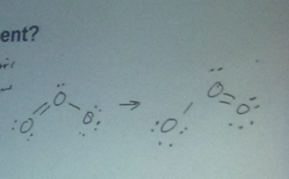

# Chapter 7

* Audio 0:23:53.507292
* Chemical Bonding II
* Valence Bond and Molecular Orbital Theory
* 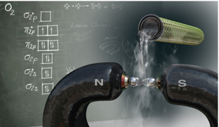

## A Magnetic Liquid: O2

* Audio 0:24:34.873518
* Oxygen is paramagnetic.
* Paramagnetic material has unpaired electrons.
* Lewis theory does not predict this result.
* 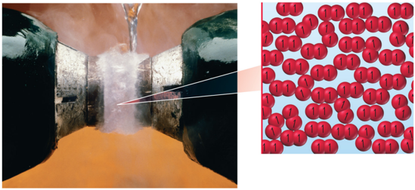

## Problems with Lewis Theory

* Audio 0:26:13.153424
* Lewis theory generally predicts trends in properties, but it does not give good numerical predictions.
  + Example: bond strength and bond length
* Lewis theory gives good first approximations of the bond angles in molecules, but it usually cannot be used to get the actual angle.
* Resonance: Lewis theory cannot write one correct structure for many molecules, and multiple resonance structures is not “elegant”.
* Lewis theory often does not predict the correct magnetic behavior of molecules.
  + For example, O2 is paramagnetic, although the Lewis structure predicts it is diamagnetic.

## Valence Bond Approach

* Audio 0:28:26.040824
* 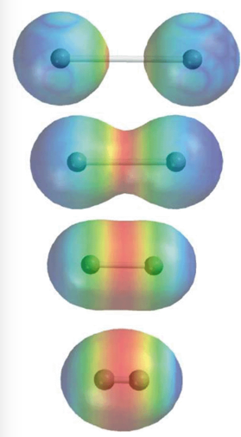
* Change in electron density as two hydrogen atoms approach each other.
  + Overlap in two 1s orbitals
* Keep getting closer until nucleus<=>nucleus repulsion balances electron<=>nucleus attraction

## Valence Bond Theory: Orbital Overlap and the Chemical Bond

* Audio 0:30:39.283988
* 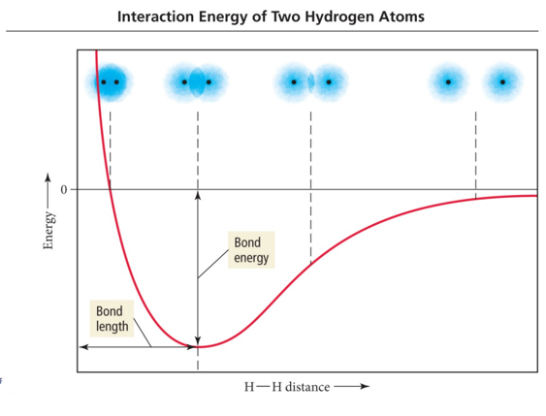

## Valence Bond Theory: Orbital Overlap and the Chemical Bond

* Applying quantum mechanics to molecules:
* Bonds between atoms should occur when the orbitals on those atoms interact to make a bond.
* Audio 0:33:58.699088
* The kind of interaction depends on whether the orbitals align along the axis between the nuclei, or outside the axis.
* 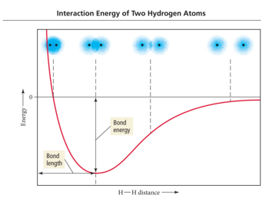

## Orbital Diagram for the Formation of H2S

* Audio 0:34:54.957208
* 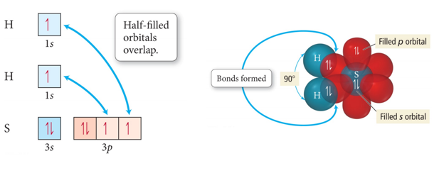

## Valence Bond Theory and NH3

* Audio 0:36:55.262109
* 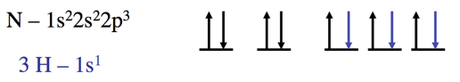
* If the bonds form from overlap of 3 2p orbitals on nitrogen with the 1s orbital on each hydrogen atom, what would the molecular geometry of NH3 be?
* 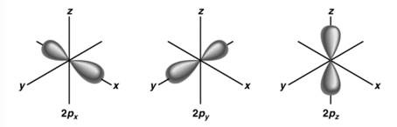
  + The predicted geometry is wrong
    - If use the 3 2p orbitals predict 90 degrees
    - Actual H-N-H bond angle is 107.30

## Hybridization – mixing of two or more atomic orbitals to form a new set of hybrid orbitals.

* Audio 0:38:09.158442
  1. Mix at least 2 nonequivalent atomic orbitals (e.g. s and p). Hybrid orbitals have very different shape from original atomic orbitals.
  2. Number of hybrid orbitals is equal to number of pure atomic orbitals used in the hybridization process.
  3. Covalent bonds are formed by:
     + a. Overlap of hybrid orbitals with atomic orbitals
     + b. Overlap of hybrid orbitals with other hybrid orbitals

## Formation of sp3 Hybrid Orbitals

* Audio 0:40:23.463058
* 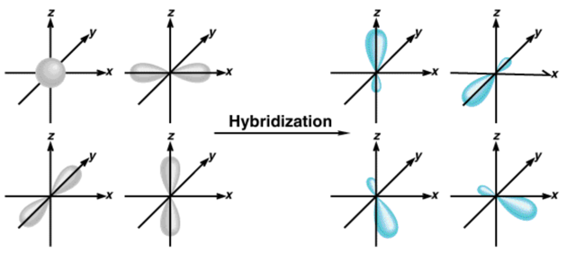
  + When we hybridize them, we get tetrahedral geometry
* 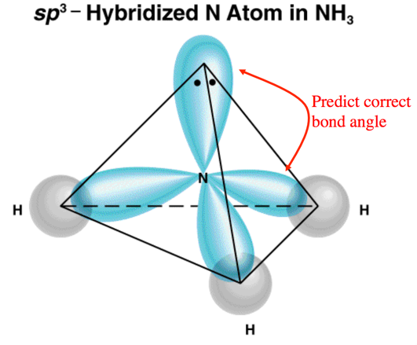
  + These are exactly the right geometry to give us the tetrahedral shape of ammonia

## Summarizing Valence Bond Theory

* Audio 0:43:00.758032
* The valence electrons of the atoms in a molecule reside in quantummechanical atomic orbitals.
* The orbitals can be the standard s, p, d, and f orbitals, or they may be hybrid combinations of these.
* A chemical bond results from the overlap of two half-filled orbitals and spin-pairing of the two valence electrons (or less commonly the overlap of a completely filled orbital with an empty orbital).
* The geometry of the overlapping orbitals determines the shape of the molecule.

## Valence Bond Theory: Main Concepts

1. The valence electrons of the atoms in a molecule reside in quantum-mechanical atomic orbitals. The orbitals can be the standard s, p, d, and f orbitals, or they may be hybrid combinations of these.
2. A chemical bond results when these atomic orbitals interact and there is a total of two electrons in the new molecular orbital. a) The electrons must be spin paired.
3. The shape of the molecule is determined by the geometry of the interacting orbitals.

Please enable JavaScript to view the [comments powered by Disqus.](https://disqus.com/?ref_noscript)

## CH101-008 UA Fall 2016

* CH101-008 UA Fall 2016
* [jmbeach1@crimson.ua.edu](mailto:jmbeach1@crimson.ua.edu)
* jmbeach
* hey_beach

Notes and study materials for The University of Alabama's Chemistry 101 course offered Fall 2016.