Week 9 - Day 1 (Chapter 7 pt 2)

Table of Contents

[CH101-008 UA Fall 2016](/CH101-008/)

[About](/CH101-008/about/)

# Week 9 - Day 1 (Chapter 7 pt 2)

Oct 10, 2016

[Quizlet](https://quizlet.com/_2mglz7)

Download Word (docx):

## Navigate using audio

# Announcements

* Audio 0:00:14.957544
* Student Affiliates of the American Chemical Society

## Unhybridized Carbon Orbitals in CH4: Predict the Wrong Bonding and Geometry

* Audio 0:01:26.977877
* 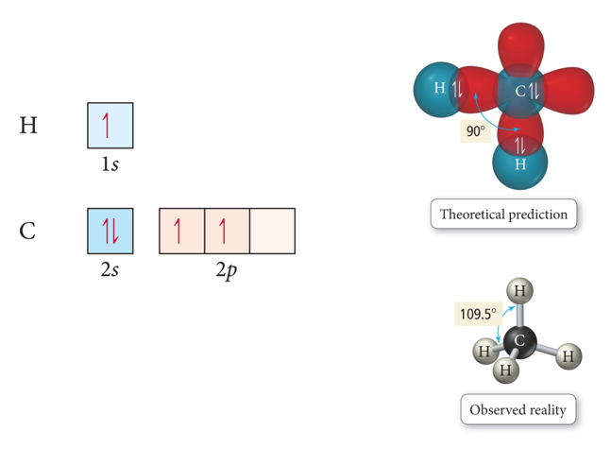

## Valence Bond Theory and Hybridization CH4

* One of the issues that arises is that the number of partially filled or empty atomic orbitals did not predict the number of bonds or orientation of bonds.
  + C = 2s^2 2px^1 2py^1 2pz^0 would predict two or three bonds that are 90° apart, rather than four bonds that are 109.5° apart.
* To adjust for these inconsistencies, it was postulated that the valence atomic orbitals could hybridize before bonding took place.
  + One hybridization of C is to mix all the 2s and 2p orbitals to get four orbitals that point at the corners of a tetrahedron.

## Hybridization

* Audio 0:02:36.629512
* Some atoms hybridize their orbitals to maximize bonding.
  + More bonds = more full orbitals = more stability
* Hybridizing is mixing different types of orbitals in the valence shell to make a new set of degenerate orbitals.
  + sp, sp2 , sp3 , sp3d, sp3d2
    - Four Hybrid orbitals
* The same type of atom can have different types of hybridization.
  + C = sp, sp2 , sp3
* 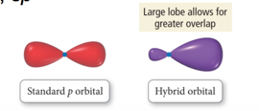
  + If we need a trigonal planar
    - Hybridize s and sp2

## Hybrid Orbitals

* Audio 0:04:49.597515
* The number of standard atomic orbitals combined = the number of hybrid orbitals formed.
  + Example for carbon:
    - Combining a 2s with a 3p gives four sp3 hybrid orbitals.
  + H cannot hybridize.
    - Its valence shell only has one orbital.
      * 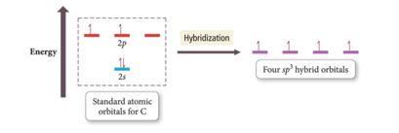
      * Audio 0:05:51.042164
* The number and type of standard atomic orbitals combined determines the shape of the hybrid orbitals.
* The particular kind of hybridization that occurs is the one that yields the lowest overall energy for the molecule.
* Audio 0:06:49.243321
* 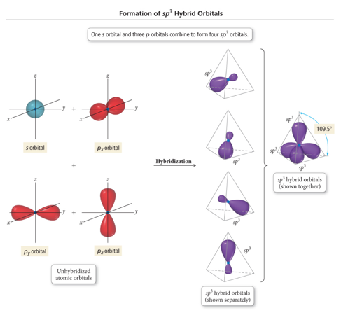
  + Take the s and 3 p orbitals and make four sp3 orbitals
    - Makes the tetrahedral geometry

## sp3 Hybridization

* Audio 0:08:30.906596
* Atom with four electron groups around it:
  + Tetrahedral geometry
  + 109.5° angles between hybrid orbitals
* Atom uses hybrid orbitals for all bonds and lone pairs
* 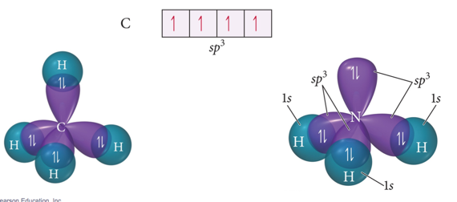
* Audio 0:08:43.856308

## Formation of sp Hybrid Orbitals

* 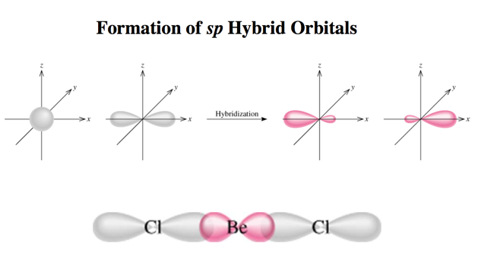

## Formation of sp2 Hybrid Orbitals

* Audio 0:09:19.885131
* 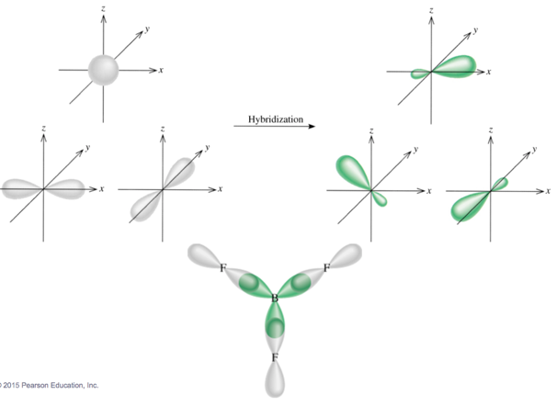

# Clicker 1

* Audio 0:09:46.537377
* Give the electron geometry (eg), molecular geometry (mg), and hybridization for H2O

A) eg = tetrahedral, mg = bent, sp3 B) eg = trigonal pyramidal, mg = trigonal pyramidal, sp3 C) eg = tetrahedral, mg = trigonal pyramidal, sp3 D) eg = bent, mg = bent, sp3 E) eg = trigonal planar, gm = trigonal planar, sp3

A

<input type=”button” onclick=”$(“#c1”).toggle()” value=”show/hide answer”/>

## sp3d Hybridized Orbital

* Audio 0:13:35.100695
* Atom with five electron groups around it:
  + Trigonal bipyramid electron geometry
  + Seesaw, T-shape, linear
  + 120° and 90° bond angles
* Use empty d orbitals from valence shell
* d orbitals—used to make π bonds
* 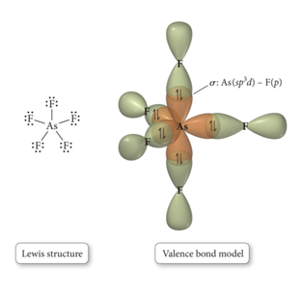

## sp3d Hybridized Orbital

* 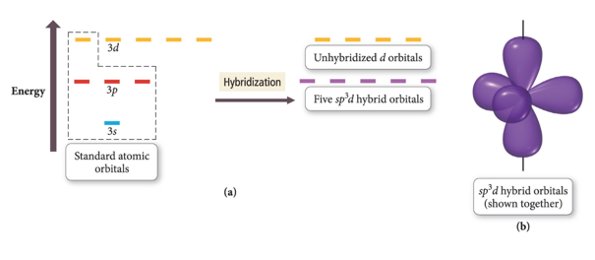

## sp3d2

* Atom with six electron groups around it:
  + Octahedral electron geometry
  + Square pyramid, square planar
  + 90° bond angles
* Use empty d orbitals from valence shell to form hybrid
* d orbitals—used to make π bonds
* 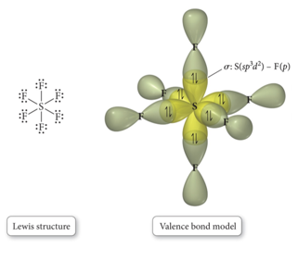

## sp3d2

* 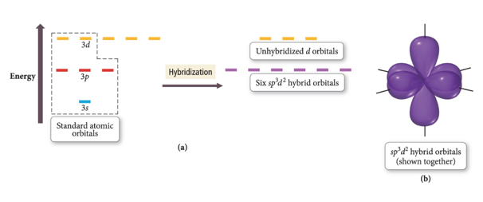
* 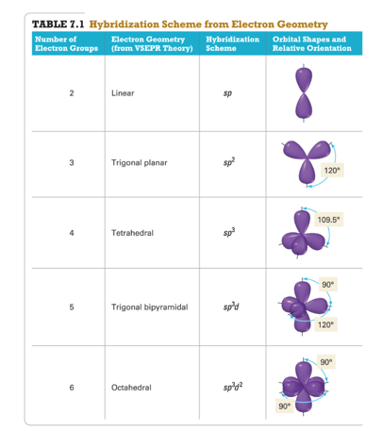

## σ and π bonds:

* σ bonds –overlap along bond axis
* 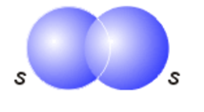

## Hybridization: sp2

* Audio 0:19:16.146819
* Atom with three electron groups around it:
* Atom uses hybrid orbitals for σ bonds and lone pairs and uses nonhybridized p orbital for π bond
* 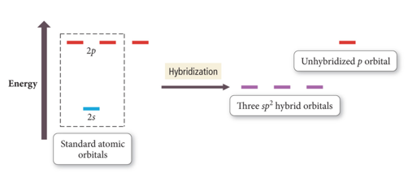
* 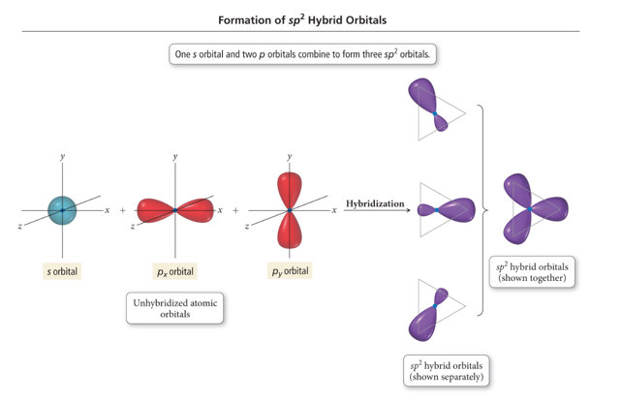

## Sigma and Pi Bonding

* Audio 0:20:37.534711
* 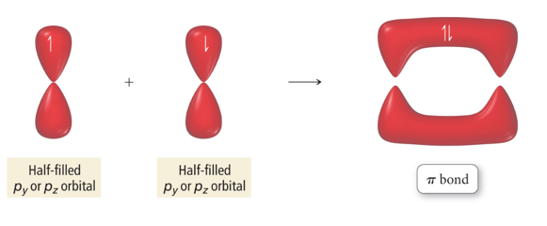

## Orbital Diagrams of Bonding: H2CO

* Audio 0:21:03.253240
* 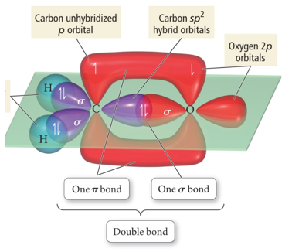
* “Overlap” between a sp2 hybrid orbital on C and s 1s orbital on H gives σ bond.
* “Overlap” between unhybridized p orbitals on C and O gives π bond.
* “Overlap” between C sp2 hybrid orbital and O sp2 gives σ bond

## Types of Bonds

* Audio 0:24:50.789254
* A *sigma (σ) bond* results when the interacting atomic orbitals point along the axis connecting the two bonding nuclei.
  + Either standard atomic orbitals or hybrids
    - s to s, p to p, hybrid to hybrid, s to hybrid, etc.
* A *pi (π) bond* results when the bonding atomic orbitals are parallel to each other and perpendicular to the axis connecting the two bonding nuclei.
  + Between unhybridized parallel p orbitals
* The interaction between parallel orbitals is not as strong as between orbitals that point at each other; therefore, σ bonds are stronger than π bonds.

## Bond Rotation

* Audio 0:26:21.602225
* Because of the orbitals that form the σ bond point along the internuclear axis, rotation around that bond does not require breaking the interaction between the orbitals.
* But the orbitals that form the π bond interact above and below the internuclear axis, so rotation around the axis requires the breaking of the interaction between the orbitals.
* 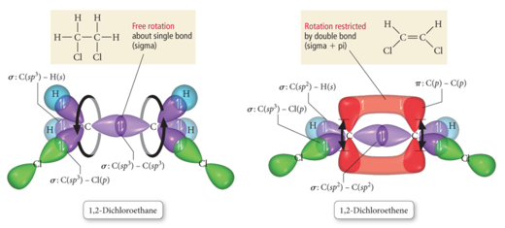
  + With a single bond, you have free rotation of the molecule around the bond
    - The rotation does not impact the strength of the bond
  + With a double bond, you’d have to break the bond to rotate
    - It actually freezes the structure of the molecule

## Cis & Trans Isomers of 1,2-Dichloroethane

* Audio 0:28:53.696722
* 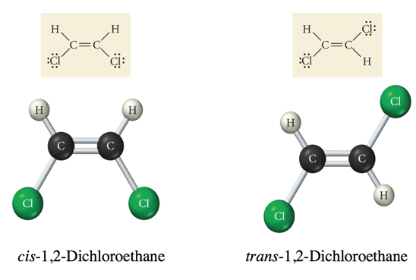
  + Same compound, different properties
  + Think about trans-fats
    - Still fat, but way more harmful

# Clicker 2

* Audio 0:32:21.778478
* place the following in order of decreasing dipole moment I. cis-CHCl=CHCl II. trans-CHCl=CHCl III. cis-CHF=CHF

A) III > I > II B) II > I > III C) I > III > II D) II > III > I E) I = III > II

A. The trans dichloroethane actually cancels itself out and has 0 dipole moment. Then for the cis flourine, it has higher dipole moment than I, so A.

<input type=”button” onclick=”$(“#c2”).toggle()” value=”show/hide answer”/>

## sp Hybridization and Triple Bonds

* Audio 0:35:28.142277
* Atom with two electron groups:
  + Linear shape
  + 180° bond angle
* Atom uses hybrid orbitals for σ bonds or lone pairs and uses nonhybridized p orbitals for π bonds
* 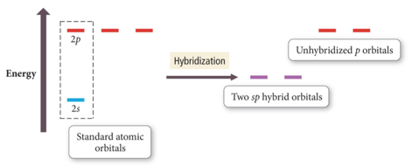

## Formation of sp Hybrid Orbital in Ethyne

* Audio 0:36:27.515559
* 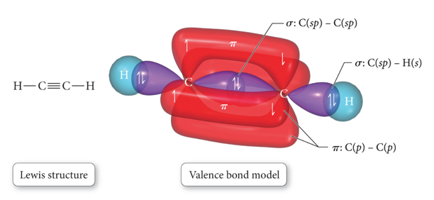

## Predicting Hybridization and Bonding Scheme

* Audio 0:36:53.510663
  1. Start by drawing the Lewis structure.
  2. Use VSEPR theory to predict the electron group geometry around each central atom.
  3. Use Table 7.1 to select the hybridization scheme that matches the electron group geometry.
  4. Sketch the atomic and hybrid orbitals on the atoms in the molecule, showing overlap of the appropriate orbitals.
  5. Label the bonds as σ or π.

## Practice Problem on Hybridization Acetaldehyde: CH3CHO

## Problems with Valence Bond (VB) Theory

* Audio 0:43:09.953460
* VB theory predicts many properties better than Lewis theory.
  + Bonding schemes, bond strengths, bond lengths, bond rigidity
* However, there are still many properties of molecules it doesn’t predict perfectly.
  + Magnetic behavior of O2
* Resonance hybrids: VB theory presumes the electrons are localized in orbitals on the atoms in the molecule, so doesn’t really address resonance structures
* Aka, we still have shortcomings

|  |  |
| --- | --- |
| term | definition |
| hybridization | mixing different types of orbitals in the valence shell to make a new set of degenerate orbitals |
| sp2 hybridization | atom with three electron groups around it (uses nonhybridized p orbital for pi bond) |
| sigma (σ) bond | results when the interacting atomic orbitals point along the axis connecting the two bonding nuclei |
| pi bond | results when the bonding atomic orbitals are parallel to each other and perpendicular to the axis connecting the two bonding nuclei |
| sigma bonds are (stronger or weaker?) than pi bonds | stronger |

Please enable JavaScript to view the [comments powered by Disqus.](https://disqus.com/?ref_noscript)

## CH101-008 UA Fall 2016

* CH101-008 UA Fall 2016
* [jmbeach1@crimson.ua.edu](mailto:jmbeach1@crimson.ua.edu)
* jmbeach
* hey_beach

Notes and study materials for The University of Alabama's Chemistry 101 course offered Fall 2016.