Week 9 - Day 2 (Ch 7 pt 3)

Table of Contents

[CH101-008 UA Fall 2016](/CH101-008/)

[About](/CH101-008/about/)

# Week 9 - Day 2 (Ch 7 pt 3)

Oct 12, 2016

[Quizlet](https://quizlet.com/_2n02mh)

Download Word (docx):

## Navigate using audio

# Announcements

* Audio 0:00:05.264857
* Recitation this evening
  + Intends on going through problems from test 2 that gave people trouble

# Clicker 1

* Audio 0:00:49.953369
* Give the hybridization for the O in OF2
* A) sp
* B) sp3
* C) sp2
* D) sp3d
* E) sp3d2

B

# Clicker 2

* Audio 0:06:22.158125
* Give the hybridization for the S in SO3
  + A) sp
  + B) sp3
  + C) sp2
  + D) sp3d
  + E) sp3d2

C

* Audio 0:08:06.363102

# Clicker 3

* How many of the following molecules have sp2 hybridization on the central atom?
* HCN SO2 OCl2 XeCl2
* A) 4
* B) 3
* C) 2
* D) 1
* E) 0

D

## Ex: Multi-Central Atom Lewis Structures Isomers of C2H4O

* Audio 0:13:35.404261
* Acetaldehyde: CH3CHO,
* Ethenol (aka vinyl alcohol): CH2CHOH
* oxirane (aka ethylene oxide): CH2OCH2
* Audio 0:20:19.010276
* Explaination of the Bonds to O
  + (More complicated example than what you’ll see in this class)

## Molecular Orbital (MO) Theory: Electron Delocalization

* Audio 0:25:00.394253
* In MO theory:
  + Applies Schrödinger’s wave equation to the molecule to calculate a set of *molecular orbitals*
    - The equation solution is estimated.
    - The estimated solution is evaluated and adjusted until the energy of the orbital is minimized.
* In this treatment, the electrons belong to the whole molecule, so the orbitals belong to the whole molecule.
  + Delocalization

## LCAO: Linear Combination of Atomic Orbitals

* Audio 0:28:20.033639
* The simplest guess starts with the atomic orbitals of the atoms adding together to make molecular orbitals; this is called the *linear combination of atomic orbitals (LCAO)* method.
  + Weighted sum
    - 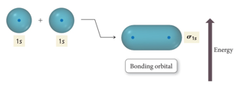
* Because the orbitals are wave functions, the waves can combine either *constructively* or *destructively*.
  + 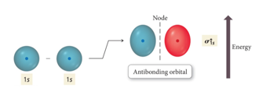

## Molecular Orbitals

* Audio 0:34:23.118169
* When the wave functions combine constructively, the resulting molecular orbital has less energy than the original atomic orbitals
  + Called a *bonding molecular orbital*
  + Designated: σ, π
  + Most of the electron density between the nuclei
* When the wave functions combine destructively, the resulting molecular orbital has more energy than the original atomic orbital.
  + Called an *antibonding molecular orbital*
  + Designated: σ*, π*
  + Most of the electron density outside the nuclei
  + Nodes between nuclei

## Interaction of 1s Orbitals

* 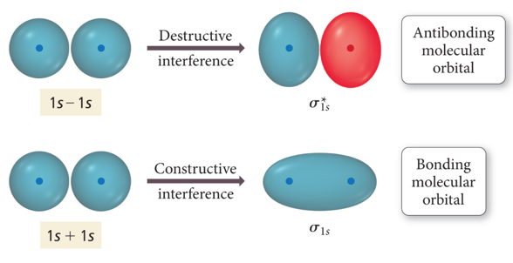

## Molecular Orbital Theory

* Audio 0:35:37.151782
* Use Aufbau approach for MO’s (as we did for individual atoms)
* electrons go into lowest energy MO’s first
* pair up when they have to
* Audio 0:35:48.854160
* Electrons in bonding MOs are stabilizing.
  + Lower energy than the atomic orbitals
* Electrons in antibonding MOs are destabilizing.
  + Higher in energy than atomic orbitals
  + Electron density located outside the internuclear axis
  + Electrons in antibonding orbitals cancel stability gained by electrons in bonding orbitals.

## MO and Properties

* Audio 0:36:16.115964
* Bond order = ½ (# Bonding Electrons – # Antibonding Electrons)
* Bond order = difference between number of electrons in bonding and antibonding orbitals
  + Only need to consider valence electrons
  + Audio 0:37:10.304038
  + May be a fraction
  + Higher bond order = stronger and shorter bonds
  + If bond order = 0, then the bond is unstable compared to individual atoms and no bond will form.
* A substance will be paramagnetic if its MO diagram has unpaired electrons.
  + If all electrons are paired, it is diamagnetic.
* Audio 0:38:35.652895
* Ex:
  + 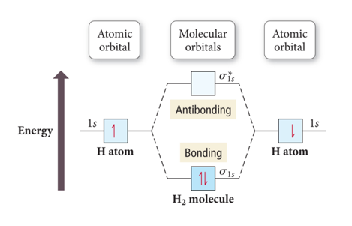
* Bond order = ½ (# Bonding Electrons – # Antibonding Electrons)
* Bond Order H2 = ½ (2 – 0) = 1
  + Corresponds to a sigma bond
  + Also coincides with Lewis models

## Why Doesn’t the Molecule He2 Exist?

* Audio 0:39:48.795249
* 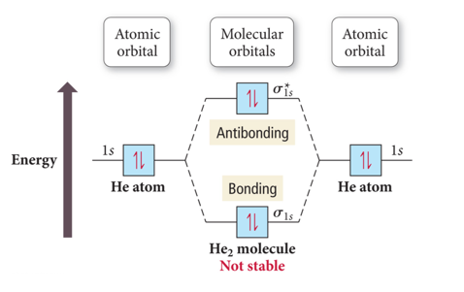
* Bond order = ½ (# Bonding Electrons – # Antibonding Electrons)
* Bond Order He2 = ½ (2 – 2) =0
  + Because the bond order is zero, dihelium doesn’t exist

## Why Does the Molecule He2+ Exist?

* Audio 0:41:11.115795
* 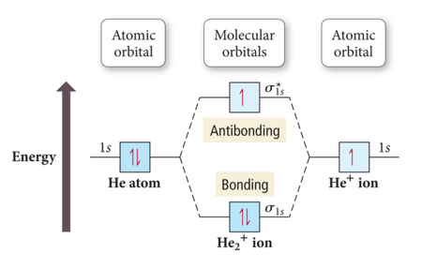
* Bond order = ½ (# Bonding Electrons – # Antibonding Electrons)
* Bond Order He2+ = ½ (2 – 1) =1/2
  + Nonzero, so it works

## Summarizing LCAO–MO Theory

* Audio 0:42:32.896527
* Molecular orbitals (MOs) are a linear combination of atomic orbitals (AOs).
  + The total number of MOs formed from a particular set of AOs always equals the number of AOs in the set.
* When two AOs combine to form two MOs, one MO is lower in energy (the bonding MO) and the other is higher in energy (the antibonding MO).
* When assigning the electrons of a molecule to MOs, we fill the lowest energy MOs first with a maximum of two spin-paired electrons per orbital.
* When assigning electrons to two MOs of the same energy, Hund’s rule is followed to fill the orbitals singly first, with parallel spins, before pairing.
* The bond order in a diatomic molecule is the number of electrons in bonding MOs minus the number in antibonding MOs divided by two.
  + Stable bonds require a positive bond order (more electrons in bonding MOs than in antibonding MOs).
* MOs are named by type: σ, π, with a subscript to indicate what AOs they were formed from.

## Practice Problem on Bond Order H2-

* Audio 0:44:01.684960

## Period Two Homonuclear Diatomic Molecules

* 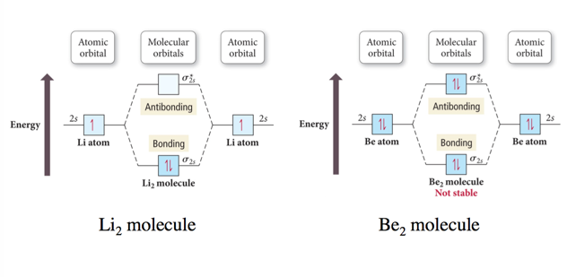

## Interaction of p Orbitals

* 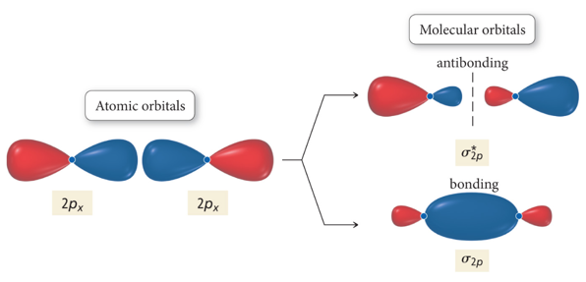
* 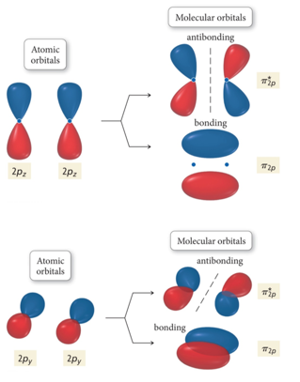

## Molecular Orbital Energy Ordering

* 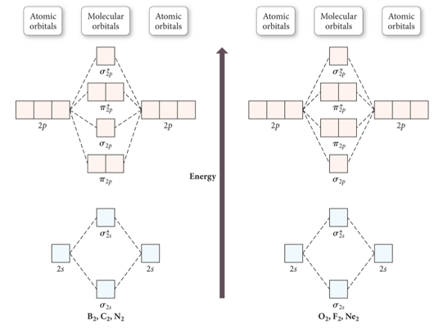

## Practice Problem on Molecular Orbital Theory N2- ion. Determine the electron configuration, and whether the ion is para or diamagnetic

## Molecular Orbital Energy Diagrams for SecondPeriod-p-Block Homonuclear Diatomic Molecules

* 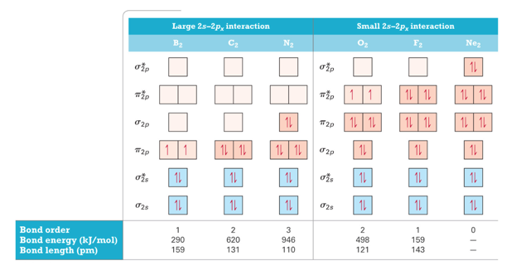
* 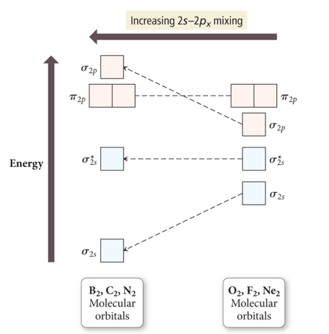

## Heteronuclear Diatomic Molecules and Ions

* When the combining atomic orbitals are identical and of equal energy, the contribution of each atomic orbital to the molecular orbital is equal.
* When the combining atomic orbitals are different types and energies, contributions to the MOs are different:
* The more electronegative an atom is, the lower in energy are its orbitals.
* Lower energy atomic orbitals contribute more to the bonding MOs.
* Higher energy atomic orbitals contribute more to the antibonding MOs.
* Nonbonding MOs remain localized on the atom donating its atomic orbitals.

## Second-Period Heteronuclear Diatomic Molecules

* 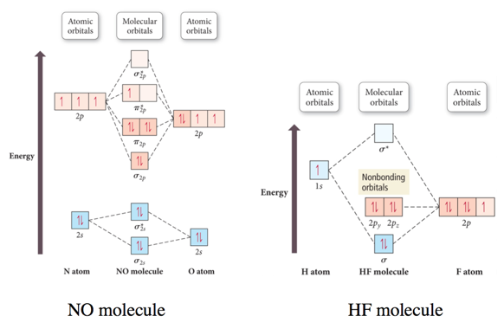

## Practice Problem on Molecular Orbital Theory CN-

## MO and Polyatomic Molecules

* When many atoms are combined together, the atomic orbitals of all the atoms are combined to make a set of molecular orbitals, which are delocalized over the entire molecule.
* Gives results that better match real molecule properties than either Lewis or valence bond theories
* 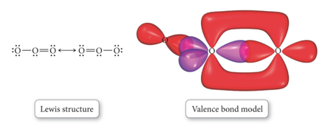
* 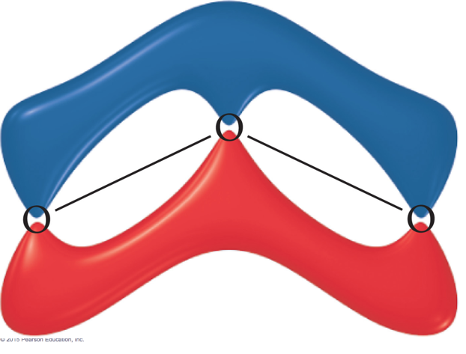
* 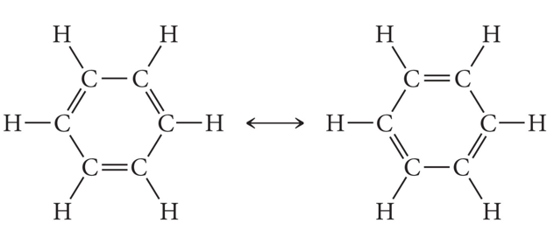

## Bonding in Metals and Semiconductors

## Bonding in Metals and Semiconductors

* The simplest theory of metallic bonding involves the metal atoms releasing their valence electrons to be shared as a pool by all the atoms/ ions in the metal.
  + An organization of metal cation islands in a sea of electrons
  + Electrons delocalized throughout the metal structure
* Bonding results from attraction of cation for the delocalized electrons.
  + 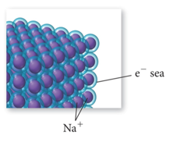
* 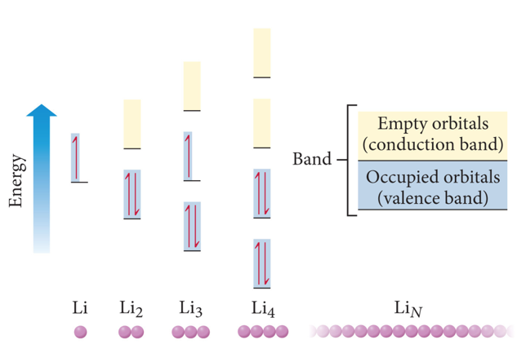

## Semiconductors and Band Theory

* Band Theory:
* Electrons become mobile when they make a transition from the highest occupied molecular orbital into higher energy empty molecular orbitals.
* These occupied molecular orbitals are referred to as the valence band.
* The unoccupied orbitals the conduction band.
* 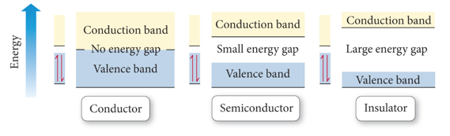
* 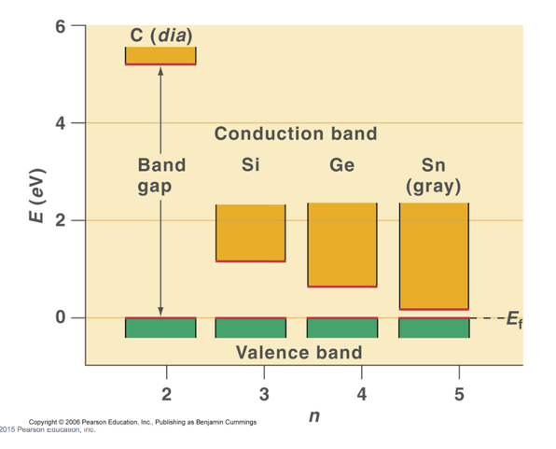
* 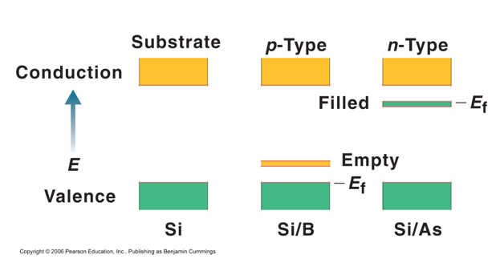

# Vocab

|  |  |
| --- | --- |
| molecular orbital theory | applies Schrödinger’s wave equation to the molecule to calculate a set of molecular orbitals |
| molecular orbital | orbitals which hold electrons which belong to an entire molecule |
| linear combination of atomic orbitals (LCAO) | weighted sum of orbitals which helps predicting the optimal energy/shape of orbitals (aka let’s take 10% of s and 90% of p) |
| bonding molecular orbital | molecular orbitals which have wave functions which combine constructively |
| bonding molecular orbitals result in an orbital which has (more or less?) energy than the originals | less |
| antibonding molecular orbitals | bonding molecular orbitals which have wave functions which combine destructively |
| bond order | half of the difference of the number of bonding electrons and antibonding electrons |

Please enable JavaScript to view the [comments powered by Disqus.](https://disqus.com/?ref_noscript)

## CH101-008 UA Fall 2016

* CH101-008 UA Fall 2016
* [jmbeach1@crimson.ua.edu](mailto:jmbeach1@crimson.ua.edu)
* jmbeach
* hey_beach

Notes and study materials for The University of Alabama's Chemistry 101 course offered Fall 2016.