Week 9 - Day 3 (Ch 7 - pt 4)

Table of Contents

[CH101-008 UA Fall 2016](/CH101-008/)

[About](/CH101-008/about/)

# Week 9 - Day 3 (Ch 7 - pt 4)

Oct 14, 2016

[Quizlet](https://quizlet.com/_2nazid)

Download Word (docx):

## Navigate using audio

# Clicker 1

* Audio 0:00:26.347467
* Give the hybridization for the C in C2F2
  + A) sp3d2
  + B) sp3d
  + C) sp3
  + D) sp2
  + E) sp

E. The lewis structure is linear because of the tripple bond between the two carbon atoms. Linear = sp

## Period Two Homonuclear Diatomic Molecules

* Audio 0:03:34.227150
* 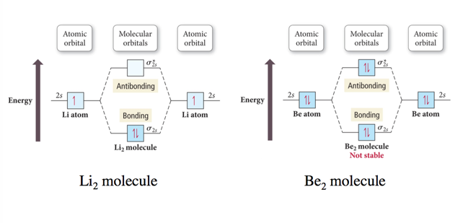
  + Exactly the same as 1s

## Interaction of p Orbitals

* Audio 0:06:30.224293
* 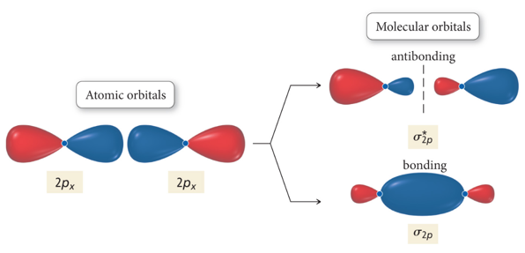
  + blue bond called sigma bond because it is symmetric
* 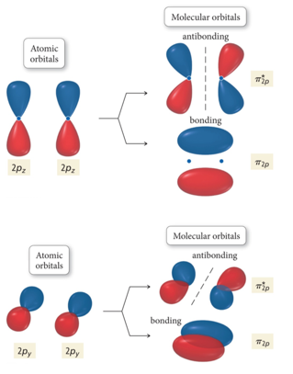
  + Called 2px and 2py because of rotation

## Molecular Orbital Energy Ordering

* Audio 0:10:03.432001
* 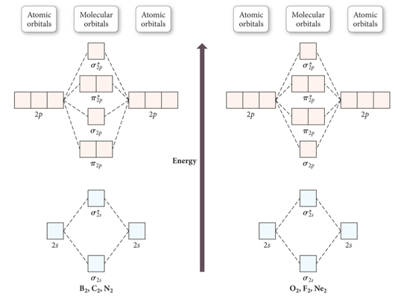
  + Complete diagram for determining molecular orbital energy ordering for <= 2p orbitals

## Practice Problem on Molecular Orbital Theory N2- ion. Determine the electron configuration, and whether the ion is para or diamagnetic

* Audio 0:12:43.087962

## Molecular Orbital Energy Diagrams for SecondPeriod-p-Block Homonuclear Diatomic Molecules

* Audio 0:13:49.174841
* 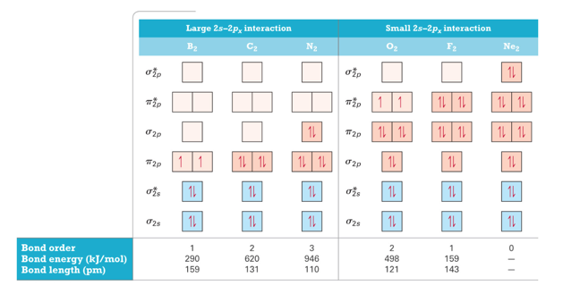
  + Molecular orbital theory accurately predicts magnetism because it shows the unbonded electrons
  + Also gets the bond order correct
* Audio 0:18:39.294522
* 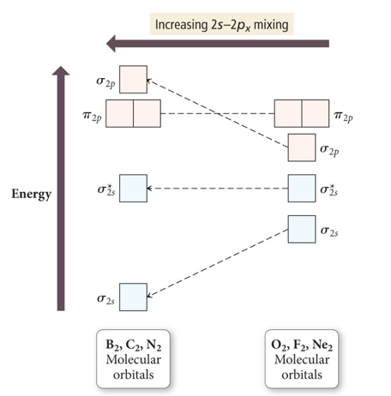
  + Mixing orbitals to get optimal energy

## Heteronuclear Diatomic Molecules and Ions

* Audio 0:20:09.219234
* When the combining atomic orbitals are identical and of equal energy, the contribution of each atomic orbital to the molecular orbital is equal.
* When the combining atomic orbitals are different types and energies, contributions to the MOs are different:
* The more electronegative an atom is, the lower in energy are its orbitals.
* Lower energy atomic orbitals contribute more to the bonding MOs.
* Higher energy atomic orbitals contribute more to the antibonding MOs.
* Nonbonding MOs remain localized on the atom donating its atomic orbitals.

## Second-Period Heteronuclear Diatomic Molecules

* Audio 0:23:28.652003
* 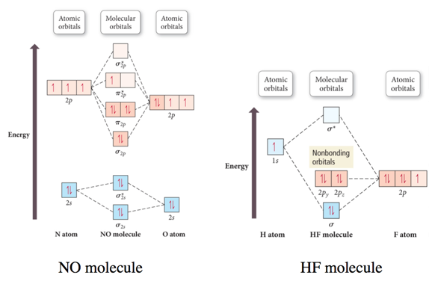

## Practice Problem on Molecular Orbital Theory CN-

## MO and Polyatomic Molecules

* Audio 0:26:43.466301
* When many atoms are combined together, the atomic orbitals of all the atoms are combined to make a set of molecular orbitals, which are delocalized over the entire molecule.
* Gives results that better match real molecule properties than either Lewis or valence bond theories
* 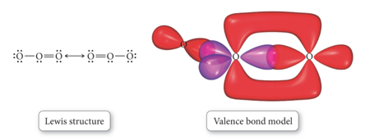
* 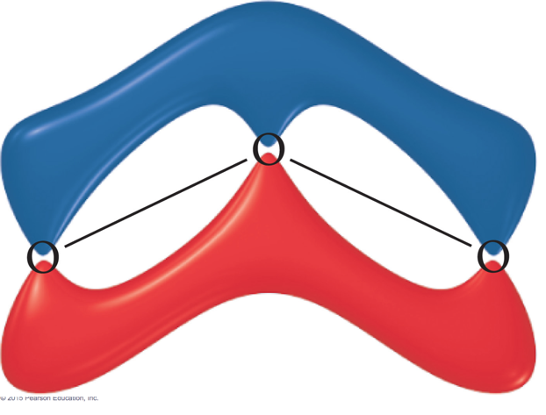
* 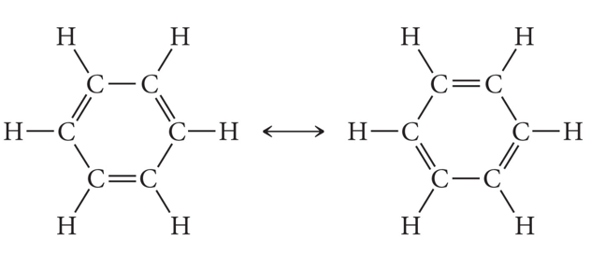

## Bonding in Metals and Semiconductors

* Audio 0:28:15.434098
* 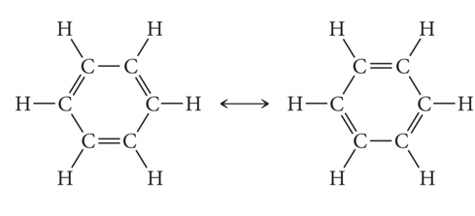
* 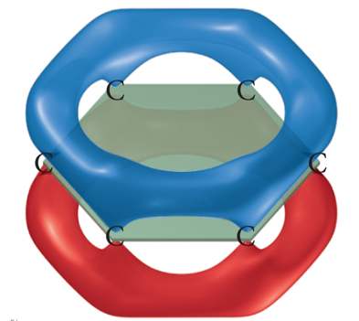

# Clicker 2

* Audio 0:29:39.260232
* How many p-orbitals participate in the Molecular orbitals in Benzene and how many MOs does this give?
  + A) 0
  + B) 2
  + C) 4
  + D) 6
  + E) 12

D

## Bonding in Metals and Semiconductors

* Audio 0:32:35.553208
* The simplest theory of metallic bonding involves the metal atoms releasing their valence electrons to be shared as a pool by all the atoms/ ions in the metal.
* An organization of metal cation islands in a sea of electrons
* Electrons delocalized throughout the metal structure
* Bonding results from attraction of cation for the delocalized electrons.
* 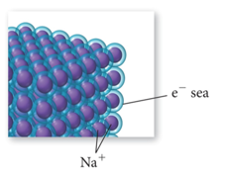
* Audio 0:33:43.544569
* 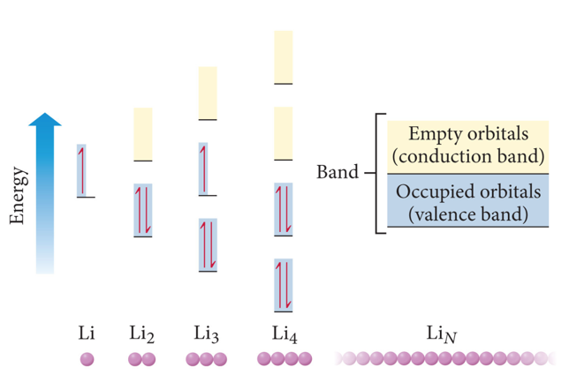

## Semiconductors and Band Theory

* Audio 0:35:46.508773
* Band Theory:
* Electrons become mobile when they make a transition from the highest occupied molecular orbital into higher energy empty molecular orbitals.
* These occupied molecular orbitals are referred to as the valence band.
* The unoccupied orbitals the conduction band.
* 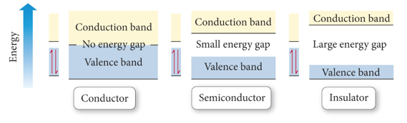
  + silicon is an insulator because it has a large energy gap between the valence band to the conduction band of orbitals
  + conductors have no gap
* Audio 0:37:16.124083
* 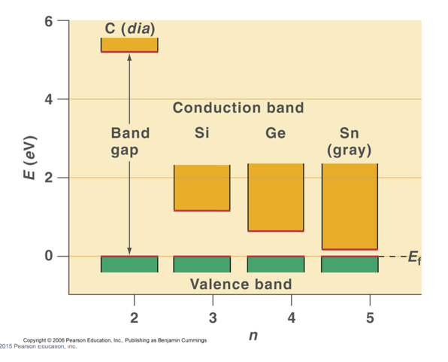
  + Bigger the gap, the less conduction
    - The funny thing is that silicon is the thing we use for conduction in transistors
      * We add stuff
* Audio 0:38:21.396460
* 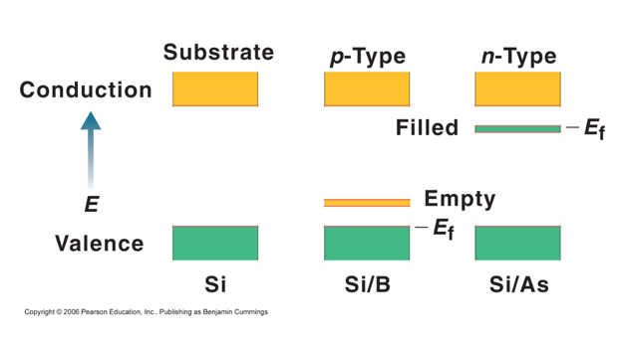
  + We add a little boron and it gives an empty orbital between the valence and the conduction bonds and allows for conduction
    - They can hop into the empty orbital

# End of Ch 7

* You must finish the homework

# Vocab

|  |  |
| --- | --- |
| Term | Definition |
| (lower or higher?) energy atomic orbitals contribute more to the bonding MOs | lower |
| (lower or higher?) energy atomic orbitals contribute more to the antibonding MOs | higher |
| band | when many orbitals are present, their energy difference becomes relatively small and we refer to them as this |

Please enable JavaScript to view the [comments powered by Disqus.](https://disqus.com/?ref_noscript)

## CH101-008 UA Fall 2016

* CH101-008 UA Fall 2016
* [jmbeach1@crimson.ua.edu](mailto:jmbeach1@crimson.ua.edu)
* jmbeach
* hey_beach

Notes and study materials for The University of Alabama's Chemistry 101 course offered Fall 2016.