Week 11 - Day 1 (Ch 13 Pt 1 Emotions and Their Functions)

[PY 101-012 - Spring 2016 (UA)](/PY101-012/)

[About](/PY101-012/about/) [Quizlets](https://quizlet.com/class/2412410/) [Research](http://researchpool.psych.ua.edu/) [Calendar](https://calendar.google.com/calendar/embed?src=ioed8v0sm1d4hooimq4e12eq7c%40group.calendar.google.com&ctz=America%2FChicago)

# Week 11 - Day 1 (Ch 13 Pt 1 Emotions and Their Functions)

Mar 28, 2016

Download Word (docx):

[Quizlet on terms from this lecture](https://quizlet.com/_25ajf0)

# Emotions & Their Functions

## Questions

* What are emotions?
* How do we know what
  + emotions we are
  + feeling?
* How do we communicate our emotions?
* How do we recognize emotions in others?
* What happens when we recognize emotions in other people?
* What functions do emotions serve?
* How might emotions have provided evolutionary benefits?

## The Components of Emotioin

* Physiological changes
  + Face
  + Brain
  + Body
* Cognitive processes
  + Beliefs & understandings
  + Why do we feel the way we do
  + Labeling our own emotions
* Action tendencies
  + Fight or flight
  + Embrace or withdraw
* Culture and social context play a role

Audio 0:03:12

## Positive & Negative Emotions

* Independent
  + Can feel them both at the same time
  + Different neurotransmitters:
    - Positive = dopamine (the reward chemical)
    - Negative = norepinephrine
  + Graduation: May feel happy & sad cry either way
  + 

## Two Main Types of Emotions

1. Primary Emotions
2. Secondayr Emotions
   * 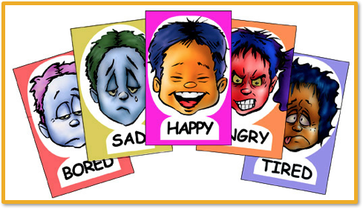

## Primary Emotions

* Five to Seven:
  + (Audio 0:06:50)
  + Fear, sadness, happiness/joy, disgust, anger
  + Maybe surprise and/or contempt
* Evolutionarily adaptive
* Shared across cultures
* Associated with specific physical states
* 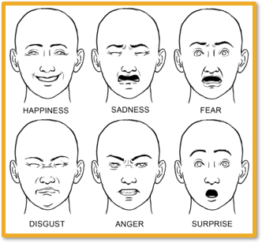
* 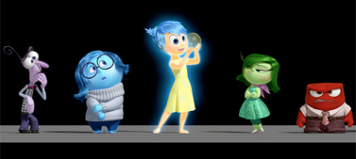
* These emotions are universal
  + Some are more associated with specific states
  + Inside Out is actually fairly accurate

## Secondary Emotions

Audio 0:08:40 + Secondary emotions are blends of primary emotions + Examples: Remorse, guilt, submission, pride, shame, embarrassment, anticipation, relief, disappointment, nervousness, etc. + Anger + sadness = guilt + 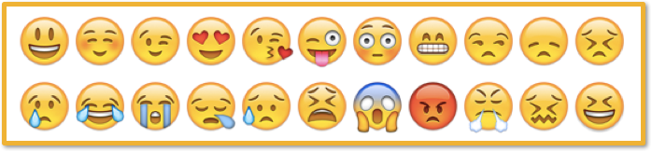

## Grimace Project

* 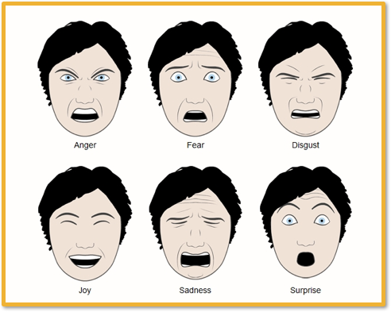
* [grimace project](http://www.grimace-project.net/)

## Circumplex Model

* Audio 0:11:13
  + Two axes:
  + Valence: Positive or negative
  + Activation: Aroused or not aroused
    - Physiological state that may include increased brain activity and/or autonomic arousal (increased heart rate, sweating, muscle tension, etc.)
    - 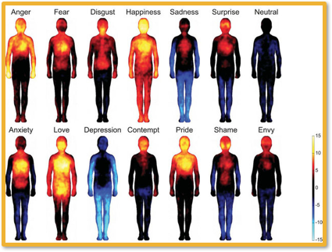
    - With depressive emotions, you kind of lose ability to use some of your extremeties
    - 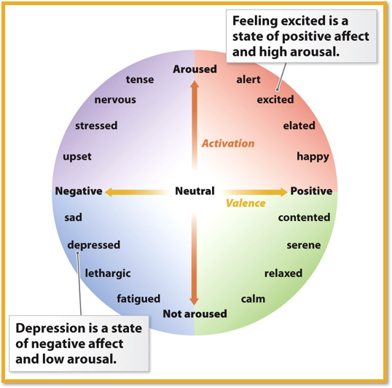
      * Ex: depressed, not fun, not arroused
      * happy: aroused and positive

## How do we experience emotions?

Audio 0:14:30 + Three theories + James-Lange Theory + Cannon-Bard Theory + The Schachter-Singer 2-Factor Theory

## James-Lange Theory

* Physical change leads person to feel an emotion 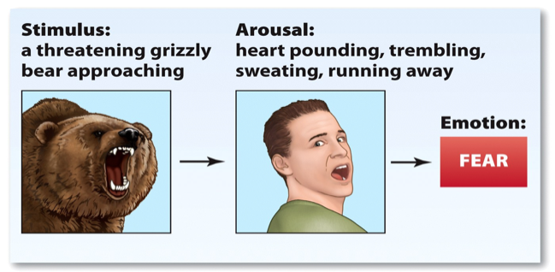

## Facial Feedback Hypothesis

* Mold facial muscles to mimic an emotion: activate the associated emotion
  + Facial expression triggers the experience of the emotion
  + 
    - People holding it like the girl on the left found jokes funnier than people holding it like the girl on the right
* “Fake it until you make it”
  + Audio 0:18:50
  + Therapy technique for depression
  + Going through routines of life as if one enjoys them actually enjoying them
* Laughter Yoga
  + Prolonged voluntary laughter performed in groups, emphasizing eye contact and playfulness
  + [https://www.youtube.com/watch?v=-ZvYBjbWXR0](https://www.youtube.com/watch?v=-ZvYBjbWXR0]) + when you make yourself laugh, it makes you happier

## Cannon-Bard Theory

Audio 0:21:00 + Experience two separate things at roughly the same time: an emotion & a physical reaction + Describes that the reactions are not because of the stimulus, it’s the emotion + 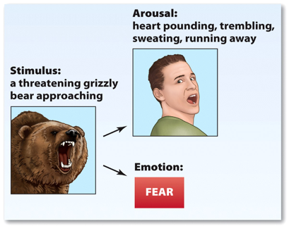

## The Schacter-Singer 2-Factor Theory

* How arousal is labeled determines the experience of emotion
  + **Appraisals**: beliefs, perceptions, expectations, and judgments that people use to explain their own and others’ behaviors, including which emotion a person will feel in a given circumstance
  + 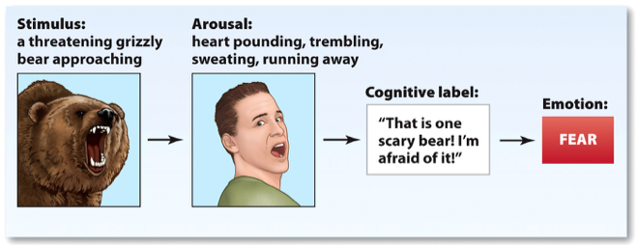

## Misattribution of Arousal

bridge story

## Excitation Transfer

* Rollercoasters, movies, etc. Cause you to be aroused and intensify your emotions. Might make you more attracted or passionate about the people around you

## Emotions are Adaptive

Audio 0:32:05 + Facial Expressions Communicate Emotion + Emotions Serve Cognitive Functions + Decision Making + Emotions Strengthen Interpersonal Relations + Guilt Strengthens Social Bonds + Discourages damaging behavior encourages positive interpersonal + behavior (motivation) + Signal of closeness and caring to other person + Manipulation tactic

## Facial Expressions

* Use others’ facial expressions to predict their behavior
* Clues about whether our behavior is acceptable and pleasing to others
  + Rejection
  + Attack
  + Affiliation
* Most important:
  + Eyes
  + Mouth 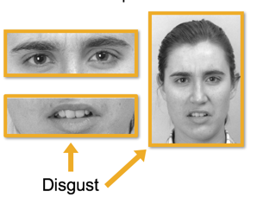

Vocab

|  |  |
| --- | --- |
| Term | Definition |
| fear, sadness, joy, disgust, anger | Primary emotions |
| excitation transfer | The effect of arousing things on your emotions toward the people around you |
| Components of emotions | includes physiological changes, cognitive processes, and action tendencies |
| Secondary emotions | includes guilt, pride, shame, etc. |
| Circumplex model | Model with two axes which describes the physical activation of parts of the body by specific emotions |
| James-Lange Theory | Theory of emotion that says physical change leads person to feel emotion |
| Facial Feedback Hypothesis | Hypothesis that says making a face associated with an emotion will make you feel that emotion |
| Cannon-Bard Theory | Theory of emotion that says emotional expression and feeling emotion happen independently. |
| The Schachter-Singer 2-Factor Theory | Theory of emotion that says how we label emotion determines how we experience it |
| Appraisals | Beliefs, perceptions, expectations, and judgments that people use to explain their own and others’ behaviors |

## PY 101-012 - Spring 2016 (UA)

* PY 101-012 - Spring 2016 (UA)
* [jmbeach1@crimson.ua.edu](mailto:jmbeach1@crimson.ua.edu)
* facebook group
* jmbeach

Website for notes and other study materials from University of Alabama's Pyschology 101 section 012 Spring 2016