Week 11 - Day 2 (Ch 13 Pt 2 Emotions & Stress)

Table of Contents

[PY 101-012 - Spring 2016 (UA)](/PY101-012/)

[About](/PY101-012/about/) [Quizlets](https://quizlet.com/class/2412410/) [Research](http://researchpool.psych.ua.edu/) [Calendar](https://calendar.google.com/calendar/embed?src=ioed8v0sm1d4hooimq4e12eq7c%40group.calendar.google.com&ctz=America%2FChicago)

# Week 11 - Day 2 (Ch 13 Pt 2 Emotions & Stress)

Mar 30, 2016

Download Word (docx):

Download PDF:

## Navigate using audio

[Quizlet on terms from this lecture](https://quizlet.com/_25n1bl)

## Differences Across Cultures

## Social Emotions

* Feel embarrassed after violating a cultural norm, losing physical poise, being teased, or experiencing a threat to his or her self-image
* Like guilt, embarrassment may reaffirm close relationships after wrongdoing
  + Showing guilt can strengthen relationships
* Recent theory and research suggests that blushing occurs when people believe others view them negatively and that blushing communicates a realization of interpersonal errors
* This nonverbal apology that elicits forgiveness in others, thereby repairing and maintaining relationships
* 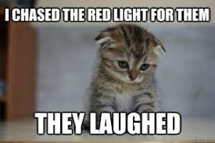

# Stress

## Stress and Health

Audio 0:05:30 + Stress: A pattern of behavioral, psychological, and physiological responses to events that match or exceed an organism’s ability to respond in a healthy way + Eustress: positive stress (e.g., getting into college) + Distress (duress): negative stress (e.g., being late to a meeting) + Stressor: An environmental event or stimulus that threatens an organism + Major life stressors: strain central areas of people’s lives + Daily hassles: day-to-day irritations and annoyances + Coping response: response an organism makes to avoid, escape from, or minimize an aversive stimulus

## Yerkes-Dodson Law

Audio 0:08:00 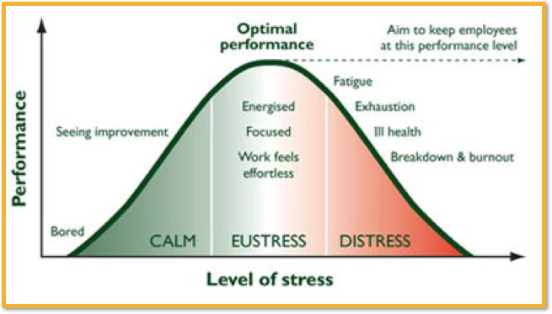

## An Example: Cold Pressor Task

Audio 0:09:40

* Stressor
  + Ice-cold water
* Stress
  + Worrying/thinking about pain
  + Shallow breathing, tightening muscles
* Coping Response
  + Distraction, talking
  + Withdrawing hand from water
* 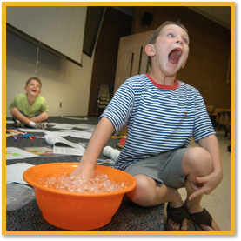

## General Adaptation Syndrome

Audio 0:12:00

* Consistent pattern of responses to stress that consists of three stages:
  + Alarm: emergency reaction that prepares body to fight or flee
    - Body is most likely to be exposed to infection & disease
  + Resistance: defenses prepare for longer, sustained attack against stressor
    - Immunity somewhat increases as body maximizes defenses
  + Exhaustion: variety of physiological and immune systems fail
    - Organs weak before stress are first to fail
  + Audio 0:14:45
  + 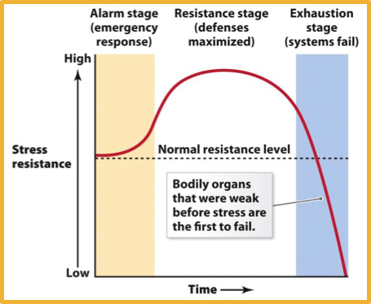

## Newer Models

HPA axis

* Audio 0:16:50
* Hypothalamus-pituitary-adrenal cortex axis
* A system activated to energize the body to respond to stressors
* The hypothalamus sends chemical messengers to the pituitary gland
* The pituitary gland prompts the adrenal cortex to produce cortisol and other hormones
* 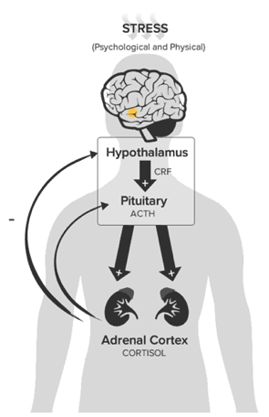

## Stress Responses

* Typical Automatic Responses to Stress:
* Fight-or-flight (male-typical)
  + Increased heart rate, redistribution of blood to muscles and brain, deepening of respiration, dilation of the pupils, inhibition of gastric secretions, and increase in glucose released from the liver Audio 0:20:23
* Tend-and-befriend (female-typical)
  + Protecting and caring for offspring, forming alliances with social groups to reduce risk of threat
  + It is possible that the release of oxytocin during social stress encourages women to affiliate with or befriend others
* Stress alters the functions of the immune system Audio 0:24:30
  + Psychoneuroimmunology: field in which the response of the body’s immune system to psychological variables is studied
  + Short-term stress boosts the immune system; chronic stress weakens it
    - Healthy volunteers had cold viruses swabbed into their noses. Those who reported the highest levels of stress prior to exposure developed worse cold symptoms than those who reported being less stressed (Cohen et al., 1991).

## Stress and the Common Cold

* 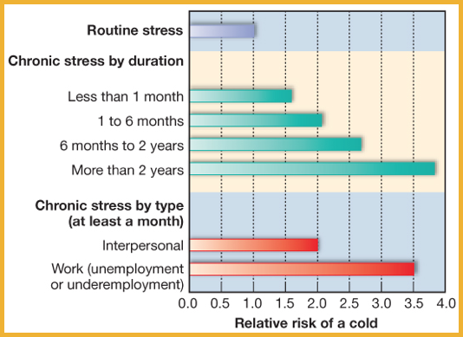

## Stress Responses

Audio 0:28:00

* Over the long term stress hormones negatively affect health
  + Chronic stress, especially psychosocial stress, is associated with the initiation and progression of a wide variety of diseases, from cancer to AIDS to cardiac disease
    - e.g., stressful jobs, poverty
  + Many people cope with stress by engaging in damaging behaviors (e.g., smoke, drink alcohol, use drugs, eat junk food)

## Stress & Heart Disease

Audio 0:33:10

* Key predictors are health behaviors and personality traits related to the way people respond to stress
  + Health behaviors:
    - Lack of exercise, obesity, smoking
  + Personality traits:
    - Type A people are competitive, achievement oriented, aggressive, hostile, impatient, and time-pressed
    - Type B people are noncompetitive, relaxed, easygoing, accommodating people
* Negative traits (e.g., hostility) and states (e.g., depression) combine to promote coronary heart disease

# Coping With Stress

Audio 0:34:30

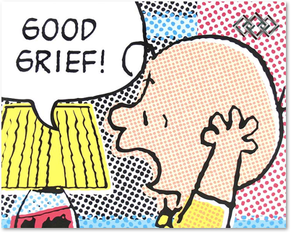

* To deal effectively with stressors we use cognitive appraisals that link feelings with thoughts
* Two-part cognitive appraisal process:
  + Primary appraisals: Decide whether stimuli are stressful, benign, or irrelevant
  + Secondary appraisals: Once an event perceived as stressful, evaluate response options and choose coping strategies
    - Once you decide it’s stressful, how you cope
* Anticipatory coping: coping that occurs before the onset of a future stressor
  + You know it’s going to happen eventually, so you get ready for it
* Two general coping categories:
  + Emotion-focused coping: a type of coping in which people try to prevent having an emotional response to a stressor
    - Tries to prevent having a response
    - Try to rationalize a stressor
    - If you are doing poorly in a class, you might avoid going to class
      * You might assert that you don’t need to go to class to get a job
  + Problem-focused coping: a type of coping in which people take direct steps to confront a stressor or problem-solve
    - You’re doing poorly in a class, so you study even harder
    - Goal oriented
  + Most people use both emotion-focused coping and problem-focused coping
* Two strategies can facilitate positive thinking using positive reappraisal:
  + Learning from the experience
  + Making social comparisons + Downward social comparisons are “At least I don’t have xyz problem” + Even people with cancer will do this and say “Well at least I don’t have a worse kind of cancer” + Upward social comparison: Look at a person who’s in the same situation as you, but doing better and asking why
* Social support! Audio 0:38:00
  + Friends, family members, neighbors, co-workers
  + How might these relationships help to reduce stress?
    - Concern and affection
    - Provide different perspectives
    - Offer resources (e.g., money, help)
  + Biological impacts
    - High social support heart rate and stress hormone levels normalize more quickly
    - Low social support chronic inflammation

## Coping with Stress: Individual Differences

* People differ in their perceptions of the amount of stress associated with various life events
* Stress resistant (“hardy”) people capable of adapting to life changes by viewing events constructively
  + “Hardiness” has three components:
    - Commitment, Challenge, and Control
* Stress-resilient people greater emotional flexibility and recover from threats more quickly than do those low in resilience
* Some researchers believe that people can learn to become more resilient
  + Understanding when emotions are adaptive, learning to regulate emotions, and working on relationships with others

## Coping Examples

* Anti-Stress Video Game
* Exercise
* Meditation
* …what else?

## Meditation

* Focus attention on external object or sense of awareness
* Develop deep sense of tranquility
* Goal: Quiet internal “voices”
* Two general kinds:
  + Concentrative meditation: Focus on one thing (breathing, mental image, mantra)
  + Mindfulness meditation: Thoughts and emotions flow freely, paying attention to them, but not reacting to or judging them
* Possible benefits of meditation:
  + Lower blood pressure
  + Improved blood lipids
  + Improved insulin resistance
  + Buffered against sadness
  + Preserved cognitive functioning in aging
  + Attention benefits
* 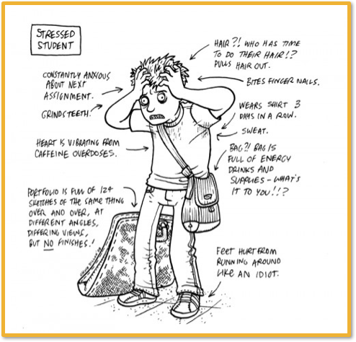
* 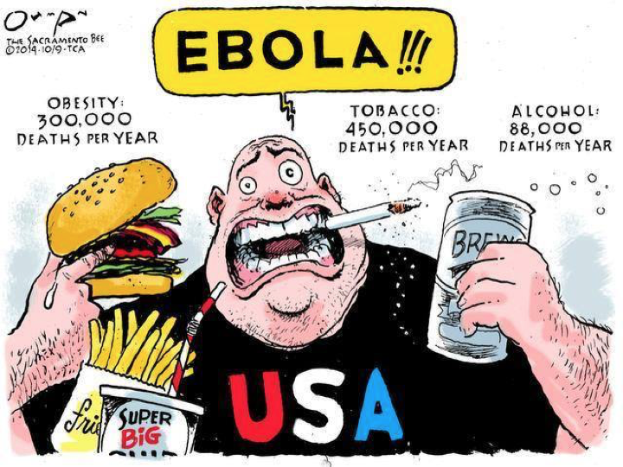

Vocab

|  |  |
| --- | --- |
| Term | Def |
| Stress | pattern of behavior, psychological and physiological responses to events that match or exceed an organism’s ability to respond in a healthy way |
| eustress | positive stress (ex: getting into college) |
| distress | negative stress (ex: being late to meeting) |
| stressor | environmental stimulus that threaten organisms |
| Coping response | response an organism makes to avoid, escape from, or minamize aversive stimuli |
| Yerkes-Dodson Law | Law that says stress increases performance to an extent until it becomes distressful |
| Cold Pressor Task | Task which is designed to make you stressed by making you put your hand in ice cold water (look at coping responses) |
| Alarm | emergency reaction that prepares body to fight or flee |
| Resistance | defenses prepare for longer, sustained attack against stressor |
| Exhaustion | variety of physiological and immune systems fail |
| HPA axis | System activated to energize the body to respond to stressors |
| Fight-or-flight | Response to stress in which heart rate increases and blood is distributed to muscles and brain |
| Tend-and-befriend | Reaction to stress in which the stressed individual protects and cares for offspring and forms alliances with groups to reduce risk of threat. |
| Psychoneuroimmunology | field in which the response of the body’s immune system to psychological variables is studied |
| Type A personality | personality which is competitive, achievement oriented, aggressive, hostile, impatient, and time-pressed |
| Type B personality | personality which is noncompetitive, relaxed, easygoing, and accommodating |
| Primary appraisals | Decide whther stimuli are stressful, benign, or irrelevant |
| Secondary appraisals | Evaluate response options and choose coping strategies once an event is perceived as stressful |
| Emotion-focused coping | a type of coping in which people try to prevent having an emotional response to a stressor |
| Problem-focused coping | a type of coping in which people take direct steps to confront a stressor or problem-solve |
| Concentrative meditation | Meditation which focuses on one thing (breathing, mental image, mantra) |
| Mindfulness meditation | Meditation in which thoughts and emotions flow freely, paying attention to them, but not reacting to them or judging them |

## PY 101-012 - Spring 2016 (UA)

* PY 101-012 - Spring 2016 (UA)
* [jmbeach1@crimson.ua.edu](mailto:jmbeach1@crimson.ua.edu)
* facebook group
* jmbeach

Website for notes and other study materials from University of Alabama's Pyschology 101 section 012 Spring 2016