Week 11 - Day 3 (Ch 5 pt 1 Sleep)

Table of Contents

[PY 101-012 - Spring 2016 (UA)](/PY101-012/)

[About](/PY101-012/about/) [Quizlets](https://quizlet.com/class/2412410/) [Research](http://researchpool.psych.ua.edu/) [Calendar](https://calendar.google.com/calendar/embed?src=ioed8v0sm1d4hooimq4e12eq7c%40group.calendar.google.com&ctz=America%2FChicago)

# Week 11 - Day 3 (Ch 5 pt 1 Sleep)

Apr 1, 2016

Download Word (docx):

## Navigate using audio

[Quizlet on terms from this lecture](https://quizlet.com/_25v1qe)

Audio 0:02:10 Announcements

# Finishing up stress

## Coping Examples:

* Anti-Stress Video Game
* Exercise
* Meditation
* …what else?

## Meditation

* Focus attention on external object or sense of awareness
* Develop deep sense of tranquility
* Goal: Quiet internal “voices”
* Two general kinds:
  + Concentrative meditation: Focus on one thing (breathing, mental image, mantra)
  + Mindfulness meditation: Thoughts and emotions flow freely, paying attention to them, but not reacting to or judging them + Audio 0:05:33 + Don’t allow yourself to become to become emotionally involved in your thoughts
* Possible benefits of meditation:
  + Lower blood pressure
  + Improved blood lipids
  + Improved insulin resistance
  + Buffered against sadness
  + Preserved cognitive functioning in aging
  + Attention benefits
    - (Covered the above vocab in last notes)

## Coping with Stress: Individual Differences

* People differ in their perceptions of the amount of stress associated with various life events
* Stress resistant (“hardy”) people capable of adapting to life changes by viewing events constructively
  + “Hardiness” has three components:
    - Commitment, Challenge, and Control
* Stress-resilient people greater emotional flexibility and recover from threats more quickly than do those low in resilience
* Some researchers believe that people can learn to become more resilient
  + Understanding when emotions are adaptive, learning to regulate emotions, and working on relationships with others
* 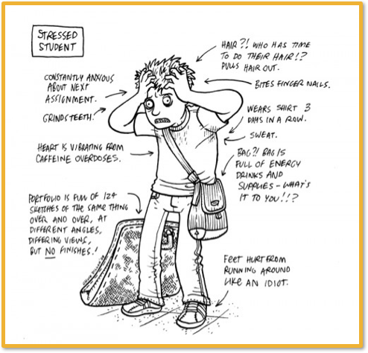
* 

# Sleep

## Body Rhythms

* Biological rhythms
  + Periodic, more or less regular fluctuations in a biological system
  + May or may not have psychological implications
  + Come from different sources
    - External stimuli (e.g., daylight, temperature)
    - Endogenous: generated from within rather by external cues
* Examples
  + Bears – hibernation
  + Bird – migration
    - Seasonal motive to fly south
  + Humans – testosterone peaks in the fall and dips in the spring

Audio 0:12:50

## Circadian Rhythms

* Biological rhythms within a period of about 24 hours
  + From peak to peak, from trough to trough
  + Related to changes in light, air pressure, and temperature
  + Affects hormone levels, urine levels, blood pressure, etc.
* Controlled by the suprachiasmatic nucleus (SCN)
  + Receptors in the back of the eye SCN tells brain and body how to adapt
  + Feedback loop between SCN and hormones/neurotransmitters
    - SCN as controller
    - Example: melatonin (sleep-inducing hormone)
      * Audio 0:15:45

## Synchronization

* Sometimes fall out of sync
  + Internal desynchronization: a state in which biological rhythms are not in phase with one another
  + Examples:
    - Traveling across multiple time zones (i.e., jet lag)
    - Staying up all night
  + Sleep and wake patterns adjust quickly; temperature and hormone cycles may take several days to normalize
    - Audio 0:18:00

## Long-term Rhythms

* Some body rhythms may take place over longer periods of time
  + Seasonal affective disorder (SAD)
    - Sadness, lethargy, and drowsiness related to low light in winter months
    - Often treated with phototherapy (sitting in front of fluorescent light for brief intervals)
  + Menstrual cycle
    - On average, 28-day cycle
    - Hormone changes related to possible conception
      * Changes in hormone could be relative to mood
      * Audio 0:20:30

# Sleep

## What is Sleep?

* State of consciousness in which awareness of the outside world is mostly turned off
  + The brain may not be aware of its surroundings, but it does not “shut down”
* Sleep is a part of the normal rhythm of life
  + Circadian rhythms
  + The secretion of melatonin, which helps people fall asleep, is linked to light-dark cycles
  + Sleep habits vary widely
    - Some adults report needing 7 – 9 hours a night
      * Audio 0:22:00
      * Sleeping too much can actually make you develop psychological problems
    - Some adults only need 1 – 2

## Stages of sleep

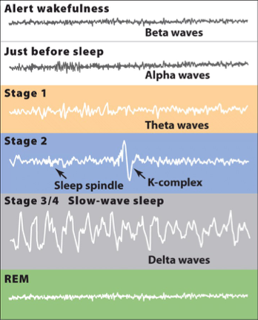

* alpha waves just before sleep
  + stage 1
    - you could wake up from this and not ever know you were asleep
      * might feel like you’re falling
      * might seel interesting colors or shapes
  + stage 2
    - become more resiliant to external stimuli
    - still atuned to alarm clock, baby crying, etc
    - sleep spindles
      * sudden bursts of activity in the brain
        + we think it’s the brain actively trying to keep you asleep

we think this because they tend to happen after loud noises

* + - stage 3/4 (slow-wave sleep)
      * deep sleep
      * someone might have to shake you awake
      * Audio 0:28:00
    - REM
      * dreaming
      * Audio 0:34:30

## REM Sleep

* The sleep cycle reverses after about 90 minutes
* Enter REM (paradoxical) stage
  + Instead of waking up from sleep, you go into REM
* Important because most dreaming occurs in REM sleep
* Amount of time spent in REM increases
  + 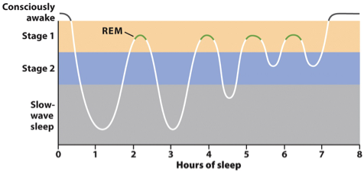
    - You spend less and less time in the other stages

## Sleep Disorders

* **Insomnia**: Difficulty falling or staying asleep
* **Obstructive Sleep Apnea**: Breathing may stop hundreds of times per night
* **Narcolepsy**: Sufferers unexpectedly fall asleep
  + Audio 0:37:30
* **REM Behavior Disorder**: Sufferers act out their dreams
* **Somnambulism**: Sleep walking
  + Happens a lot more with children
  + Interestingly happens more often in slow-wave sleep
  + 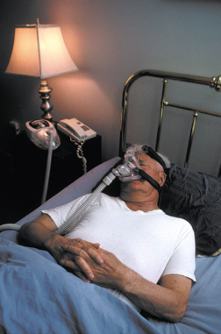

## Why Do We Sleep?

* It’s adaptive, of course!
  + This might seem counterintuitive
* Sleep serves important biological purposes:
  + Restoration
  + Circadian rhythms
  + Facilitation of learning/Consolidation

## Restoration

* **Restorative Theory**: Sleep allows the body to rest and repair itself
* The evidence:
  + Sleep increases after strenuous physical activity
    - Audio 0:40:30
  + Growth hormones secreted in sleep
  + Replenishes the brain’s energy stores
  + Strengthens the immune system
    - immune system tries to repair itself
* **Effects of sleep deprivation**:
  + Mood problems (e.g., irritability)
  + Problems with cognitive performance (e.g., attention and short-term memory lapses)
  + May compromise the immune system
  + Falling asleep for a few seconds to a minute (microsleeps) can impair ability to perform critical tasks (e.g., driving)

## Circadian Rhythms

* **Circadian rhythm theory**:
* Many creatures are quiet and inactive during the night because darkness is the time when danger is highest
* Sleeping reduces risk of exposure to predators
  + 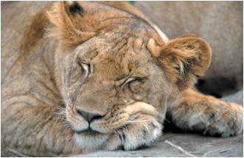
  + Audio 0:44:25

## Facilitation of Learning

* **Sleep** strengthens neural connections needed for learning to occur
  + Research shows memory in participants who slept was greater than those who didn’t
  + REM and slow-wave (stages 3 & 4) important for learning to take place
  + Sleep may assist in problem-solving
    - Volunteers trained on a math procedure that they would on an exam later
    - They were not told about a hidden shortcut that would greatly reduce their work
    - Those that slept for eight hours at night were 3 times more likely to discover the shortcut
      * Audio 0:48:13
  + Students spend more time in REM during exam periods

# Vocab

|  |  |
| --- | --- |
| Term | Def |
| Stress-resilient people | people with greater emotional flexibility who recover from threats quickly |
| biological rhythms | periodic, regular fuctuations in a biological system (sleep, digestion, etc) |
| endogenous | generated from within by external cues (urine volume, blood pressure, etc) |
| Circadian rhythms | biological rhythms within a period of about 24 hours (related to changes in light, air pressure, and temperature) |
| SCN (Suprachiasmatic nucleus) | Controls the circadian rhythm (ex: melatonin induces sleep by communicating with SCN) |
| Internal desynchronization | state in which biological rhythms are not in phase with one another (ex: jet lag) |
| Long-term rhythms | body rhythms witch take place over longer periods of time (include Seasonal affective disorder (SAD) and menstrual cycle |
| Sleep | State of consciousness in which awareness of the outside world is mostly turned off |
| Insomnia | Difficulty falling asleep |
| Obstructive sleep apnea | breathing may stop hundreds of times per night |
| REM Behavior Disorder | People with this disorder act out their dreams |
| Somnambulism | Sleep walking |
| Restorative Theory | Theory that says that sleep allows the body to rest and repair itself |
| microsleeps | falling asleep for a few seconds to a minute (can impair ability to do critical tasks like driving) |
| Circadian Rhythms | Many creatures are quiet and inactive during the night because that is the most dangerous time |

## PY 101-012 - Spring 2016 (UA)

* PY 101-012 - Spring 2016 (UA)
* [jmbeach1@crimson.ua.edu](mailto:jmbeach1@crimson.ua.edu)
* facebook group
* jmbeach

Website for notes and other study materials from University of Alabama's Pyschology 101 section 012 Spring 2016