Week 13 - Day 1 (Ch 10 pt 1 Behavior in Social & Cultural Context)

[PY 101-012 - Spring 2016 (UA)](/PY101-012/)

[About](/PY101-012/about/) [Quizlets](https://quizlet.com/class/2412410/) [Research](http://researchpool.psych.ua.edu/) [Calendar](https://calendar.google.com/calendar/embed?src=ioed8v0sm1d4hooimq4e12eq7c%40group.calendar.google.com&ctz=America%2FChicago)

# Week 13 - Day 1 (Ch 10 pt 1 Behavior in Social & Cultural Context)

Apr 11, 2016

## Navigate using audio

Download Word (docx):

## Quizlet

* [Quizlet on this lecture](https://quizlet.com/_26qopy)

# Behavior in Social & Cultural Context



Audio 0:02:50

## What governs our thoughts and behaviors

* Norms - rules that regulate social life, including explicit laws and implicit cultural conventions
  + Things that are known implicitly
  + Even things like traffic rules
* Role - social positions that are governed by a set of norms for proper behavior
  + Audio 0:06:00
  + Examples
  + Police officer
  + Professor
  + Adult
  + Victim + Be submissive, etc
  + Parent/child
  + Doctor/patient



## Culture

* Norms + Traditions + Beliefs/Values = CULTURE
  + Audio 0:08:00
  + A program of shared rules that govern the behavior of members of a community or society
  + A set of values, beliefs, and customs shared by most members of that community
* 

## Example

* How do you behave to ride an elevator?
  + 
  + What would you do if this is what you saw?
    - 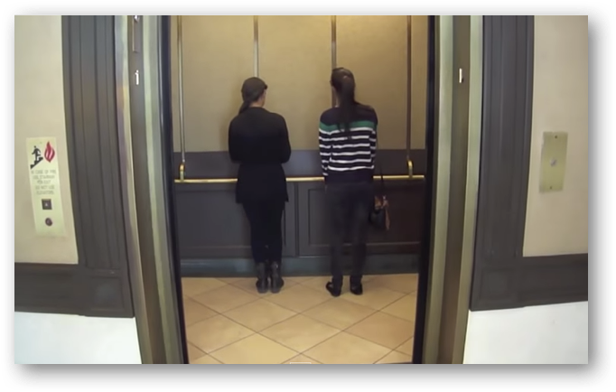
      * [Video](https://www.youtube.com/watch?v=BgRoiTWkBHU&nohtml5=False)

## Conformity

* Audio 0:13:30
* Altering one’s behaviors and opinions to match those of other people or to match other people’s expectations
* 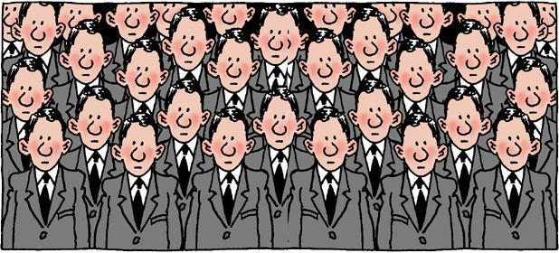

## Why do we conform?

* Social norms
  + Adolescents conform to peer pressure to smoke
  + People stand in line to buy tickets instead of “cutting in”
* Need for social acceptance: occurs when we go along with the crowd to comply with norms, avoid looking foolish
  + Audio 0:16:00
* Need for information: occurs when we assume that the behavior of the crowd represents the correct way to respond
  + We assume that the behavior of the crowd is the correct way to behave
    - Say you see a crowd running towards you and they’re screaming, you’ll probably feel inclined to do the same
* Research consistently has demonstrated that people tend to conform to social norms

## Asch Conformity Experiments

* Audio 0:19:20
  + The question using the image below is “Which line on the right is the same length as the line on the left?”
    - The answer is pretty easy to tell “C”, but what if you were in a group and everybody else said a different answer
* 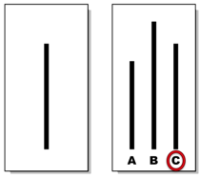
  + [video](https://www.youtube.com/watch?v=TYIh4MkcfJA)

## When do people reject social norms?

* Audio 0:24:30
* When do people reject social norms?
  + Presence of a dissenter threatens group unanimity
    - One person steps out
  + Publicness of behavior or attitudes
  + Conformity varies with group size
* Groups tend to enforce conformity
  + Those who fail to go along are rejected
    - 

## What are the consequences of social norms?

* What are the consequences?
  + Positive
    - Society runs more smoothly
    - Aids in decision-making processes
    - Confers belongingness
    - Society runs more smoothly
    - Aids in decision-making processes
    - Confers belongingness
      * Audio 0:28:00
    - Society runs more smoothly
    - Aids in decision-making processes
    - Confers belongingness
  + Negative
    - Groupthink
      * Audio 0:29:00
      * Tendency for all members of a group to think alike for the sake of harmony
      * Tendency to suppress disagreement
        + Not wanting to make waves
        + Pressure to conform
        + 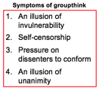
    - Diffusion of responsibility
      * Audio 0:31:25
    - The tendency of members of groups to avoid taking action because thy assume that others will
      * 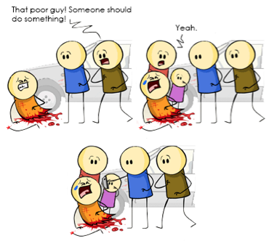
      * People assume someone else will take cair of a problem
    - Groupthink
    - Diffusion of responsibility
    - Deindividuation
      * Audio 0:32:20
      * The tendency to lose awareness of one’s own individuality in groups or crowds
        + You feel like you’re part of a larger entity that can’t be held responsible for something as an individual
      * 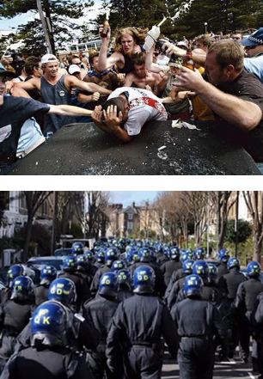
        + Wearing a uniform or a mask changes your morality

## Obedience to Authority

* Milgram experiment
  + Audio 0:35:20
  + 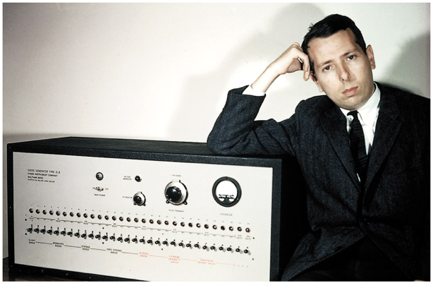
    - You think someon’s in power, so you listen
      * Like a man in a white coat
  + 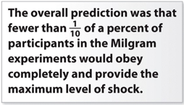

## Why did people not obey

* Audio 0:40:00
* When the experimenter left the room
* When the experimenter was an average Joe
* etc

## Why do people obey??

* Obvious negative consequences
  + Get fired
  + Be suspended from school
  + Get arrested
    - Audio 0:41:30
* Attempts to gain advantages or benefits
  + Promotions, gain privileged knowledge
  + Dependence on and respect for authority
  + Fitting in, curry favor
* Psychological reasons
  + Entrapment: process by which individuals escalate their commitment to a course of action to justify their investment of time, money, and effort

## Stanford Prison Experiment

* [Video](https://www.youtube.com/watch?v=Z0jYx8nwjFQ)
* 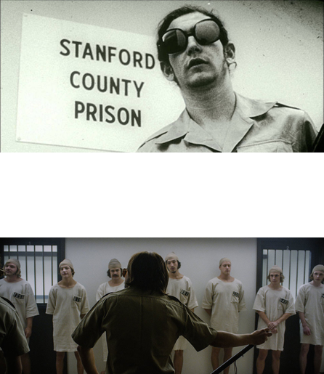

## What does this tell us about roles?

* Criticisms of the study
* Selective sampling
* Lack of replicability
* Instructions may have encouraged the observed behavior
* Could this also be viewed as a study about obedience to authority?
* If so, in what way?

# Vocab

|  |  |
| --- | --- |
| Term | Definition |
| Norms | rules that regulate social life, including explicit laws and implicit cultural conventions |
| Roles | social positions that are governed by a set of norms for proper behavior |
| Culture | A program of shared rules that govern the behavior of members of a community or society |
| Conformity | Altering one’s behaviors and opinions to match those of other people or to match other people’s expectations |
| Reasons for conforming | Need for social acceptance and information in a social setting |
| When people reject social norms | Happens when someone steps out of social norms, you are in private, group size is small |
| Deindividualization | The tendency to lose awareness of one’s own individuality in groups or crowds |
| Groupthink | tendency for all members of a group to think alike for the sake of harmony |
| entrapment | process by which individuals escalate their commitment to a course of action to justify theory investment of time, money, and effort |
| Milgram experiment | Experiment on obedience and authority figures which had people administer electric shock when ordered by an authority |

## PY 101-012 - Spring 2016 (UA)

* PY 101-012 - Spring 2016 (UA)
* [jmbeach1@crimson.ua.edu](mailto:jmbeach1@crimson.ua.edu)
* facebook group
* jmbeach

Website for notes and other study materials from University of Alabama's Pyschology 101 section 012 Spring 2016