Week 13 - Day 2 (Chapter 10 pt 2 Behavior in Social & Cultural Context)

Table of Contents

[PY 101-012 - Spring 2016 (UA)](/PY101-012/)

[About](/PY101-012/about/) [Quizlets](https://quizlet.com/class/2412410/) [Research](http://researchpool.psych.ua.edu/) [Calendar](https://calendar.google.com/calendar/embed?src=ioed8v0sm1d4hooimq4e12eq7c%40group.calendar.google.com&ctz=America%2FChicago)

# Week 13 - Day 2 (Chapter 10 pt 2 Behavior in Social & Cultural Context)

Apr 13, 2016

[Quizlet](https://quizlet.com/_271z04)

Download Word (docx):

## Navigate using audio

# Behaviors in Social & Cultural Context

## Stanford Prison Experiment

* [Video](https://www.youtube.com/watch?v=Z0jYx8nwjFQ)
  + Audio 0:02:06.831751
    - Watching video
* 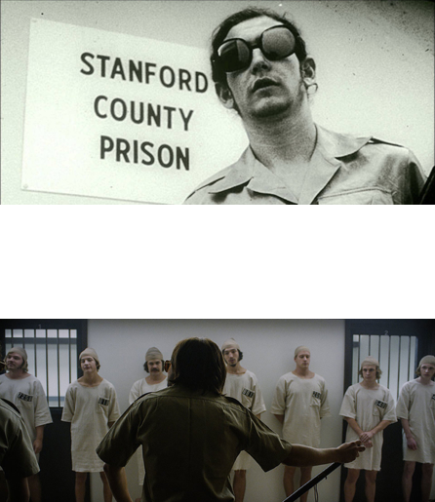

## What does this tell us about roles?

* Audio 0:08:03.815588
  + Roles are everywhere and they are powerful
  + They cause us to behave differently
* Criticisms of the study
  + Selective sampling
    - Some belief that some of the people who wanted to be in the study were kind of biased to want power
* Lack of replicability
  + Huge violation of participant rights
  + Made a significant impact on the field in terms of what is okay to do
* Instructions may have encouraged the observed behavior
  + Zambardo might have encouraged them to be agressive
* Could this also be viewed as a study about obedience to authority?
  + If so, in what way?
    - Audio 0:11:49.064318
  + In studies, there is an implicit desire to please the experimenter
    - Audio 0:15:08.827373
      * Maybe the prisoners felt they needed to finish the experiment
      * Audio 0:17:35.436633

Audio 0:18:29.961066

## ICA #13

* ____ are social positions that are governed by specific societal rules about what is and is not appropriate in social situations
  + A: Norms
  + B: Roles
  + C: Occupations
  + D: Relationships
    - (B)
* Why do people conform their behaviors and opinions to fall in line with the behavior or expectations of others
  + A: conforming is easy and feels good
  + B: Because they want to avoid looking foolish
  + C: We assume if other people are doing it, it’s right
  + D: Both B and C
    - (D)
      * Audio 0:23:18.668246
* ____ is the tendency for all the members of a group to think alike and suppress disagreement for the sake of harmony.
  + A: diffusion of responsibility
  + B: deindividuation
  + C: group think
  + D: obedience
    - (C)
* Which of the following is NOT a reason why people obey authorities
  + A: Avoid consequences
  + B: maintain consistency
  + C: they believe authority should be respected
  + D: To gain privileged access or knowledge
  + E: All of the above
    - (E)

## What’s driving these behaviors

### Social cognition

Audio 0:25:50.754674

* An area of social psychology concerned with social influences on thought, memory, perception, and beliefs

### Attributions

* Our causal explanations for other people’s behavior
* “Joe did what?! Why?????”
* Logical (not covered here) and illogical attributions
  + Audio 0:27:56.242063
    - Assume people are making rational judgements of their environment
    - Thinking about all the available options and picking the one that makes the most sense
      * This doesn’t match reality
* Attribution theory suggests that people are motivated to find situational or dispositional causes for their own and other people’s behaviors
  + Audio 0:29:31.190519
    - Person + Environment = Behavior
* Situational attribution
  + 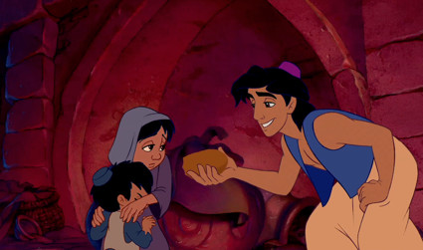
    - Aladin
      * Audio 0:30:09.597260
      * He’s poor
        + That’s why he steals bread
* Dispositional attribution
  + 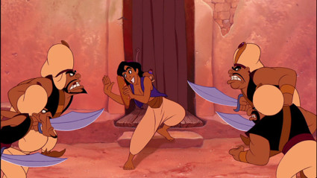
    - Aladin
      * He steals becauase he’s a theif

### What determines the nature of our attribution (dispositional vs. situational)?

* Usually, the target of the attribution
  + Dave Chappelle on attributions:
    - Audio 0:32:31.083686
    - <https://www.youtube.com/watch?v=GLdim8hWR44>
  + Louis CK: <https://www.youtube.com/watch?v=xquhBIlDIpM>
* What is Dave getting at?
  + Audio 0:35:10.221291
  + The situational look at Oscar is he’s a grouch because he lives in a trash can
  + The dispositional look is that he’s a grouch by nature
* Fundamental attribution error (FAE)
  + The tendency to overestimate personality factors and underestimate the influence of the situation when drawing conclusions about the behavior of other people
  + Audio 0:36:11.649640
    - Think about someone with chronic pain
    - They might be upset or irritable often
      * You might make an FAE and say that that’s part of their personality

### What causes the FAE?

* Audio 0:37:17.998503
* Situations lack salience and go unnoticed
  + When you see someone doing something, you don’t care about what they were doing 4 minutes before
    - If someone cuts you off in traffic, do you think “Oh I bet his wife is in labor and he’s going to see her in the hospital”
      * You probably think “f*** you!”
  + Availability heuristic
* Underestimating the impact of the situation
  + Classic experiments from last lecture
* Impact of situation may be salient initially, but then fade over time
  + Audio 0:39:08.193296
    - You might forget that your friend Kathy has a chronic pain disorder
* Belief that the person caused the situation
  + Kathy is a bad person who does bad things
    - Therefore she causes her own pain
    - Or: Therefore she deserves her pain

### What determines the nature of our attribution (dispositional vs. situational)?

* Audio 0:41:29.745766
* Usually, the target of the attribution (others FAE)
* Self-serving biases
  + Audio 0:42:39.612463
  + Tendency to attribute our successes to dispositional factors and our failures to situational factors
  + 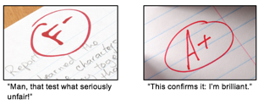

### Self-Serving Biases

1. Choosing the most flattering and forgiving attributions for our behavior
   * “I’m not sexist; the male job candidate’s credentials were honestly just better.”
   * “Well, I didn’t hire her because I honestly think a man would do the job better.”
2. The “better than average” effect
   * The tendency to believe that we are better, smarter, and kinder than others
   * Example
     + 70% of high school students said they were above the median for leadership skills
       - Everyone is inclined to think they are above average
     + 85% for getting along well with others
   * When the average person is exposed to the suffering of an innocent person, how do you think they will respond?
   * What is a normative response?
     + Audio 0:45:55.005819
     + Feel bad for them
   * Do normative responses always occur?
     + No, usually people try to find a way that the person caused their pain
3. The bias to believe that the world is fair
   * Good people are rewarded and bad people are punished
     + Karma essentially
   * The just-world hypothesis
   * “You reap what so you sow”, “They deserve what’s coming to them”
   * Rooted in the need to predict one’s environment and make long-term goals
   * Motivated responses victim blaming and victim derogation

# Vocab

|  |  |
| --- | --- |
| Term | Definition |
| social cognition | An area of social psychology concerned with social influences on thought, memory, perception, and beliefs |
| attributions | Our causal explanations for other people’s behavior |
| attribution theory | suggests that people are motivated to find situational or dispositional causes for their own and other people’s behaviors |
| situational attribution | Explaining behavior based on someone’s situation |
| dispositional attribution | Explaining behavior based on someone’s inate personality |
| fundamental attribution error | The tendency to overestimate personality factors and underestimate the influence of the situation when drawing conclusions about the behavior of other people |
| self-serving bias | Tendency to attribute our successes to dispositional factors and our failures to situational factors |
| better than average effect | Tendency to believe that we are better, smarter, and kinder than others |
| just-world hypotheses | idea that good people are rewarded and bad people are punished (You reap what you sew) |

## PY 101-012 - Spring 2016 (UA)

* PY 101-012 - Spring 2016 (UA)
* [jmbeach1@crimson.ua.edu](mailto:jmbeach1@crimson.ua.edu)
* facebook group
* jmbeach

Website for notes and other study materials from University of Alabama's Pyschology 101 section 012 Spring 2016