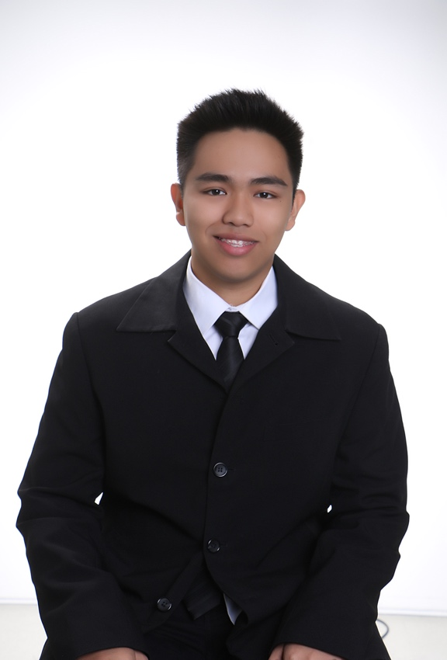

**ALEXANDER JOHN M. PUNZALAN**

999 Aragon Street, Malate Manila City, Metro Manila 1004

+639051370678; (02) 536-6895

[alexander_punzalan@dlsu.edu.ph](mailto:alexander_punzalan@dlsu.edu.ph)

**OBJECTIVE** To be a part of a company where I can maximize my knowledge and skills in computer literacy and be able to work on a task that can improve what I have acquired to attain an incredible performance.

# EDUCATION

2013 – 2017 **DE LA SALLE UNIVERSITY**

Bachelor of Science in Computer Science Major in Computer Systems Engineering

2009 – 2013 **UNIVERSITY OF SANTO TOMAS-HIGH SCHOOL**

High School Diploma, March 2013.

Class Top 6, March 2009; Class Top 3, March 2011; Class Top 2, March 2012;

# WORK EXPERIENCE

# July 2015 – PRACTICUM TRAINEE, PLDT INC.

# August 2015 South GMM – Ramon Cojuangco Building, Makati

# EXTRA-CURRICULAR ACTIVITIES

2013-2015 **LA SALLE COMPUTER SOCIETY - MEMBER**

Helps the organization by voicing out our concerns so that they can come up with projects that will be beneficial to the student body.

2013-2014 **STUDENT CATHOLIC ACTION**

Promotes to students the true value of faith whatever religion they are in.

2012-2013; **NATURAL SCIENCE CLUB**

2010-2011 Learned how to properly care for nature and helping students to be knowledgeable in proper garbage segregation.

2011-2012 **KNIGHTS OF THE ALTAR**

Helped out in the community during masses as well as strengthen my faith in the Lord.

# SEMINARS ATTENDED

October 2016 **INTRODUCTION TO GOOGLE CLOUD COMPUTING**

Computer Technology Department - College of Computer Studies

De La Salle University

April 2015 **TECHNOLOGY SKILLS TRAINING SERIES – MODULE 4:**

**ANDROID APP DEVELOPMENT SEMINAR**

Computer Technology Department - College of Computer Studies

De La Salle University

February 2015 **TECHNOLOGY SKILLS TRAINING SERIES – MODULE 3:**

**WEB DEVELOPMENT SEMINAR**

Computer Technology Department - College of Computer Studies

De La Salle University

January 2015 **TECHNOLOGY SKILLS TRAINING SERIES – MODULE 2:**

**NETWORK POLICIES SEMINAR**

Computer Technology Department - College of Computer Studies

De La Salle University

January 2015 **CCS MOCK INTERVIEW SEMINAR**

Office of the Dean - College of Computer Studies

De La Salle University

# December 2014 TECHNOLOGY SKILLS TRAINING SERIES – MODULE 1: COMPUTER NETWORKS AND SECURITY

Computer Technology Department - College of Computer Studies

De La Salle University

November 2014 **LEGGO MINDSTORM**

La Salle Computer Society - College of Computer Studies

De La Salle University

January 2014 **LET IT CATCH ON - SPECIALIZATION TALK**

CATCH2T17 Batch Government - College of Computer Studies

De La Salle University

# SEMINARS CONDUCTED

# June 2017 PHILIPPINE SCIENCE HIGH SCHOOL – SCIENCE AND TECHNOLOGY

# INTERNSHIP PROGRAM 2017

# Center for Automation Research – College of Computer Studies

# De La Salle University

# RESEARCH PAPERS PREPARED

# August 2017 FRINGE-AREA DATA ACCESS BY TRANSIENT ALTITUDE PROVISION

# Developed an improvised hot air balloon system with a burner control system – consists of temperature sensors, microcontrollers, and automated burner – and an antenna positioning system – capable of enabling the directional antenna to be oriented to a preset location of the cellular tower.

# July 2017 DEVELOPMENT OF A PROTOTYPE LIGHT-PAYLOAD HOT AIR BALLOON

# TEMPERATURE CONTROL SYSTEM

# Developed a hot air balloon system with an automated burner control system. Automating the burner reduces the manpower needed to operate

# a hot air balloon, thus, reducing the weight the hot air balloon has to lift and also reducing the size of the hot air balloon.

# PERSONAL BACKGROUND

Born on June 2, 1997 in Manila City, Metro Manila, Philippines. Good in speaking both in English and Filipino. Knowledgeable about various programming languages such as Assembly Language, C, Java, HTML, and R. Fond of using the basic word-processing programs like Microsoft Word, Microsoft Excel, and Microsoft Powerpoint. Always seeking for improvements, determined, practical and critical thinker.

# REFERENCES

Available upon request.