**Supplemental Material 2: Cubic Spline Interpolation Simulation**

The present study collected observations with uneven sampling intervals of 4-, 4-, 4-, and 12-hours. We then used cubic spline interpolation to resample the observations to even 6-hour intervals. The following simulation study was run to examine the extent of any bias introduced by the resampling procedure.

The heart of the simulation involved creating an evenly spaced time series using a known lag-3 autoregression [AR (3)], created using the arima.sim function in *R*. Here, an AR (3) means an autoregressive process in which all autoregressive components except the third are set to zero. Regarding the sampling times of this series as two hour intervals implies that the three interval lag in the AR (3) process corresponds to six hours. We then subsample the simulated series at uneven intervals of 4, 4, 4, and 12 hours (2, 2, 2, and 6 observations). This subsampled sequence was then resampled to an even, 6-hour interval using the spline function in *R*, with a Forsythe, Malcolm, and Moler (1977) cubic spline. Finally, the difference between the resampled and the original sequences was observed and both the mean and the median value reported. The median difference value was preferred over the mean, as the distributions of differences were negatively skewed at higher AR coefficients. This procedure was repeated 10,000 times each for AR (3)’s of *r* = .10, .20, .30, .40, .50, .60, .70, .80, and .90.

The average percentage difference across the nine comparisons was 0.8%. This suggests that the cubic spline interpolation recovered greater than 99% of the known AR. It should be noted, however, that the simulation appeared systematically biased toward underestimation.

We chose to use an AR (3) model to resolve issues with subsampling the simulated sequence at uneven intervals. The AR (3) model allowed the creation of a sequence where all AR effects can be regarded as occurring at a six-hour offset (by assuming each time step in the simulation represents two hours), and which can be subsampled to match both even six-hour intervals and uneven 4, 4, 4, 12 hour intervals.

Table 1 reports the simulated AR, the mean resampled AR, the median difference between the resampled mean and the known AR, and the percentage of the original AR this difference represented. Figures 1-3 present the distributions of differences, with the median indicated by a vertical line. The *R* code for the simulation and interpolation procedure is presented below.

***R* code for simulation and interpolation.**

lagpad <- function(x, k) {

c(rep(NA, k), x)[1 : length(x)]

}

M=matrix(ncol=10000,nrow=999)

for(i in 1:10000){

xi = arima.sim(list(ar=c(0,0,.50),ma=0),n=999)

M[,i]=xi

}

test=data.frame(resamp=numeric(10000),lag3=numeric(10000))

for(i in 1:10000){

xi=M[,i]

ui=rep(c(1,1,1,1,0,0),143)[1:999]

dati=as.data.frame(cbind(xi,ui))

dati$time=seq(0,(nrow(dati)-1),1)

uneveni=subset(dati,ui==1)[1:665,]

x1i=(spline(x=(uneveni$time), y=uneveni$xi,665,xout=seq(0,996,3),method='fmm'))$y

lagx1i=lagpad(x1i,1)

lagxi=lagpad(xi,3)

test[i,1]=cor.test(x1i,lagx1i)[4]$estimate

test[i,2]=cor.test(xi,lagxi)[4]$estimate

}

test$dif=test[,1]-test[,2]

hist(test$dif, col=rgb(1,0,0,0.2), main='', xlab='Difference')

abline(v = median(test$dif,na.rm=TRUE), col = rgb(1,0,0,1), lwd = 2)

test$per=test[,3]/test[,2]

mean(test[,1])

mean(test[,2])

mean(test$dif)

median(test$dif)

Table: 1: Results of simulations for comparison between even time series and cubic spline interpolated time series across 10,000 simulations.

|  |  |  |  |
| --- | --- | --- | --- |
| Simulated Evenly Sampled AR | Cubic Spline Interpolated AR | Median difference | Difference as percentage of effect |
| .10 | .097 | .001 | .01 |
| .20 | .196 | .002 | .01 |
| .30 | .295 | .002 | .007 |
| .40 | .393 | .003 | .008 |
| .50 | .493 | .004 | .008 |
| .60 | .592 | .004 | .007 |
| .70 | .691 | .004 | .006 |
| .80 | .789 | .005 | .006 |
| .90 | .889 | .005 | .006 |

AR = autoregression.

Figure 1: Clockwise from top-left: differences between AR (3) of evenly sampled time series and AR (1) from resampled time series, across 10,000 replications, for *AR* = .10, .20, .30, and .40.

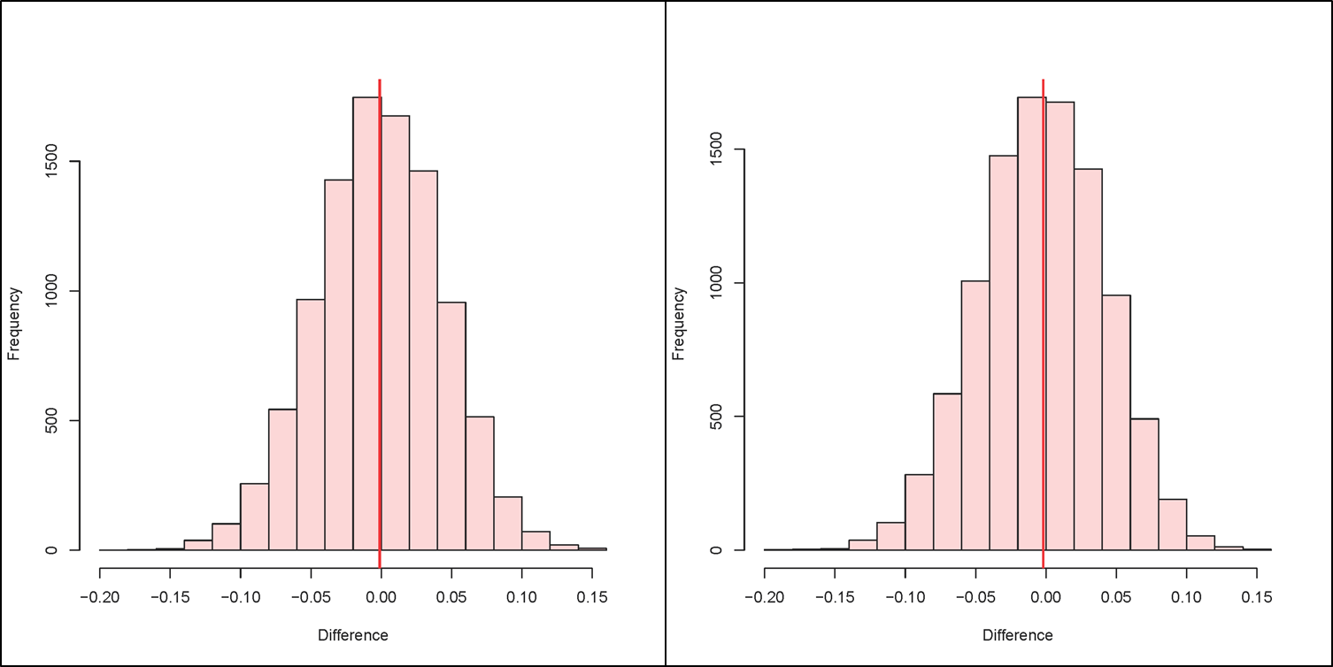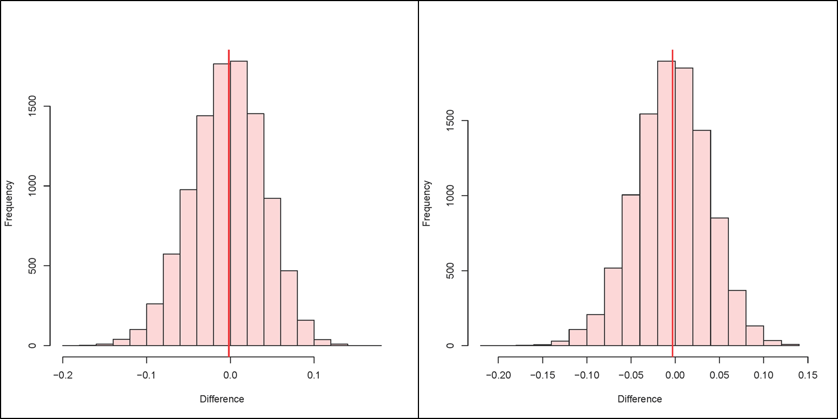

Figure 2: Clockwise from top-left: differences between AR (3) of evenly sampled time series and AR (1) from resampled time series, across 10,000 replications, for *AR* = .50, .60, .70, and .80.

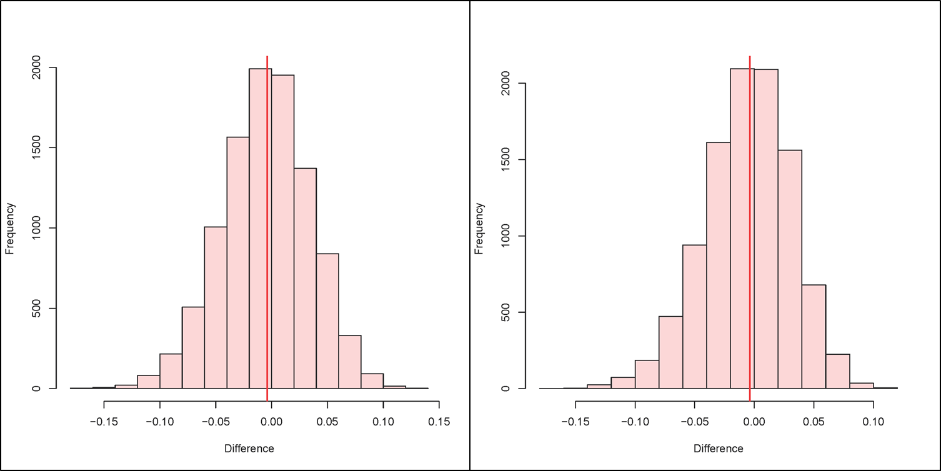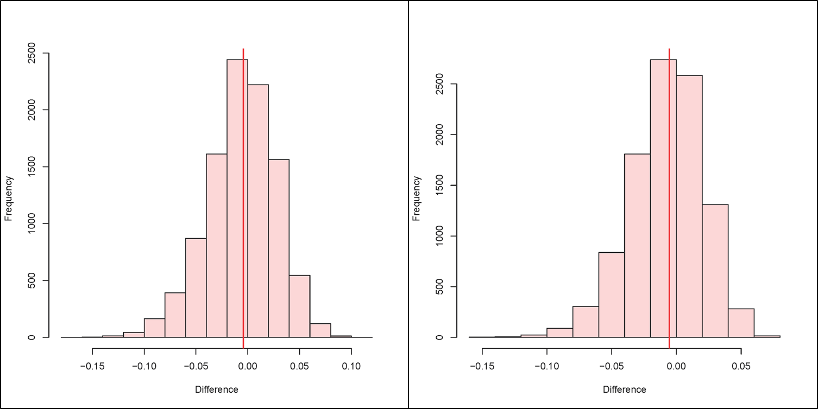

Figure 3: Difference between AR (3) of evenly sampled time series and AR (1) from resampled time series, across 10,000 replications, for *AR* = 90.

