Day 6 Assignment
Designing a REST API with OpenAPI/Swagger Documentation
John Michael Bilbao
Techstart
August 13, 2026

Introduction
This assignment asks for a REST API for a book management system, documented with OpenAPI, with screenshots of each endpoint being exercised.
I wrote the OpenAPI document first and then implemented it, rather than the other way round. That order is the reason the two agree: the validation rules in the code are the limits written in the schemas, and the error shape the endpoints return is the one the document advertises. There is also a set of tests that reads openapi.yaml and checks the real responses against the schemas in it, so the two cannot quietly drift apart later.
The API is Flask, the document is OpenAPI 3.0.3, and the application serves both the specification at /openapi.yaml and Swagger UI at /docs. Every screenshot in this report is of that running API.

Step 1: The endpoints
Five endpoints, covering the four CRUD operations:
Method and path | What it does | Success | Failures
POST /books | Create a book | 201 | 400, 409
GET /books | List every book, optionally filtered by author | 200 | —
GET /books/{id} | Retrieve one book | 200 | 404
PUT /books/{id} | Update the fields given | 200 | 400, 404, 409
DELETE /books/{id} | Delete a book | 204 | 404

A few of those choices are worth explaining. POST returns 201 with a Location header pointing at the new book, so a client does not have to guess the URL it just created. DELETE returns 204 and no body, because there is nothing meaningful to send back. PUT changes only the fields present in the body, which means marking a book as out on loan is {"available": false} rather than a full copy of the record.
409 is there because a duplicate is not a malformed request. The body is perfectly valid; it conflicts with something already stored. Returning 400 for it would tell the client to fix its JSON, which is not the problem.
Every failure uses the same two-field shape, an error code and a sentence, so a client only has to learn one error format:
{
"error": "not_found",
"message": "No book with id 99."
}

Step 2: The OpenAPI document
openapi.yaml is about 260 lines and describes all five operations, the query parameter, the request bodies, every response, and four schemas: Book, NewBook, BookUpdate and Error. The POST operation as it appears in the file:
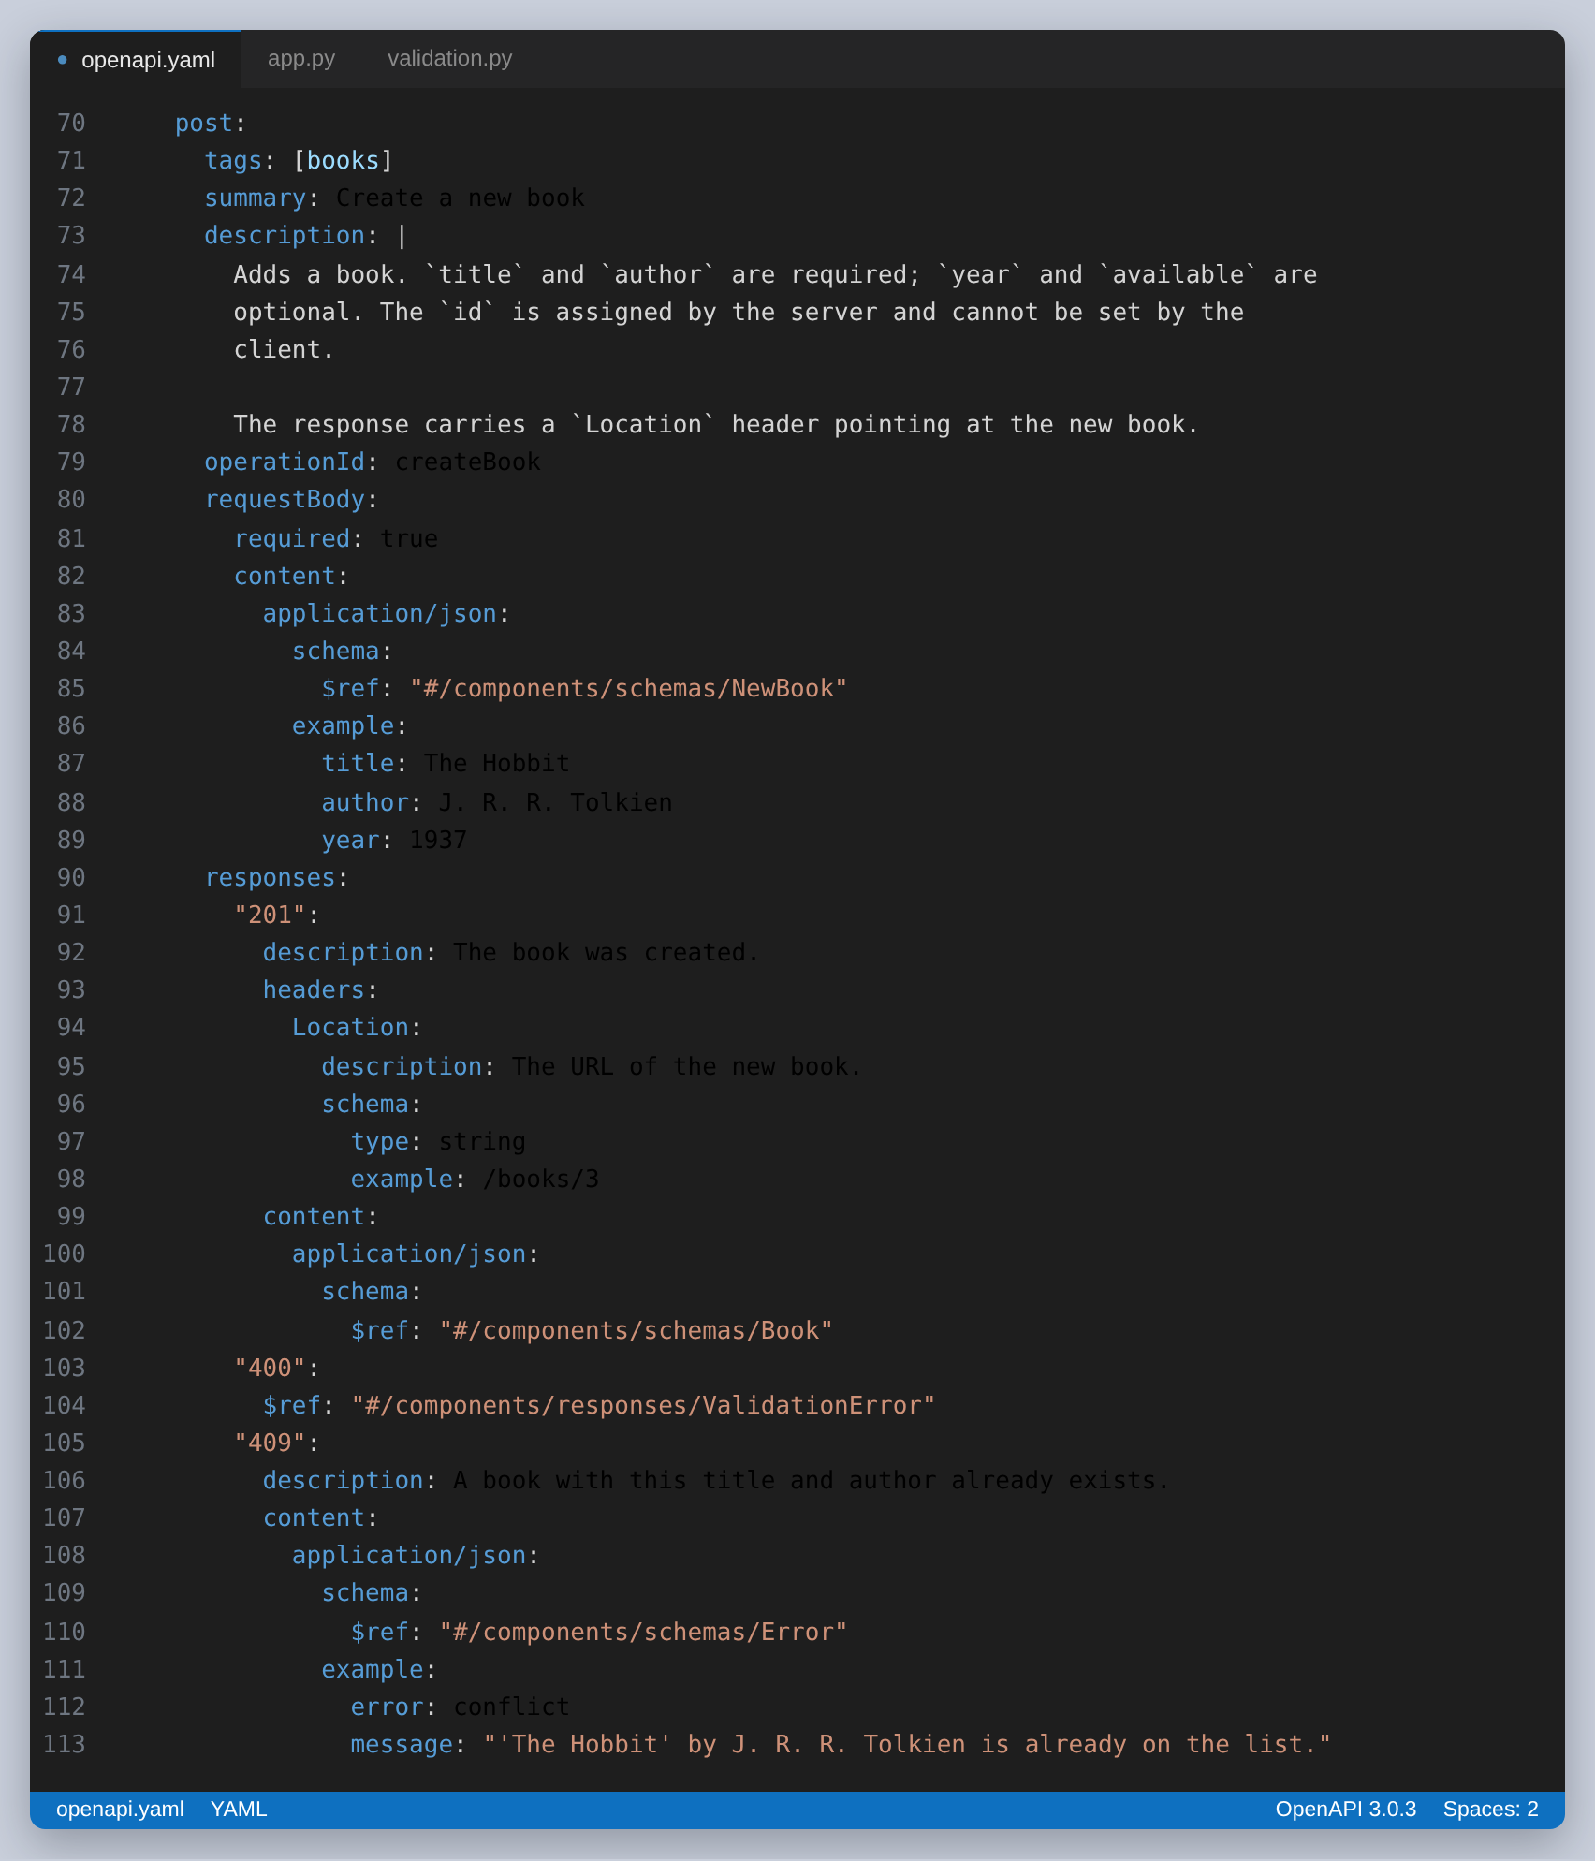
Figure 1: The POST /books operation in openapi.yaml
Three schemas rather than one is a deliberate choice. Book is what comes back and includes the server-assigned id. NewBook is what a client may send to create one, and has no id at all, which is how the document says that ids are not the client's to choose. BookUpdate is every writable field made optional with minProperties: 1, which is how it says that a partial update is fine but an empty body is not.
The repeated responses are written once under components and referenced. NotFound is defined in one place and pointed at from the three endpoints that can return it, so the description cannot end up saying three slightly different things.
Swagger UI reads that file directly. All five operations and the four schemas, as served at /docs:
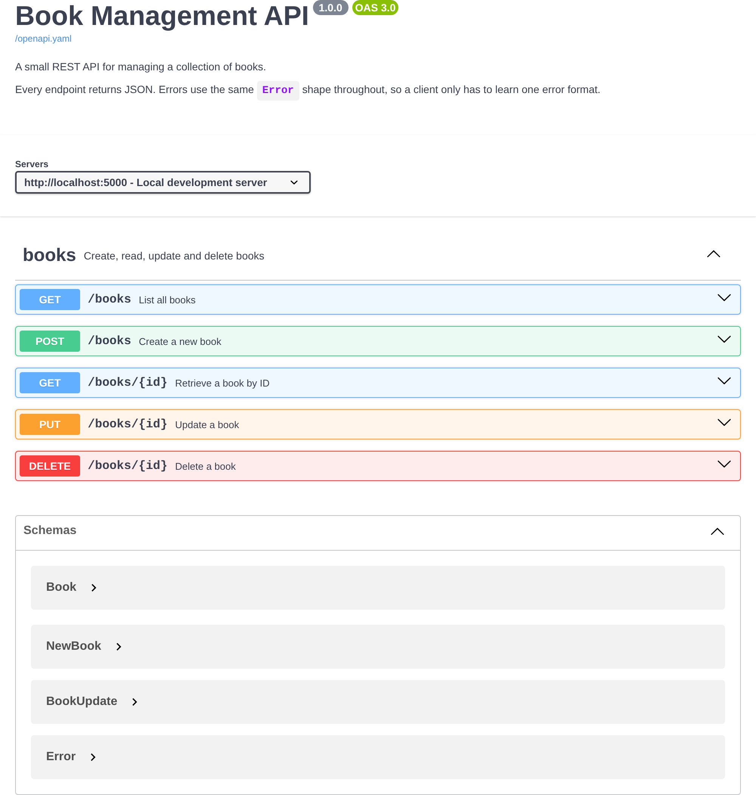
Figure 2: Swagger UI rendering openapi.yaml at /docs
Expanding POST /books shows what the document gives a reader: the required fields, the limits on each one, an example body, and all three responses it can produce with an example of each.
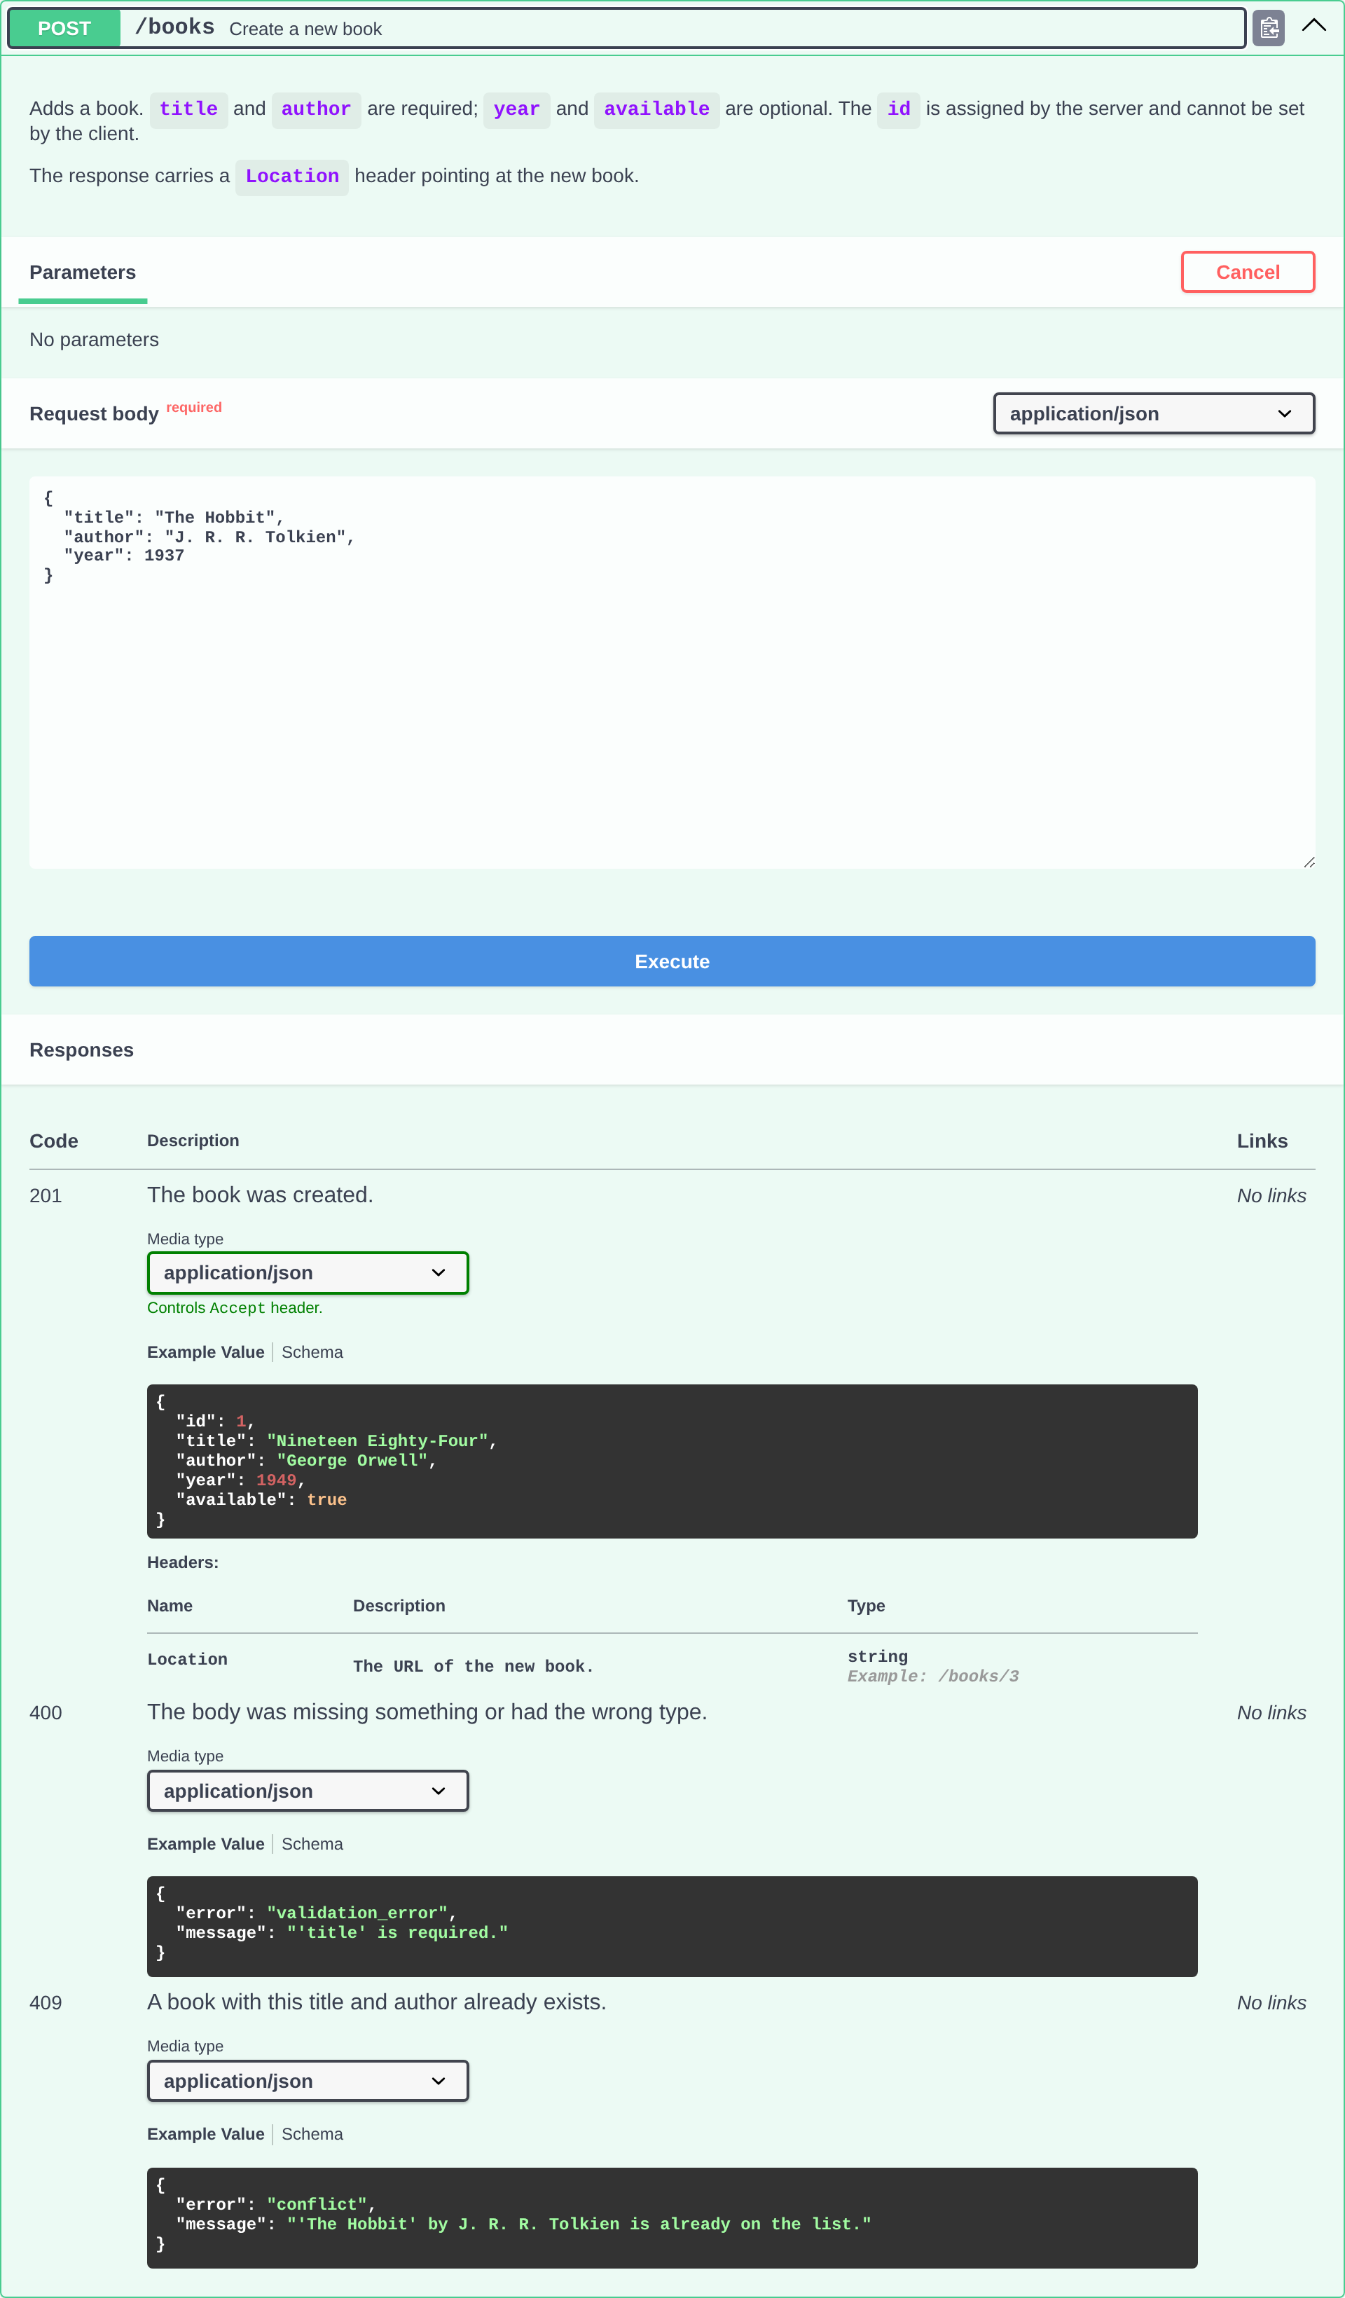
Figure 3: POST /books expanded, showing the request body and every documented response
The schemas at the bottom of the page are the same definitions the endpoints reference:
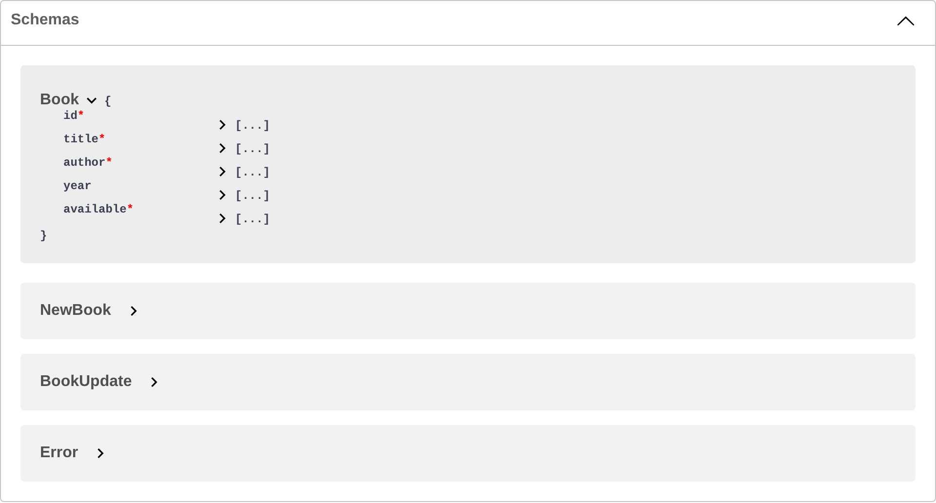
Figure 4: The Book schema, with the constraints the API enforces

Step 3: Testing each endpoint
Each endpoint below was called with curl against the running server. The -i flag prints the status line and headers as well as the body. The only thing changed in these screenshots is that the JSON body is indented; Flask sends it on one line, which runs off the edge of the page.
Creating a book. Note the 201 and the Location header:
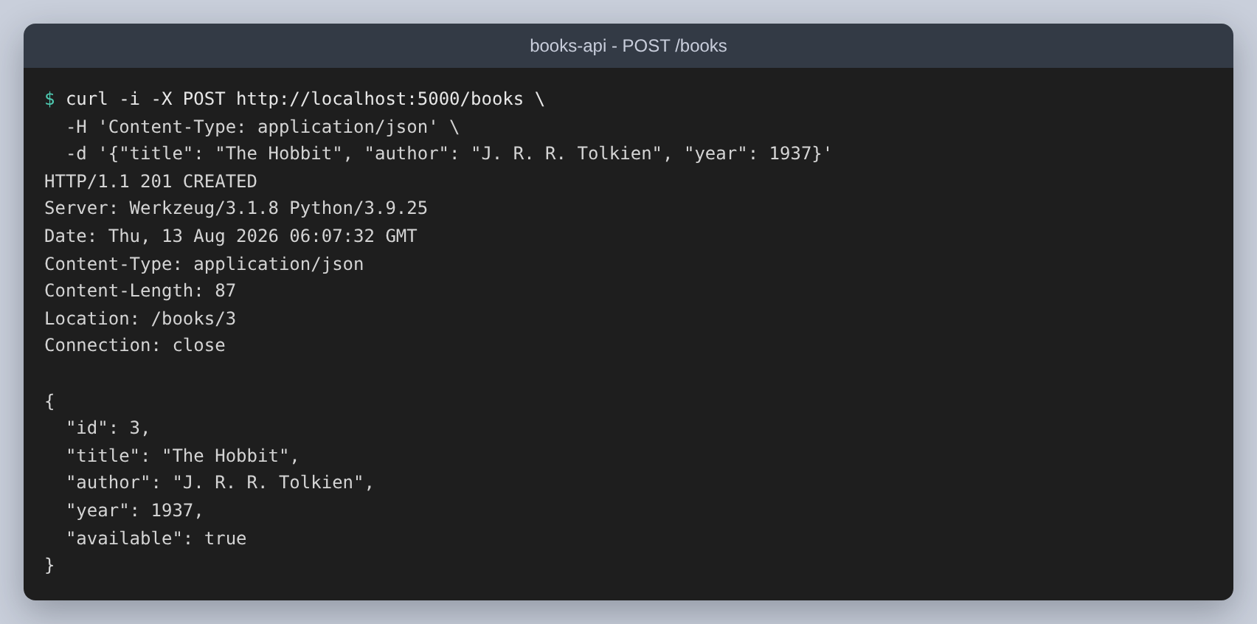
Figure 5: POST /books
Listing everything. The two seeded books plus the one just created:
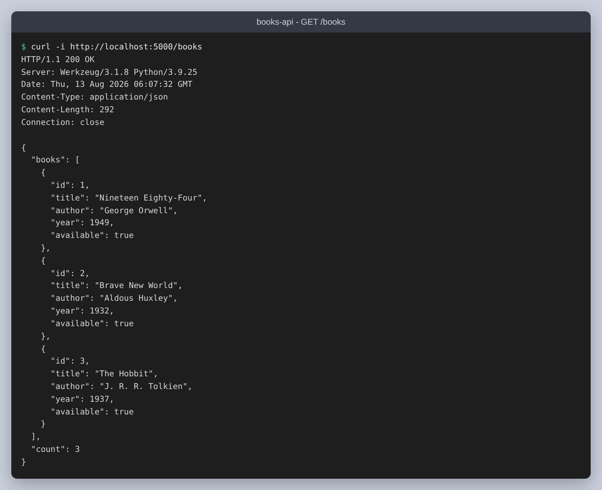
Figure 6: GET /books
The documented query parameter, matching on part of the author's name, case-insensitively:
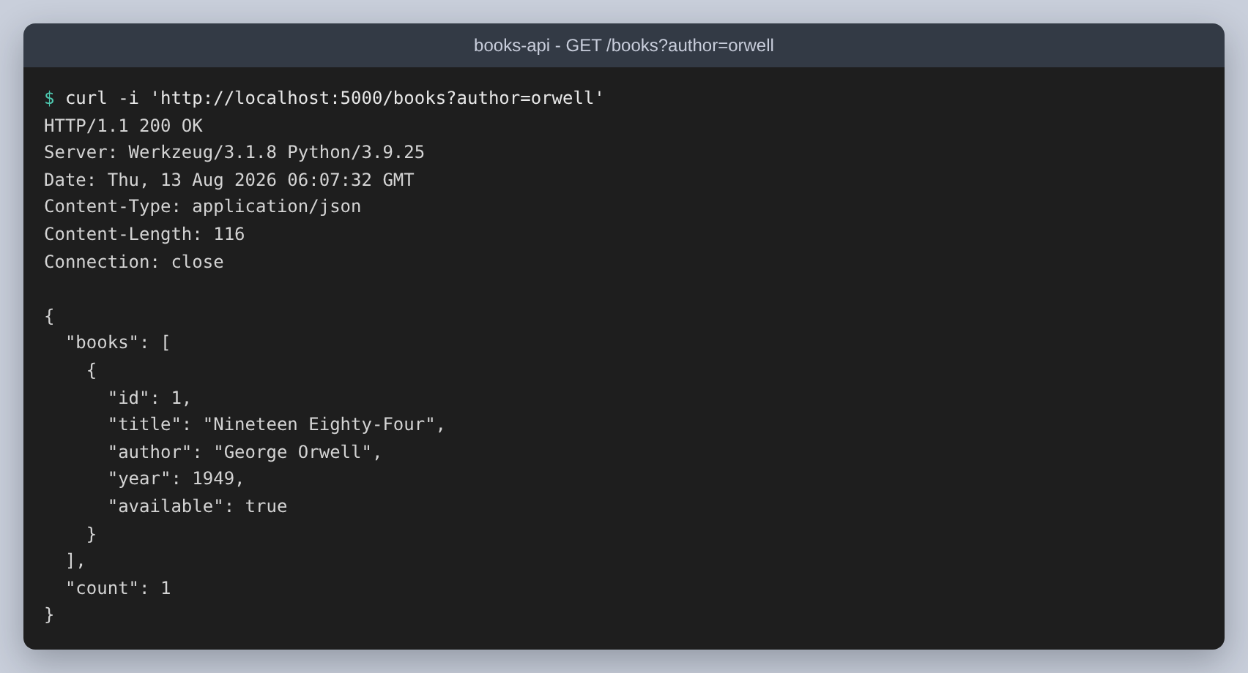
Figure 7: GET /books?author=orwell
Retrieving the new book by its id:
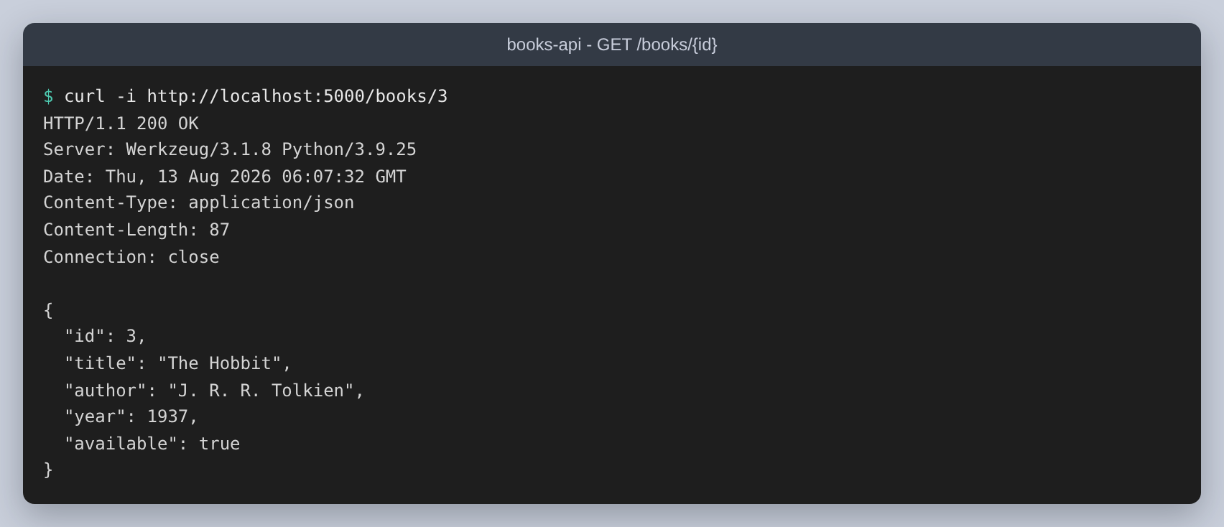
Figure 8: GET /books/3
Updating one field. Only available was sent, and the title, author and year are unchanged in the response:
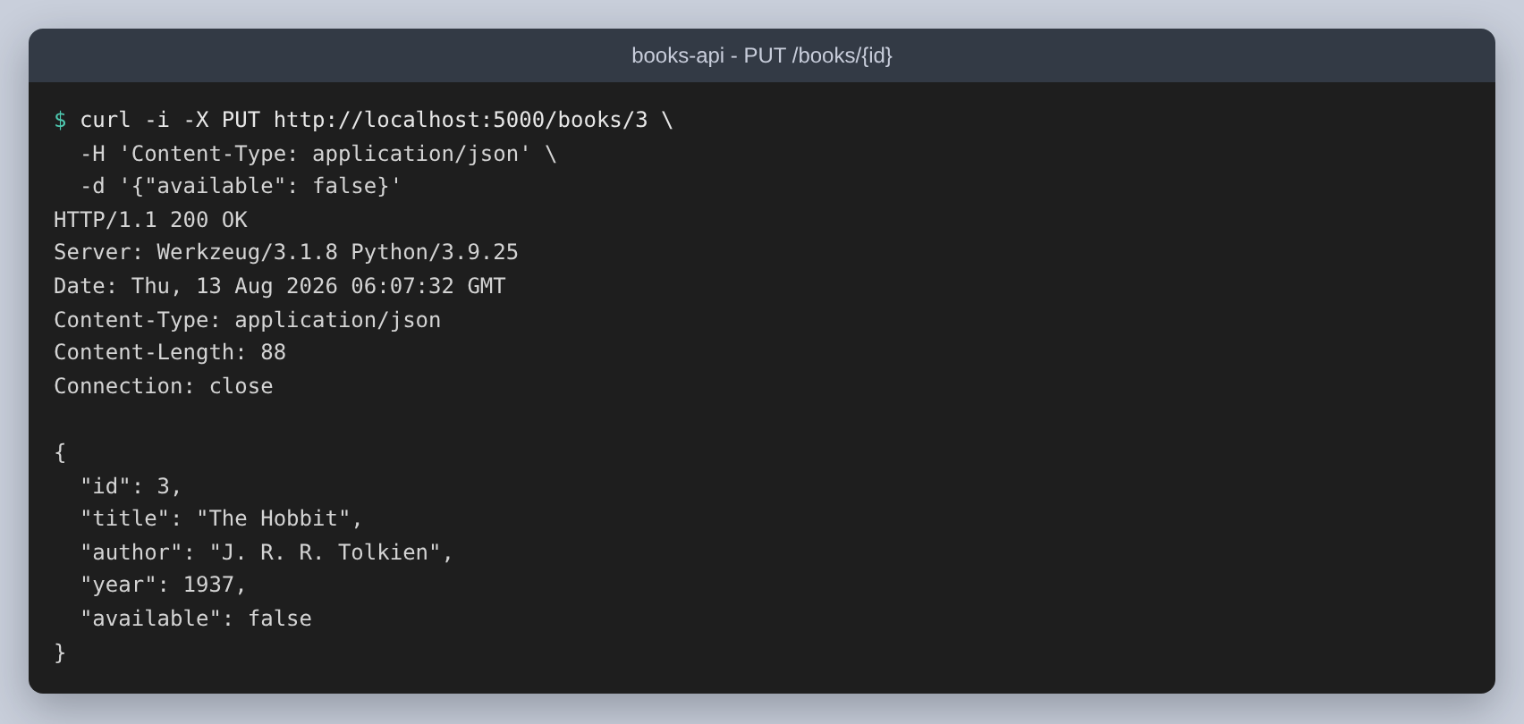
Figure 9: PUT /books/3
Deleting it. The 204 carries no body, and no Content-Type either, since there is no content to describe. Reading the same id afterwards gives the 404:
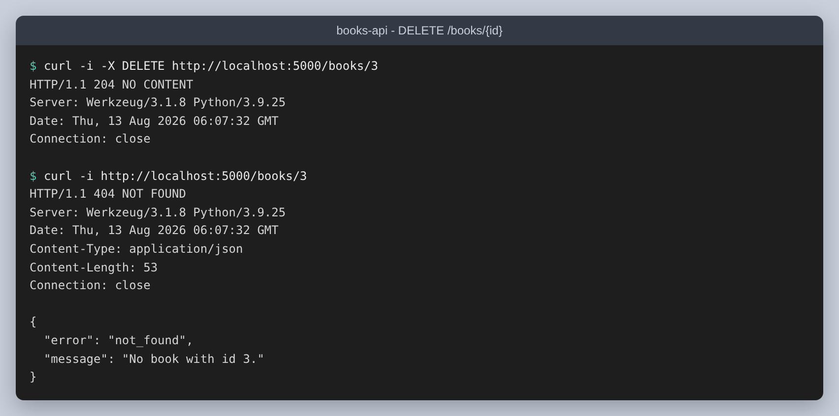
Figure 10: DELETE /books/3, then GET /books/3
Swagger UI can also call the API itself. This is Try it out on GET /books/{id}, executed against the running server, showing the request it sent and the response and headers that came back:
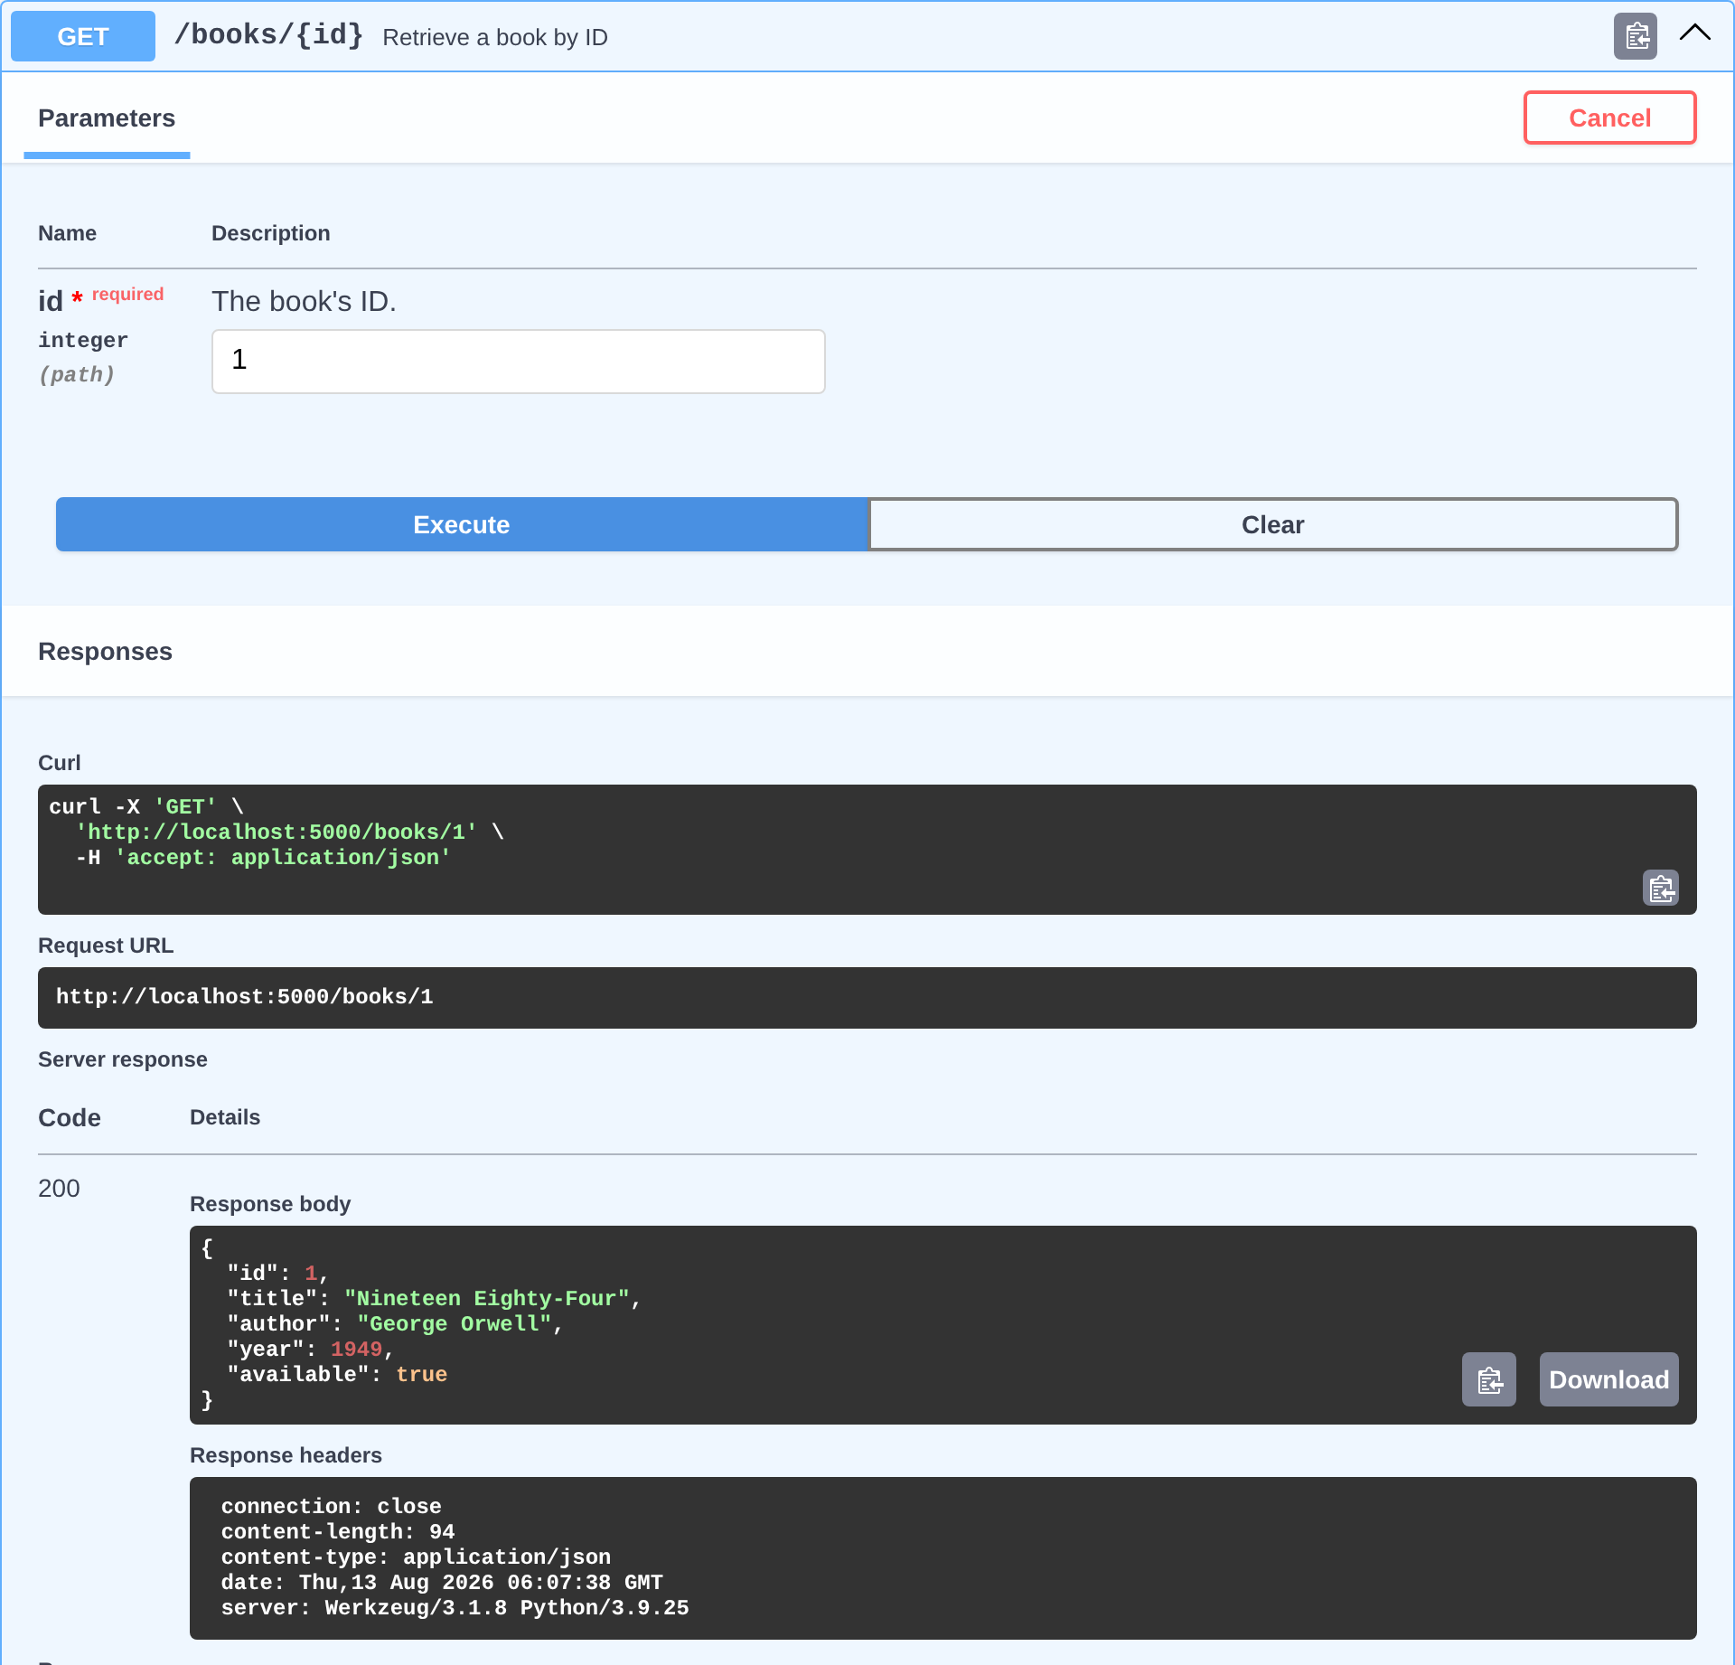
Figure 11: Try it out on GET /books/{id}, run against the live API

The error responses
The three failure cases, all returning the shape the document describes: a body with no title, a book that is already on the list, and an id that does not exist.
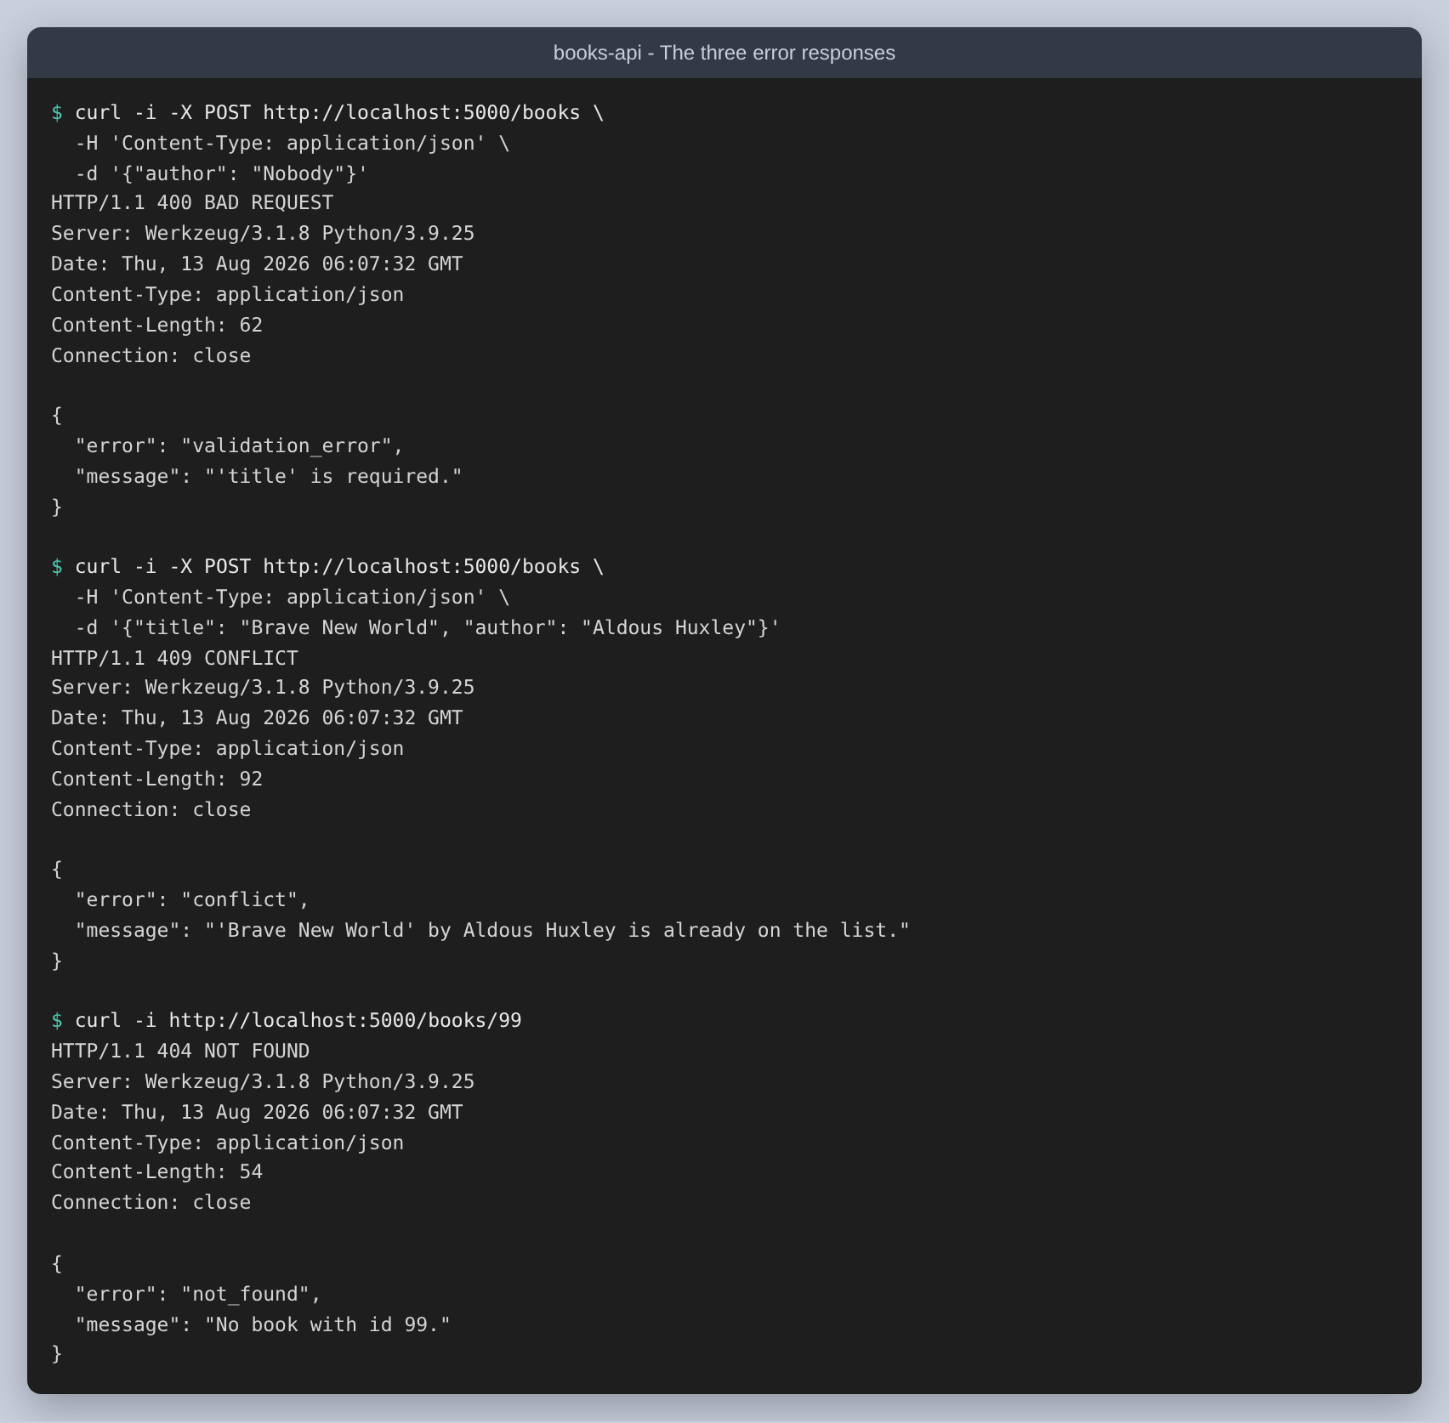
Figure 12: 400, 409 and 404, all using the Error schema
The 400 names the field that was wrong rather than saying the request was invalid, which is the difference between a client developer fixing it in a minute and reading the spec line by line to work out which field the server disliked.

Keeping the document and the code in agreement
A specification that describes what the API was intended to do is worth very little. The part of this assignment I spent most time on was making the document checkable.
There are 48 tests. 34 cover behaviour. The other 14 load openapi.yaml and compare it against the running application:
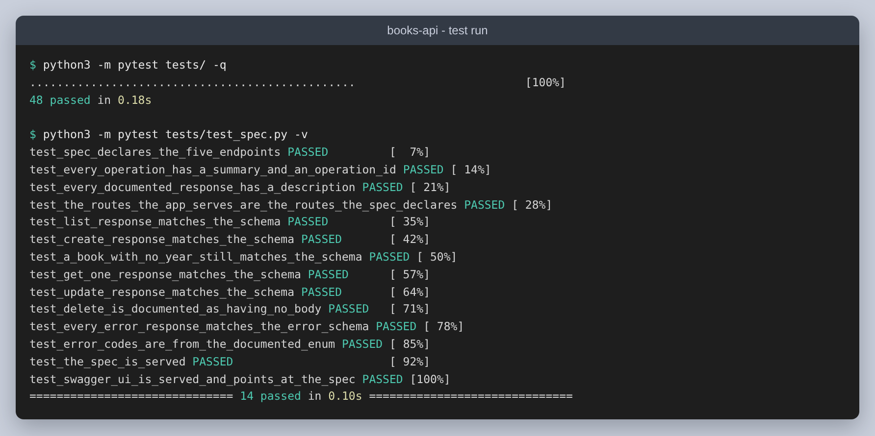
Figure 13: The test run
Those 14 do four kinds of check. They confirm the document declares exactly the five operations and no more, and that each has a summary and an operationId. They walk Flask's own routing table and assert that every path the application serves under /books is one the document declares, so a route added in code and forgotten in the spec fails the build. They validate real responses against the response schemas with jsonschema, including a book with no year, since year is documented as nullable. And they check that every error response matches the Error schema and that the code is one of the three values in its enum.
Getting the schema validation working took one real piece of work. OpenAPI's nullable is not a JSON Schema keyword, so jsonschema ignores it, and a book with year: null failed against type: integer even though the document says null is allowed. The test helper resolves the $refs and rewrites a nullable field's type into [type, "null"] before validating. Without that the tests would have quietly disagreed with the document they were meant to be enforcing.

What I would do differently
Writing the document first was the right call, and not because of the document. Deciding on paper that POST returns 201 with a Location header, that DELETE returns 204 with no body, and that a duplicate is a 409 rather than a 400, meant those questions were settled before any endpoint was written. When I have started from the code instead, the status codes end up being whatever the first implementation happened to return.
Two things I would change. The store is in memory, so the list resets when the server restarts; that was a deliberate trade to keep the endpoint code short, but it is the first thing I would replace. And PUT here updates only the fields it is given, which is really PATCH behaviour. The assignment specifies PUT, so PUT is what I documented and implemented, and the description says plainly that it replaces only the fields given, but on a real API I would either make PUT a full replacement or move this behaviour to PATCH.

