Day 13 Hands-on Assignment
Spring Cloud Service Discovery and Configuration: An E-Commerce Use Case
John Michael Bilbao
Techstart
August 28, 2026

The application
Bilbao Bazaar is a small e-commerce back end split into two business services. The Product Service owns the catalogue: eight products, their prices and their stock. The Order Service places orders, and to price one it has to ask the Product Service what the item costs.
That single cross-service call is where the whole assignment lives. The Order Service has to find the Product Service without being told where it is, which is service discovery, and both services have to agree on the tax rate and the currency without either of them declaring it, which is configuration management. Two more applications exist to make that possible: a Eureka server that holds the registry, and a Config Server that holds the configuration.
Application | Port | What it does
config-server | 8888 | Serves the YAML in config-repo/ over HTTP
eureka-server | 8761 | The service registry, and the dashboard
product-service | 9081 | The catalogue. Registers with Eureka, configured by the Config Server
order-service | 9082 | Places orders. Finds the Product Service through Eureka

Everything below ran on Java 21.0.2 with Spring Boot 3.4.1 and Spring Cloud 2024.0.0. The Eureka dashboard, the Config Server and both service APIs were photographed in a real browser at the URLs shown in each address bar; the terminal figures are captured command output. Nothing is retyped, so no figure can show something the applications did not do.
The one design decision worth stating up front: no host and no port for the Product Service appears anywhere in the Order Service. It calls http://product-service/products/{id} and lets the registry resolve the name. The proof that this is real rather than incidental comes at the end, where the Product Service is restarted on a different port (9091 instead of 9081) and the Order Service keeps working without a restart or a configuration change.

Step 1: setting up the environment
The four applications are Maven modules under one aggregator pom. Declaring the Spring Cloud BOM once there is what keeps the Eureka and Config dependencies in the modules version-free, and stops the two from drifting apart.
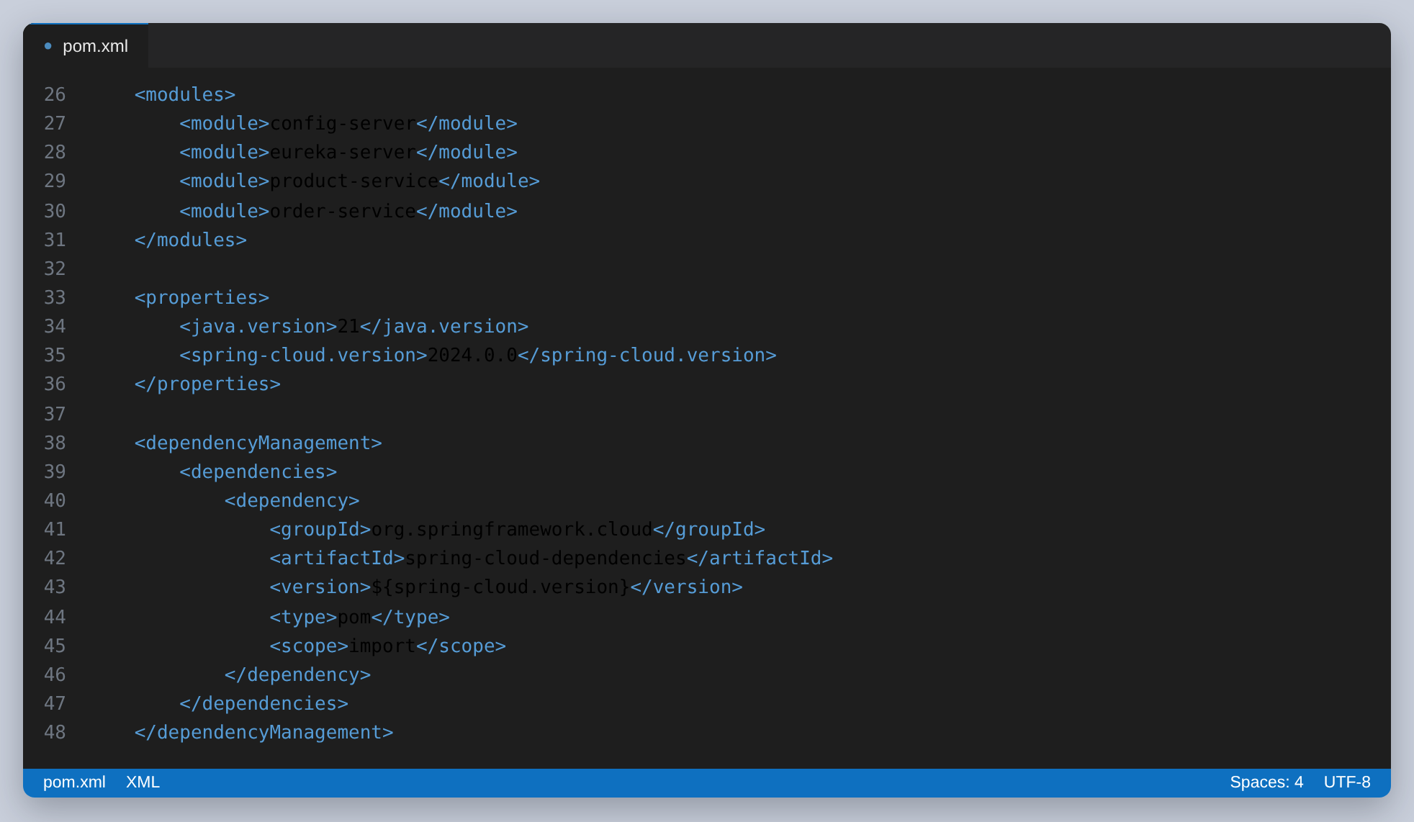
Figure 1: The aggregator pom: the module list, and the Spring Cloud BOM imported once for all four.
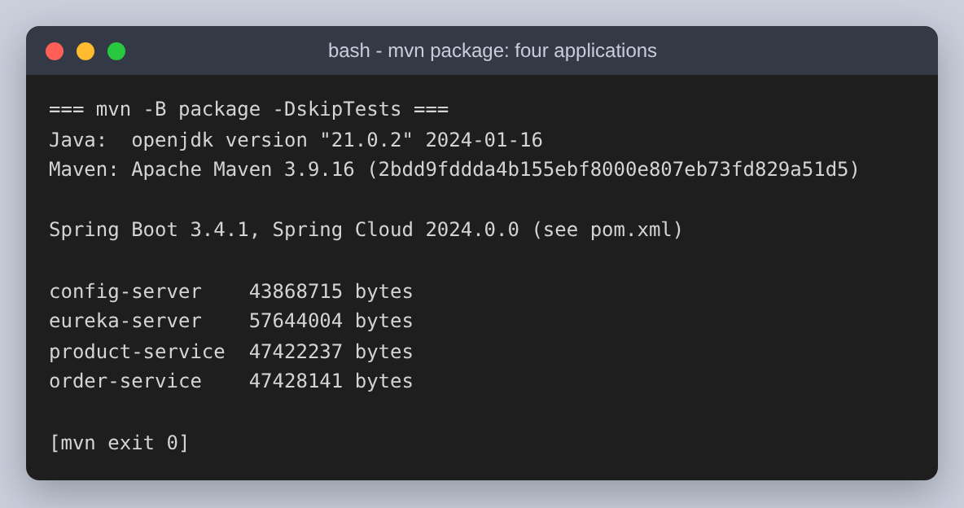
Figure 2: One mvn package builds all four executable jars.

Step 3 comes first: the Config Server
The assignment lists configuration third, but it has to be built second, because the two business services ask the Config Server for their configuration during startup rather than after it. With no Config Server running there is nothing for them to be configured from, so it is the first thing that has to exist after the build.
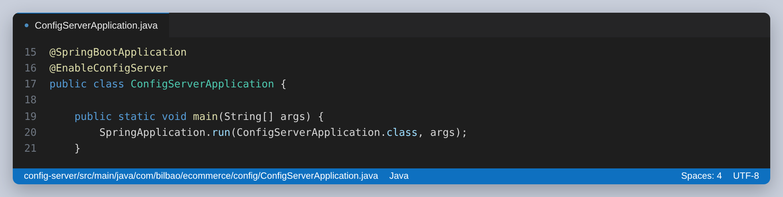
Figure 3: The entire Config Server. One annotation.
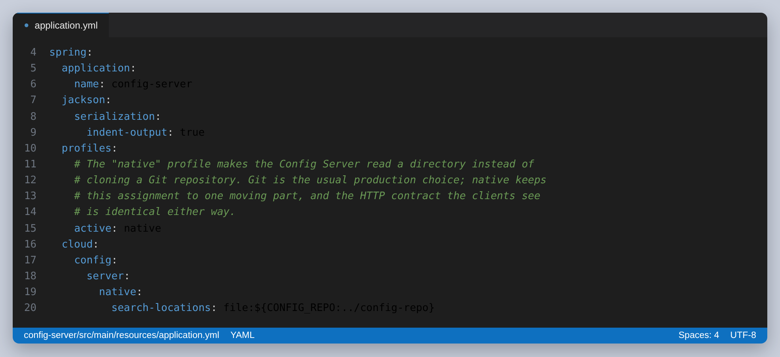
Figure 4: The native profile points the server at a directory instead of a Git repository. Git is the usual production choice; the HTTP contract the clients see is identical either way, and this keeps the assignment to one moving part.
The configuration itself is split in two, and the split is the argument for having a Config Server at all. Anything both services need lives in application.yml. Anything only one service needs lives in a file named after that service.
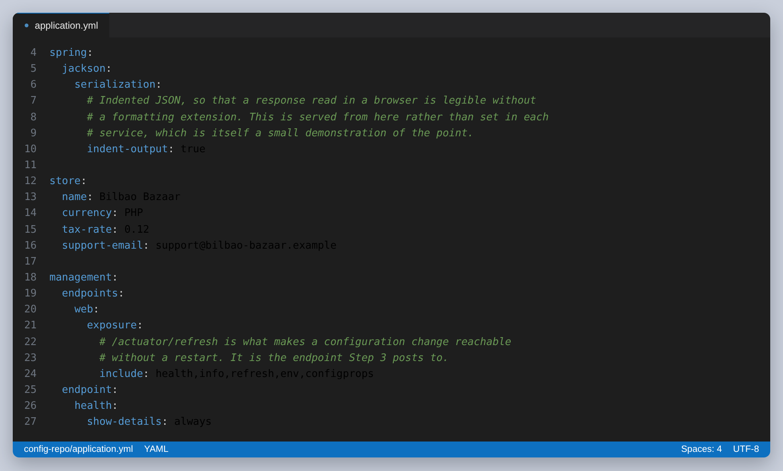
Figure 5: config-repo/application.yml: the store name, currency and tax rate, defined once for every service that asks.
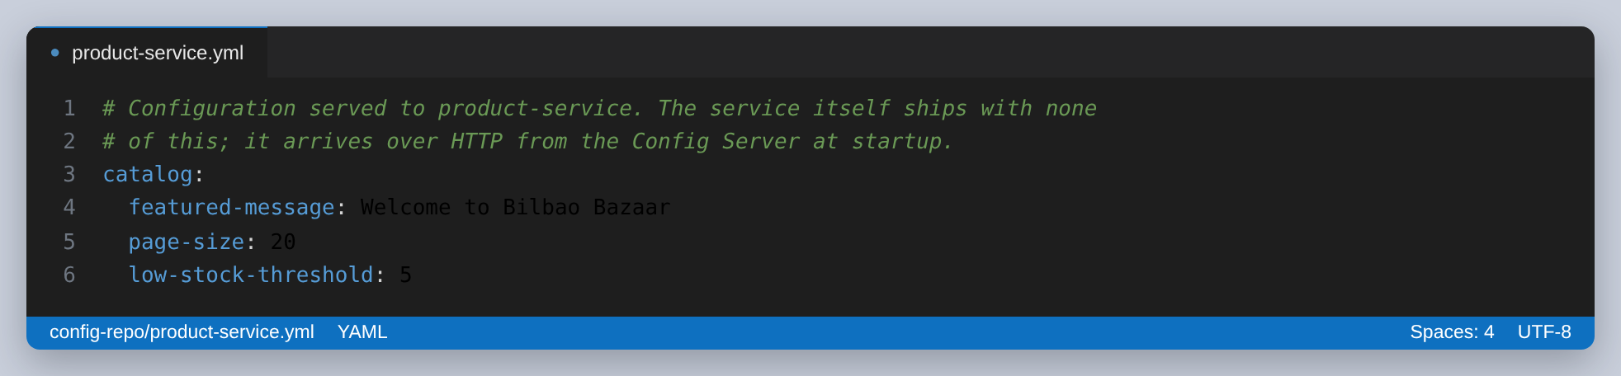
Figure 6: config-repo/product-service.yml. The file name is not arbitrary: it has to match the service's spring.application.name, which is how the server knows which file to serve to whom.
The server exposes it at /{application}/{profile}, and merges the two files for the caller. Asking for the shared file directly shows what every service receives:
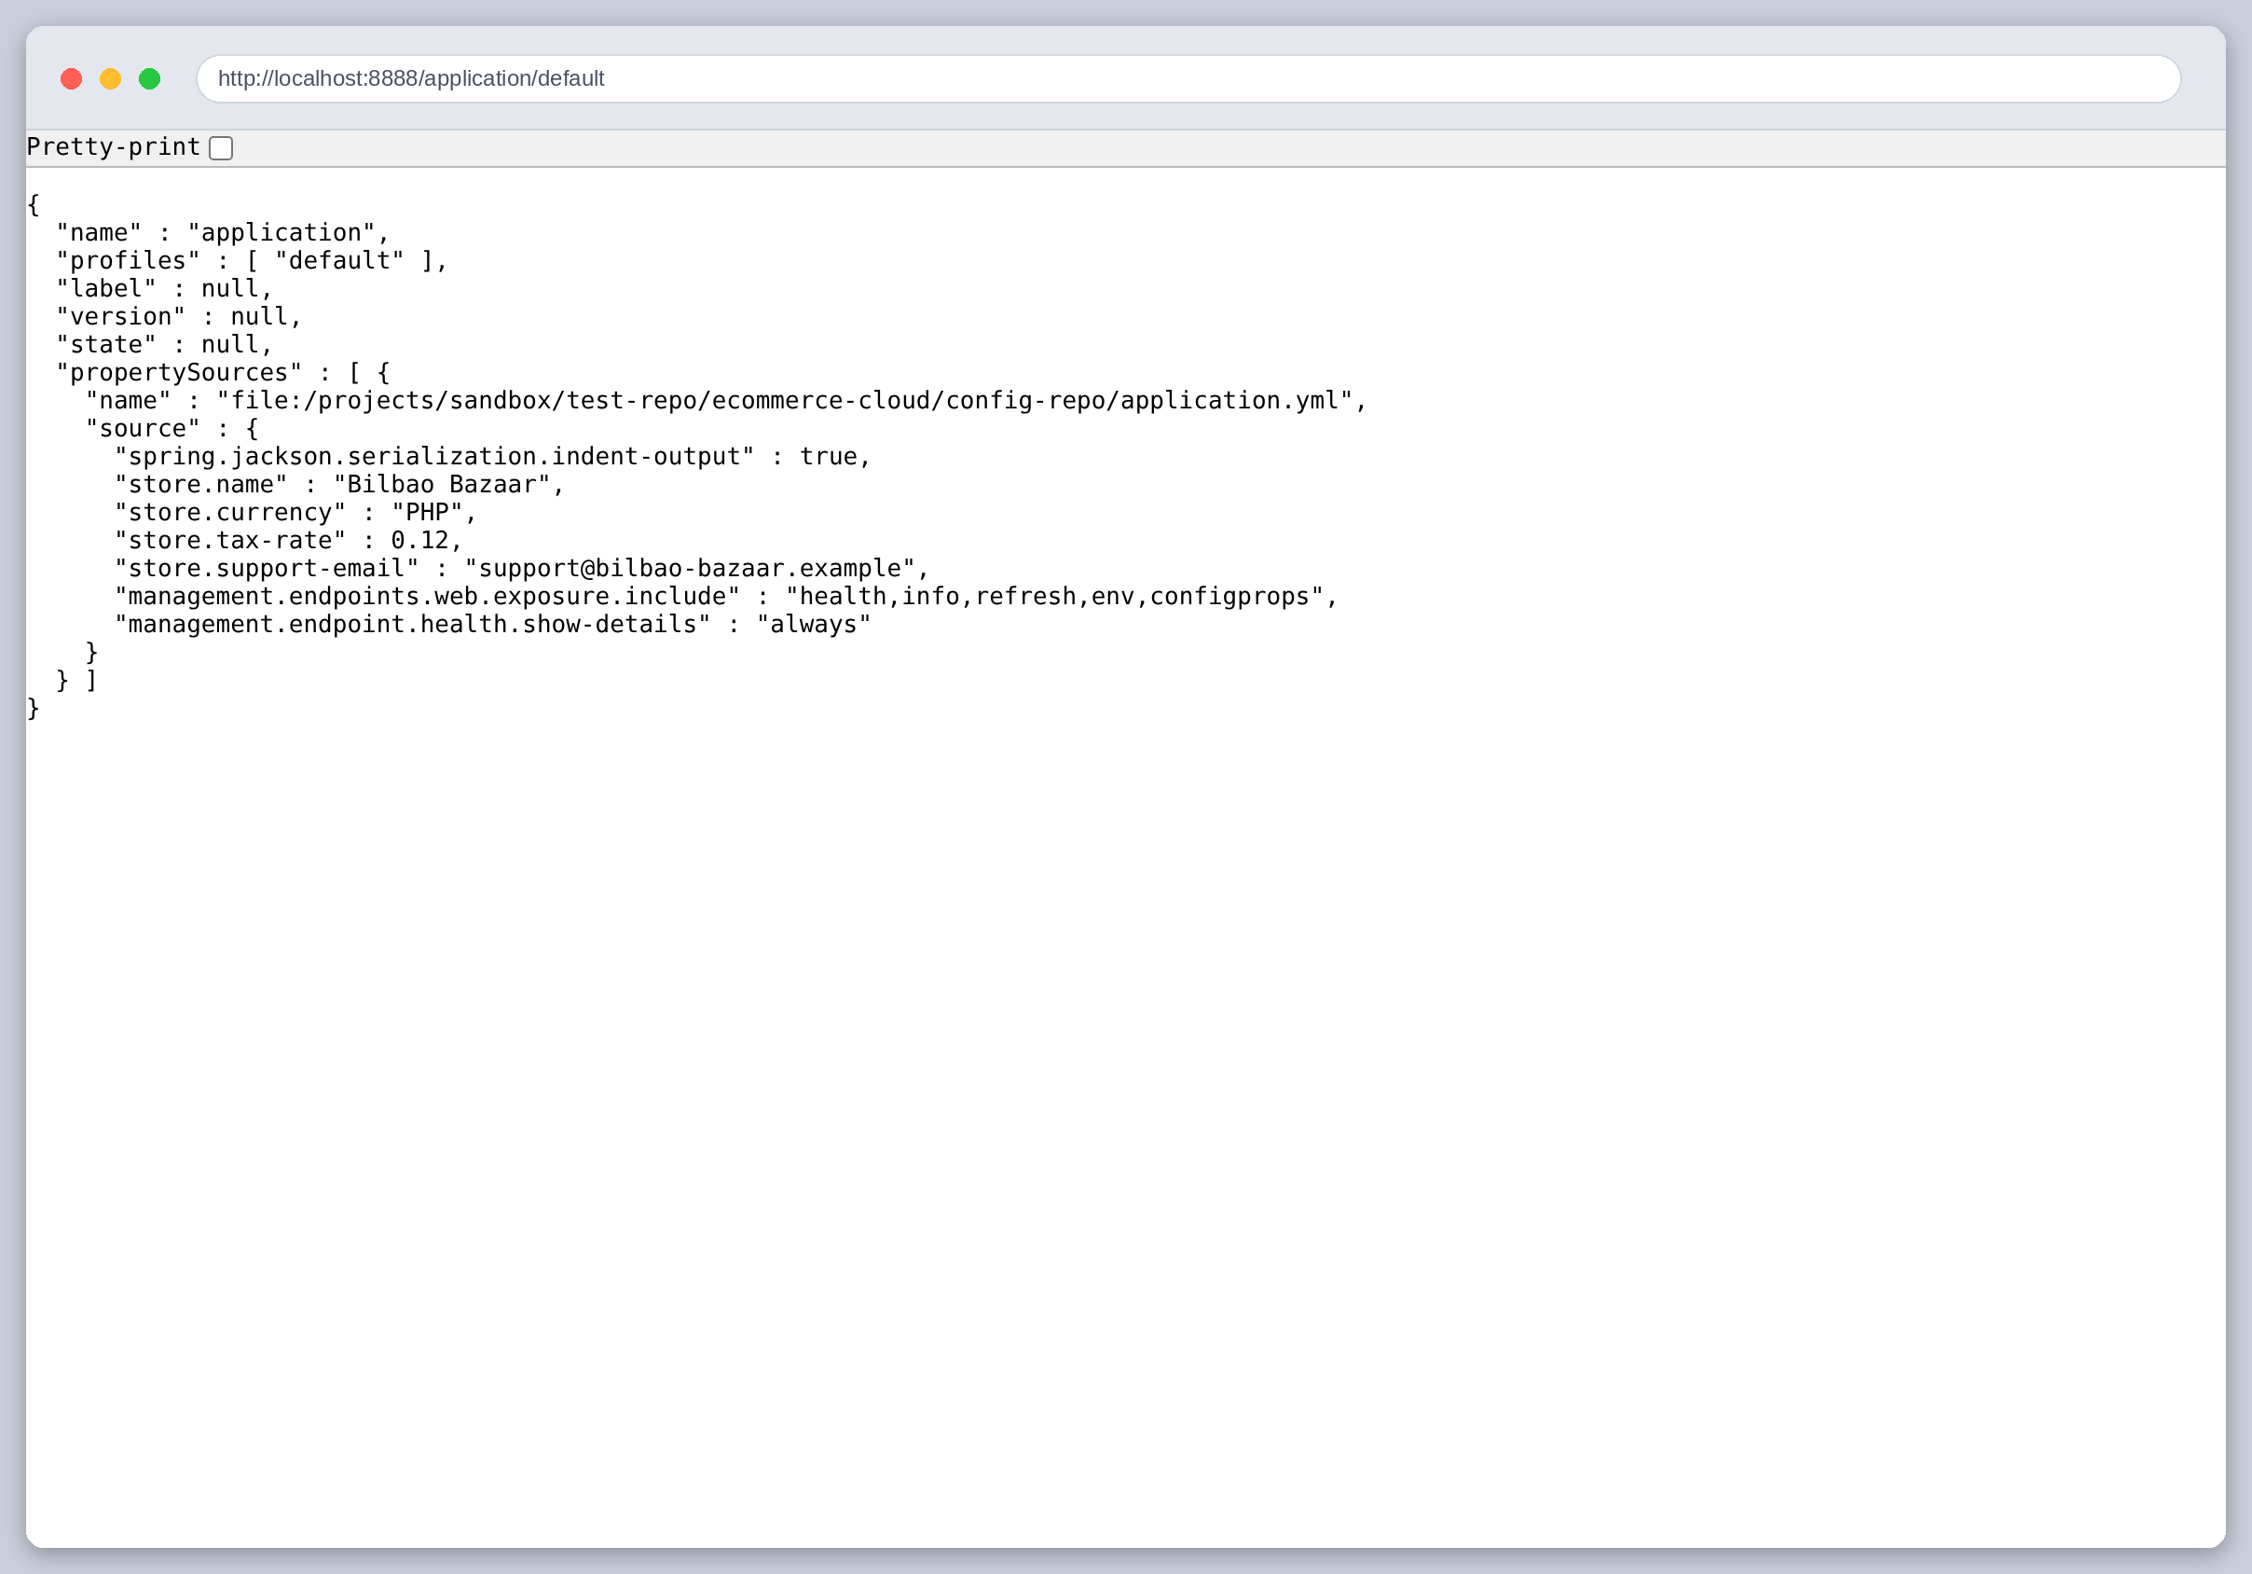
Figure 7: The Config Server serving the shared configuration, in a browser at localhost:8888/application/default.
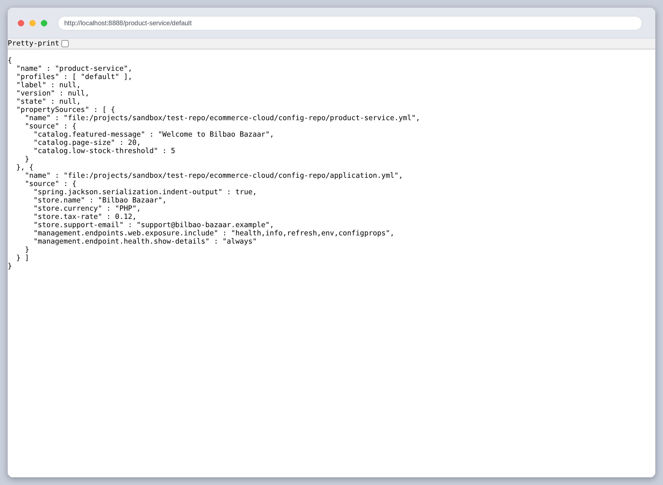
Figure 8: The same endpoint for product-service. Two property sources come back: the service-specific file first, then the shared one. That order is the precedence rule, and it is why a service can override a shared default.
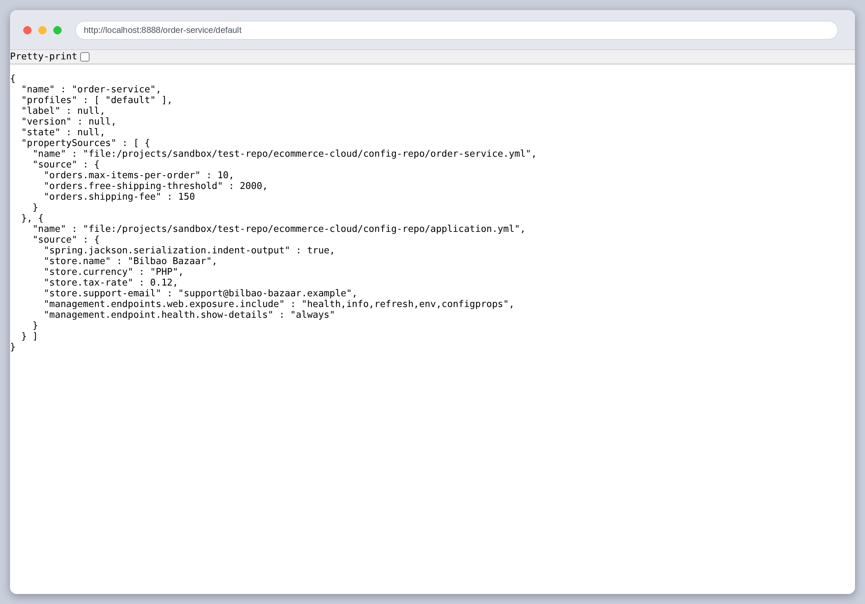
Figure 9: And for order-service, which gets its own orders.* values plus the same shared store.* block.
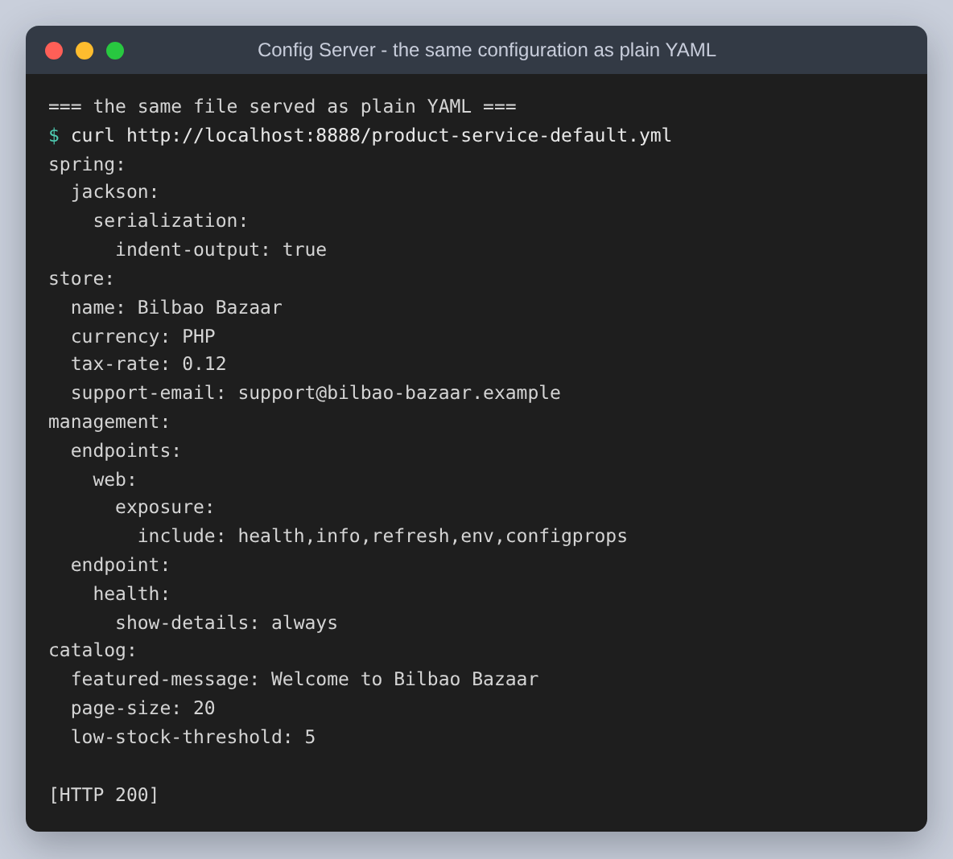
Figure 10: The same configuration served as plain YAML rather than as the server's JSON envelope, which is the form that is easiest to check by eye.

Step 2: service discovery with Eureka
The Eureka server is the registry: services report in when they start, renew a lease while they are alive, and are removed when they stop or stop renewing. It is as small as the Config Server.
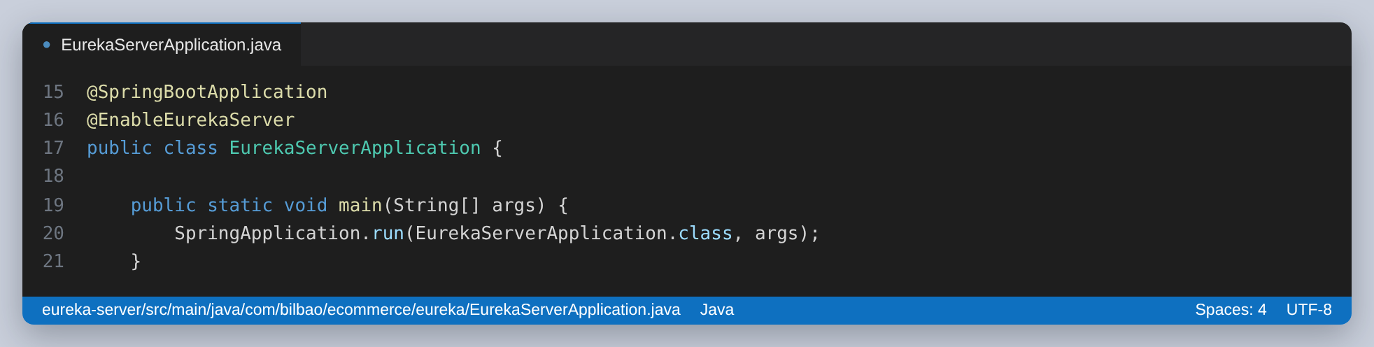
Figure 11: The Eureka server. It registers nothing itself, which is why both client flags are false in its configuration.
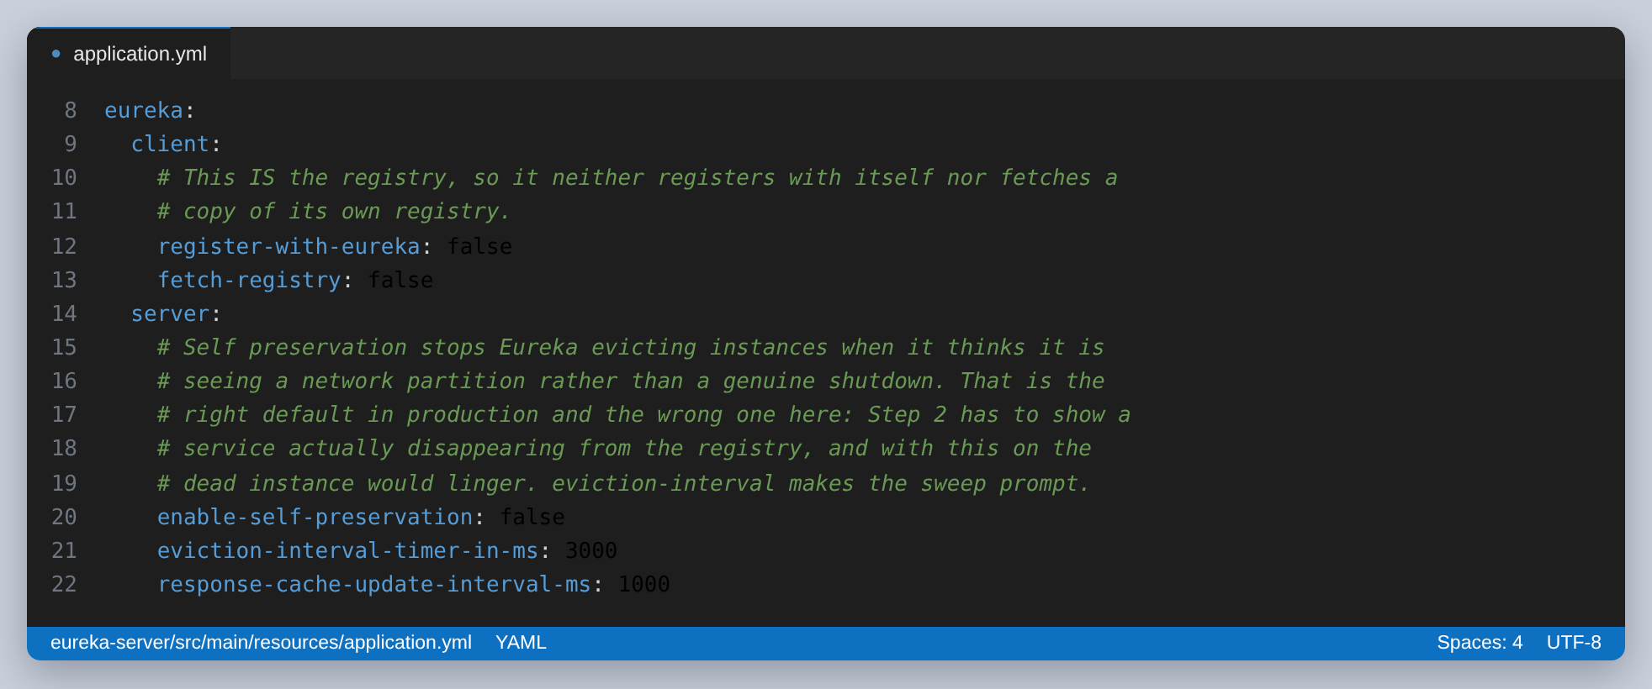
Figure 12: Two settings here are deliberate departures from the defaults, and the comment says why: self preservation would stop Eureka evicting a stopped instance, and this assignment has to show one actually disappearing.
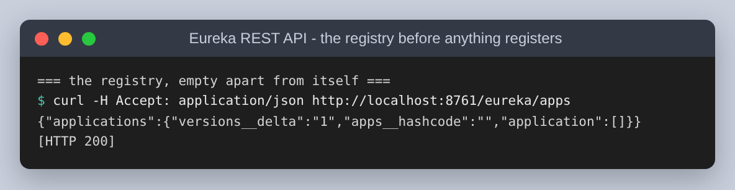
Figure 13: The registry immediately after the server starts: empty.
A service becomes a client by adding the Eureka client starter and pointing it at the registry. Its spring.application.name does double duty: Eureka registers the instance under it, and the Config Server uses it to choose a file.
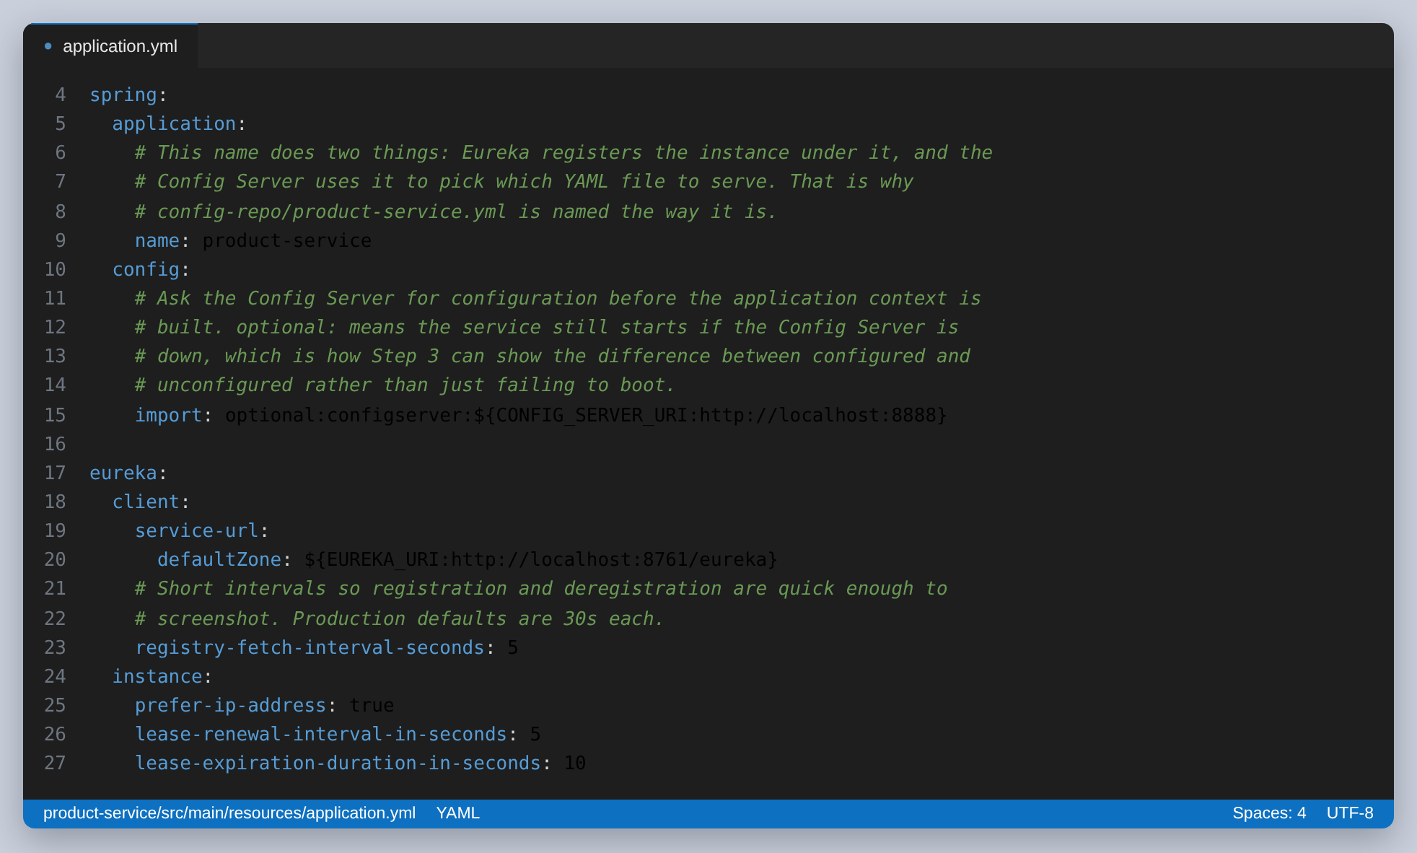
Figure 14: All the Product Service knows: its own name, where the Config Server is, and where Eureka is. The lease intervals are shortened from the 30-second defaults so registration and eviction are quick enough to observe.
Both services then start, and the startup logs show the two mechanisms in sequence: fetch configuration, then register.
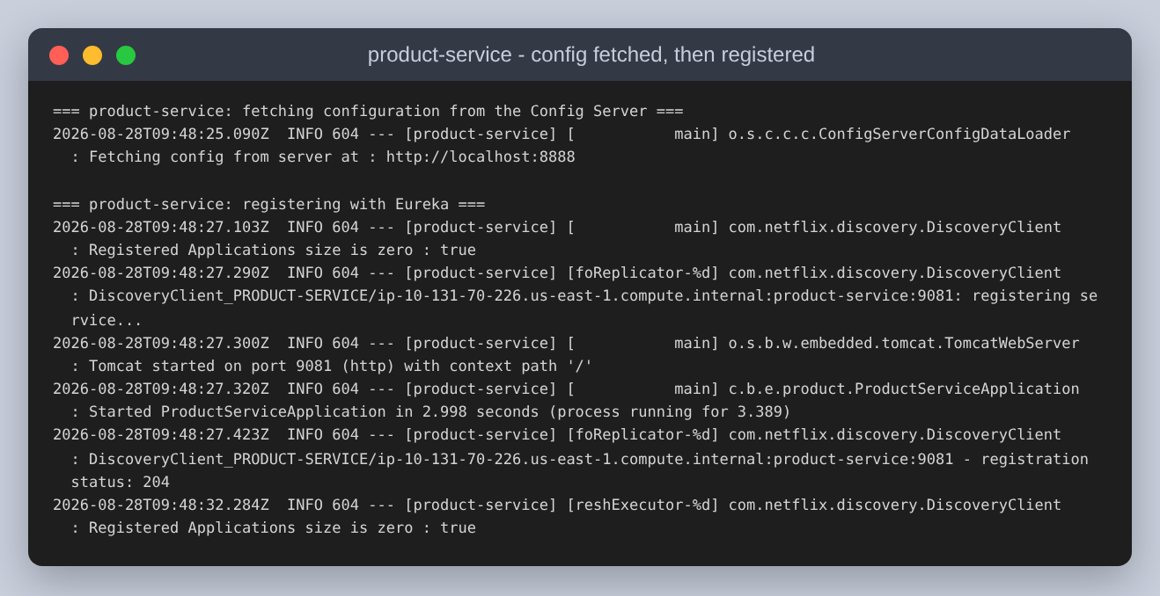
Figure 15: product-service: it fetches its configuration from localhost:8888, then registers with Eureka and Tomcat starts on 9081. Registration status 204 is Eureka acknowledging the lease.
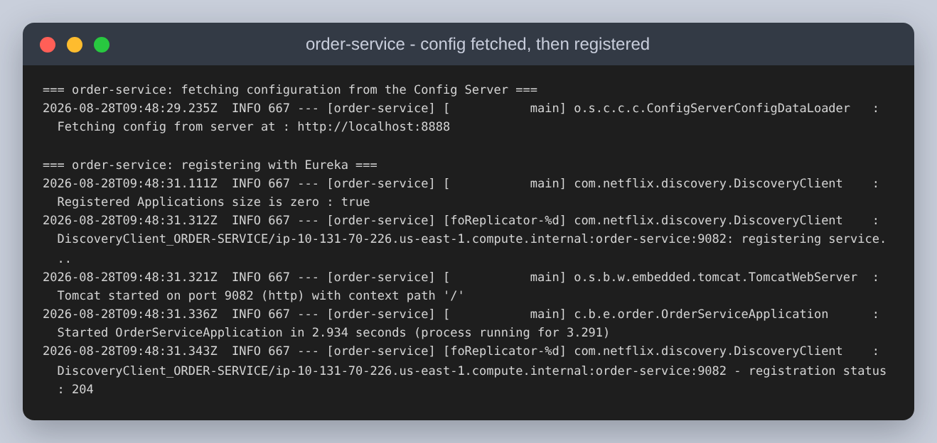
Figure 16: order-service doing the same thing.
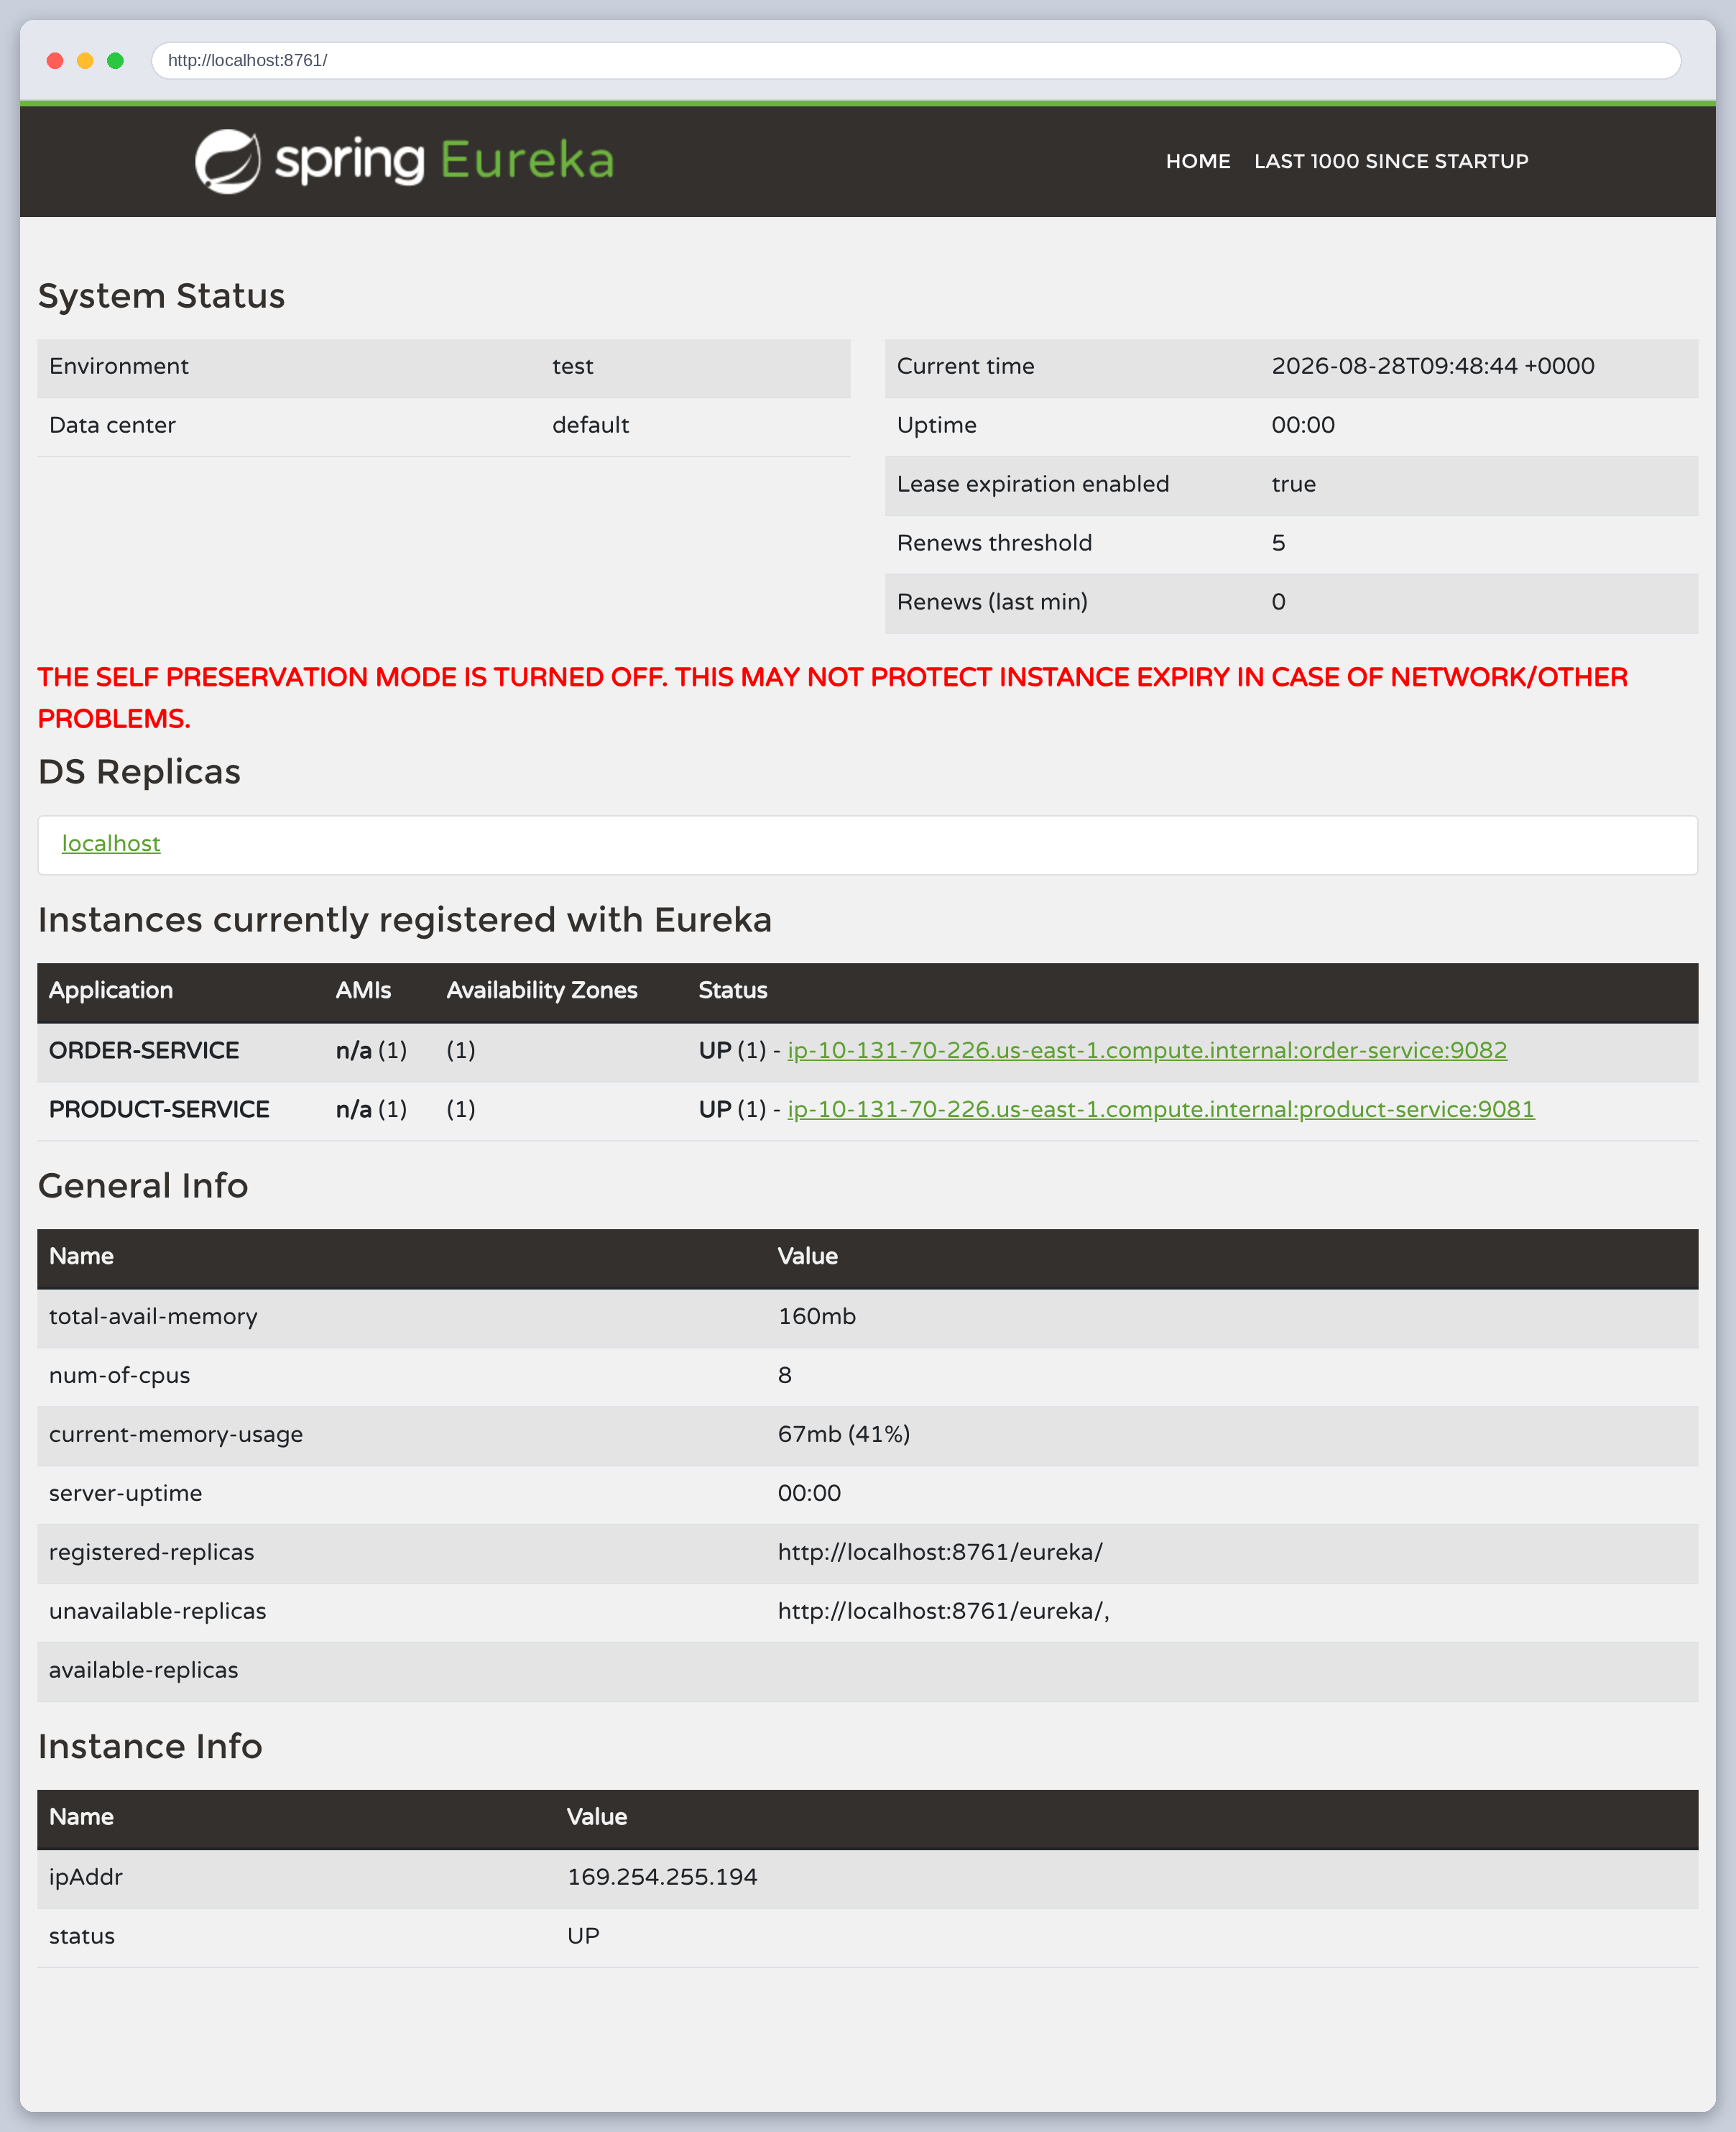
Figure 17: The Eureka dashboard with both services registered and UP. This is the screenshot the assignment asks for.
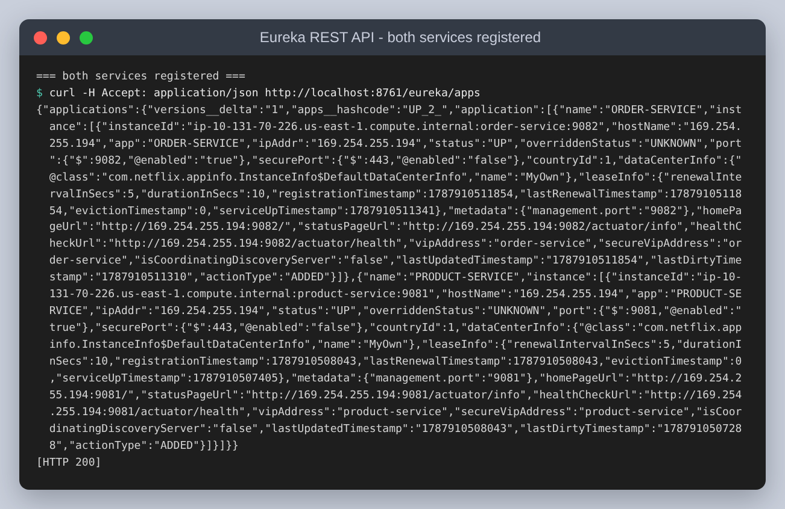
Figure 18: The same registry over Eureka's REST API rather than the dashboard, which is what a client actually consumes.
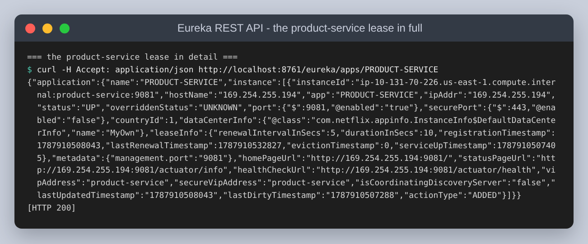
Figure 19: One lease in full. The interesting fields are vipAddress, the logical name callers use, and leaseInfo, which carries the renewal interval and the duration after which the lease expires.

Using the registry, rather than just filling it
Registering is the easy half. The Order Service has to resolve the name to an address, and that is one bean.
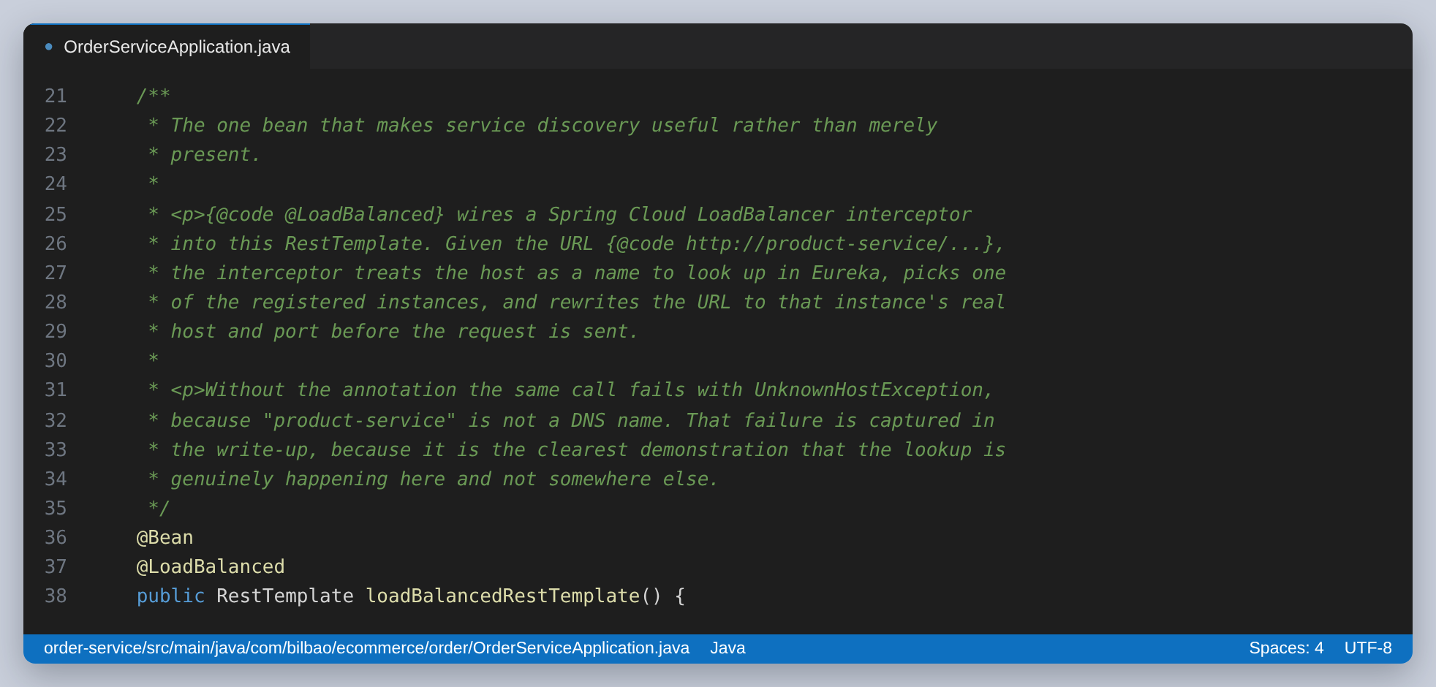
Figure 20: The bean that makes discovery useful. @LoadBalanced adds an interceptor that treats the host in the URL as a name to look up in Eureka, picks a registered instance, and rewrites the URL before the request goes out.
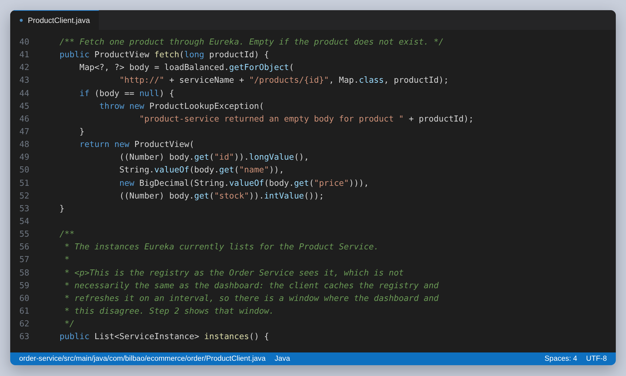
Figure 21: The client. Every URL uses the logical name; no host or port appears anywhere in the Order Service.
It is worth proving that the lookup is really happening here, and not that something else is quietly resolving the name. The same call on a plain RestTemplate, with no interceptor, is exposed as its own endpoint:
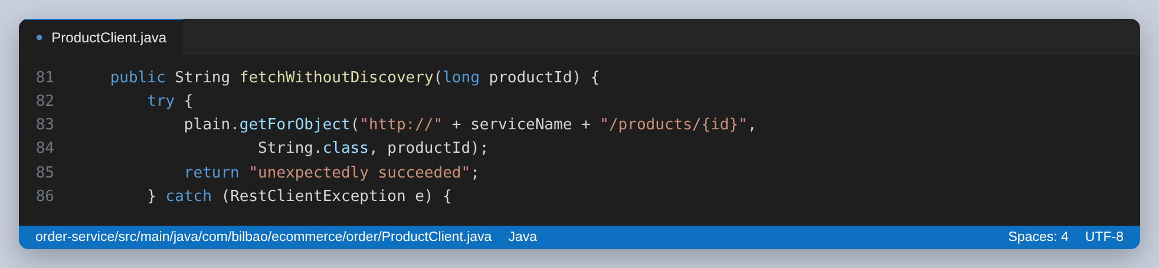
Figure 22: The deliberately broken call, kept as an endpoint so the failure can be captured rather than described.
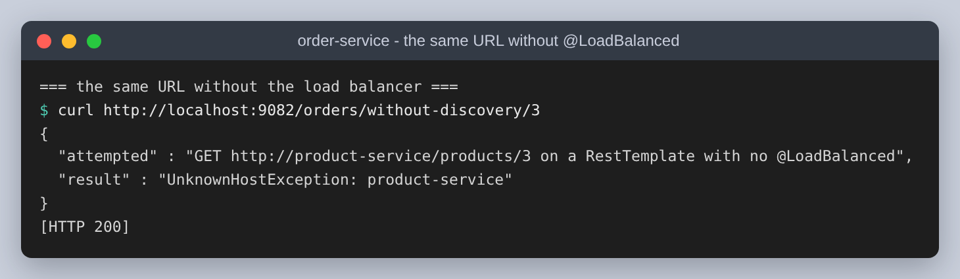
Figure 23: UnknownHostException: product-service. The name is not a DNS name and nothing on the machine can resolve it, so the working call must be going through the registry.

Step 4: the two services working together
With both mechanisms in place the application does something. The catalogue response is wrapped in values the Product Service did not declare: the store name and currency came from the shared file, the banner and page size from its own.
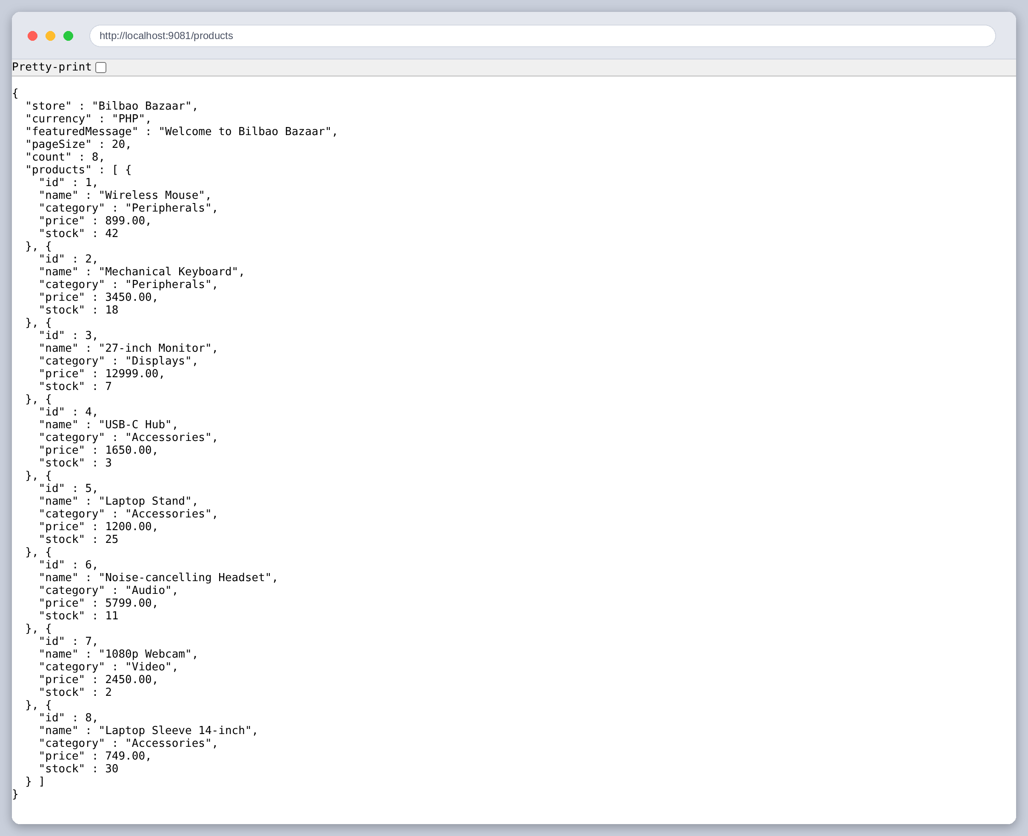
Figure 24: GET /products in a browser. featuredMessage and pageSize are configuration, not code.
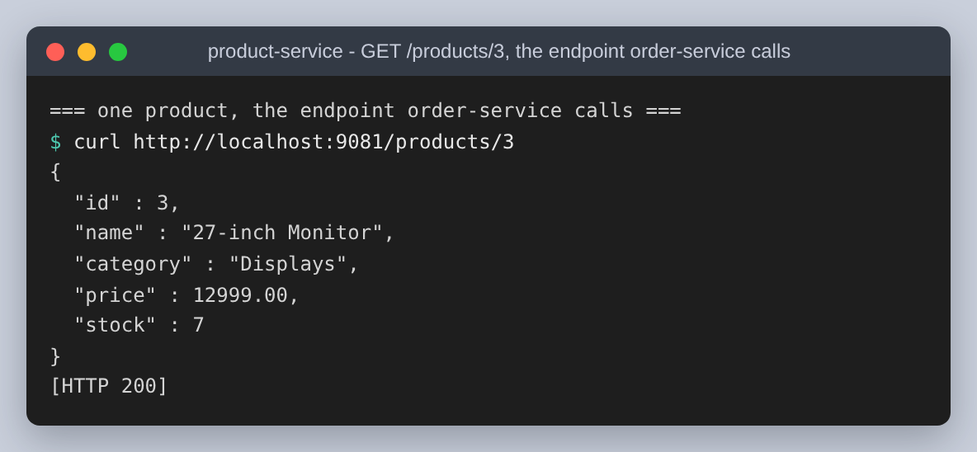
Figure 25: GET /products/3, the endpoint the Order Service calls through Eureka.
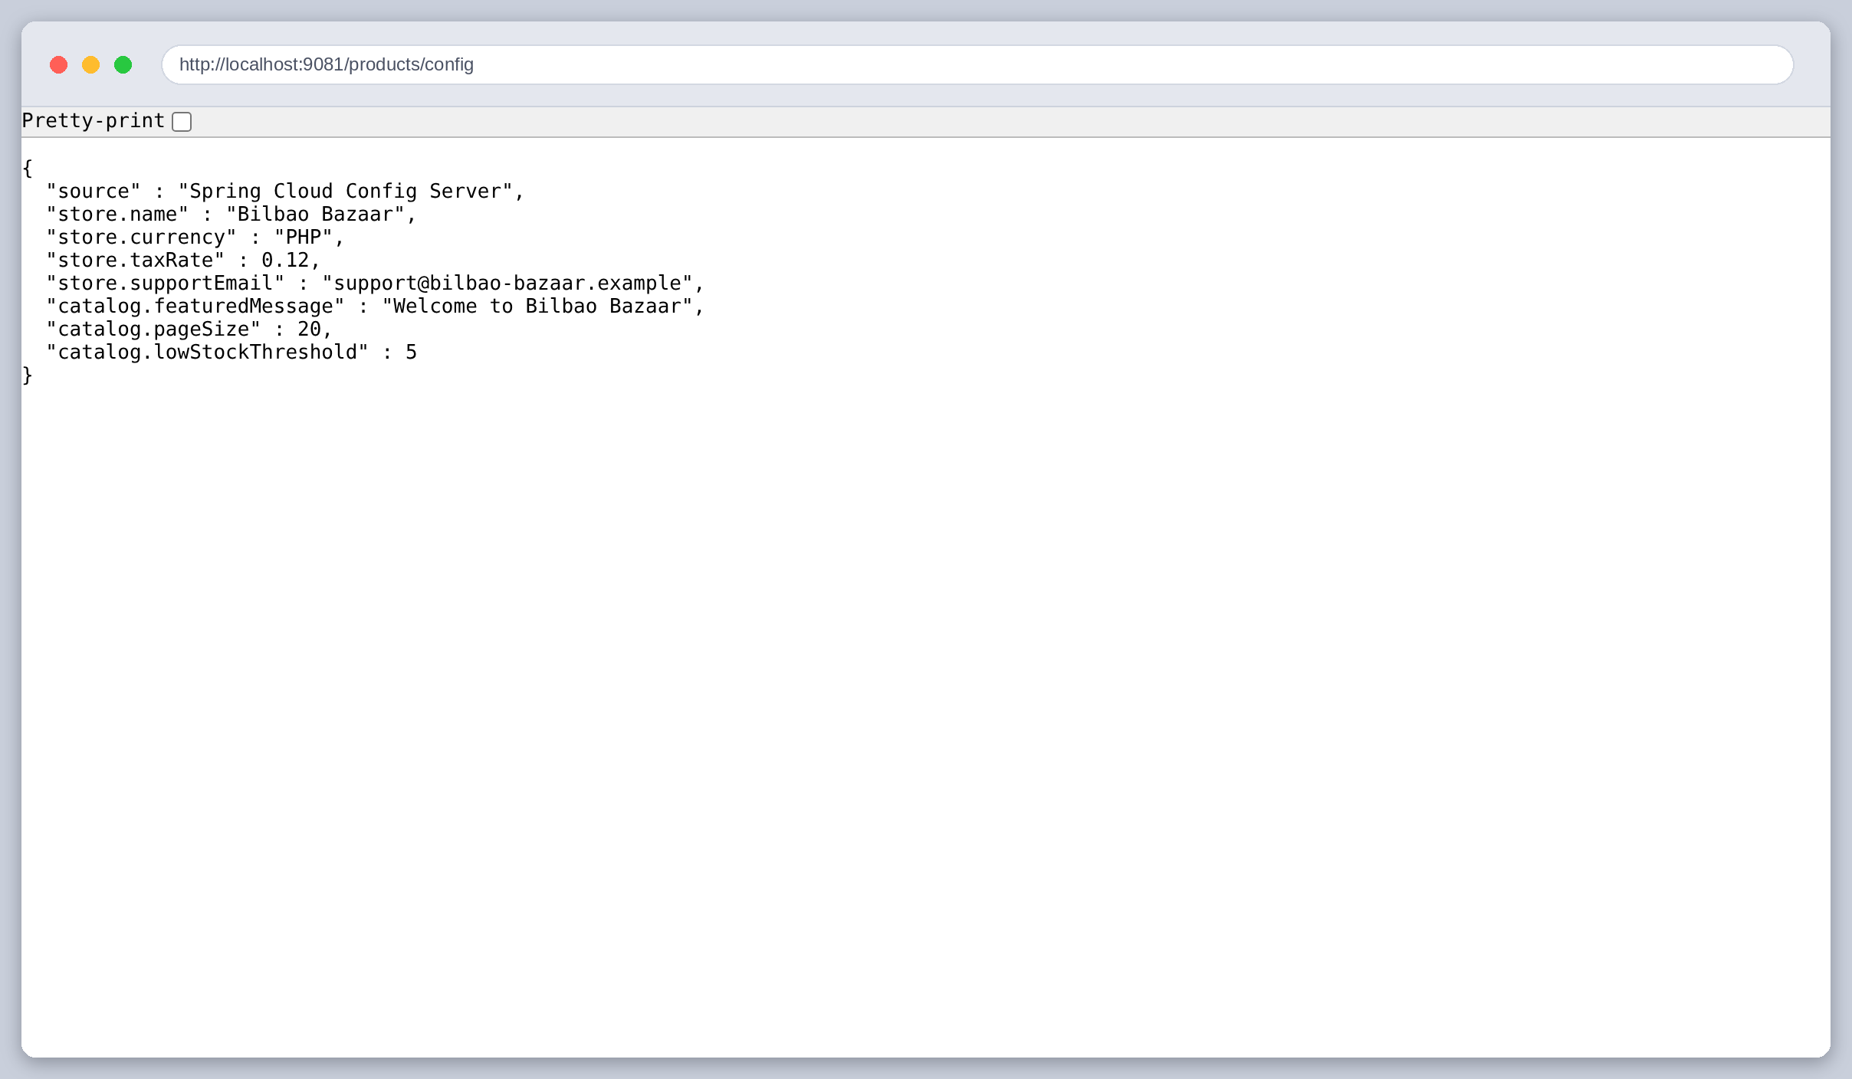
Figure 26: GET /products/config reports everything this service was told, which makes the effect of a configuration change visible in one place.
The Order Service exposes the same idea from the other side: one endpoint that answers whether discovery is working and whether configuration is working at the same time.
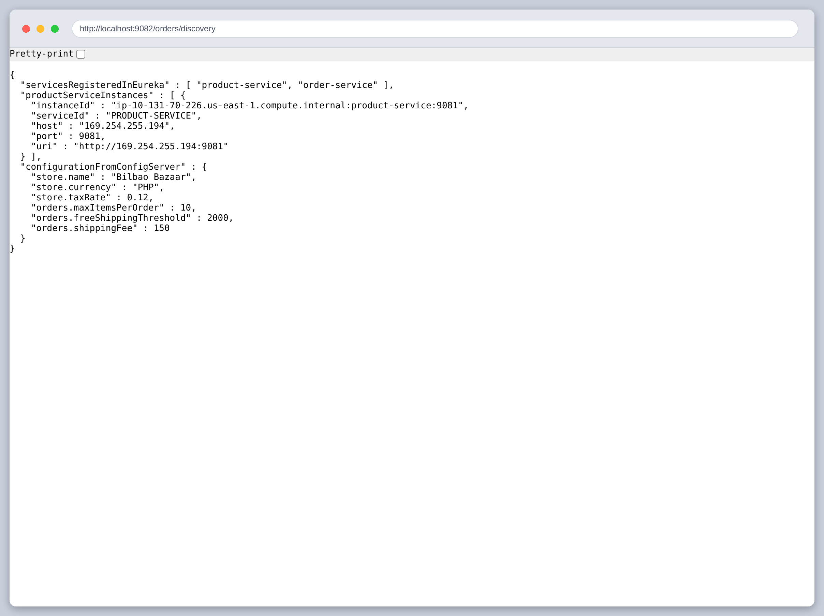
Figure 27: GET /orders/discovery: the service names Eureka knows, the concrete instances of product-service with their host and port, and the configuration this service received.
Placing an order uses both. The price is fetched from the Product Service found through Eureka; the tax rate, the shipping fee and the free-shipping threshold all come from the Config Server.
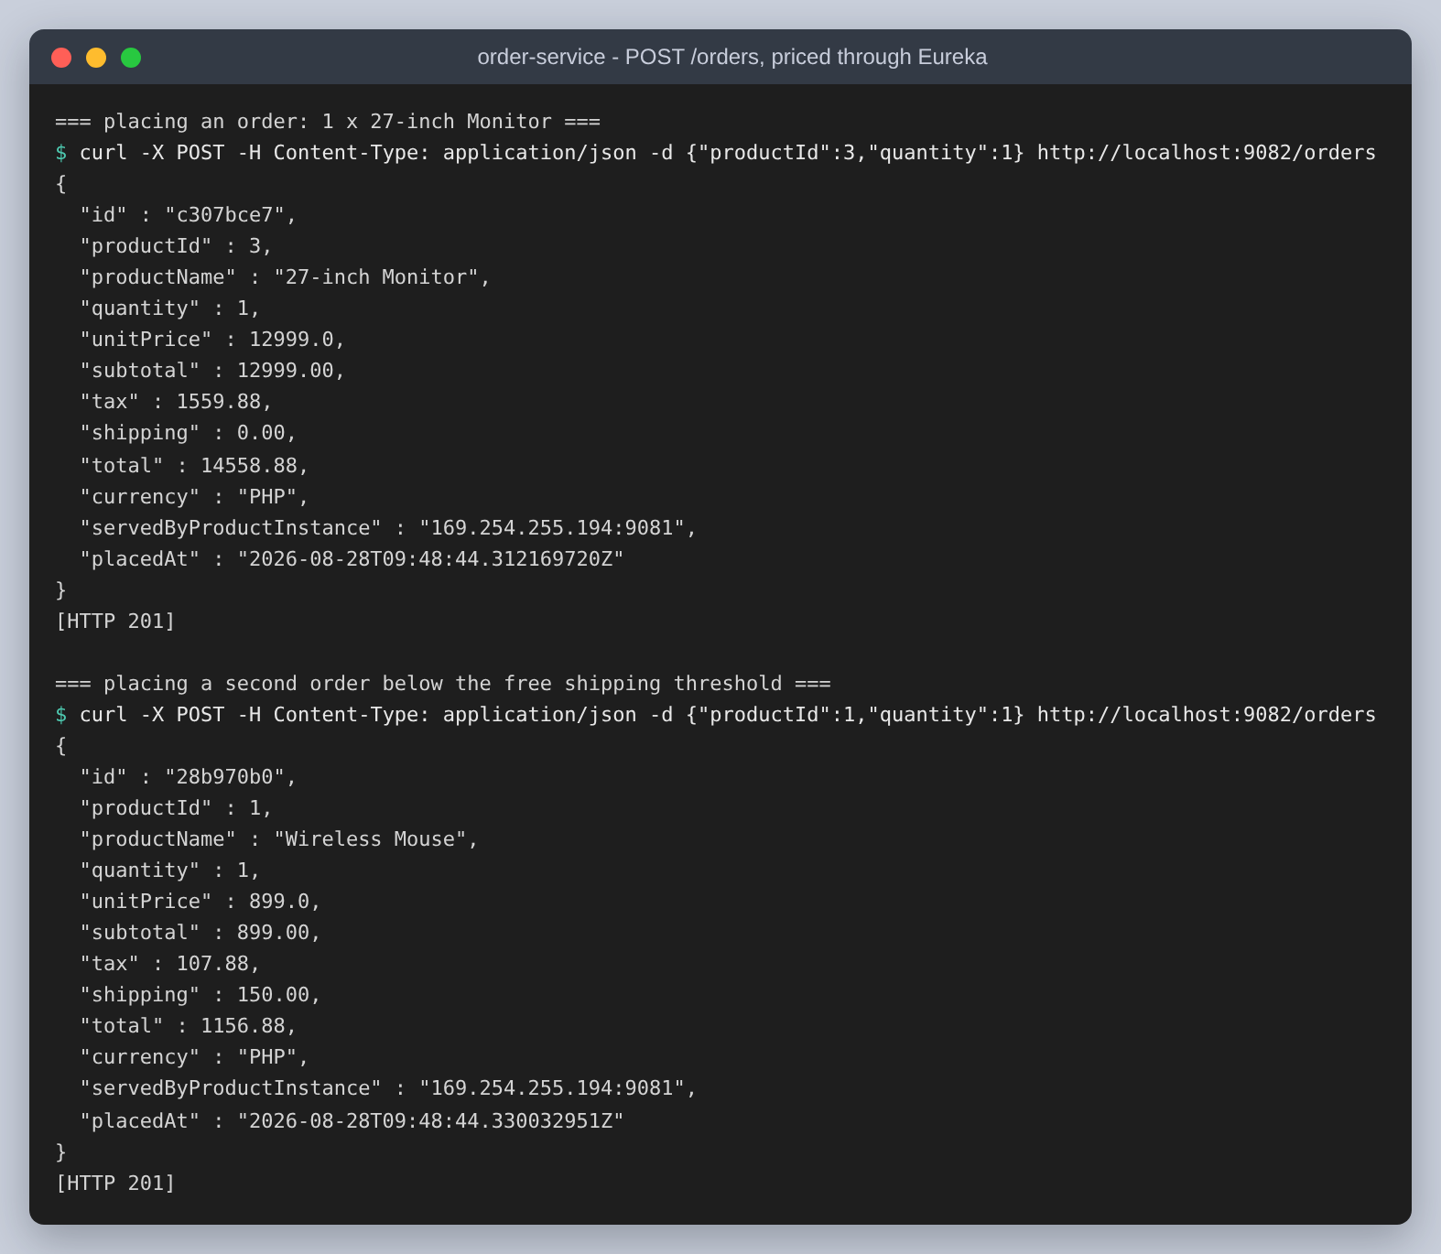
Figure 28: Two orders. The monitor is over the 2,000 free-shipping threshold so shipping is zero; the mouse is under it and is charged 150. Both figures are configuration, and servedByProductInstance records which discovered instance answered.
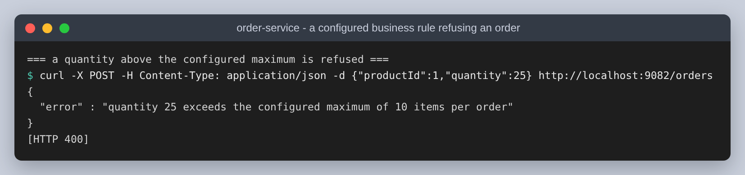
Figure 29: A configured business rule refusing an order. The maximum is not a constant in the Order Service; it is a value the Config Server supplied, and the error message quotes it.
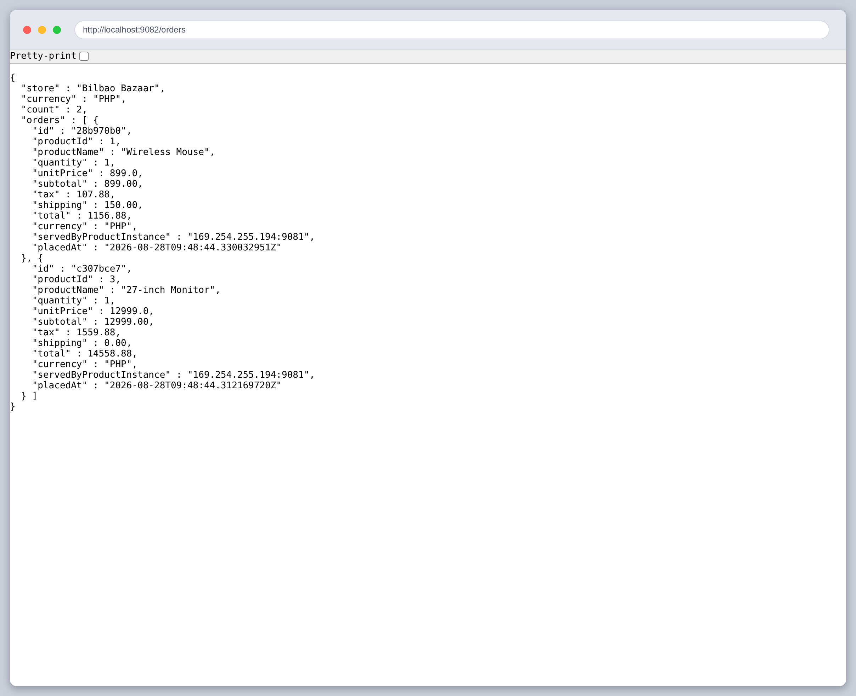
Figure 30: GET /orders in a browser, with both orders and the configured store name and currency.
One deliberate choice in the Order model: productName and unitPrice are copied from the Product Service when the order is placed, not looked up again on every read. An order is a record of what was agreed, and a later price change must not silently rewrite it. This is the kind of decision service boundaries force you to make explicitly, which is an argument in their favour.

Step 3: changing configuration on a running service
The assignment asks for configuration values to be updated and retrieved. Retrieving them is already shown. Updating them is more interesting than it sounds, because there are three separate states and it is easy to mistake one for another.
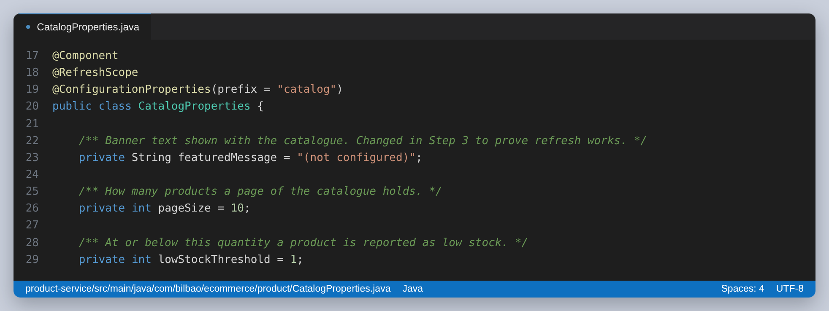
Figure 31: @RefreshScope is what makes an update possible without a restart. Without it these values are bound once at startup; with it, the bean is discarded and rebuilt on next use after a refresh.
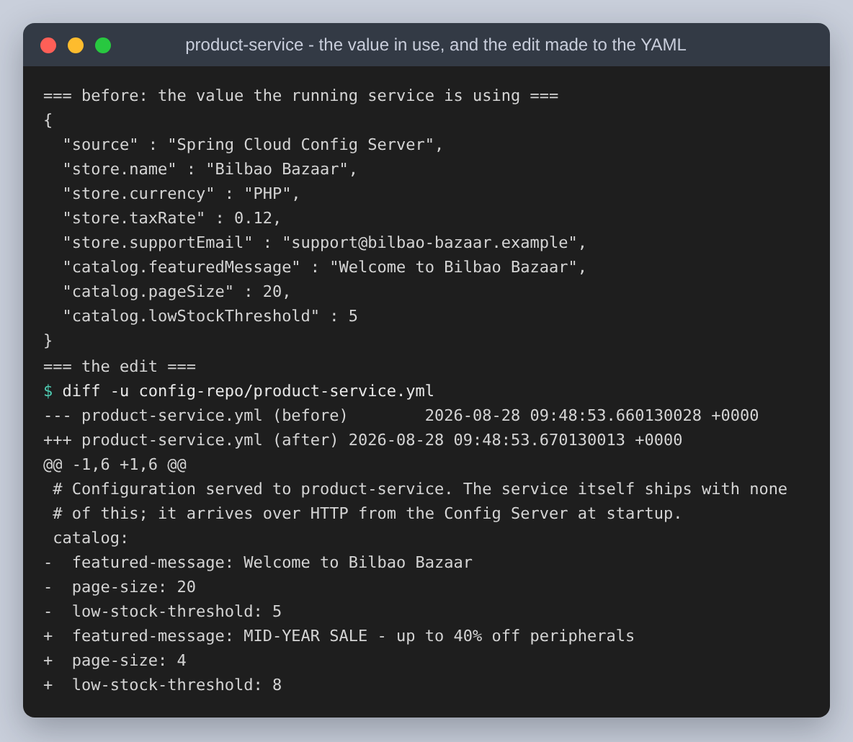
Figure 32: The value the running service is using, then the edit: a new banner, the page size cut from 20 to 4, and the low-stock threshold raised from 5 to 8.
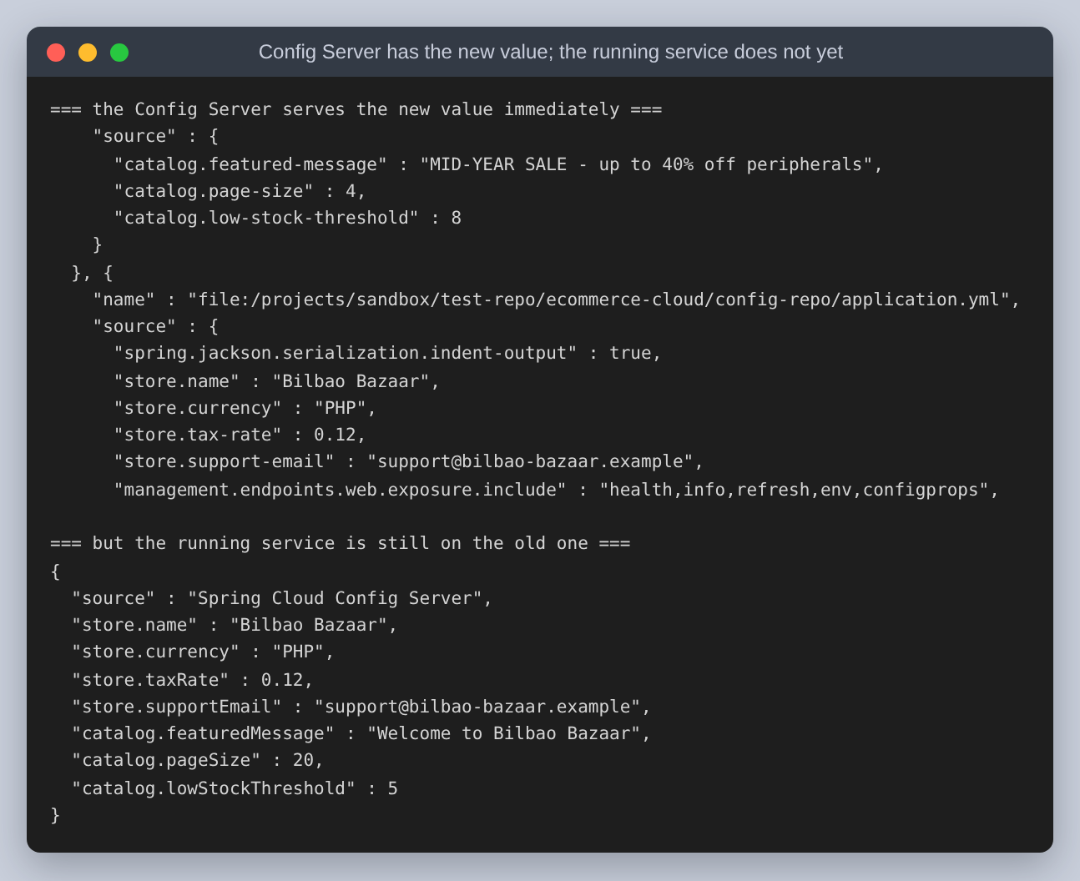
Figure 33: The state that is easy to miss. The Config Server serves the new values the moment the file is saved, and the running service is still on the old ones. Checking the Config Server alone would have looked like success.
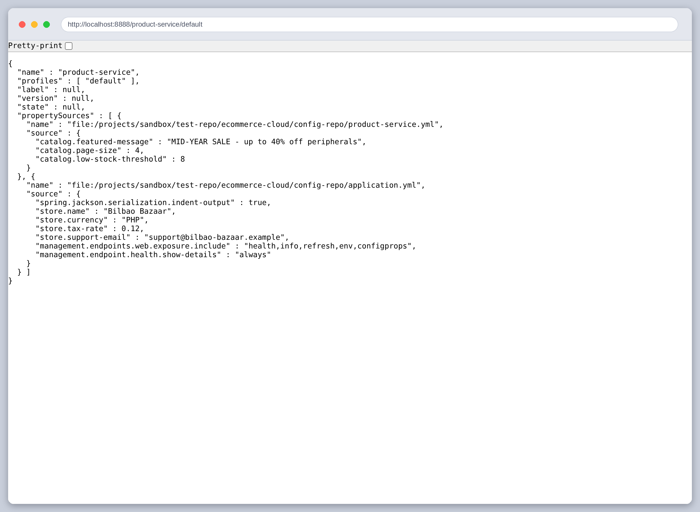
Figure 34: The Config Server in a browser after the edit, serving the new values.
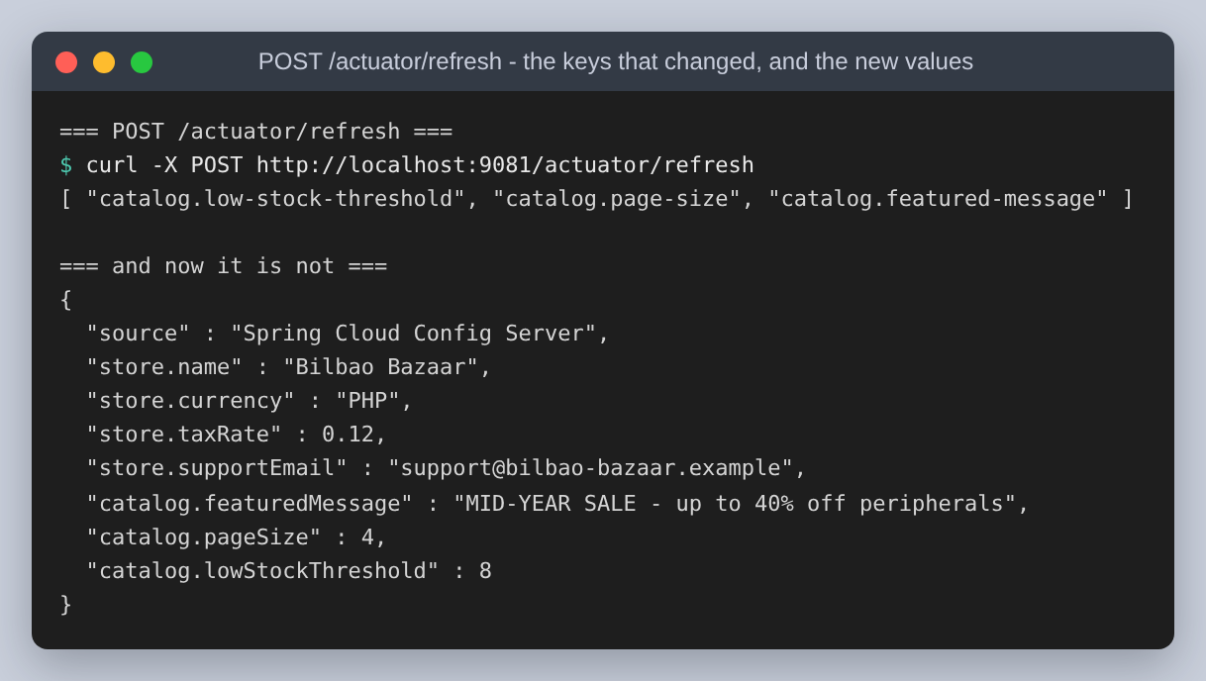
Figure 35: POST /actuator/refresh returns [ "catalog.low-stock-threshold", "catalog.page-size", "catalog.featured-message" ], the keys it found changed, and the service now reports the new values.
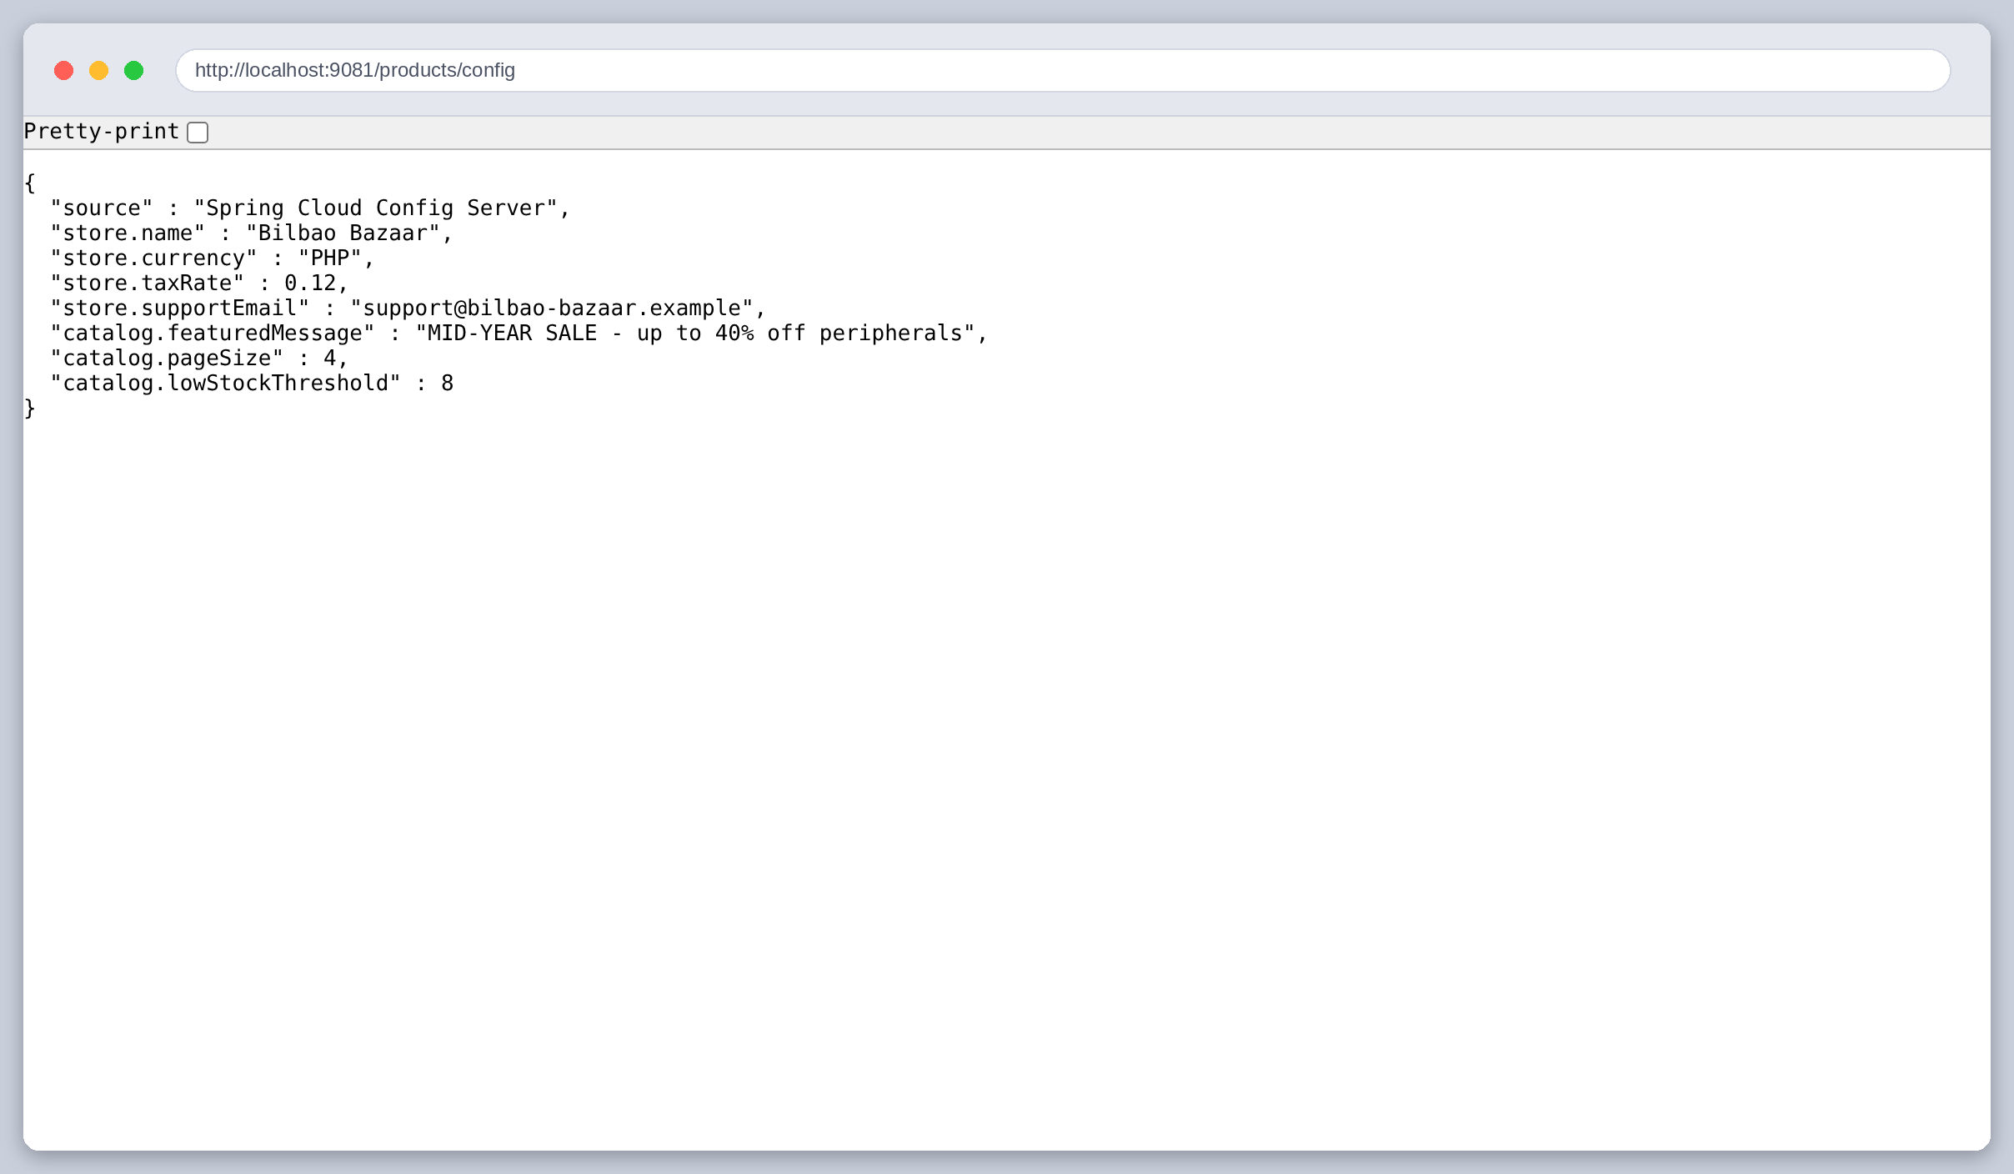
Figure 36: The same endpoint in a browser after the refresh. Compare with the earlier screenshot of this URL.
A configuration endpoint reporting a new number is still only a report. The threshold is used to decide which products count as low stock, so raising it from 5 to 8 should change what a different endpoint returns:
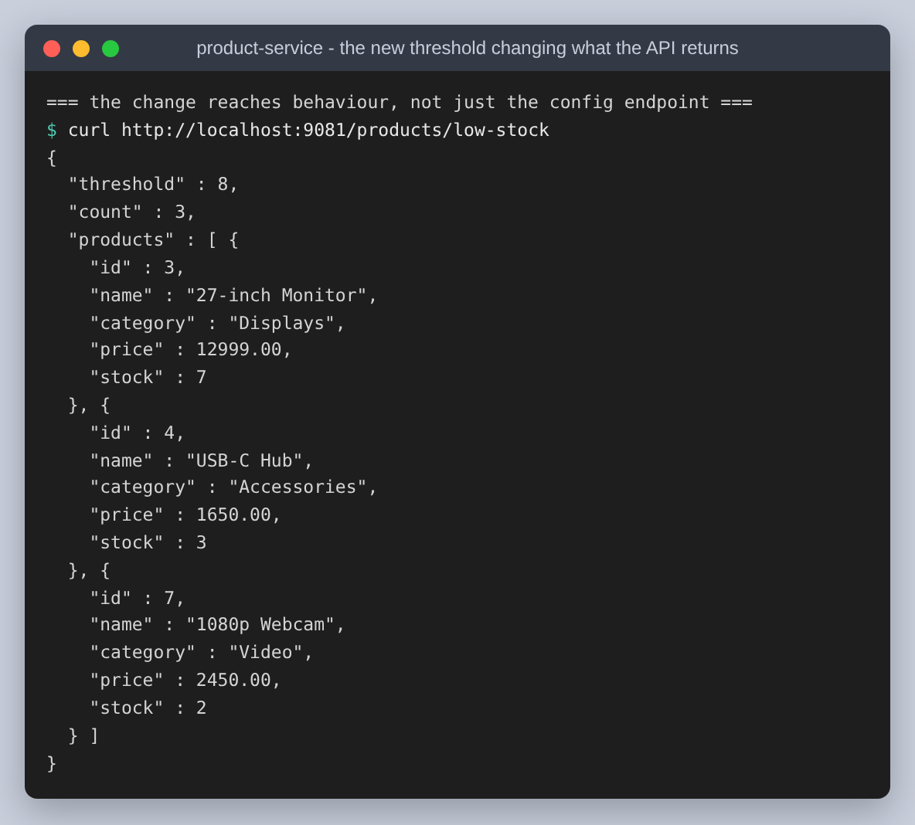
Figure 37: The new threshold changing behaviour: 3 products now count as low stock, including the monitor with 7 in stock, which did not qualify under the old threshold of 5.
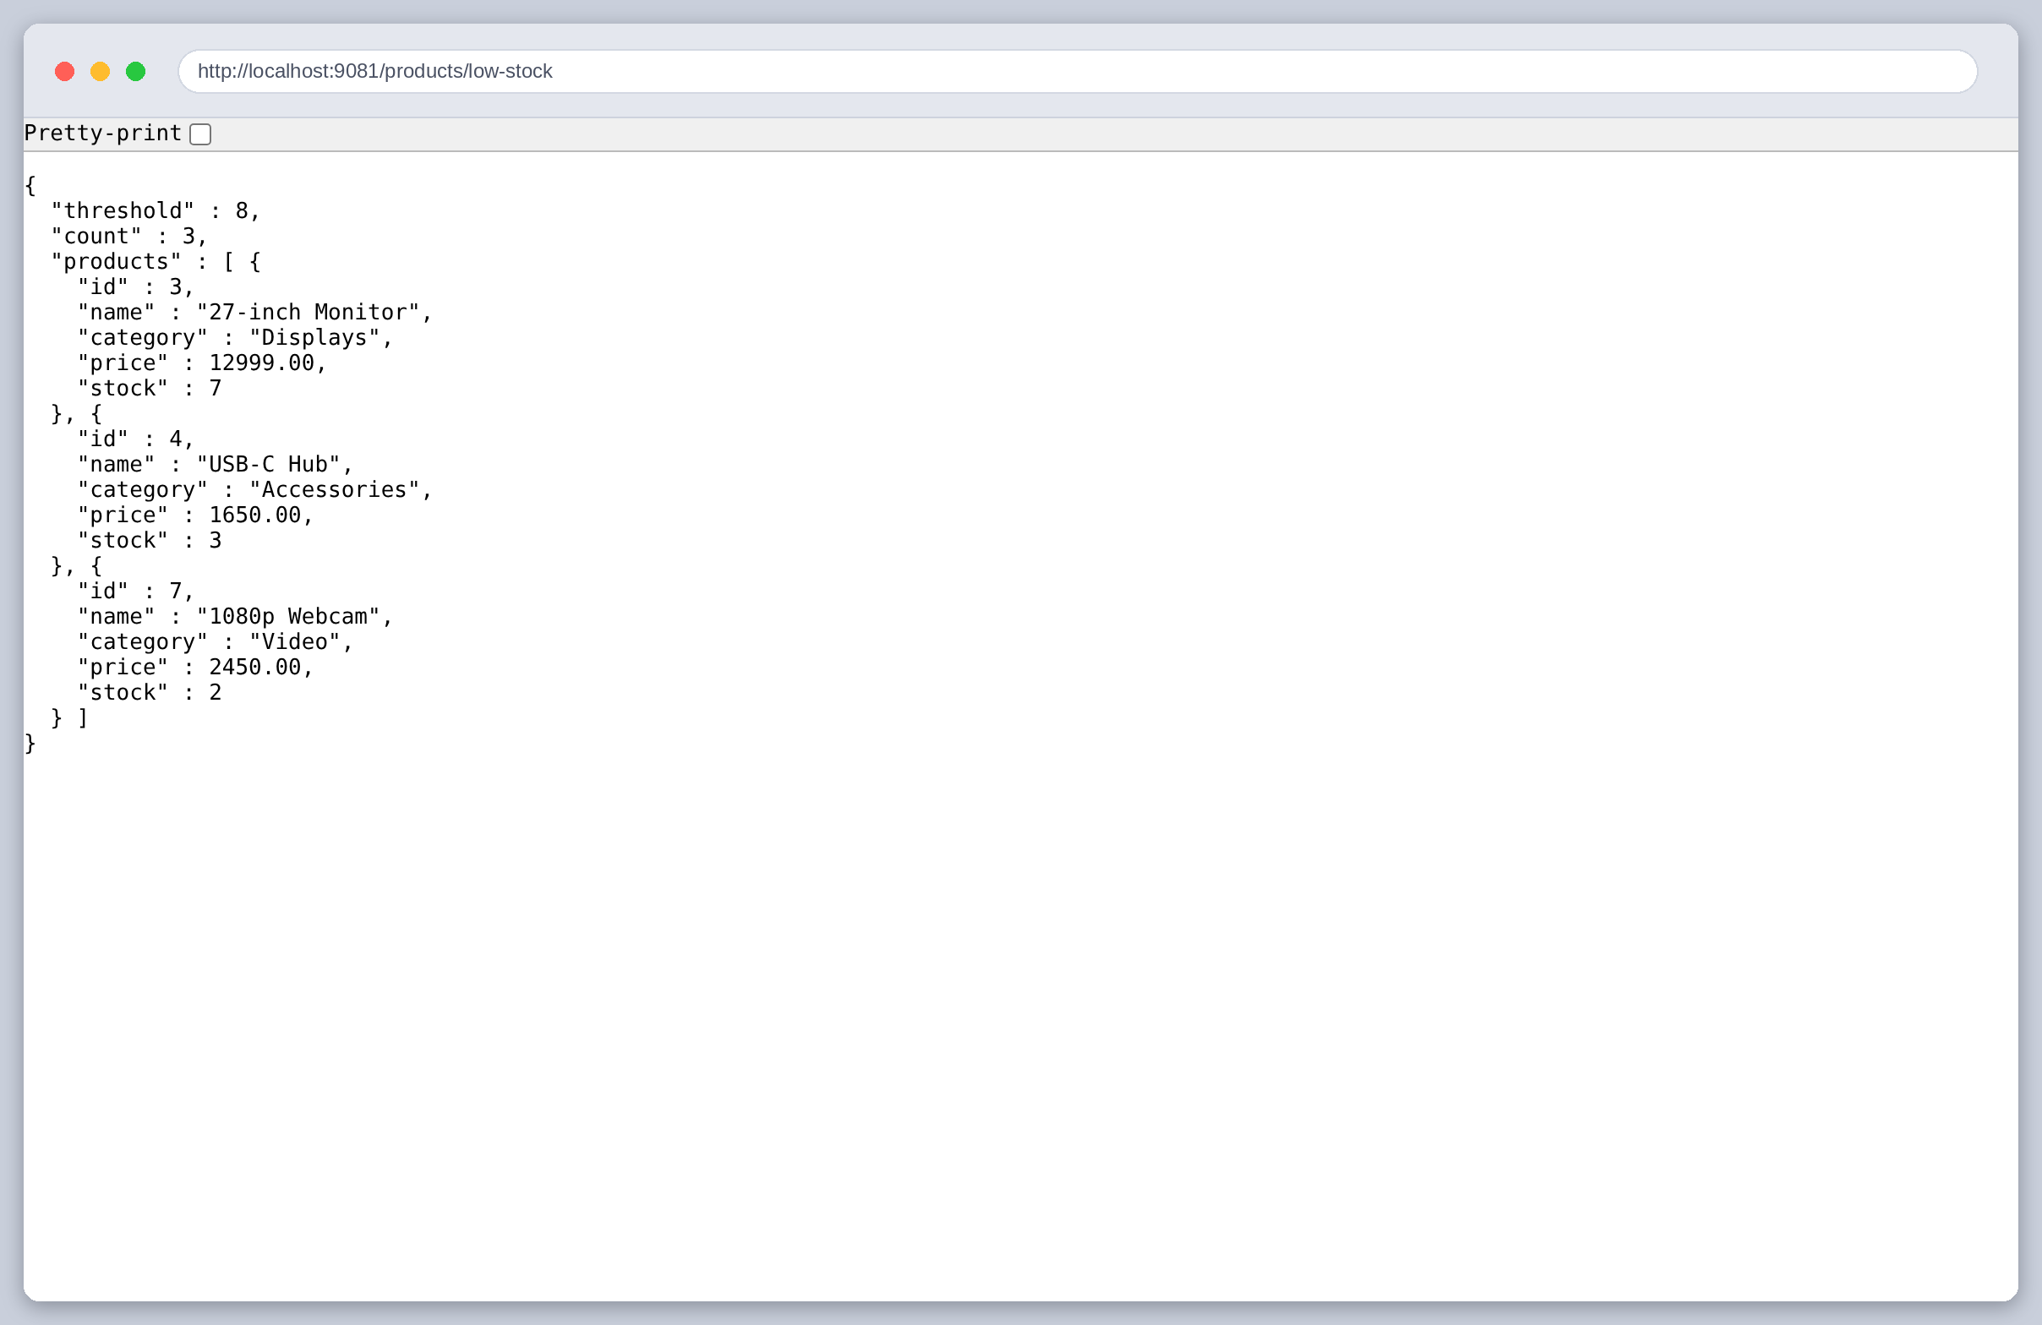
Figure 38: The same result in a browser.

Step 2 again: deregistering, and coming back somewhere else
The assignment asks for service discovery to be tested by registering and deregistering. Registering is shown above. Deregistering is where a registry earns its place, because the interesting question is what happens to the caller.
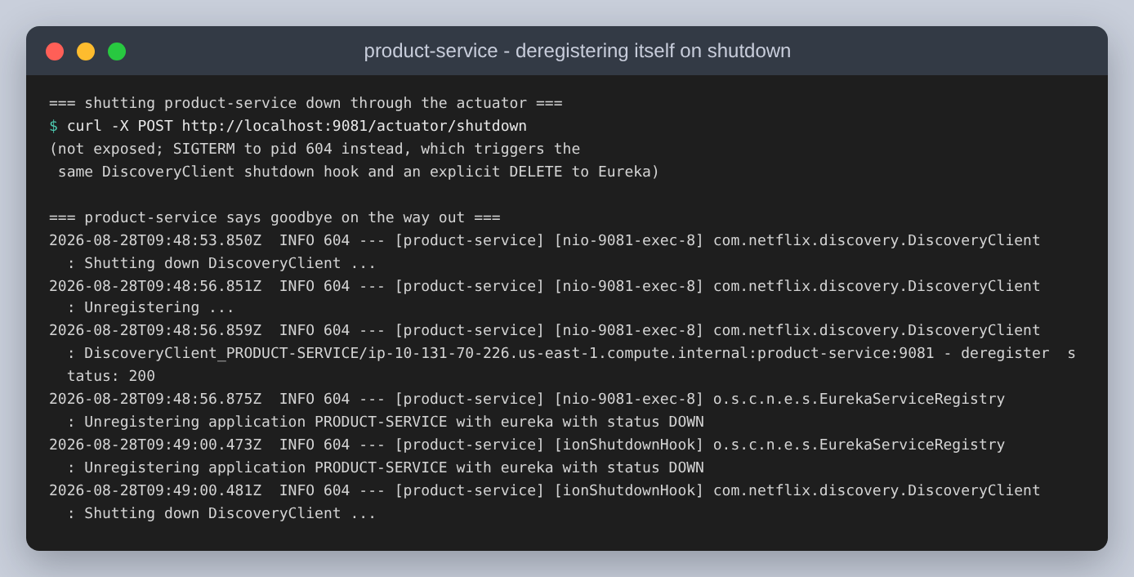
Figure 39: The Product Service on the way out. Spring's shutdown hook runs the DiscoveryClient shutdown, which sends an explicit deregistration and gets 200 back. A service that is stopped cleanly does not wait to be evicted; it says it is going.
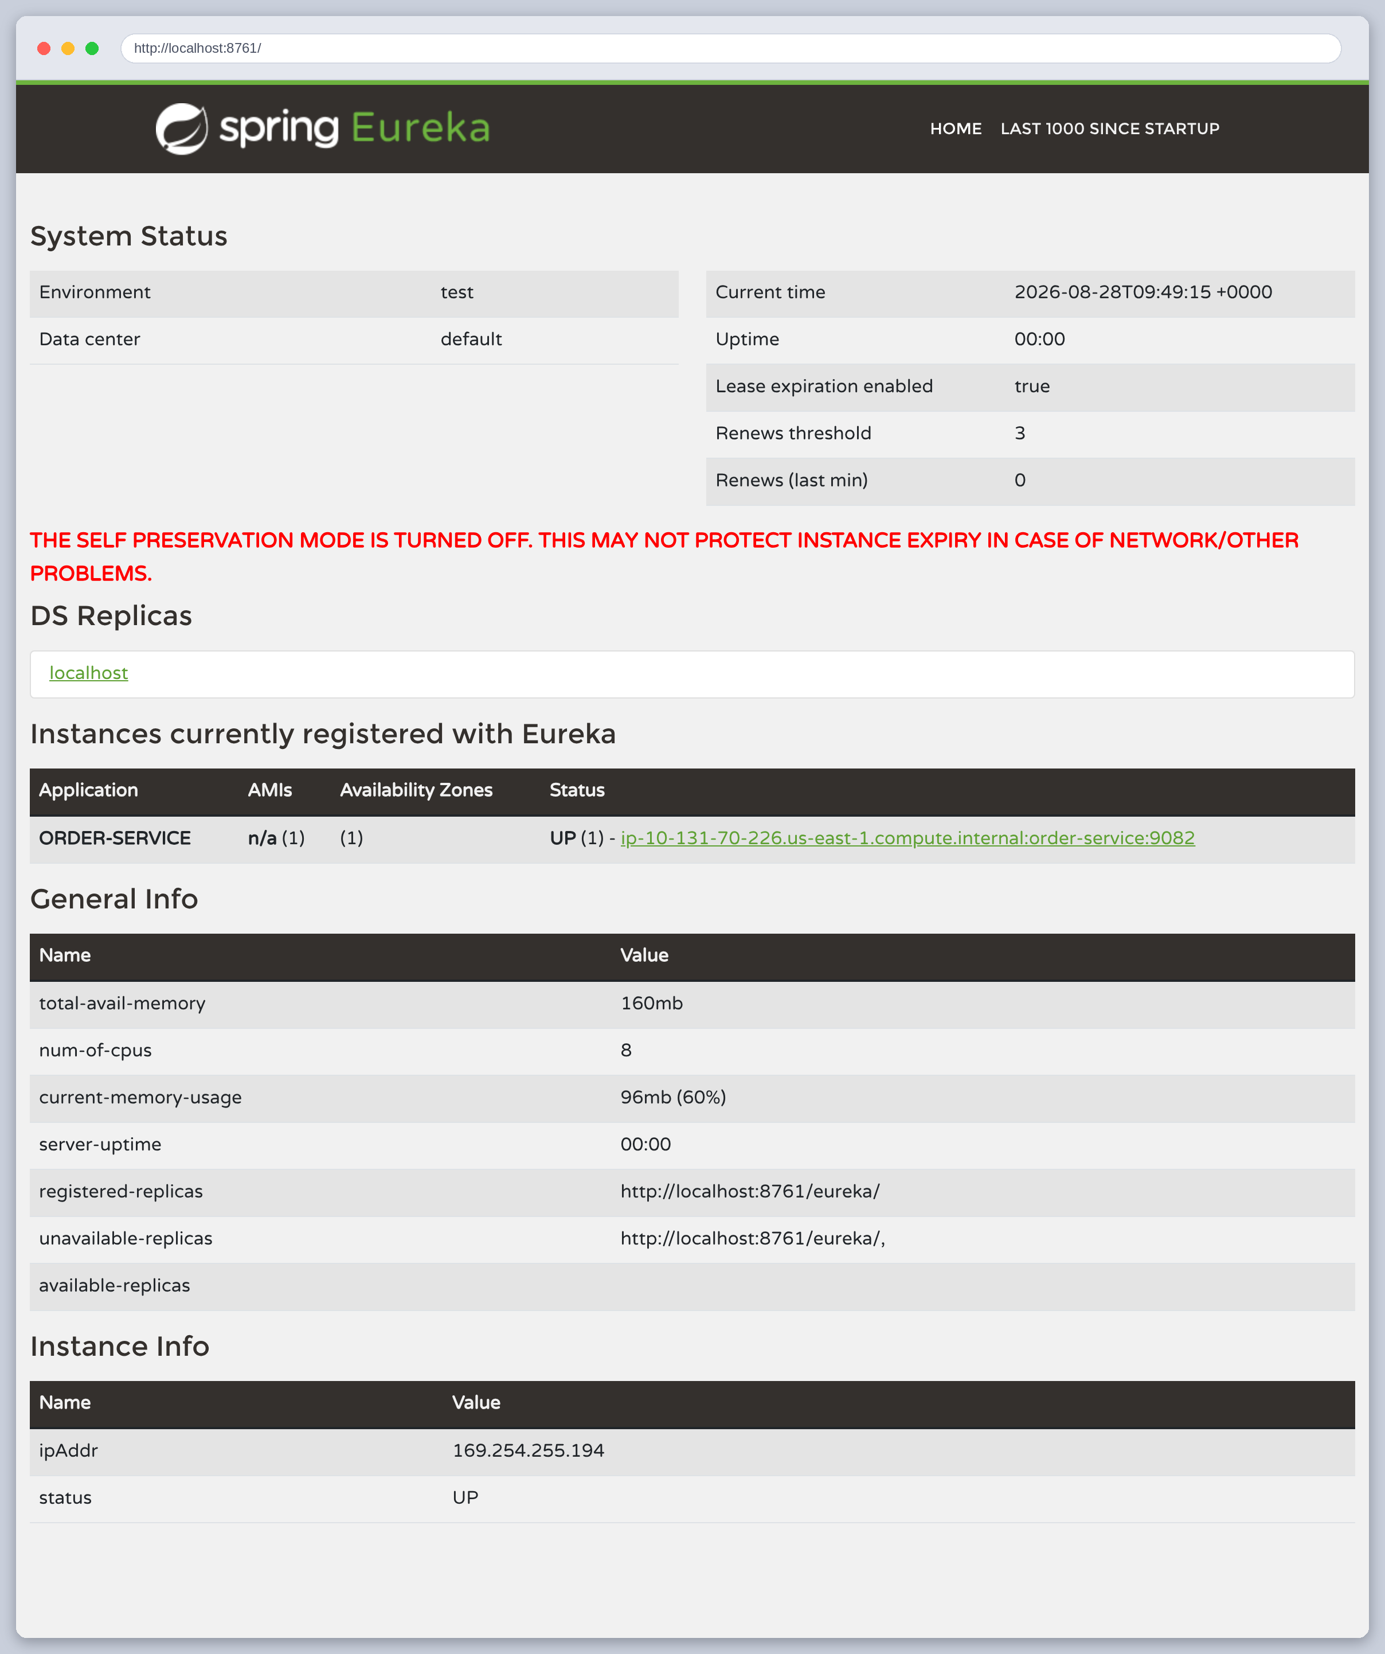
Figure 40: The dashboard with only ORDER-SERVICE left. The assignment's deregistration test, in the browser.
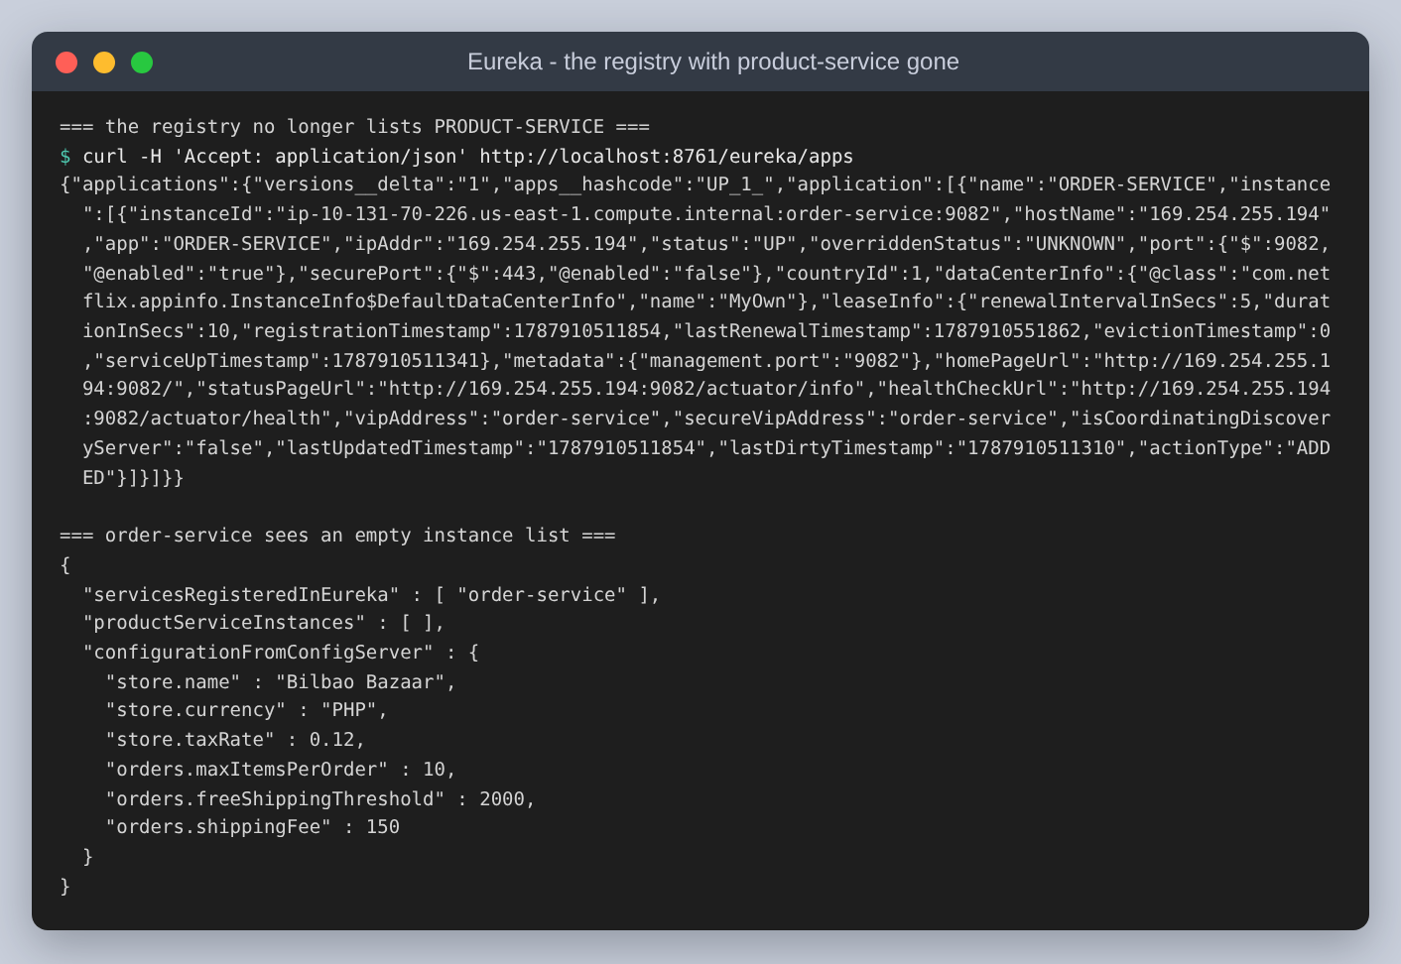
Figure 41: The same absence over the REST API.
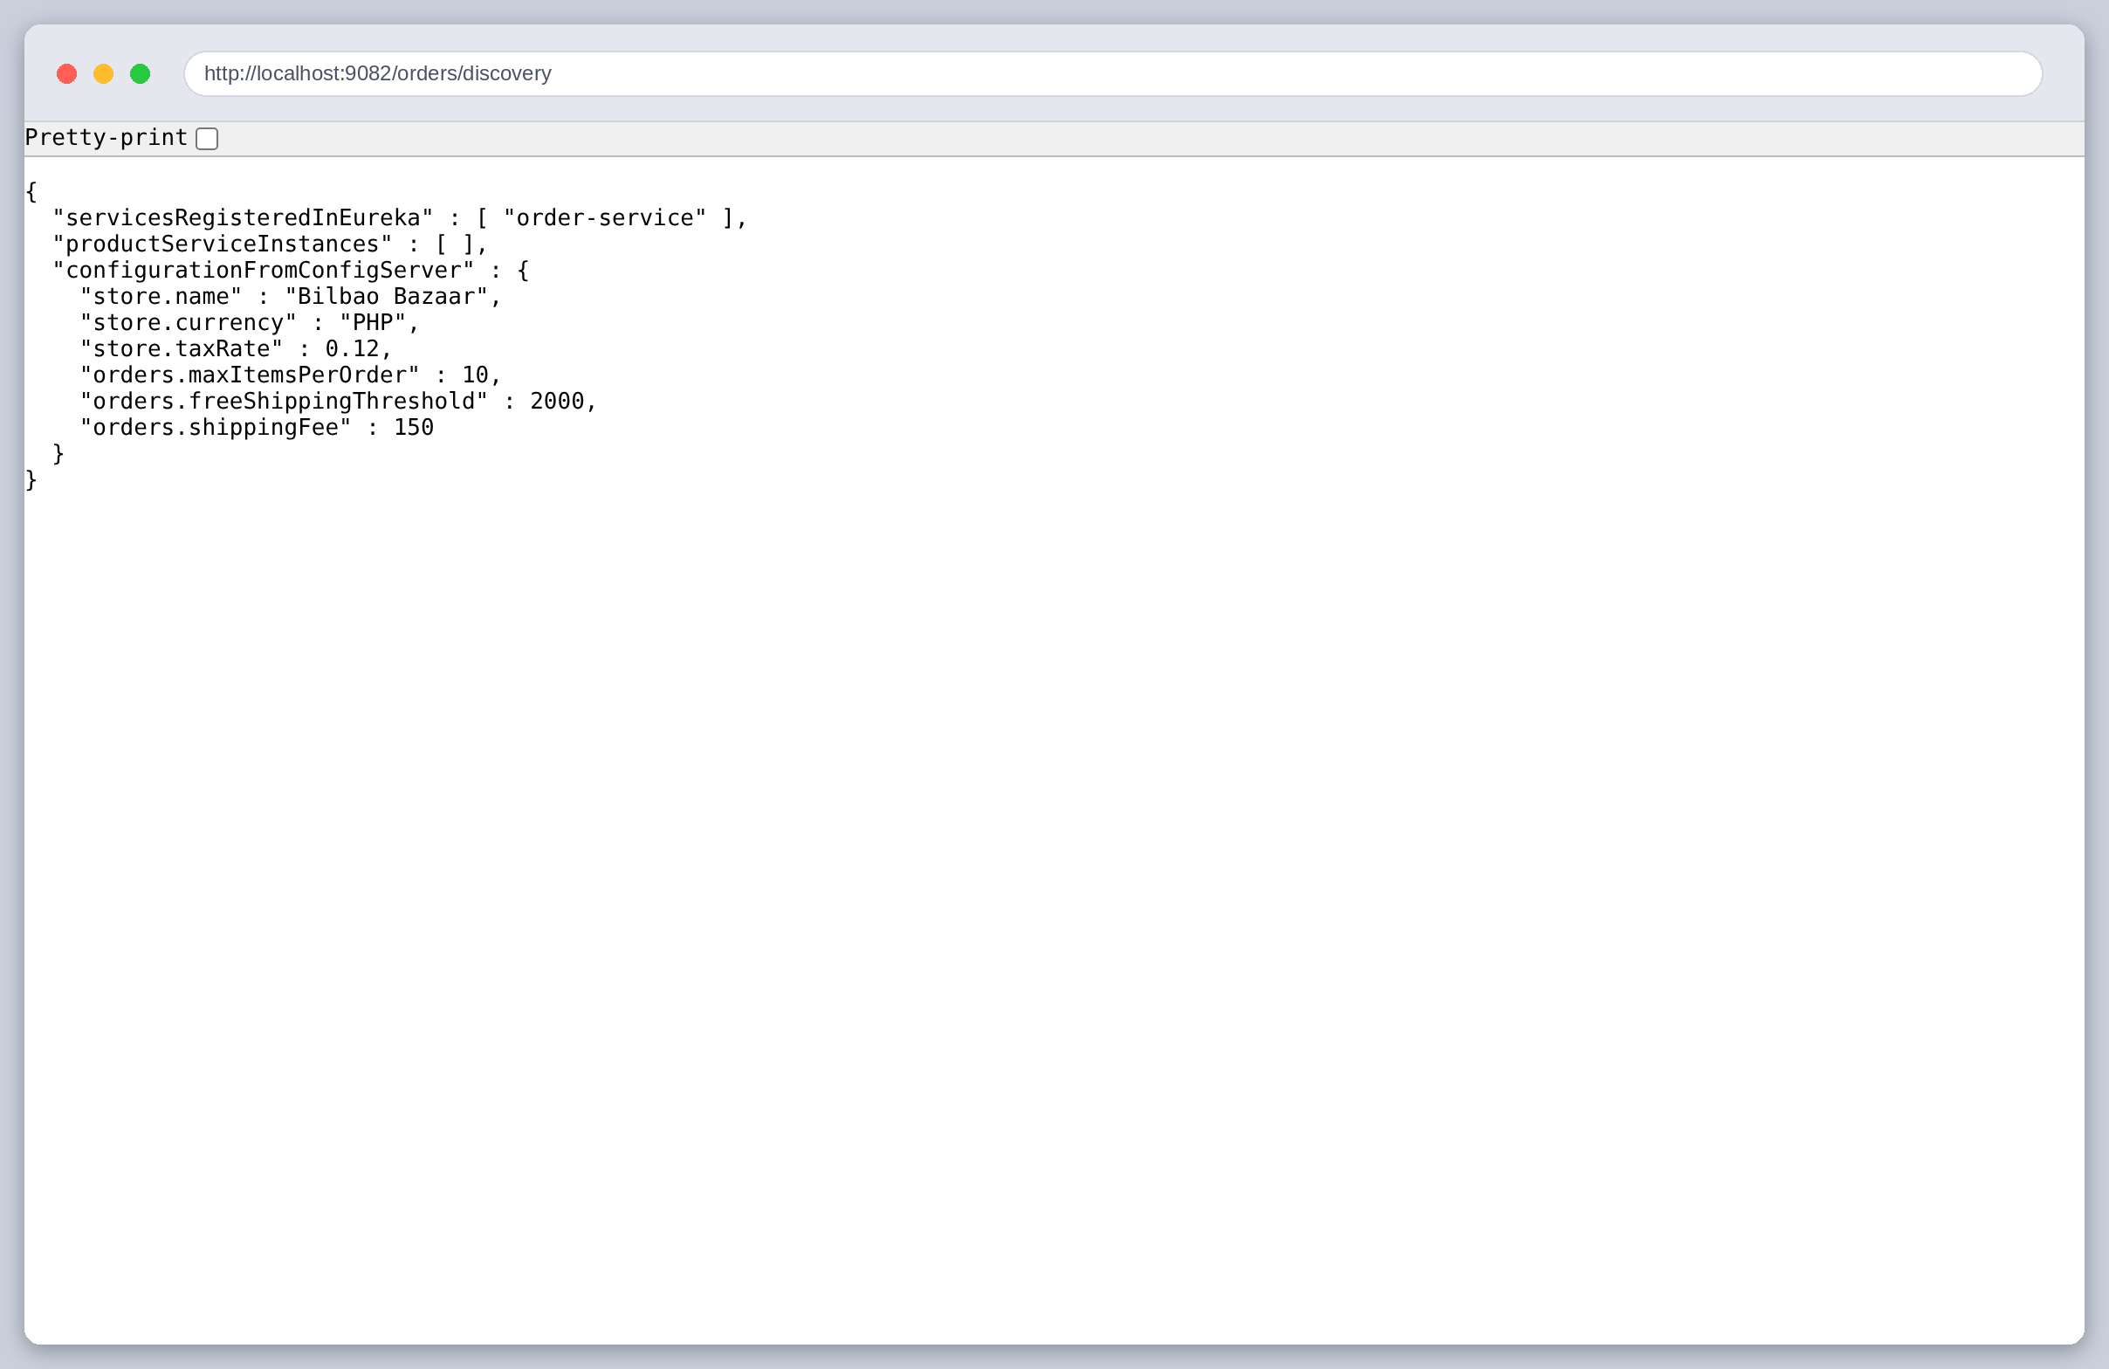
Figure 42: The Order Service now sees an empty instance list for product-service, while its own configuration is untouched. Discovery and configuration fail independently, which is worth knowing when something breaks.
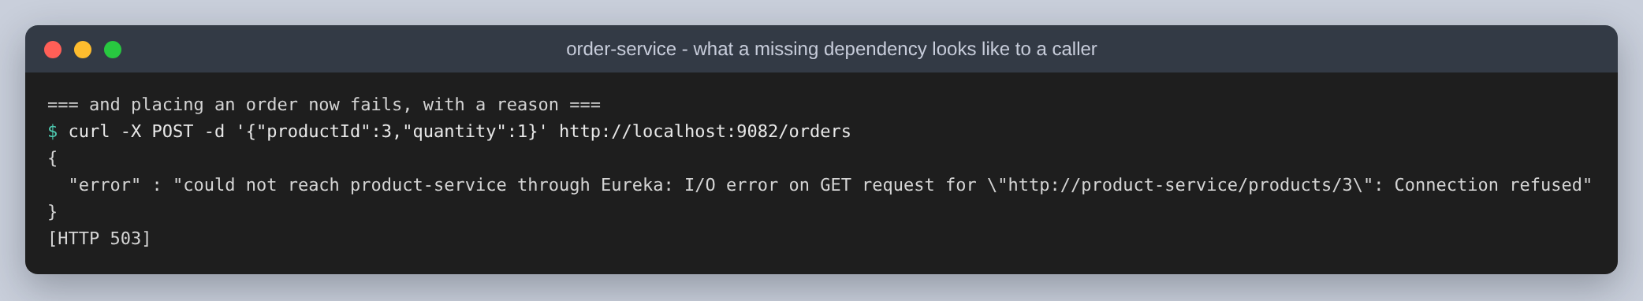
Figure 43: Placing an order now fails with 503 and a readable reason rather than a stack trace. A missing dependency is an operational state, not a bug in the Order Service, and orders already placed are unaffected.
Then the Product Service is started again, deliberately on port 9091 rather than the 9081 it had before. Nothing in the Order Service is changed, and it is not restarted.
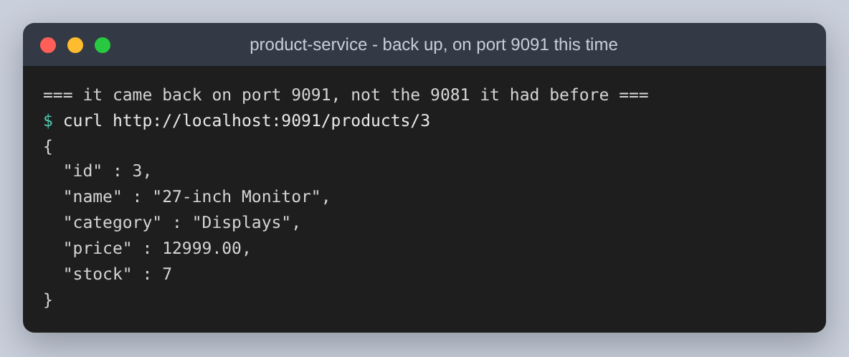
Figure 44: The Product Service answering on 9091.
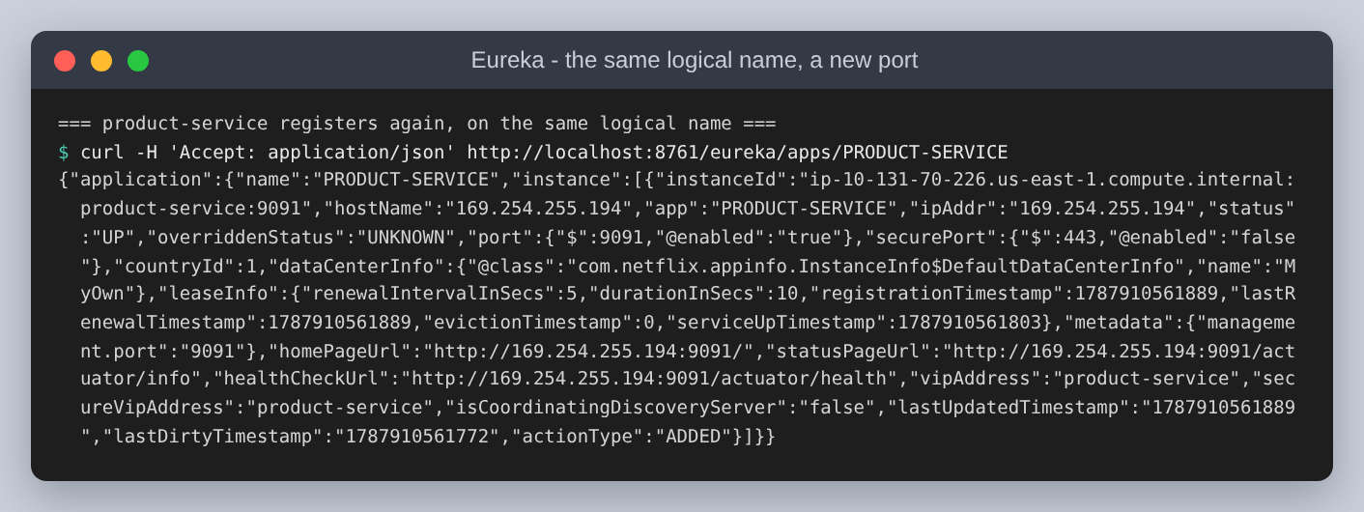
Figure 45: It registers under the same logical name, PRODUCT-SERVICE, with the new port in the lease.
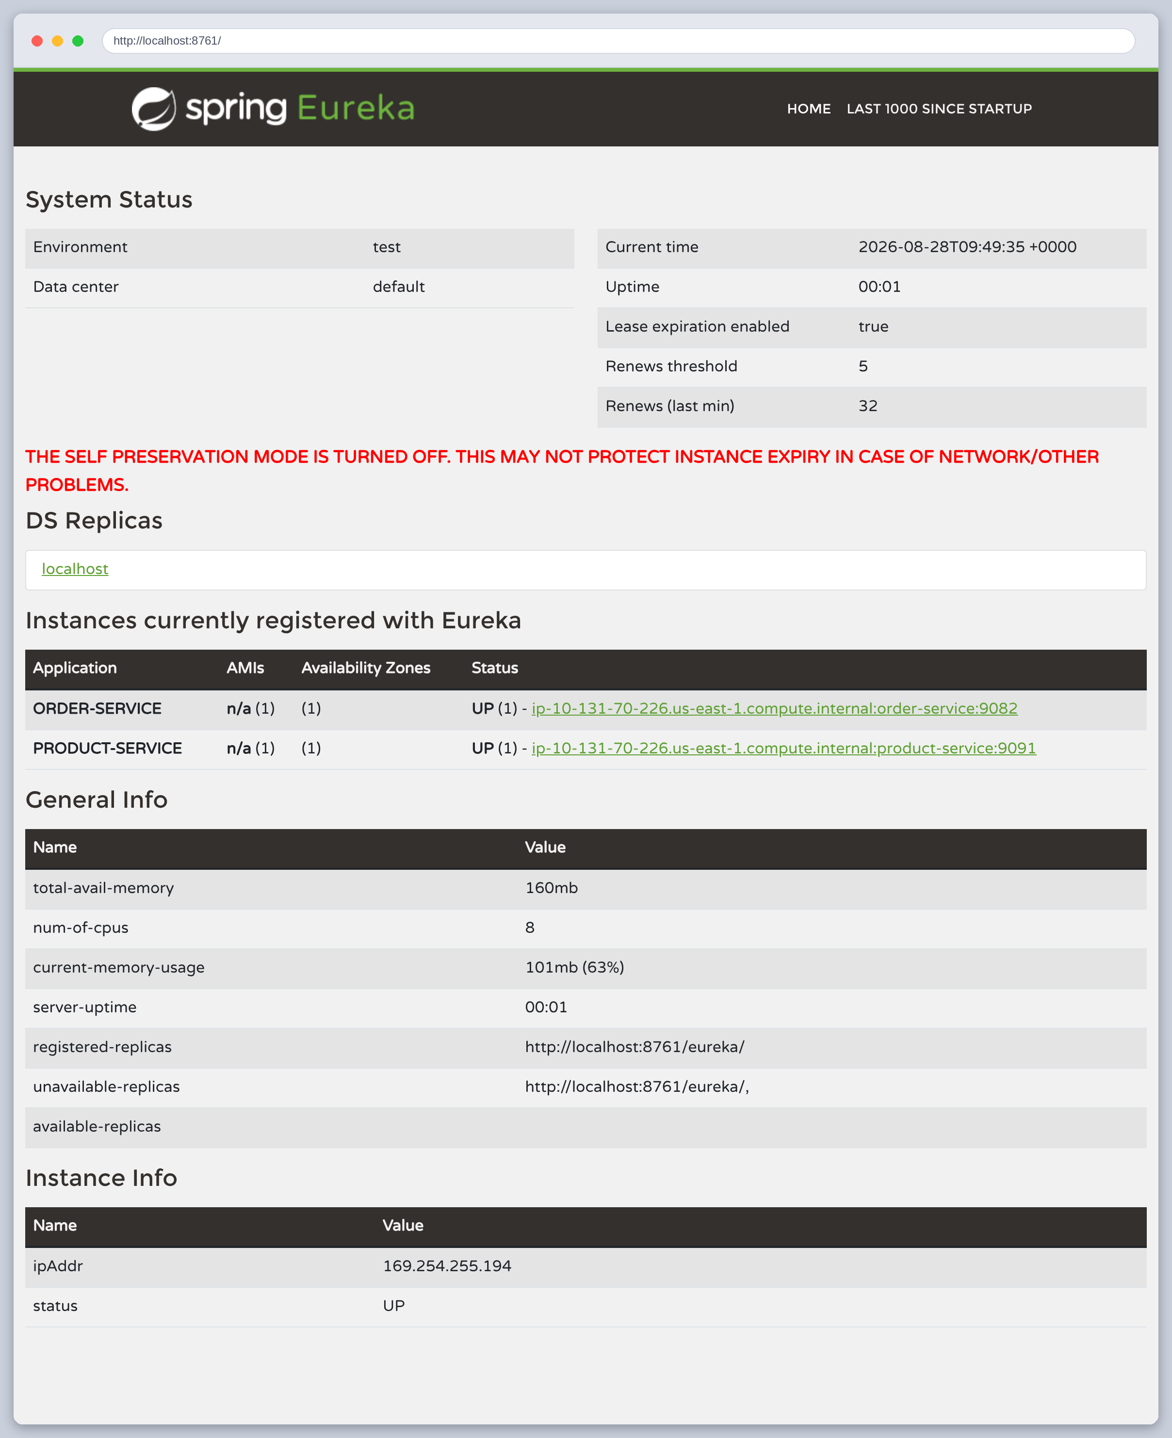
Figure 46: The dashboard: both services UP again, product-service now on 9091.
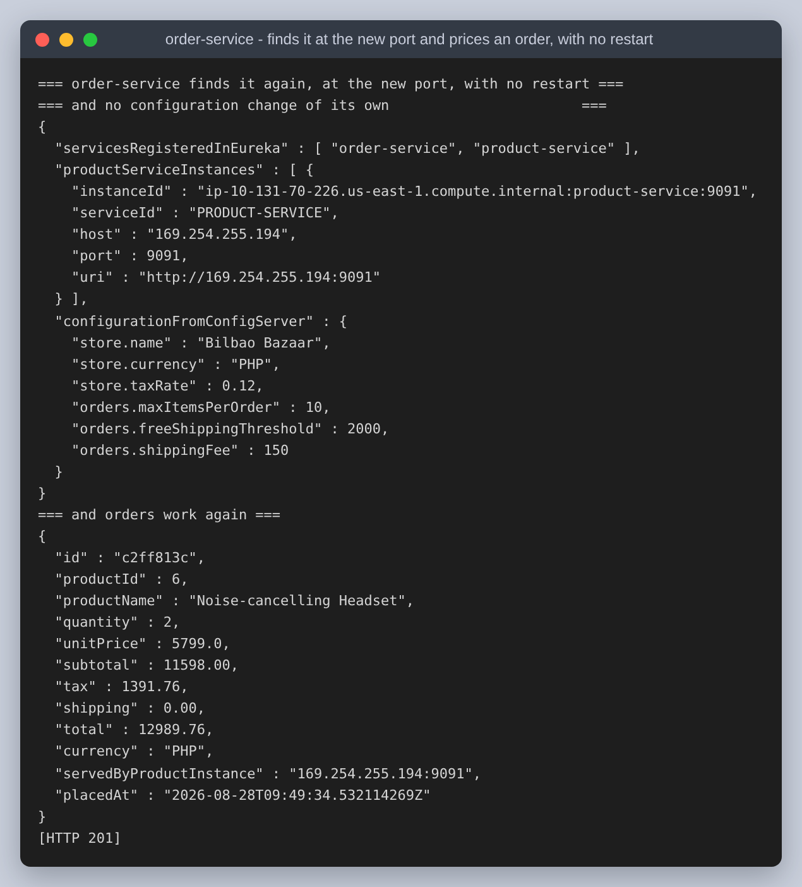
Figure 47: The payoff. The Order Service finds it at the new port and prices an order, total 12989.76, served by 169.254.255.194:9091 - with no restart and no configuration change of its own.
This is the part of the assignment that is hard to fake and easy to underrate. Had the Order Service held the Product Service's address in a config file, this restart would have broken it, and fixing it would have meant editing configuration and refreshing. Because the address is resolved from the registry on every call, the move cost nothing. That is the entire practical argument for service discovery, and it took a port change to actually demonstrate it.

How it was implemented, in order
- One aggregator pom with the Spring Cloud BOM imported once, so the four modules cannot disagree on versions.
- Config Server: spring-cloud-config-server and @EnableConfigServer, pointed at config-repo/ with the native profile. Shared values in application.yml, per-service values in a file named after the service's spring.application.name.
- Eureka server: spring-cloud-starter-netflix-eureka-server and @EnableEurekaServer, with register-with-eureka and fetch-registry off because it is the registry, and self preservation off so eviction can be observed.
- Both business services: the Eureka client starter to register, spring-cloud-starter-config plus spring.config.import to be configured at startup, and actuator to expose /actuator/refresh.
- @RefreshScope on the @ConfigurationProperties beans, which is what lets POST /actuator/refresh rebind them without a restart.
- A @LoadBalanced RestTemplate in the Order Service, so http://product-service/... resolves through the registry. This is the only place discovery is actually consumed rather than merely configured.

The two pieces of code that matter
Everything else is annotations and YAML. These two are the load-bearing parts, quoted from the source.
@Bean
@LoadBalanced
public RestTemplate loadBalancedRestTemplate() {
And the call that uses it, where the logical name appears instead of an address:
public ProductView fetch(long productId) {
Map<?, ?> body = loadBalanced.getForObject(
"http://" + serviceName + "/products/{id}", Map.class, productId);
if (body == null) {
throw new ProductLookupException(
"product-service returned an empty body for product " + productId);
}

Reproducing it
cd ecommerce-cloud
./run.sh # builds, starts all four, exercises everything
python3 scripts/make_figures.py # results/ and screenshots/ into figures/
python3 build.py # figures/ into the .docx and .pdf
run.sh does the whole thing in one invocation, because the four services are its child processes and splitting the steps across separate shells would lose them in between. It starts them in dependency order, waits on each health endpoint, exercises both mechanisms, drives a real browser for the screenshots, and shuts everything down and restores the edited YAML on the way out.

Conclusion and takeaways
Both mechanisms did what they claim, and building them was less work than expected: the Config Server and the Eureka server are one annotation each. What took the actual thinking was working out how to show they were working rather than merely running.
- A registry is only doing something if the caller uses it. Registering both services and screenshotting the dashboard demonstrates almost nothing on its own; the same dashboard would look identical if the Order Service had the Product Service's port hard-coded. Restarting the Product Service on a different port is what turns the claim into evidence.
- The failing case is the clearest proof. UnknownHostException on a plain RestTemplate shows that the logical name is genuinely unresolvable, and therefore that the working call is doing a registry lookup. A test that only ever passes cannot tell you which mechanism made it pass.
- There are three states in a configuration change, not two: the file, the Config Server's view of it, and the running service's view of it. The Config Server picked up the edit immediately while the service was still serving old values. Checking the server alone would have looked like success and been wrong.
- Refreshing a value is not the same as changing behaviour. The config endpoint reported the new threshold, and it was worth checking a second endpoint that uses it to confirm the new value was actually being applied.
- Startup order is a real dependency. The business services fetch configuration during startup, so the Config Server has to be up first. Using optional: in spring.config.import means they still start without it, which is a better failure than refusing to boot, but they start unconfigured.
- Ordinary defaults get in the way of demonstrating things. Eureka's self preservation and its 30-second lease intervals are correct for production and wrong for an assignment that needs to show a service disappearing within a screenshot's patience.

