Day 7 Assignment
Securing and Documenting a REST API with OAuth2, JWT and Rate Limiting
John Michael Bilbao
Techstart
August 18, 2026

Introduction
This assignment asks for an API secured with OAuth2 and JWT, protected with rate limiting, documented with Swagger and Postman, and put to use by a practical client.
What I built is an expense reports API. The reports themselves are incidental; they exist so there is something worth protecting. Three accounts have different permissions, which is what makes it possible to show the difference between a caller the API does not recognise, one it recognises but will not let through, and one it lets through.
The API is FastAPI. I chose it over Flask for this particular assignment because its OAuth2PasswordBearer is a real implementation of the password grant rather than a bearer-token helper: it produces the Authorize dialog in Swagger UI with the scopes as checkboxes, and that dialog performs an actual token exchange. Every screenshot of a refusal in this document is a response the running API sent.
Everything is run from PowerShell on Windows.

Step 1: The API
Nine endpoints. Only /health is open; everything else needs a token, and the reports endpoints each need a specific scope.
Endpoint | Purpose | Scope required
POST /auth/token | Exchange username and password for tokens | — open
POST /auth/refresh | Trade a refresh token for a new access token | a refresh token
GET /auth/me | Who the presented token belongs to | any token
GET /reports | List reports | reports:read
GET /reports/{id} | One report | reports:read
GET /reports/summary | Totals by category | reports:read
POST /reports | Create a report | reports:write
DELETE /reports/{id} | Delete a report | reports:delete
GET /health | Service status | — open

The three accounts, and what each may be granted:
Account | Password | Scopes it may hold
analyst | analyst-password | reports:read
manager | manager-password | reports:read, reports:write
admin | admin-password | reports:read, reports:write, reports:delete

There is also a disabled account, so the difference between credentials being wrong and an account being turned off can be shown.
Setting up is four packages, plus Newman for running the Postman collection from the command line:
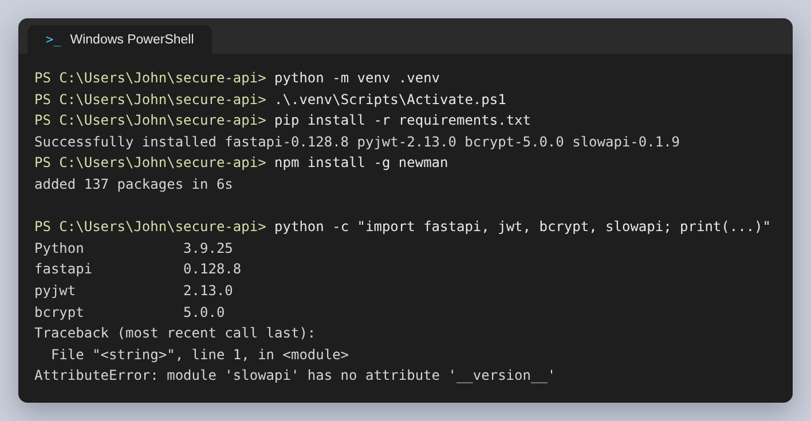
Figure 1: The environment and the versions in it
The FastAPI command line tool runs it, and reports where the documentation is:
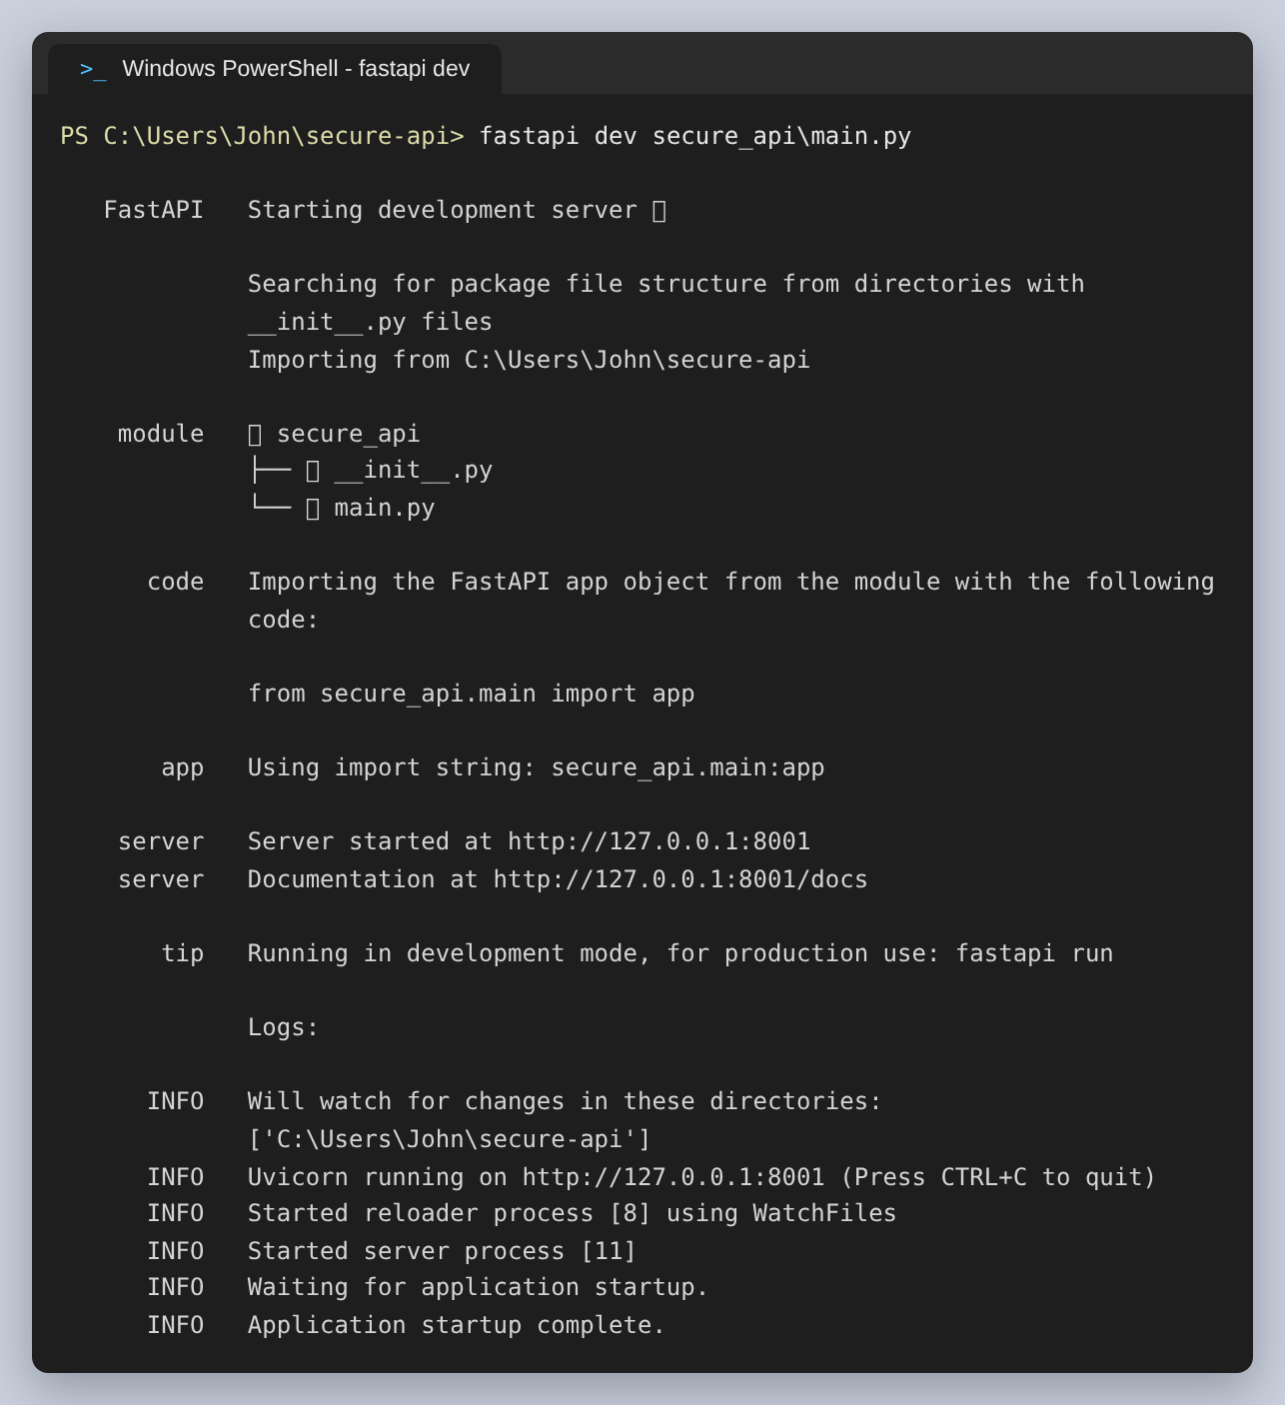
Figure 2: fastapi dev starting the server
The open endpoint answers without any credentials, and says which scopes exist:
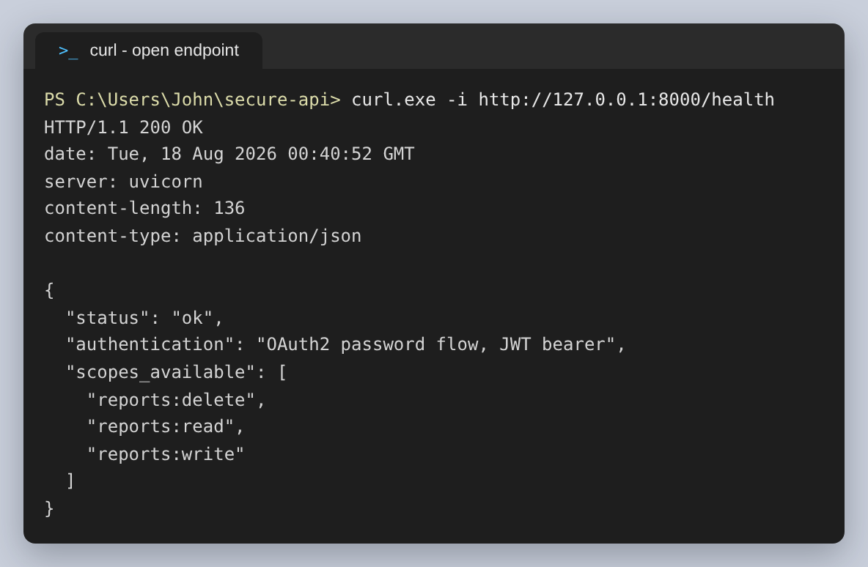
Figure 3: GET /health, no token needed

Step 2: OAuth2 and JWT
OAuth2 is a framework of several flows rather than one protocol. The one used here is the password grant, which is the flow for a client the API owner controls: the client collects the username and password, posts them once to the token endpoint, and from then on holds a token instead. The credentials are not stored by the client and not sent again.
The token endpoint takes form fields rather than JSON, which is what OAuth2 specifies. It returns two tokens:
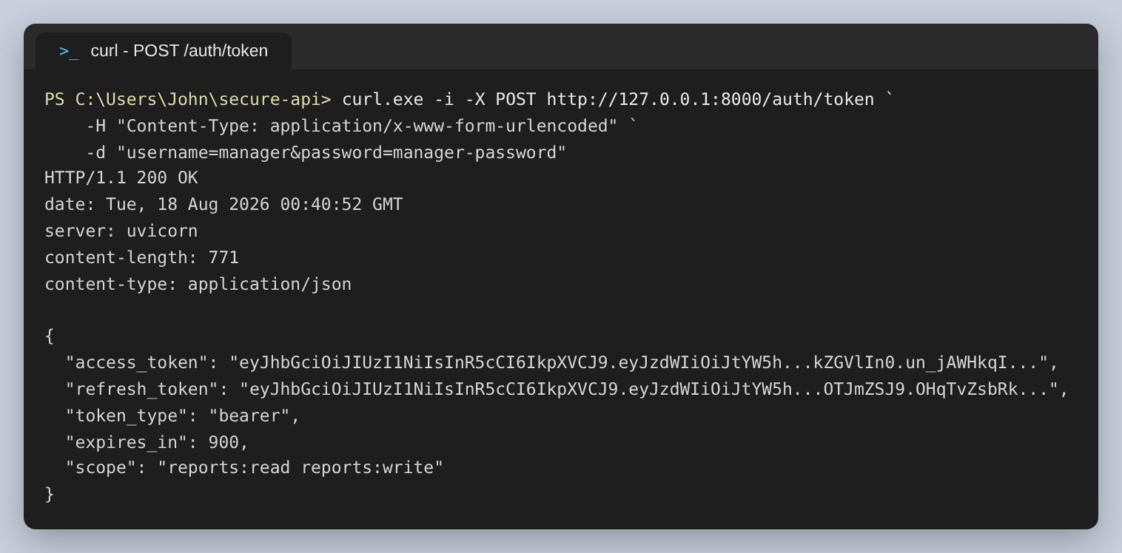
Figure 4: POST /auth/token. The tokens are shortened in this screenshot; a real one is about 300 characters.
Two tokens rather than one is the part worth explaining. The access token expires in 15 minutes, which limits the damage if it leaks, but nobody wants to retype a password every 15 minutes. The refresh token lasts 24 hours and can be exchanged for a new access token. It carries no scopes at all, so it cannot be used to reach a protected endpoint even though it is a perfectly valid JWT.

What is actually inside a JWT
A JWT is three base64 sections joined by dots. It is worth being precise about what that means: the first two are encoded, not encrypted. Anyone holding the token can read them.
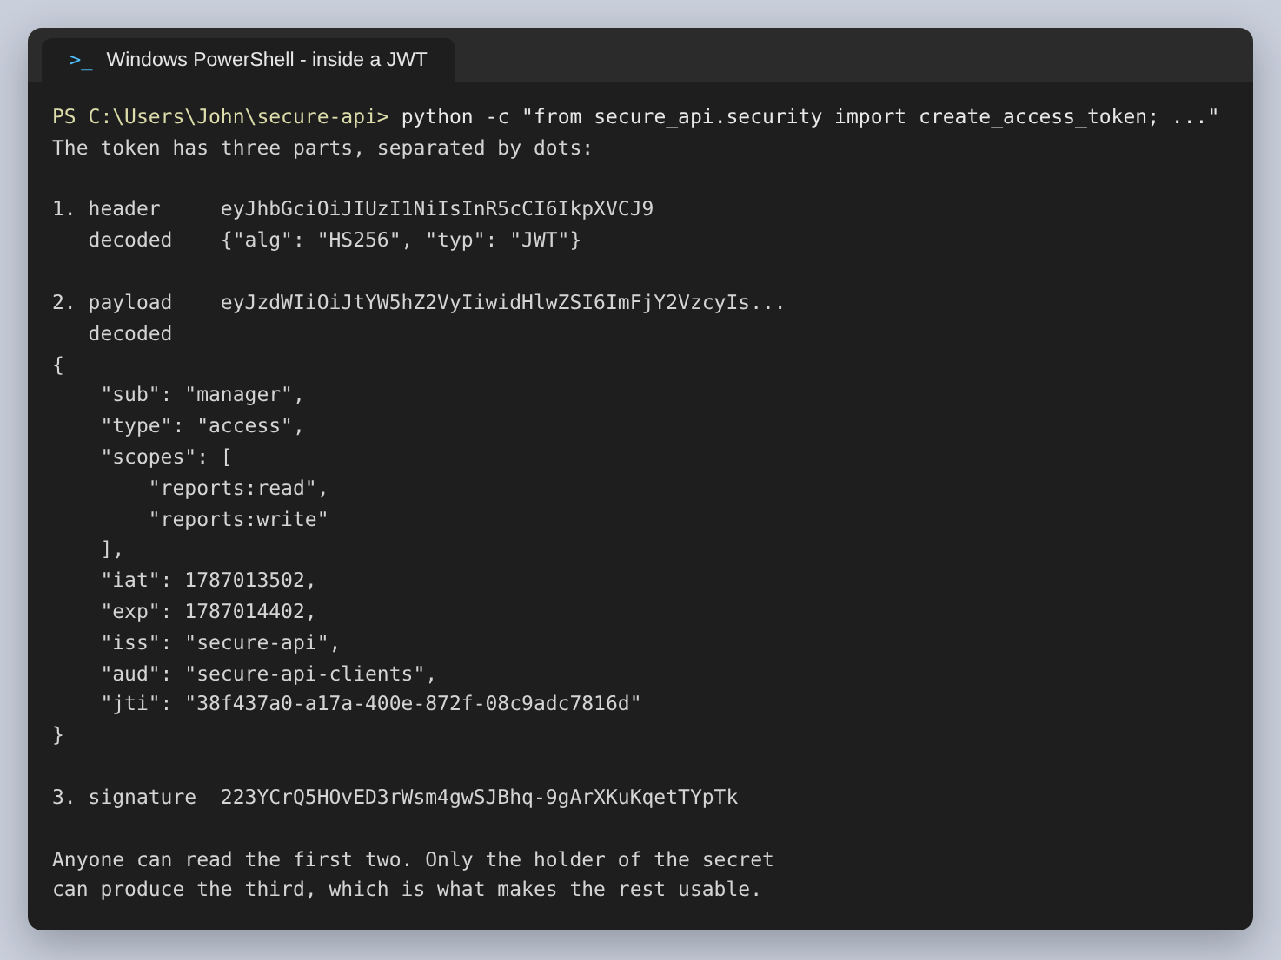
Figure 5: A real token taken apart. The payload is readable by anyone who has the token.
So the security does not come from hiding the claims. It comes from the third section, the signature. The API signs the header and payload with a secret using HS256; anyone can verify the token is intact, but only the holder of the secret can produce a signature for claims they have changed. That is why nothing secret is ever put in a payload.
The claims are what the API relies on. sub is the account, scopes is what the token may do, exp is when it stops working, iat is when it was issued, iss and aud say who issued it and who it was issued for, and jti is a unique id for this token. This is the function that assembles them:
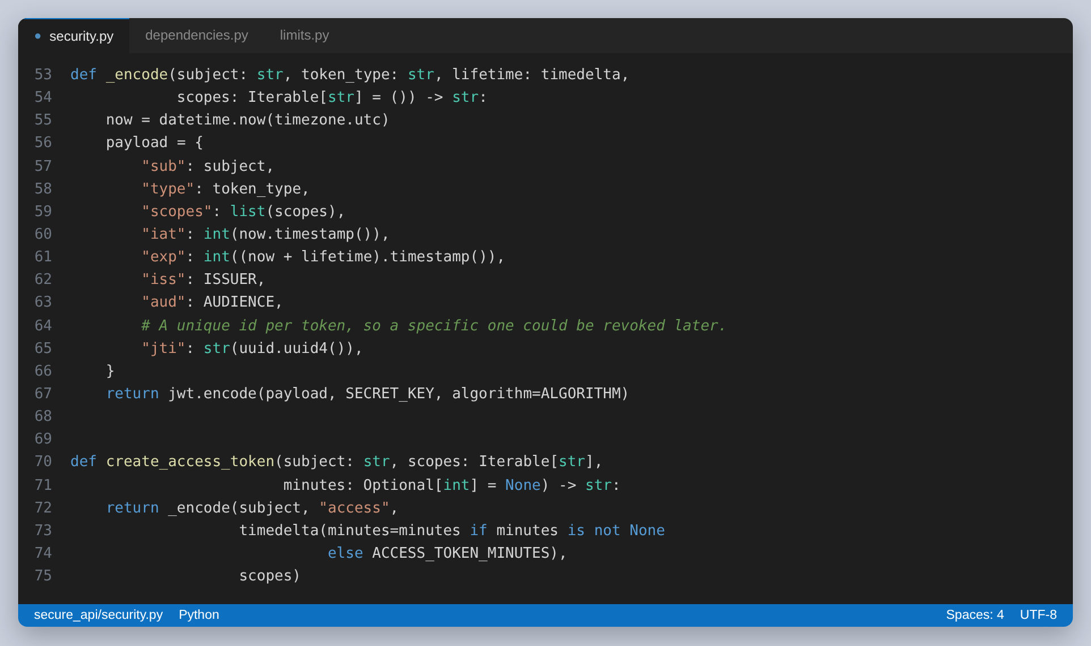
Figure 6: Building the payload and signing it
Verifying is where the care goes. Every claim that was written has to be checked, and each failure has to produce a message that helps a legitimate client without helping an attacker:
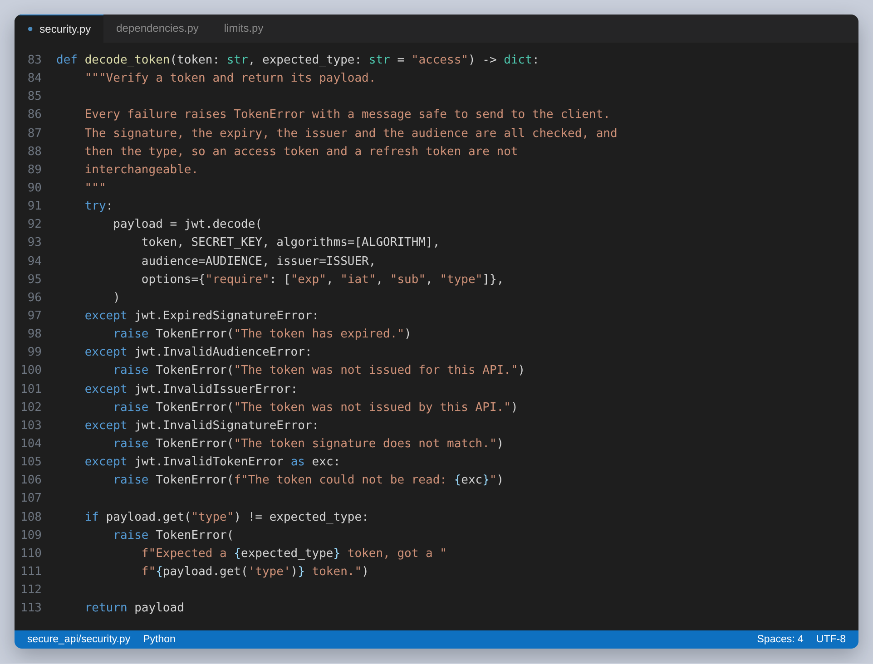
Figure 7: Verifying a token. The type check is what stops a refresh token being used as an access token.
Passwords are never stored, only bcrypt hashes. bcrypt is deliberately slow and salts each hash, so two accounts with the same password get different hashes and a stolen list cannot be reversed with a lookup table:
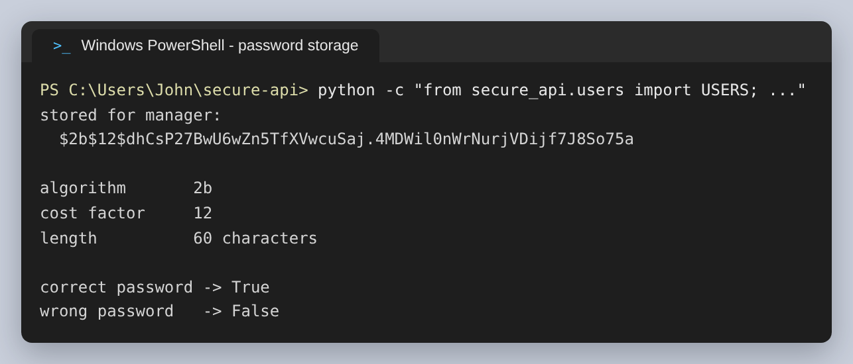
Figure 8: What is stored for the manager account: algorithm 2b, cost factor 12, 60 characters

Authentication is not authorisation
This is the distinction the scopes exist to enforce, and the one the status codes have to reflect. A 401 means the API does not know who you are. A 403 means it knows exactly who you are and is refusing anyway. Returning 401 for both would tell a client to sign in again when signing in again would not help.
FastAPI's SecurityScopes makes the requirement part of the endpoint declaration, so the rule lives where the endpoint is defined:
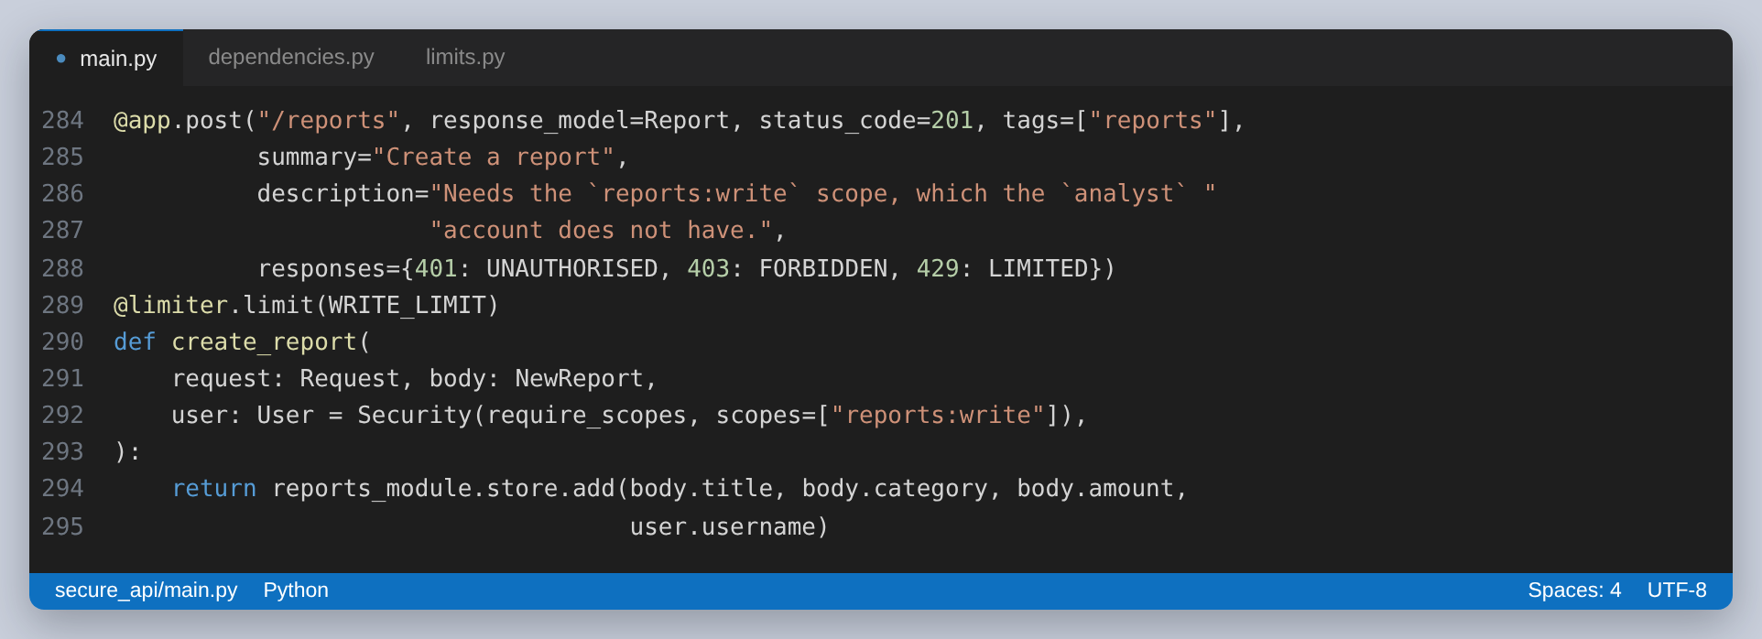
Figure 9: The scope required is declared on the endpoint itself
And the dependency that enforces it:
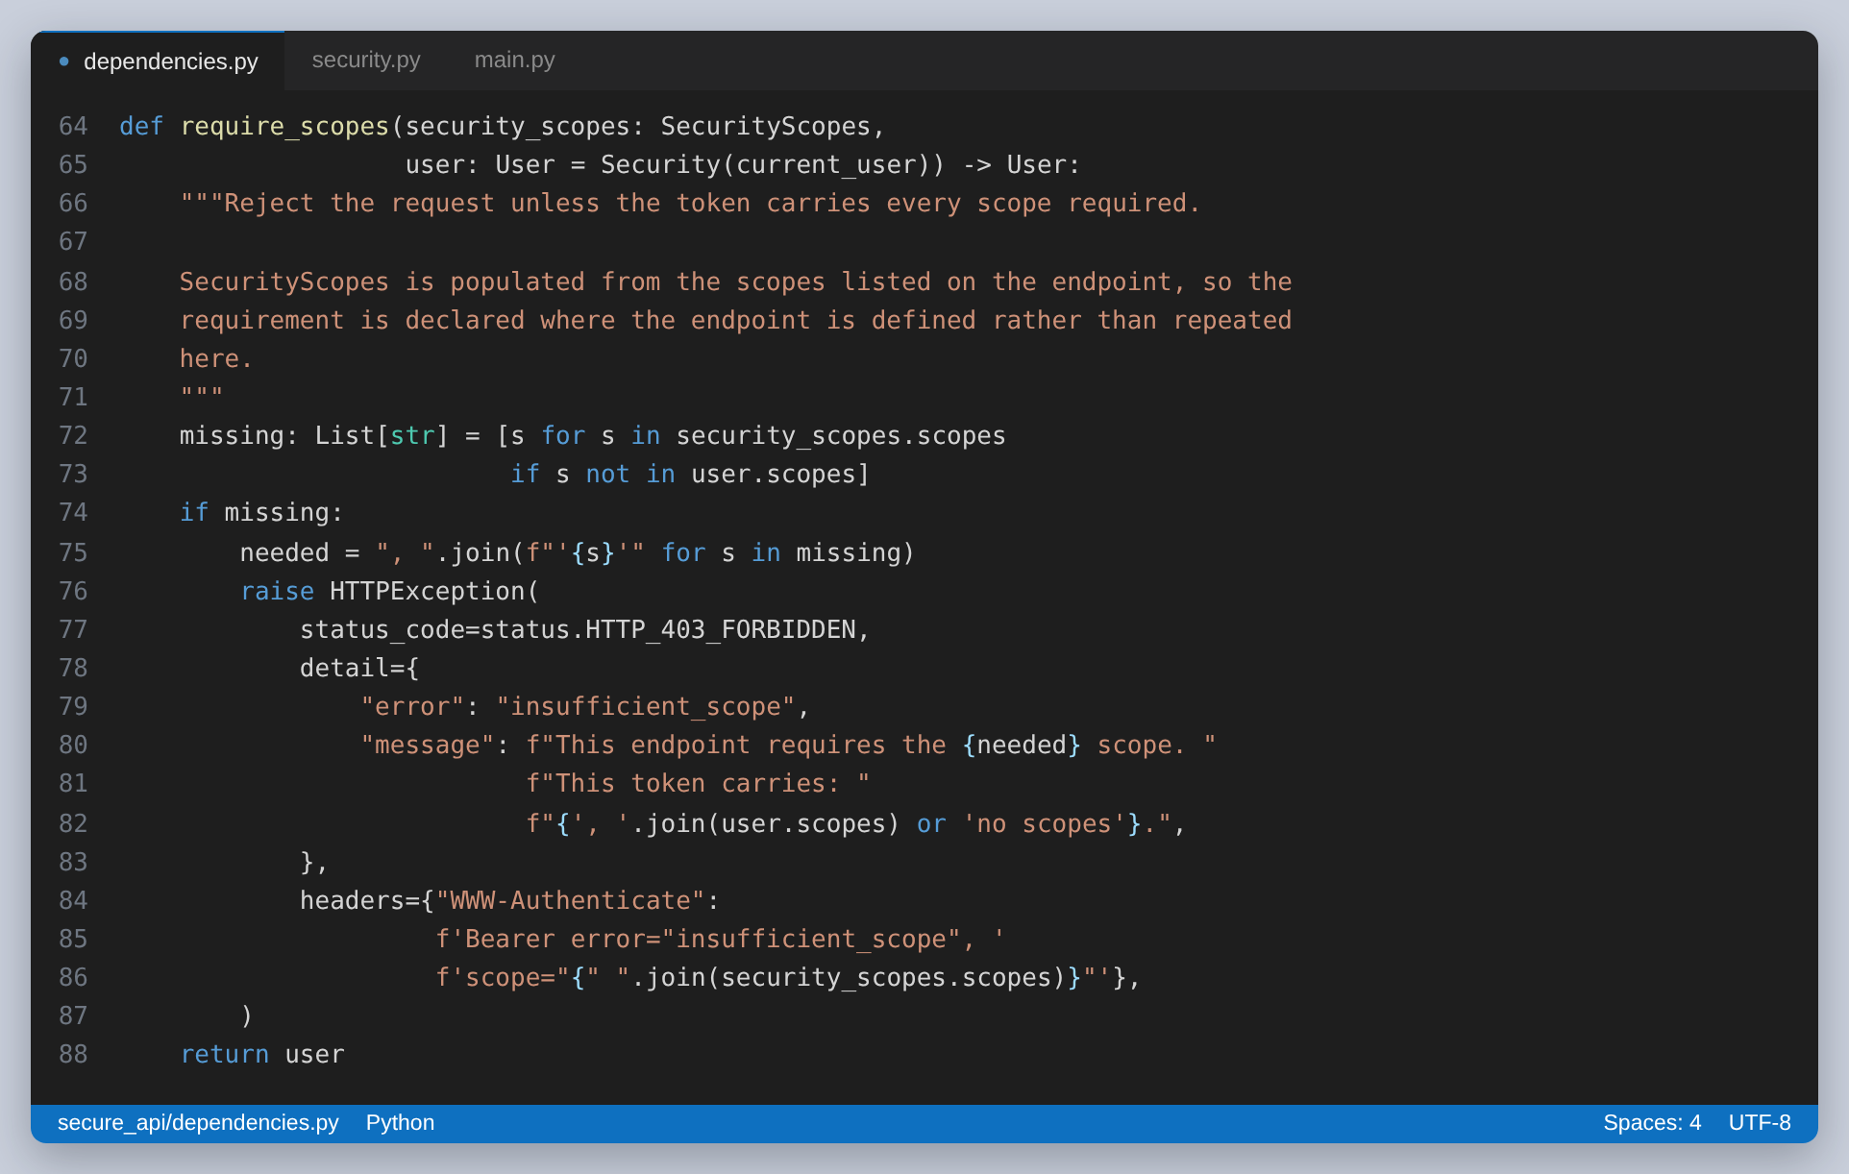
Figure 10: Refusing a request whose token lacks a scope, with the scope named in the response
A token also carries only what was asked for. The admin account may hold all three scopes, but a client can request fewer, and then the token can do less. A client that only reads should ask only to read:
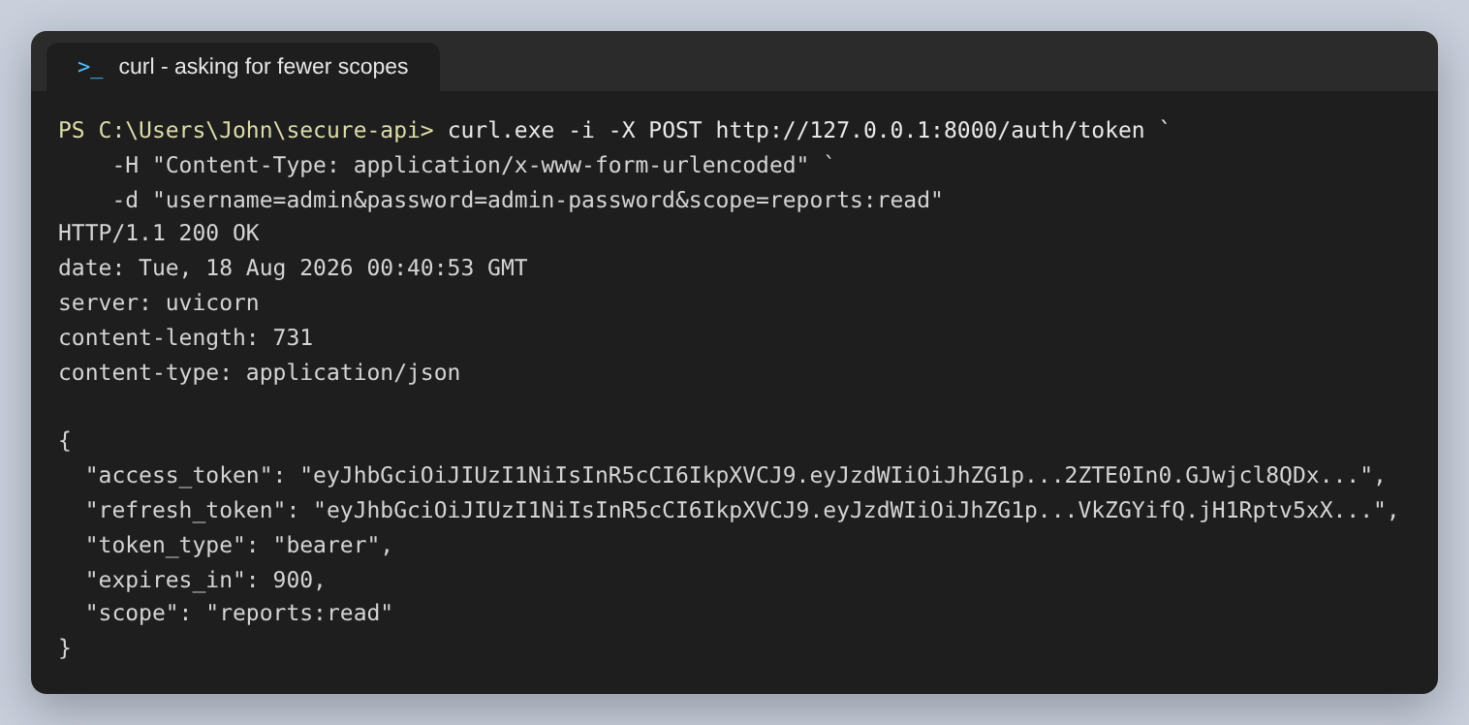
Figure 11: The admin account signing in with reports:read only
Reading back what a token represents:
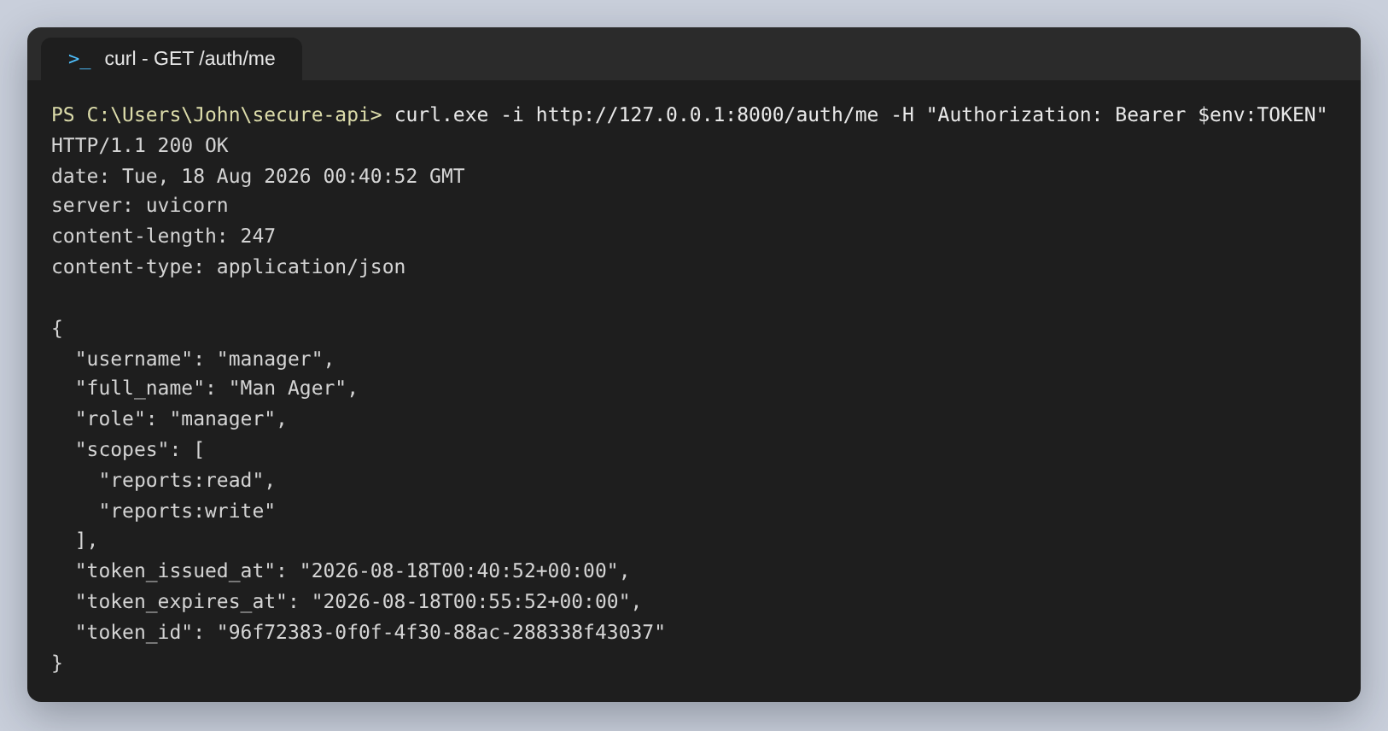
Figure 12: GET /auth/me
Listing the protected data:
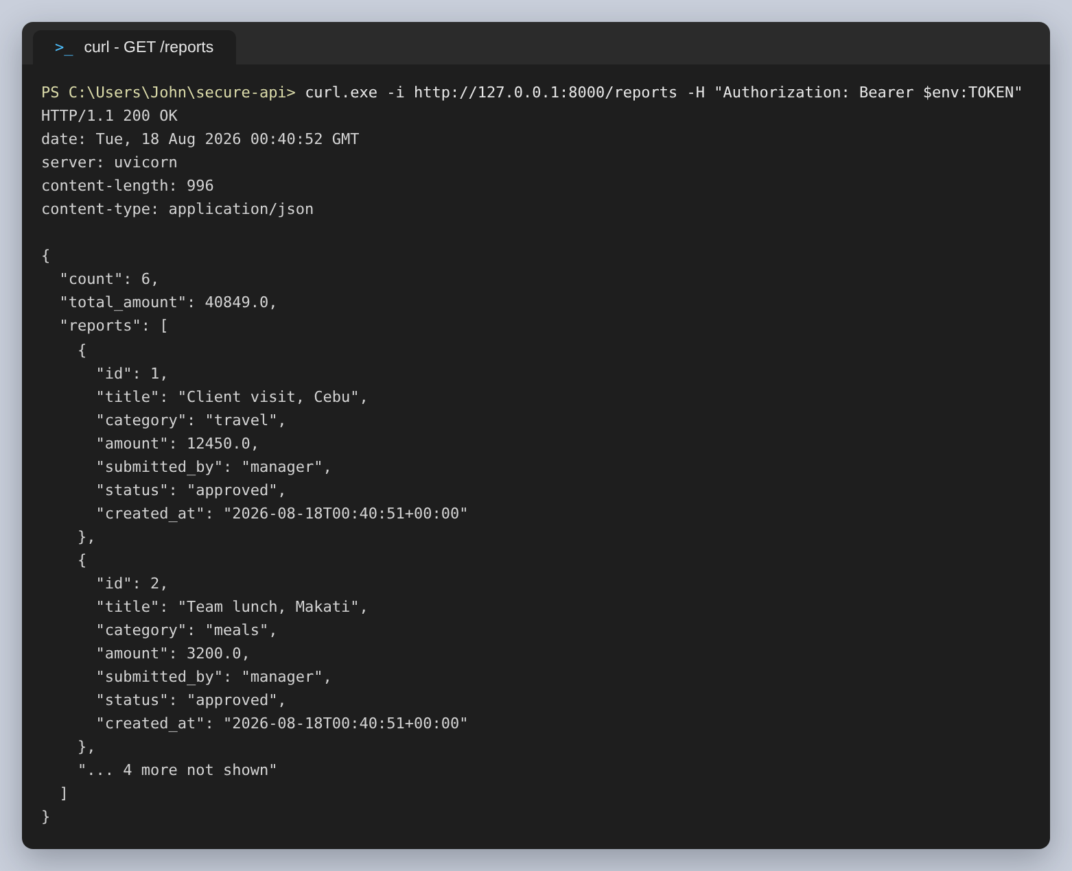
Figure 13: GET /reports with a valid token. The list is shortened here.
The aggregate endpoint:
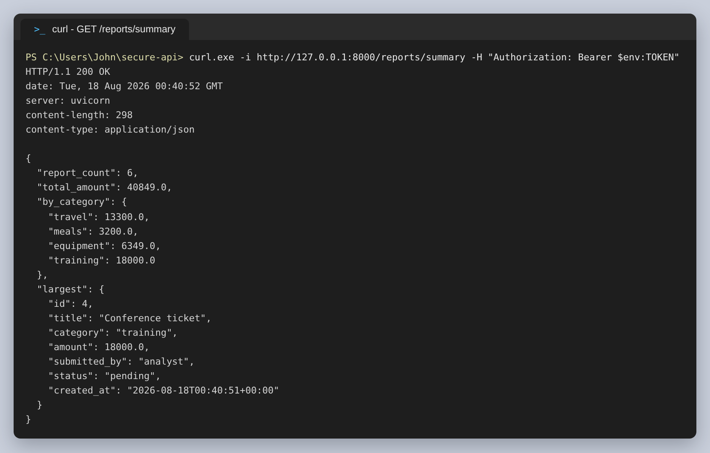
Figure 14: GET /reports/summary
A write, which needs a second scope:
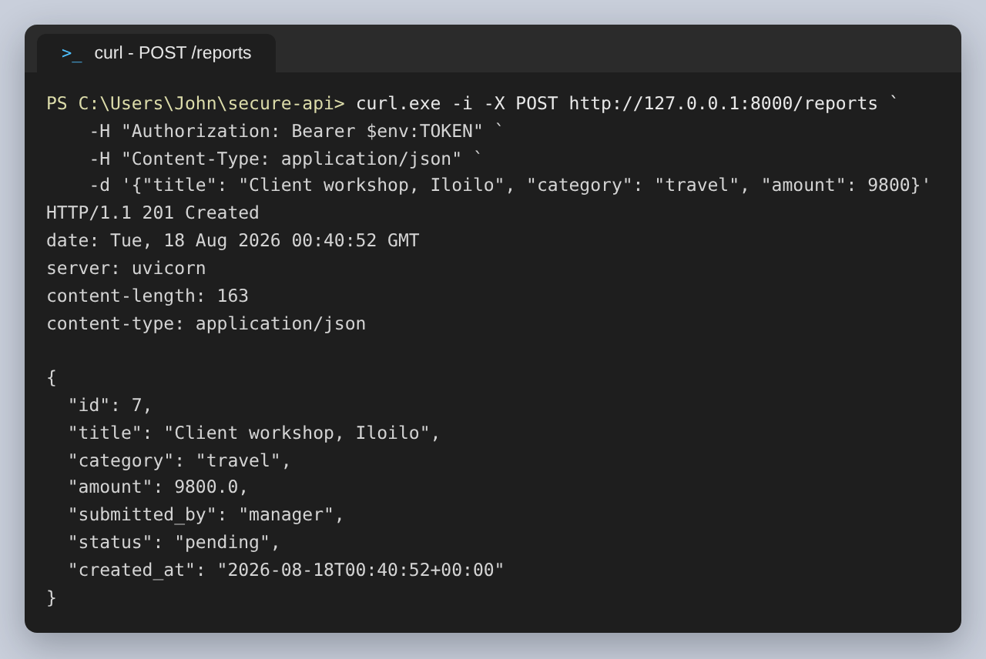
Figure 15: POST /reports as manager
And a delete, which only admin can do:
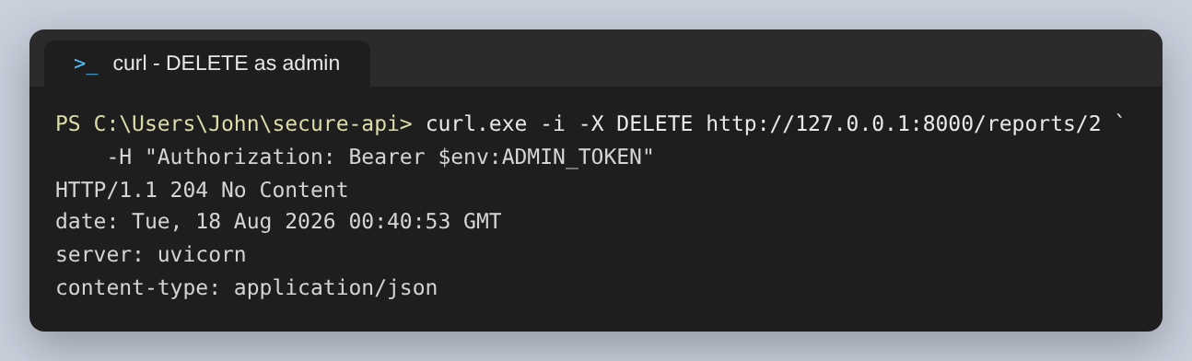
Figure 16: DELETE /reports/2 as admin

Every way a request gets turned away
This is the part I spent most of the time on, because an API is only as good as its refusals. No token at all:
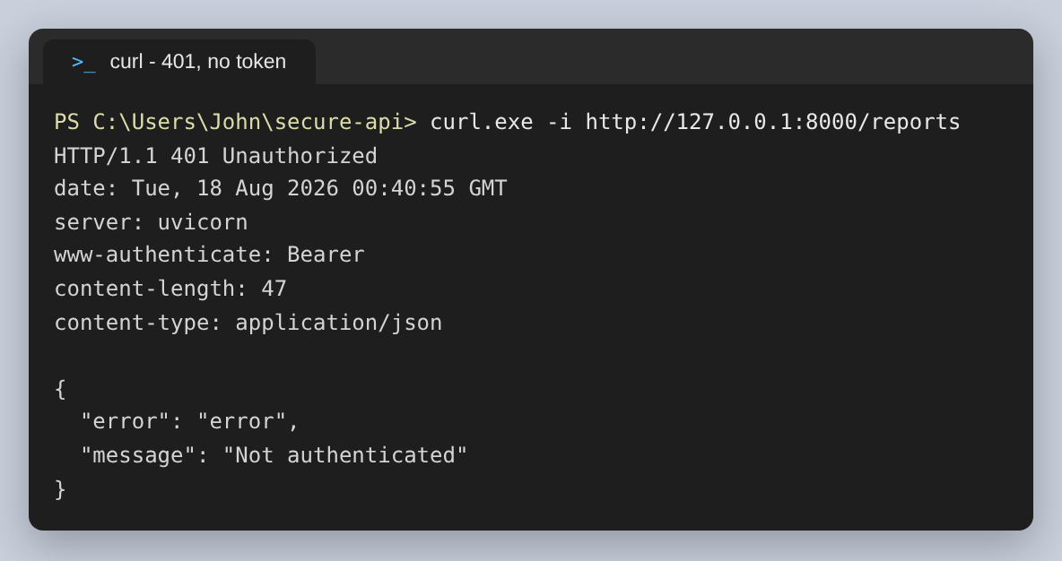
Figure 17: 401 with a WWW-Authenticate header
A token with one character of its signature changed. The claims are still perfectly readable, and it still does not work, which is the whole point of signing:
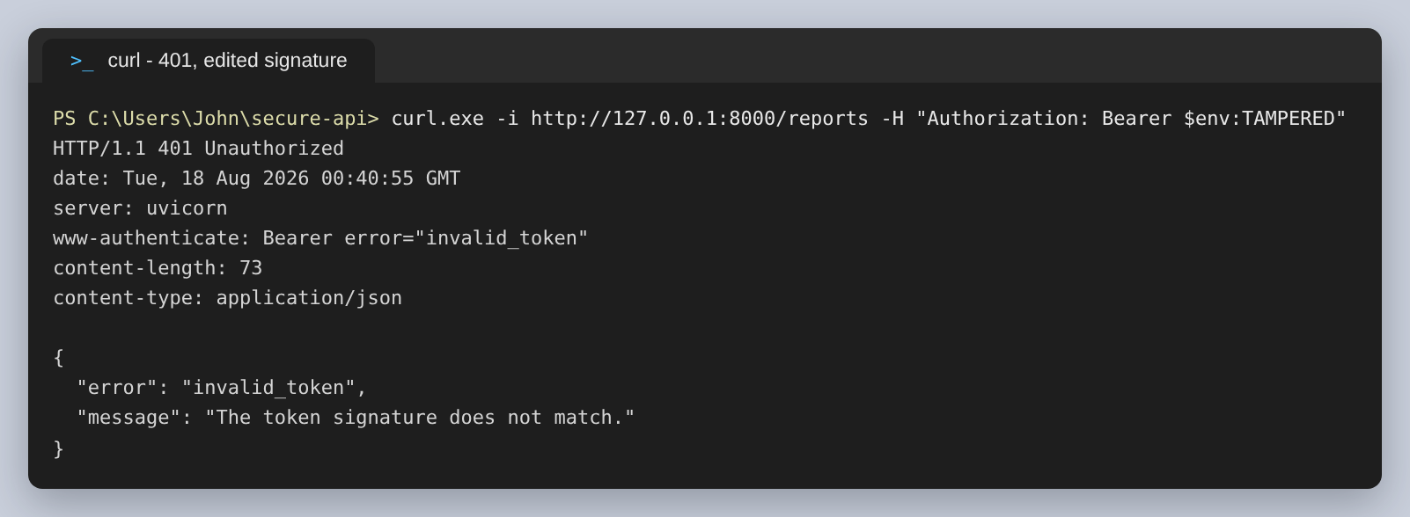
Figure 18: 401, the signature does not match
A token that has expired:
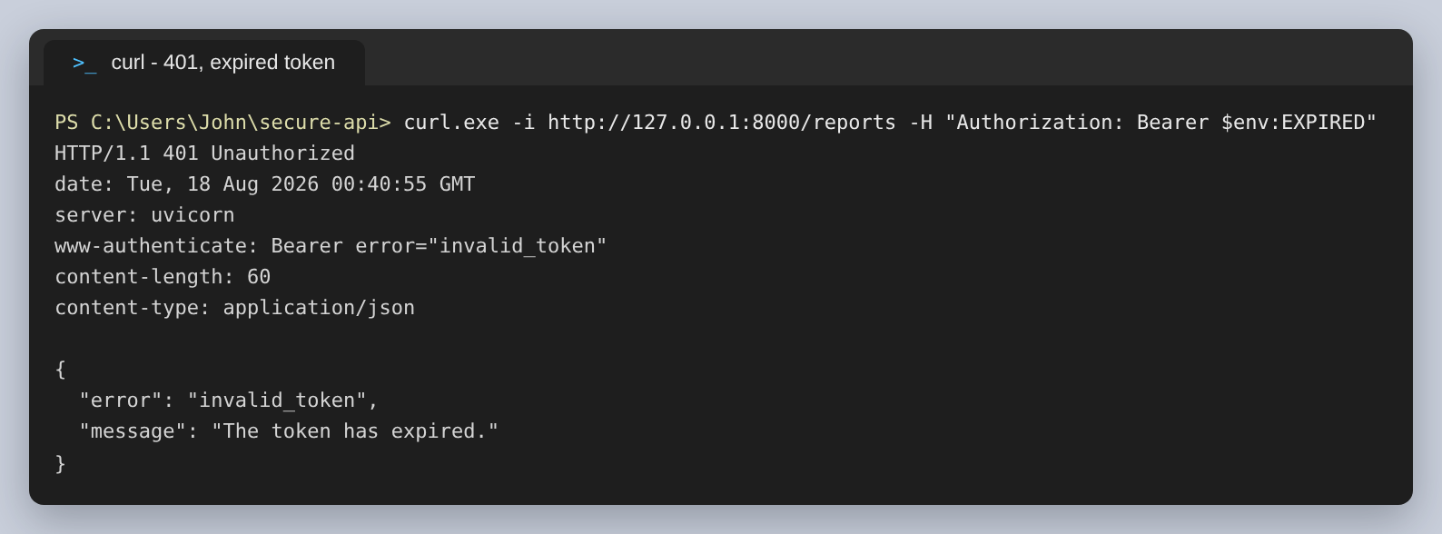
Figure 19: 401, expired
A refresh token presented where an access token belongs. Both are valid JWTs signed by this API; the type claim is what separates them:
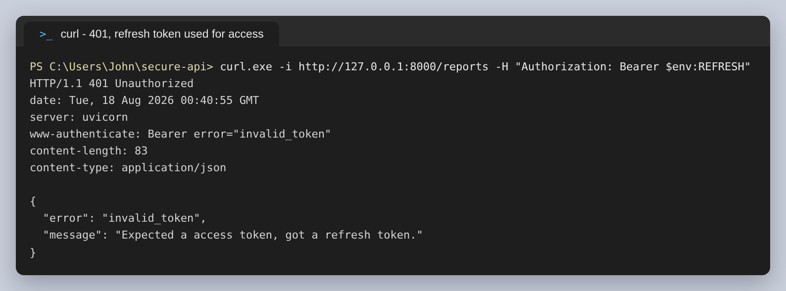
Figure 20: 401, the wrong kind of token
A valid token whose scopes do not stretch far enough. Note the 403 and that the message names both the scope needed and the scopes held:
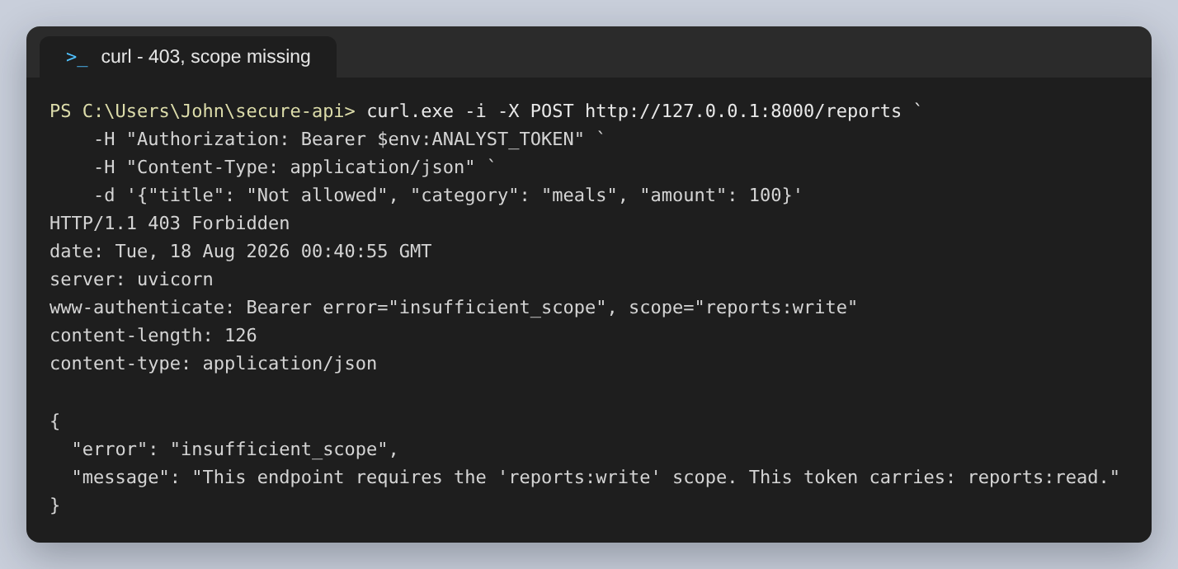
Figure 21: 403 for the analyst account attempting a write
The same for a manager attempting a delete, which shows that write is not a superset of delete:
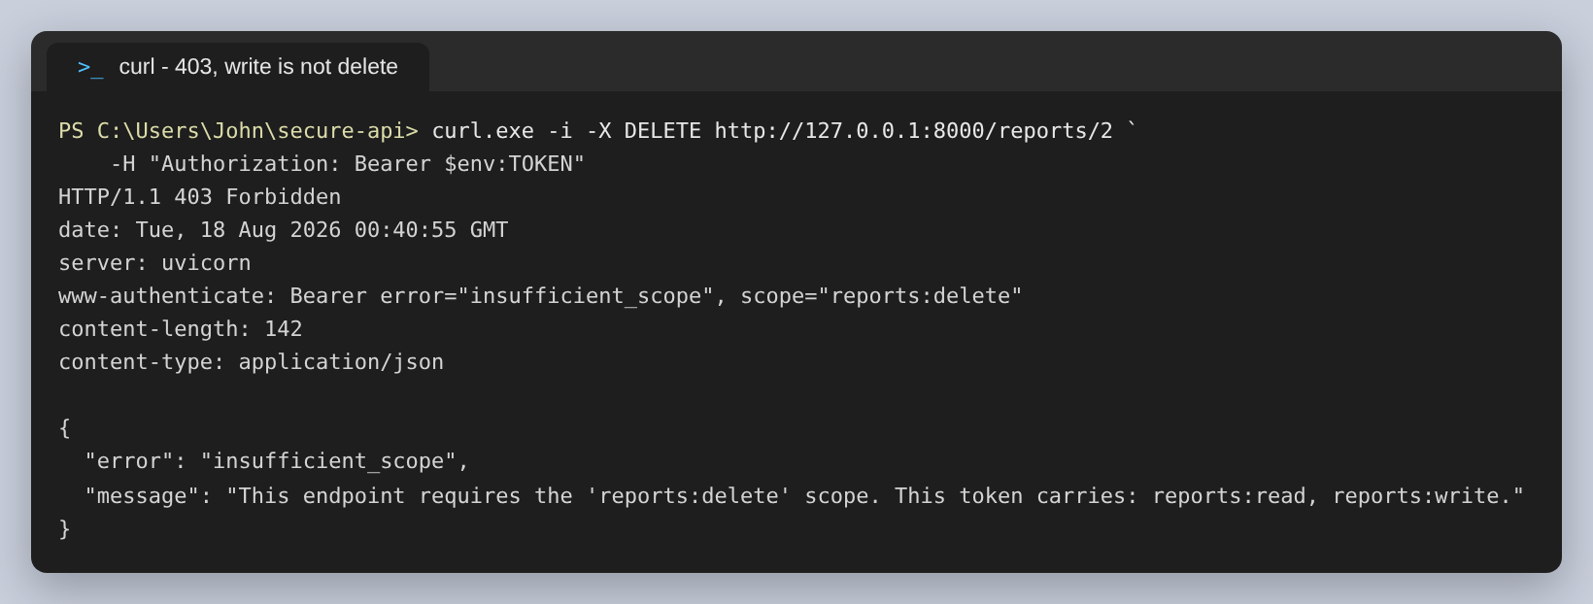
Figure 22: 403, reports:write is not reports:delete
A wrong password. The message is deliberately the same one an unknown username produces, because a different message would let someone work out which accounts exist:
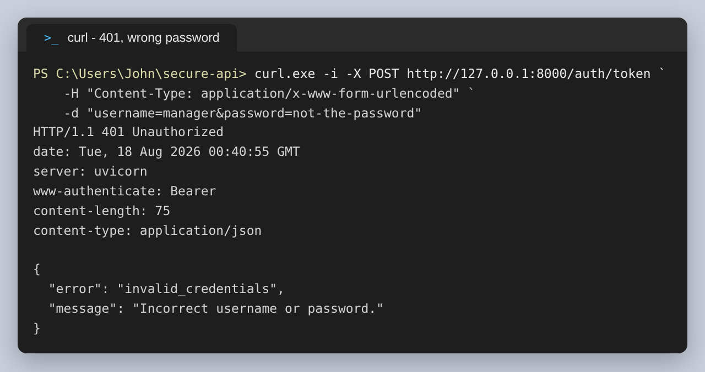
Figure 23: 401, wrong password
And asking for a scope the account may not hold, which is refused rather than quietly granted in a reduced form:
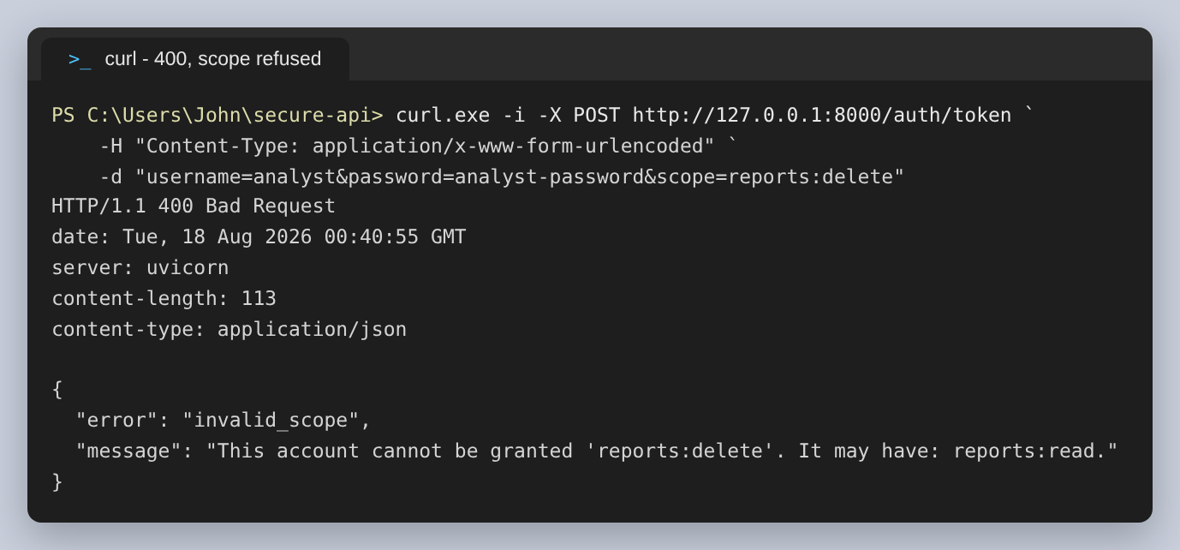
Figure 24: 400, scope refused

Step 3: Rate limiting
Rate limiting is here because authentication alone does not stop abuse. Nothing in the token logic prevents someone posting thousands of password guesses to the token endpoint, and each one would be correctly rejected while the attacker worked through a word list.
SlowAPI is the FastAPI equivalent of Flask-Limiter and works the same way: a limit per endpoint, counted against a key. Four limits are used:
Endpoint | Limit | Counted against | Why
POST /auth/token | 5 / minute | the client address | This is where password guessing happens
POST, DELETE /reports | 10 / minute | the token id | Writes cost more than reads
GET /reports/summary | 20 / minute | the token id | Aggregates more work per call
Everything else | 60 / minute | the token id | A sane default

The key matters as much as the number. Counting reads per address would mean an office behind one address shares a single allowance, and one busy client could lock out its colleagues. So an authenticated request is counted against the token's jti claim instead. Logins have no token yet, so those are counted per address, which is the right key for the thing being defended against:
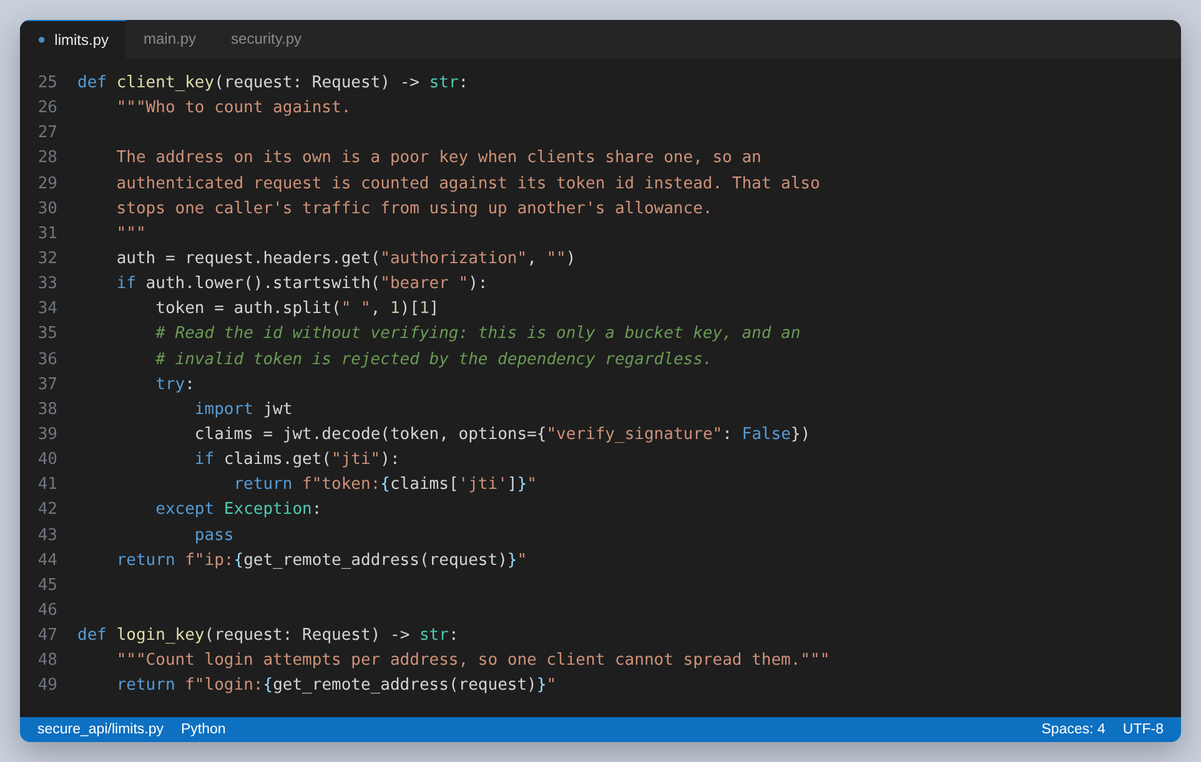
Figure 25: Choosing what to count a request against
Six password guesses in a row. The first five are refused as wrong; the sixth is refused for being the sixth. The call after that has the correct password and is still refused, which is what makes this useful:
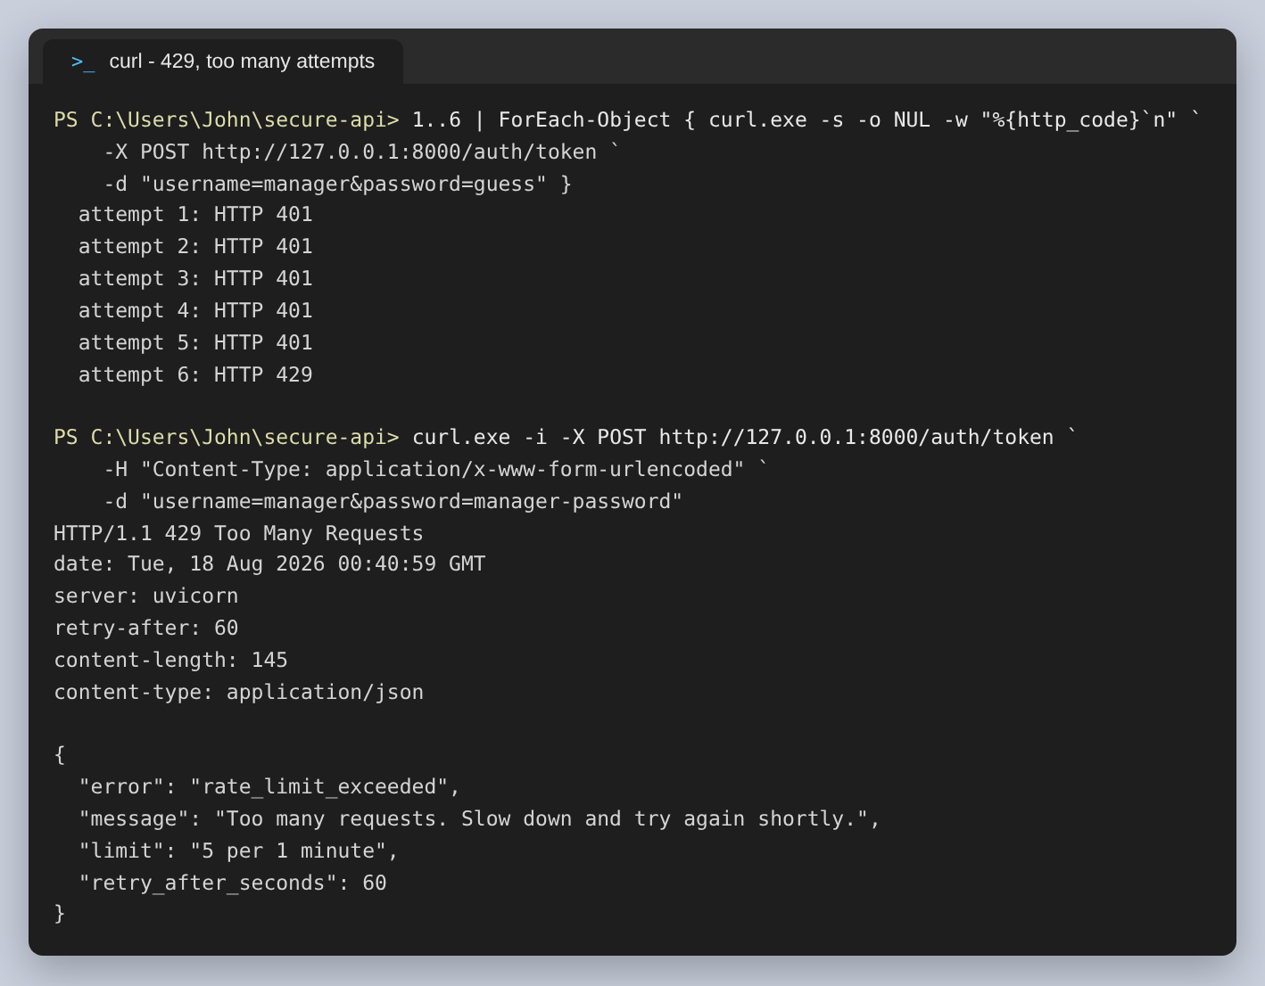
Figure 26: 429 after five attempts, with the limit and a Retry-After header
The 429 says what the limit was and when to try again, so a legitimate client that has been too eager can back off correctly instead of guessing.

Step 4: Documentation, with Swagger
FastAPI generates the OpenAPI document from the type hints and the response models. Nothing in the pages below was written separately; the descriptions come from the endpoint decorators and the Pydantic fields.
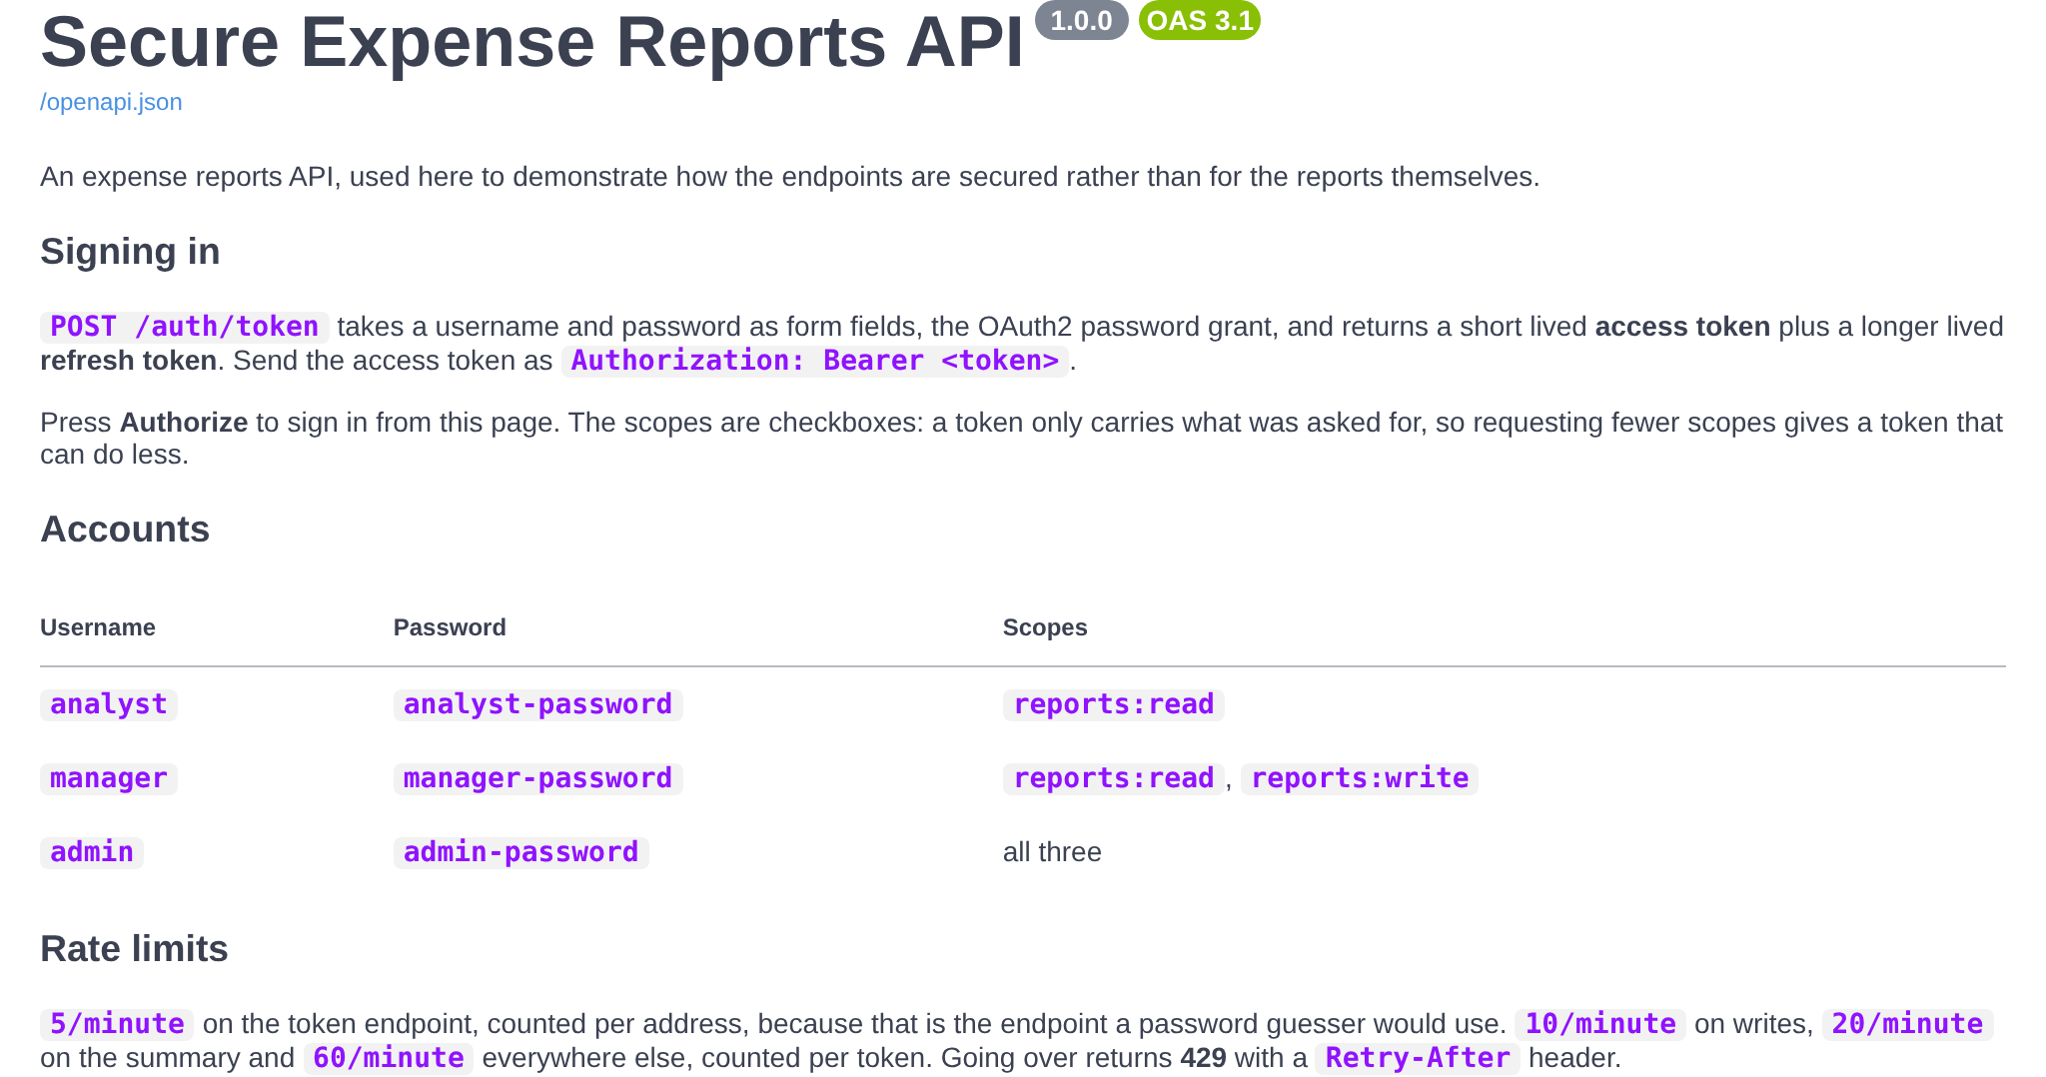
Figure 27: The description at /docs, including the accounts and the rate limits
The endpoints, each with a padlock showing it is protected:
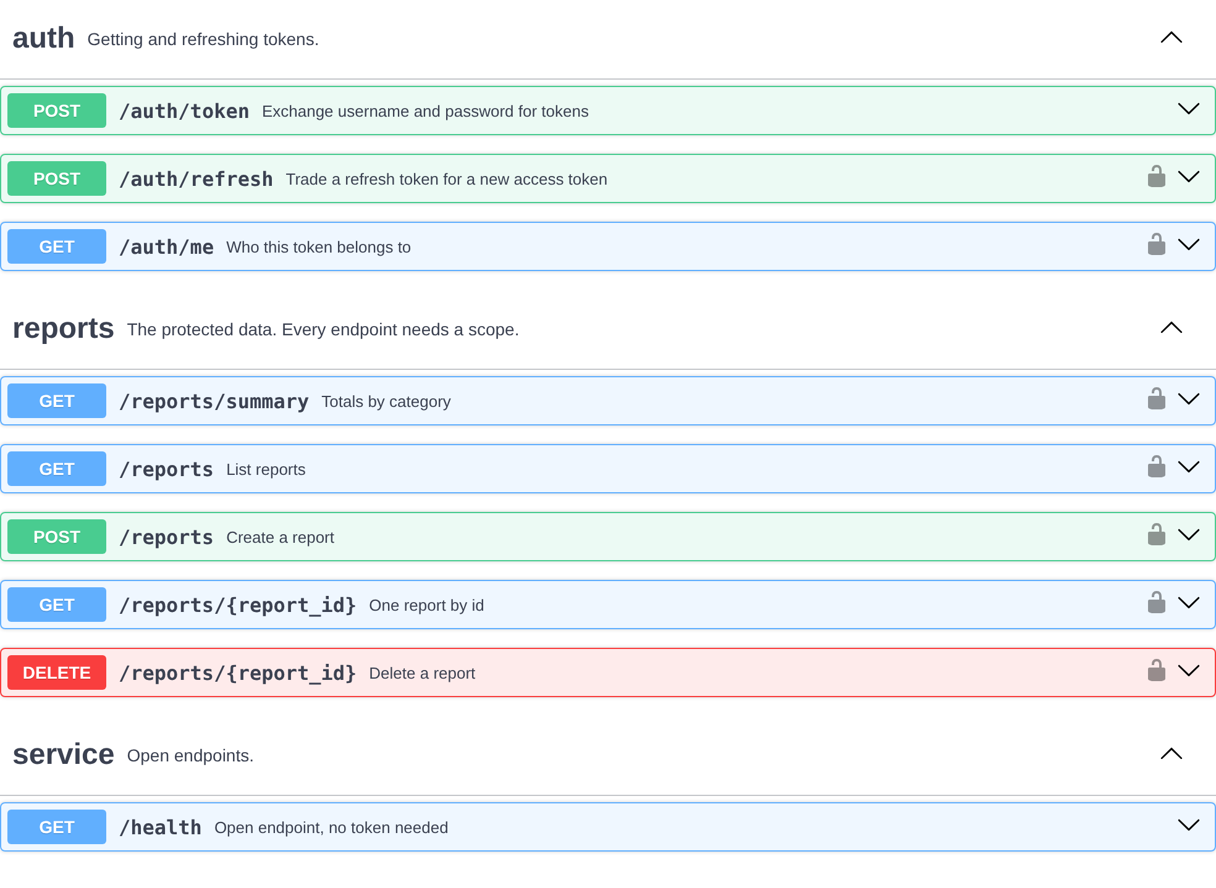
Figure 28: All nine endpoints. Only /health has no padlock.
The Authorize button opens the OAuth2 dialog. This is the clearest evidence that the flow is real OAuth2 rather than a bearer token pasted into a header: Swagger UI knows the flow is password, knows the token URL, and lists the scopes as checkboxes because the API declared them.
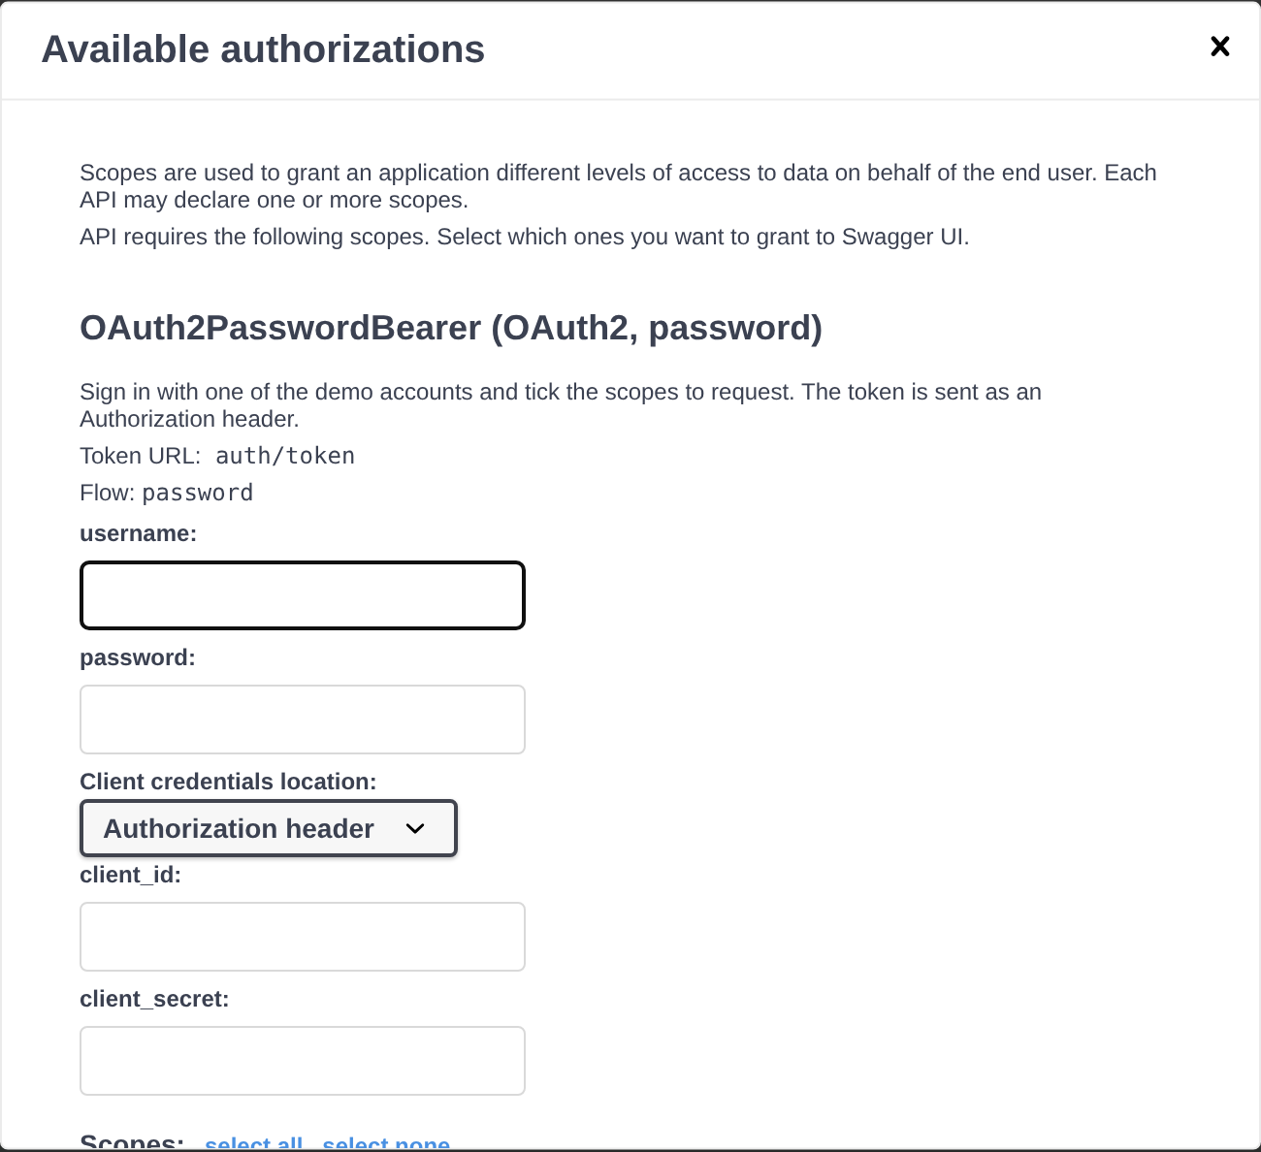
Figure 29: The Authorize dialog, showing the password flow and the token URL
Filled in as manager, with two of the three scopes ticked:
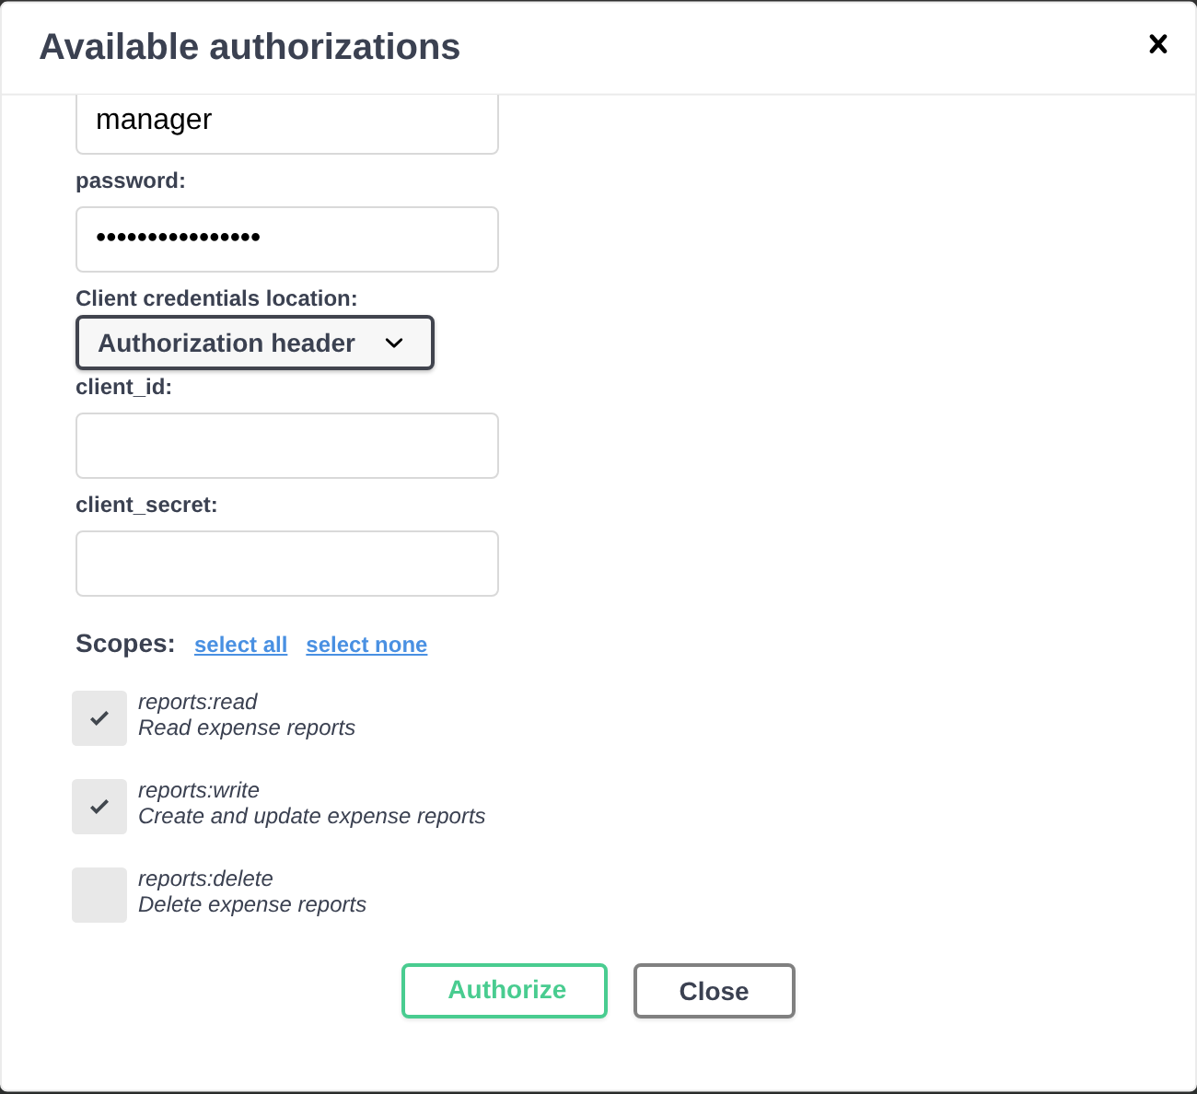
Figure 30: Requesting reports:read and reports:write
Pressing Authorize performs the token exchange against /auth/token. The dialog then shows the session as authorised:
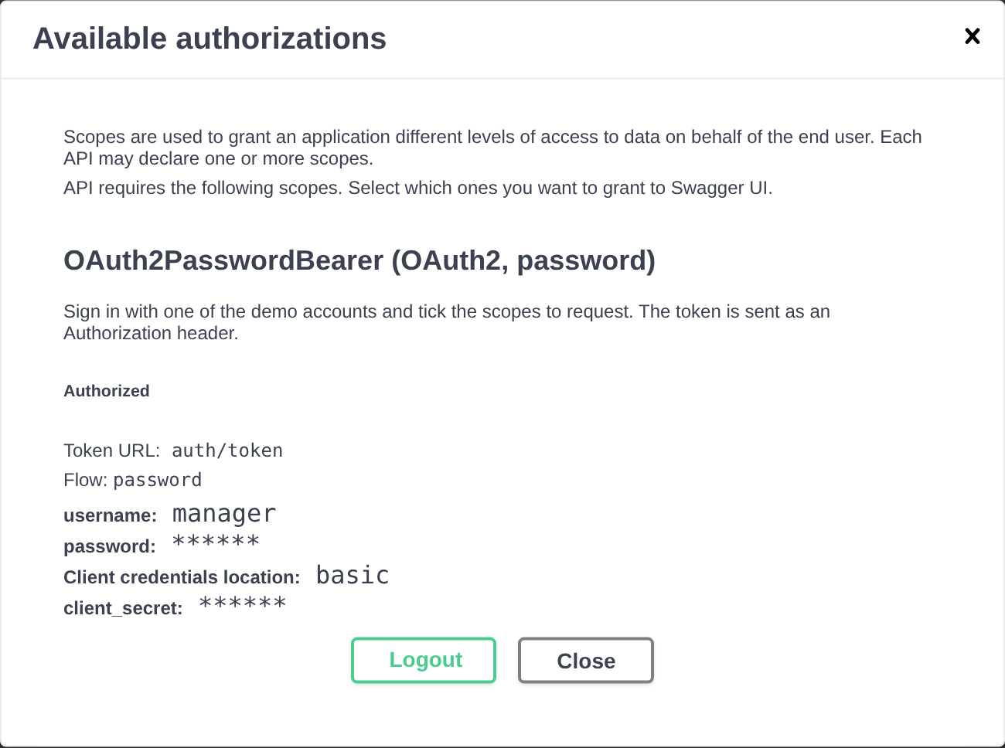
Figure 31: Authorized. Swagger UI now holds a token and sends it with every call.
The token endpoint as documented:
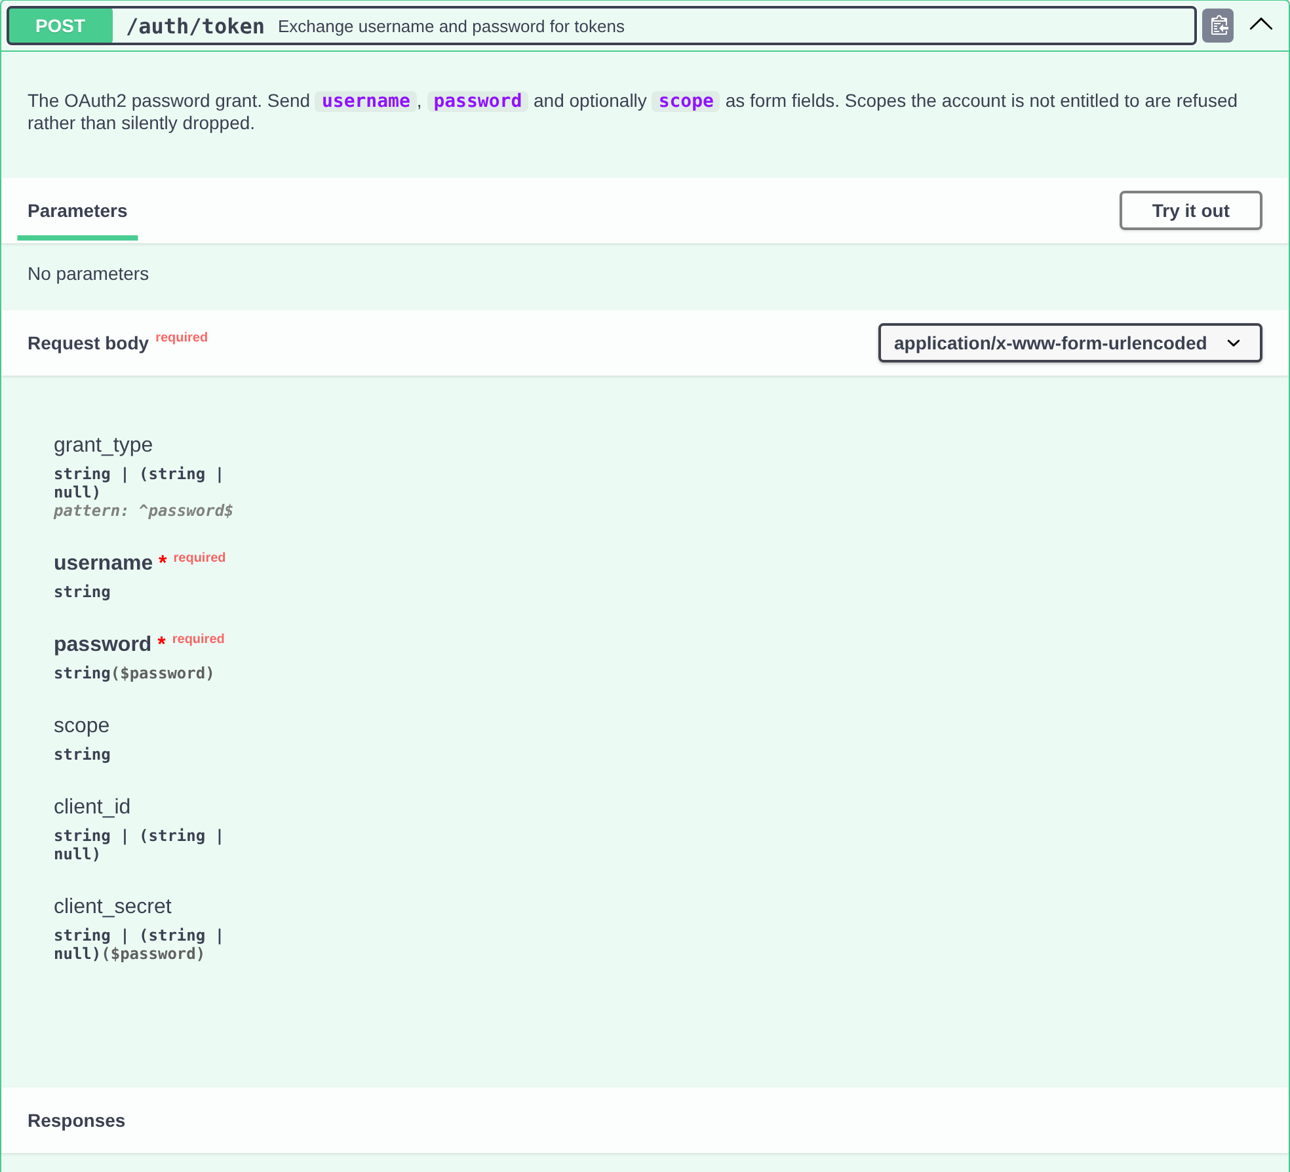
Figure 32: POST /auth/token, with its form fields and every response it can give
With the session authorised, Try it out sends the token. This response came back from the running API:
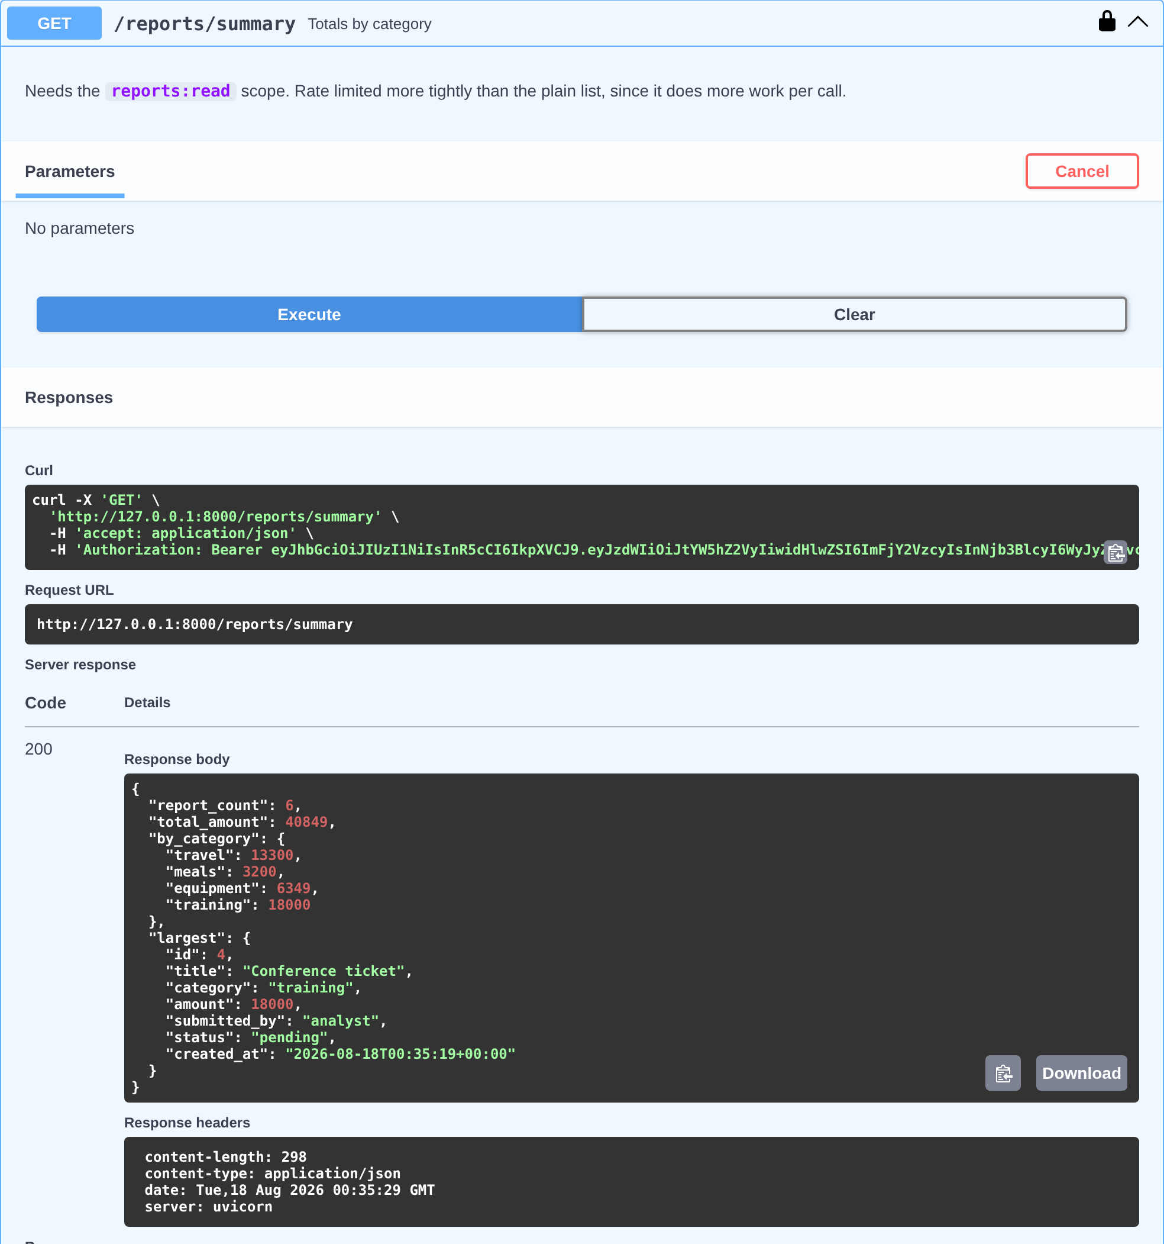
Figure 33: GET /reports executed from /docs, with the token attached
The same session attempting a delete. The token carries read and write but not delete, and the API refuses it. The curl command Swagger UI shows is the exact request, and the response headers include the scope that would have been needed:
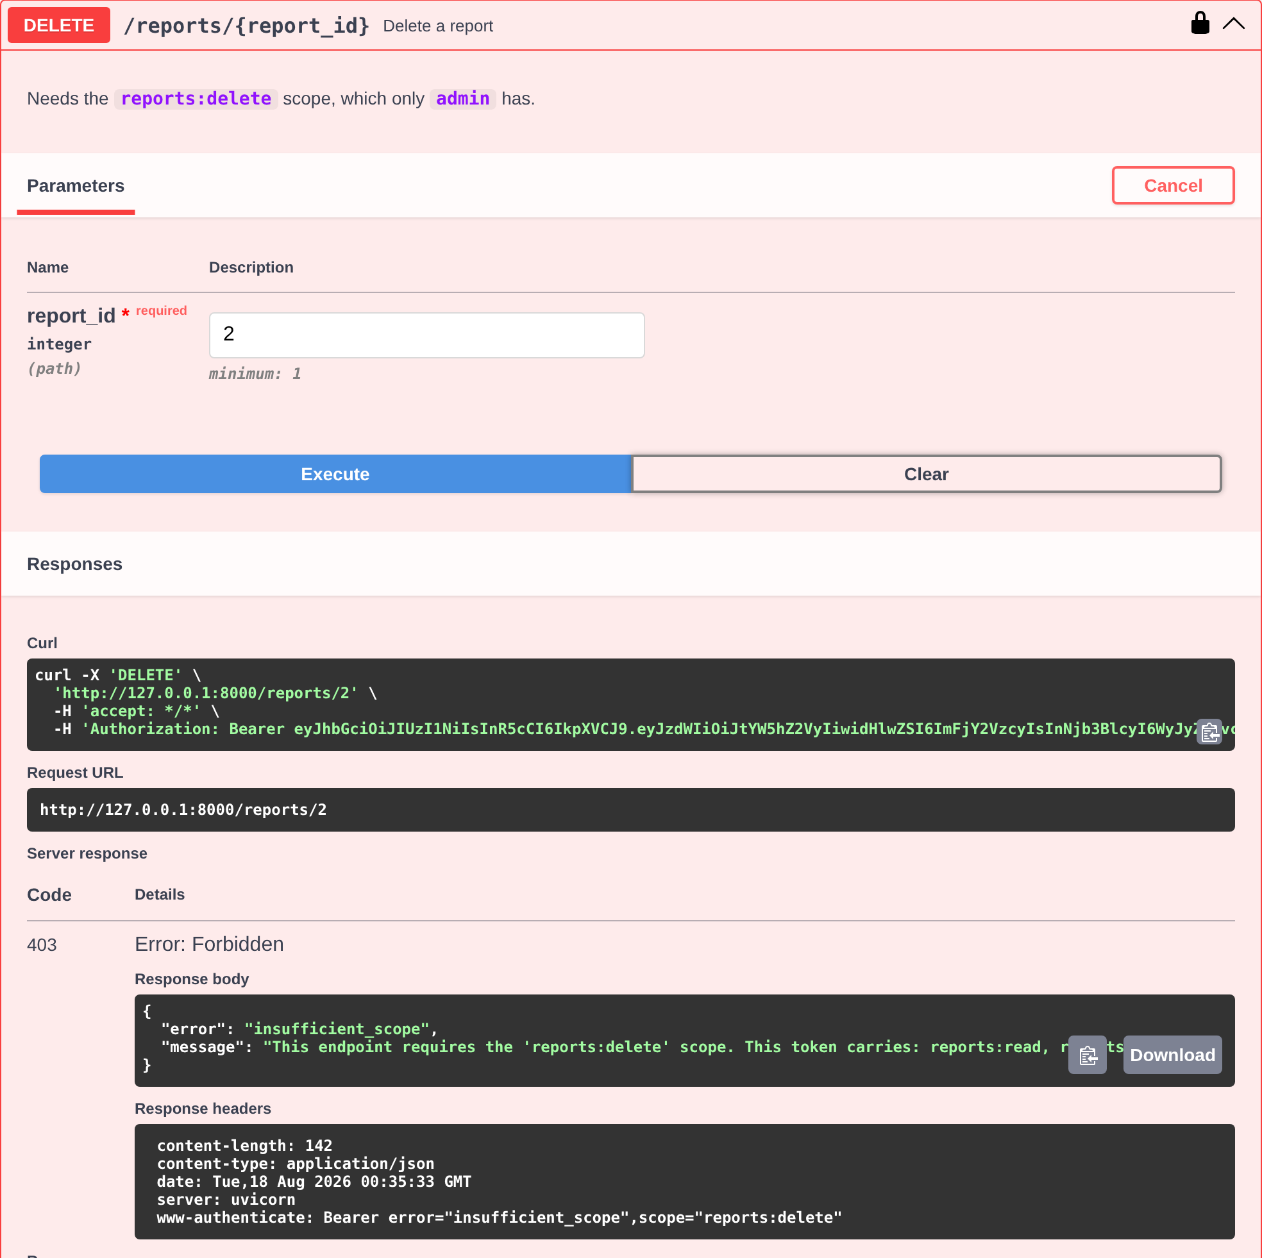
Figure 34: A live 403 from /docs: authenticated, not authorised
The generated schemas, including the Error shape every failure uses:
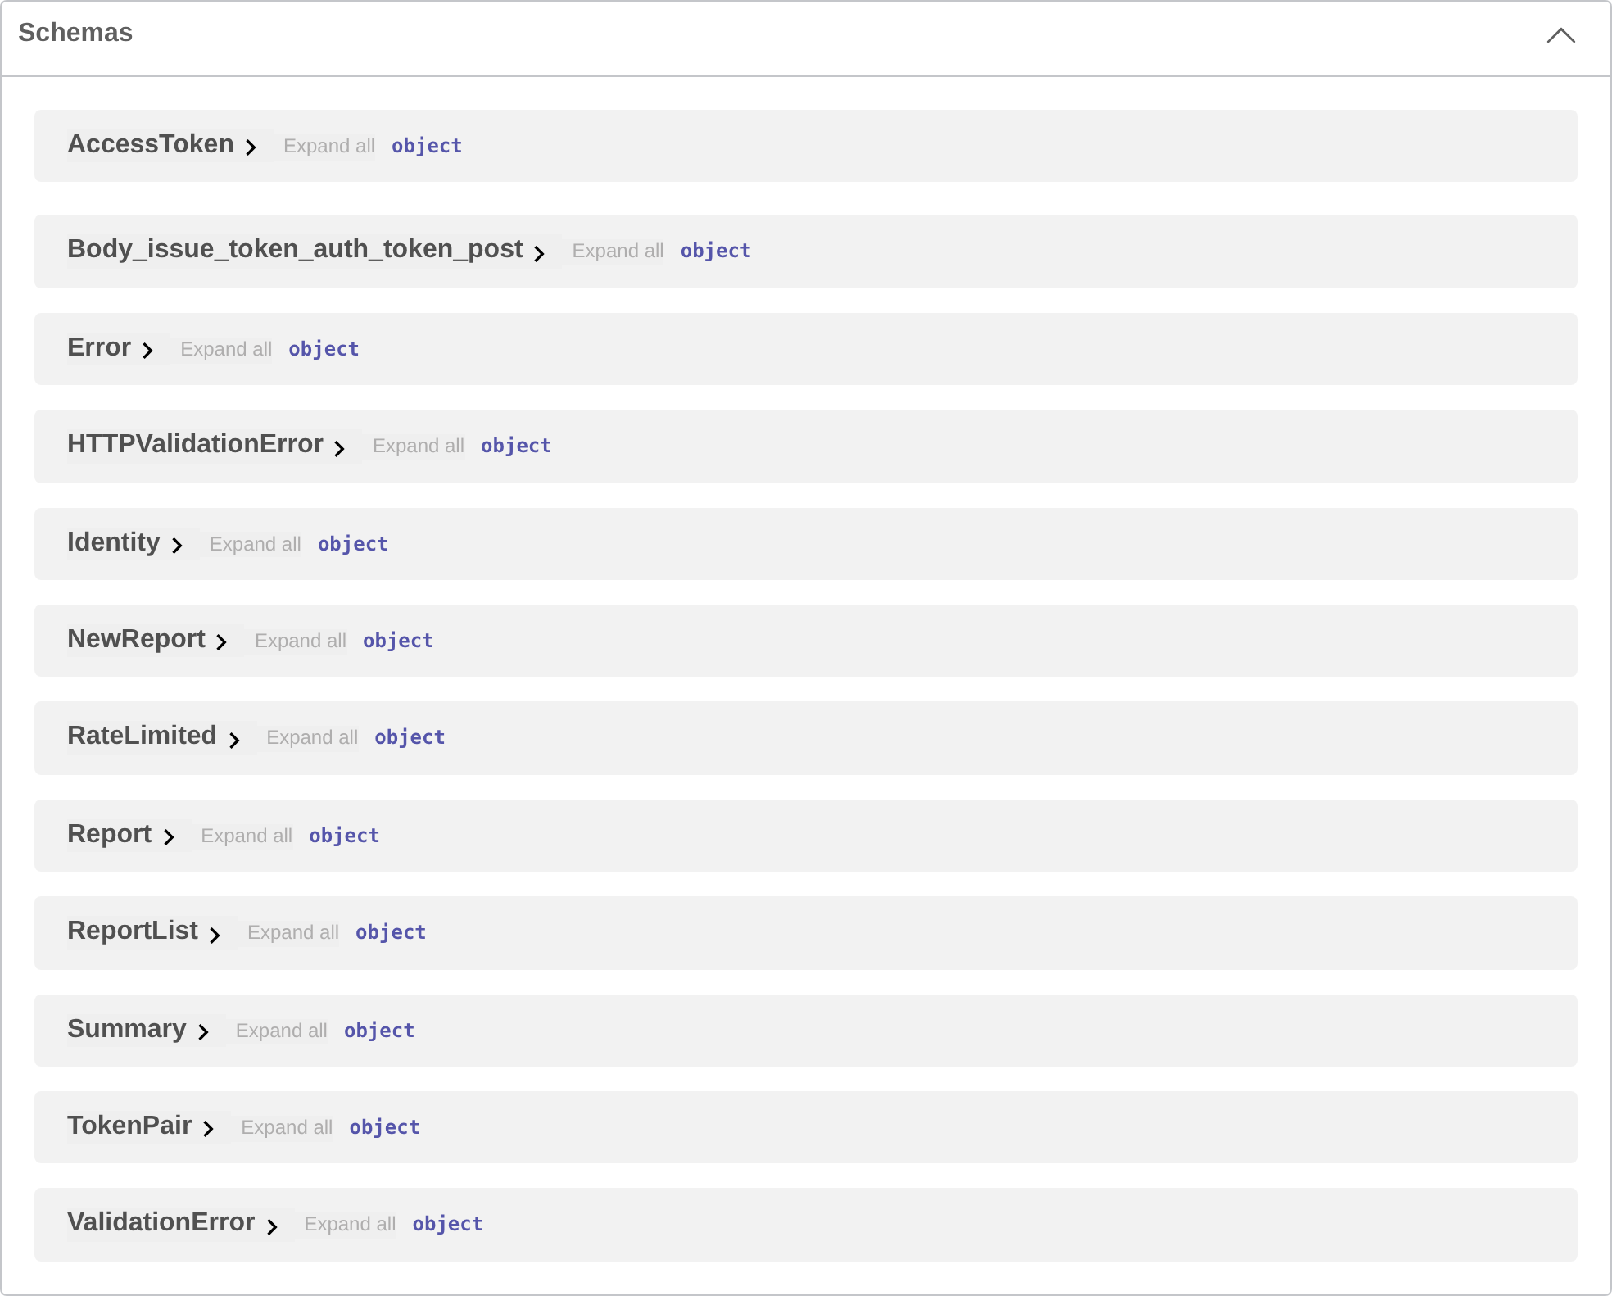
Figure 35: The generated schemas
The same document also renders as ReDoc:
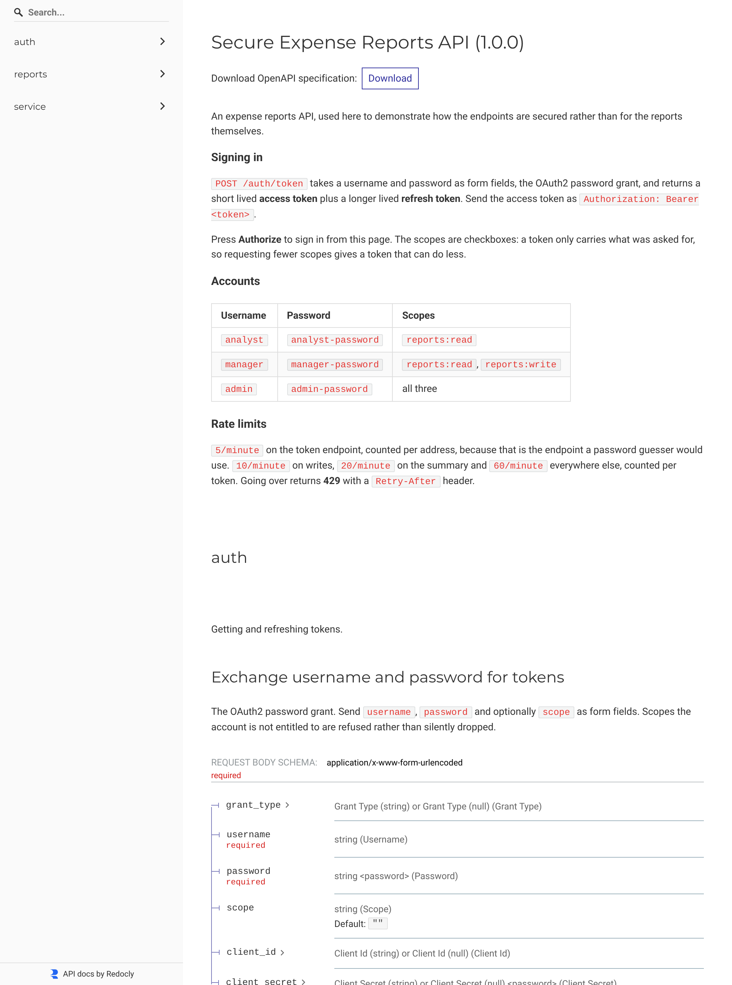
Figure 36: The API at /redoc

Step 4, continued: the Postman collection
The collection is at postman/secure-api.postman_collection.json, in Postman's v2.1 format, with 16 requests in three folders: Auth, Reports and Rejected.
The piece that makes it pleasant to use is the test script on the sign-in request. It saves both tokens into collection variables, and the collection's own auth is set to send the access token as a bearer, so every request after sign-in is authorised without anything being pasted anywhere. It also decodes the payload and checks the claims:
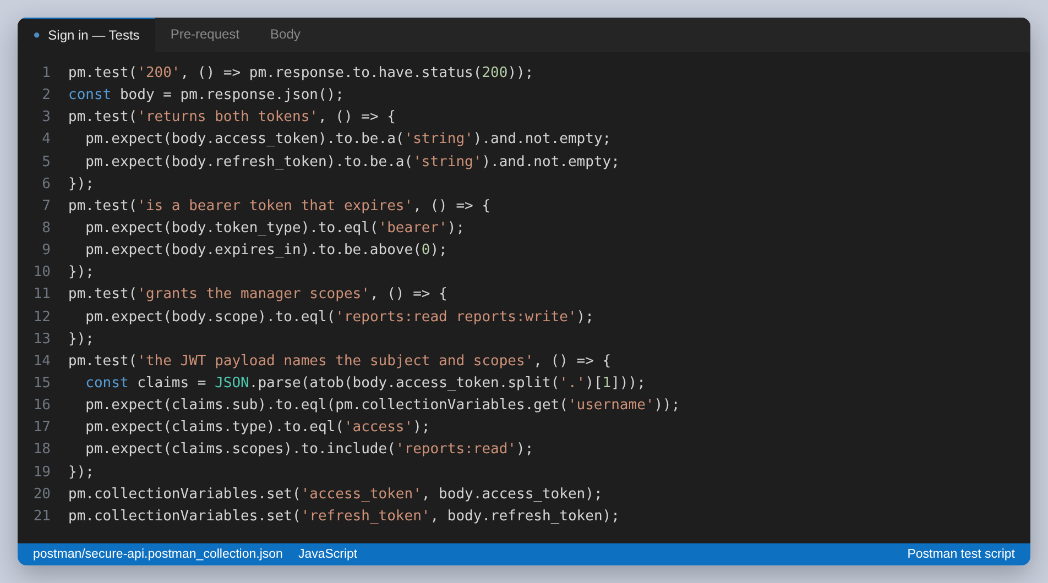
Figure 37: The test script on the Sign in request
Every request carries assertions, which means the collection is not only documentation but a check on the API. The Rejected folder asserts the refusals: that no token gives 401, that a tampered token names the signature, that a missing scope gives 403 and not 401, and that a wrong password gives a message which does not reveal whether the account exists.
Newman is Postman's command line runner and reads the same file, so the collection can be run without the app:
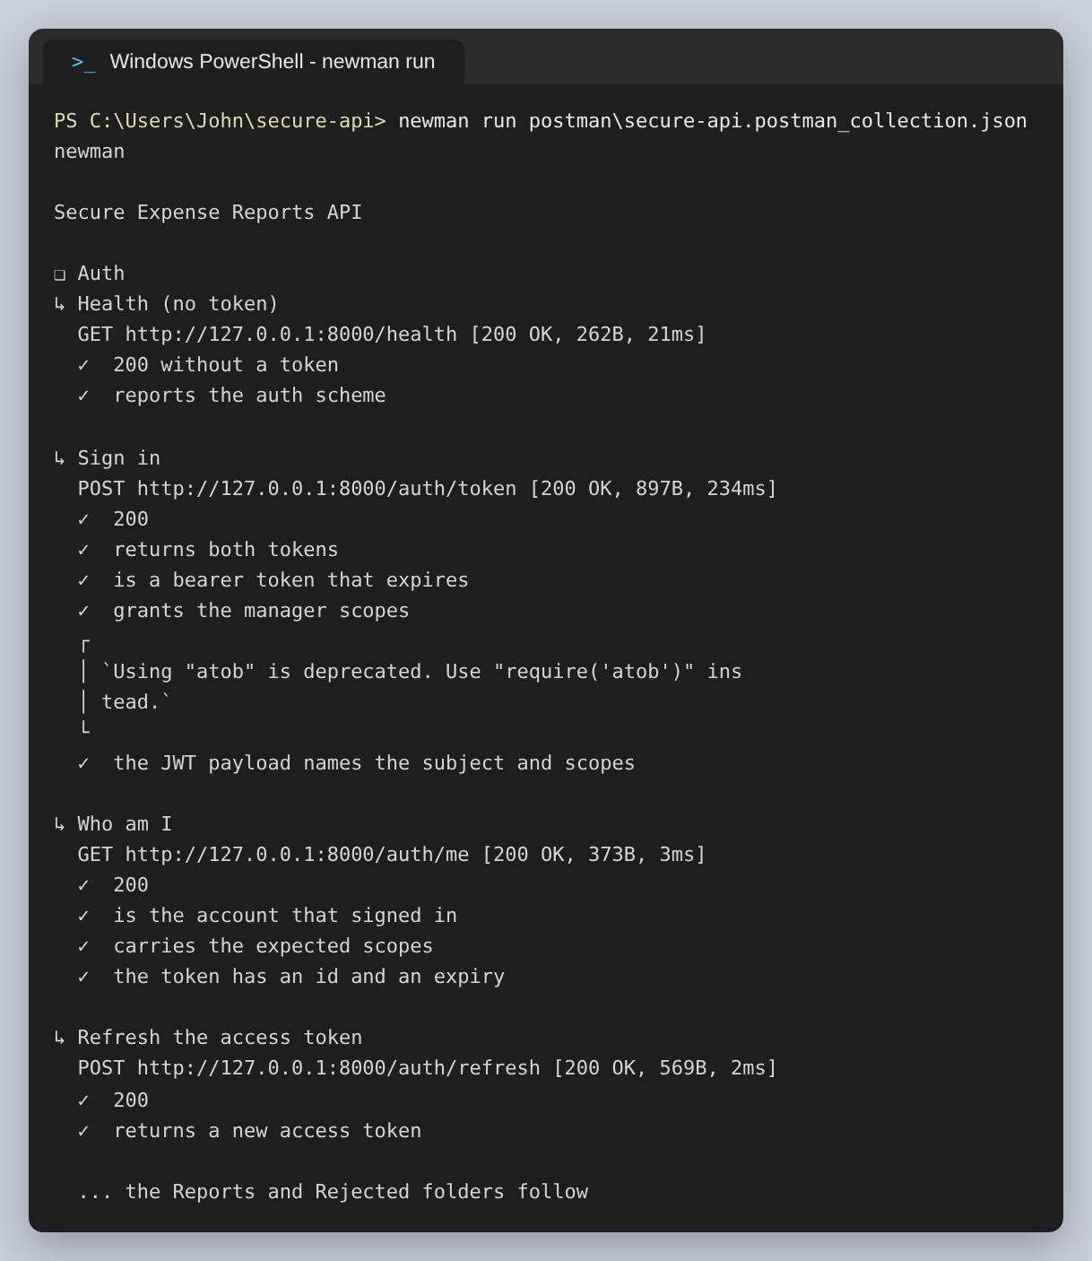
Figure 38: newman run, showing the Auth folder and its assertions
The totals for the whole run:
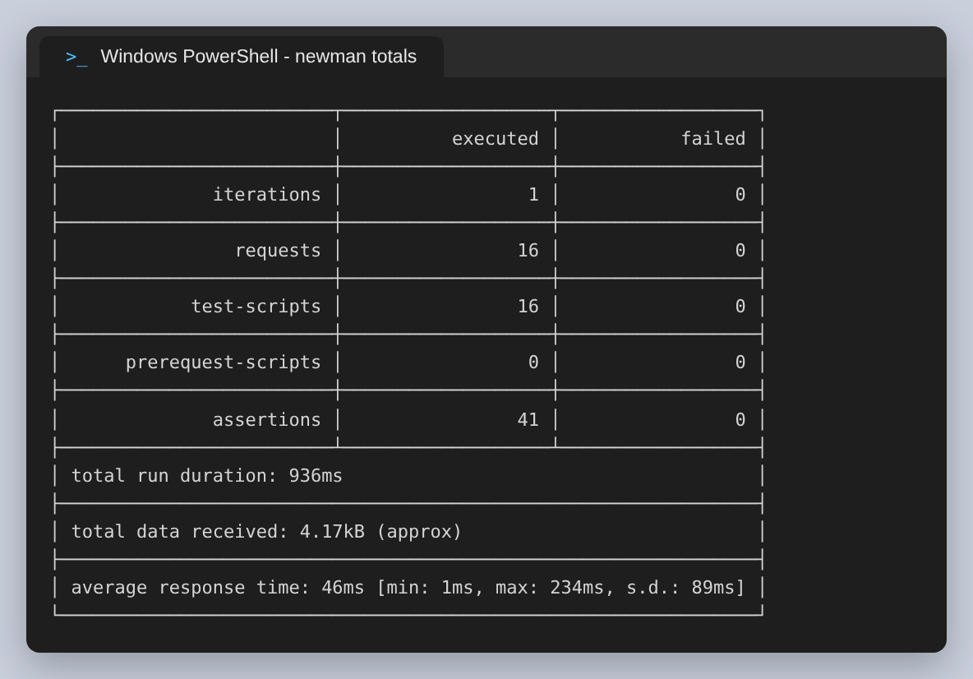
Figure 39: 16 requests, 41 assertions, nothing failed
One assertion did fail the first time I ran this, and it was my own mistake rather than the API's: the collection saved the new report's id as a number and then compared it against a string. Worth mentioning because it is exactly the sort of thing that makes a collection worse than nothing if it is written and never executed.

Step 5: The practical use case
The client is a single page served by the API itself at /app. It signs in, holds the token, and calls the same endpoints as everything above. It is the practical use case the assignment asks for, and it is also where the security decisions become visible to a person.
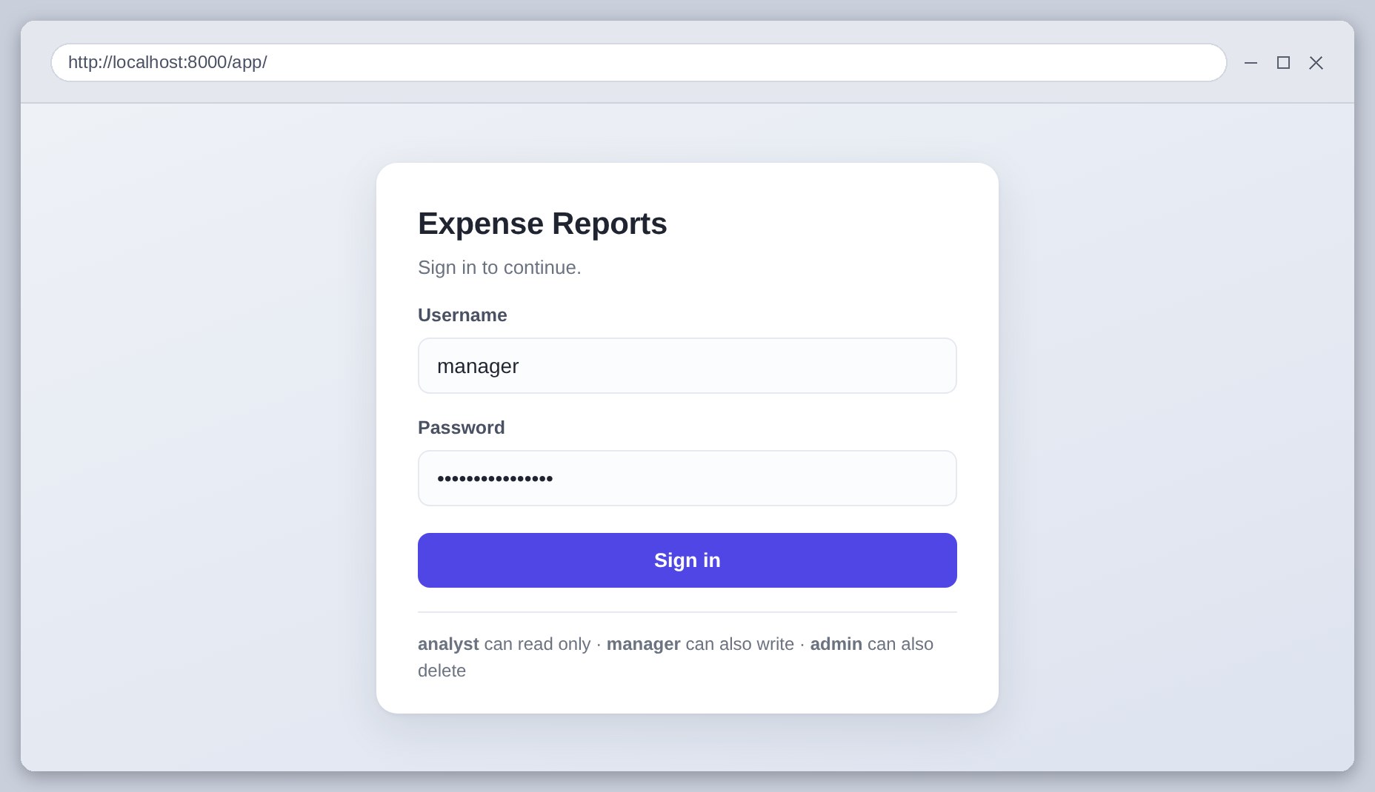
Figure 40: The sign-in screen. This posts to /auth/token, the same endpoint curl used.
Signed in as manager. The scopes the token carries are shown next to the account name, the totals come from /reports/summary and the table from /reports, each with the token attached:
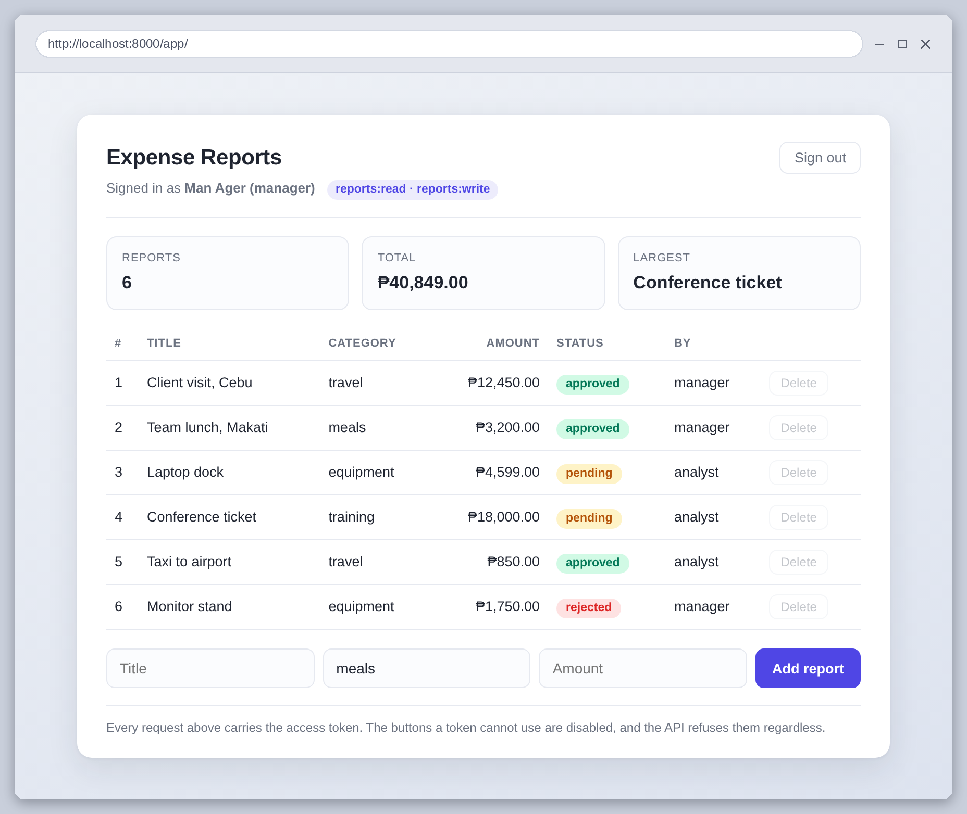
Figure 41: The client, signed in as manager
Adding a report, which needs reports:write:
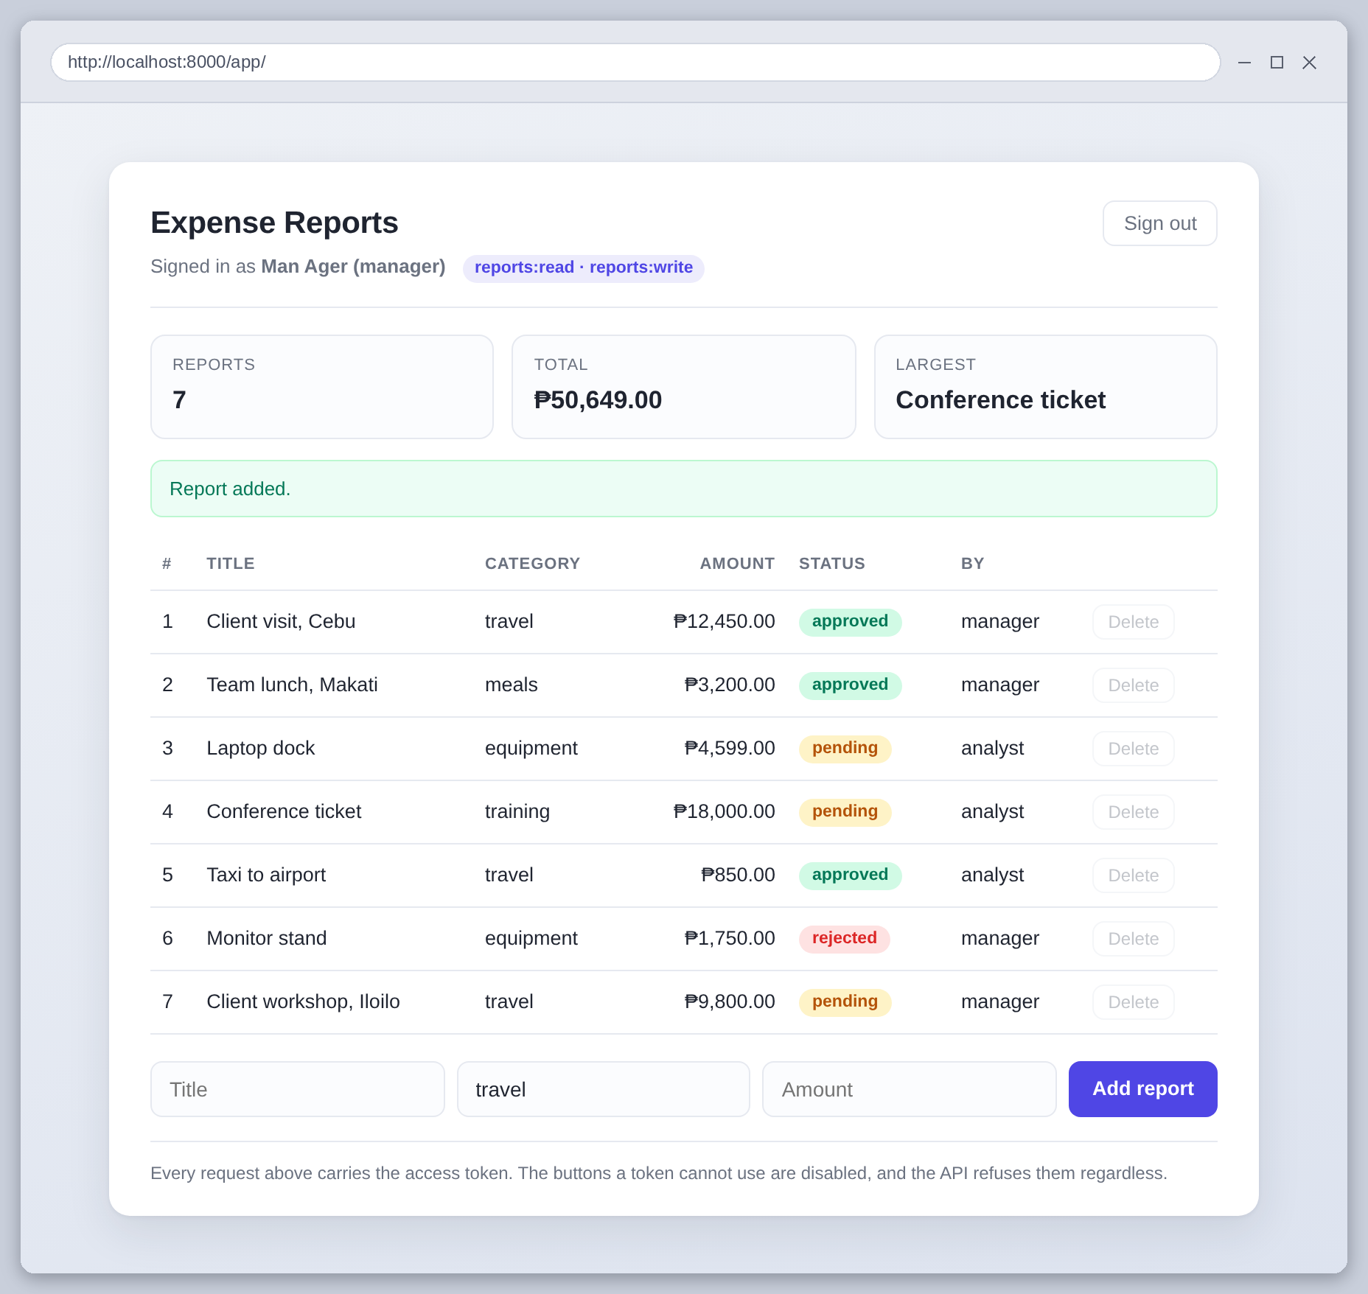
Figure 42: A report created through the client
The delete buttons are disabled, because this token does not carry reports:delete. That is a courtesy to the user, not a security measure, and the distinction matters. To show why, I enabled a delete button in the browser and pressed it, which is exactly what a modified client would do. The API refused it:
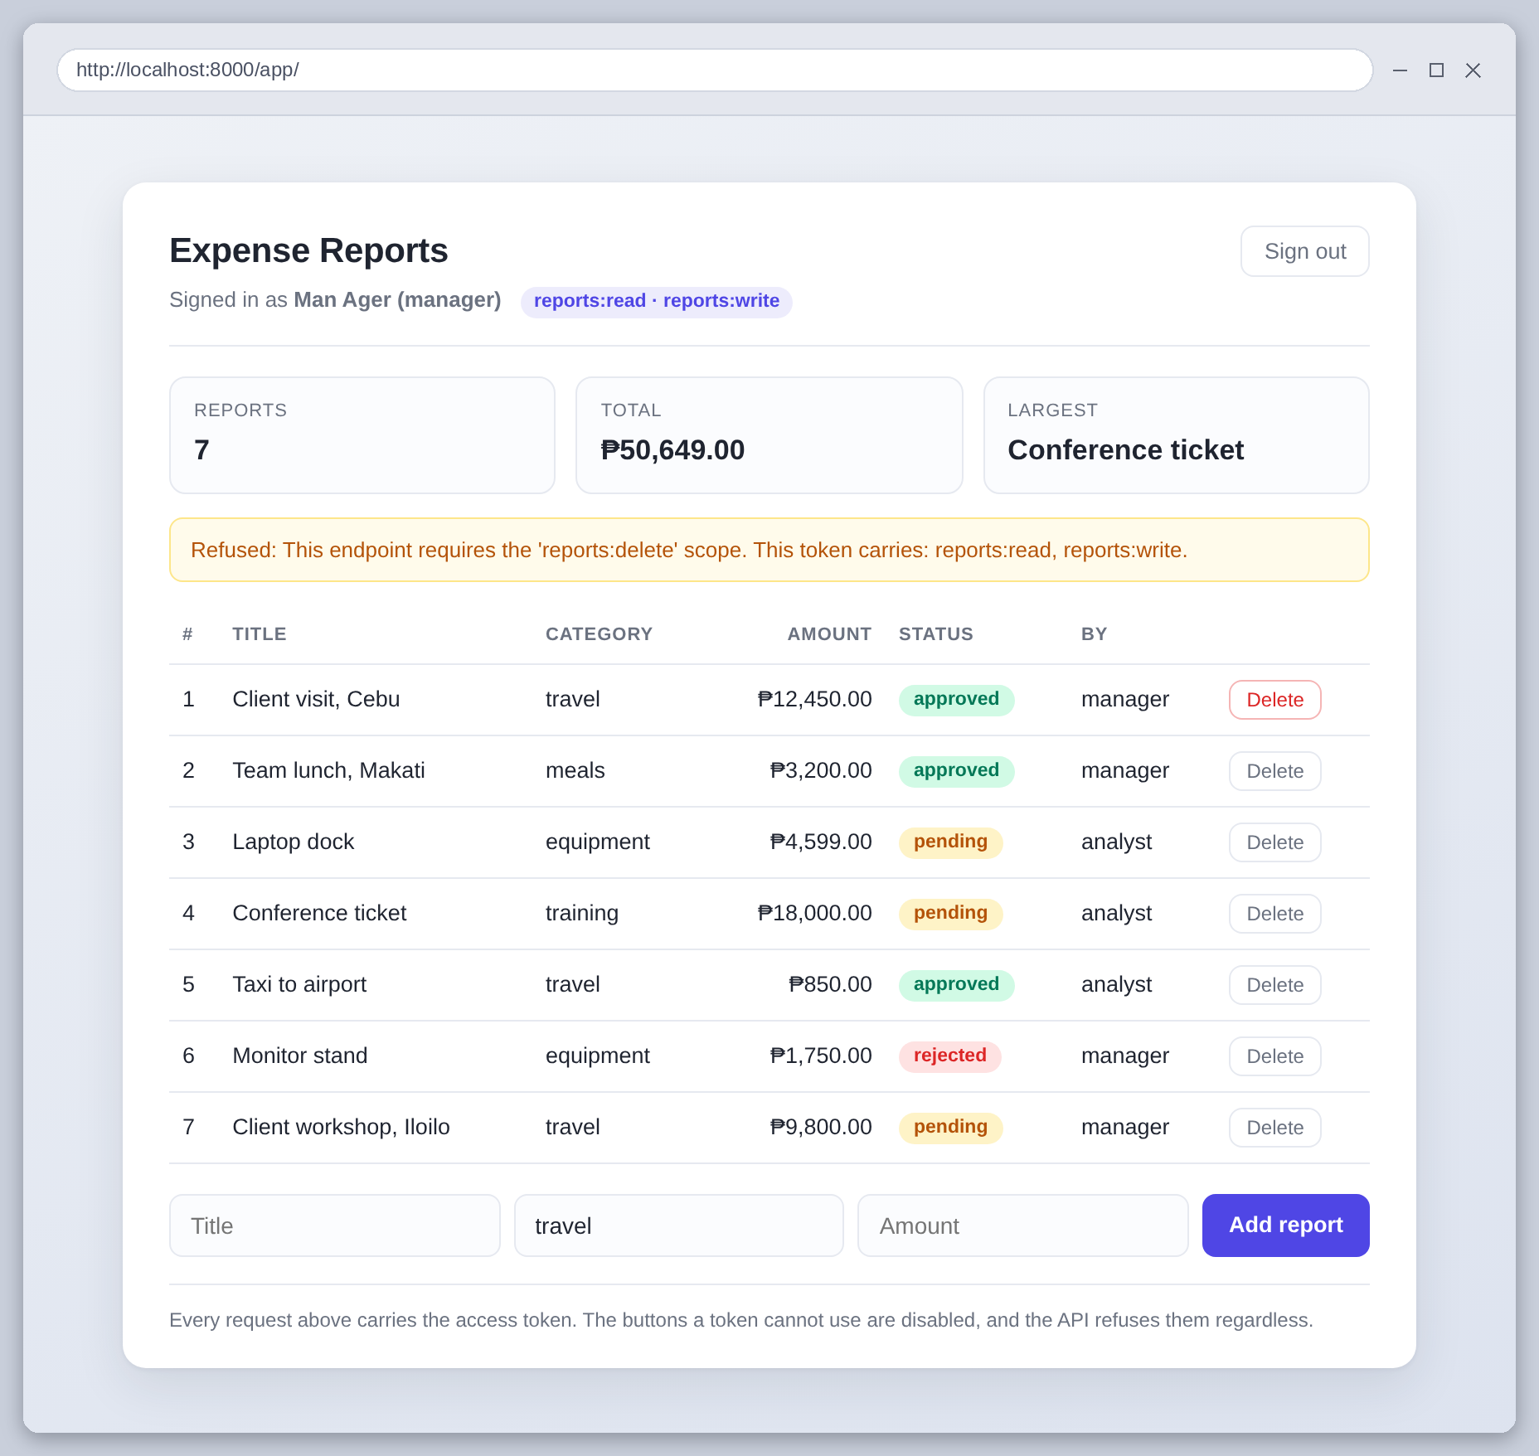
Figure 43: The API refusing a delete after the disabled button was re-enabled in the browser. The message is the API's own.
Signed in as analyst instead, the add form is not rendered at all, because that token cannot write:
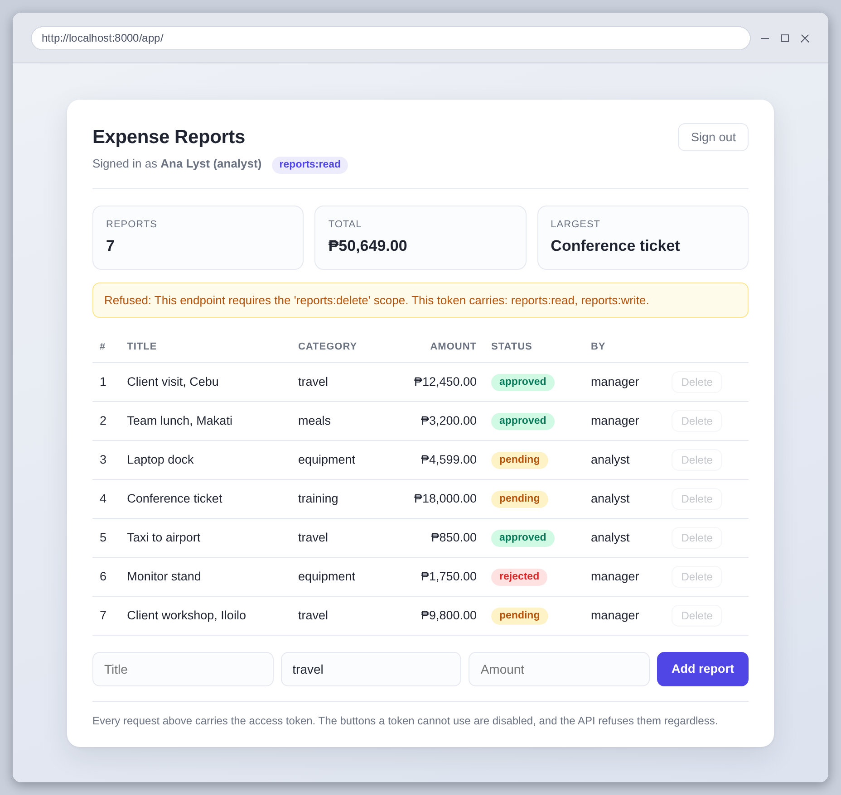
Figure 44: The same client with a read-only token
And the login rate limit as a user meets it, after six wrong passwords:
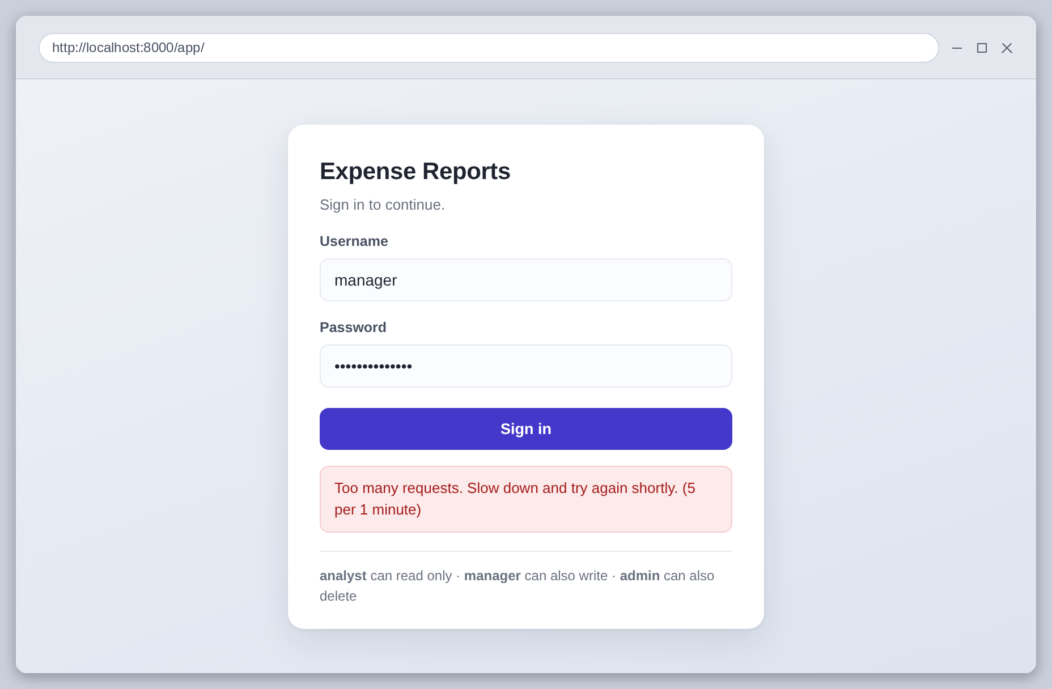
Figure 45: The 429 surfaced in the client, with the limit that was hit
Three things in the client are deliberate. The token is kept in a variable and not in localStorage, because anything in localStorage can be read by any script on the page, so one injected script would be enough to steal it. A 401 sends the user back to the sign-in screen, since a token that is expired or not trusted cannot be recovered from. And a 403 shows the API's own message rather than a generic failure, so the user is told what permission they are missing.

Tests
49 tests, in three files: 23 for authentication, 18 for scopes and 8 for the rate limits.
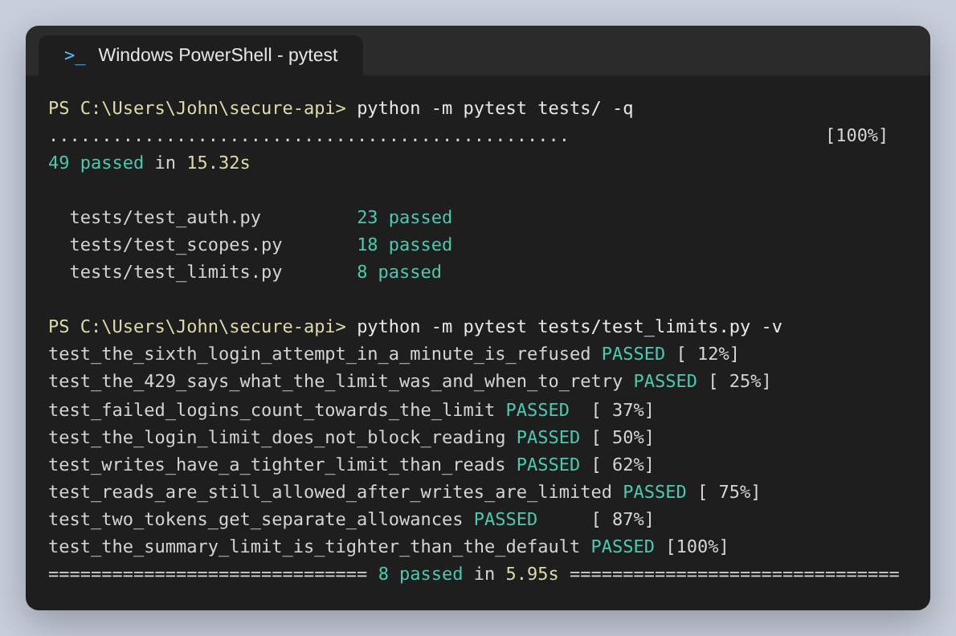
Figure 46: The test run, and the rate limit tests by name
The ones I would keep if I could keep only a few are the attacks. One edits the scopes inside a token's payload to add reports:delete and confirms the request is still refused, which is the test that proves the signature is doing its job. One signs a well-formed token with a different secret. One presents a refresh token as an access token. One checks that a wrong password and an unknown username produce byte for byte the same response.
The rate limit tests needed a fixture I did not expect to write. The limiter counts across requests, which is the point of it, so one test's traffic was spending the next test's allowance and unrelated tests were failing with 429s. It is switched off by default and turned on only for the tests that are about limiting.
The same problem bit the screenshot script. Its own setup was signing in often enough to trip the five-per-minute login limit, so it started collecting 429s it had not asked for. It now restarts the server between groups of captures, since the counters live in the process.

What I would change
The tokens cannot be revoked. Every token carries a jti precisely so that a specific one could be blacklisted, but nothing reads it yet, so a leaked access token stays usable for its full 15 minutes and a refresh token for a day. A store of revoked ids checked on each request is the first thing I would add.
The secret has a fallback default so the project runs after a clone, which is convenient and wrong. It should refuse to start without SECRET_KEY set in the environment. The accounts are in a module for the same reason and would be a database.
The rate limit counters are in memory, so they are per process. Two workers would give an attacker twice the allowance, and a restart clears the count entirely. Flask-Limiter and SlowAPI both support Redis for this, which is what a deployment would use.
What I got most out of was the difference between 401 and 403. Before this I would have treated them as roughly interchangeable. Building the scope dependency made it concrete: they are answers to two different questions, and a client can only respond sensibly, by signing in again or by giving up, if the API is precise about which one it is asking.

