Day 14 Hands-on Assignment
Designing an API Gateway and Service Communication for a Simple E-commerce Application
John Michael Bilbao
Techstart
September 2, 2026

Introduction
Bilbao Bazaar is a small online shop split into two microservices. One owns the catalogue: what is for sale, what it costs, how many are left. The other takes orders. They are separate programs in separate containers, and neither can read the other's data.
That split is why the assignment needs a gateway. A customer should not have to know that products live on one port and orders on another, and the browser should not be making requests to two different origins to draw one page. So a third container sits in front of both and is the only thing anybody talks to. It is an NGINX instance, and it does the routing.
There is a second kind of traffic that has nothing to do with the customer. When an order arrives, the orders service does not know what anything costs, so it has to ask the catalogue. That call goes sideways, service to service, and it turned out to be the more interesting half of the design.
Everything runs on Docker: three images, three containers, one compose file. run.sh builds, starts, exercises and tears down the whole stack in one invocation and writes every command and response into results/. The figures below are rendered from those captures and from real Chromium screenshots, so nothing here is retyped by hand.
Container | Image | Listens on | What it does
bazaar-gateway | bazaar/api-gateway:1.0 | 0.0.0.0:8091 | NGINX. Routes /api/... to both services, serves the storefront.
bazaar-products | bazaar/products-service:1.0 | 127.0.0.1:8000 | The catalogue. Products, prices, stock. Calls nobody.
bazaar-orders | bazaar/orders-service:1.0 | 127.0.0.1:8001 | Takes orders. Prices every line through products-service.

The two services are FastAPI applications on Python 3.12. The gateway is nginx 1.27 on Alpine, which is why its image is 49.7 MB against 171 MB for a service carrying a Python runtime.
A note on the networking, because it is not the shape a textbook would draw. The intended compose file put all three containers on a bridge network and published only the gateway's port. That does not run on the machine I built this on: the container runtime is Podman without CAP_NET_ADMIN, so it allocates addresses on the bridge and then programs no routes to them. All three containers share the host network namespace instead, and the isolation is done with bind addresses. The last section explains how I worked that out.

The two microservices
The catalogue is eight products with an id, a name, a category, a price in pesos and a stock count, held in memory. Two of the rows are chosen rather than invented: product 1006 has zero stock and product 1004 has three units, so there is something for the order rules to refuse. Without them every request succeeds and the validation code never appears in a screenshot.
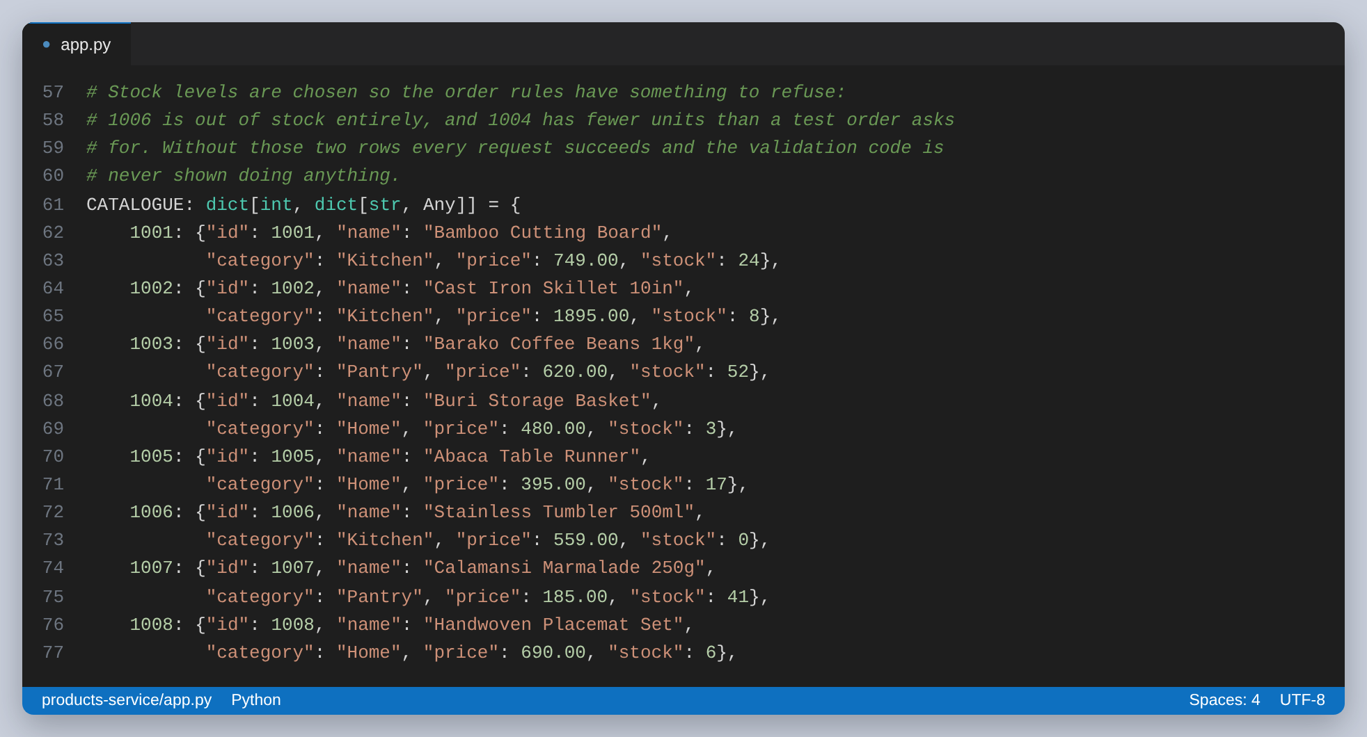
Figure 1: The catalogue. Two rows exist to make the order rules do something visible
The endpoint the orders service depends on is the single-product one. It returns a 404 for an id that is not there, and that 404 is what makes an order for a nonexistent product fail with a 404 rather than a 500.
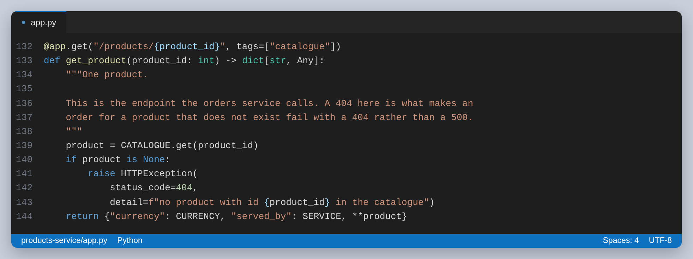
Figure 2: GET /products/{id}, the endpoint the orders service calls
The orders service holds no prices at all. It takes a product id and a quantity, asks the catalogue what that product costs, checks the answer against its own rules, and only then writes an order. The address it asks is configuration, never a literal:
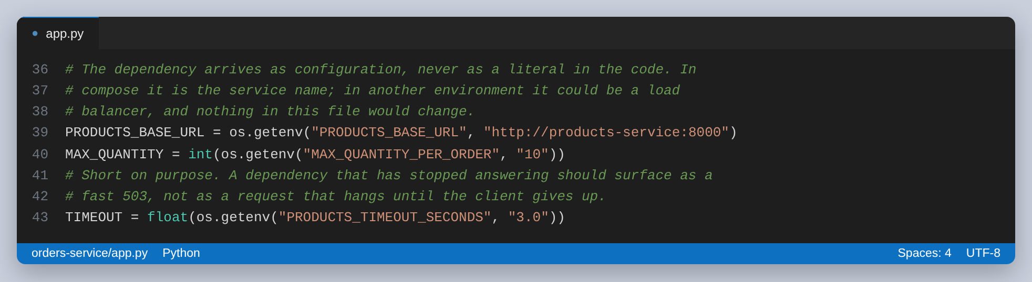
Figure 3: The dependency and the two limits, all arriving as environment variables

Task 1: Designing the API gateway
I used NGINX rather than a managed gateway because the whole design then fits in one file I can show, and because it runs in a container next to the services instead of in somebody's cloud console.
The first decision is how the services are named. Each gets an upstream block, so the address appears exactly once and the routes below refer to it by name. Adding a second replica of the catalogue is one more line inside the block and no change anywhere else.
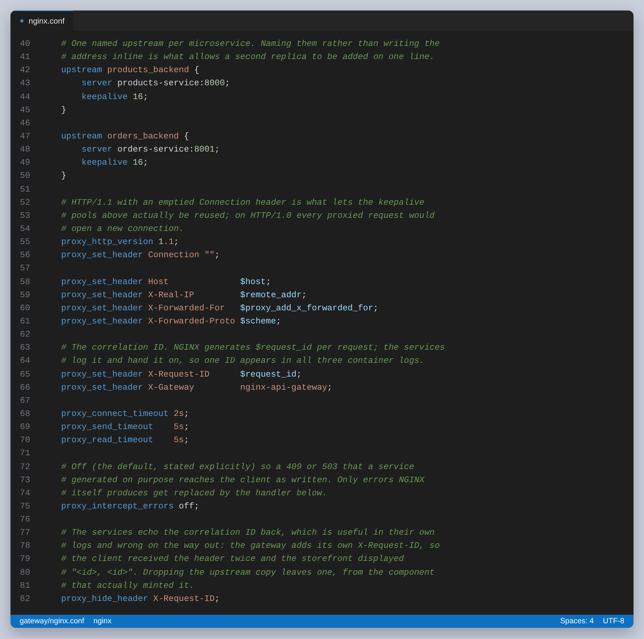
Figure 4: The two upstreams, and the proxy defaults that apply to both
The headers under them are the gateway's responsibility. X-Forwarded-For and X-Forwarded-Proto are there so a service can still tell who is asking after the hop. X-Request-ID is the one that matters for Task 2: NGINX generates a fresh value per request and the services log it. The timeouts are deliberately short, so a service that has stopped answering becomes a fast error rather than a client that hangs.
The routes are prefixes. Because proxy_pass is given a URI as well as a host, the matched prefix is replaced rather than appended, so the public path and the internal path are free to differ.
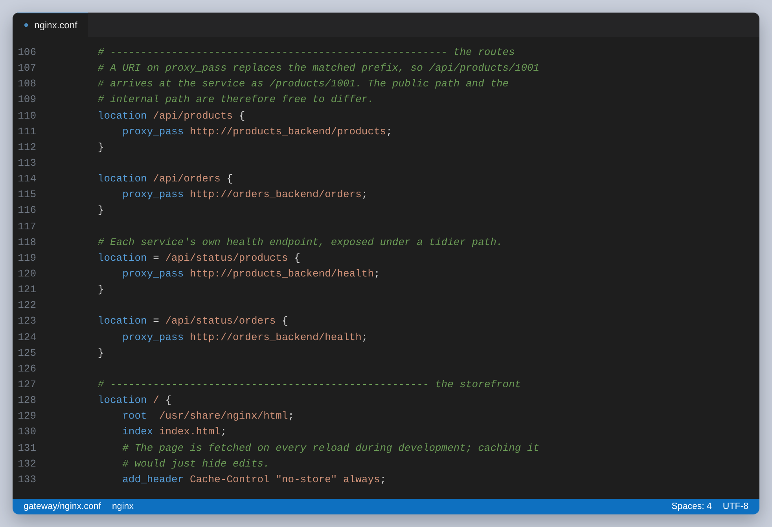
Figure 5: Path-based routing. /api/products/1002 reaches the service as /products/1002
Public route | Goes to | Methods
/api/products | products-service:8000/products | GET
/api/products/{id} | products-service:8000/products/{id} | GET
/api/orders | orders-service:8001/orders | GET, POST
/api/orders/{id} | orders-service:8001/orders/{id} | GET
/api/orders/dependency | orders-service:8001/orders/dependency | GET
/api/status/products | products-service:8000/health | GET
/api/status/orders | orders-service:8001/health | GET
/health | answered by the gateway itself | GET
/ | the storefront, served from disk | GET

The last two rows are why the storefront is worth having. The page and the API sit on one origin, so the JavaScript fetches /api/products as a same-origin request and there is no CORS configuration anywhere in this project. That is a real benefit of a gateway and it is easy to miss, because what it produces is the absence of work.
Finally, a gateway that returns NGINX's default HTML error page is a strange thing for a JSON API to do, so failures NGINX generates itself are shaped into JSON:
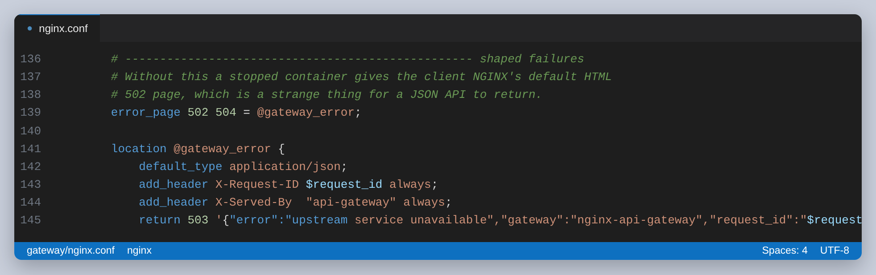
Figure 6: A JSON 503 for failures NGINX produces itself
proxy_intercept_errors is left off, which is the default but worth stating, because it is what lets a 409 or a 503 that a service produced on purpose reach the client exactly as the service wrote it. Only errors NGINX generates get replaced.

Building it, and a check I had to remove
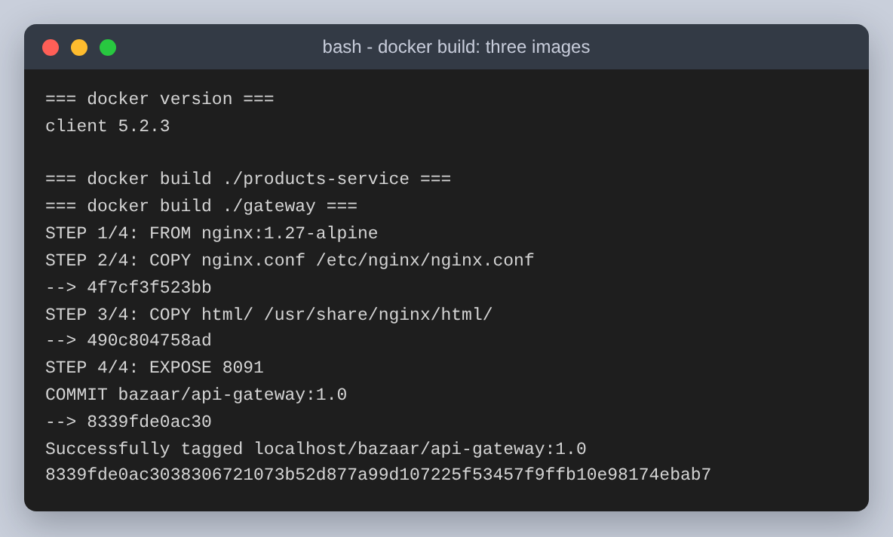
Figure 7: docker build, three images from three Dockerfiles
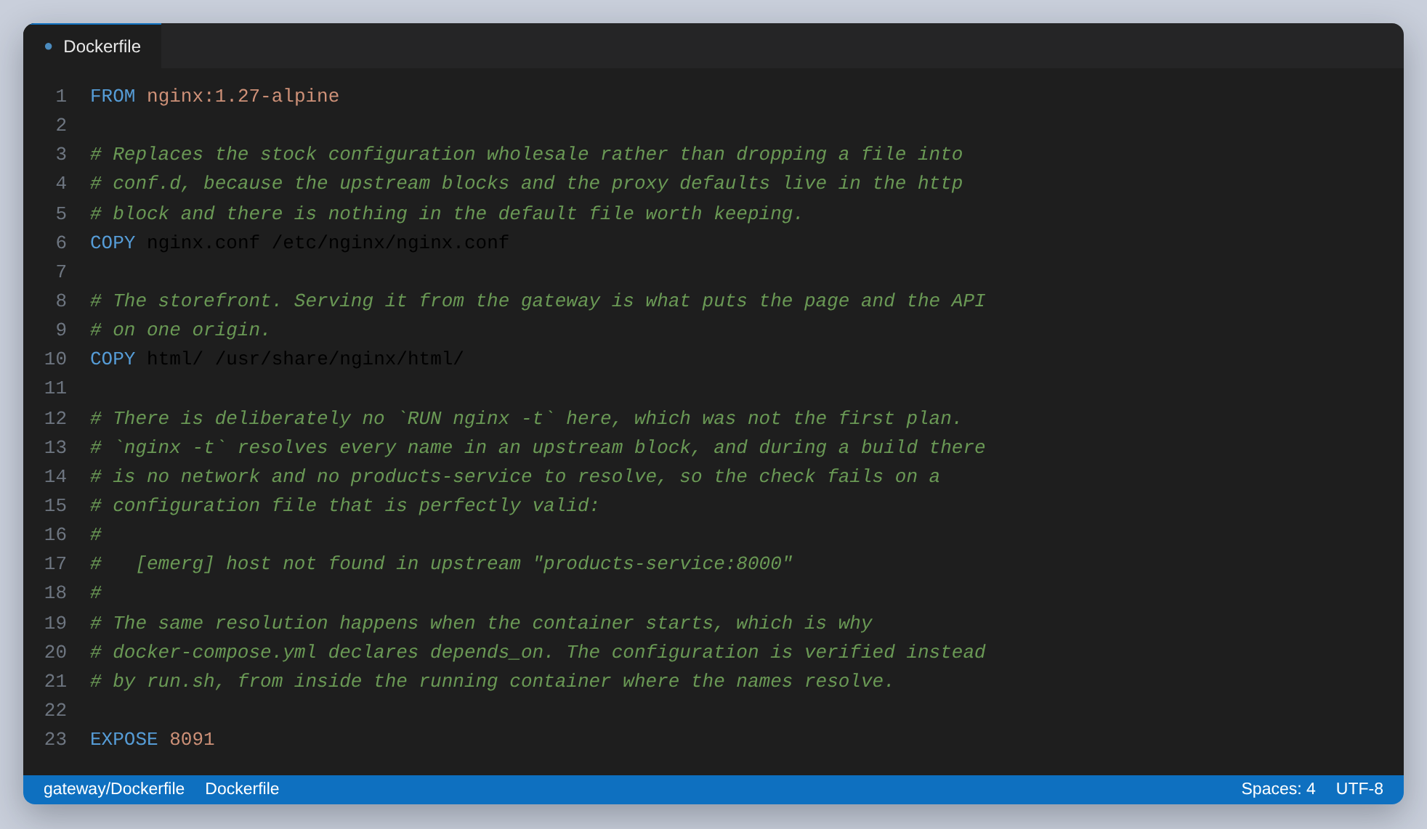
Figure 8: The gateway image, and the comment explaining what is missing from it
What is missing there is a validation step. I had written RUN nginx -t into the Dockerfile, on the reasoning that a bad directive should fail the build rather than produce an image that crash-loops. The build then failed on a file that was completely valid, because nginx -t resolves every name in an upstream block, and during a build there is no network and no products-service to resolve.
Running the same check on the same image twice, with nothing different but whether the names resolve, shows exactly that:
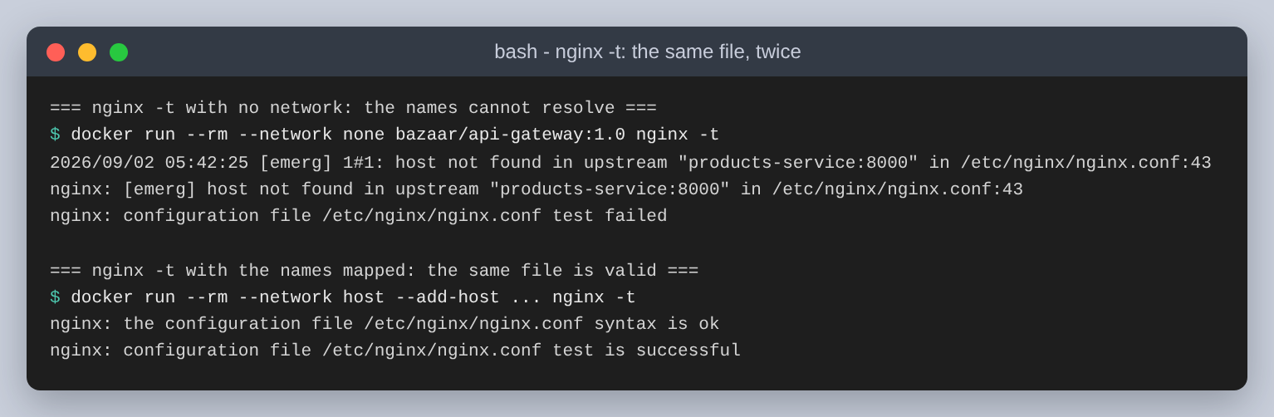
Figure 9: The same image and the same config file. Only name resolution differs
That is worth more than the build-time check I lost. NGINX resolves upstream names once, at startup, which is why the containers must exist before the gateway starts and why compose declares depends_on. It also comes back in the very last test.
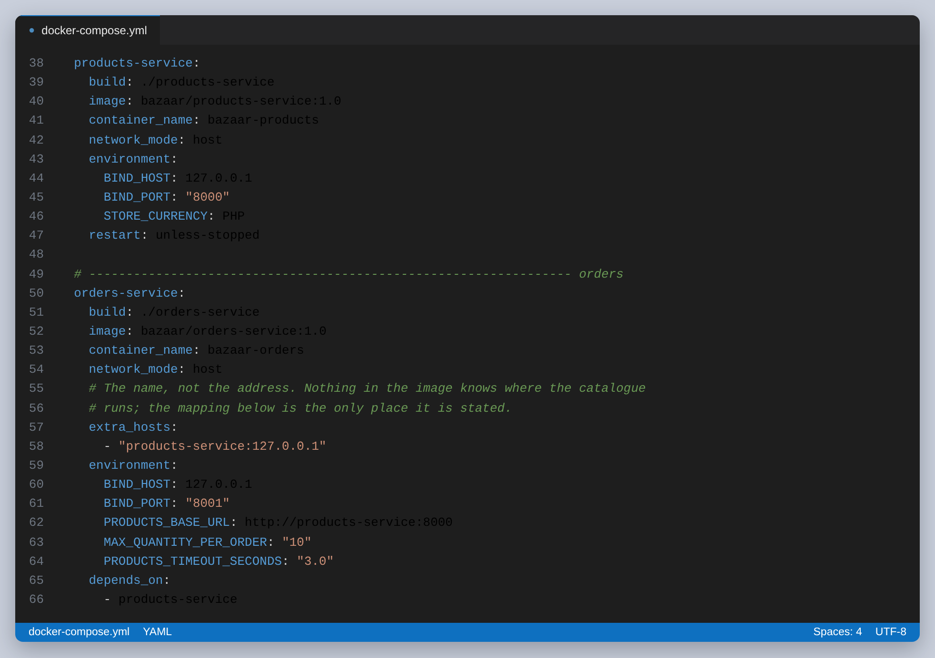
Figure 10: The two services in docker-compose.yml
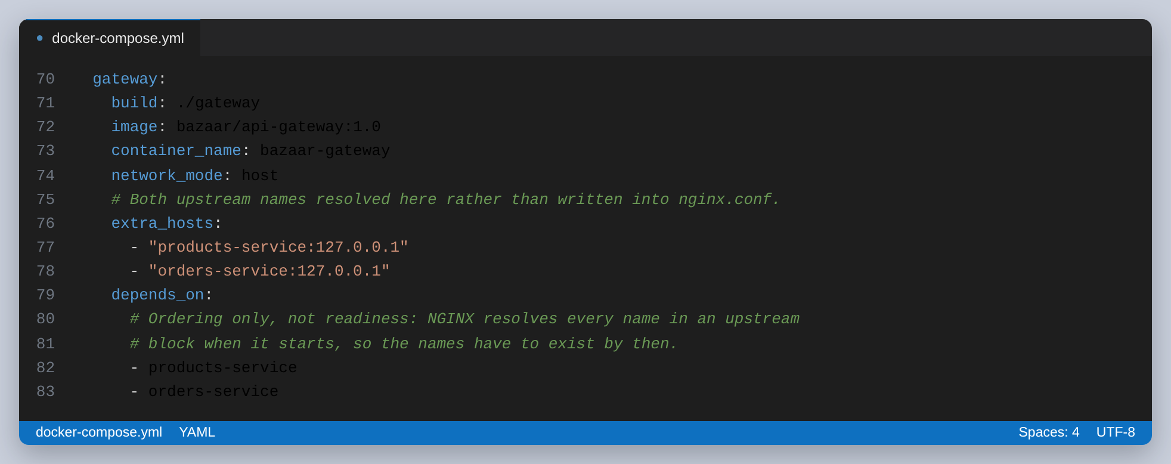
Figure 11: The gateway. The names it needs are mapped here, not written into nginx.conf
With the images built, all three containers come up and the gateway is the only one with a reachable address:
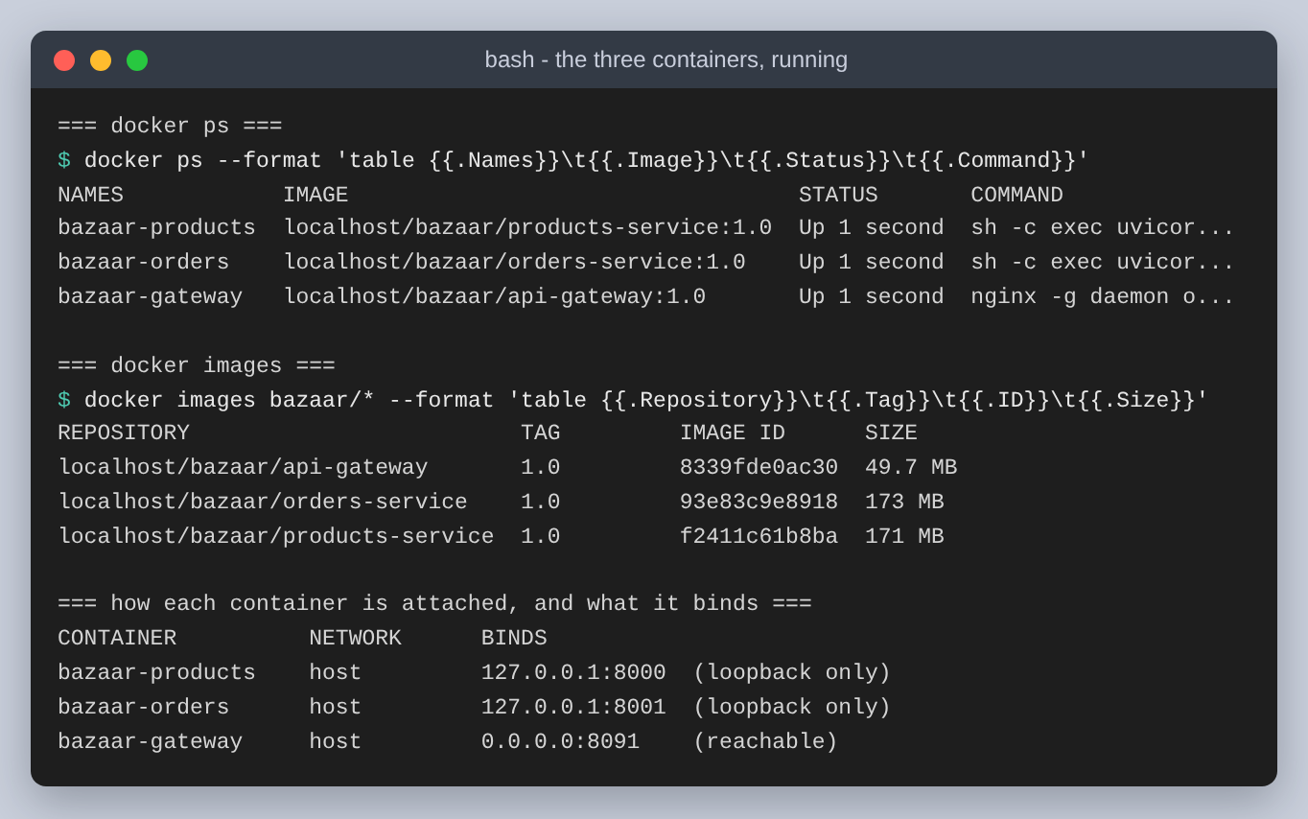
Figure 12: docker ps, the three images, and what each container binds
The gateway answers for itself without touching either service, which is what makes it useful to poll:
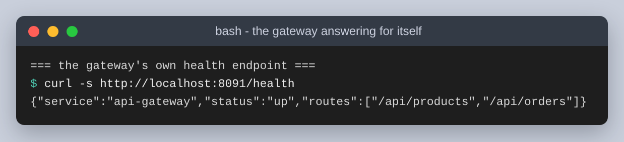
Figure 13: GET /health, answered by NGINX
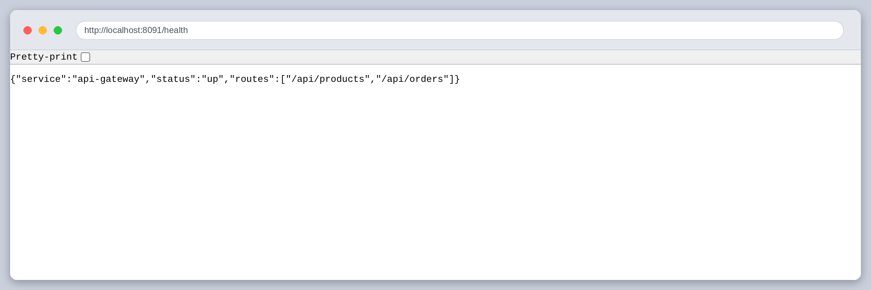
Figure 14: The same endpoint in a browser
And on a proxied route, the two headers the gateway adds come back with the response:
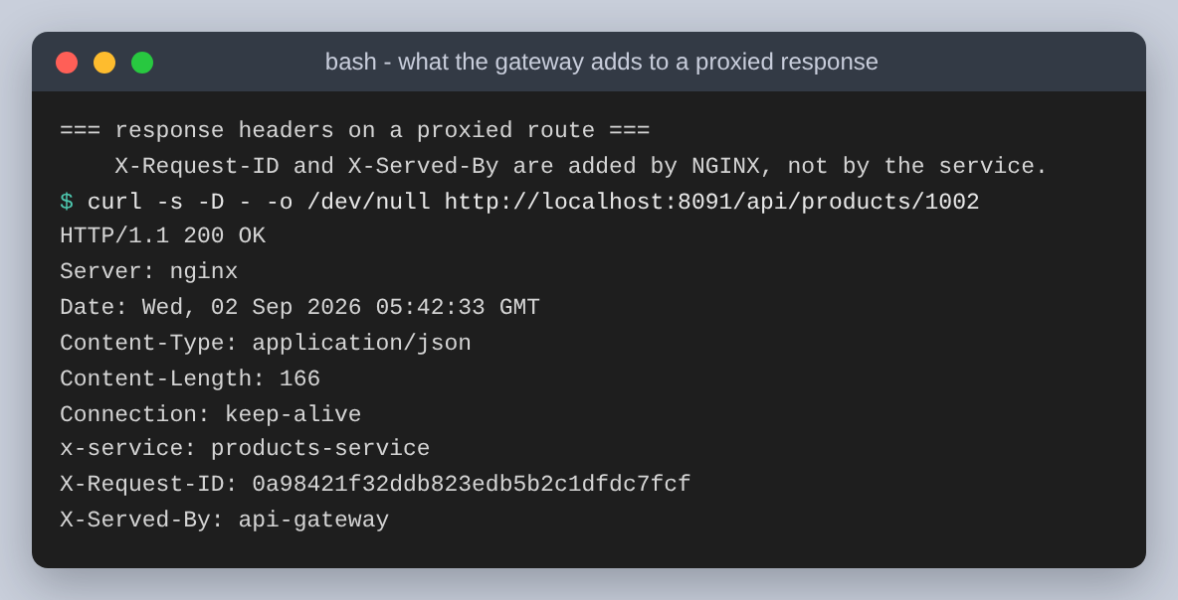
Figure 15: X-Request-ID and X-Served-By are added by the gateway; x-service came from the service
Getting those headers onto every route took two attempts. NGINX does not merge add_header across levels: the moment a location block declares one of its own, every add_header inherited from the server block is dropped. My /health block set Content-Type that way, and /health came back with no X-Request-ID while every proxied route had one. The fix is to set the type with default_type and repeat the two headers inside the block, which is why they appear twice in the file.
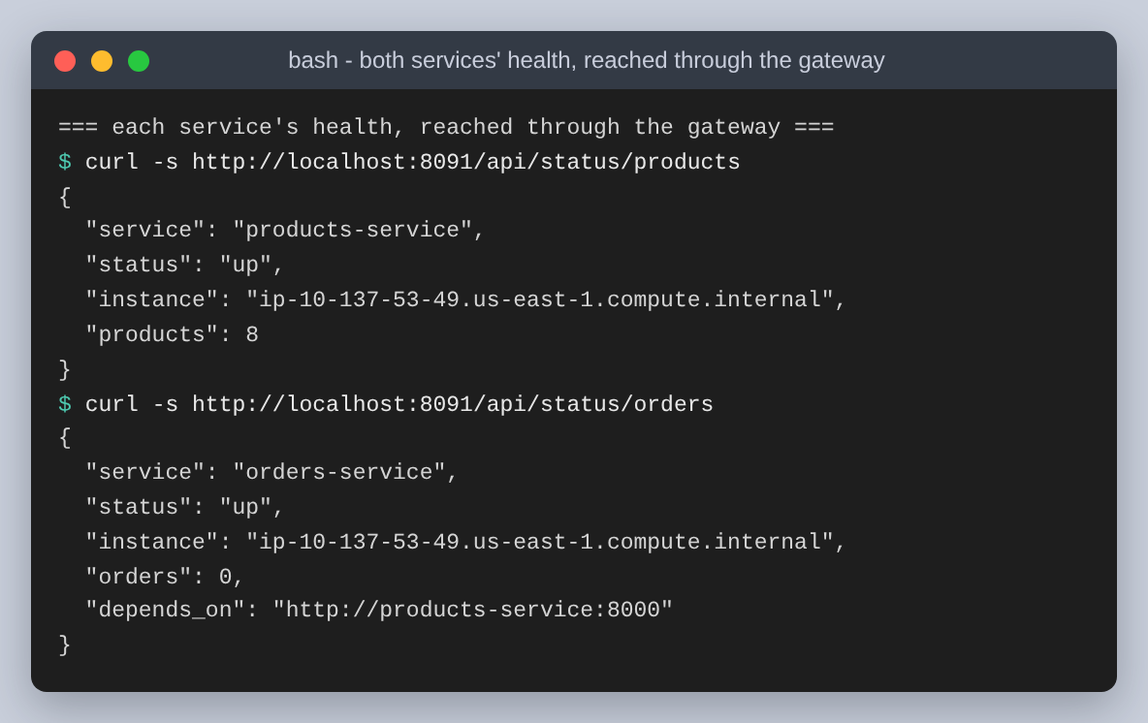
Figure 16: Both services' health, reached through the gateway under a tidier path than they use internally

Task 2: Service communication patterns
There are two directions of traffic here and they are not the same problem.
- North-south: a client to a service, through the gateway. The client knows one address and one set of paths. This is what Task 1 built.
- East-west: the orders service to the products service. No client is involved and no browser is waiting. This call does not go through the gateway at all.
I chose synchronous REST over HTTP for the east-west call rather than a message queue, and the reason is the nature of the work: the orders service cannot write an order until it knows the price. There is nothing to do while it waits, so a queue would add a broker to run and a reply to correlate without removing any waiting. A queue earns its place when the caller does not need the answer to continue, and pricing is the opposite of that.
The internal call also skips the gateway on purpose. Routing sideways traffic through the front door adds a hop to every internal request and makes the gateway a single point of failure for calls no client is waiting on.
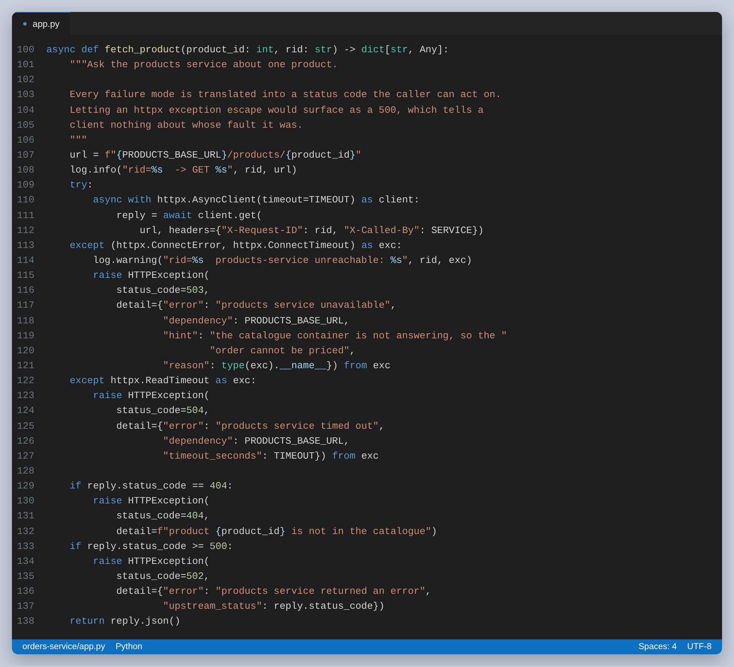
Figure 17: The east-west call. Every failure mode becomes a status code the caller can act on
Most of that function is error translation, and that is the point of it. If an httpx exception were allowed to escape, a stopped catalogue would surface to the customer as a 500, which says only that something broke. Instead a refused connection becomes a 503 naming the dependency, a slow answer becomes a 504 with the timeout that was exceeded, and the catalogue's own 404 is passed along as a 404.
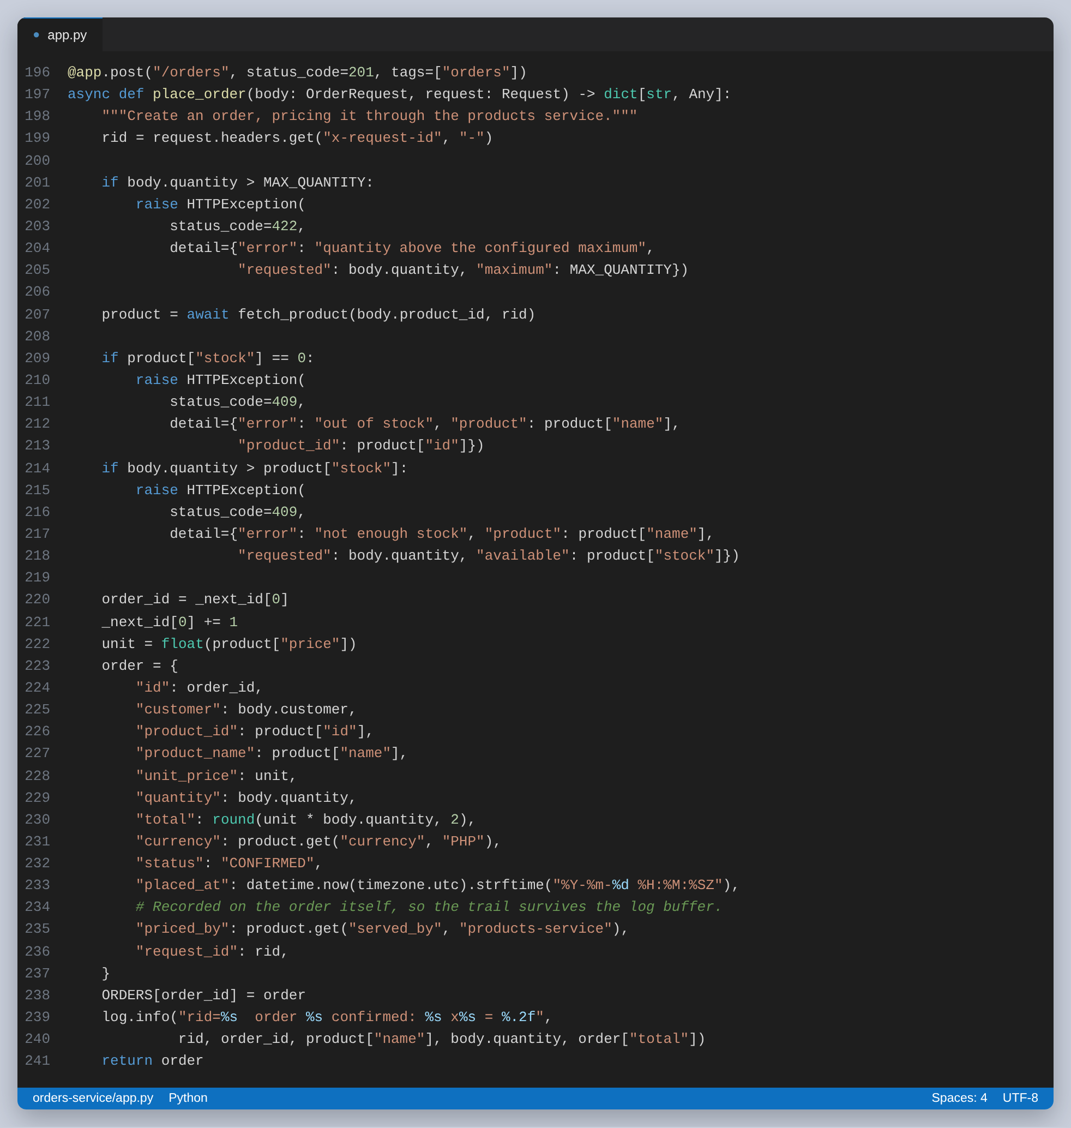
Figure 18: Placing an order: the local rule first, then the call, then the stock checks
The quantity limit is checked before the call, because there is no reason to ask the catalogue about an order that is already invalid. The stock checks have to come after it, because stock is the catalogue's data and the orders service has no copy of it.

Where the address comes from
Nothing in the orders service image knows where the catalogue runs. It reads a name from PRODUCTS_BASE_URL and the name is resolved when the call is made. The service will report what it currently sees:
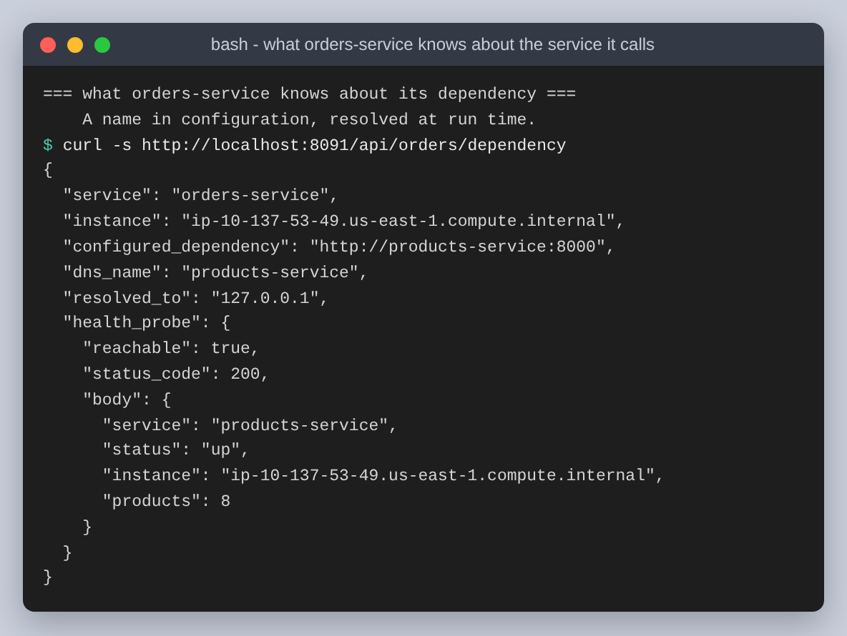
Figure 19: GET /api/orders/dependency, through the gateway
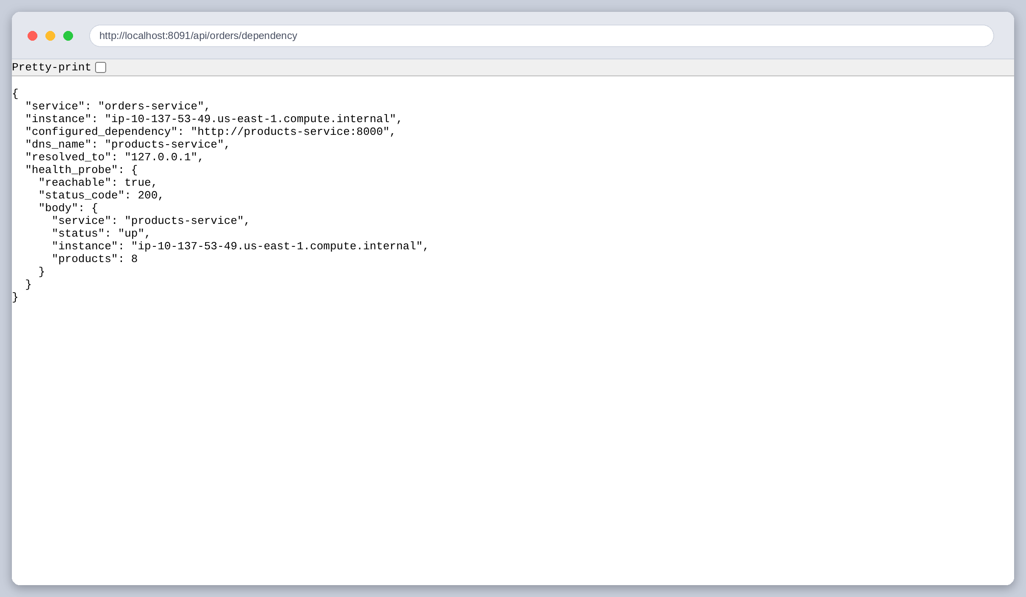
Figure 20: The same view in a browser
The configured value is a name, the address underneath it was resolved at run time, and the health probe was made just now. On the bridge network this was meant to run on, that address would have been the catalogue container's address, resolved by the runtime's DNS. Here it resolves to loopback. The mechanism is the same either way: the code holds a name and the environment supplies the mapping.

An order, end to end
A POST to /api/orders goes through both patterns in one request. The gateway routes it north-south to the orders service; the orders service calls the catalogue east-west to price it; the order comes back with a total the orders service never had the data to compute on its own.
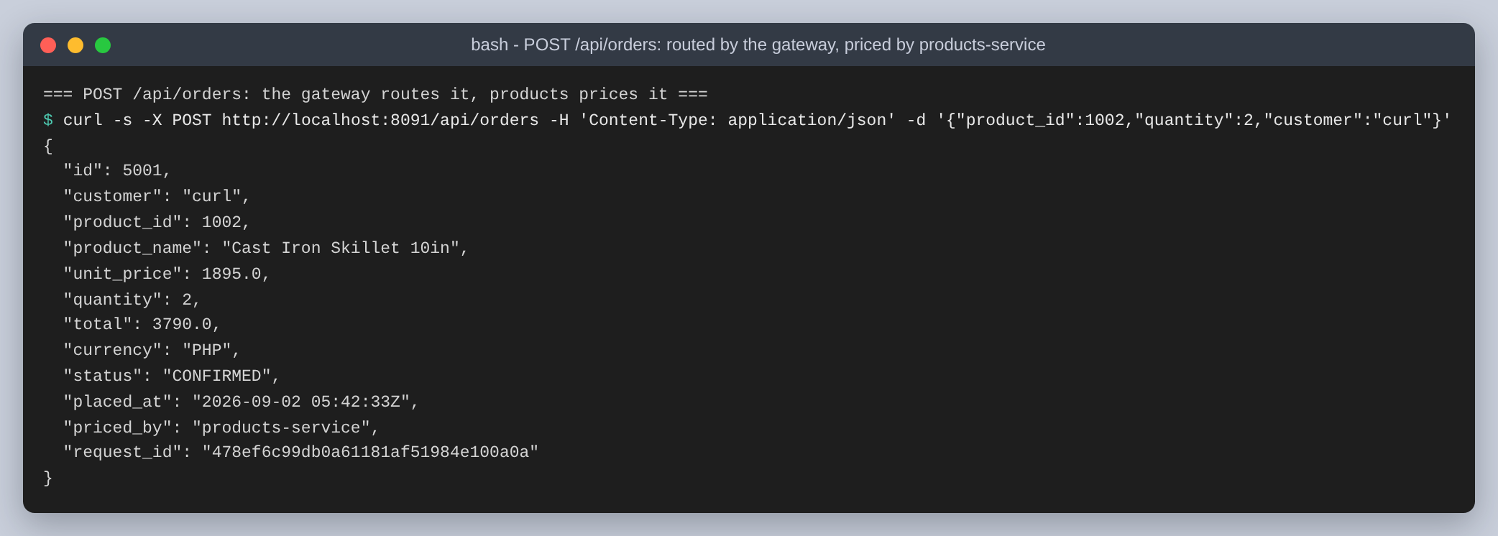
Figure 21: One POST /api/orders. unit_price and priced_by both came from the other service

Following one request through three containers
This is the part I would keep if I had to throw the rest away. The gateway stamps every incoming request with an X-Request-ID. The orders service logs it and forwards it on its own outbound call. The products service logs it again, with who called. So one customer request leaves the same identifier in three separate container logs, and grep is enough to reconstruct the whole path.
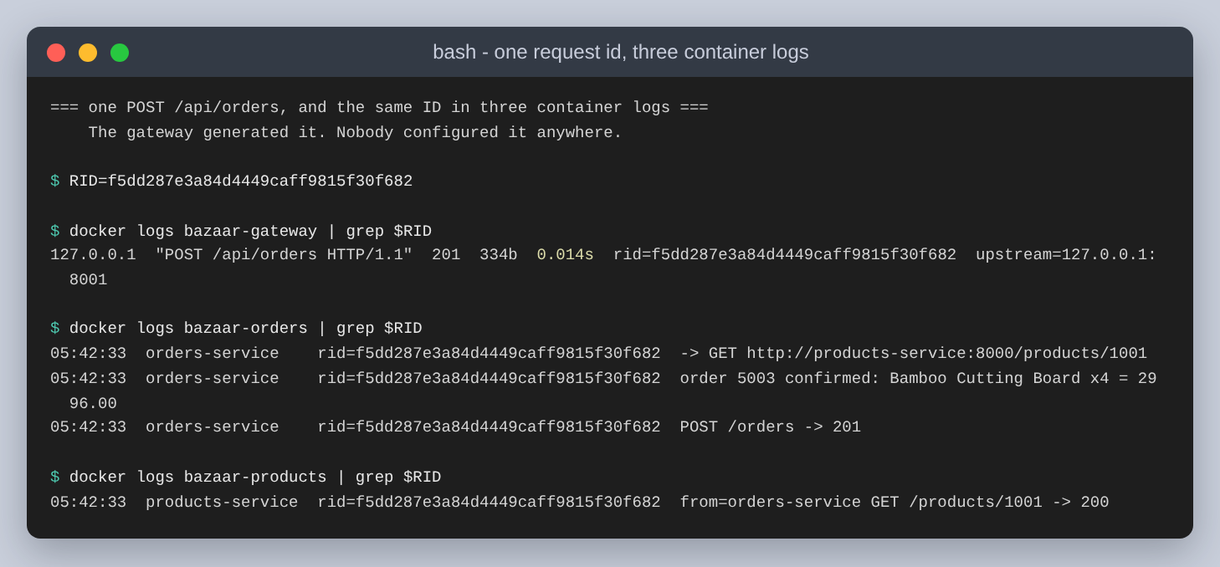
Figure 22: One POST /api/orders. The id f5dd287e3a84 appears in all three logs
Read top to bottom that is the entire journey of one request: NGINX accepted it and sent it to 127.0.0.1:8001, the orders service asked products-service for a price on product 1001, the catalogue answered 200 and recorded that the caller was orders-service, and the order was confirmed. Nobody configured the identifier. NGINX generated it, and the only reason it travels is one proxy_set_header line plus the header the orders service copies onto its outbound call.
It is also stored on the order, so a support question about one order can be turned back into the log lines that produced it:
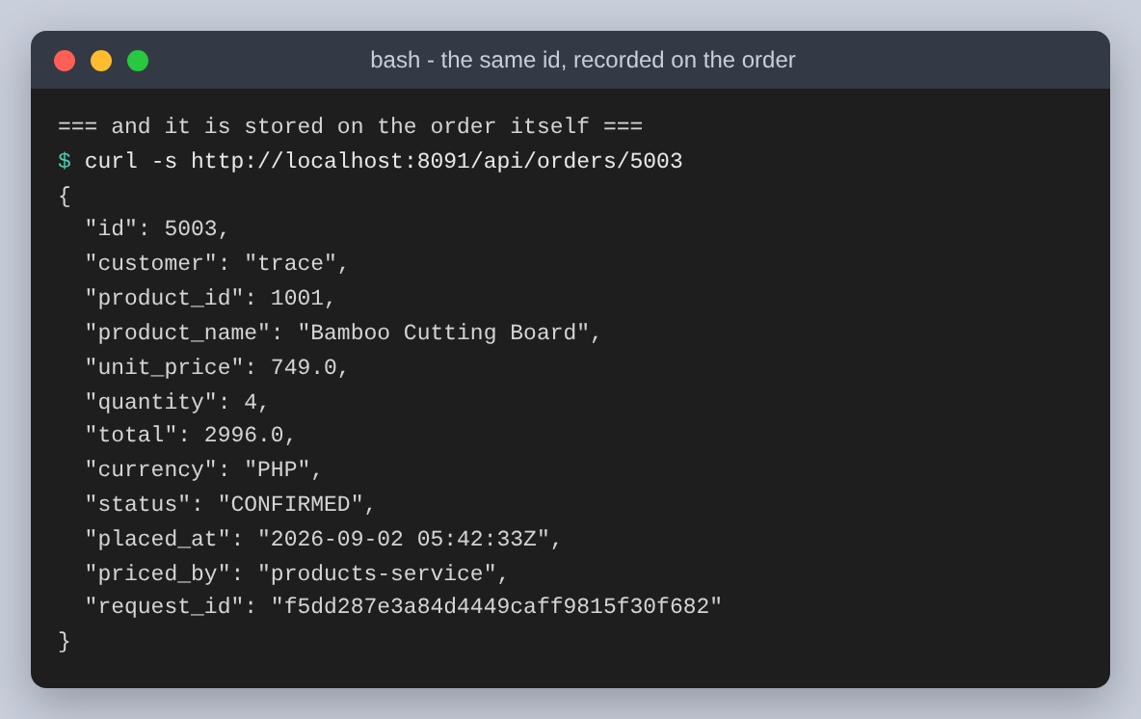
Figure 23: The same id, recorded on the order
The gateway's access log is worth a look on its own, because $upstream_addr records which container actually served each request. That is the difference between believing the routing works and being able to show it.
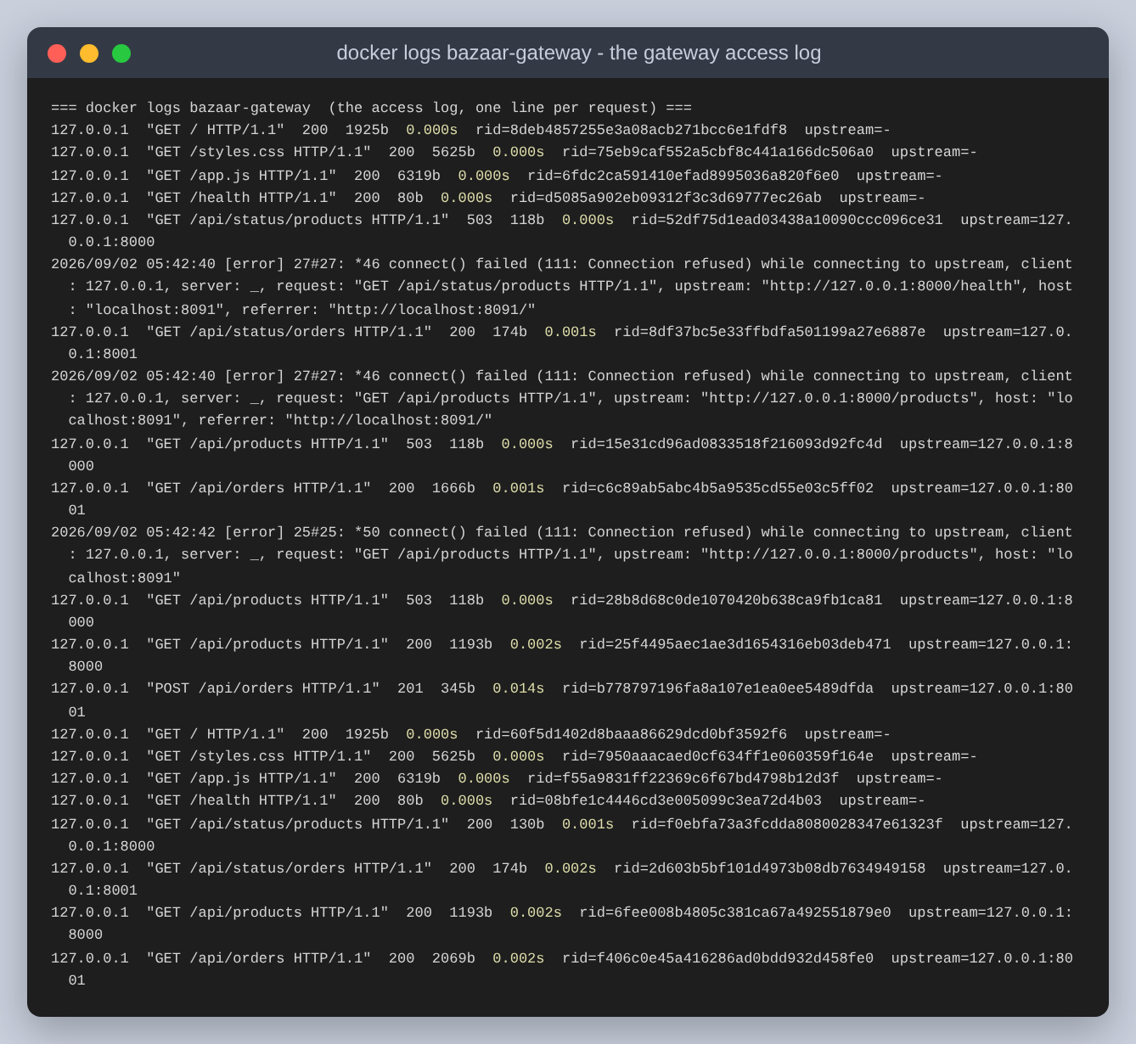
Figure 24: The gateway access log. The upstream column shows :8000 or :8001 per request
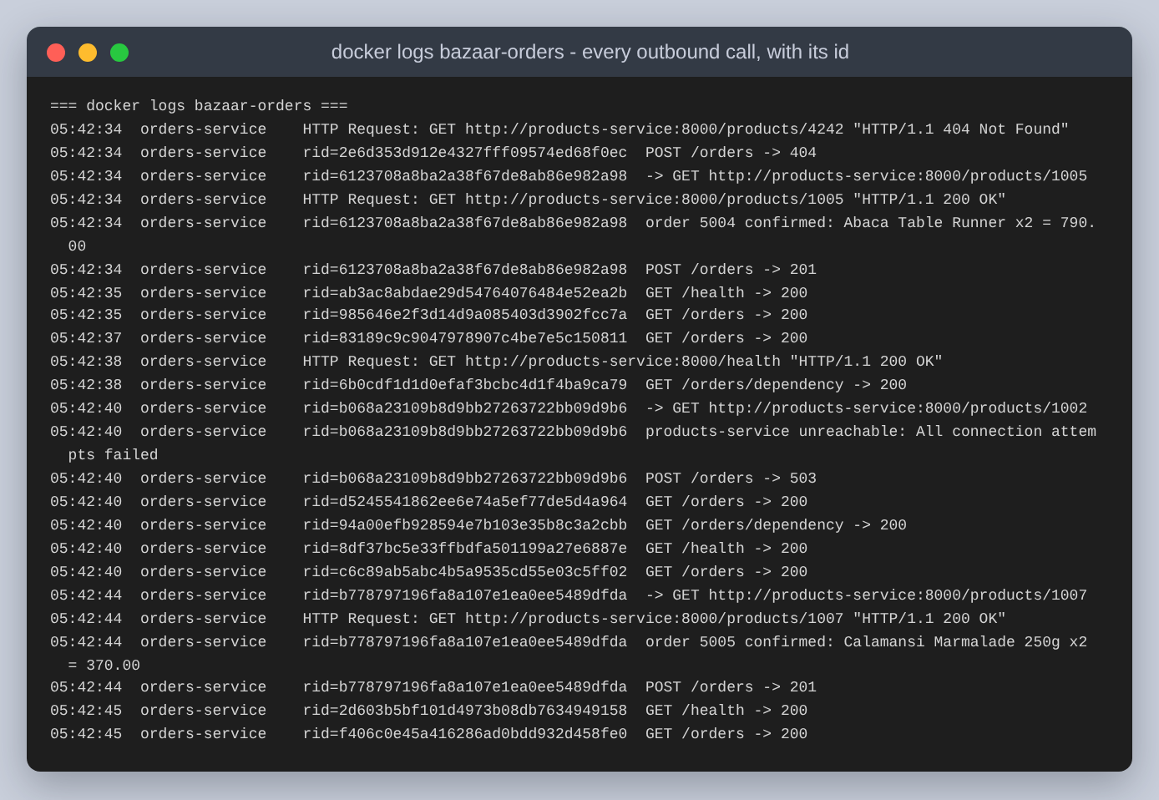
Figure 25: The orders service log. Every outbound call is logged before it is made
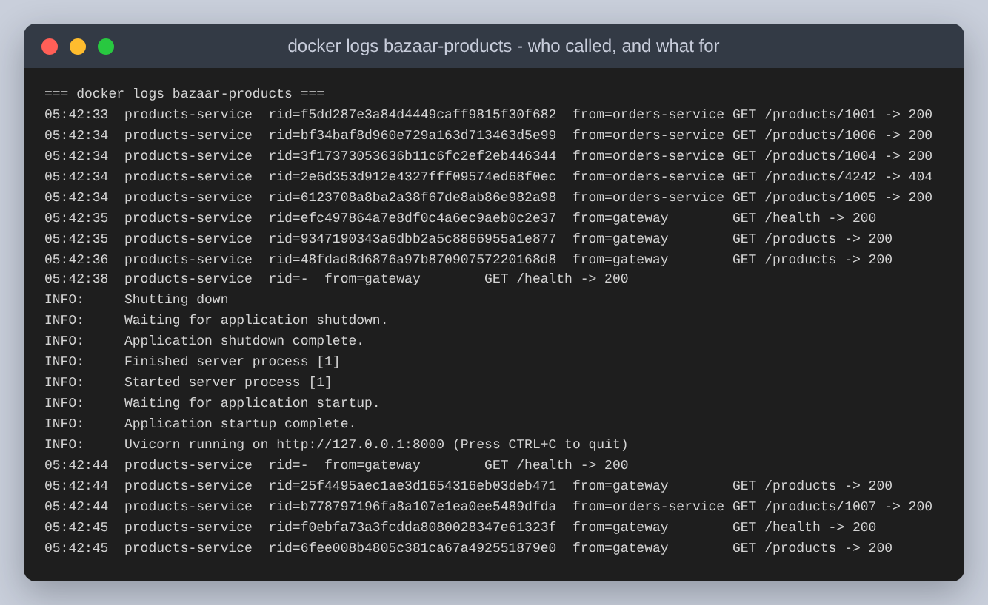
Figure 26: The catalogue log. from= distinguishes the gateway from the orders service

Task 3: Testing the gateway and the service communication
I tested with curl for the API and a real browser for the storefront. All of it goes through http://localhost:8091, and no test addresses a service directly apart from one comparison where that is the point.

Routing
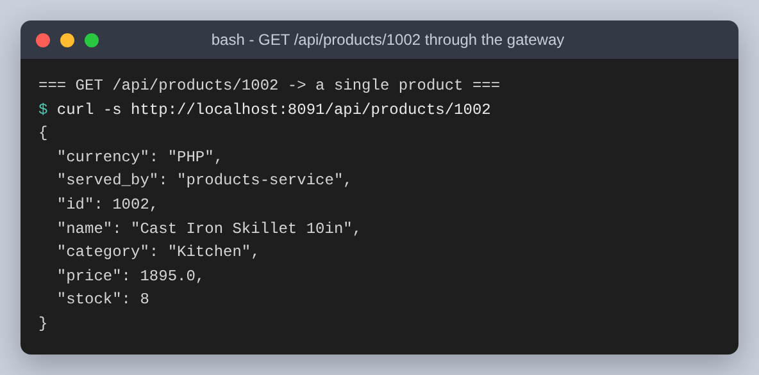
Figure 27: GET /api/products/1002. served_by names the service that answered
The same product fetched twice, once through the gateway and once straight at the service on loopback: 2.0 ms through the gateway against 1.7 ms direct.
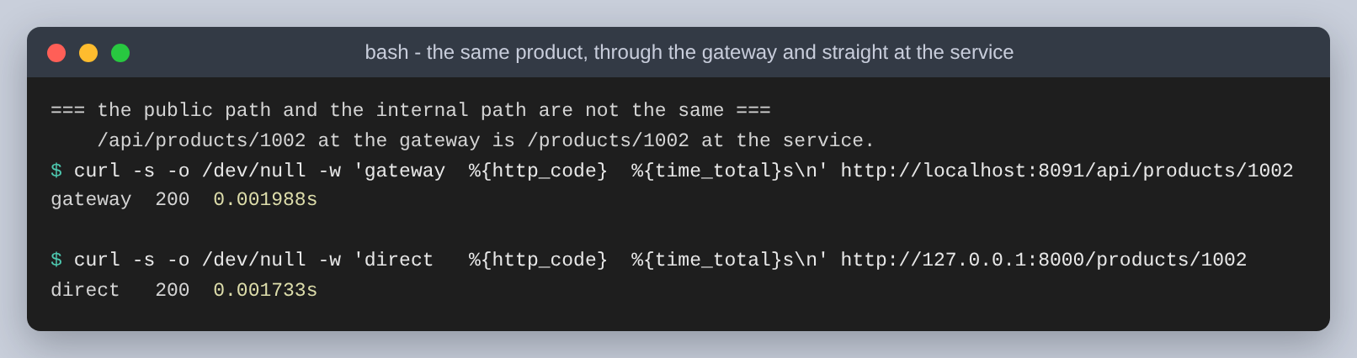
Figure 28: The extra hop, measured
The gateway came out marginally faster, which is not a real result. Both numbers are around a millisecond and a millisecond is mostly noise on loopback; run it again and they swap. What it does establish is that the extra hop costs nothing measurable at this scale, which is the useful half of the question.
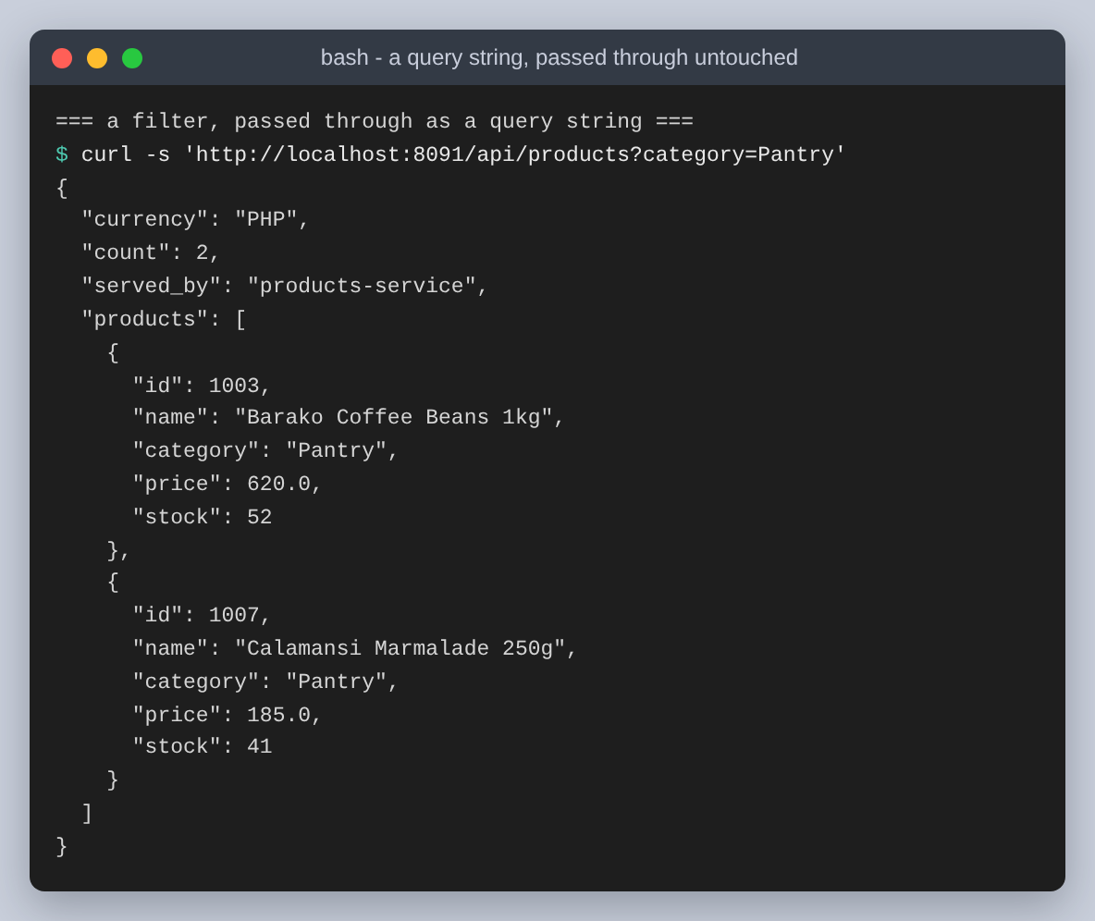
Figure 29: A query string, passed through untouched, so filtering stays the service's job
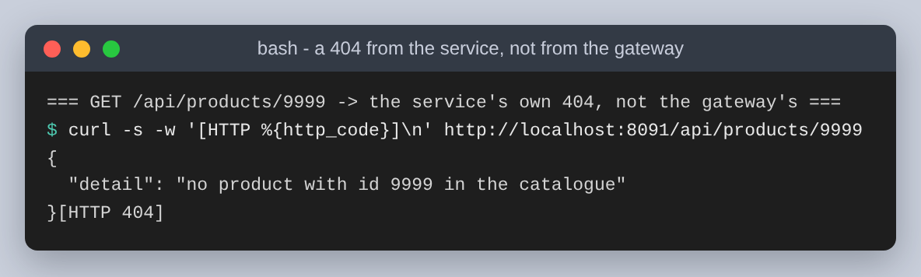
Figure 30: An id that is not in the catalogue gives the service's own 404, not a generic gateway error

The refusals
Four requests that should not succeed. The interesting thing is not that they fail but that each fails at the layer that owns the rule, with a status code that says which:
Request | Status | Refused by | Why
1006, qty 1 | 409 | orders-service | Stock is zero. Needs the catalogue's answer first.
1004, qty 5 | 409 | orders-service | Only three in stock. Also needs the catalogue.
1003, qty 25 | 422 | orders-service | Over the configured maximum of 10. No call is made.
4242, qty 1 | 404 | products-service | No such product. The 404 travels back through two hops.

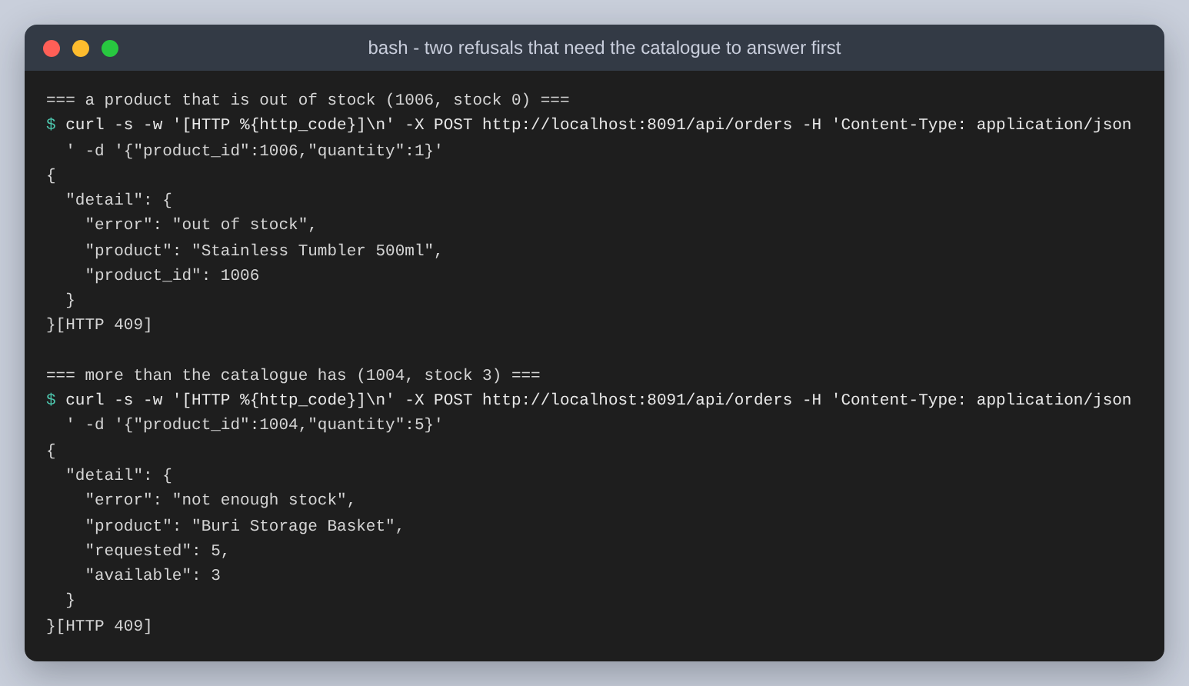
Figure 31: Two refusals that both required the catalogue to answer first
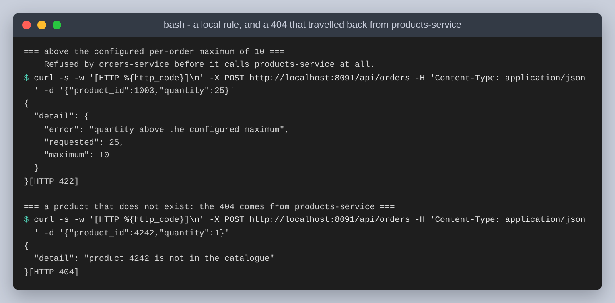
Figure 32: A purely local rule, and a 404 that travelled back from the other service
The 422 shows the boundary clearly. The quantity limit is the orders service's own configuration, so it refuses without ever contacting the catalogue, and the products service log has no line for that request.

The storefront
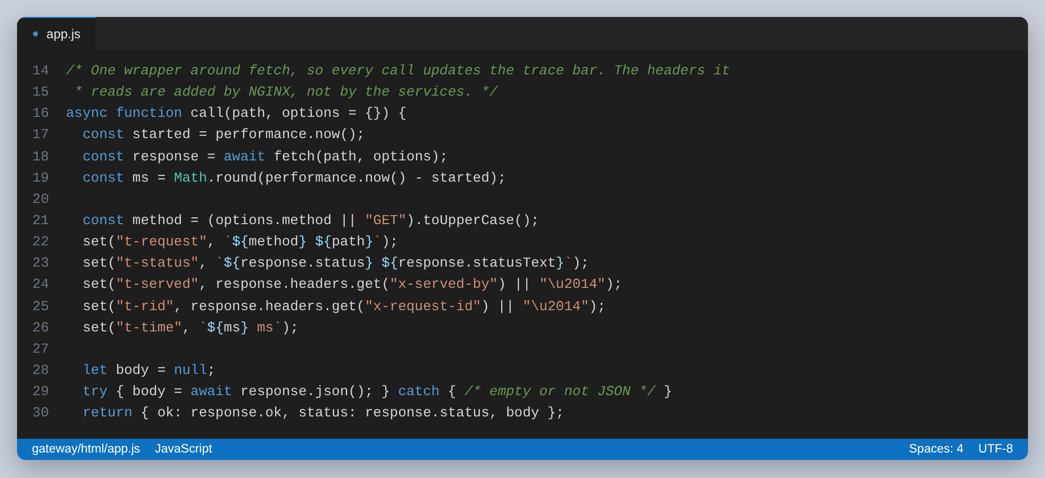
Figure 33: The only place the storefront talks to the API. Every path is relative
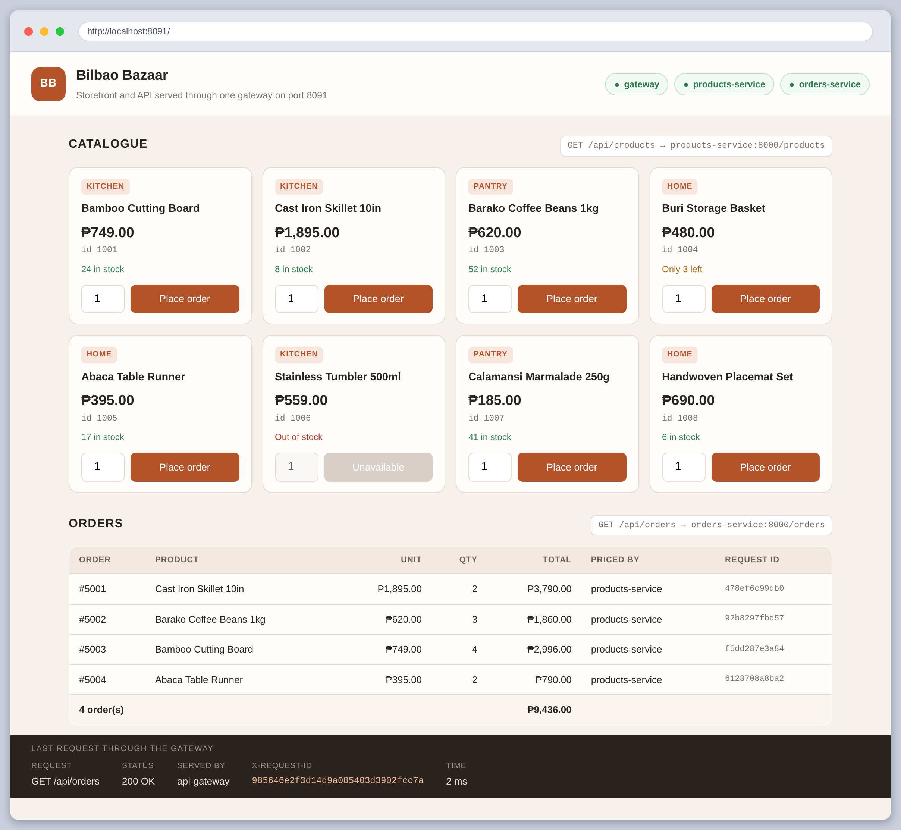
Figure 34: The storefront in Chromium. Eight products from products-service, orders from orders-service, and the gateway's own headers along the bottom
Everything on that page arrived through the gateway. The three pills top right are live polls of /health, /api/status/products and /api/status/orders. The catalogue is a GET /api/products. Each Place order button is a POST /api/orders, so every row in the orders table is a service-to-service call that has already happened: the priced by column names products-service, and the 5650.0 peso total was computed from prices the orders service had to ask for.
Product 1006 is the one to look at. It shows Out of stock with its button disabled, and the storefront was not told which product that is. It renders whatever stock the catalogue reports.
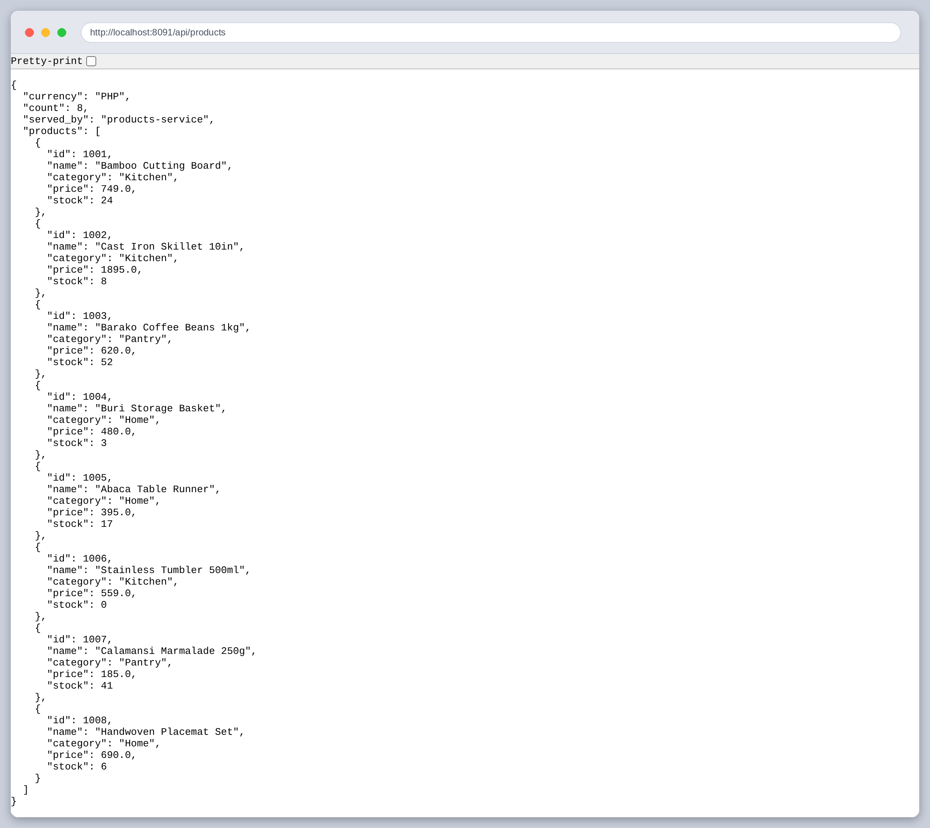
Figure 35: GET /api/products in the browser, through the gateway
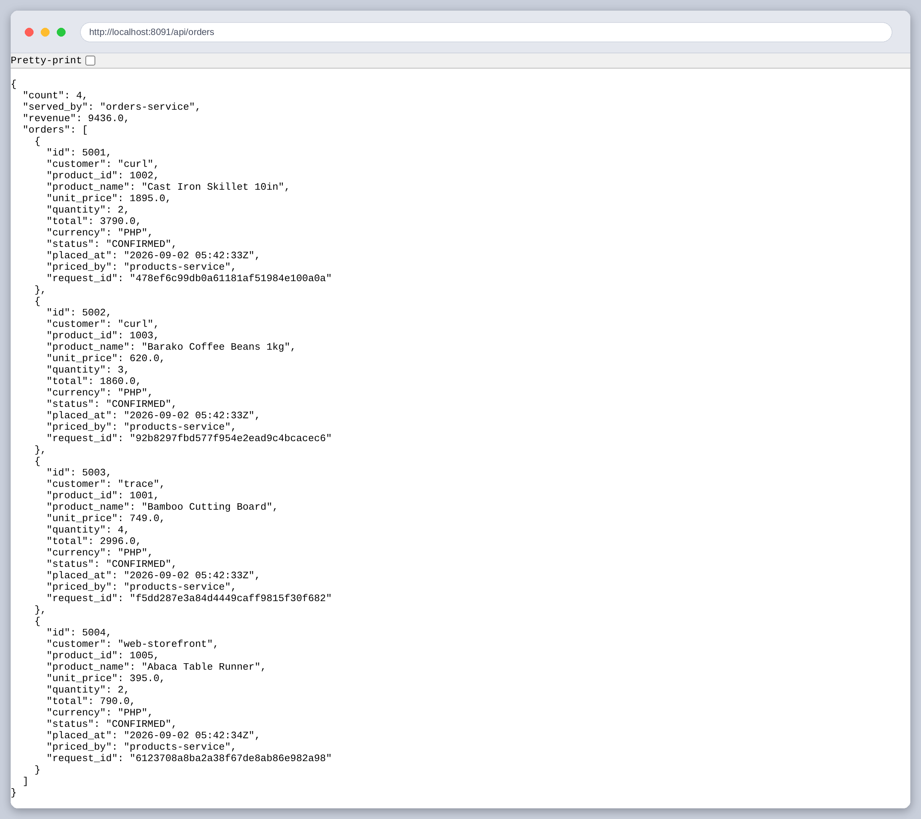
Figure 36: GET /api/orders. Every order carries the id of the request that created it

Is the gateway really the only way in?
The claim that the services are unreachable is easy to assert and easy to get wrong, so it is tested rather than stated. The same three ports are dialled twice: once on loopback and once on 169.254.255.194, the address another machine would use to reach this one.
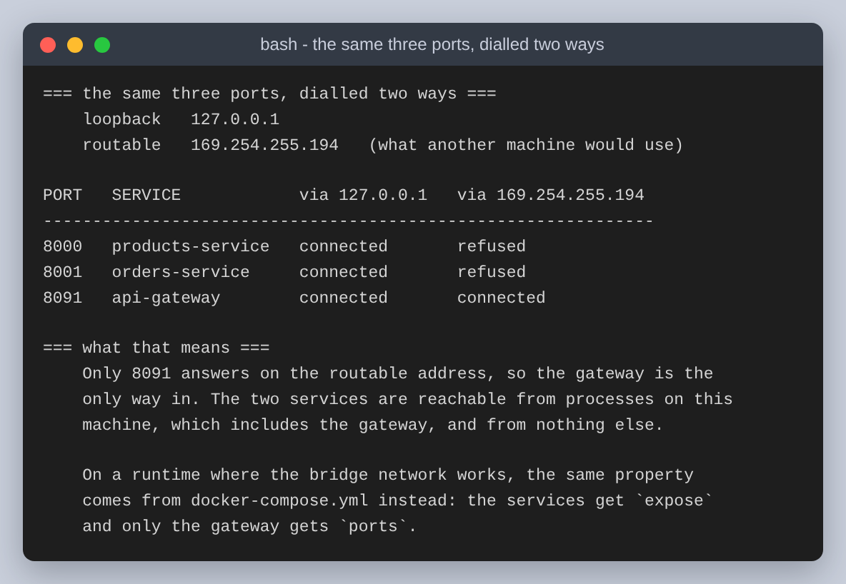
Figure 37: The same three ports, dialled two ways
Only 8091 answers on the routable address. The two services accept connections from processes on this machine, which includes the gateway, and refuse everything else. On a runtime where the bridge network works the same property comes from the compose file instead, with expose on the services and ports on the gateway only.

What happens when a service dies
The last test says the most about the design. I stopped the catalogue container and left everything else running.
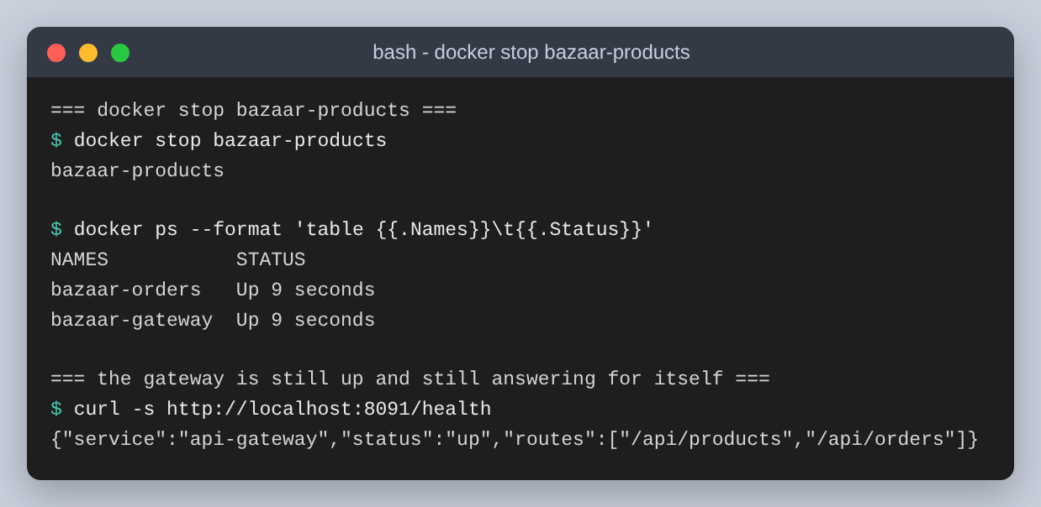
Figure 38: docker stop bazaar-products. Two containers left, and the gateway still answering for itself
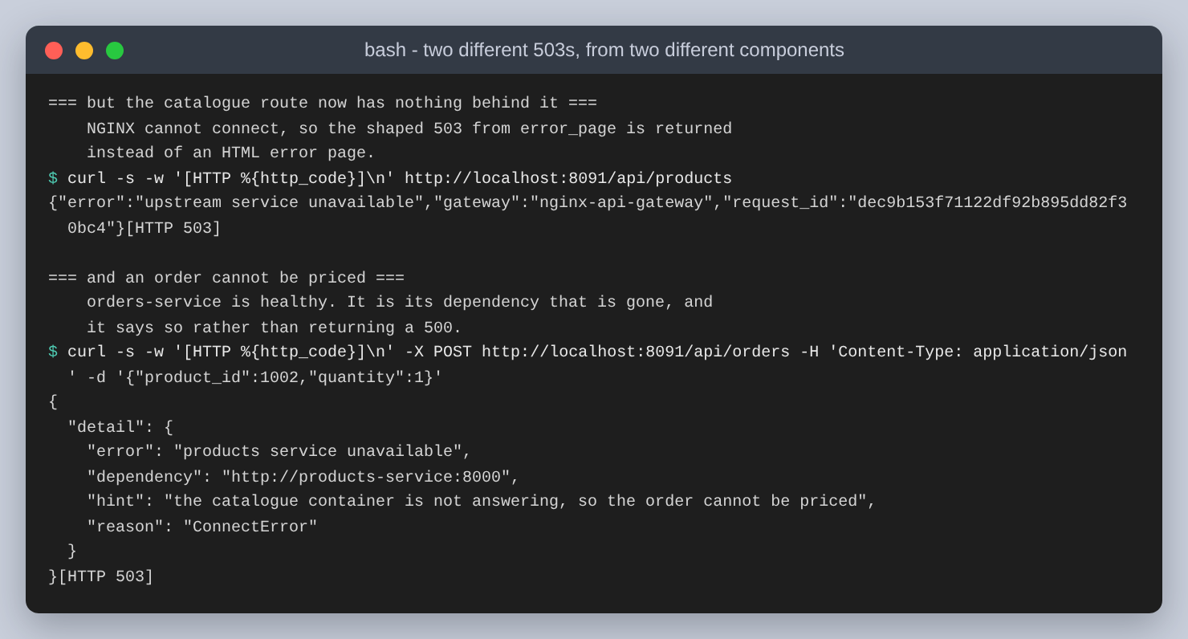
Figure 39: One 503 from NGINX, one from the orders service
Those two 503s are not the same 503. The first is the gateway's: NGINX could not connect to an upstream at all, so error_page produced the shaped JSON from Task 1 instead of an HTML page. The second is the orders service's own, and it is the more useful message, because the orders service is perfectly healthy and it says which dependency is missing, at which address, and why that stops it pricing an order. From those two responses a caller can tell that the catalogue is the problem and the order pipeline is not.
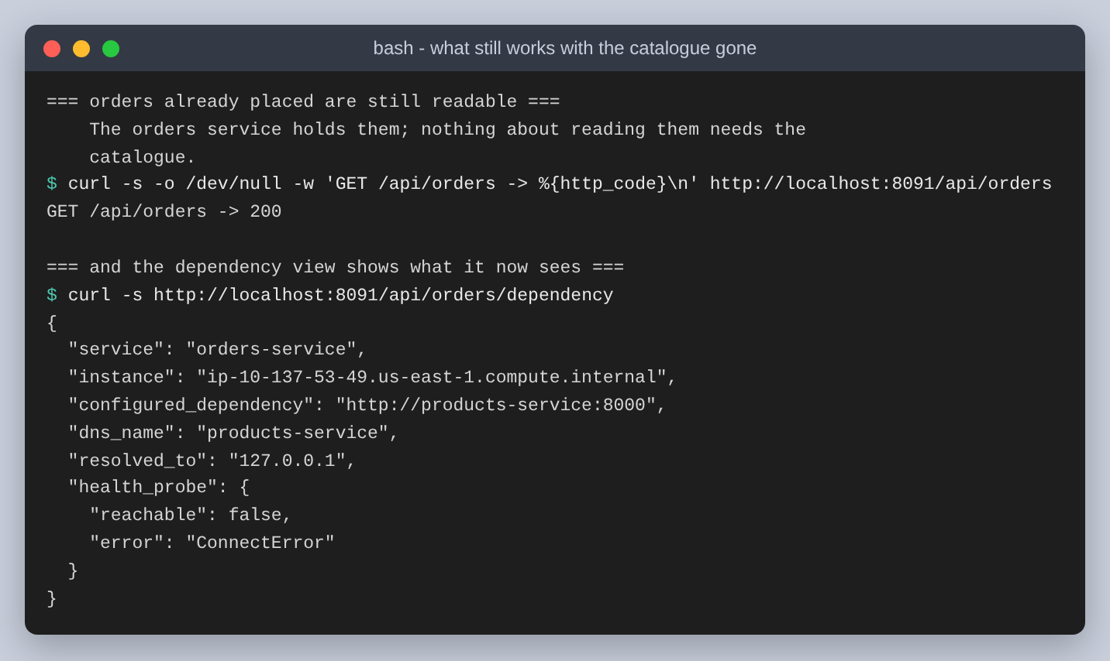
Figure 40: Orders already placed are still readable, and the dependency probe reports what it now sees
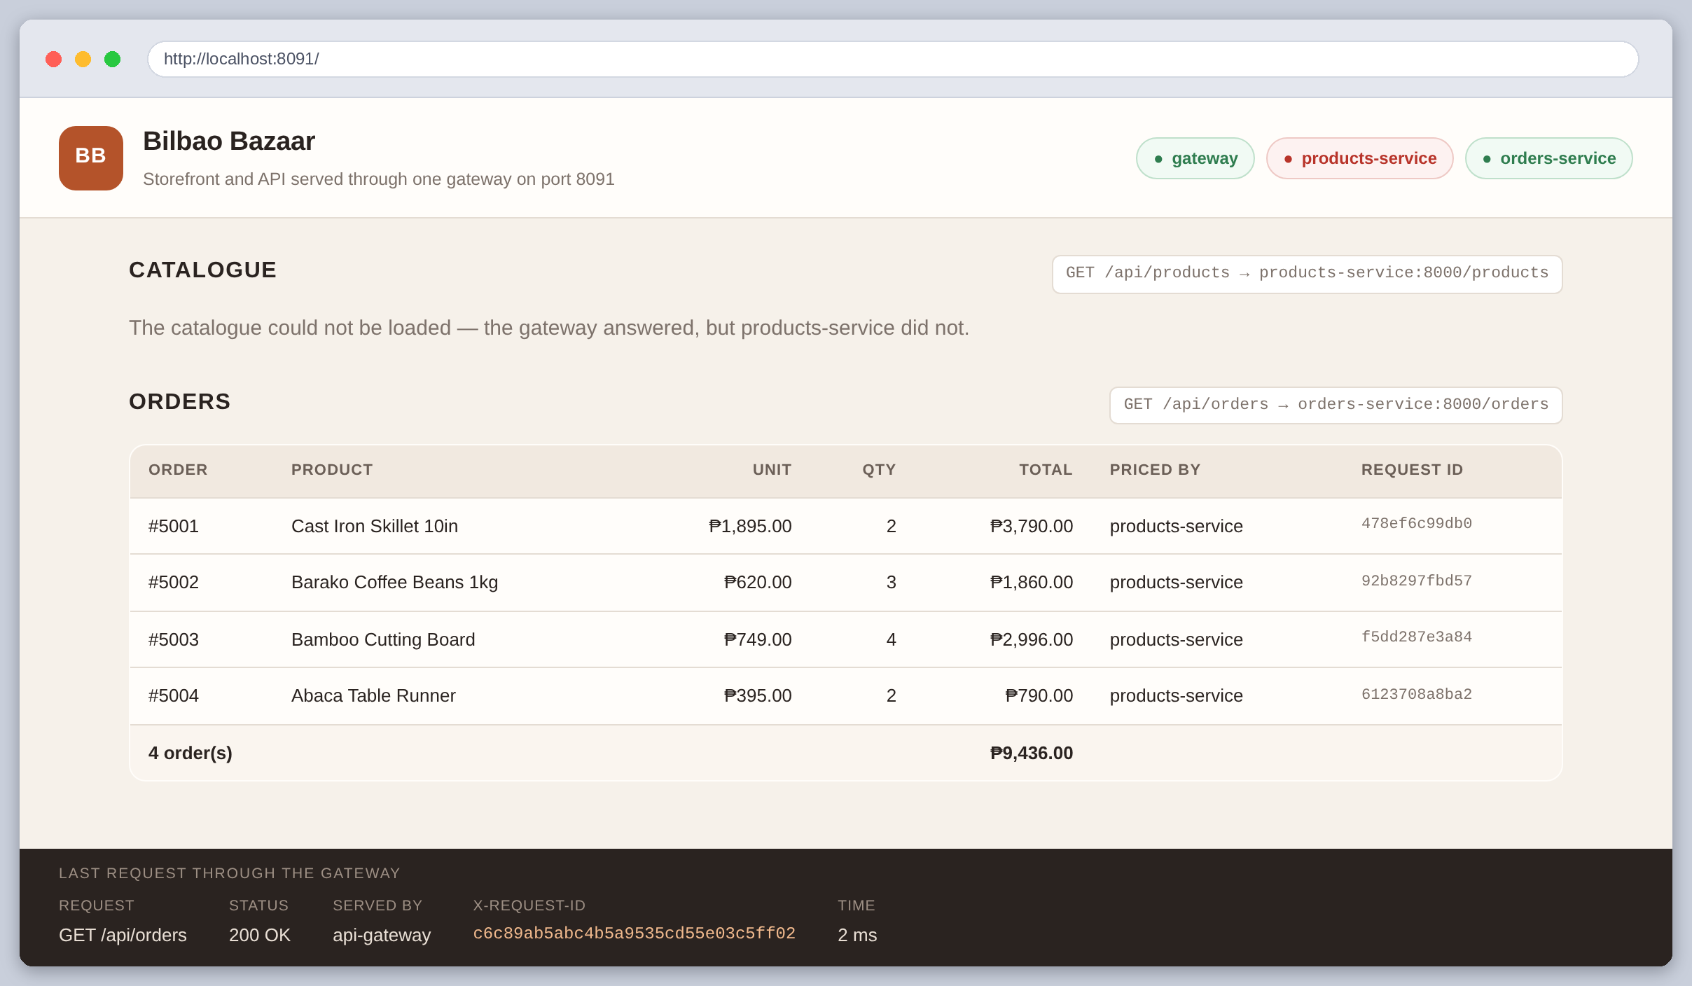
Figure 41: The same page with the catalogue container stopped. The products-service pill has gone red, the catalogue is a message, and the orders table is still there
That screenshot is the clearest thing in this document. The page is not broken, it is partly available, and it is obvious from looking at it which service is down.
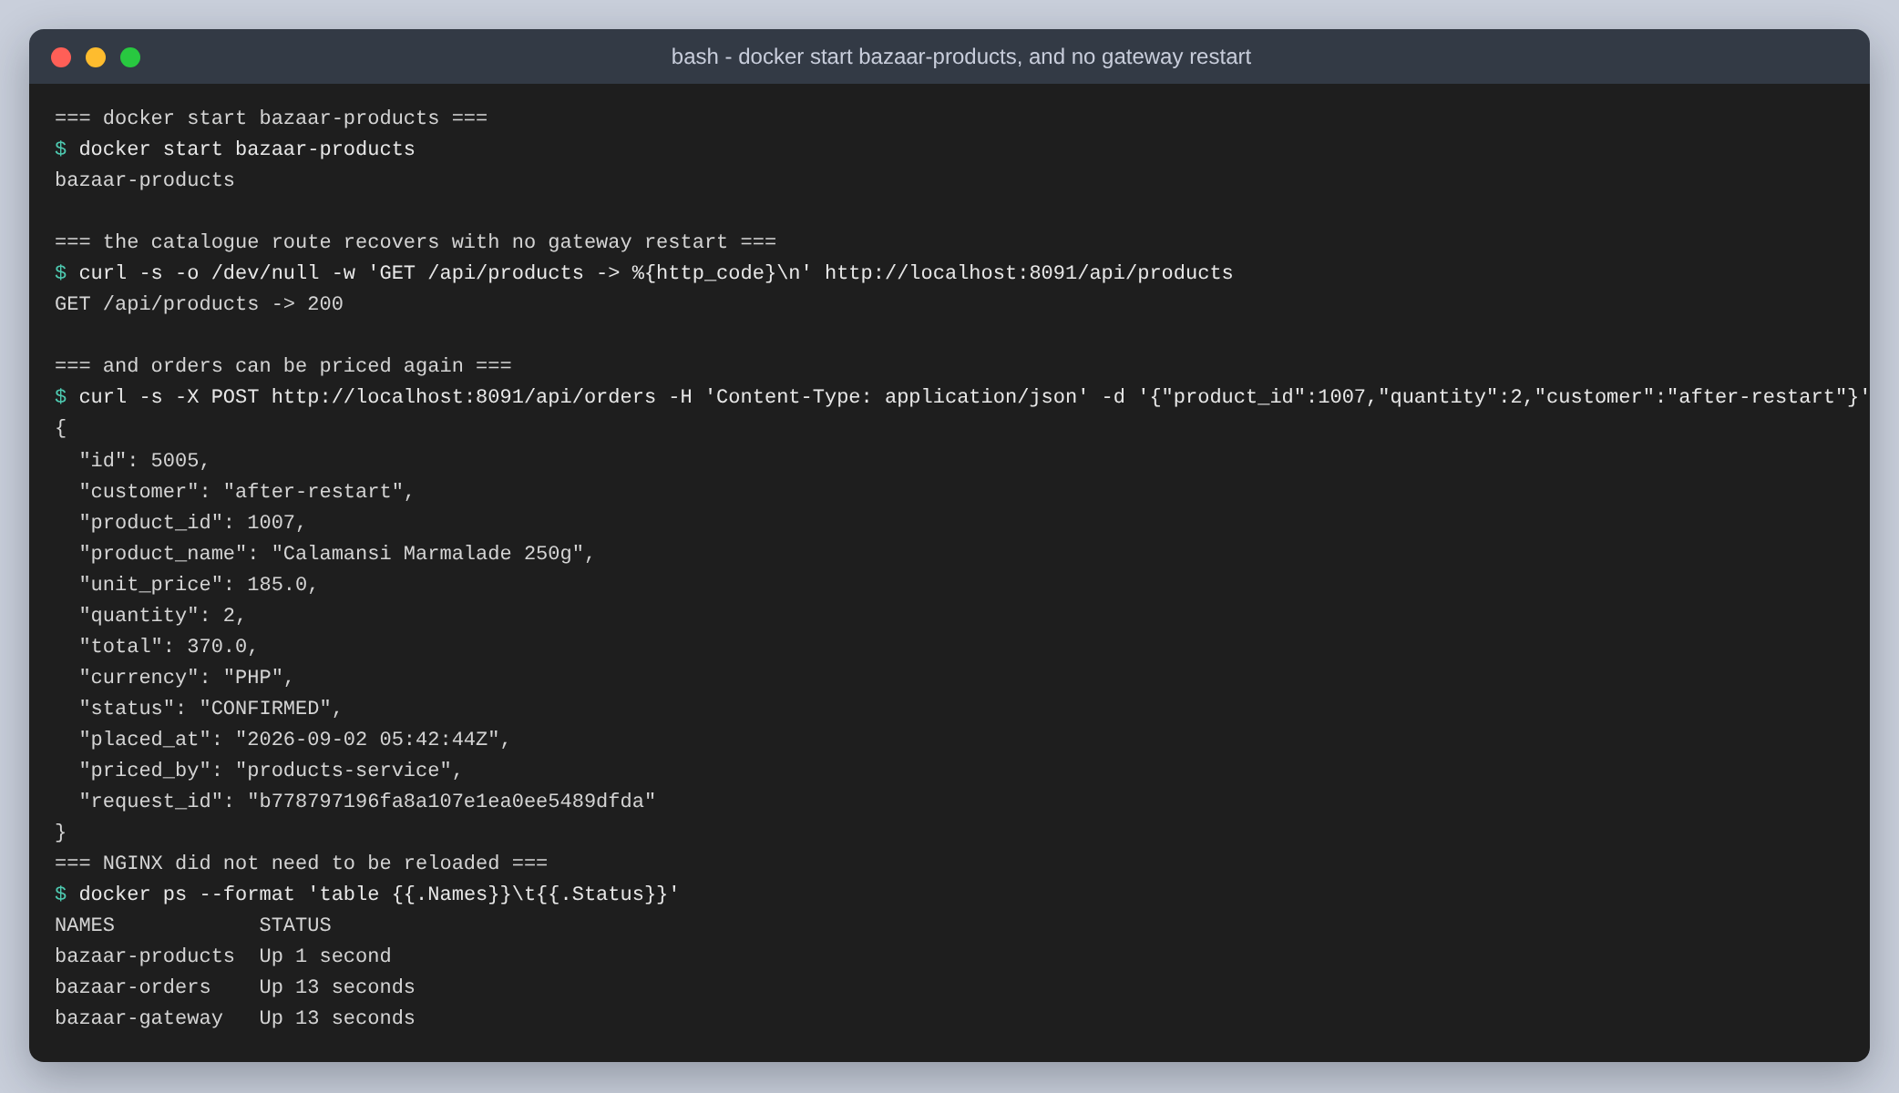
Figure 42: docker start, and the catalogue route recovering with no gateway restart and no reload
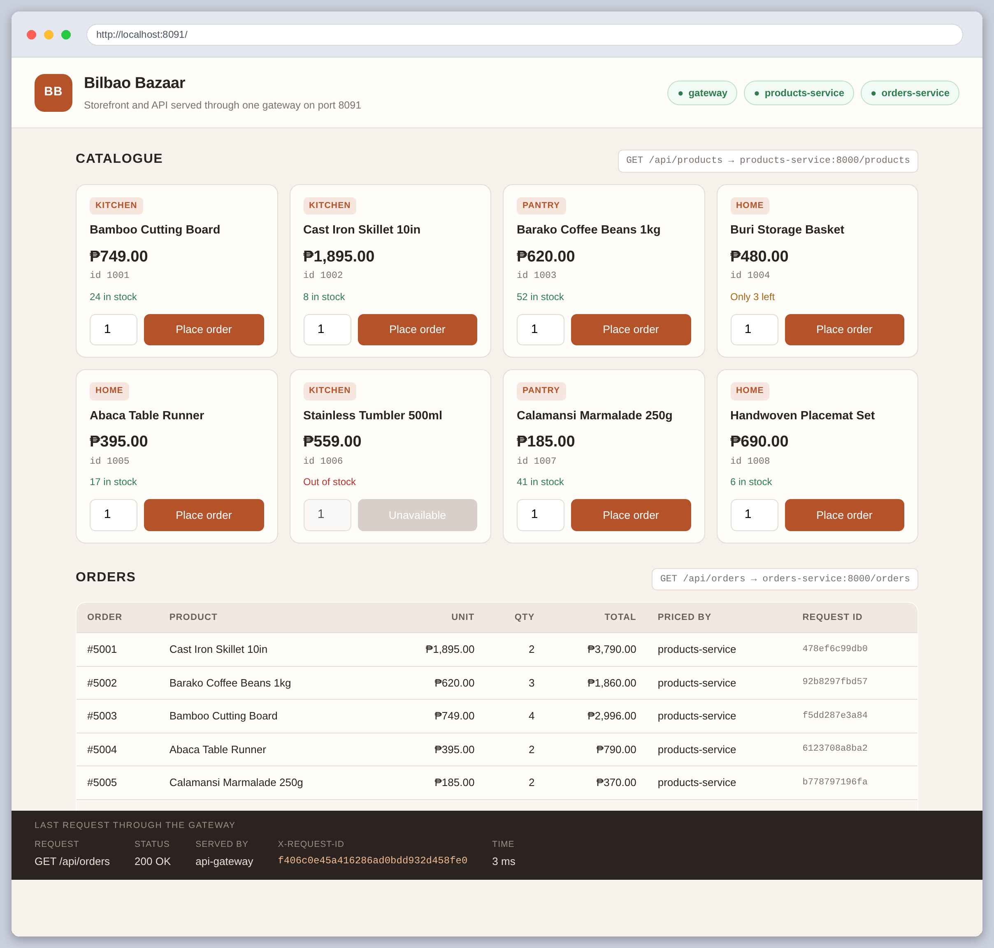
Figure 43: The storefront after the catalogue came back. The pill recovers on its own; the poll runs every five seconds
This one deserves a caveat I only understood because of the nginx -t finding earlier. NGINX resolved products-service once, at startup, so recovery worked here because the container came back at the same address. Had it come back somewhere else, the gateway would have kept sending traffic to the old address until it was reloaded. Getting that right needs a resolver directive and the upstream in a variable, and it is the difference between a gateway that survives a restart and one that only appears to.

What went wrong
The application was the quick part. Most of the time went on the container runtime, and the sequence is worth recording because none of it announced itself clearly.
The first version was ordinary: a bridge network, the gateway publishing 8080, the two services on expose so only the gateway could reach them. The gateway would not start, because 8080 was already taken on the machine. I moved it to 8090, and the container started, answered exactly one health check, and died.
From there it got stranger. Podman reported the port as published while nothing was listening on it. Container-to-container calls failed by name, so I tried by address and they failed that way too, which ruled out DNS and pointed at the network itself. Both containers had addresses on the bridge that no packet could reach from anywhere. docker exec refused to run at all, complaining it could not find root in the passwd file. Then podman deadlocked hard enough to need podman system renumber before it would delete a container.
The cause is in podman info, a few lines below where I first looked. The runtime is not rootless, but its capability list has no CAP_NET_ADMIN. Without that, netavark can allocate addresses on a bridge and cannot program any routes to them, so containers get addresses that do not work, and publishing a port fails for the same reason because publishing is NAT. Running podman rootless instead would have given it full capabilities inside a user namespace, and that failed too, with a bare permission denied.
The deadlock had a separate cause worth knowing: podman-compose puts every service in a pod, so the containers shared an infra container's network namespace, and that combination is what wedged the runtime. So docker-compose.yml is validated with docker compose config and is the declarative description of the system, but run.sh starts the containers with explicit docker run commands carrying the same environment. I would rather ship a compose file that says what the system is and be honest that the evidence came from the equivalent commands.
Host networking was the way out: all three containers share the host network namespace, the services bind loopback, the gateway binds everything. The isolation test earlier is what convinced me the property I wanted had actually survived the change.
One more, which cost the most time for the least reason. After all that, the gateway was demonstrably listening on 8090 in the right namespace and no connection to it ever completed. A plain Python HTTP server on the same port behaved identically, which finally removed NGINX from suspicion. Port 8090 is filtered somewhere in that sandbox: a process binds it happily and nothing ever arrives. 8091 works. Nothing was wrong with the configuration at all.
The lesson I will actually keep: when a component looks broken, replace it with the most boring possible substitute before reading its configuration again. One python3 -m http.server would have saved me an hour if I had reached for it first, instead of assuming that a web server failing to serve was a web server problem.

Bugs in my own work
Three, all found by looking at output rather than by reasoning about code.
- The X-Request-ID came back twice. The gateway adds it and the services echo it, and the storefront duly displayed the identifier, a comma, and the same identifier again, because fetch joins repeated headers. proxy_hide_header drops the upstream copy so only the one from the component that minted it leaves.
- /health returned no X-Request-ID while every other route had one. That is the add_header inheritance rule described in Task 1, and I would not have noticed if the health endpoint had not been in the same table of captured headers as the proxied routes.
- Successful responses were indented and error responses were not, because FastAPI's default_response_class applies to routes and not to exception handlers. Two figures side by side disagreeing about formatting is what made me look.

Conclusion
The routing was the smallest part of this. Two upstream blocks and four location blocks and the gateway does what the assignment asked, and I had that working before I understood anything interesting.
What the gateway is actually worth showed up around the routing. The storefront needs no CORS configuration because the page and the API share an origin, and that is work I never had to do rather than a feature I can point at. A stopped container produces a JSON 503 instead of an HTML error page because of four lines near the bottom of the file. Every request gets an identifier that makes it traceable across three containers, and no service had to be taught to generate one.
On the service-to-service side, the thing I would carry into a bigger system is that most of the code in the east-west call is error translation, and that this is correct rather than defensive clutter. The outage test proved it: an orders service returning a 503 that names its missing dependency is genuinely more useful than a 500, and it cost about ten lines. Choosing REST over a queue was right here for a boring reason, which is that the caller cannot proceed without the answer, and I would rather be able to say why than have reached for a broker because the assignment mentioned one.
The rest of what I learned was about being wrong efficiently. A build failing on a valid config file taught me when NGINX resolves upstream names, which then explained both why compose needs depends_on and why the recovery test only worked because the container came back at the same address. An hour lost to a filtered port taught me to substitute the simplest possible component before rereading configuration. Both came from things not working, which is not the part of an assignment I would have chosen and is most of what I took away from it.

