Day 6 Assignment
Building a Data Processing API with Pandas, NumPy and FastAPI
John Michael Bilbao
Techstart
August 14, 2026

Introduction
This assignment asks for a FastAPI service that does data processing work with Pandas and NumPy, tested with curl and documented with screenshots.
The dataset is the Iris measurements, 150 rows and five columns, which ships with the project as a CSV. POST /load_data reads it into a Pandas DataFrame that is held in memory, and the other seven endpoints work on that DataFrame. Pandas does the loading, describing, filtering and grouping; NumPy does the statistics and the correlation matrix.
The three endpoints the assignment names are all there, and I added five more, because /load_data and /describe_data on their own do not really exercise either library. Everything is run from PowerShell on Windows.

Step 1: Setting up the environment
A virtual environment, then the four packages. FastAPI is installed with the standard extras, which is what brings in Uvicorn and the fastapi command line tool.
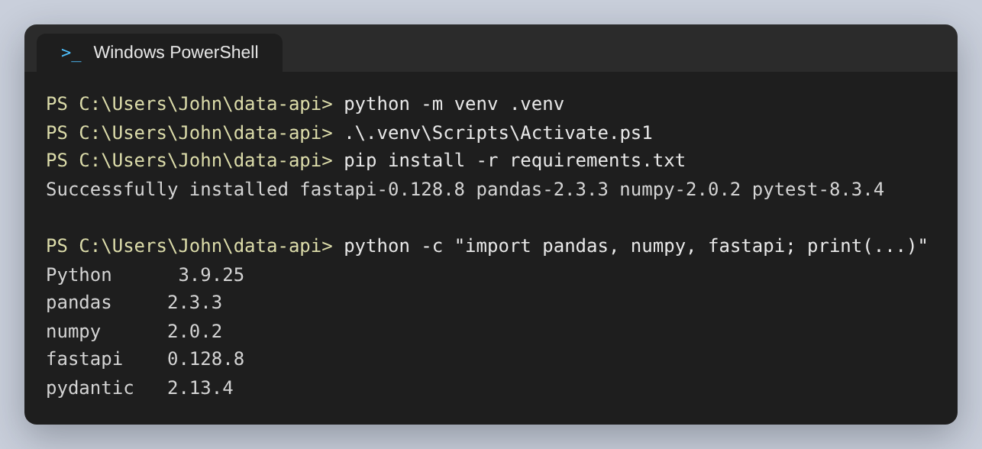
Figure 1: The environment, and the versions in it
Before writing any endpoint I looked at the data in a plain Python session, because the shape of the API follows from the shape of the dataset. Four float columns and one text column is what leads to /stats refusing text columns and /filter_data needing to convert its value before comparing.
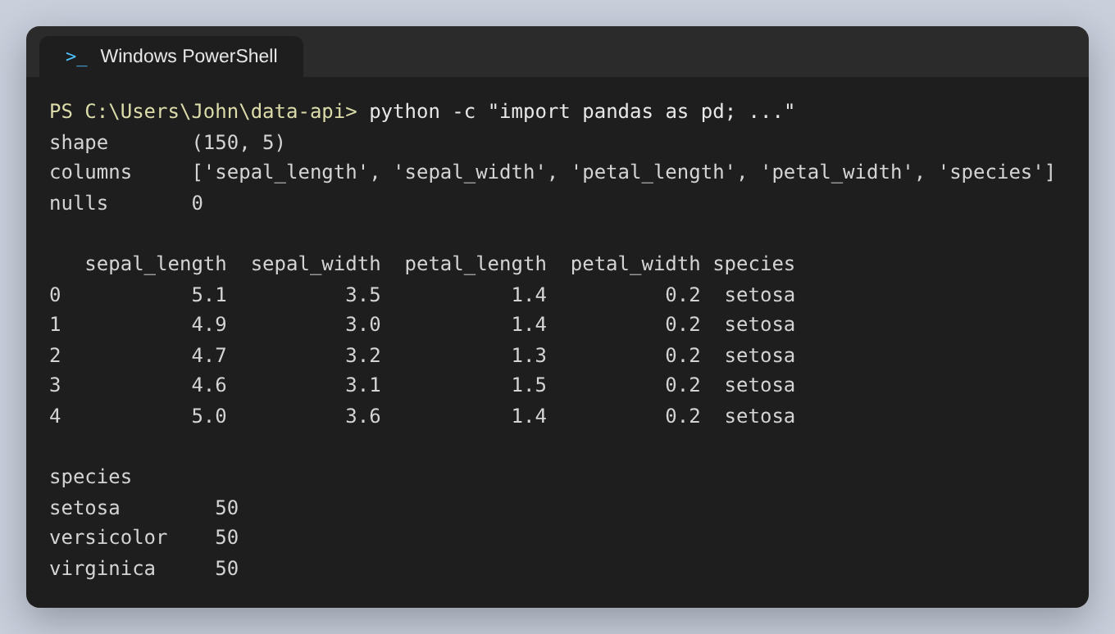
Figure 2: The dataset: 150 rows, four numeric columns, one text column, no missing values
The assignment asks for the project to be started with the fastapi command line tool, so the server runs with fastapi dev. It finds the app object itself, turns on reloading, and prints where the service and its documentation are:
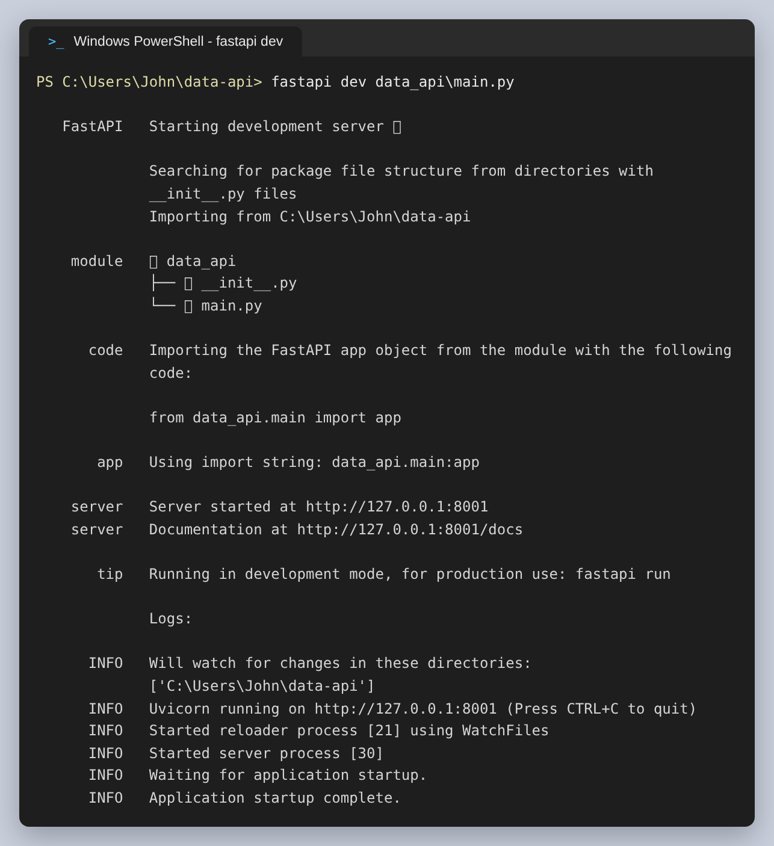
Figure 3: fastapi dev starting the development server

Step 2: Designing the API endpoints
Eight endpoints. The three in the assignment, four more that do actual processing, and a health check:
Endpoint | What it does | Library
POST /load_data | Read the CSV into a DataFrame and report its shape, dtypes, memory use and first five rows | Pandas
GET /describe_data | describe(include='all'), so text columns are summarised too | Pandas
GET /filter_data | Filter rows with one of seven comparisons | Pandas
GET /columns | Per-column dtype, null count and distinct count | Pandas
GET /stats/{column} | Mean, median, standard deviation, quartiles and Tukey outlier fences | NumPy
GET /group_by | Group on one column, aggregate another | Pandas
GET /correlation | Pearson matrix over the numeric columns | NumPy
GET /health | Whether the service is up and data is loaded | —

The design decision that shaped everything else is that the DataFrame is state. It has to be loaded before anything can read it, so every read returns 409 with a message naming the endpoint to call first, rather than an empty result that looks like an answer.
The other decision is that every argument goes in the query string. Nothing takes a request body, which keeps the curl commands short enough to fit in a screenshot and means each endpoint is a URL that can be pasted into a browser.
The failures are three codes: 409 when nothing is loaded, 404 for a column that does not exist or is the wrong type, and 400 when the arguments cannot be applied to the data. All of them return the same two fields:
{
"error": "data_not_loaded",
"message": "No dataset is loaded. Call POST /load_data first."
}

Step 3: Implementing the endpoints
The endpoints themselves are thin. Each one gets the DataFrame, calls a function in processing.py and wraps the result in a response model. /filter_data is the most involved, because it is the one with real parameters:
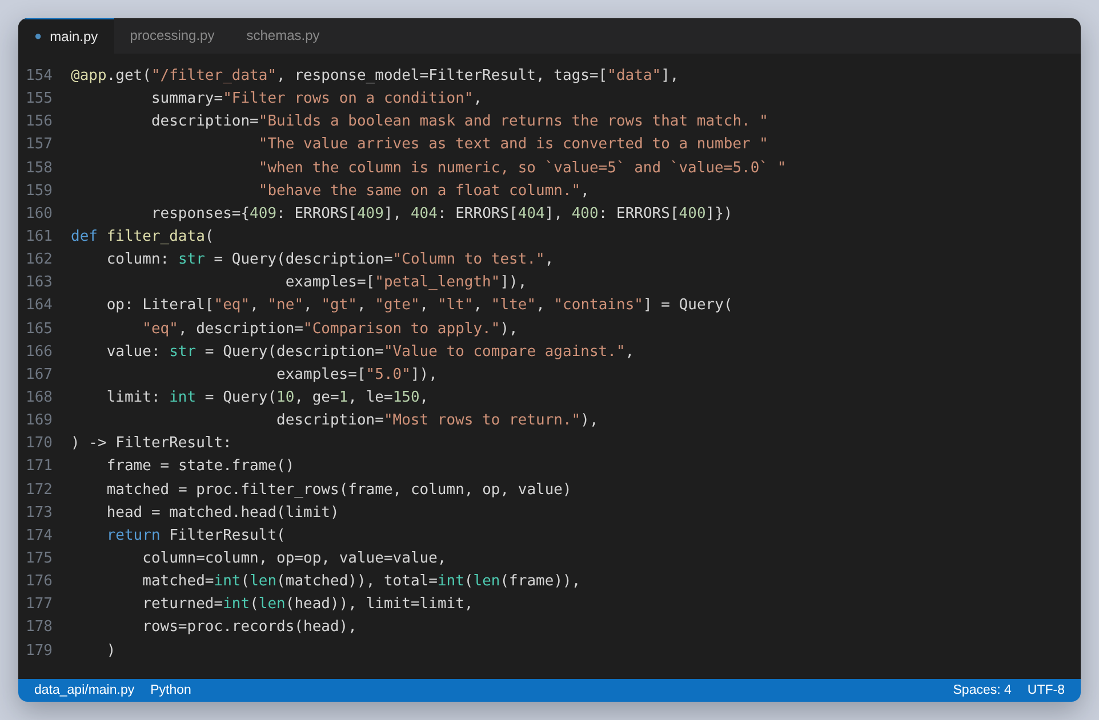
Figure 4: The /filter_data endpoint. Declaring op as a Literal is what makes FastAPI reject an unknown operator before the function runs.
Declaring op as a Literal rather than a string is worth pointing out. It gives FastAPI the list of valid operators, so a bad one is rejected with a 422 before the endpoint body executes, and it turns into a dropdown in the generated documentation. I did not have to write that validation.
The NumPy work is in processing.py. Pandas would give most of these figures directly, but the outlier bounds are easier to express as arithmetic on percentiles, and the assignment asks for NumPy:
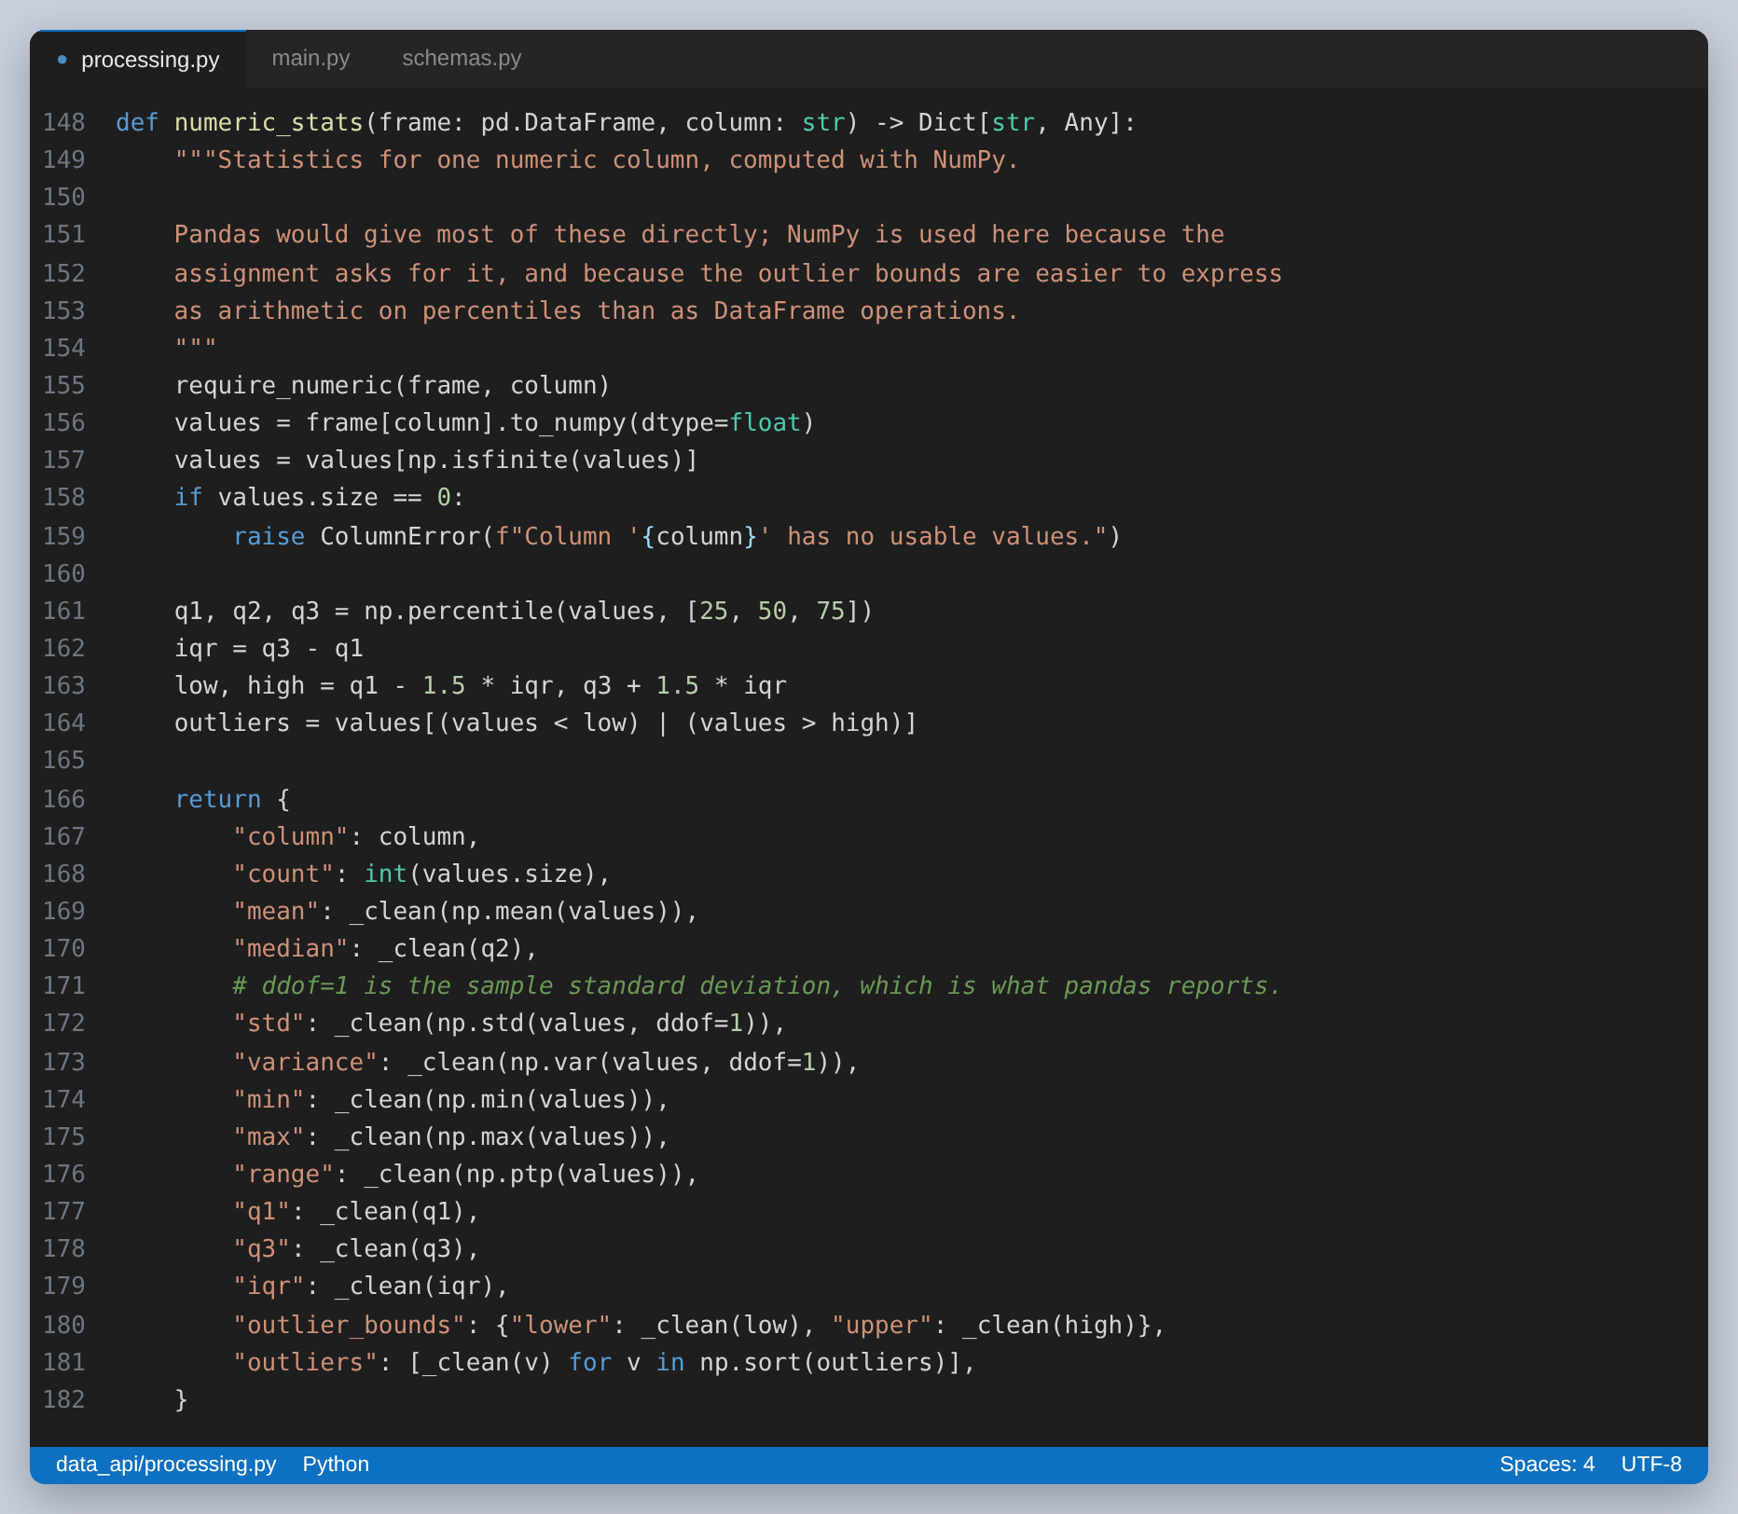
Figure 5: The statistics, computed on the column as a float array
Two details in there caused real problems. NumPy scalars are not JSON serialisable, so every value goes through a helper that converts them to Python numbers. And NaN is not valid JSON at all, so any non-finite value becomes null; that is why describe() comes back with nulls where a statistic does not apply to a text column instead of failing to encode.

Step 4: Testing the API with curl
Every endpoint below was called with curl.exe against the running server. The -i flag prints the status line and the headers as well as the body.
First, the health check before and after loading. This is the state the rest of the API depends on:
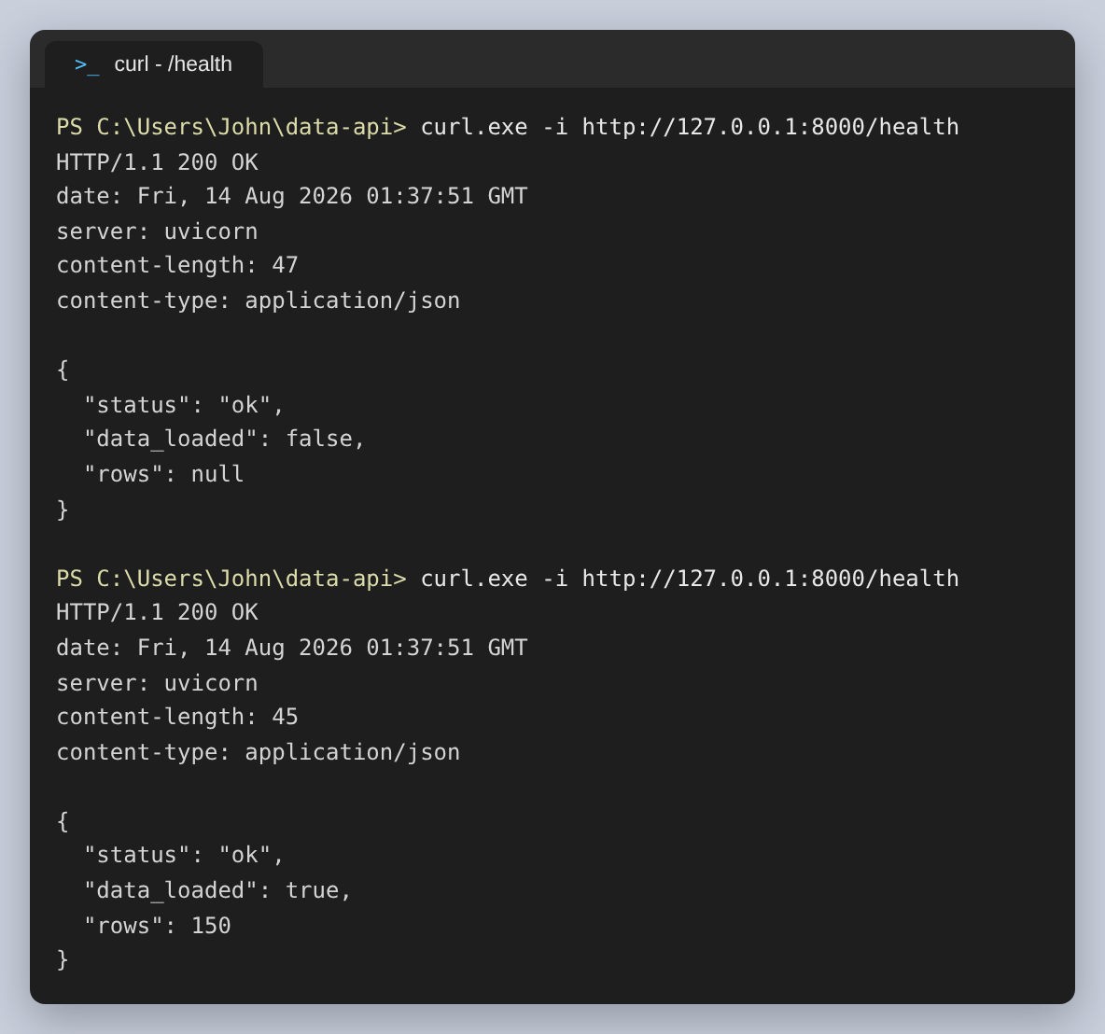
Figure 6: GET /health, before and after the dataset is loaded
Loading the data. The response is the DataFrame's shape, the dtypes Pandas inferred, how much memory it occupies and the first five rows:
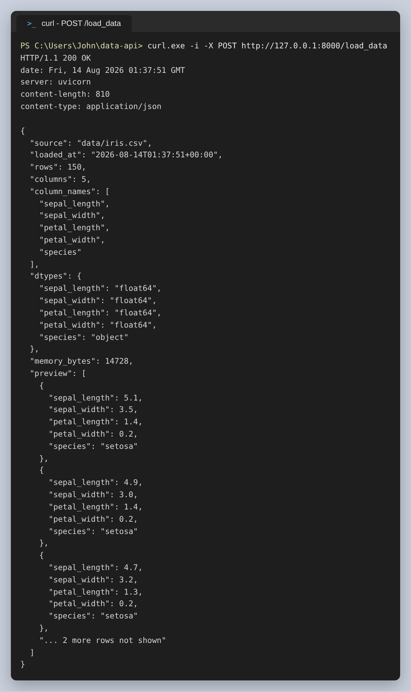
Figure 7: POST /load_data
The per-column view, which is what tells a client which columns it can ask for statistics on. species is the only one with numeric false, and its three distinct values are the three species:
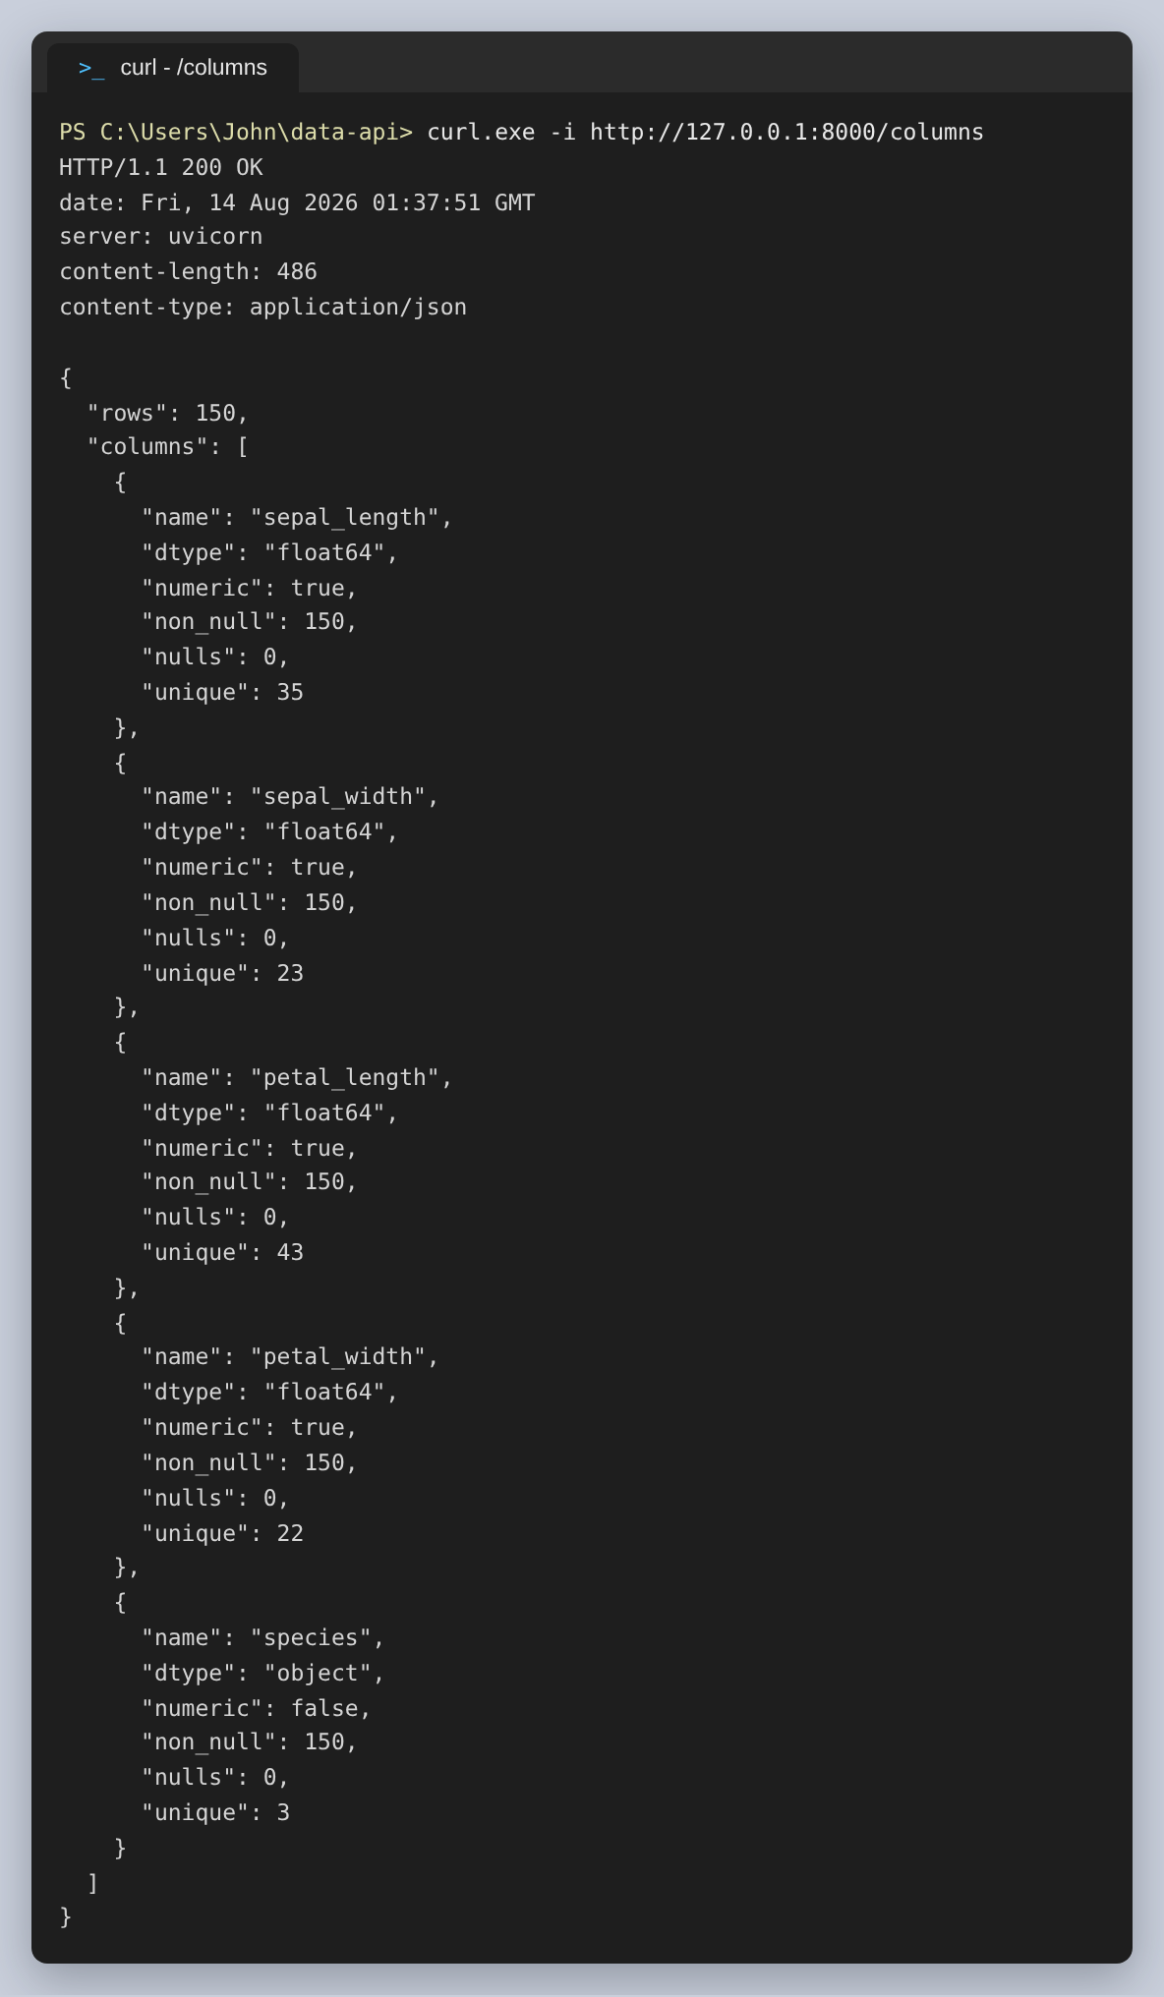
Figure 8: GET /columns
describe() across all five columns. Two columns are omitted from the screenshot to keep it on one page; the endpoint returns all five:
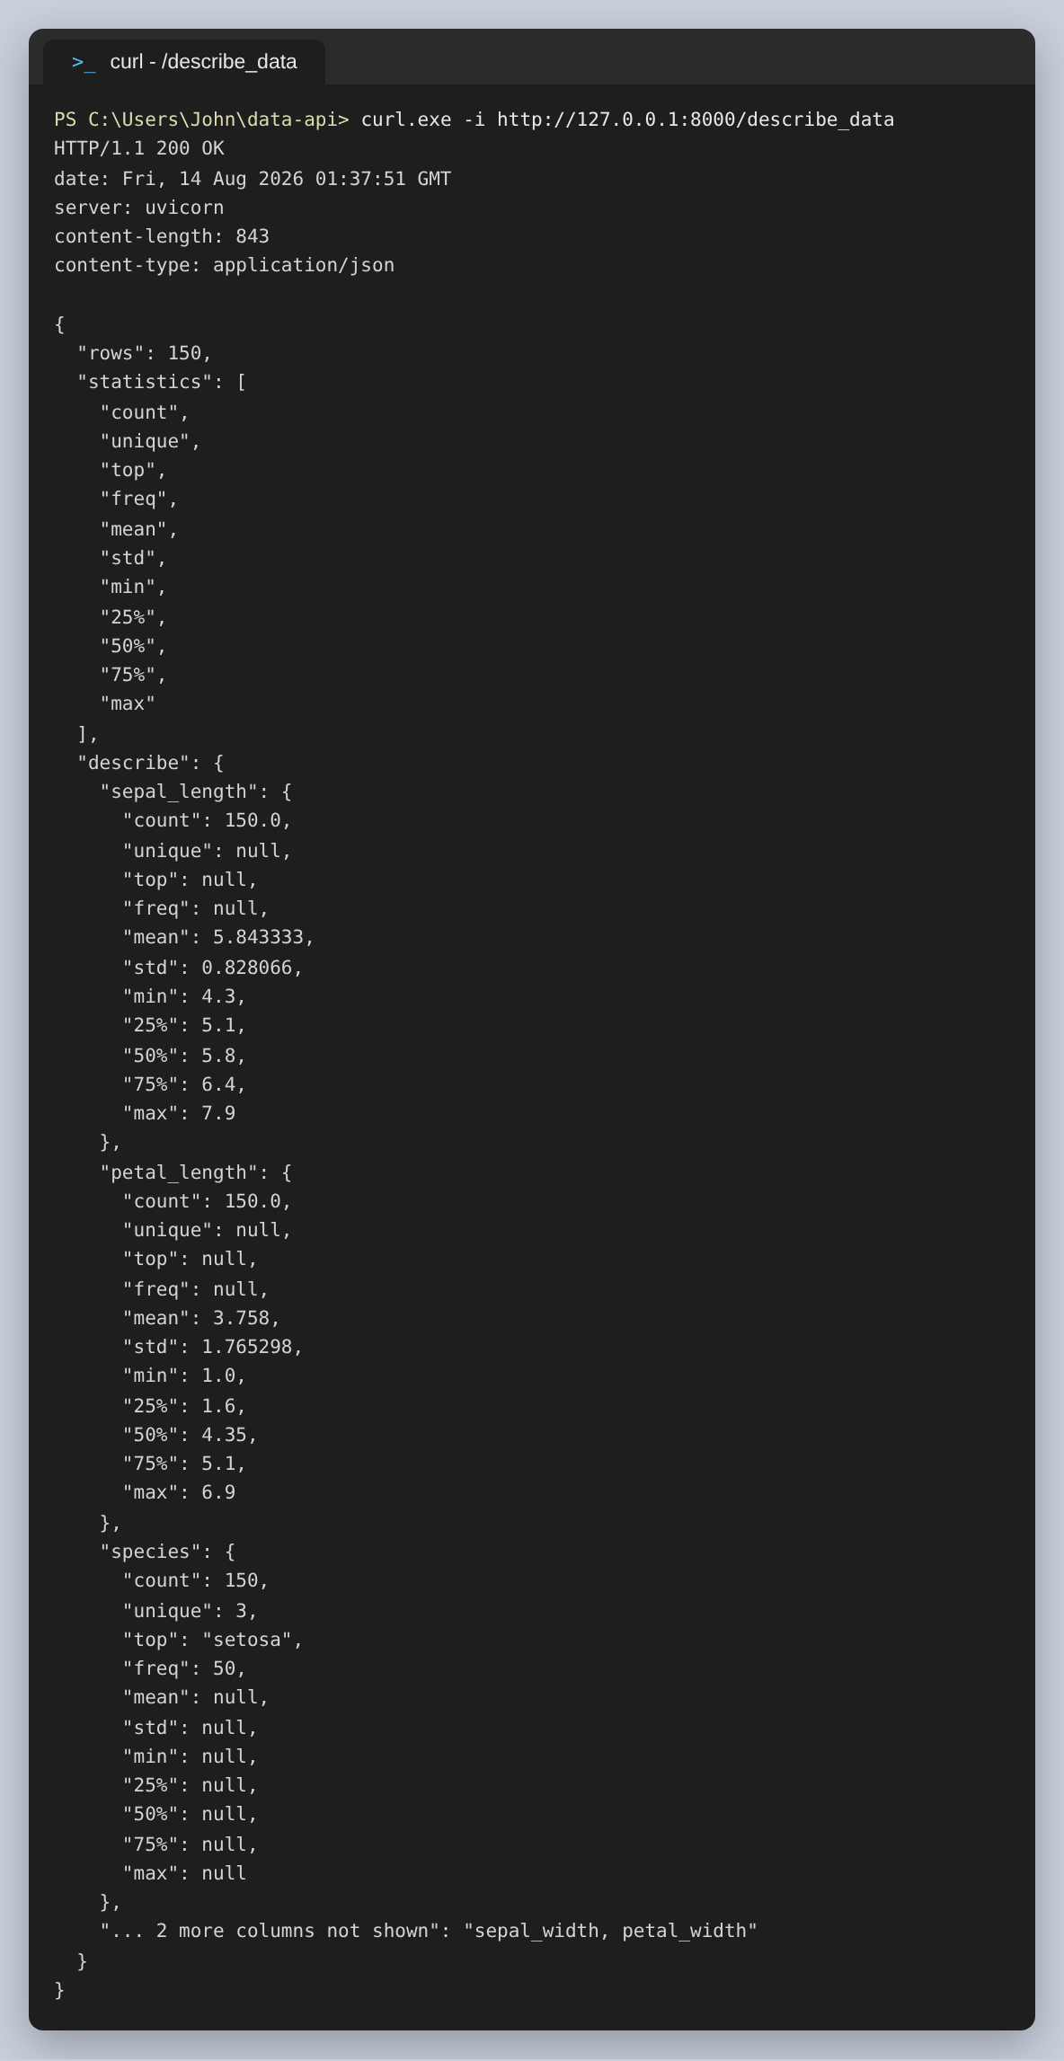
Figure 9: GET /describe_data
Filtering on the text column. 50 of the 150 rows are setosa, which is what the dataset should give:
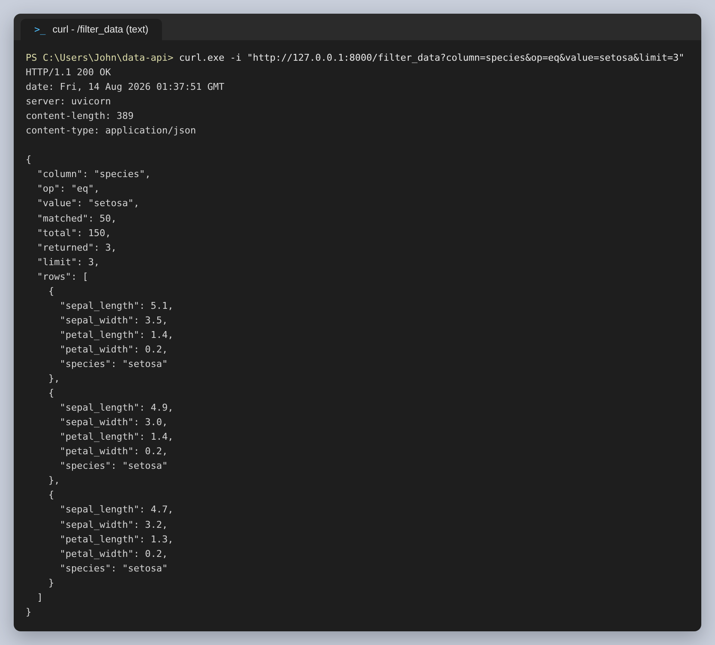
Figure 10: GET /filter_data with an equality match on species
Filtering on a numeric column. 42 rows have a petal length above 5.0, and matched reports the true total while limit controls how many rows come back:
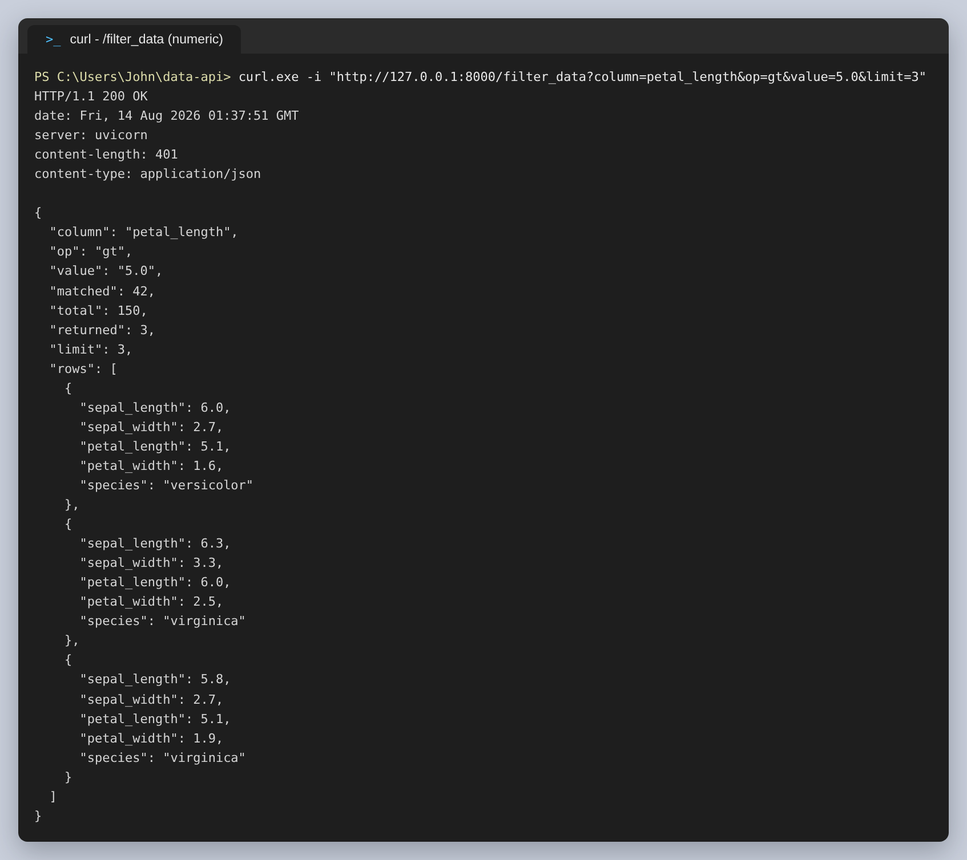
Figure 11: GET /filter_data with a greater-than comparison
The contains comparison, which is case-insensitive, so VIRGIN in upper case still finds all 50 virginica rows:
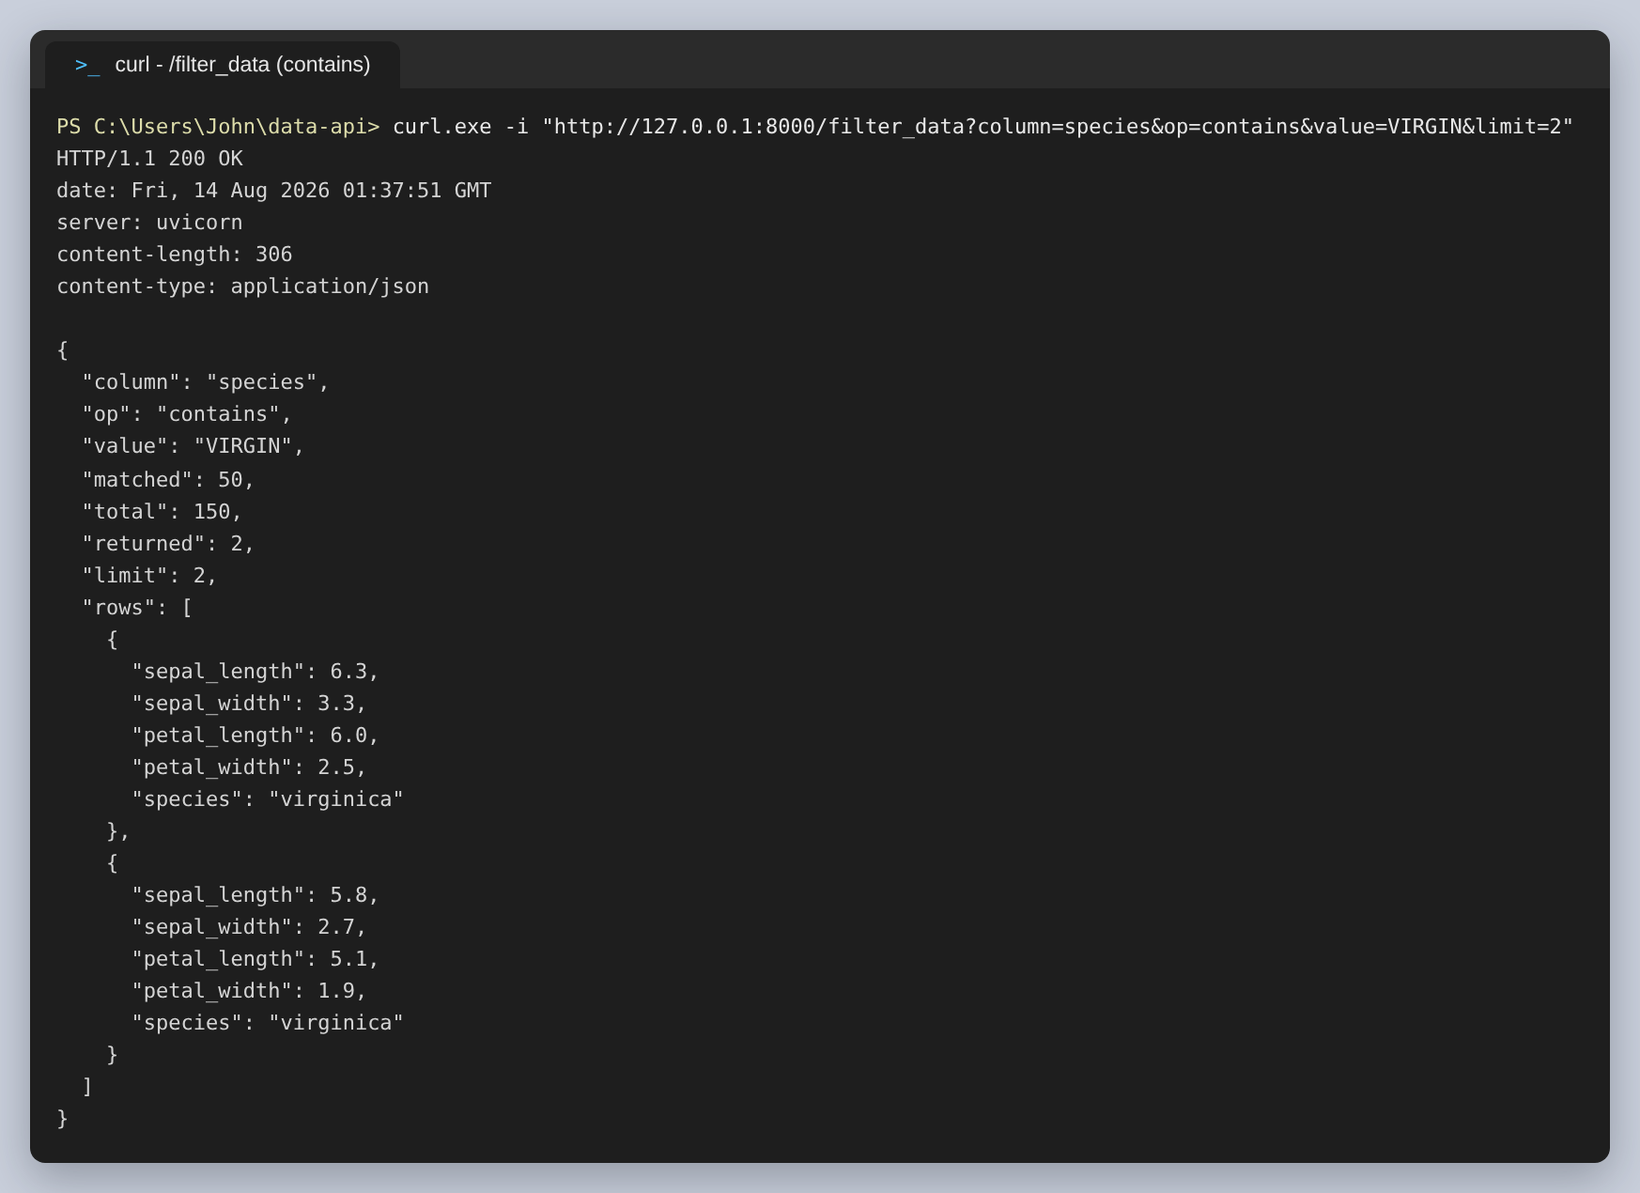
Figure 12: GET /filter_data with a partial, case-insensitive match
The NumPy statistics for petal length. The mean of 3.758 and the median of 4.35 are far apart, which is the two-cluster shape of this dataset showing up in a single column:
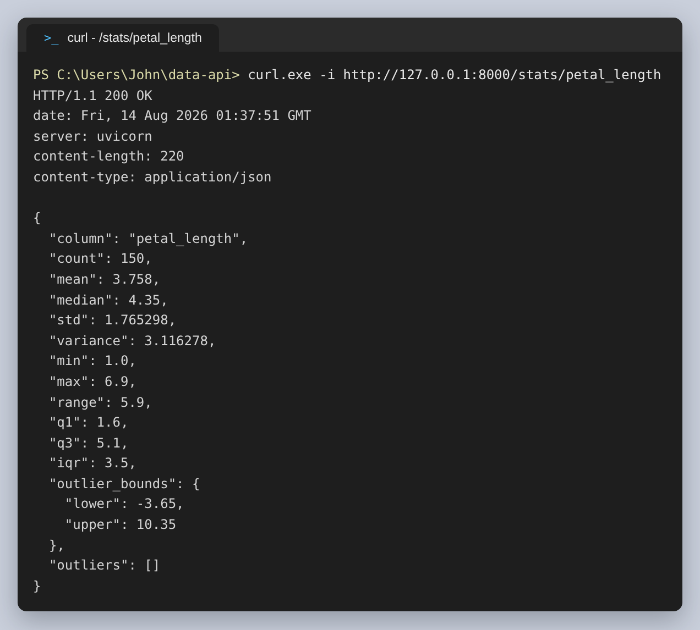
Figure 13: GET /stats/petal_length
Sepal width is the column with outliers. The fences come out at 2.05 and 4.05, and four measurements fall outside them:
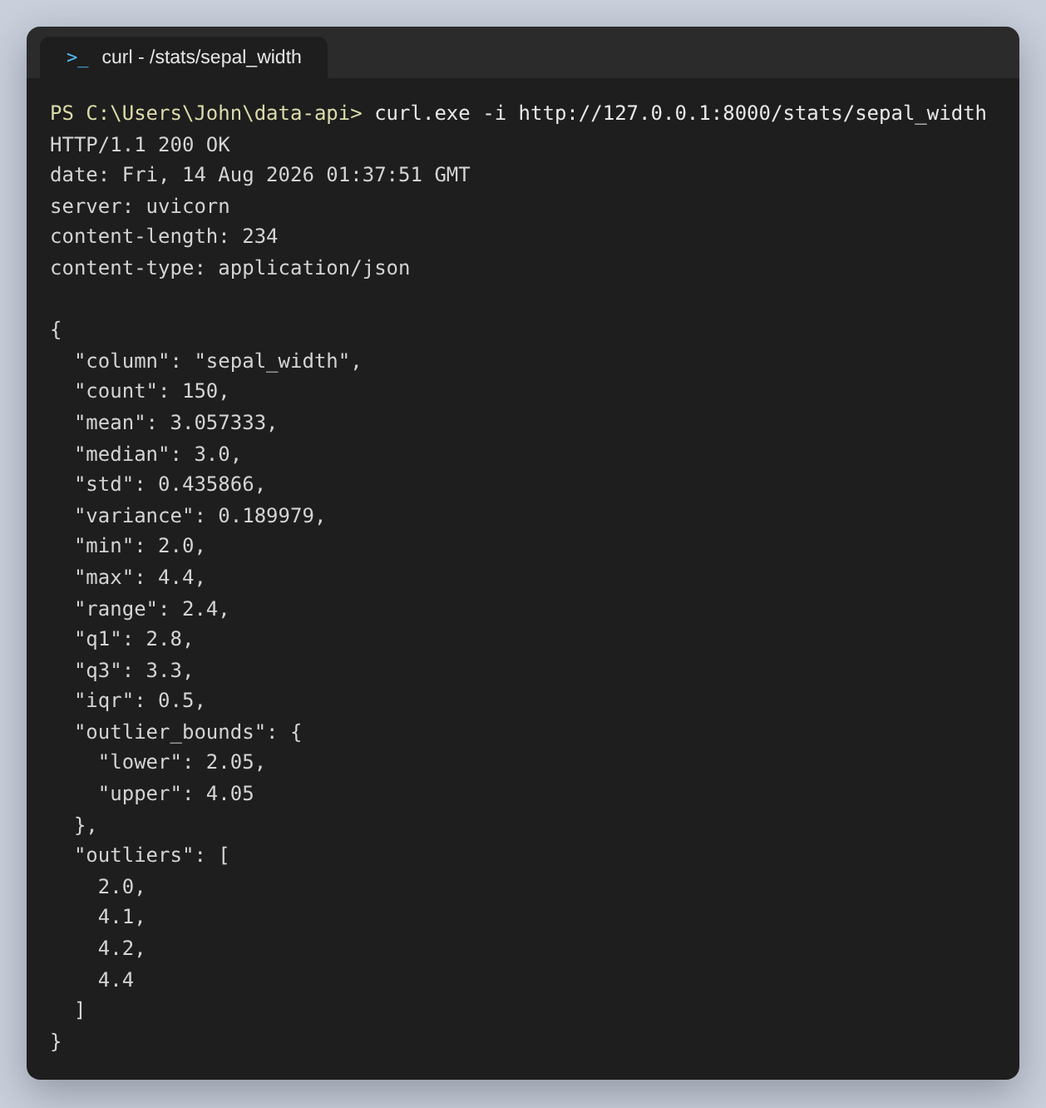
Figure 14: GET /stats/sepal_width, where the Tukey fences catch four values
Grouping. Mean petal length per species separates the three cleanly, 1.462 against 4.26 against 5.552, and the second call shows a different aggregation on a different column:
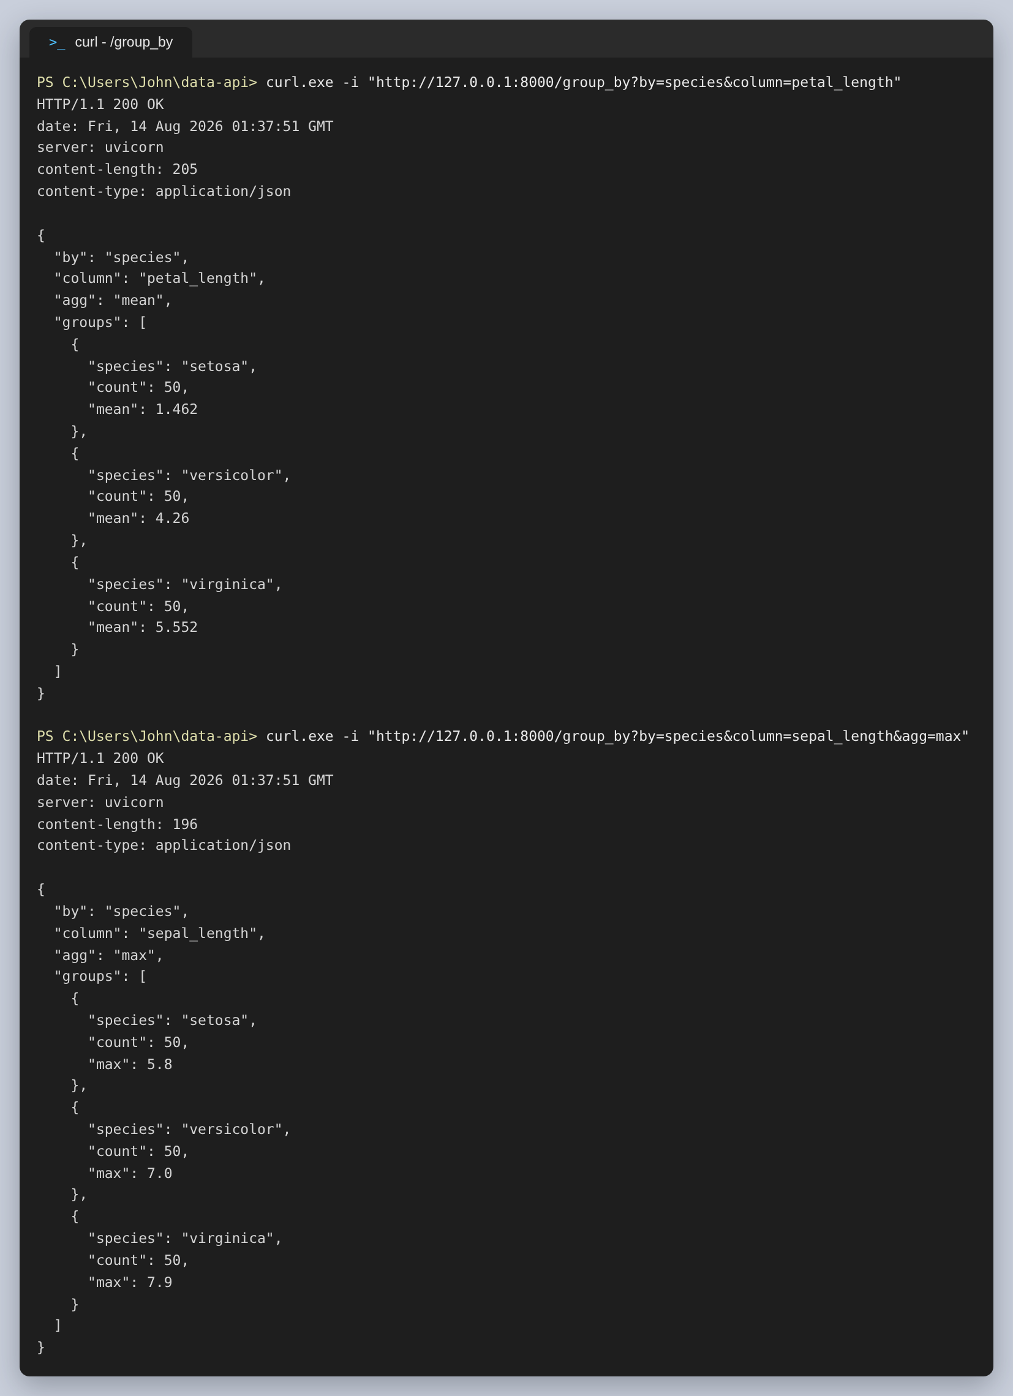
Figure 15: GET /group_by, with mean and then max
The correlation matrix. Petal length and petal width come out at 0.963, nearly collinear, while sepal width is slightly negatively correlated with everything else:
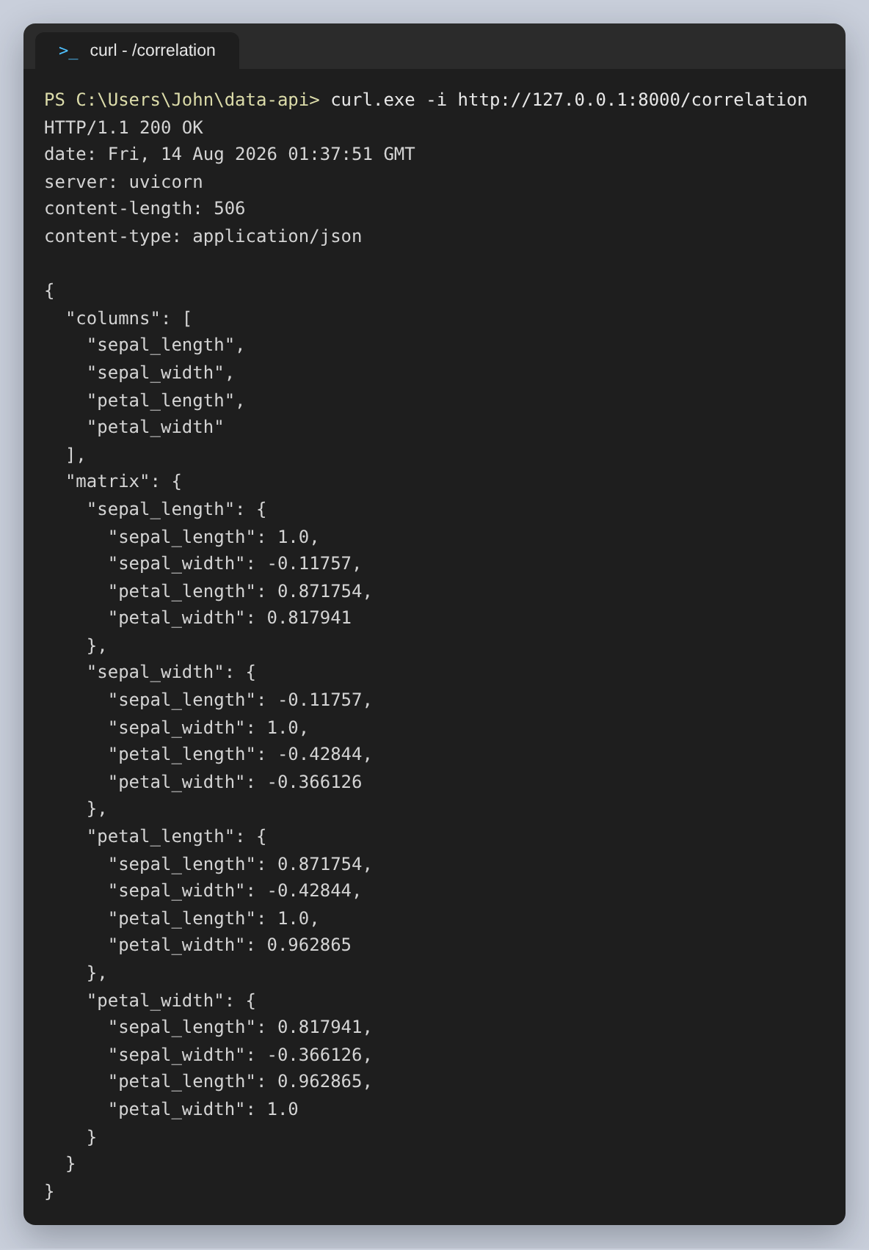
Figure 16: GET /correlation

The failure cases
A read before anything is loaded, and a column that does not exist. The 404 lists the columns that do exist, which saves the caller a trip to the documentation:
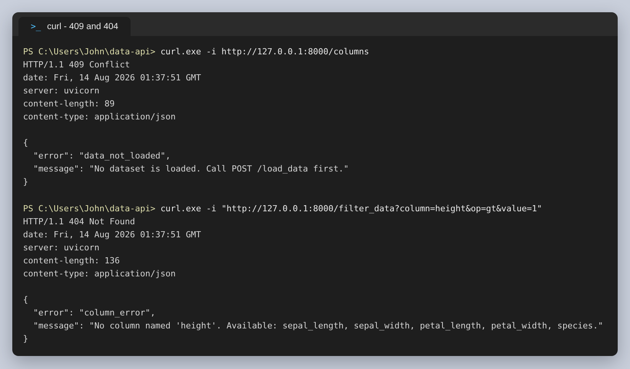
Figure 17: 409 before loading, and 404 for an unknown column
Then three more: text compared against a numeric column, statistics asked for on a text column, and an operator the API does not accept. The last one is a 422 rather than a 400 because FastAPI rejects it from the Literal before the endpoint runs, and its message names the seven values it would have accepted:
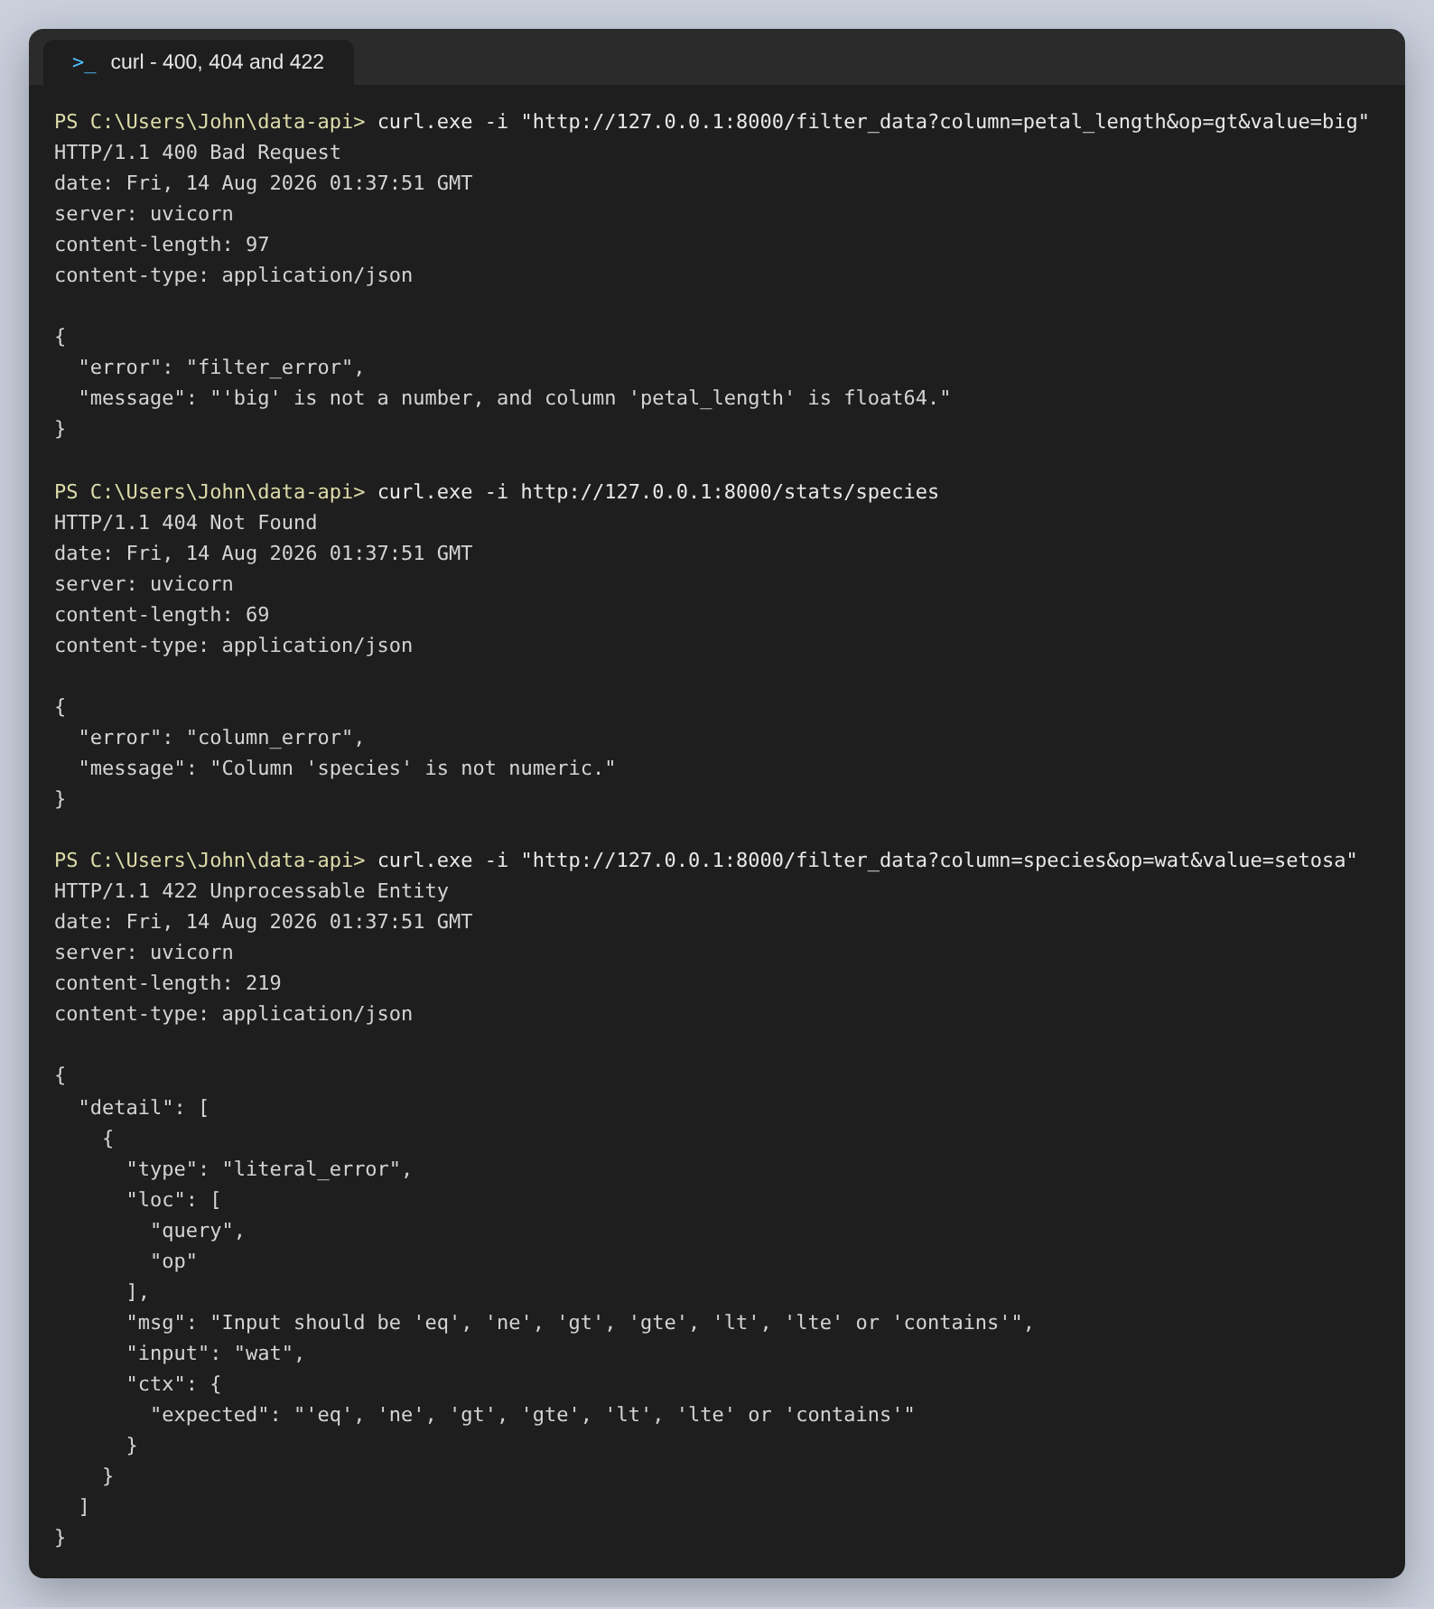
Figure 18: 400 for a value that cannot be compared, 404 for statistics on text, and FastAPI's own 422 for a bad operator

Step 5: The generated documentation
FastAPI builds an OpenAPI document from the type hints and the response models, and serves two interactive views of it. Nothing here was written by hand; the descriptions come from the endpoint decorators and the field descriptions in schemas.py.
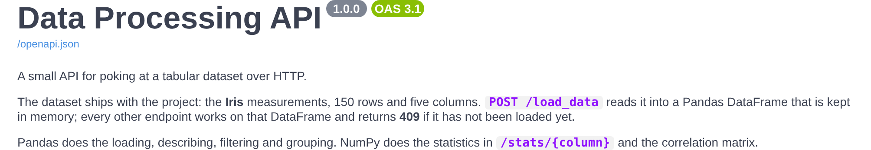
Figure 19: The service description at /docs, taken from the FastAPI constructor
All eight endpoints, grouped by the tags they were given:
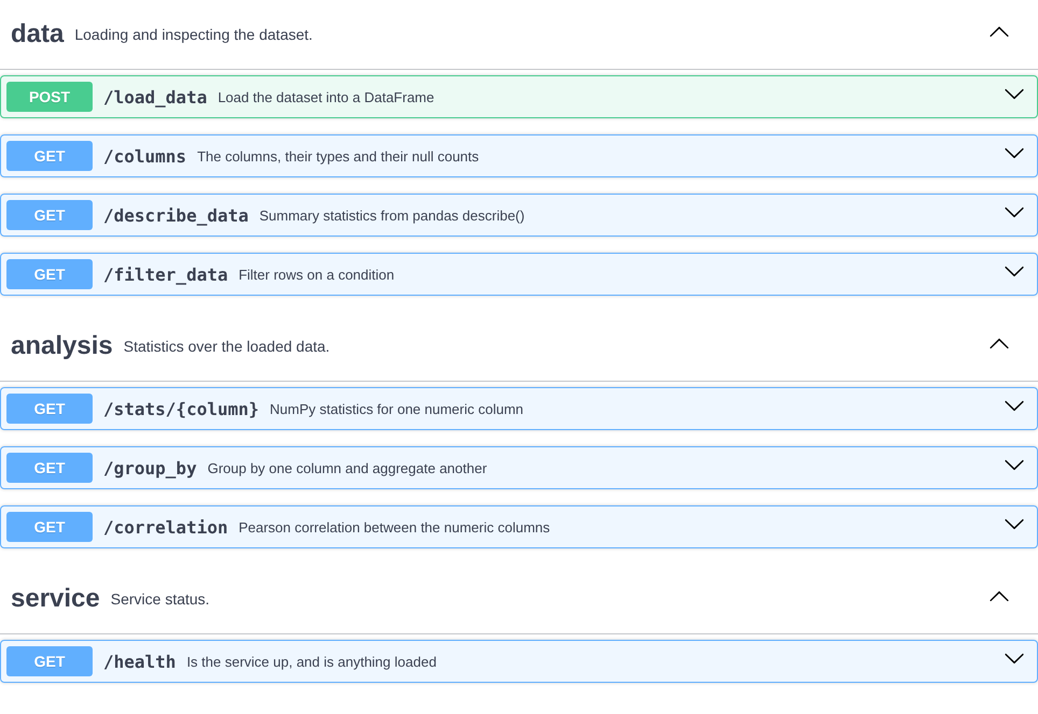
Figure 20: The endpoints at /docs
Expanding POST /load_data shows the response model with every field described, and an example built from the model itself:
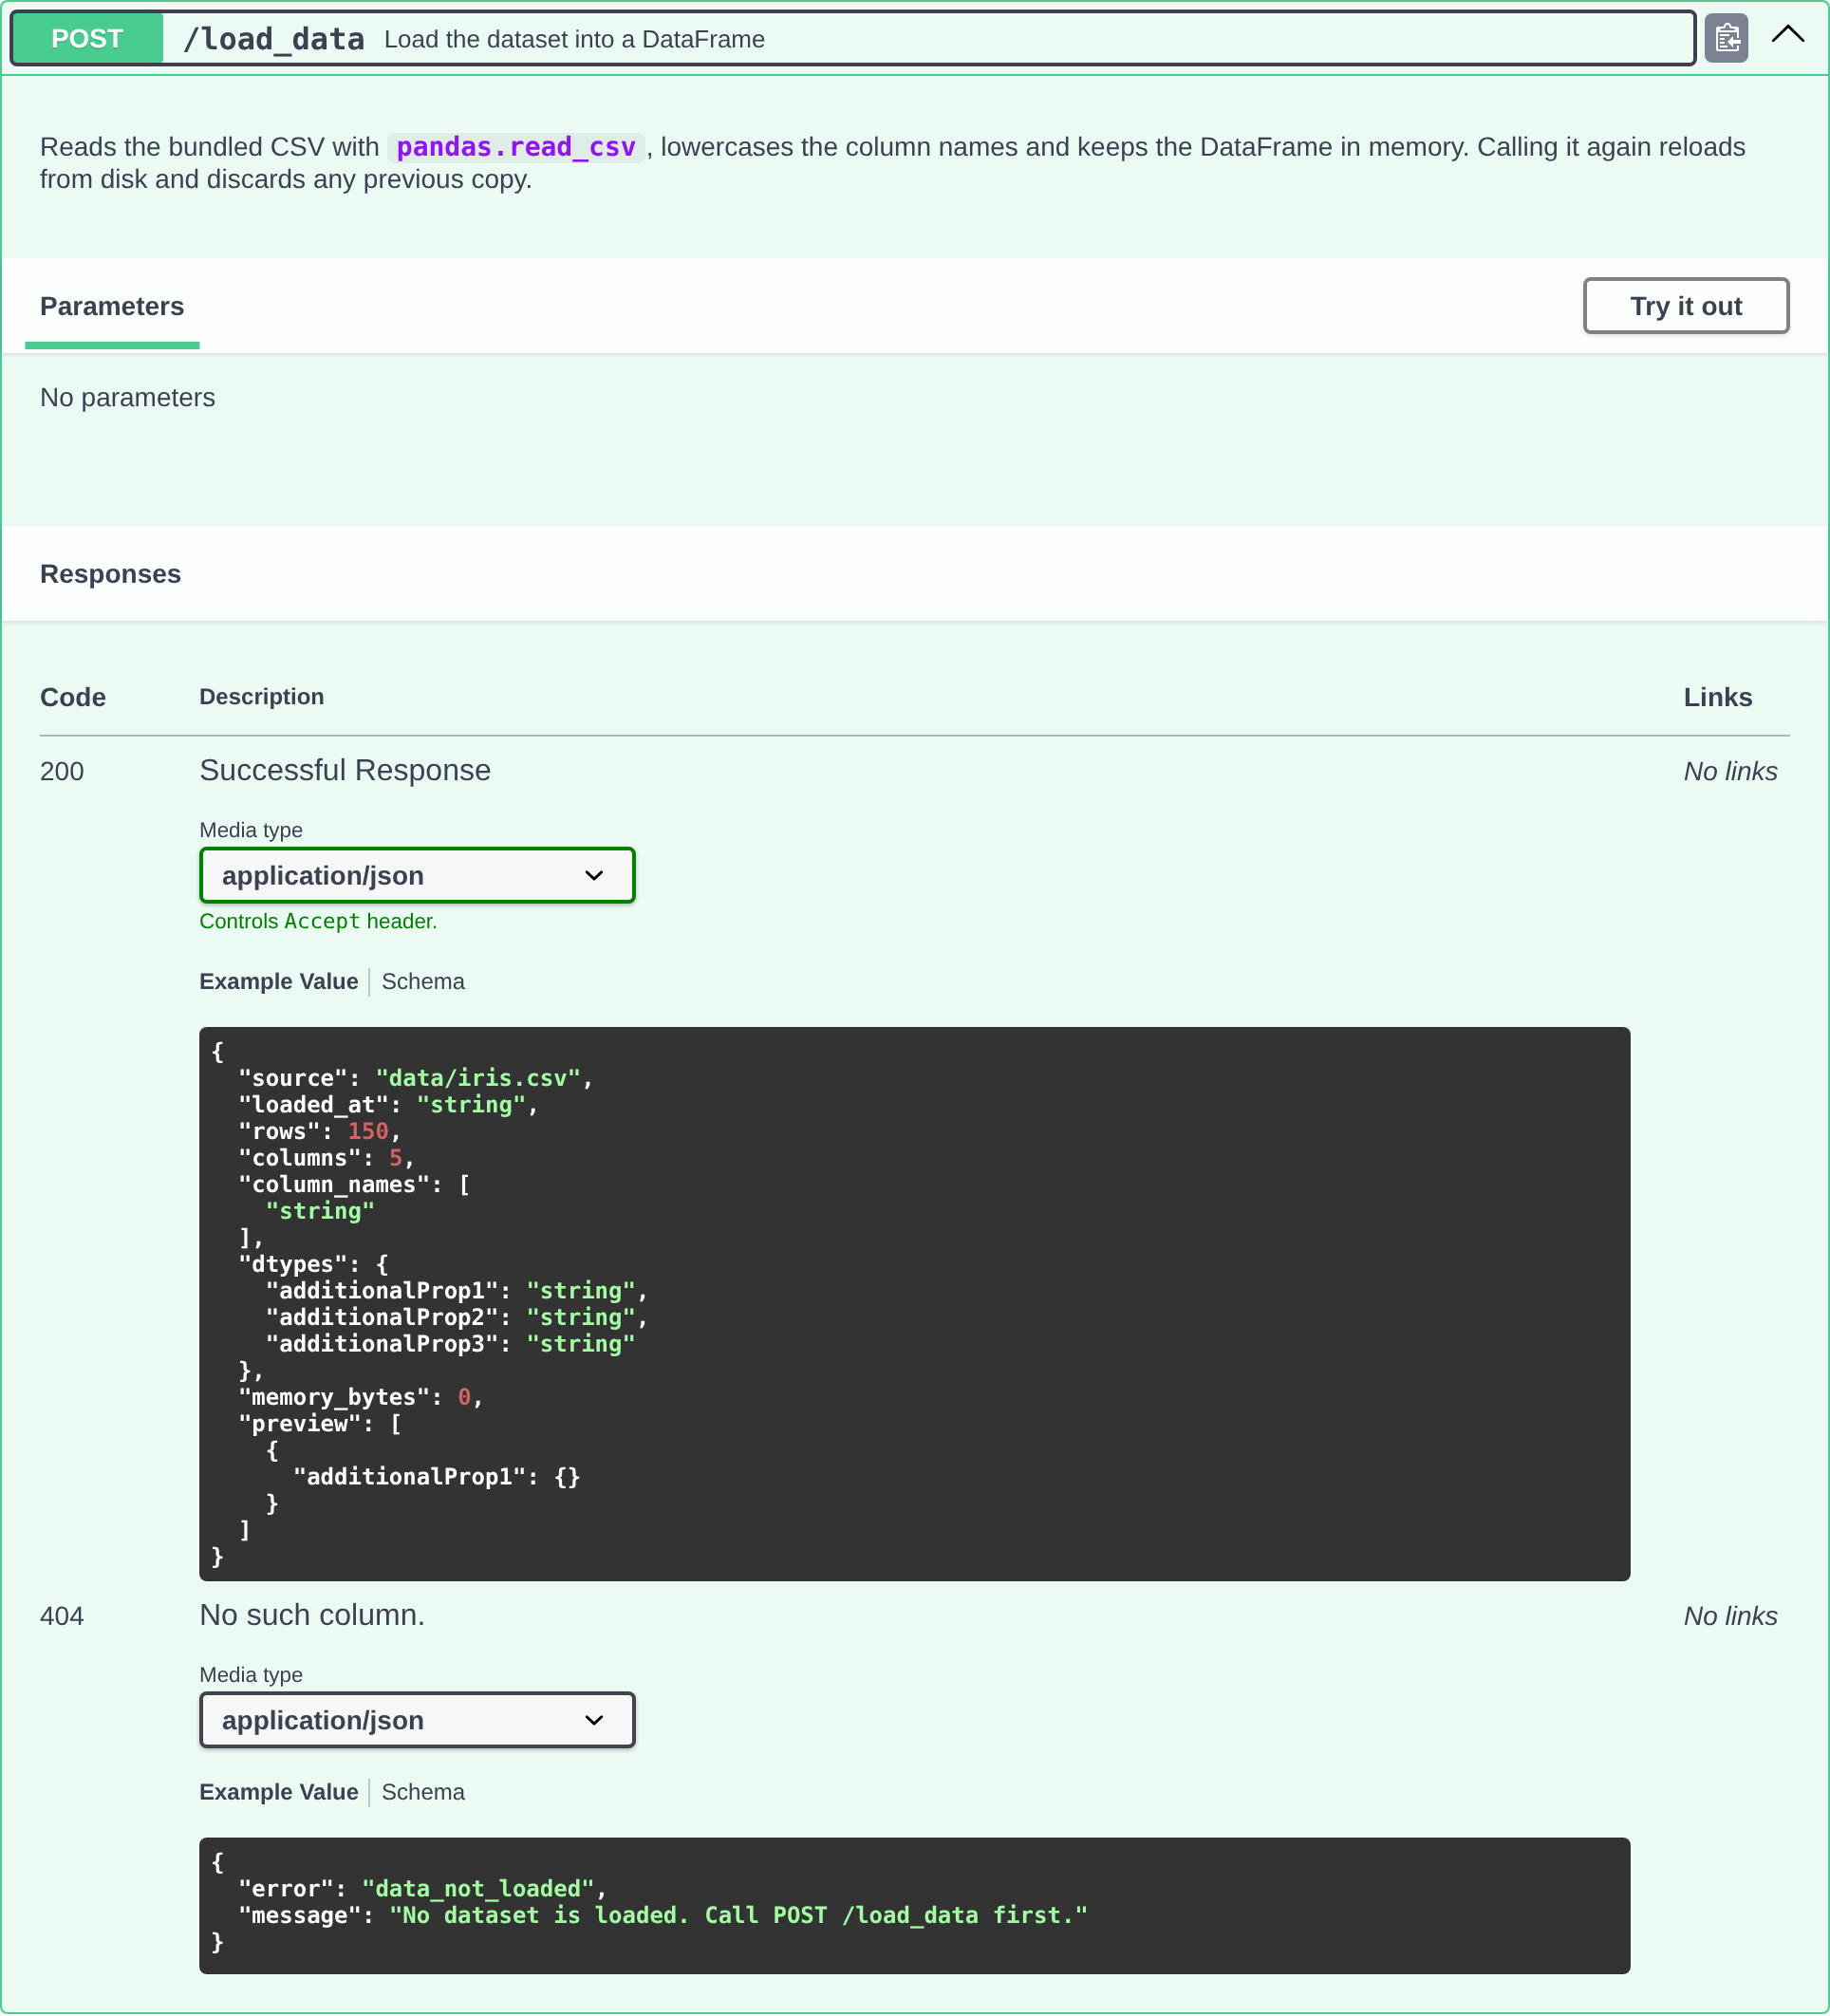
Figure 21: POST /load_data expanded
/filter_data shows what the type hints bought. Each parameter has its description and example, op is a dropdown of the seven operators, limit shows its range, and the three error responses are listed with the shape they return:
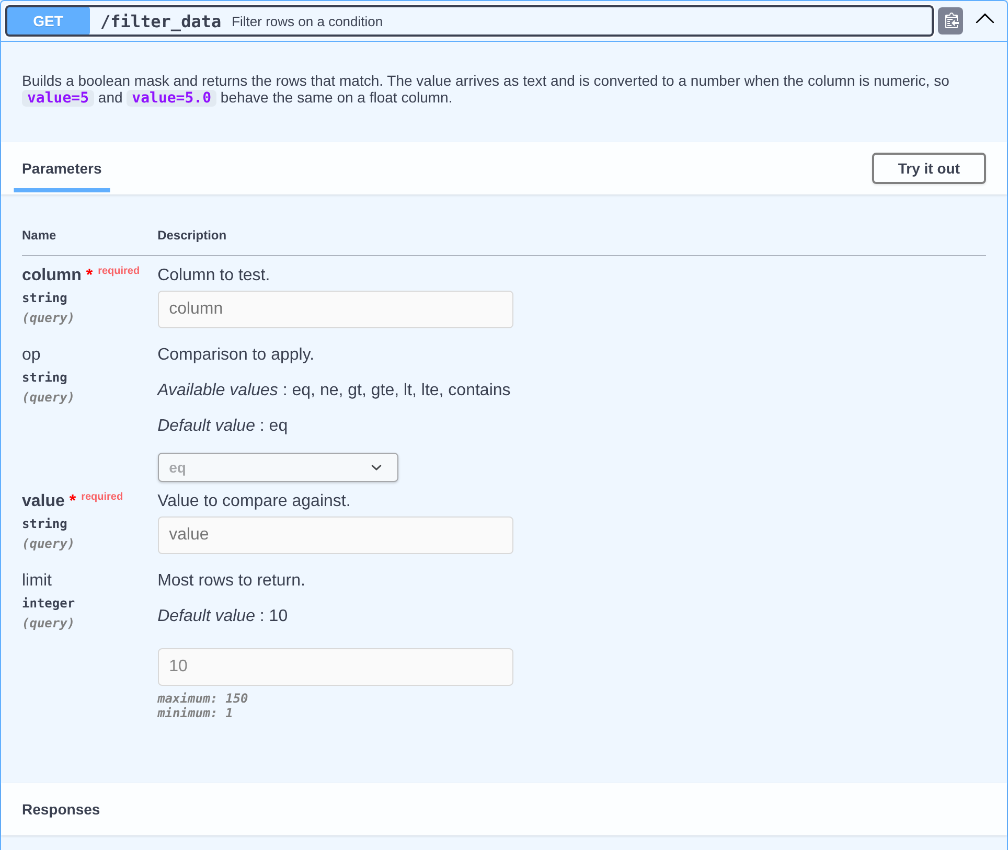
Figure 22: /filter_data expanded, with the parameters FastAPI derived from the function signature
The schemas section lists every model. ValidationError and HTTPValidationError were not written by me; FastAPI adds them because it does the parameter validation:
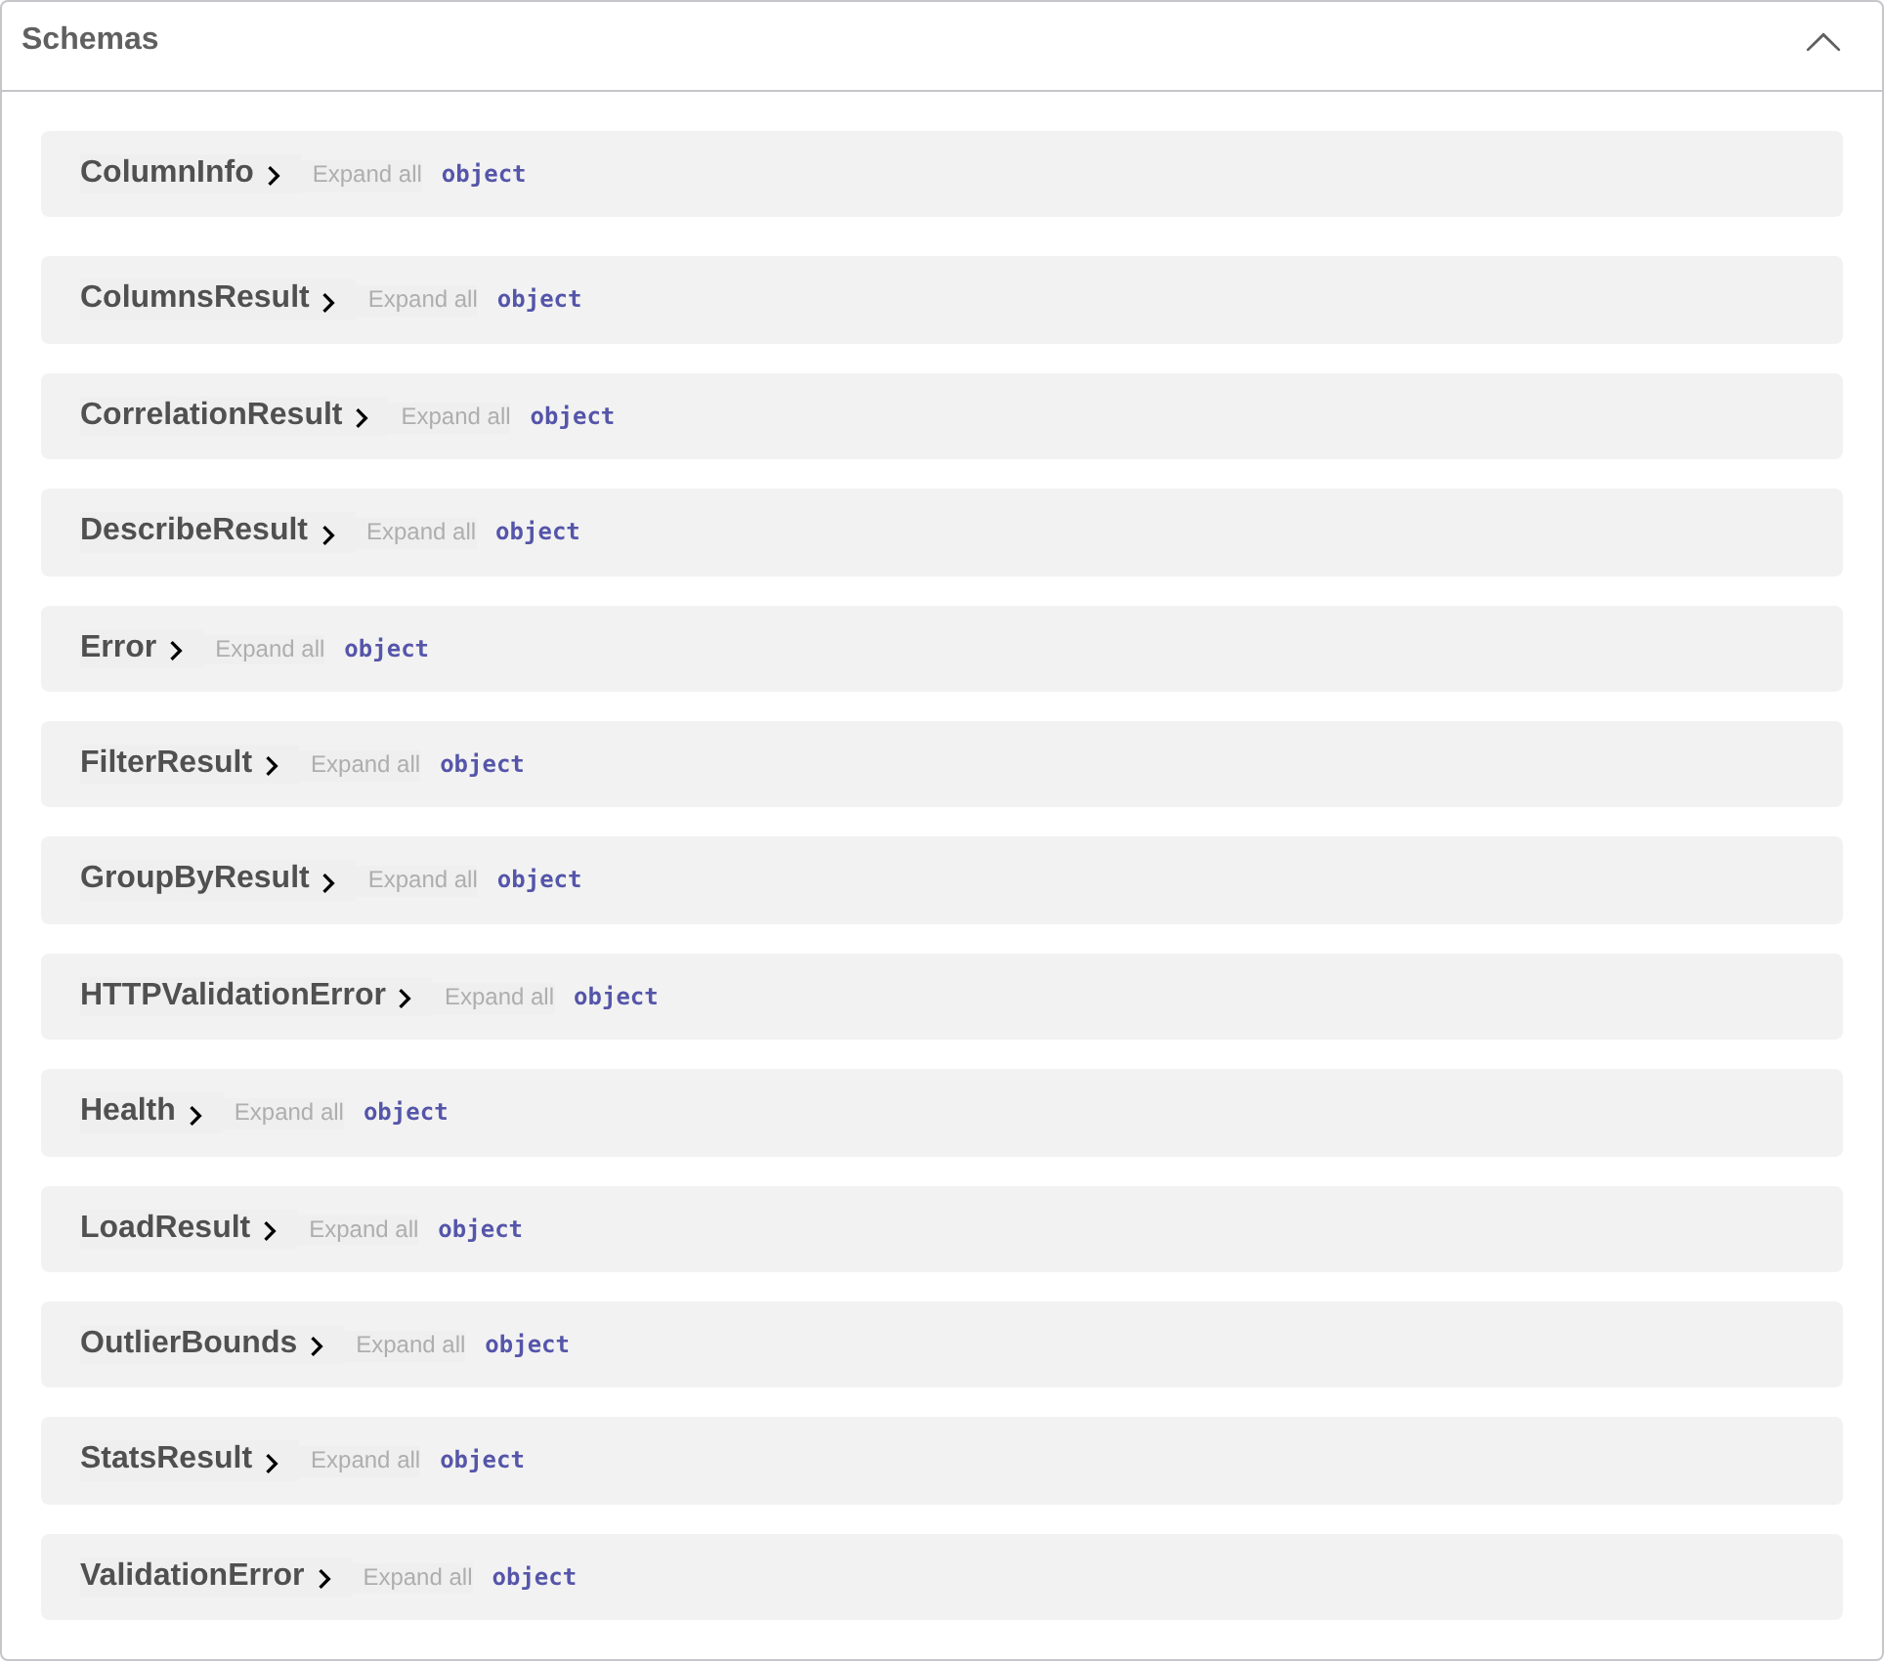
Figure 23: The generated schemas
StatsResult expanded, with the descriptions from the Pydantic fields:
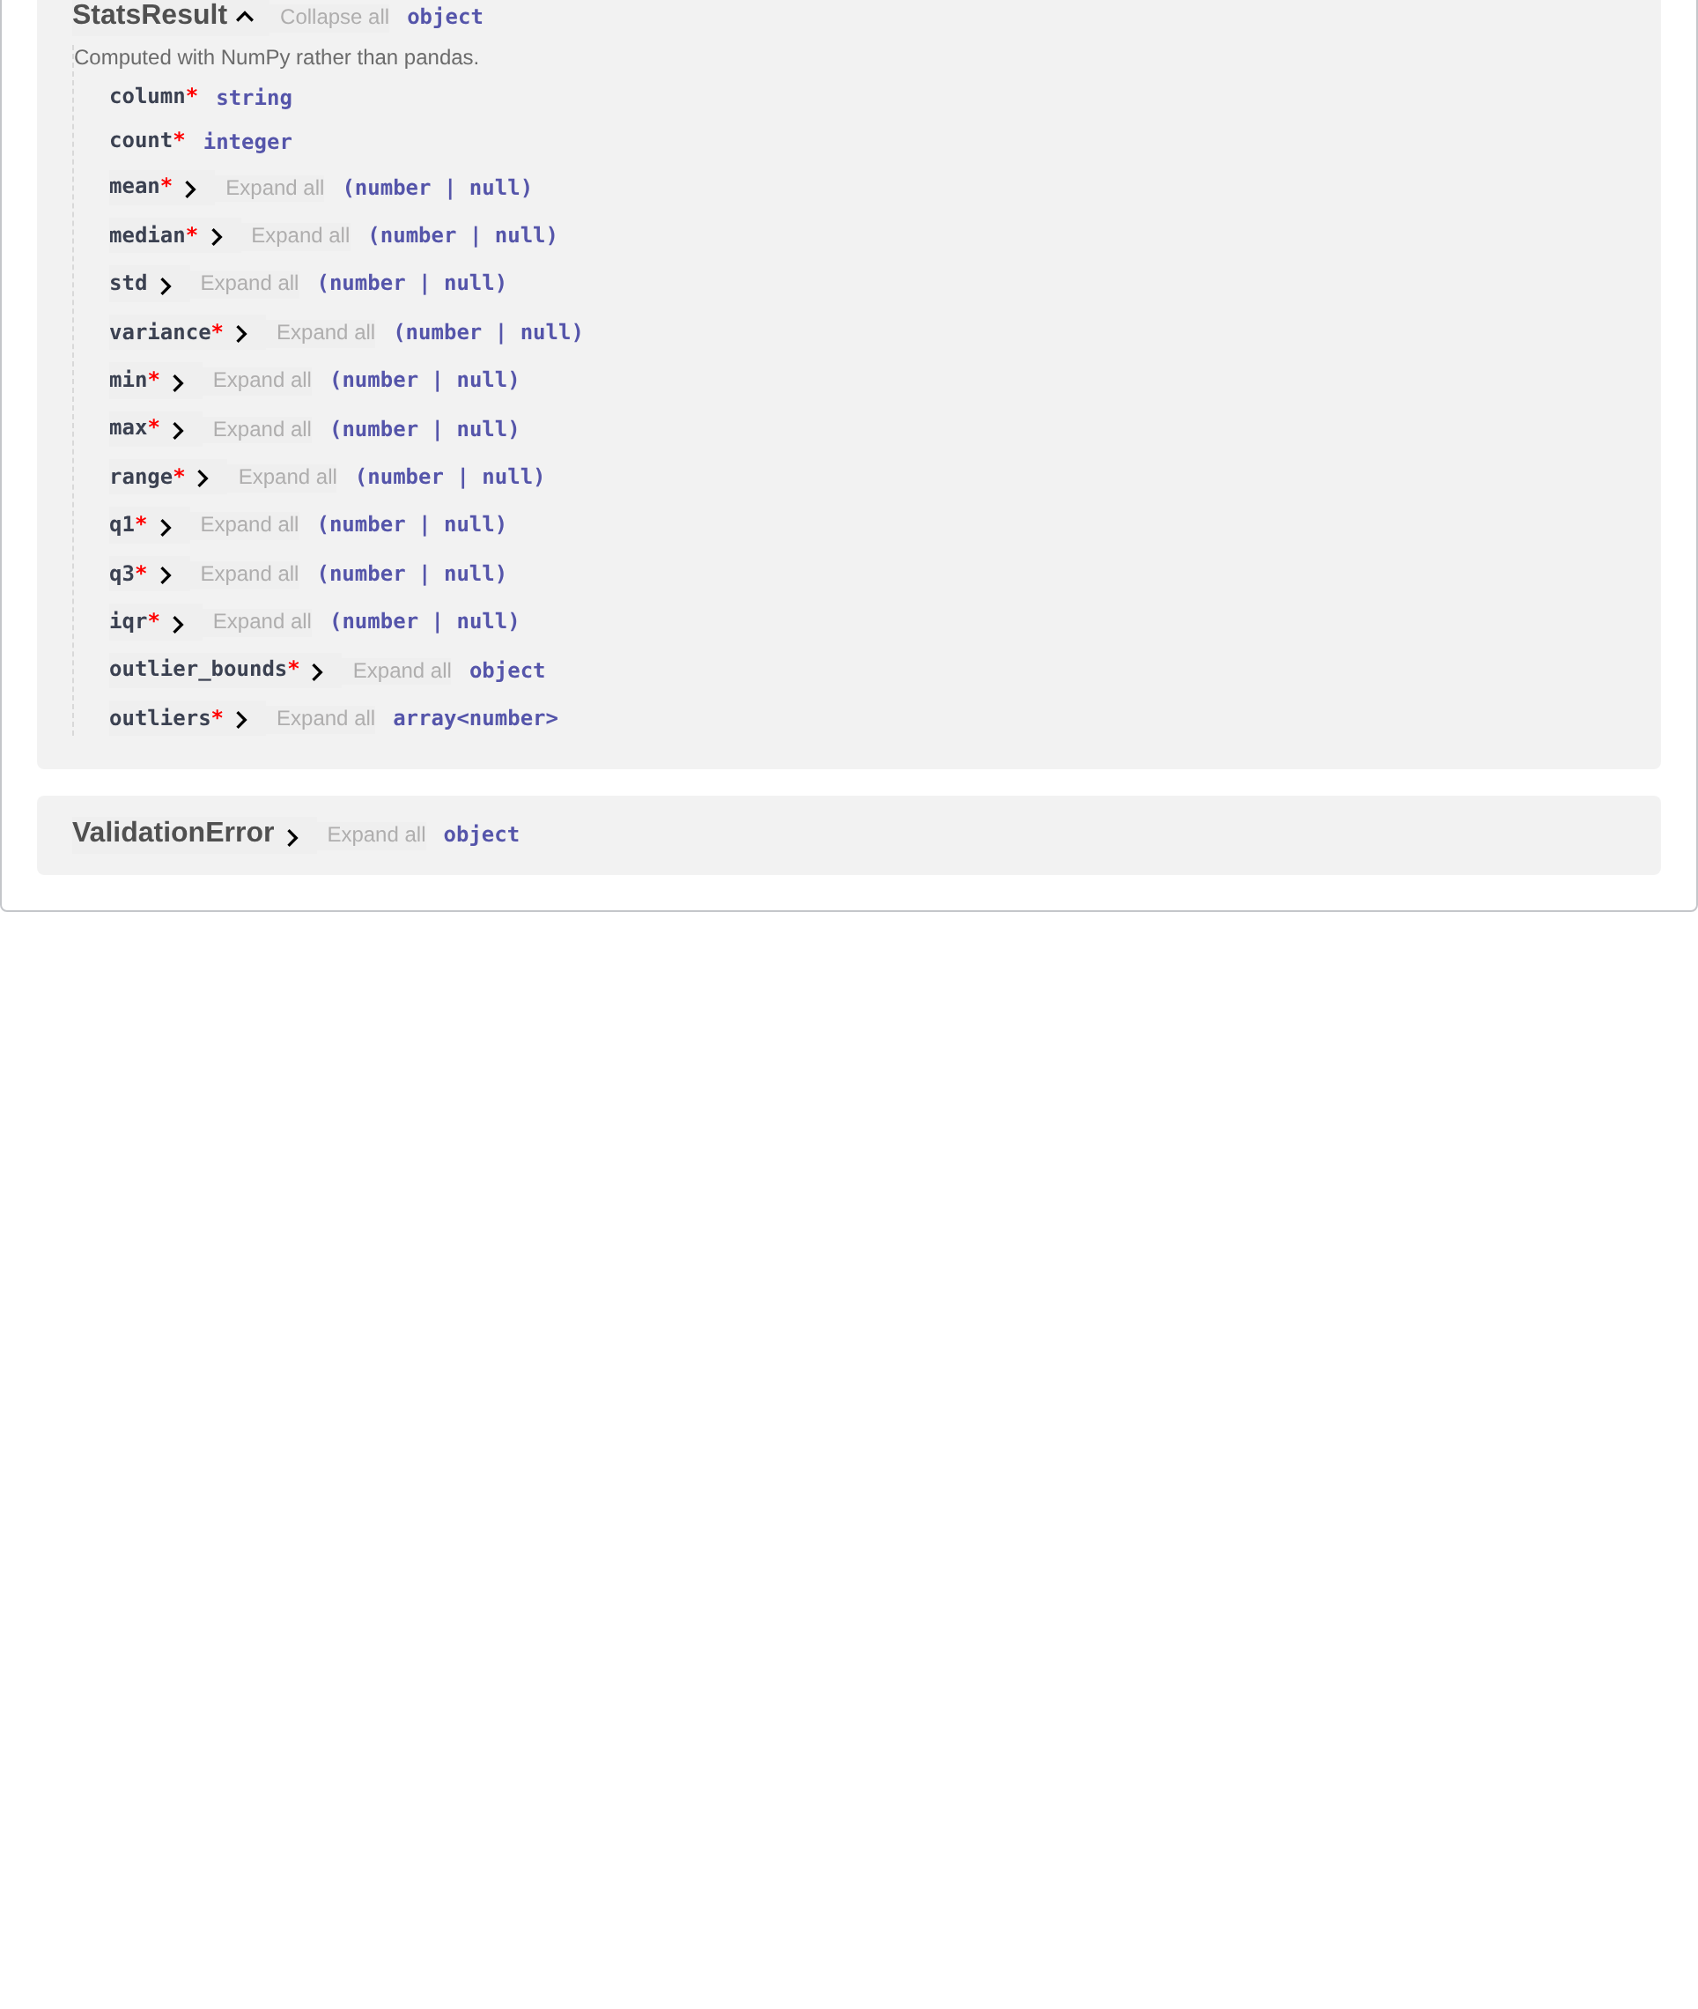
Figure 24: The StatsResult schema
The same document also renders as ReDoc at /redoc, which is easier to read end to end:
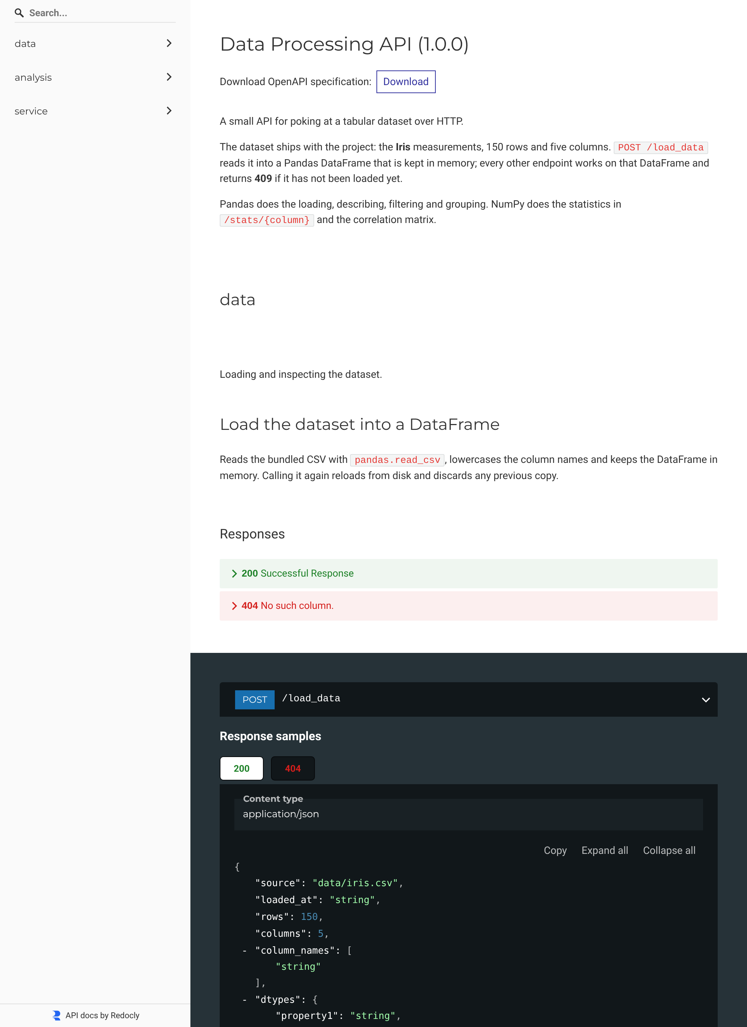
Figure 25: The same API at /redoc

Calling the API from the documentation
Swagger UI can call the service itself, which makes the documentation a test client. The responses below came back from the running API.
Loading the data from the browser. This has to happen first, for the same reason it does from curl:
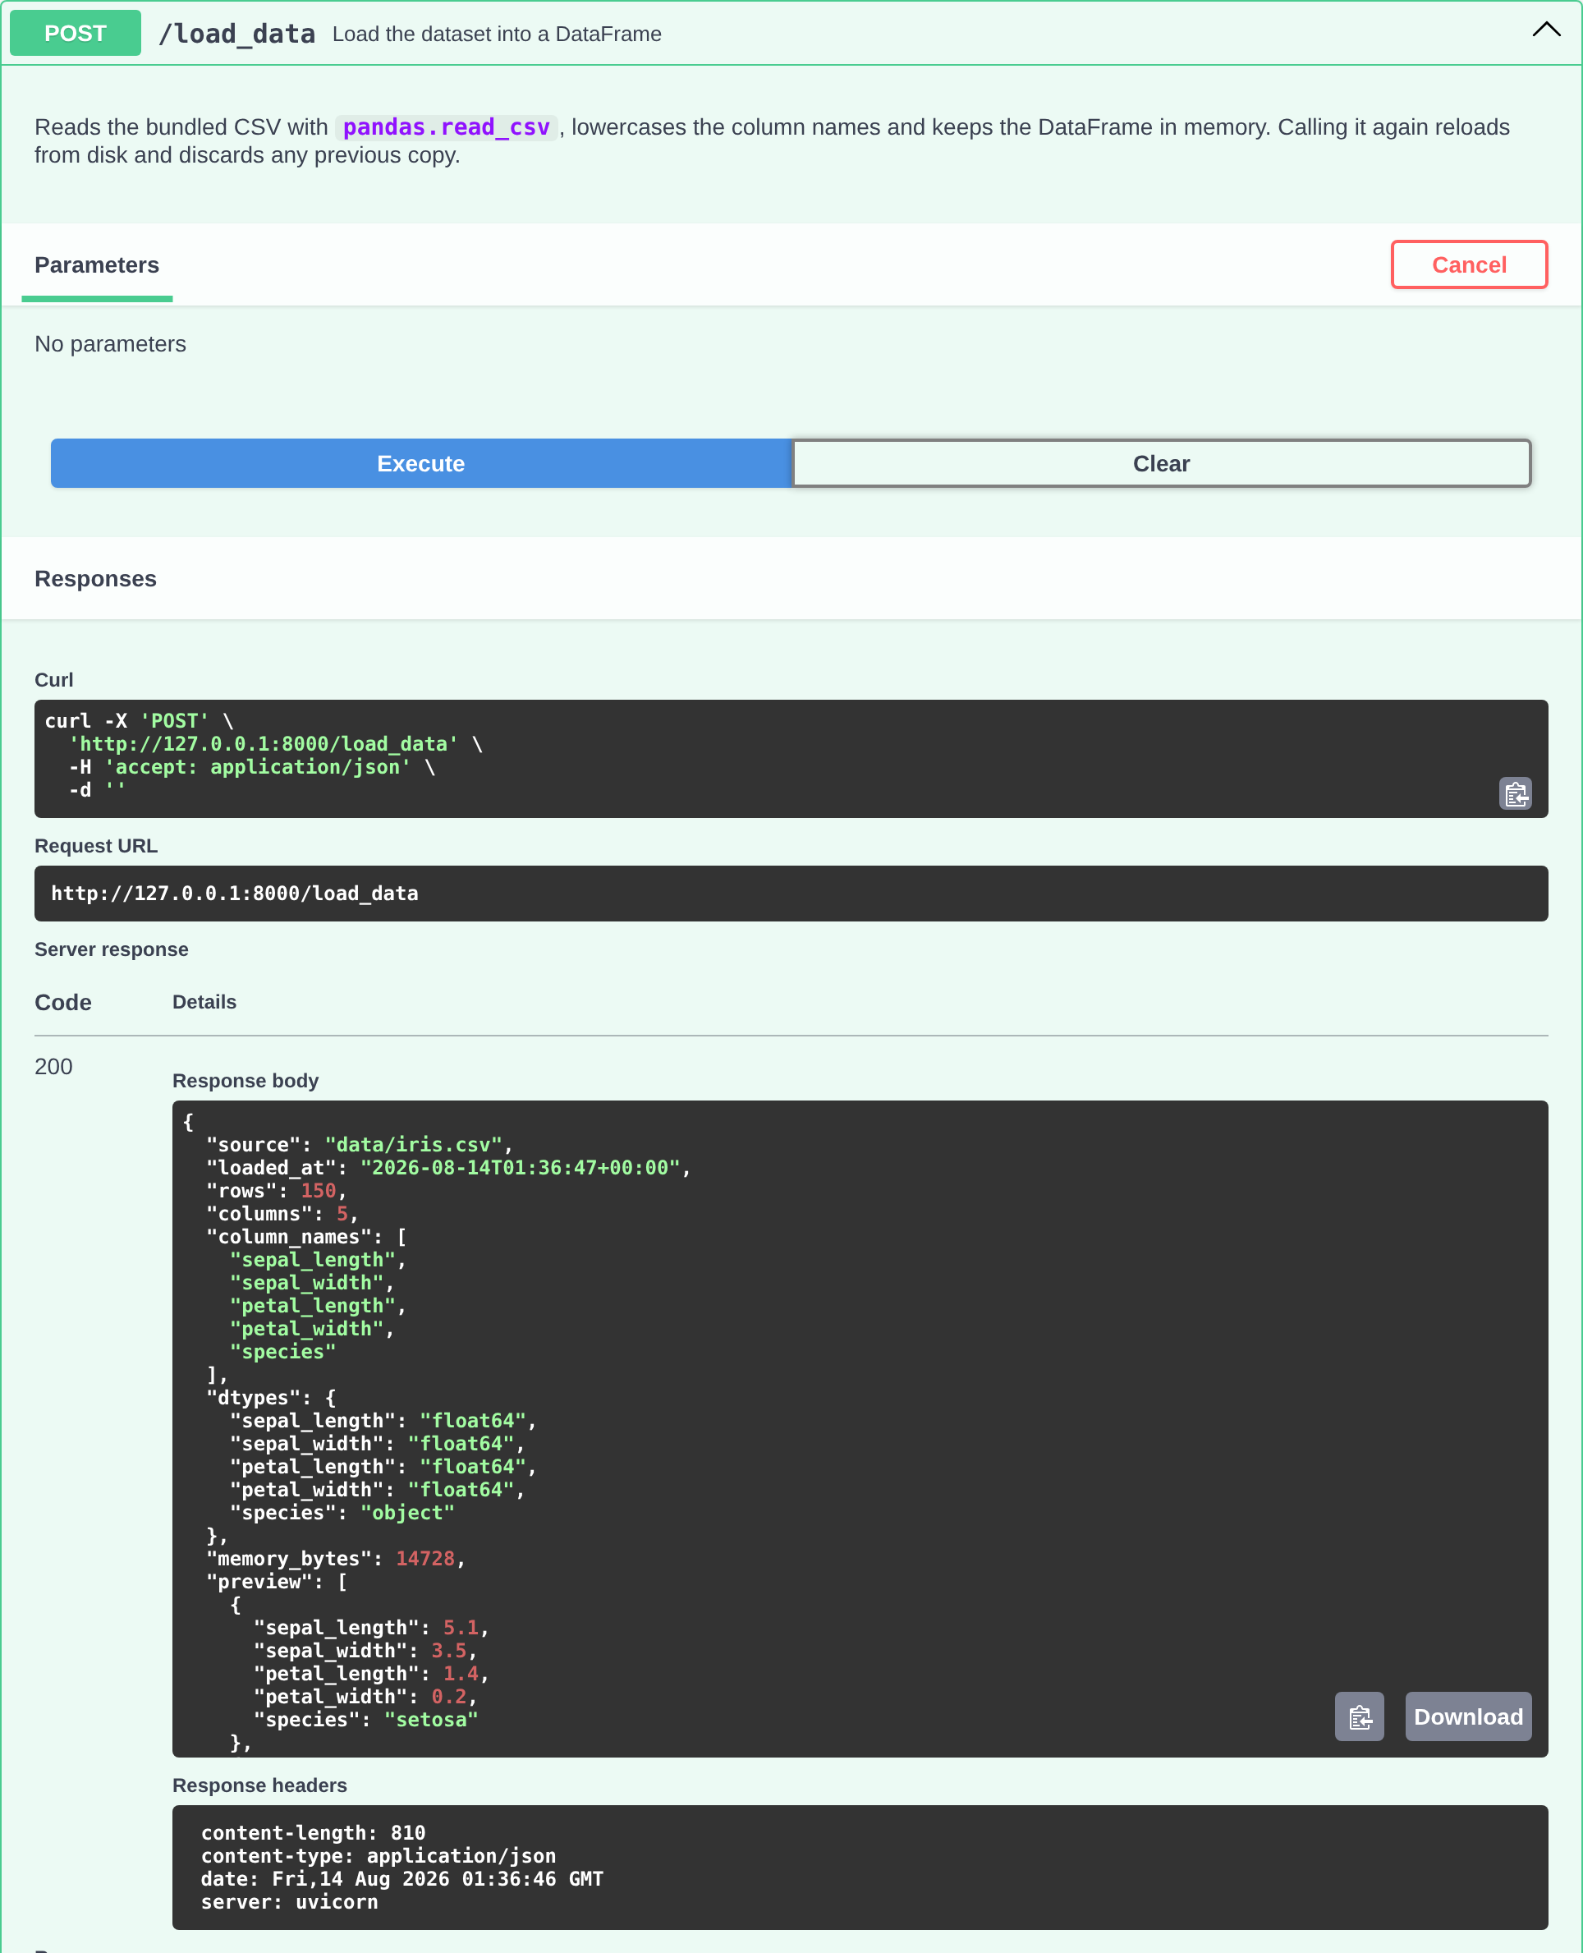
Figure 26: POST /load_data executed from /docs
Then filtering, with the parameters filled in the form. The curl command Swagger UI shows is the same request written out, which is a convenient way to get a working command line:
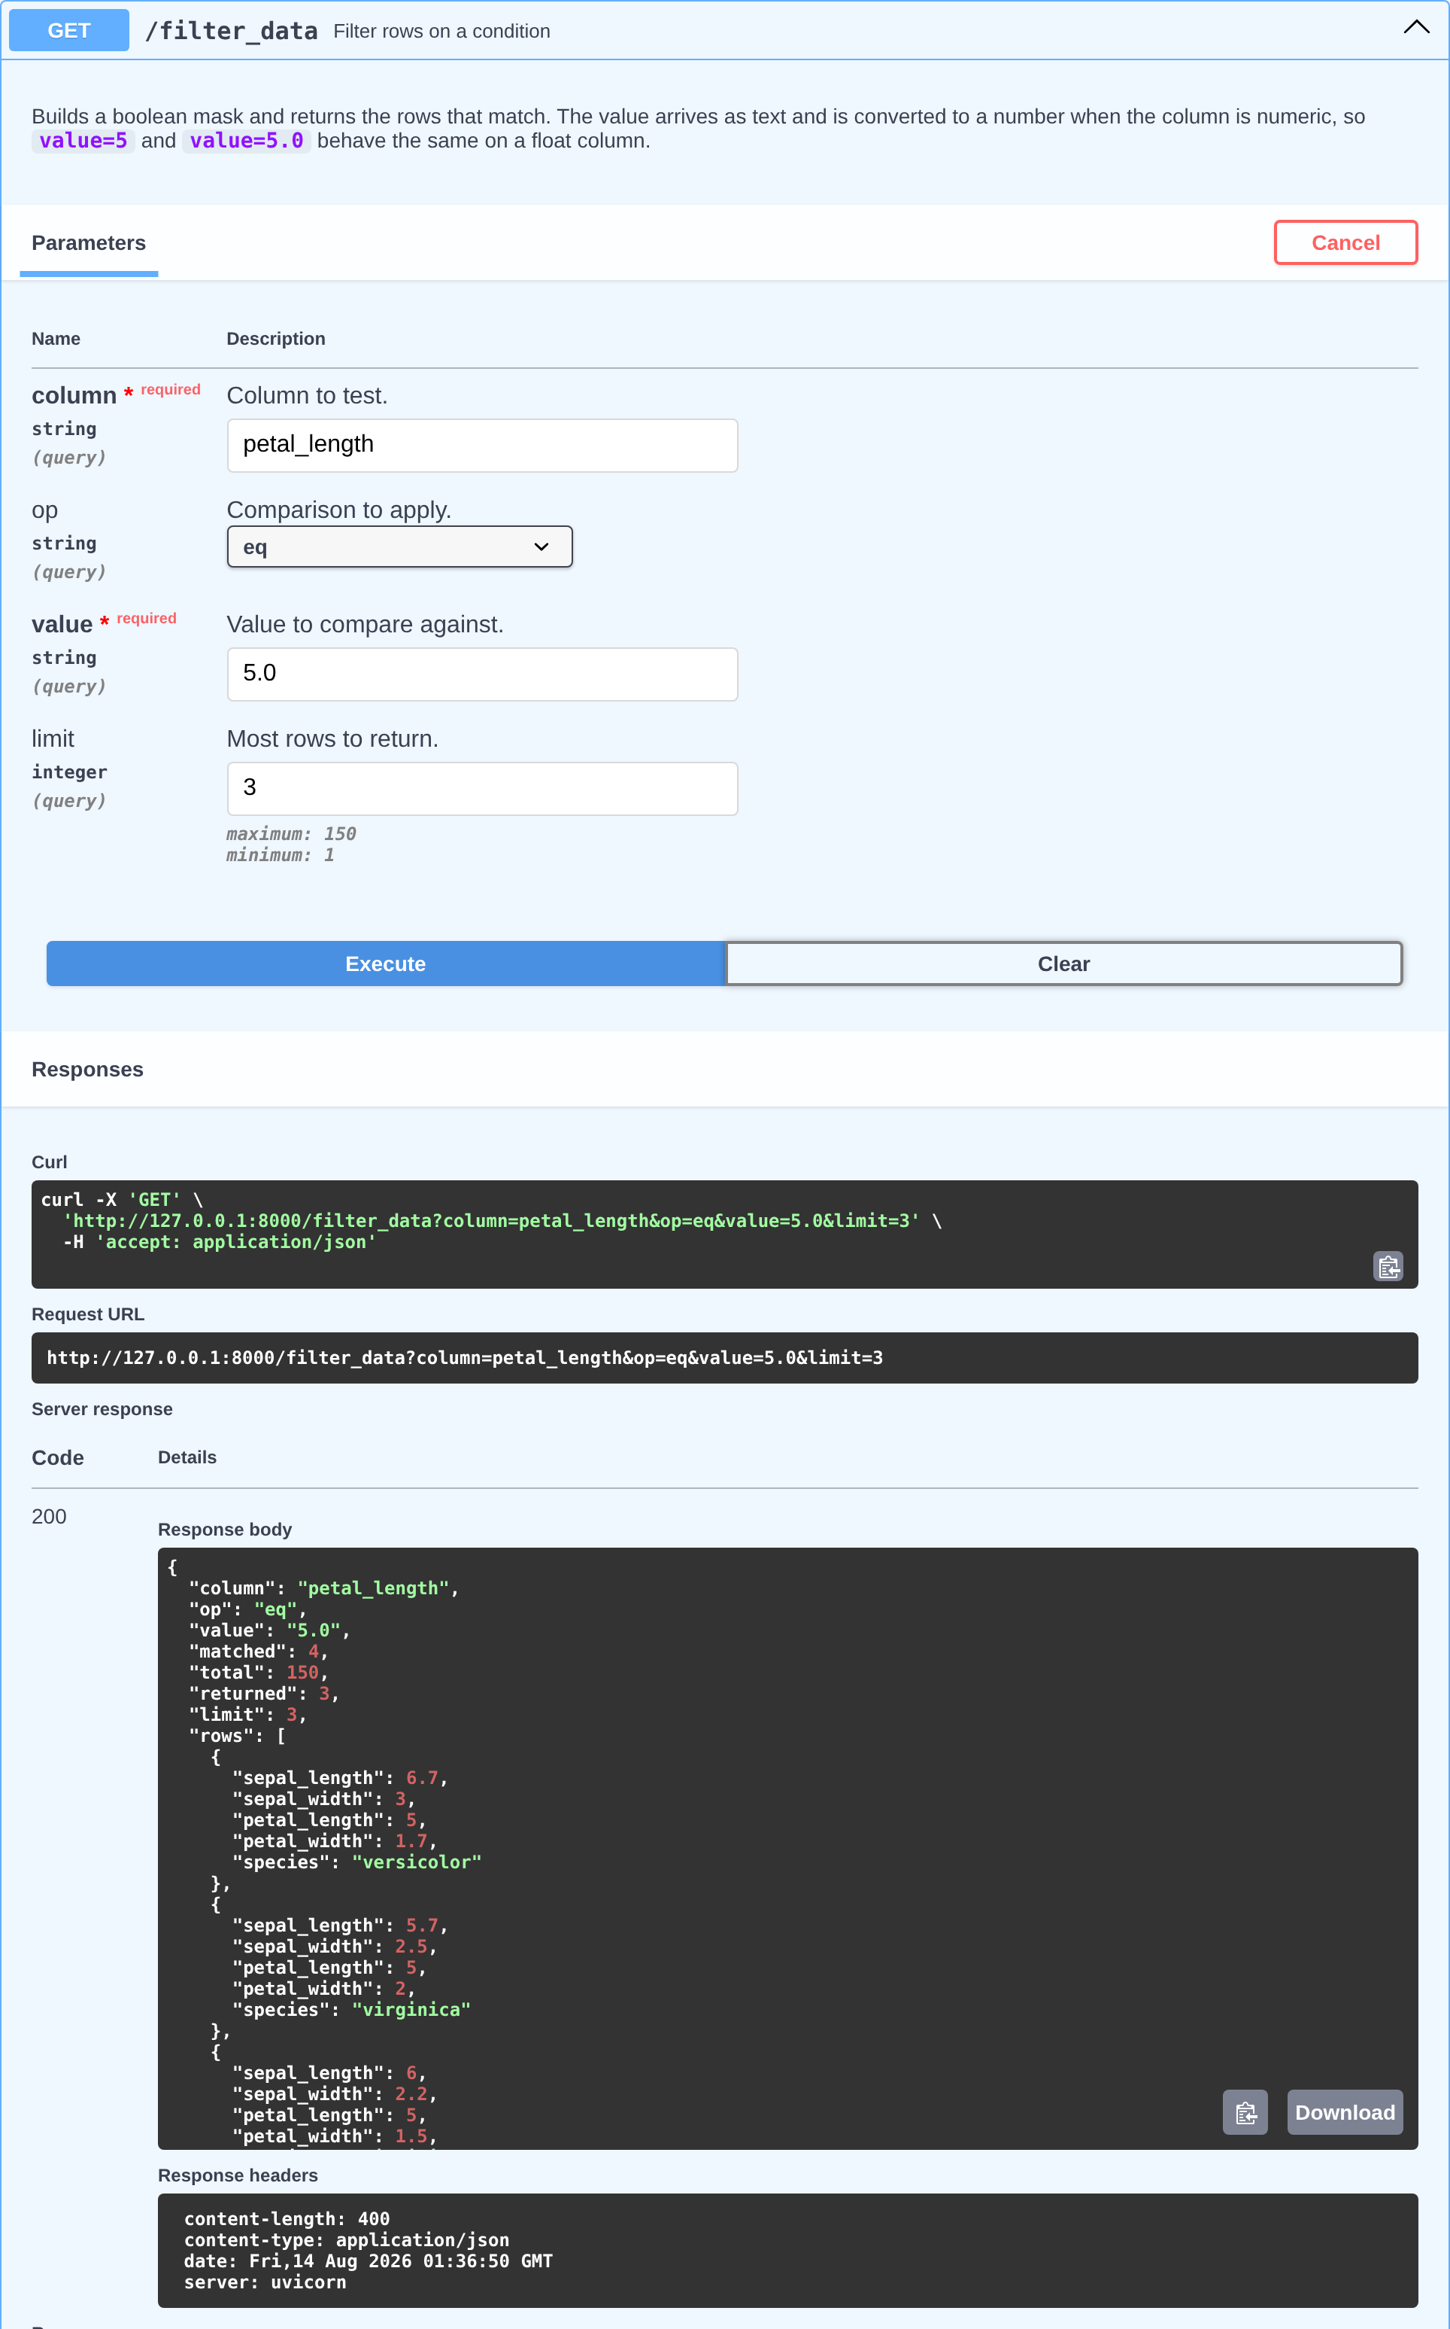
Figure 27: /filter_data executed from /docs, with the equivalent curl command
And the statistics endpoint, with the column supplied as a path parameter:
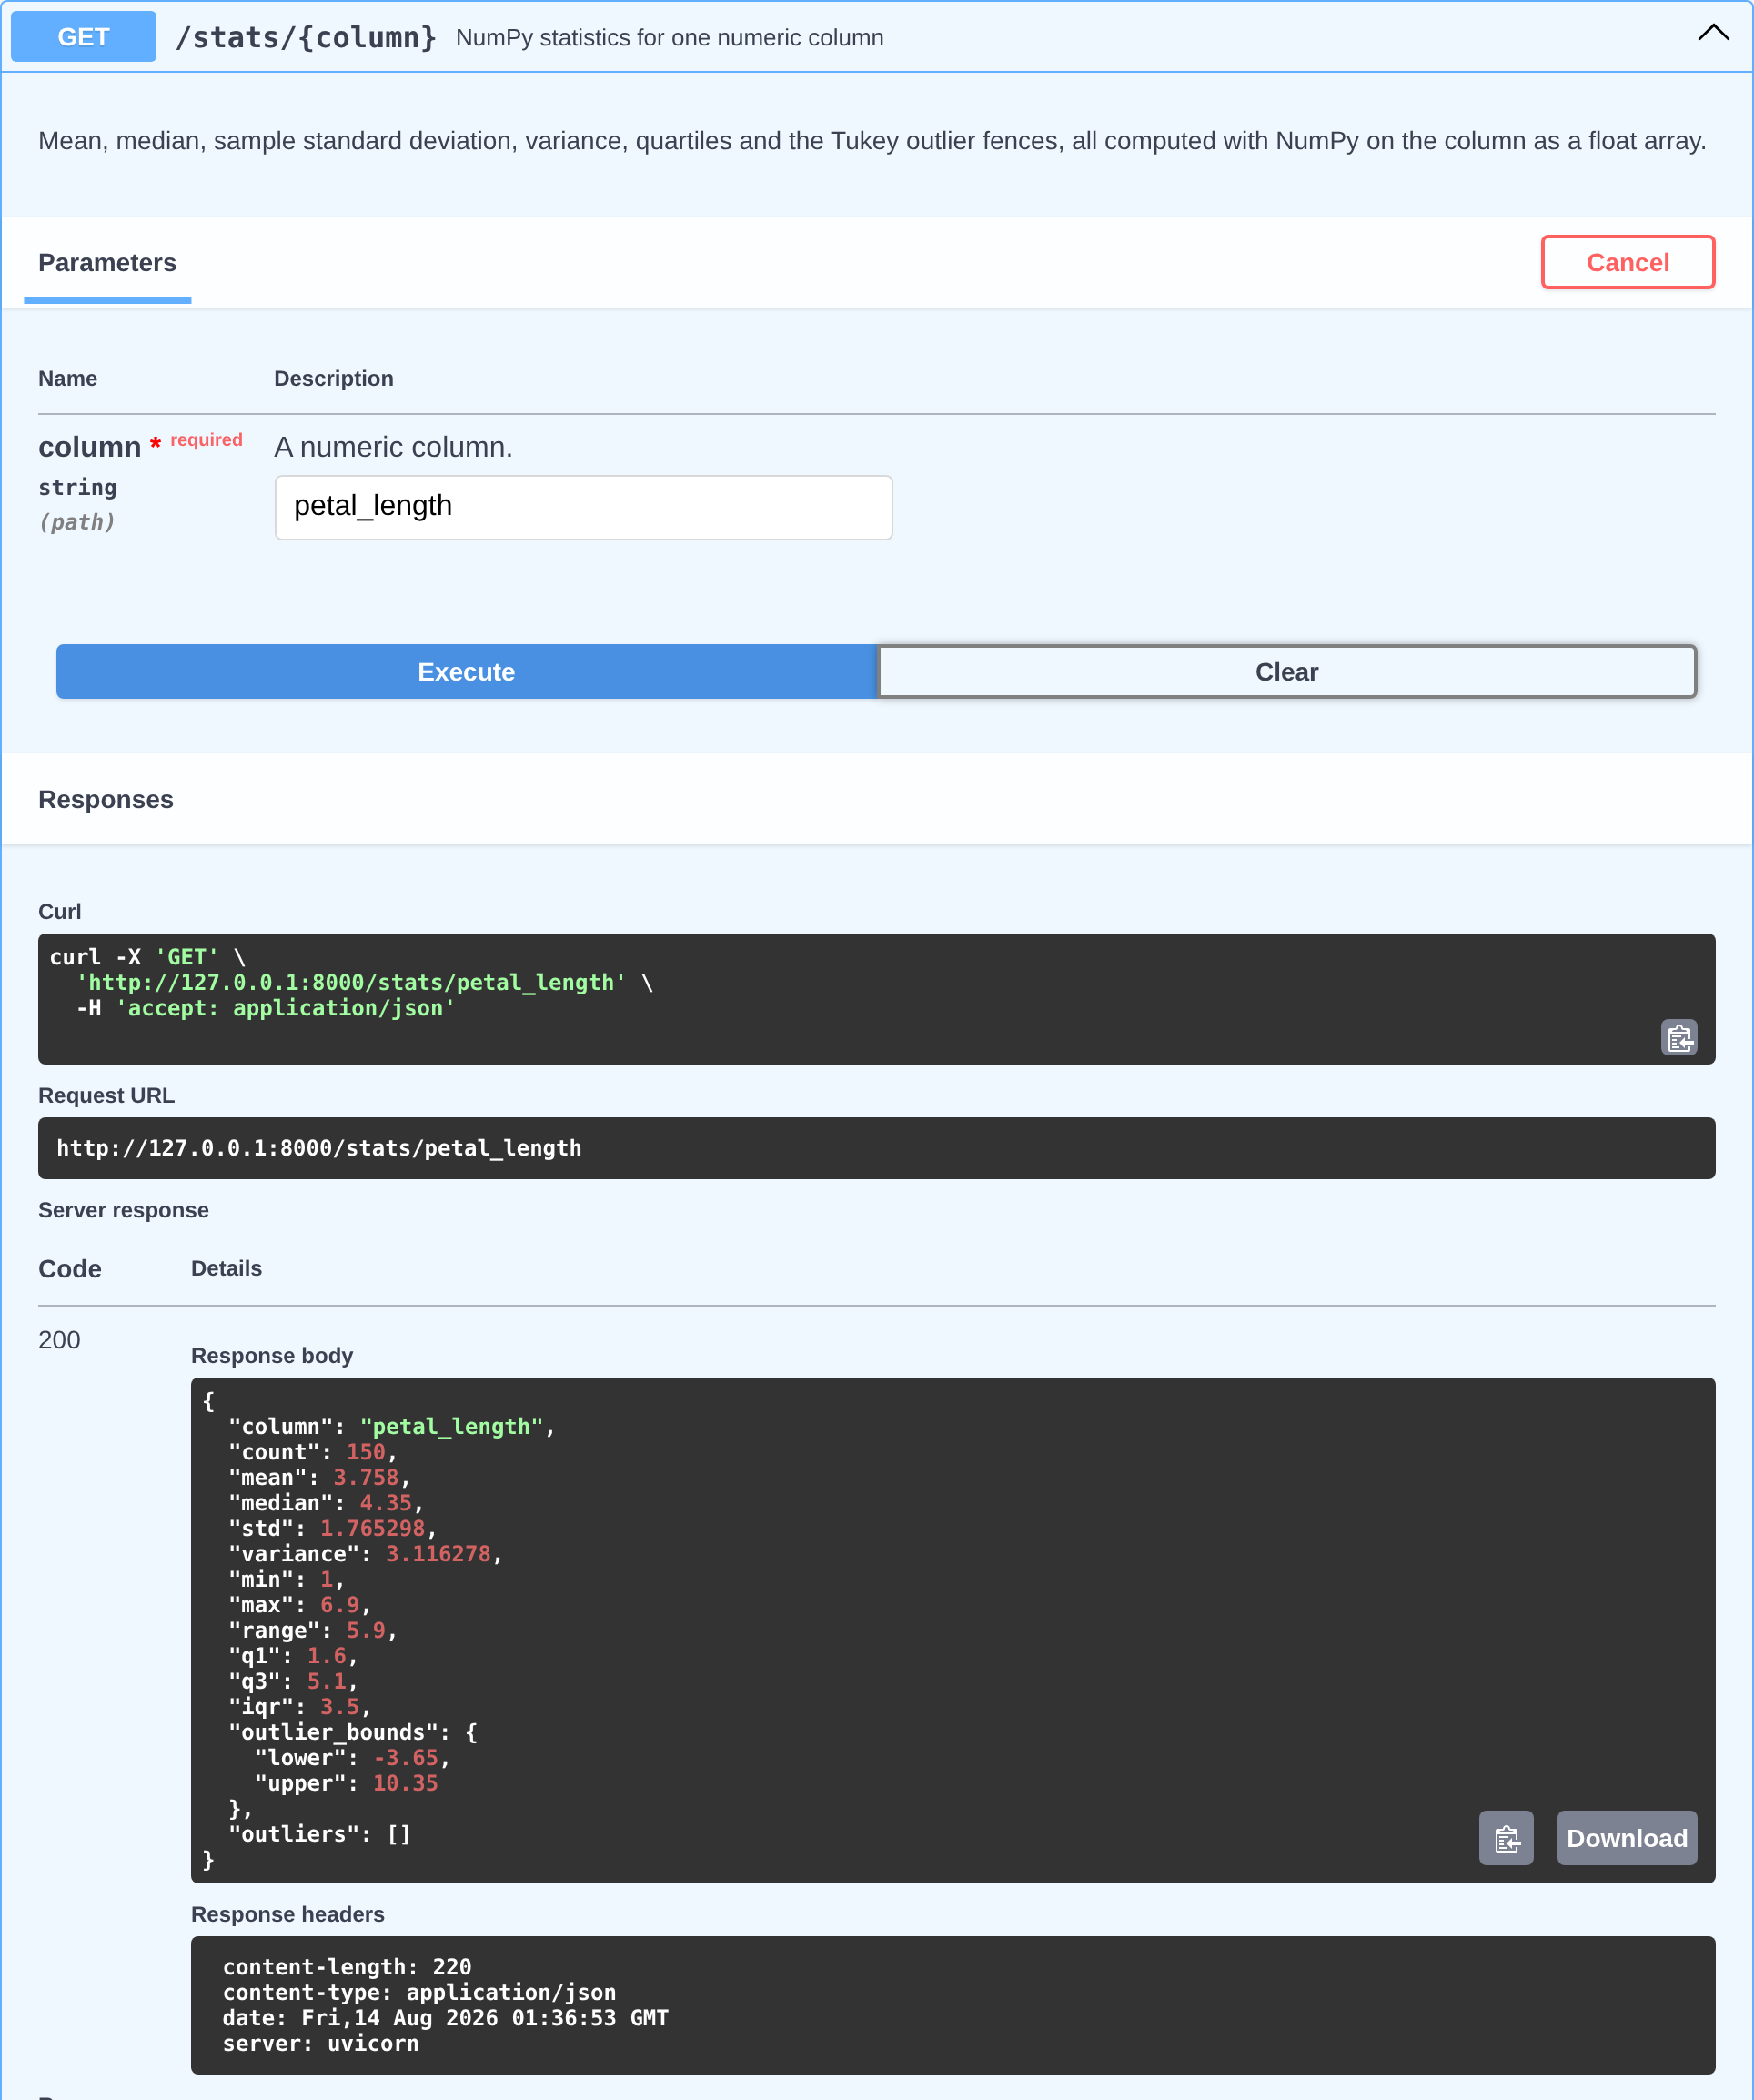
Figure 28: /stats/petal_length executed from /docs

Automated tests
40 tests cover the endpoints. They are worth more than the screenshots, because a screenshot proves the API worked once and these keep proving it.
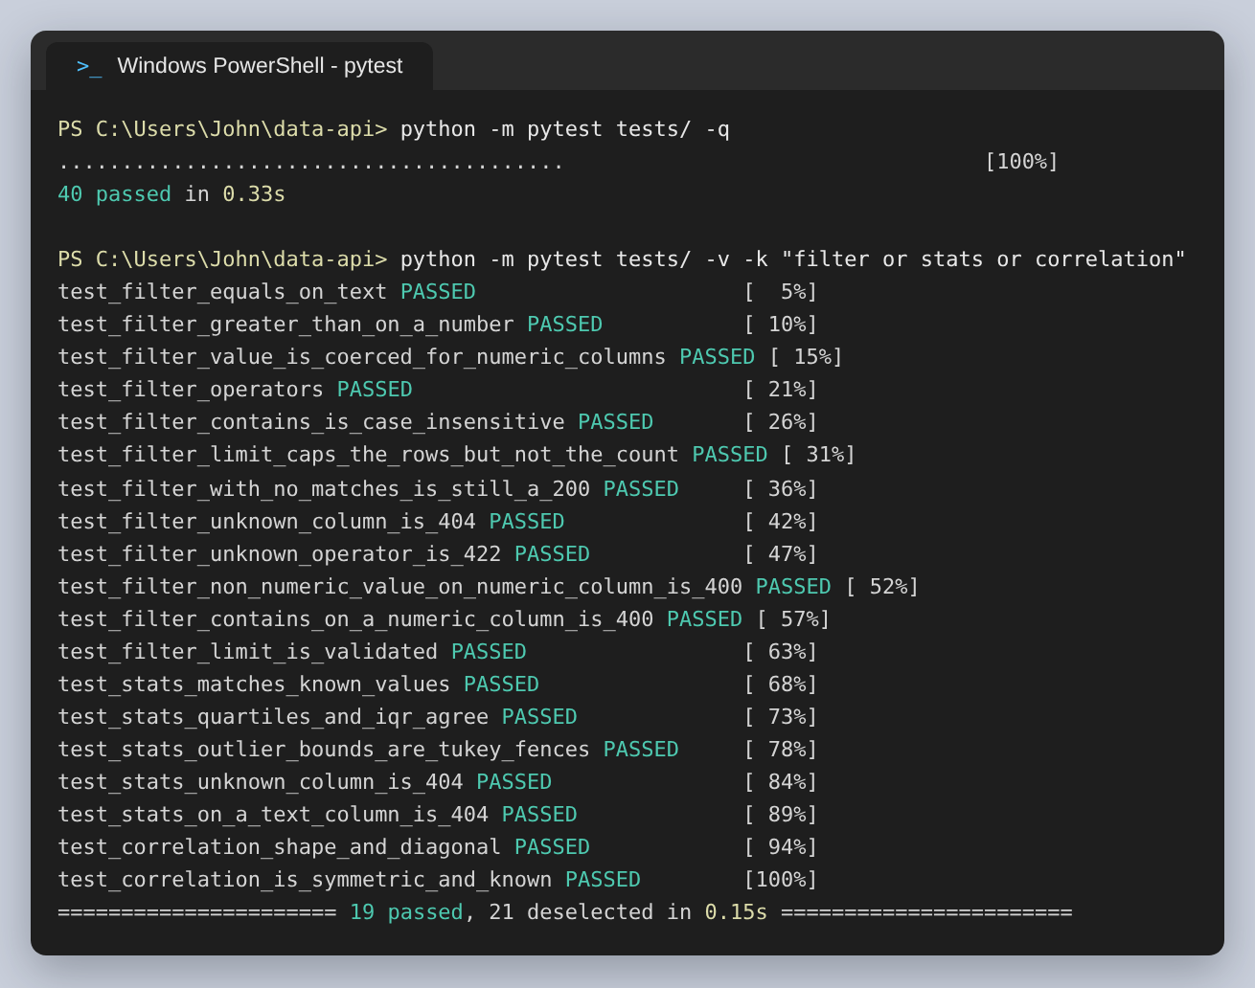
Figure 29: The test run, and the filter, statistics and correlation tests by name
The values are asserted against numbers that are known for this dataset: a petal length mean of 3.758, a median of 4.35, 42 rows above 5.0, a setosa mean of 1.462 and a petal length to petal width correlation of 0.963. If a filter or a statistic quietly broke, those would catch it, which a test that only checks for a 200 would not.
Several tests exist because of mistakes I made. One checks that no response body contains the text NaN, after describe() first failed to encode. One checks that value=5 and value=5.0 match the same 42 rows, after an early version compared the query string against a float column as text and returned nothing. One checks that every read returns 409 before loading, across all six read endpoints at once.

What I would change
The DataFrame in memory is the obvious weakness. It is a module-level variable, so two workers would each have their own copy and a client would get different answers depending on which one it reached. For anything real the data would be loaded at startup, or held somewhere both workers could see.
I would also add pagination properly. /filter_data has a limit but no offset, so there is no way to walk past the first page of matches. The matched and returned counts in the response were meant to make the truncation obvious, and they do, but they are not a substitute for being able to ask for the rest.
What went better than I expected was how much of the documentation came for free. Declaring op as a Literal, giving limit a range and putting descriptions on the Pydantic fields produced the parameter table, the dropdown, the validation and the examples in the screenshots above without any separate specification to keep in step. On the previous assignment I wrote an OpenAPI document by hand and needed tests to stop it drifting from the code; here the code is the document.

